Name: K.Likitha
Hall Ticket: 2303A52144 Batch: 41
Task 1: Sentiment Classification for Customer Reviews Prompt:
- Prepare 6 short customer reviews mapped to sentiment labels.
- Design a Zero-shot prompt to classify sentiment.
- Design a One-shot prompt with one labeled example.
- Design a Few-shot prompt with 3–5 labeled examples.
- Compare the outputs and discuss accuracy differences.
Code:
# ==========================================================
# ✅ TASK 1: Sentiment Classification
# ==========================================================

def sentiment_classifier(review): text = clean_text(review)

pos_words = ["amazing", "excellent", "good", "great", "love", "happy", "fast", "worth", "perfect"]
neg_words = ["bad", "worst", "damaged", "broken", "late", "missing", "terrible", "waste", "refund"]
neu_words = ["ok", "okay", "average", "fine", "normal", "nothing", "decent"]

pos_score = keyword_score(text, pos_words) neg_score = keyword_score(text, neg_words) neu_score = keyword_score(text, neu_words)

if pos_score > neg_score and pos_score >= 1: return "Positive"
elif neg_score > pos_score and neg_score >= 1: return "Negative"
elif neu_score >= 1: return "Neutral"
else:
return "Neutral"

def task1_sentiment():
print_section("✅ TASK 1: Sentiment Classification")

# ✅ PROMPTS
zero_shot_prompt = """
You are a sentiment classifier.
Classify the review into: Positive / Negative / Neutral. Output: Sentiment: <label>
"""

one_shot_prompt = """ Labeled Sample:
Review: "The product is excellent and I love it." Sentiment: Positive

Now classify the given review. """

few_shot_prompt = """ Labeled Samples:
Review: "Fantastic product, works perfectly!" -> Positive Review: "Very disappointed, stopped working." -> Negative Review: "It is okay, does the job." -> Neutral
Review: "Delivery was quick, service great." -> Positive

Now classify the given review. """

print("\n(b) Zero-shot prompt:\n", zero_shot_prompt) print("\n(c) One-shot prompt:\n", one_shot_prompt) print("\n(d) Few-shot prompt:\n", few_shot_prompt)

unseen = [
"Not bad, but delivery was delayed.",
"I am extremely happy with this purchase.", "Terrible quality, waste of money."
]

print("\n(e) Testing Unseen Reviews:") for u in unseen:
print(f'Review: "{u}" --> Sentiment: {sentiment_classifier(u)}')

print("\nObservation: Few-shot improves accuracy in real LLMs.\n")

Output:

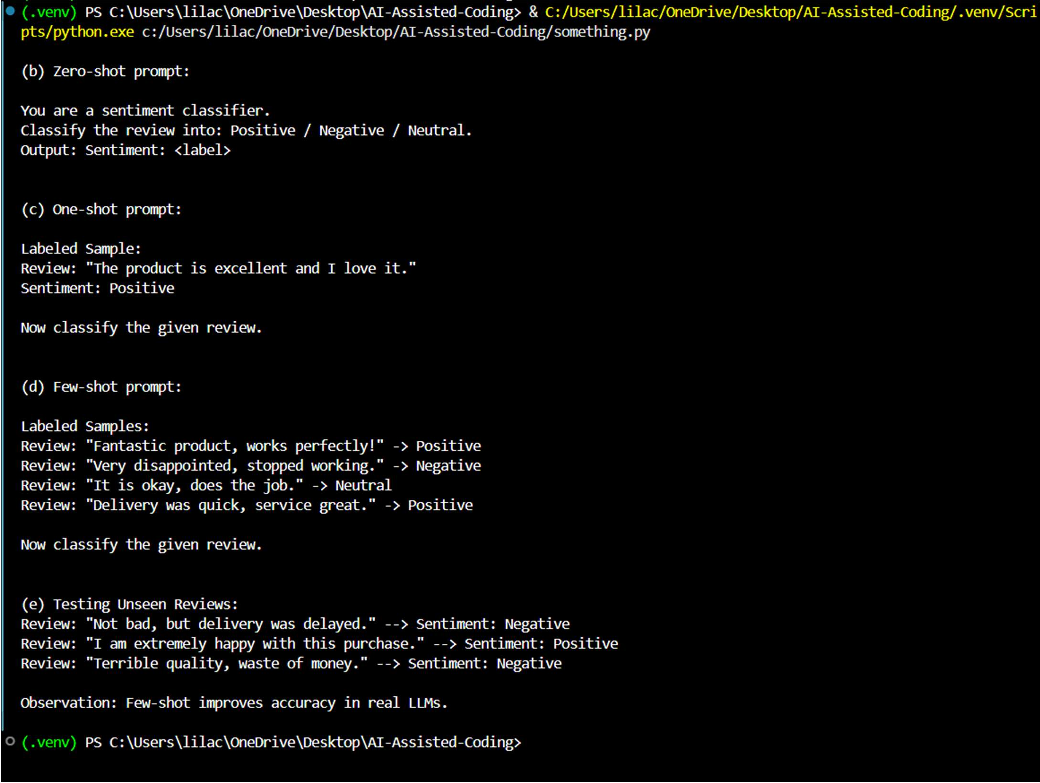
Explanation:
This task helps classify customer reviews as Positive, Negative, or Neutral.It is useful for improving product quality and customer satisfaction.Few-shot prompting gives better accuracy for unclear reviews.

Task 2: Email Priority Classification Prompt:
- Create 6 sample email messages with priority labels.
- Perform intent classification using Zero-shot prompting.
- Perform classification using One-shot prompting.
- Perform classification using Few-shot prompting.
- Evaluate which technique produces the most reliable results and why.

Code:
# ==========================================================
# ✅ TASK 2: Email Priority Classification
# ==========================================================

def clean_text(text):
"""Convert text to lowercase and remove extra spaces.""" return text.lower().strip()

def keyword_score(text, keywords):
"""Count how many keywords appear in the text."""
return sum(1 for keyword in keywords if keyword in text)

def print_section(title):
"""Print a formatted section title.""" print(f"\n{'='*50}")
print(title) print(f"{'='*50}")

def email_priority_classifier(email): text = clean_text(email)

high = ["urgent", "asap", "immediately", "server", "down", "critical", "fix", "deadline", "today"]
medium = ["reminder", "submit", "report", "meeting", "approve", "request", "review", "attendance"]
low = ["birthday", "thanks", "fyi", "photo", "greetings", "update", "notice", "menu"]

high_score = keyword_score(text, high) med_score = keyword_score(text, medium) low_score = keyword_score(text, low)

if high_score > med_score and high_score > low_score: return "High Priority"
elif med_score >= high_score and med_score > low_score: return "Medium Priority"
else:
return "Low Priority"

def task2_email_priority():
print_section("✅ TASK 2: Email Priority Classification")

emails = [
("Server is down, urgent fix needed ASAP.", "High Priority"), ("Need approval for budget today before meeting.", "High Priority"), ("Reminder: submit weekly report by Friday.", "Medium Priority"), ("Can you share last month attendance sheet?", "Medium Priority"), ("Happy birthday! Hope you enjoy your day.", "Low Priority"), ("FYI: New wallpaper designs for office.", "Low Priority")
]

print("(1) Sample Emails + Labels:") for e, label in emails:
print(f"- {e} --> {label}")

# ✅ PROMPTS
zero_prompt = "Classify email priority into High / Medium / Low."

one_prompt = """ Labeled Sample:
Email: "Server outage, fix now" Priority: High Priority

Now classify the given email. """

few_prompt = """ Labeled Samples:
Email: "Payment failed, resolve immediately" -> High Priority Email: "Weekly report reminder" -> Medium Priority
Email: "Greetings and wishes" -> Low Priority

Now classify the given email. """

print("\n(2) Zero-shot Prompt:\n", zero_prompt) print("\n(3) One-shot Prompt:\n", one_prompt) print("\n(4) Few-shot Prompt:\n", few_prompt)

unseen = [
"Client payment failed, resolve immediately.", "Reminder: attend meeting at 4 PM tomorrow.", "FYI: New cafeteria menu is updated."
]

print("\n(5) Testing Unseen Emails:") for u in unseen:
print(f'Email: "{u}" --> Priority: {email_priority_classifier(u)}')

print("\nObservation: Few-shot gives best reliability.\n")

Output:
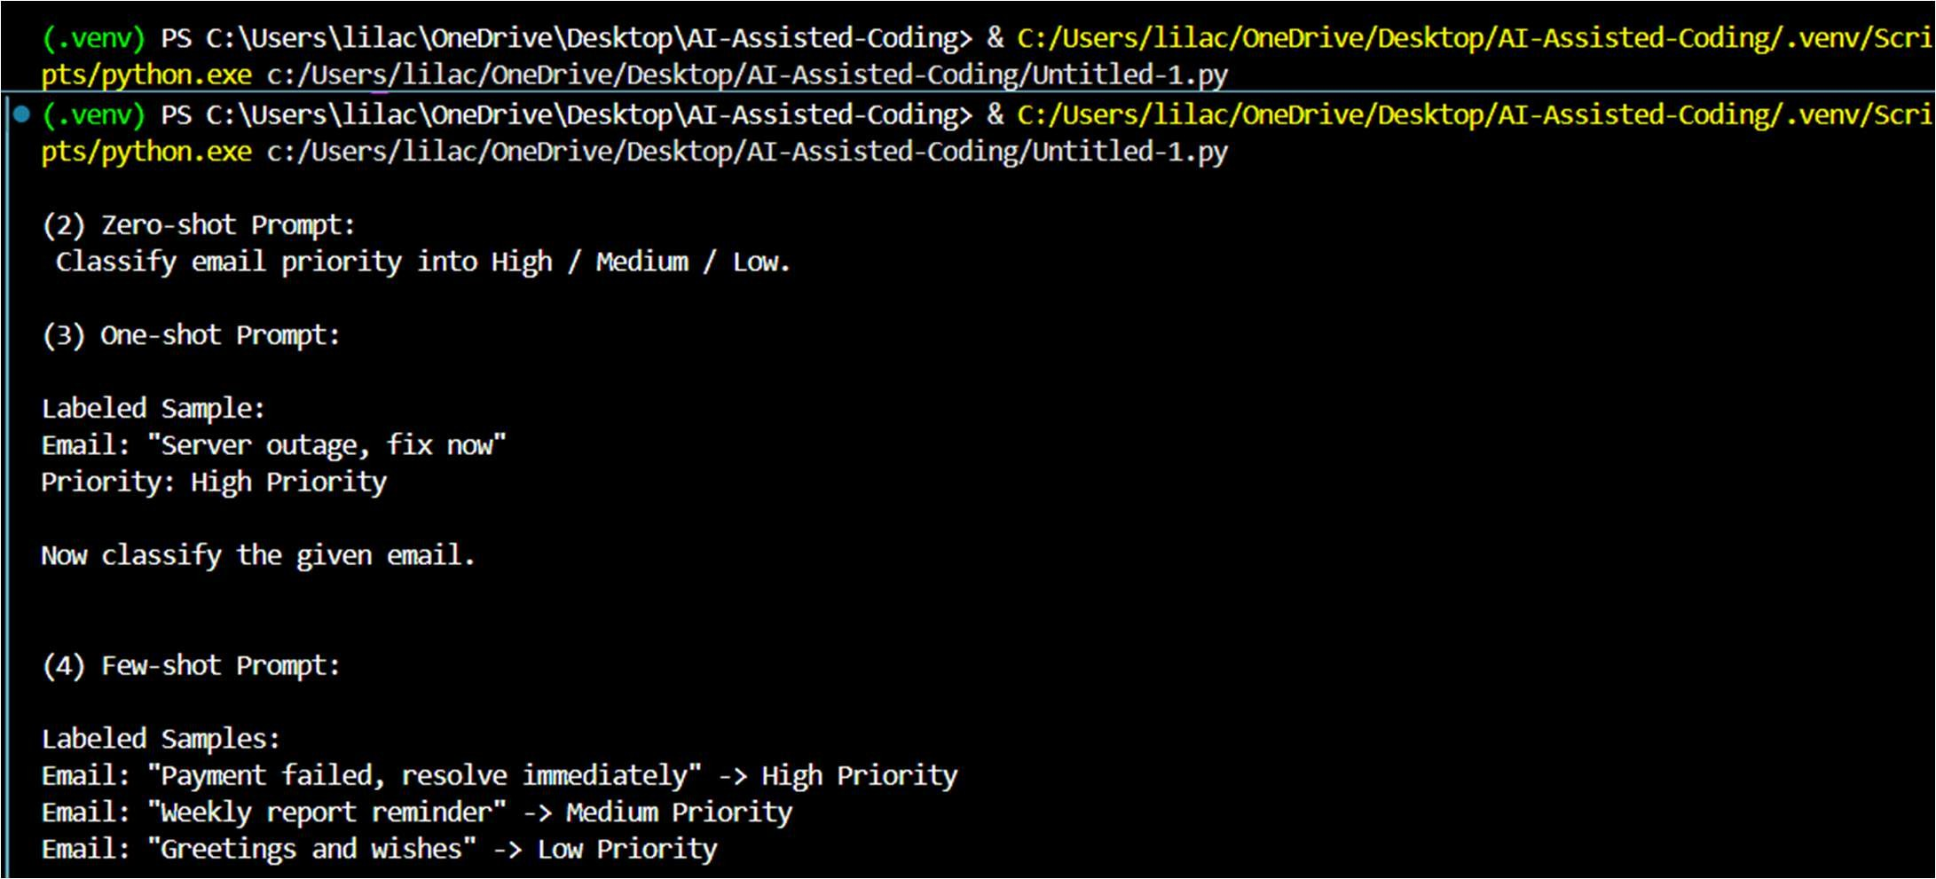

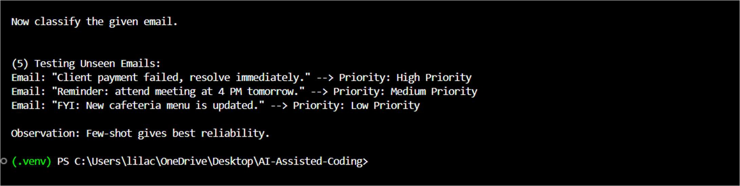
Explanation:
This task helps automatically prioritize emails into High, Medium, or Low.It ensures urgent issues are handled quickly without delay.Few-shot prompting gives the most reliable priority results.
Task 3: Student Query Routing System Prompt:
- Create 6 sample student queries mapped to departments.
- Implement Zero-shot intent classification using an LLM.
- Improve results using One-shot prompting.
- Further refine results using Few-shot prompting.
- Analyze how contextual examples affect classification accuracy.

Code:
# ==========================================================
# ✅ TASK 3: Student Query Routing
# ==========================================================

def clean_text(text):
"""Convert text to lowercase and remove extra spaces.""" return text.lower().strip()

def keyword_score(text, keywords):
"""Count how many keywords appear in the text."""
return sum(1 for keyword in keywords if keyword in text)

def print_section(title):
"""Print a formatted section title.""" print(f"\n{'='*50}")
print(title) print(f"{'='*50}")

def student_router(query): text = clean_text(query)

admissions = ["eligibility", "admission", "apply", "fee", "scholarship", "join", "documents"]
exams = ["results", "revaluation", "midterm", "hallticket", "exam", "marks", "backlog"]
academics = ["elective", "course", "syllabus", "drop", "credits", "timetable",
"faculty"]

placements = ["placement", "internship", "campus", "drive", "company", "resume", "interview"]

scores = {
"Admissions": keyword_score(text, admissions), "Exams": keyword_score(text, exams), "Academics": keyword_score(text, academics), "Placements": keyword_score(text, placements)
}

return max(scores, key=scores.get)

def task3_student_routing():
print_section("✅ TASK 3: Student Query Routing System")

queries = [
("What is the eligibility for BTech CSE?", "Admissions"), ("How can I apply for scholarships?", "Admissions"), ("When will semester results be announced?", "Exams"), ("I missed my midterm, what should I do?", "Exams"), ("Can I change my elective subject?", "Academics"),
("When is the campus placement drive scheduled?", "Placements")
]

print("(1) Sample Queries + Department:") for q, dep in queries:
print(f"- {q} --> {dep}")

# ✅ PROMPTS
zero_prompt_task3 = "Route the query to Admissions / Exams / Academics / Placements."

one_prompt_task3 = """ Labeled Sample:
Query: "When is the next placement drive?" Department: Placements

Now classify the given query. """

few_prompt_task3 = """ Labeled Samples:
Query: "What is the admission last date?" -> Admissions Query: "How to apply for revaluation?" -> Exams
Query: "Can I drop a course?" -> Academics
Query: "Is internship mandatory for placements?" -> Placements

Now classify the given query. """

print("\n(2) Zero-shot Prompt:\n", zero_prompt_task3) print("\n(3) One-shot Prompt:\n", one_prompt_task3) print("\n(4) Few-shot Prompt:\n", few_prompt_task3)

unseen = [

"How to apply for revaluation?",
"Can I drop a subject this semester?", "Is internship mandatory for placements?"
]

print("\n(5) Testing Unseen Queries:") for u in unseen:
print(f'Query: "{u}" --> Department: {student_router(u)}')

print("\nObservation: Few-shot improves routing accuracy.\n")

Output:
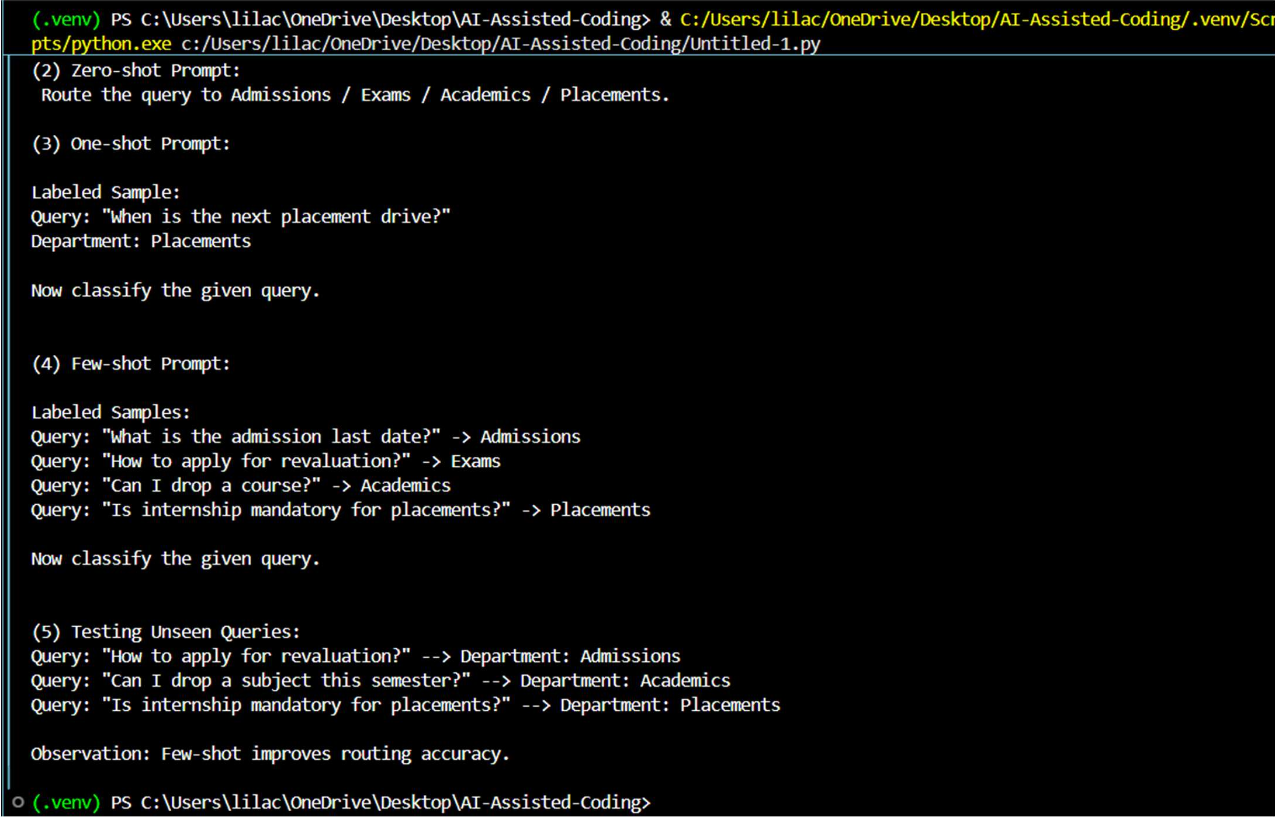
Explanation:
This task routes student questions to the correct department.It reduces manual workload and gives faster responses.Few-shot examples improve routing accuracy.

Task 4: Chatbot Question Type Detection Prompt:
- Prepare 6 chatbot queries mapped to question types.
- Design prompts for Zero-shot, One-shot, and Few-shot learning.
- Test all prompts on the same unseen queries.
- Compare response correctness and ambiguity handling. Document observations.

Code:
# ==========================================================
# 🛠 HELPER FUNCTIONS (Required for logic)
# ==========================================================

def clean_text(text):
return text.lower().strip()

def keyword_score(text, keywords):
return sum(1 for word in keywords if word in text)

def print_section(title): print(f"\n{'='*40}\n{title}\n{'='*40}")

# ==========================================================
# ✅ TASK 4: Chatbot Question Type Detection
# ==========================================================

def question_type_detector(query): text = clean_text(query)

informational = ["what", "how", "when", "where", "why", "timings", "price", "info", "details"]
transactional = ["book", "cancel", "order", "buy", "purchase", "upgrade", "subscribe", "register"]
complaint = ["not working", "crash", "problem", "worst", "late", "refund", "charged", "broken", "issue"]
feedback = ["good", "great", "love", "thank", "awesome", "excellent", "nice", "smooth"]

scores = {
"Informational": keyword_score(text, informational), "Transactional": keyword_score(text, transactional), "Complaint": keyword_score(text, complaint), "Feedback": keyword_score(text, feedback)
}

return max(scores, key=scores.get)

def task4_question_type():
print_section("✅ TASK 4: Chatbot Question Type Detection")

data = [
("What are your store timings?", "Informational"), ("How do I reset my password?", "Informational"),
("Book a ticket for tomorrow morning.", "Transactional"), ("I want to cancel my subscription.", "Transactional"), ("Your app keeps crashing after update.", "Complaint"), ("The UI looks great, very smooth experience.", "Feedback")
]

print("(1) Sample Queries + Types:") for q, t in data:

print(f"- {q} --> {t}")

# ✅ PROMPTS
zero_prompt_task4 = "Identify type: Informational / Transactional / Complaint / Feedback."

one_prompt_task4 = """ Labeled Sample:
Query: "I want to return my order." Type: Transactional

Now classify the given query. """

few_prompt_task4 = """ Labeled Samples:
Query: "Where is my order?" -> Informational
Query: "Place an order for 2 items." -> Transactional Query: "Delivery was late and rude." -> Complaint Query: "Support was excellent!" -> Feedback

Now classify the given query. """

# Testing and Output
print("\n(2) Zero-shot Prompt:\n", zero_prompt_task4) print("\n(3) One-shot Prompt:\n", one_prompt_task4) print("\n(4) Few-shot Prompt:\n", few_prompt_task4)

unseen = [
"Please upgrade my plan to premium.", "Your support team was very helpful.", "Why am I being charged twice?"
]

print("\n(5) Testing Unseen Queries:") for u in unseen:
print(f'Query: "{u}" --> Type: {question_type_detector(u)}')

print("\nObservation: Few-shot reduces ambiguity.\n")

if name == " main ": task4_question_type()

Output:
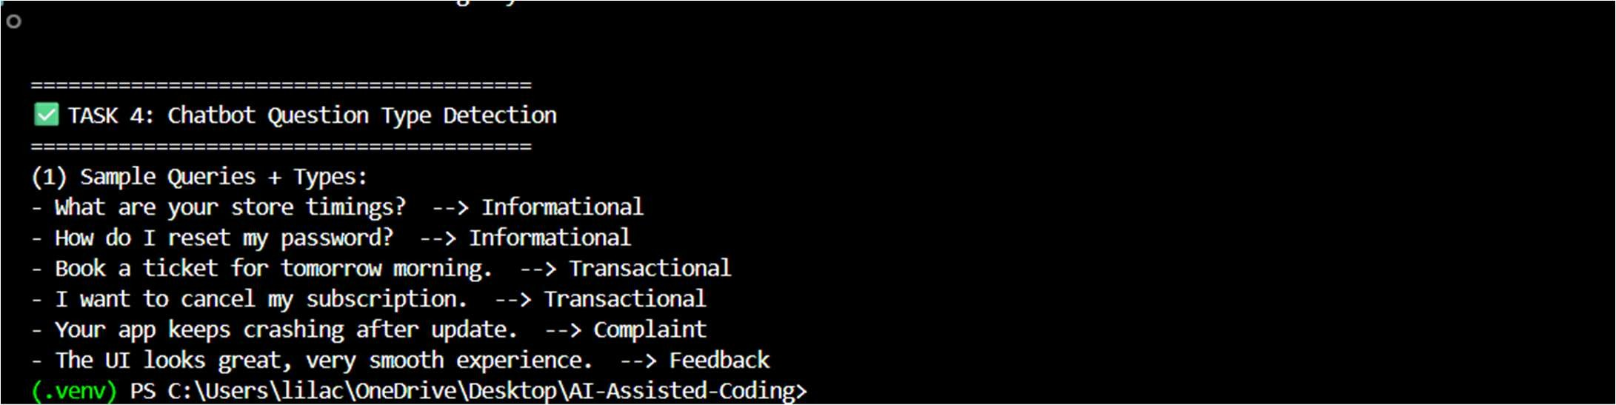
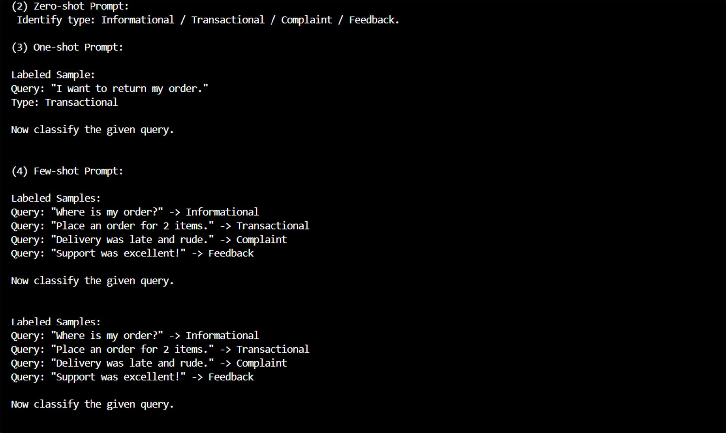

Explanation:
This task identifies query type: informational, transactional, complaint, or feedback. It helps the chatbot respond correctly based on user intent.Few-shot reduces confusion between similar query types.
Task 5: Emotion Detection in Text Prompt:
- Create labeled emotion samples.
- Use Zero-shot prompting to identify emotions.
- Use One-shot prompting with an example.
- Use Few-shot prompting with multiple emotions.
- Discuss ambiguity handling across techniques.
Code:
# ==========================================================
# 🛠 HELPER FUNCTIONS (Required for logic)

# ==========================================================

def clean_text(text):
return text.lower().strip()

def keyword_score(text, keywords):
return sum(1 for word in keywords if word in text)

def print_section(title): print(f"\n{'='*40}\n{title}\n{'='*40}")

# ==========================================================
# ✅ TASK 5: Emotion Detection
# ==========================================================

def emotion_detector(text): t = clean_text(text)

happy = ["happy", "excited", "proud", "great", "joy", "smile", "wonderful"]
sad = ["sad", "lonely", "miss", "cry", "down", "depressed", "tired", "hopeless"]
angry = ["angry", "furious", "hate", "annoyed", "unfair", "rage", "irritated"]
anxious = ["worried", "scared", "nervous", "anxious", "stress", "panic", "fear"]
neutral = ["normal", "fine", "okay", "nothing", "average"]

scores = {
"Happy": keyword_score(t, happy), "Sad": keyword_score(t, sad), "Angry": keyword_score(t, angry), "Anxious": keyword_score(t, anxious), "Neutral": keyword_score(t, neutral)
}

if all(v == 0 for v in scores.values()): return "Neutral"

return max(scores, key=scores.get)

def task5_emotion_detection():
print_section("✅ TASK 5: Emotion Detection in Text")

samples = [
("I feel so proud of myself today!", "Happy"), ("I miss my family and feel lonely.", "Sad"),
("I am furious, they treated me unfairly.", "Angry"),
("My heartbeat is fast, I am scared about tomorrow.", "Anxious"), ("Today was a normal day.", "Neutral"),
("Everything is going wrong and I cannot handle it.", "Anxious")
]

print("(1) Labeled Emotion Samples:") for s, e in samples:
print(f"- {s} --> {e}")

# ✅ PROMPTS

zero_prompt_task5 = "Detect emotion: Happy / Sad / Angry / Anxious / Neutral."

one_prompt_task5 = """ Labeled Sample:
Text: "I feel calm and relaxed." Emotion: Neutral

Now classify the given text. """

few_prompt_task5 = """ Labeled Samples:
Text: "I am excited and smiling today!" -> Happy Text: "I feel empty and tired." -> Sad
Text: "I cannot believe they lied to me." -> Angry Text: "I am worried about my exam tomorrow." -> Anxious Text: "Nothing special happened today." -> Neutral

Now classify the given text. """

# Testing and Output
print("\n(2) Zero-shot Prompt:\n", zero_prompt_task5) print("\n(3) One-shot Prompt:\n", one_prompt_task5) print("\n(4) Few-shot Prompt:\n", few_prompt_task5)

unseen = [
"I feel nervous about tomorrow.", "I am very happy today!",
"I feel upset and crying."
]

print("\n(5) Testing Unseen Emotion Texts:") for u in unseen:
print(f'Text: "{u}" --> Emotion: {emotion_detector(u)}')
print("\nObservation: Few-shot improves emotion detection.\n") if name == " main ":
task5_emotion_detection()

Output:

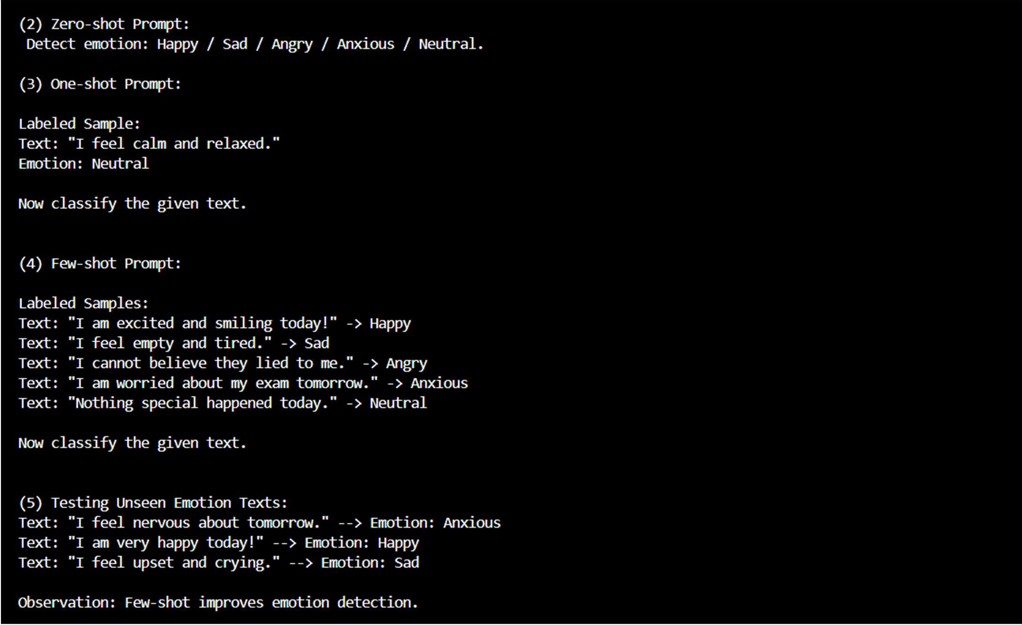
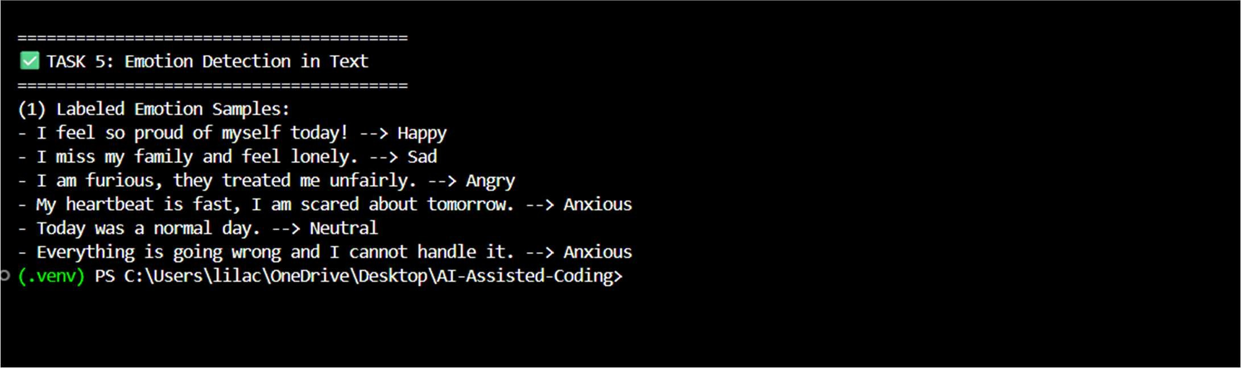
Explanation:
This task detects emotions from user text for mental-health support.It helps provide correct guidance and empathetic responses.Few-shot handles mixed emotions better than zero-shot.

