Name: B.Priyanka
Hall Ticket: 2303A52468
Batch: 42
Task 1: Problem Iden fica on & AI-Assisted Idea on
Prompt:
Build a Civic Complaint Management System for a smart city where users can submit complaints with loca on tagging, track status in real me, receive no fica ons, and allow admins to manage, assign, and monitor complaints through a dashboard. Ensure the system improves transparency, reduces delays, and supports ci zens, municipal staff, and field workers.
Code:
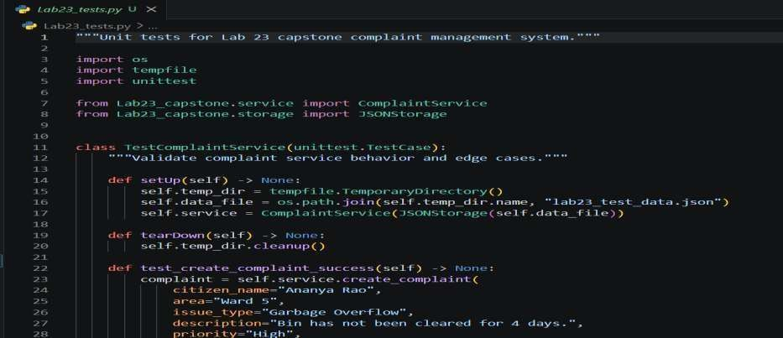
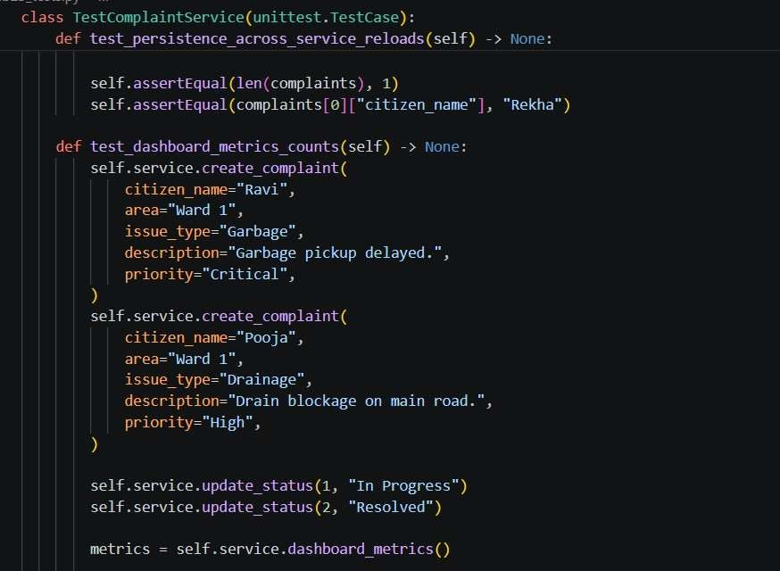
Output:
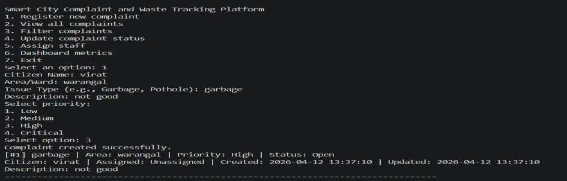
Explana on:
I chose the Civic Issue Repor ng System to solve the gap in repor ng and tracking civic issues. The current manual process causes delays and lack of transparency. A digital system enables easy tracking, faster resolu on, and be er efficiency.

Task 2: System Planning & Architecture Design
Prompt:
Act as a system architect and design a simple prototype architecture for a smart city complaint system called CivicFix. Include frontend, backend, and database components, explain the data flow, and propose a basic schema for users and complaints. Also define the main APIs/modules required.
Code:
Architecture & Schema (Text-based):
- Frontend: CLI (Command Line Interface) for prototype (can be extended to React.js web app later)
- Backend: Python application using modular functions (input handling, complaint management, status update)
- Database: In-memory Python lists/dictionaries (can be upgraded to SQLite for real use)●
Data Flow:
User enters complaint → Backend validates input → System generates Ticket ID → Data stored in dictionary → Confirmation shown to user
- Database Schema:
○ Users: {user_id: INT, name: STR, role: STR [citizen, admin]}
○ Complaints: {ticket_id: INT, citizen_name: STR, category: STR, description: STR, status: STR [Open, In-Progress, Resolved]}
● APIs / Modules:
○ register_complaint()
○ view_complaints()
○ update_status() ○ get_complaint_by_id()
Explana on:
I chose a simple and modular architecture for quick development and easy tes ng. The CLI-based frontend and Python backend keep the system clear and manageable, while in-memory storage reduces complexity for the prototype. This design is flexible and allows future upgrades like adding a database or web interface without changing core logic. Task 3: Modular Code Development with AI
Prompt:
Write a modular Python program for a CivicFix complaint system with func ons for registering complaints, viewing and upda ng status, and storing data using a list of dic onaries. Include proper input handling and error handling to keep the structure clean and manageable.
Code:
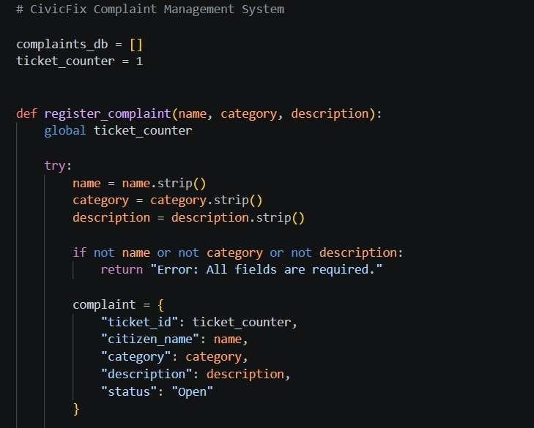
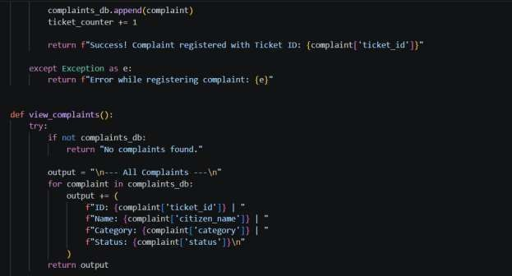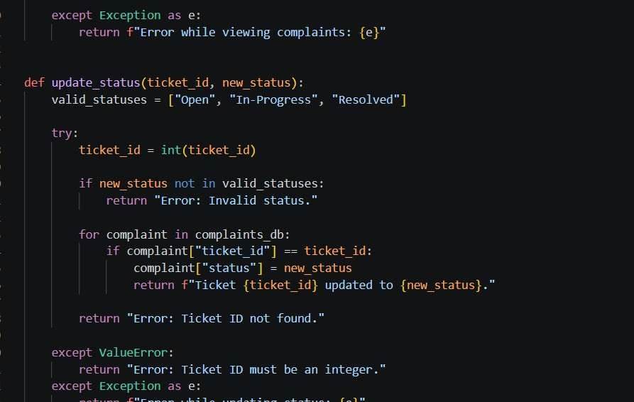
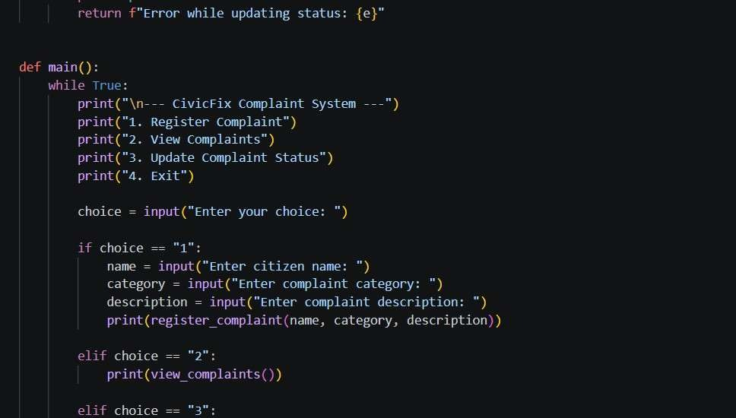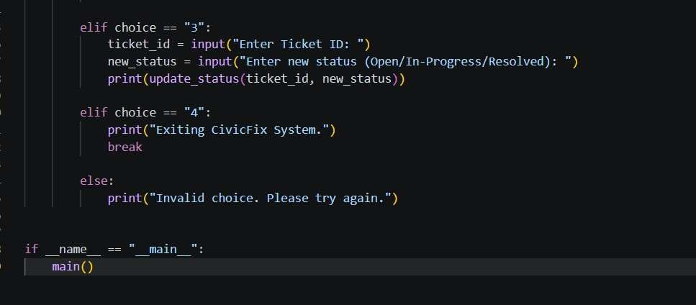

Output:
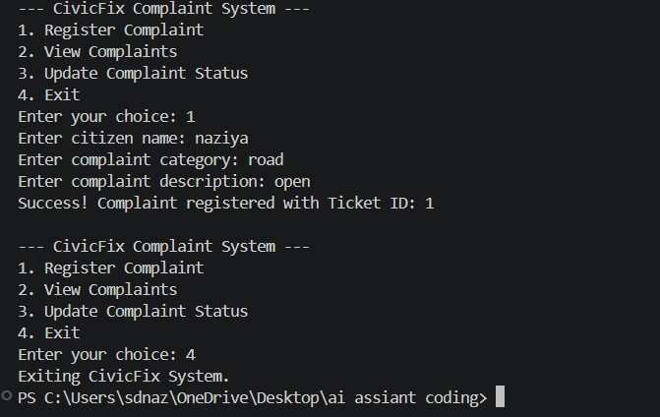
Explana on:
I used AI to create modular code with separate func ons for registering, viewing, and upda ng complaints. This improves clarity and maintainability, while error handling prevents crashes. Using lists and dic onaries keeps the design simple and suitable for a prototype.
Task 4: AI-Assisted Tes ng, Debugging & Op miza on
Prompt:
Review the CivicFix Python code, generate test cases, identify potential bugs, and provide an optimized version with better input validation, proper try-except error handling, and a cleaner code structure.
Code:
Test Cases & Bug Identification:
- Test Case 1 (Valid Input): Register complaint with valid strings. Result: Pass.
- Test Case 2 (Invalid Ticket ID): Try to update status of Ticket ID 99 or passing a string instead of an int. Result: Bug iden fied - code fails silently or crashes if a string is passed instead of an integer ID.
- Test Case 3 (Empty Input): Pass empty strings to register_complaint. Result: Pass (handled by exis ng basic valida on).
Op mized Code:

complaints_db = [] cket_counter = 1

def register_complaint(name: str, category: str, descrip on: str) -> str: global cket_counter
try:
# Op miza on: Stripping whitespace
name, category, descrip on = name.strip(), category.strip(), descrip on.strip() if not name or not category or not descrip on:
raise ValueError("Fields cannot be empty or just spaces.")

complaint = {
"id": cket_counter, "name": name, "category": category, "descrip on": descrip on, "status":
"Open"
}
complaints_db.append(complaint)
cket_counter += 1
return f"Success: Ticket ID {complaint['id']} created." except Excep on as e:
return f"Error registering complaint: {e}"

def update_status( cket_id: int, new_status: str) -> str: valid_statuses = ["Open", "In-Progress", "Resolved"] try:
cket_id = int( cket_id) # Type enforcement op miza on if
new_status not in valid_statuses:
raise ValueError("Invalid status provided.")

# Op miza on: using next() with a generator expression for faster lookup O(N) complaint = next((c for c in complaints_db if c["id"] == cket_id), None)
if complaint:
complaint["status"] = new_status return f"Success: Ticket { cket_id} updated." else:
Output:
(Tes ng Op mized Code)
Output for update_status("abc", "Resolved"): Input Error: invalid literal for int() with base 10: 'abc' Explana on:
The ini al code was weak in handling data types, causing crashes on invalid input like "one" instead of 1. I improved it using input sani za on with .strip(), proper try-except blocks, and clearer type handling. I also op mized search using a generator expression (next(...)) to stop once the ID is found.

Task 5: Documenta on, Version Control & Reflec on
Prompt:
Generate a concise README.md for the CivicFix app covering setup and usage, suggest 5 standard Git commit messages, and include a short reflec on on AI usage, limita ons, and future improvements.
README Snippet:

# CivicFix: Smart City Complaint System
A lightweight CLI applica on for repor ng and tracking civic issues.

## Setup
- Ensure Python 3.8+ is installed.
- Clone the repository: `git clone https://github.com/...`
- Run the applica on: `python app.py`
## Usage
- Developers can import `register_complaint` and `update_status` from `app.py`.
- Data is stored in-memory per session.

Simulated Git Commit Messages:
- init: setup ini al project structure and README
- feat: add register_complaint func on and core data dictionary
- feat: implement cket status update logic
- fix: add input sanita on and try-except error handling
- docs: add python docstrings to core logic functions

Explana on:
Proper documenta on and version control dis nguish basic scripts from professional so ware. Using AI to generate the README and commit history helped me learn standard prac ces. It also showed that while AI is useful, the developer must guide the design to ensure good so ware engineering principles.

