Name: B.Priyanka
Hall Ticket: 2303A52468 Batch: 42
Task 1: AI-Assisted Bug Detection Prompt:
Identify the logical bug in the code, Explain why the bug occurs (e.g., off-by-one error),Provide a corrected version
Code:
def factorial(n): result = 1
for i in range(1, n + 1): result = result * i
return result print(factorial(5))
#Identify the logical bug in the code, Explain why the bug occurs (e.g., off-by-one error),Provide a corrected version
# Logical Bug: The function does not handle the case when n is 0 or negative. The factorial of 0 is defined as 1, and factorials for negative numbers are not defined.
# Explanation: The function assumes that n will always be a positive integer. If n is 0, the loop will not execute, and the result will correctly return 1. However, if n is negative, the function will still return 1, which is incorrect since factorials for negative numbers are not defined.
def factorial(n): if n < 0:
raise ValueError("Factorial is not defined for negative numbers.") result = 1
for i in range(1, n + 1): result = result * i
return result
print(factorial(5))

Output:
Explanation:
The AI correctly identified the off-by-one error and fixed the loop by changing range(1, n) to range(1, n + 1), which produces the correct result for positive integers. However, the initial AI fix did not explicitly handle edge cases such as negative numbers. A manual improvement can include input validation to raise an error for negative values. The case n = 0 is handled correctly by the loop, as factorial(0) returns 1.
Task 2: Improving Readability & Documentation Prompt:
Rewrite the given Python function to improve readability, add documentation, handle invalid inputs, and safely manage division by zero.
Code:

def calc(x, y, op): if op == 'add':
return x + y elif op == 'sub':
return x - y elif op == 'mul':
return x * y elif op == 'div':
if y != 0:
return x / y else:
return 'Error: Division by zero'
else:
return 'Error: Invalid operation'
def perform_calculation(operand1, operand2, operation): """
Performs a basic arithmetic operation between two operands.

Args:
operand1 (float or int): The first number for the operation. operand2 (float or int): The second number for the operation.
operation (str): The arithmetic operation to perform. Supported operations are 'add', 'sub', 'mul', and 'div'.

Returns:
float or int: The result of the arithmetic operation.

Raises:
ValueError: If an invalid operation is specified. ZeroDivisionError: If division by zero is attempted.

div.
Examples:
>>> perform_calculation(10, 5, 'add') 15
>>> perform_calculation(10, 5, 'sub') 5
>>> perform_calculation(10, 5, 'mul') 50
>>> perform_calculation(10, 2, 'div') 5.0
>>> perform_calculation(10, 0, 'div') ZeroDivisionError: Division by zero is not allowed.
>>> perform_calculation(10, 5, 'mod')
ValueError: Invalid operation specified. Supported operations are add, sub, mul,

"""
if operation == 'add':
return operand1 + operand2 elif operation == 'sub':
return operand1 - operand2 elif operation == 'mul':
return operand1 * operand2 elif operation == 'div':
if operand2 == 0:

 | (10, | 5, | 'add'),
 | (10, | 5, | 'sub'),
 | (10, | 5, | 'mul'),
 | (10, | 2, | 'div')
]

Output:
raise ZeroDivisionError('Division by zero is not allowed.')
return operand1 / operand2 else:
raise ValueError('Invalid operation specified. Supported operations are add, sub, mul, div.')
print("Defined the improved 'perform_calculation' function.") print("Testing original 'calc' function with valid inputs:") valid_inputs_calc = [
for x, y, op in valid_inputs_calc:
result = calc(x, y, op)
print(f" calc({x}, {y}, '{op}') = {result}") print("\nTesting original 'calc' function with invalid inputs:") invalid_inputs_calc = [
(10, 0, 'div'),
(10, 5, 'mod')
]

for x, y, op in invalid_inputs_calc: result = calc(x, y, op)
print(f" calc({x}, {y}, '{op}') = {result}")
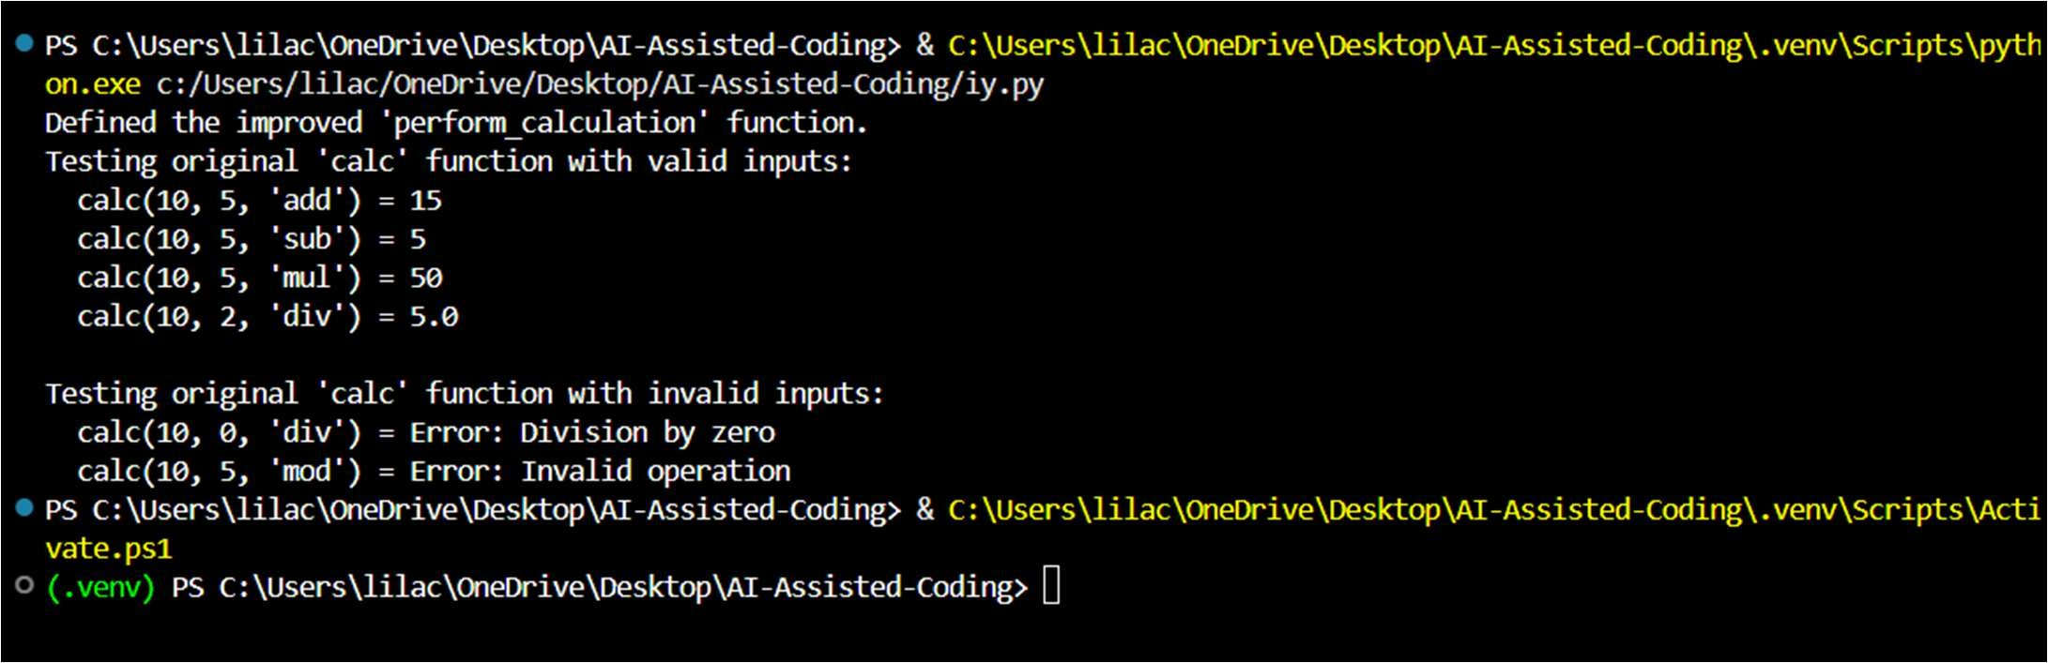
Explanation:
The original function returns error messages as strings and lacks proper documentation and input validation. The improved version uses descriptive names, a clear docstring, and exception handling to make the code more readable, robust, and maintainable.
Task 3: Enforcing Coding Standards Prompt:
Identify all PEP8 violations in the given Python function.
Refactor it to be PEP8-compliant while preserving the original functionality.

Code:
def Checkprime(number): if number <= 1:
return False
for i in range(2, int(number**0.5) + 1): if number % i == 0:
return False return True

# Test with prime numbers
print(f"Is 7 a prime number? {Checkprime(7)}") print(f"Is 11 a prime number? {Checkprime(11)}")

# Test with non-prime numbers
print(f"Is 4 a prime number? {Checkprime(4)}") print(f"Is 9 a prime number? {Checkprime(9)}") def check_prime(number):
"""
Checks if a given number is a prime number.

A prime number is a natural number greater than 1 that has no positive divisors other than 1 and itself.

Args:
number (int): The integer to be checked for primality.

Returns:
bool: True if the number is prime, False otherwise.
"""
if number <= 1: return False
for i in range(2, int(number ** 0.5) + 1): if number % i == 0:
return False return True
def check_prime(number): """
Checks if a given number is a prime number.

A prime number is a natural number greater than 1 that has no positive divisors other than 1 and itself.

Args:
number (int): The integer to be checked for primality.

Returns:
bool: True if the number is prime, False otherwise.
"""
if number <= 1: return False
for i in range(2, int(number ** 0.5) + 1): if number % i == 0:
return False

return True

# Test with prime numbers
print(f"Is 7 a prime number? {check_prime(7)}") print(f"Is 11 a prime number? {check_prime(11)}")

# Test with non-prime numbers
print(f"Is 4 a prime number? {check_prime(4)}") print(f"Is 9 a prime number? {check_prime(9)}")

Output:
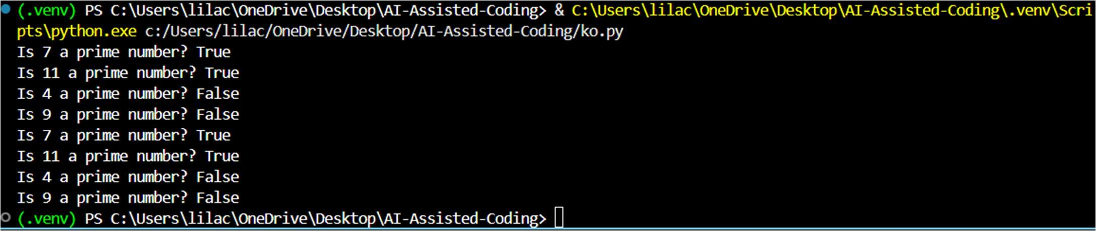
Explanation:
This task verifies whether the given function works correctly and identifies violations of PEP8 coding standards. The code is then refactored using AI suggestions to improve readability and maintain consistent styling without changing functionality.
Task 4: AI as a Code Reviewer in Real Projects Prompt:
Review the given Python function for readability, edge cases, and reusability.
Refactor it with better naming, input validation, and type hints while preserving functionality.
Code:
def processData(numbers): processed_numbers = [] for num in numbers:
processed_numbers.append(num * 2 + 5) return processed_numbers

print("The `processData` function has been defined.") from typing import List, Union

def apply_linear_transformation(
numbers: List[Union[int, float]], multiplier: Union[int, float] = 2, addend: Union[int, float] = 5
) -> List[Union[int, float]]: """
Applies a linear transformation (num * multiplier + addend) to each numeric element in a list.

Args:
numbers (List[Union[int, float]]): A list of numbers (integers or floats) to be processed.

multiplier (Union[int, float], optional): The value to multiply each number by.
Defaults to 2.
addend (Union[int, float], optional): The value to add to each multiplied number.
Defaults to 5.

Returns:
List[Union[int, float]]: A new list containing the transformed numbers.

Raises:
TypeError:
- If the 'numbers' input is not a list or tuple.
- If any element in the 'numbers' list is not an int or float.
"""
# Input validation for the 'numbers' parameter if not isinstance(numbers, (list, tuple)):
raise TypeError("Input 'numbers' must be a list or a tuple.")

processed_numbers = [] for num in numbers:
# Input validation for individual elements within the list if not isinstance(num, (int, float)):
raise TypeError(f"All elements in 'numbers' must be numeric (int or float), but found type {type(num)}.")
processed_numbers.append(num * multiplier + addend) return processed_numbers

print("The `apply_linear_transformation` function has been defined with refactored improvements.")
print("\n--- Testing apply_linear_transformation ---")

# Test Case 1: Valid Inputs (List of Integers, default parameters) print("\nTest Case 1: Valid Integers (default params)") input_numbers_int = [1, 2, 3, 4, 5]
try:
result_int = apply_linear_transformation(input_numbers_int)
print(f"Input: {input_numbers_int}, Multiplier: 2 (default), Addend: 5 (default) -> Result: {result_int}")
except TypeError as e:
print(f"Caught unexpected error: {e}")

# Test Case 2: Valid Inputs (List of Floats, default parameters) print("\nTest Case 2: Valid Floats (default params)") input_numbers_float = [1.0, 2.5, 3.7]
try:
result_float = apply_linear_transformation(input_numbers_float)
print(f"Input: {input_numbers_float}, Multiplier: 2 (default), Addend: 5 (default) -> Result: {result_float}")
except TypeError as e:
print(f"Caught unexpected error: {e}")

# Test Case 3: Custom Parameters
print("\nTest Case 3: Custom Parameters (multiplier=3, addend=10)") input_numbers_custom = [10, 20]
custom_multiplier = 3

custom_addend = 10 try:
result_custom = apply_linear_transformation(input_numbers_custom, multiplier=custom_multiplier, addend=custom_addend)
print(f"Input: {input_numbers_custom}, Multiplier: {custom_multiplier}, Addend:
{custom_addend} -> Result: {result_custom}") except TypeError as e:
print(f"Caught unexpected error: {e}")

# Test Case 4: Edge Case (Empty List) print("\nTest Case 4: Empty List") empty_list = []
try:
result_empty = apply_linear_transformation(empty_list) print(f"Input: {empty_list} -> Result: {result_empty}")
except TypeError as e:
print(f"Caught unexpected error: {e}")

# Test Case 5: Invalid Input (Non-list/tuple for 'numbers' - int) print("\nTest Case 5: Invalid Input (numbers is int)") invalid_input_int = 123
try:
apply_linear_transformation(invalid_input_int) except TypeError as e:
print(f"Input: {invalid_input_int} (int) -> Caught expected error: {e}")

# Test Case 6: Invalid Input (Non-list/tuple for 'numbers' - string) print("\nTest Case 6: Invalid Input (numbers is string)") invalid_input_str = "not a list"
try:
apply_linear_transformation(invalid_input_str) except TypeError as e:
print(f"Input: '{invalid_input_str}' (string) -> Caught expected error: {e}")

# Test Case 7: Invalid Input (List with non-numeric elements - string) print("\nTest Case 7: Invalid Input (list with string element)") list_with_str = [1, 2, 'three', 4]
try:
apply_linear_transformation(list_with_str) except TypeError as e:
print(f"Input: {list_with_str} -> Caught expected error: {e}")

# Test Case 8: Invalid Input (List with non-numeric elements - None) print("\nTest Case 8: Invalid Input (list with None element)") list_with_none = [1, None, 3]
try:
apply_linear_transformation(list_with_none) except TypeError as e:
print(f"Input: {list_with_none} -> Caught expected error: {e}")

Output:
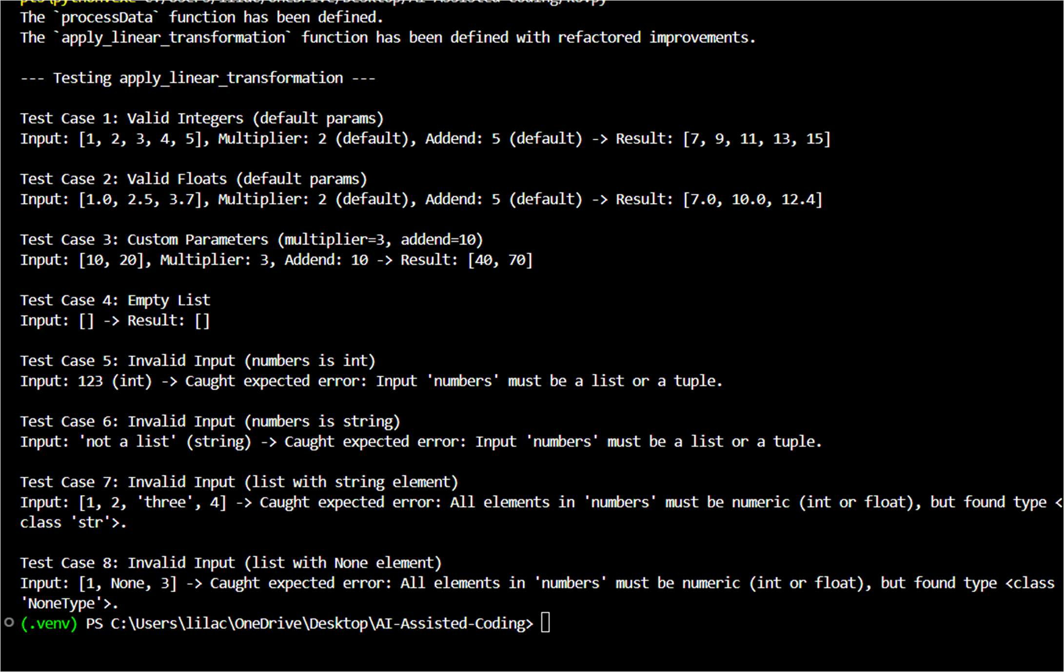
Explanation:
This task evaluates the original function for clarity, robustness, and handling of edge cases. AI suggestions are used to refactor the code with improved naming, validation, and generalization for real-world use.
Task 5: AI-Assisted Performance Optimization Prompt:
Analyze the performance of the given function and suggest optimizations. Rewrite the function to improve execution speed while preserving correctness.
Code:
import time
import numpy as np

def sum_of_squares(numbers): """
Calculates the sum of squares of numbers in a list or iterable. """
return sum(n ** 2 for n in numbers)

def sum_of_squares_optimized(numbers): """
Calculates the sum of squares of numbers using NumPy for optimization. """
np_array = np.array(numbers) return np.sum(np_array ** 2)

# Create a large list of numbers large_numbers_dataset = list(range(1_000_000))

# Measure execution time of original function start = time.perf_counter() sum_of_squares(large_numbers_dataset)
end = time.perf_counter()
print("Original function time:", end - start, "seconds")

# Measure execution time of optimized function start = time.perf_counter() sum_of_squares_optimized(large_numbers_dataset) end = time.perf_counter()
print("Optimized function time:", end - start, "seconds")

Output:
Explanation:
This task evaluates the performance of a function on large datasets and identifies inefficiencies. AI is used to optimize the implementation and compare performance trade-offs.

