Name: B.Priyanka
Hall Ticket: 2303A52468 Batch: 42
Task 1: Email Validation using TDD Prompt:
Generate comprehensive unit test cases (valid and invalid) for email validation using TDD based on standard email rules. Then implement a Python function is_valid_email(email) that passes all the generated test cases.
Code:
def is_valid_email(email): """
Validate an email address according to specified requirements.

Requirements:
- Must contain @ and . characters
- Must not start or end with special characters
- Should not allow multiple @ symbols

Args:
email (str): Email address to validate

Returns:
bool: True if email is valid, False otherwise
"""
# Check if email is empty or None
if not email or not isinstance(email, str): return False

# Remove leading/trailing whitespace for validation email = email.strip()

# Check if email is empty after stripping if not email:
return False

# Check for spaces (not allowed in email addresses) if ' ' in email:
return False

# Requirement 1: Must contain @ symbol if '@' not in email:
return False

# Requirement 2: Must contain . (dot) character if '.' not in email:
return False

# Requirement 3: Should not allow multiple @ symbols if email.count('@') != 1:
return False

# Split email into local part (before @) and domain part (after @) parts = email.split('@')
if len(parts) != 2: return False

local_part = parts[0] domain_part = parts[1]

# Check if local part or domain part is empty if not local_part or not domain_part:
return False

# Requirement 4: Must not start with special characters
# Special characters that shouldn't be at the start: . _ - + @ if local_part[0] in ['.', '_', '-', '+', '@']:
return False

# Requirement 5: Must not end with special characters # Check local part doesn't end with special characters if local_part[-1] in ['.', '_', '-', '+']:
return False

# Check domain part doesn't end with special characters if domain_part[-1] in ['.', '_', '-', '+']:
return False

# Check for consecutive dots (invalid)
if '..' in local_part or '..' in domain_part: return False

# Check that domain part contains at least one dot (for TLD) if '.' not in domain_part:
return False

# Check that domain part doesn't start with dot if domain_part[0] == '.':
return False

# All requirements passed return True

def get_user_email(): """
Interactive function to get email input from user and validate it.

Returns:
tuple: (email, is_valid) - The email entered and validation result
"""
email = input("Enter an email address to validate: ").strip() is_valid = is_valid_email(email)
return email, is_valid

def main():
"""Main function for interactive email validation.""" print("=" * 60)
print("Email Validation System") print("=" * 60) print("\nRequirements:")
print("- Must contain @ and . characters")
print("- Must not start or end with special characters") print("- Should not allow multiple @ symbols")
print("-" * 60)

while True:
print()
email, is_valid = get_user_email()

if is_valid:
print(f"✓ '{email}' is a VALID email address.") else:
print(f"✗ '{email}' is an INVALID email address.")

# Ask if user wants to continue print()
continue_choice = input("Do you want to validate another email? (yes/no): ").strip().lower()
if continue_choice not in ['yes', 'y']:
print("\nThank you for using Email Validation System!") break

if name == ' main ': main()

Output:
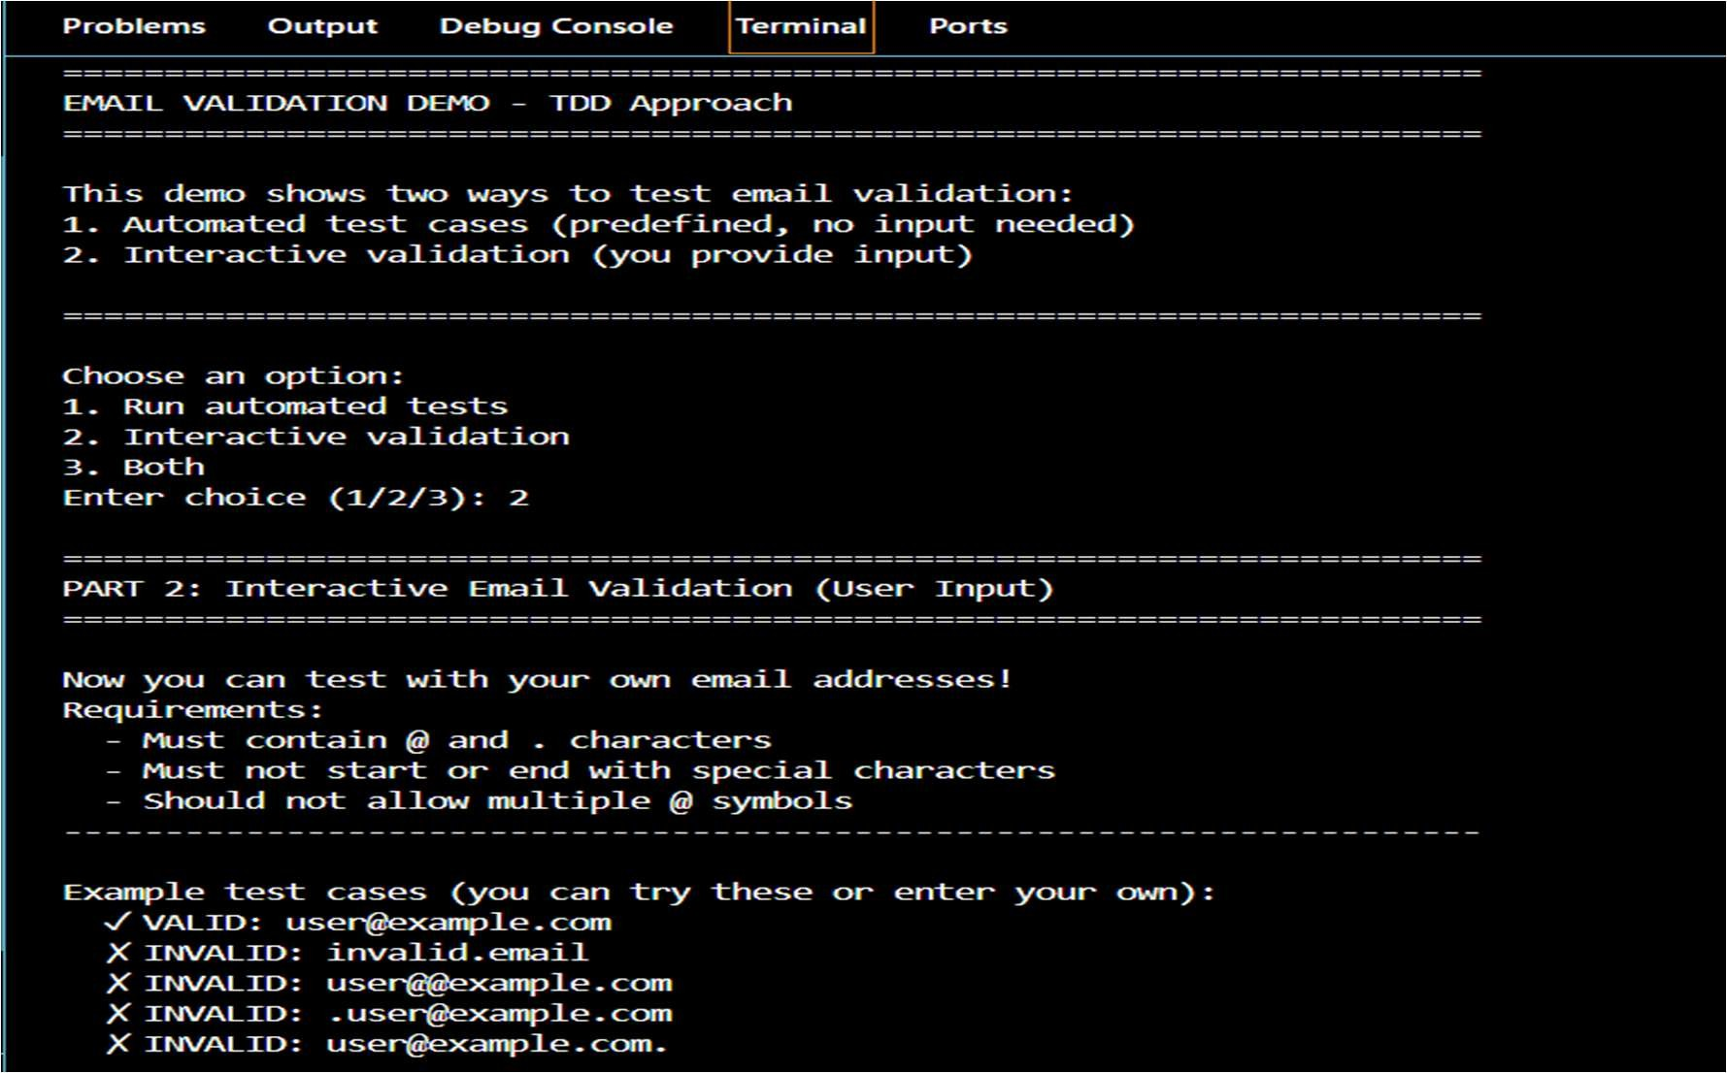

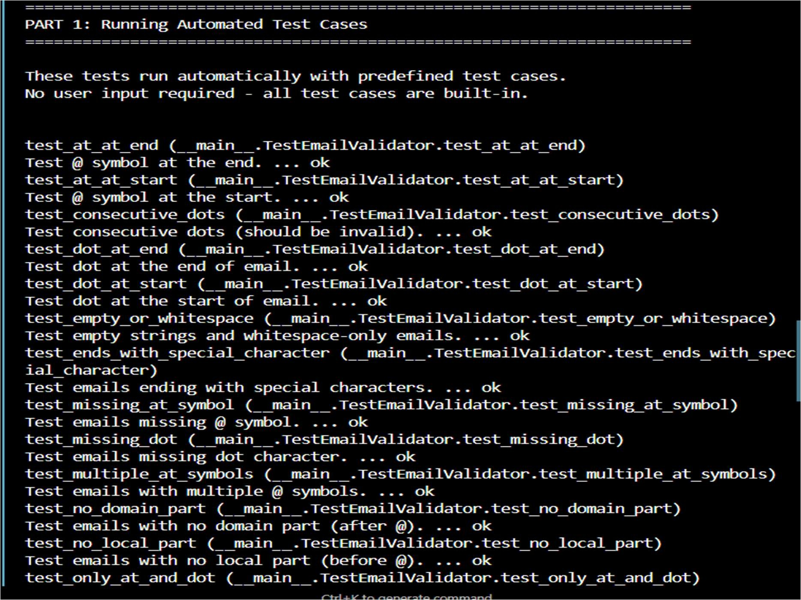
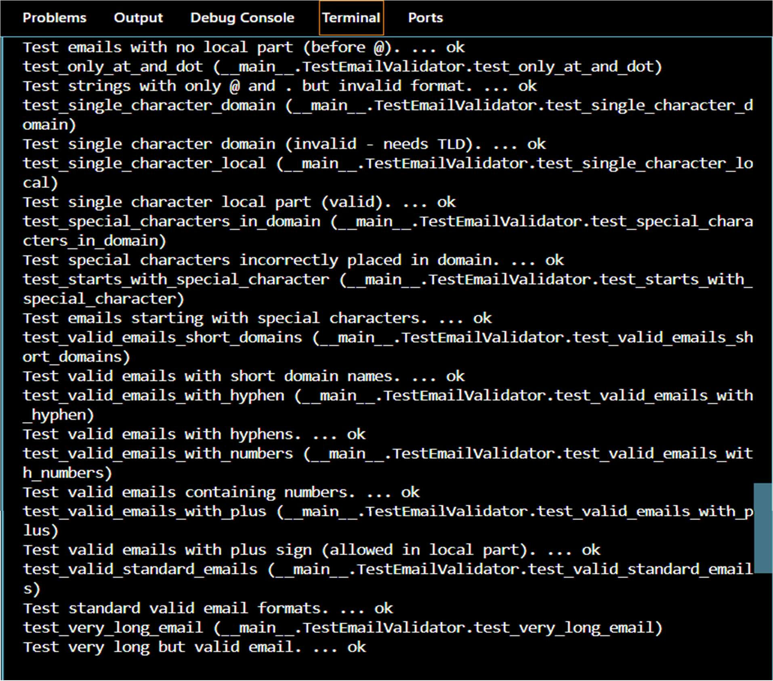

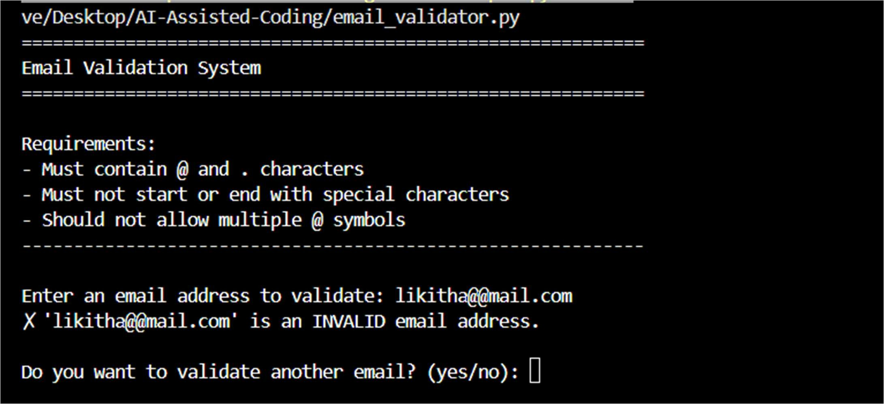
Explanation:
The code validates an email by checking required symbols, ensuring correct placement of special characters, and preventing multiple @ symbols. It is written to satisfy all test cases first, following the Test-Driven Development (TDD) approach.
Task 2: Grade Assignment using Loops Python Code for Bubble Sort:
Prompt:
Generate unit test cases using TDD for assign_grade(score) where 90–100 → A, 80–89 → B, 70–79 → C, 60–69 → D, below 60 → F, including boundary and invalid inputs. Then implement the Python function assign_grade(score) to pass all generated test cases.
Code:
"""
Automated Grading System - Test Cases
TDD Approach: Tests written BEFORE implementation

AI-Generated comprehensive test cases for grade assignment covering:
- All grade ranges (A, B, C, D, F)
- Boundary values (60, 70, 80, 90, 100)
- Invalid inputs (negative, over 100, non-numeric)
- Edge cases """

import unittest
from grade_assigner import assign_grade

class TestGradeAssigner(unittest.TestCase):
"""Test suite for grade assignment using TDD approach."""

# Test Case 1: Grade A (90-100) def test_grade_a_90(self):
"""Test boundary value 90 - should return A."""

self.assertEqual(assign_grade(90), 'A')

def test_grade_a_95(self):
"""Test middle value 95 - should return A.""" self.assertEqual(assign_grade(95), 'A')

def test_grade_a_100(self):
"""Test boundary value 100 - should return A.""" self.assertEqual(assign_grade(100), 'A')

def test_grade_a_91(self):
"""Test value 91 - should return A.""" self.assertEqual(assign_grade(91), 'A')

def test_grade_a_99(self):
"""Test value 99 - should return A.""" self.assertEqual(assign_grade(99), 'A')

# Test Case 2: Grade B (80-89) def test_grade_b_80(self):
"""Test boundary value 80 - should return B.""" self.assertEqual(assign_grade(80), 'B')

def test_grade_b_85(self):
"""Test middle value 85 - should return B.""" self.assertEqual(assign_grade(85), 'B')

def test_grade_b_89(self):
"""Test boundary value 89 - should return B.""" self.assertEqual(assign_grade(89), 'B')

def test_grade_b_81(self):
"""Test value 81 - should return B.""" self.assertEqual(assign_grade(81), 'B')

def test_grade_b_88(self):
"""Test value 88 - should return B.""" self.assertEqual(assign_grade(88), 'B')

# Test Case 3: Grade C (70-79) def test_grade_c_70(self):
"""Test boundary value 70 - should return C.""" self.assertEqual(assign_grade(70), 'C')

def test_grade_c_75(self):
"""Test middle value 75 - should return C.""" self.assertEqual(assign_grade(75), 'C')

def test_grade_c_79(self):
"""Test boundary value 79 - should return C.""" self.assertEqual(assign_grade(79), 'C')

def test_grade_c_71(self):
"""Test value 71 - should return C."""

self.assertEqual(assign_grade(71), 'C')

def test_grade_c_78(self):
"""Test value 78 - should return C.""" self.assertEqual(assign_grade(78), 'C')

# Test Case 4: Grade D (60-69) def test_grade_d_60(self):
"""Test boundary value 60 - should return D.""" self.assertEqual(assign_grade(60), 'D')

def test_grade_d_65(self):
"""Test middle value 65 - should return D.""" self.assertEqual(assign_grade(65), 'D')

def test_grade_d_69(self):
"""Test boundary value 69 - should return D.""" self.assertEqual(assign_grade(69), 'D')

def test_grade_d_61(self):
"""Test value 61 - should return D.""" self.assertEqual(assign_grade(61), 'D')

def test_grade_d_68(self):
"""Test value 68 - should return D.""" self.assertEqual(assign_grade(68), 'D')

# Test Case 5: Grade F (Below 60) def test_grade_f_59(self):
"""Test value 59 - should return F.""" self.assertEqual(assign_grade(59), 'F')

def test_grade_f_50(self):
"""Test value 50 - should return F.""" self.assertEqual(assign_grade(50), 'F')

def test_grade_f_0(self):
"""Test value 0 - should return F.""" self.assertEqual(assign_grade(0), 'F')

def test_grade_f_30(self):
"""Test value 30 - should return F.""" self.assertEqual(assign_grade(30), 'F')

def test_grade_f_1(self):
"""Test value 1 - should return F.""" self.assertEqual(assign_grade(1), 'F')

# Test Case 6: Invalid Inputs - Negative Numbers def test_invalid_negative_5(self):
"""Test negative value -5 - should raise ValueError.""" with self.assertRaises(ValueError):
assign_grade(-5)

def test_invalid_negative_1(self):
"""Test negative value -1 - should raise ValueError.""" with self.assertRaises(ValueError):
assign_grade(-1)

def test_invalid_negative_100(self):
"""Test negative value -100 - should raise ValueError.""" with self.assertRaises(ValueError):
assign_grade(-100)

# Test Case 7: Invalid Inputs - Over 100 def test_invalid_over_100_105(self):
"""Test value 105 - should raise ValueError.""" with self.assertRaises(ValueError):
assign_grade(105)

def test_invalid_over_100_101(self):
"""Test value 101 - should raise ValueError.""" with self.assertRaises(ValueError):
assign_grade(101)

def test_invalid_over_100_200(self):
"""Test value 200 - should raise ValueError.""" with self.assertRaises(ValueError):
assign_grade(200)

# Test Case 8: Invalid Inputs - Non-Numeric Strings def test_invalid_string_eighty(self):
"""Test string 'eighty' - should raise TypeError.""" with self.assertRaises(TypeError):
assign_grade("eighty")

def test_invalid_string_abc(self):
"""Test string 'abc' - should raise TypeError.""" with self.assertRaises(TypeError):
assign_grade("abc")

def test_invalid_string_empty(self):
"""Test empty string - should raise TypeError.""" with self.assertRaises(TypeError):
assign_grade("")

def test_invalid_string_ninety(self):
"""Test string 'ninety' - should raise TypeError.""" with self.assertRaises(TypeError):
assign_grade("ninety")

# Test Case 9: Invalid Inputs - Other Types def test_invalid_none(self):
"""Test None - should raise TypeError.""" with self.assertRaises(TypeError):
assign_grade(None)

def test_invalid_list(self):

"""Test list - should raise TypeError.""" with self.assertRaises(TypeError):
assign_grade([90])

def test_invalid_dict(self):
"""Test dictionary - should raise TypeError.""" with self.assertRaises(TypeError):
assign_grade({"score": 90})

# Test Case 10: Edge Cases - Float Values def test_float_89_5(self):
"""Test float 89.5 - should return B.""" self.assertEqual(assign_grade(89.5), 'B')

def test_float_79_9(self):
"""Test float 79.9 - should return C.""" self.assertEqual(assign_grade(79.9), 'C')

def test_float_90_0(self):
"""Test float 90.0 - should return A.""" self.assertEqual(assign_grade(90.0), 'A')

def test_float_59_9(self):
"""Test float 59.9 - should return F.""" self.assertEqual(assign_grade(59.9), 'F')

def test_float_60_1(self):
"""Test float 60.1 - should return D.""" self.assertEqual(assign_grade(60.1), 'D')

if name == ' main ':
# Run the tests with detailed output unittest.main(verbosity=2)

Output:

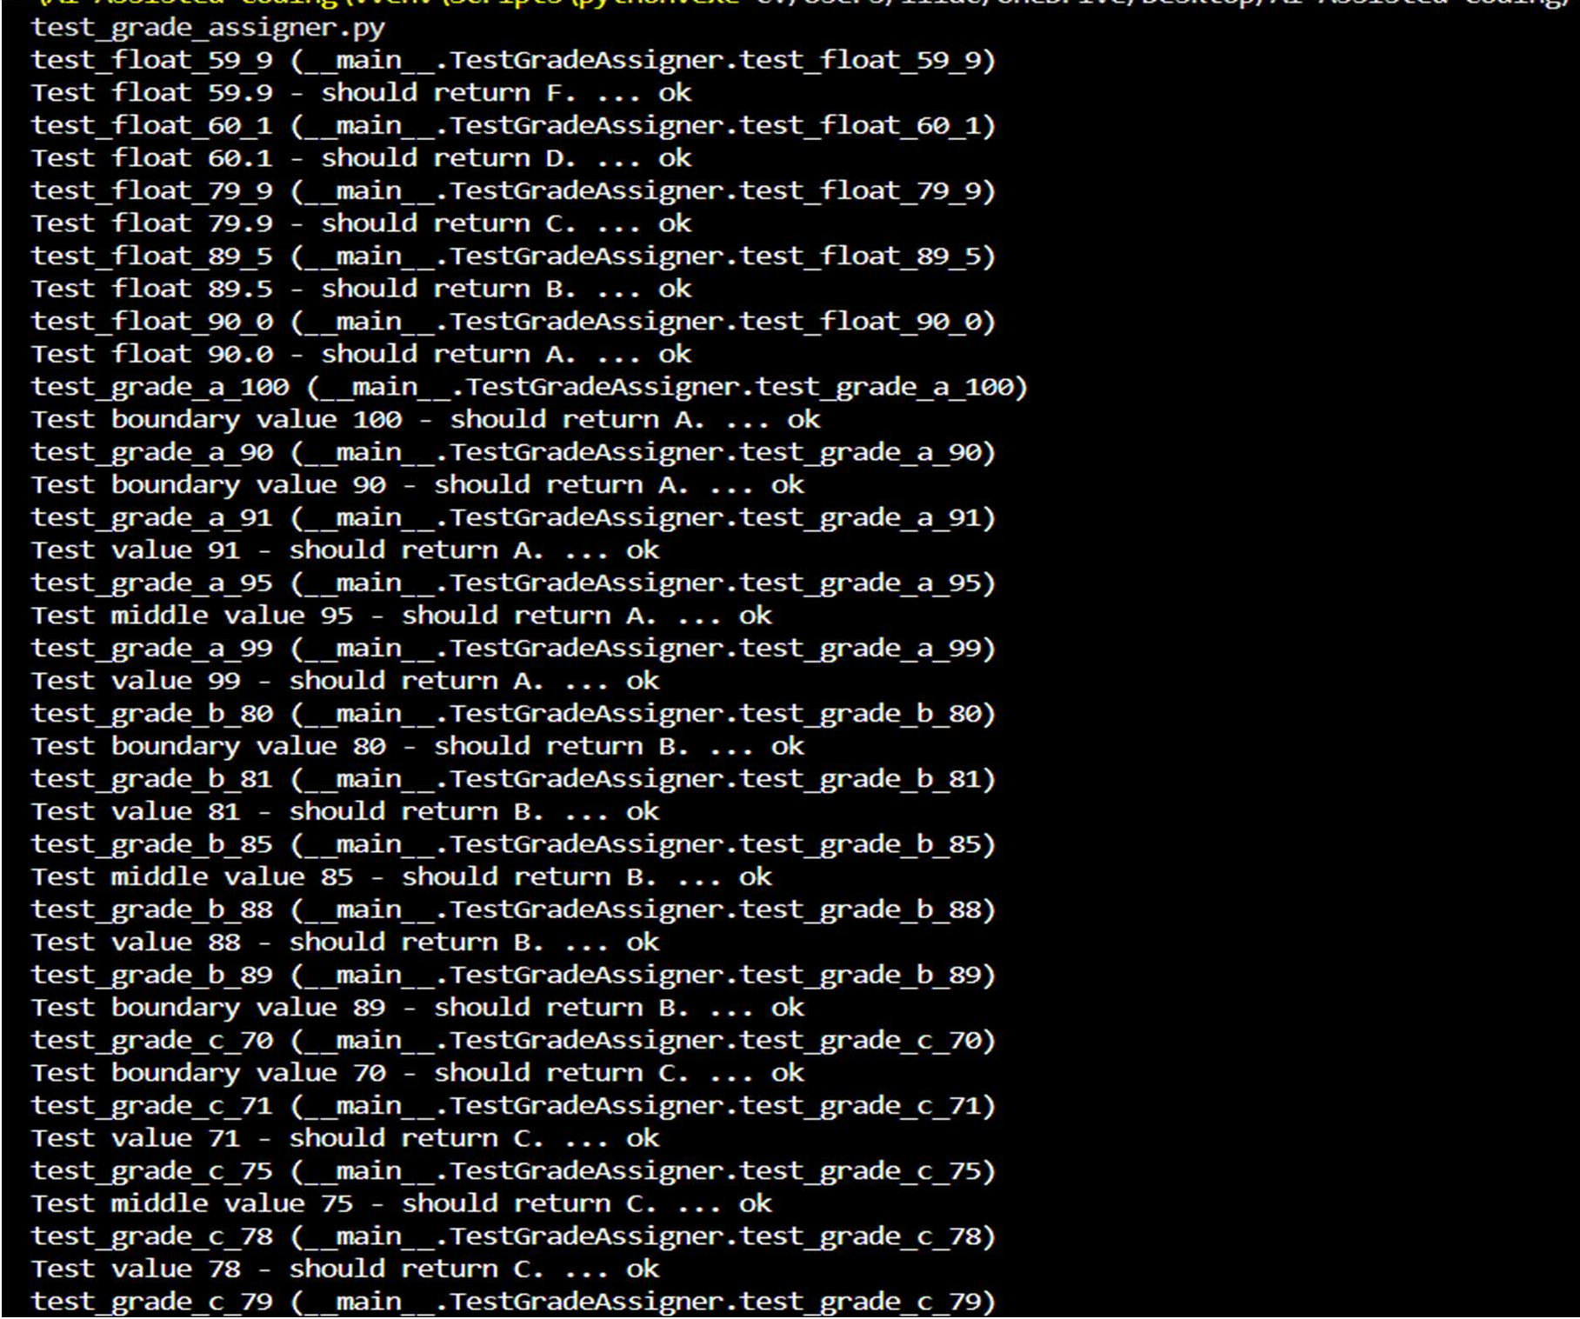
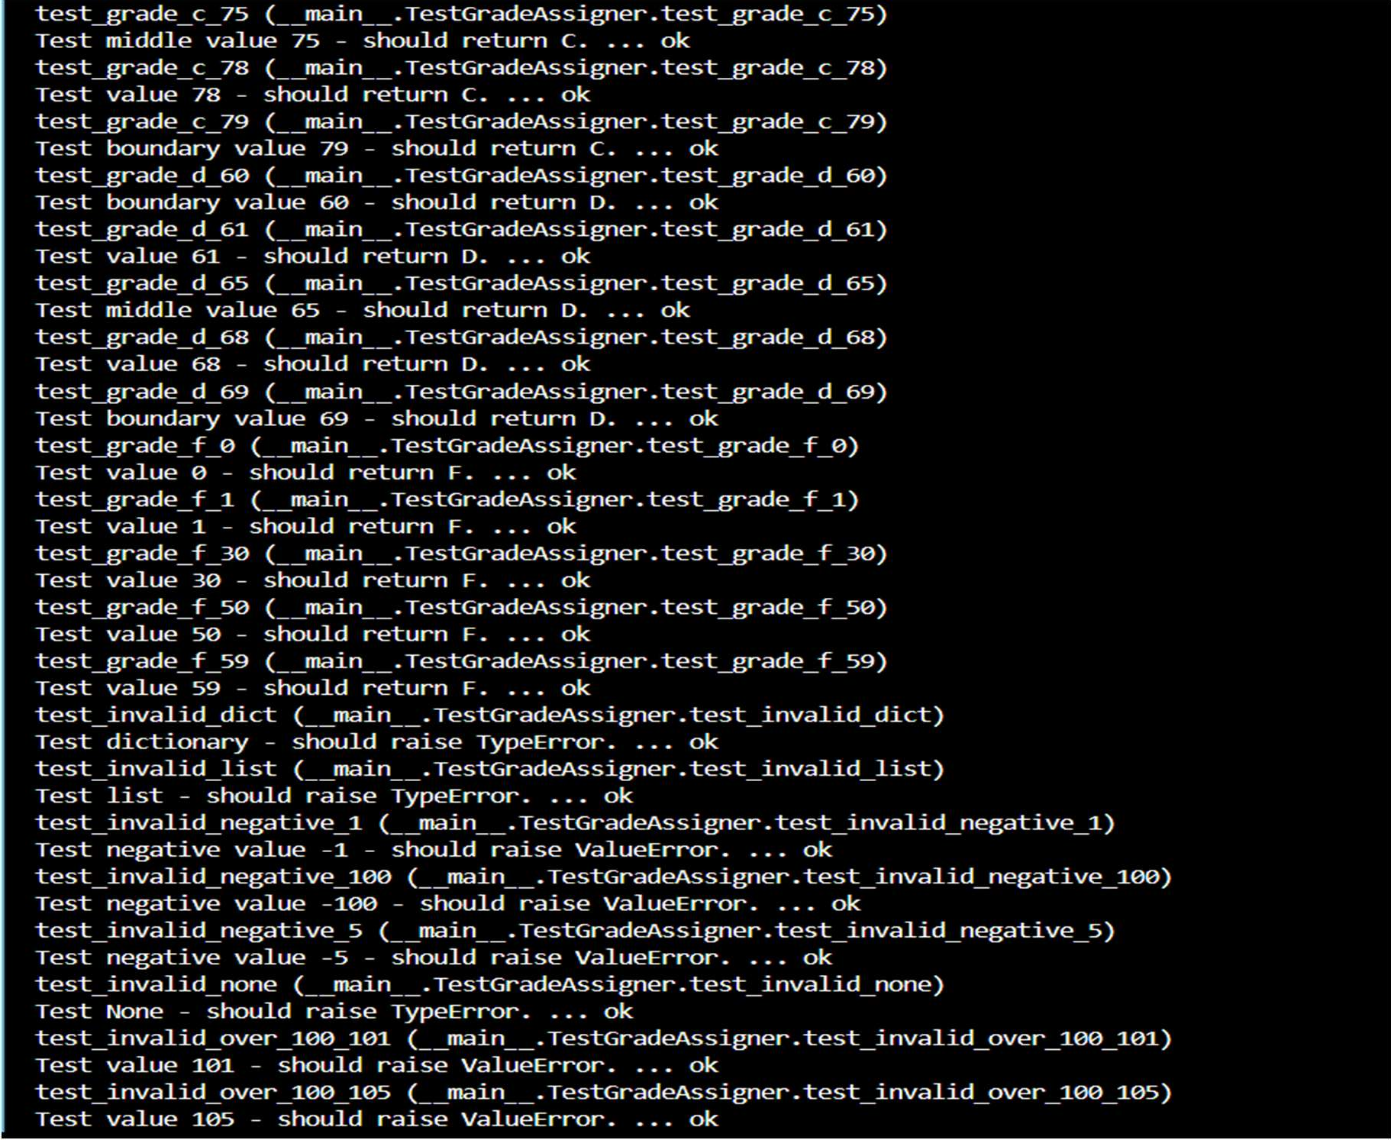

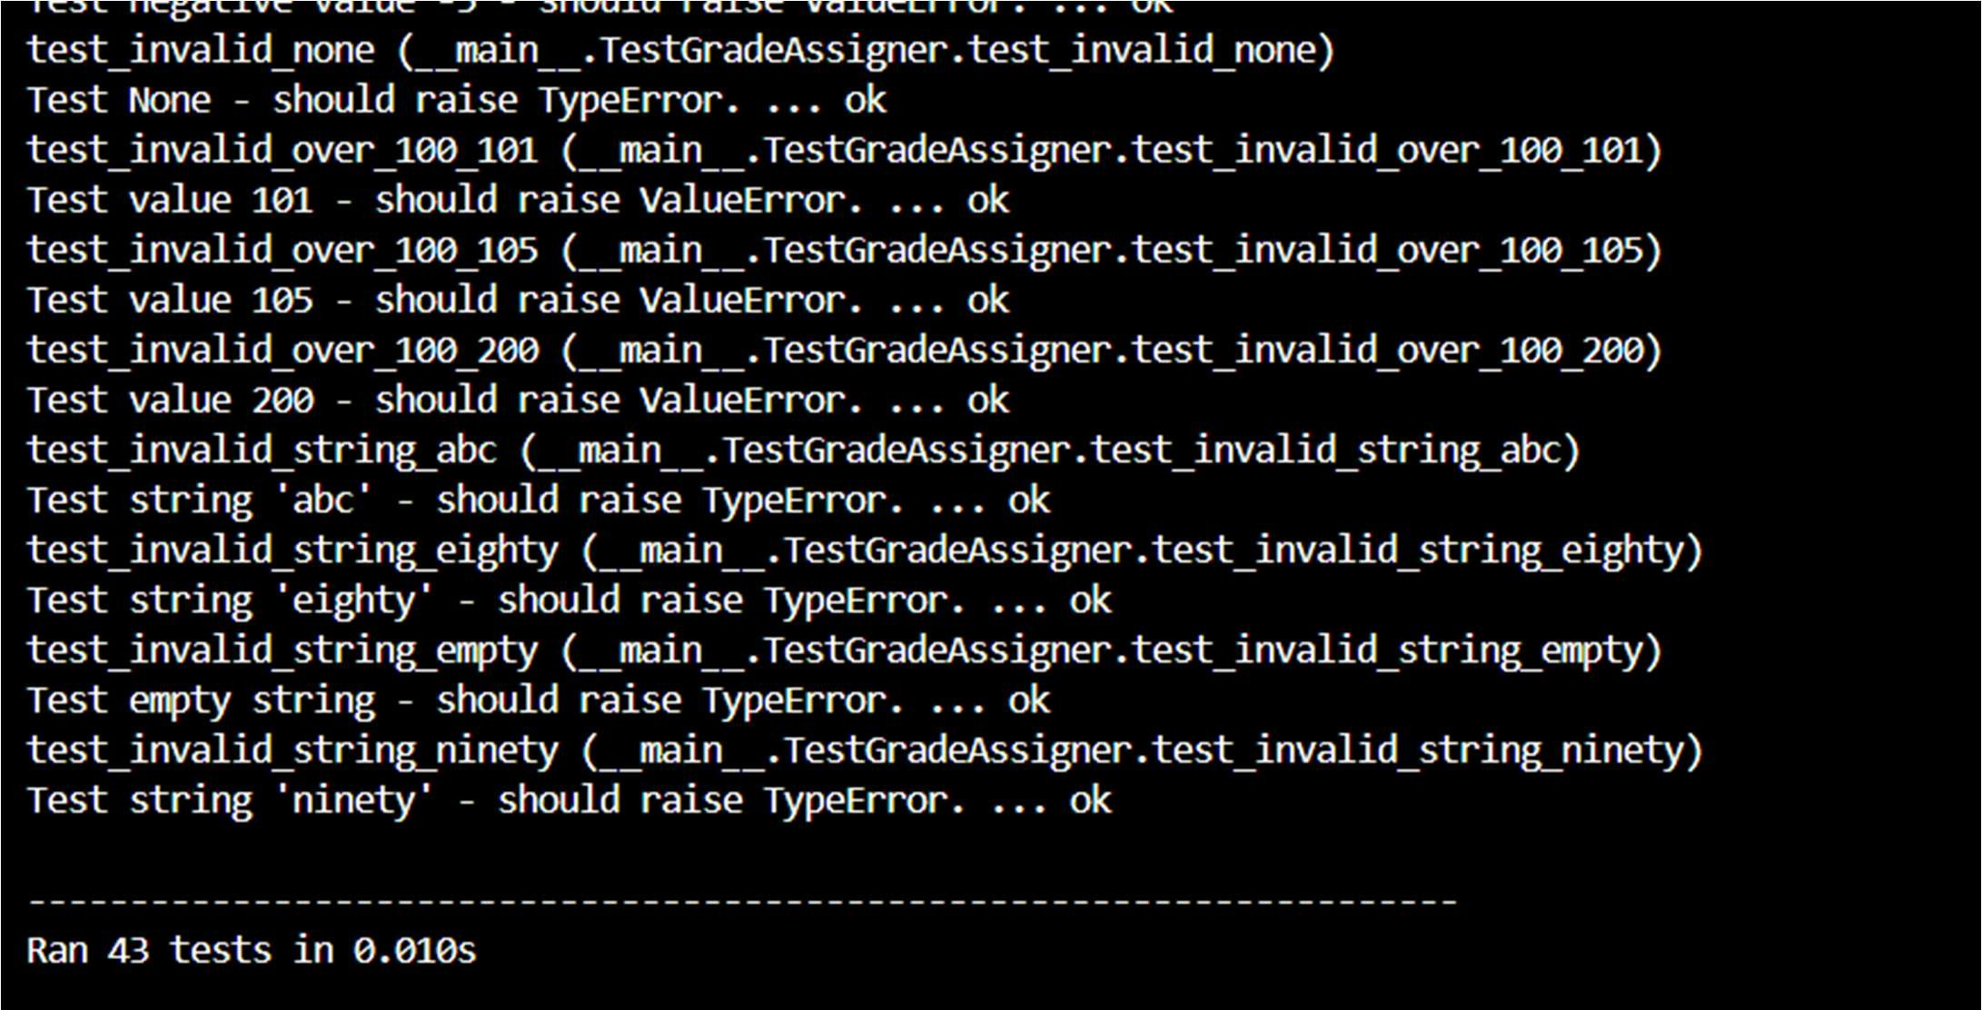
Explanation:
The function assigns letter grades based on score ranges while correctly handling boundary values. Invalid inputs are detected and handled to ensure reliable and safe grading.
Task 3: Sentence Palindrome Checker Prompt:
Generate comprehensive unit test cases for is_sentence_palindrome(sentence) that ignore case, spaces, and punctuation, covering both palindromic and non-palindromic sentences. Then implement the Python function is_sentence_palindrome(sentence) so it passes all the generated test cases.
Code:
"""
Task 3: Sentence Palindrome Checker - Menu App

Menu:
- Check a sentence (user input)
- Run automated test cases
- Exit """

from future import annotations import subprocess
from sentence_palindrome import is_sentence_palindrome

def run_tests() -> None:
"""Run the unittest suite for sentence palindrome checker.""" print("\nRunning automated tests...\n")
# -v gives verbose test output
subprocess.run(["python", "test_sentence_palindrome.py"], check=False)

def check_user_sentence() -> None:
"""Prompt the user for a sentence and print palindrome result.""" sentence = input("Enter a sentence: ")
result = is_sentence_palindrome(sentence) if result:
print("Result: Palindrome sentence (True)") else:
print("Result: Not a palindrome sentence (False)")

def main() -> None: while True:
print("\nSentence Palindrome Checker") print("1. Check a sentence (user input)") print("2. Run automated test cases") print("3. Exit")
choice = input("Enter your choice (1/2/3): ").strip() if choice == "1":
check_user_sentence()
elif choice == "2": run_tests()
elif choice == "3": print("Goodbye!") break
else:
print("Invalid choice. Please enter 1, 2, or 3.")

if name == " main ": main()

Output:
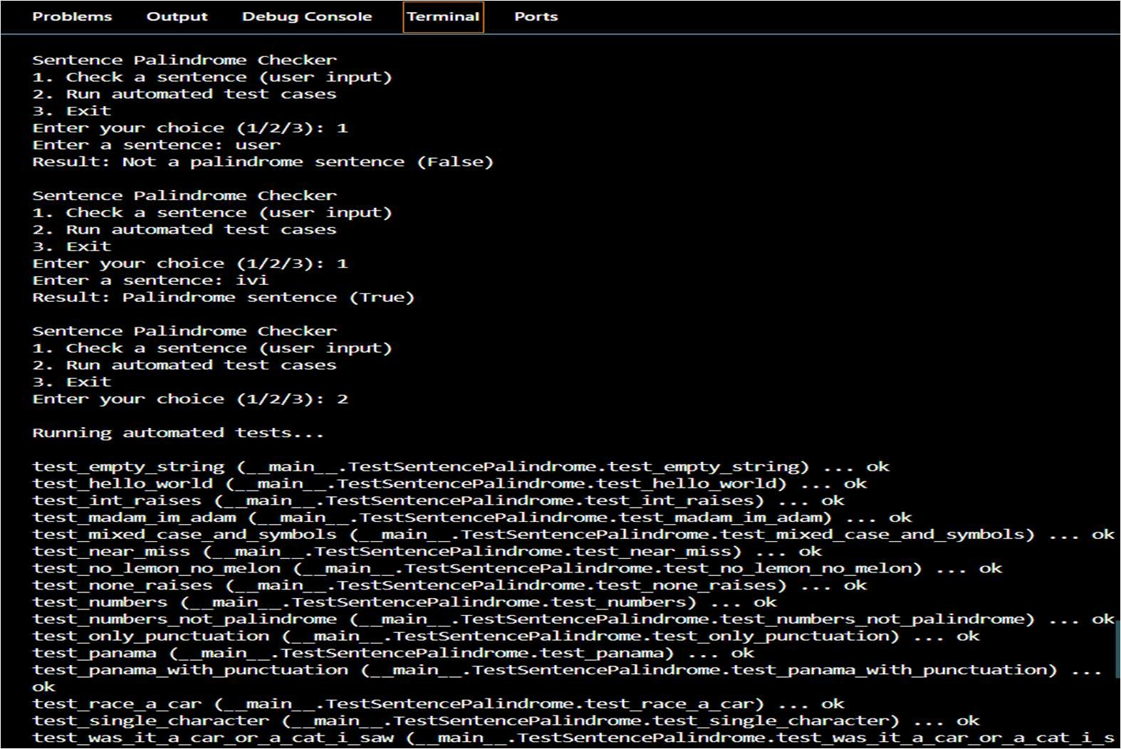

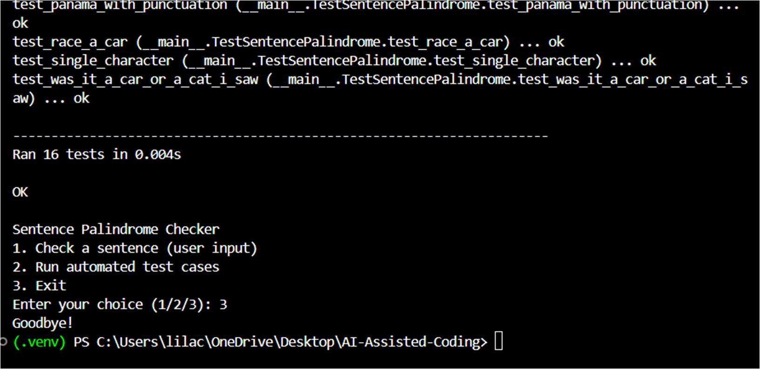
Explanation:
The function checks whether a sentence reads the same forward and backward after removing spaces, punctuation, and case differences.
Task 4: ShoppingCart Class Prompt:
Generate TDD-based unit test cases for a ShoppingCart class with add_item, remove_item, and total_cost methods, covering correct operations, cost calculation, and empty cart scenarios, then implement the class to pass all tests.
Code:
"""
Shopping Cart - Menu App

Menu:
- User input (add/remove/total)
- Run automated test cases
- Exit """

from future import annotations import subprocess
from shopping_cart import ShoppingCart

def run_tests() -> None:
print("\nRunning automated tests...\n") subprocess.run(["python", "test_shopping_cart.py"], check=False)

def prompt_price() -> float | None:
raw = input("Enter price: ").strip() try:
return float(raw) except ValueError:
print("Invalid price. Please enter a number (e.g., 9.99).")
return None

def user_mode() -> None: cart = ShoppingCart() while True:
print("\nUser Mode - Shopping Cart") print("1. Add item")
print("2. Remove item") print("3. Show total cost") print("4. Back to main menu")

choice = input("Choose (1/2/3/4): ").strip()

if choice == "1":
name = input("Enter item name: ").strip() price = prompt_price()
if price is None: continue
try:
cart.add_item(name, price) print(f"Added: {name} (${price:.2f})")
except (TypeError, ValueError) as e: print(f"Error: {e}")

elif choice == "2":
name = input("Enter item name to remove: ").strip() try:
removed = cart.remove_item(name) if removed:
print(f"Removed one '{name}'.") else:
print(f"Item '{name}' not found.") except TypeError as e:
print(f"Error: {e}")

elif choice == "3":
print(f"Total cost: ${cart.total_cost():.2f}")

elif choice == "4": break
else:
print("Invalid choice.")

def main() -> None: while True:
print("\nShopping Cart Module") print("1. User input") print("2. Run test cases") print("3. Exit")

choice = input("Enter your choice (1/2/3): ").strip()

if choice == "1":

user_mode() elif choice == "2":
run_tests() elif choice == "3":
print("Goodbye!") break
else:
print("Invalid choice. Please enter 1, 2, or 3.")

if name == " main ": main()

Output:
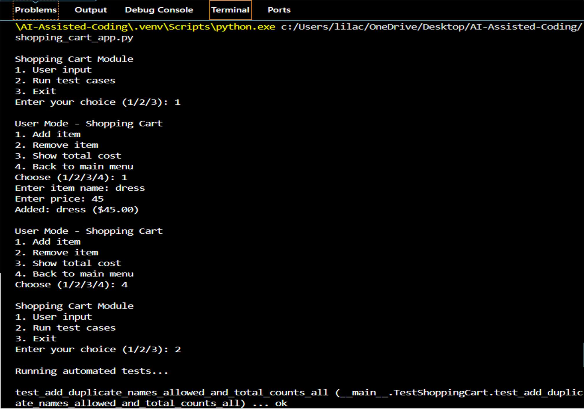

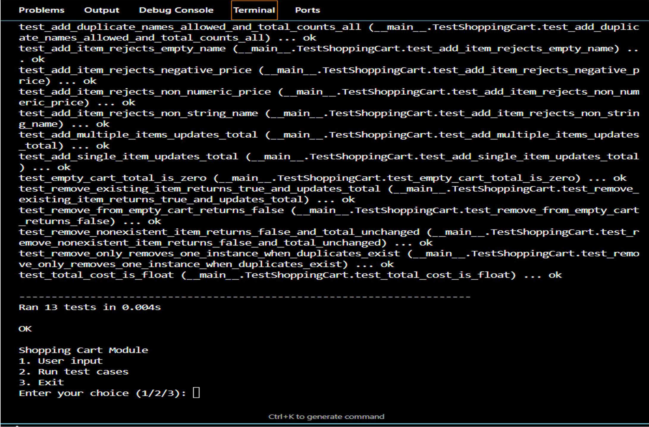

Explanation:
The module manages cart items and accurately calculates the total cost while safely handling additions, removals, and empty cart cases.
Task 5: Date Format Conversion Prompt:
Generate TDD-based unit test cases for convert_date_format(date_str) that converts dates from "YYYY-MM-DD" to "DD-MM-YYYY", then implement the Python function to pass all generated tests.
Code:
"""
Task 5: Date Format Conversion - Menu App

Menu:
- Convert a date (user input)
- Run automated test cases
- Exit """

from future import annotations import subprocess
from date_converter import convert_date_format

def run_tests() -> None:
print("\nRunning automated tests...\n")
subprocess.run(["python", "test_date_converter.py"], check=False)

def user_convert() -> None:
date_str = input("Enter a date in YYYY-MM-DD format: ") try:
converted = convert_date_format(date_str) print(f"Converted date: {converted}")
except (TypeError, ValueError) as e: print(f"Error: {e}")

def main() -> None: while True:
print("\nDate Format Converter") print("1. User input (convert date)") print("2. Run test cases")
print("3. Exit")

choice = input("Enter your choice (1/2/3): ").strip()

if choice == "1": user_convert()
elif choice == "2": run_tests()
elif choice == "3": print("Goodbye!") break
else:
print("Invalid choice. Please enter 1, 2, or 3.")

if name == " main ": main()

"""
Task 5: Date Format Conversion (TDD)

convert_date_format(date_str):
- Input: "YYYY-MM-DD"
- Output: "DD-MM-YYYY" """

from future import annotations

import re
from datetime import date from typing import Final

_DATE_RE: Final[re.Pattern[str]] = re.compile(r"^(?P<y>\d{4})-(?P<m>\d{2})-(?P<d>\d{2})$")

def convert_date_format(date_str: str) -> str: """
Convert a date string from 'YYYY-MM-DD' to 'DD-MM-YYYY'.

Args:
date_str: Date string in the input format.

Returns:
Converted date string in the output format.

Raises:
TypeError: If date_str is not a string.
ValueError: If date_str is not exactly 'YYYY-MM-DD' or is not a real calendar
date.
"""
if not isinstance(date_str, str):
raise TypeError(f"date_str must be str, got {type(date_str). name }")

match = _DATE_RE.match(date_str) if not match:
raise ValueError("Invalid date format. Expected 'YYYY-MM-DD' (e.g., 2023-10-15).")

y = int(match.group("y"))
m = int(match.group("m"))
d = int(match.group("d"))

# Validate actual calendar date (handles leap years, month lengths, etc.) try:
date(y, m, d) except ValueError as e:
raise ValueError(f"Invalid date: {e}") from None

return f"{d:02d}-{m:02d}-{y:04d}"

Output:
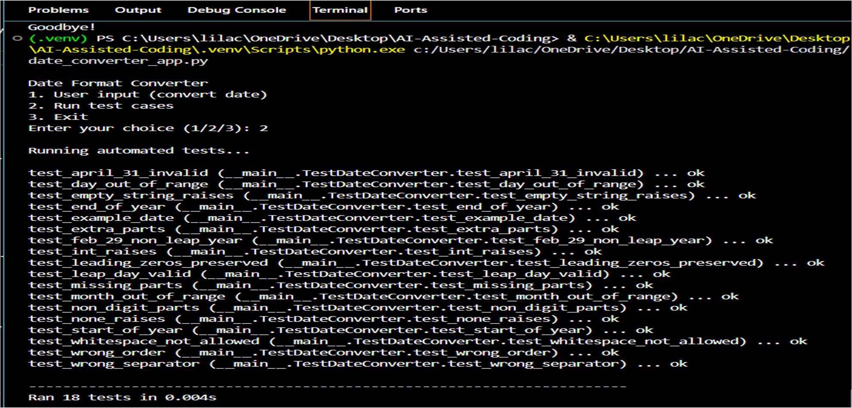

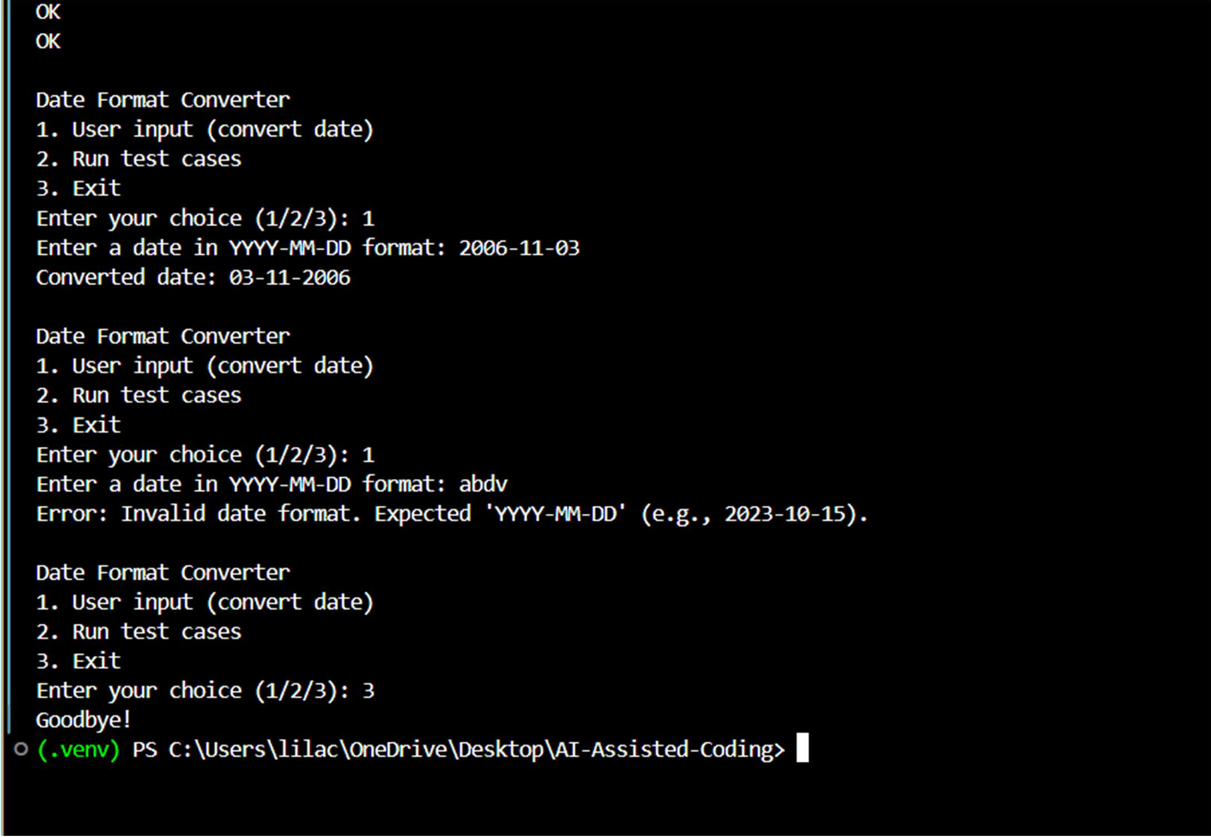

Explanation:
The function rearranges a valid date string from year–month–day format into day–month–year format while preserving correctness.

