Name: B.Priyanka
Hall Ticket: 2303A52468
Batch: 42
Task 1: Hospital Management Database Prompt:
Generate a complete SQL solution for a Hospital Management System by creating a normalized database schema with three tables: Doctors, Patients, and Appointments. Include primary keys, foreign keys, and proper constraints such as NOT NULL and UNIQUE, with appropriate data types compatible with SQLite. Then write SQL queries using joins to list all appointments for a specific doctor using doctor_id, retrieve full patient history using patient_id, and count the total distinct patients treated by each doctor. Also include sample INSERT statements for testing and a few SELECT queries to verify the data. The output should be clean, well-structured, and executable in SQLite without errors.

Code:
-- SQLite
-- DROP old tables (important if you ran before) DROP TABLE IF EXISTS Appointments;
DROP TABLE IF EXISTS Doctors; DROP TABLE IF EXISTS Patients;

-- Create Doctors table CREATE TABLE Doctors (
doctor_id INTEGER PRIMARY KEY AUTOINCREMENT,
first_name TEXT NOT NULL, last_name TEXT NOT NULL, specialty TEXT NOT NULL, UNIQUE (first_name, last_name)
);

-- Create Patients table CREATE TABLE Patients (
patient_id INTEGER PRIMARY KEY AUTOINCREMENT,
first_name TEXT NOT NULL, last_name TEXT NOT NULL, date_of_birth TEXT NOT NULL,
UNIQUE (first_name, last_name, date_of_birth)
);

-- Create Appointments table CREATE TABLE Appointments (
appointment_id INTEGER PRIMARY KEY AUTOINCREMENT, doctor_id INTEGER NOT NULL,
patient_id INTEGER NOT NULL, appointment_date TEXT NOT NULL,
FOREIGN KEY (doctor_id) REFERENCES Doctors(doctor_id), FOREIGN KEY (patient_id) REFERENCES Patients(patient_id)
);

-- Insert data
INSERT INTO Doctors (first_name, last_name, specialty) VALUES

('John', 'Doe', 'Cardiology'),
('Jane', 'Smith', 'Neurology');

INSERT INTO Patients (first_name, last_name, date_of_birth) VALUES ('Alice', 'Johnson', '1980-05-15'),
('Bob', 'Brown', '1990-08-22');

INSERT INTO Appointments (doctor_id, patient_id, appointment_date) VALUES

(1, | 1, | '2024-07-01'),
(1, | 2, | '2024-07-02'),
(2, | 1, | '2024-07-03');

-- TEST OUTPUT (IMPORTANT)
SELECT * FROM Doctors; SELECT * FROM Patients; SELECT * FROM Appointments;

-- Required Queries
SELECT a.appointment_id, d.first_name, d.last_name, p.first_name, p.last_name, a.appointment_date
FROM Appointments a
JOIN Doctors d ON a.doctor_id = d.doctor_id JOIN Patients p ON a.patient_id = p.patient_id WHERE a.doctor_id = 1;

SELECT a.appointment_id, d.first_name, d.last_name, a.appointment_date FROM Appointments a
JOIN Doctors d ON a.doctor_id = d.doctor_id WHERE a.patient_id = 1;

SELECT d.doctor_id, d.first_name, d.last_name, COUNT(DISTINCT a.patient_id) FROM Doctors d
LEFT JOIN Appointments a ON d.doctor_id = a.doctor_id GROUP BY d.doctor_id;
CREATE TABLE test123 (id INTEGER);
SELECT name FROM sqlite_master;

Output:
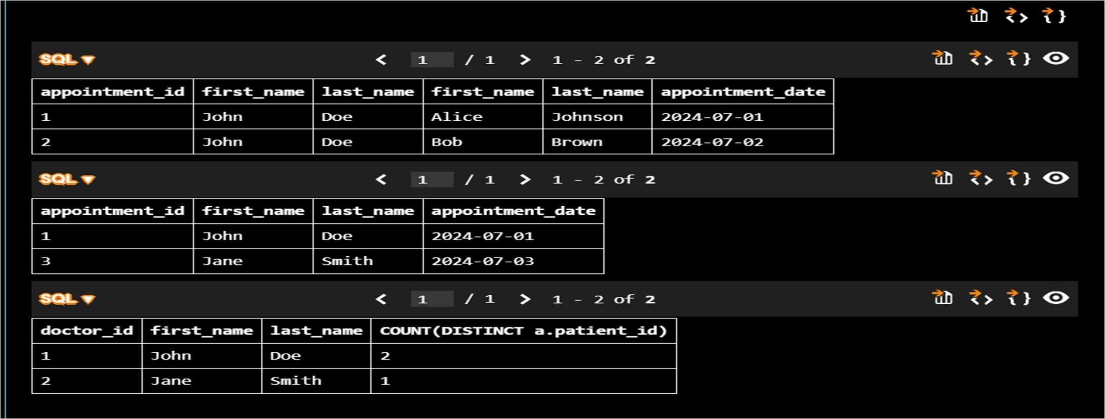

Explanation:
The database is designed with three related tables where the Appointments table links Doctors and Patients using foreign keys, ensuring proper normalization. SQL joins are used to combine data across tables to retrieve appointments, patient history, and aggregated counts efficiently.

Task 2: Real-Time Application: Online Shopping Database Prompt:
Generate a complete SQL solution for an E-commerce (Online Shopping) database system by creating a normalized schema with the tables Users, Products, Orders, and OrderDetails. Include primary keys, foreign keys, appropriate data types, and constraints such as NOT NULL and UNIQUE, ensuring compatibility with SQLite. Establish proper relationships between tables and maintain at least Third Normal Form (3NF). Then write SQL queries using joins to retrieve all orders placed by a specific user using user_id, find the most purchased product based on total quantity sold, and calculate total revenue for a given month. Include sample INSERT statements for testing and SELECT queries to verify data. Also suggest brief normalization improvements and query optimization techniques. The output should be clean, well-structured, and fully executable without errors.

Code:
-- SQLite
-- SQLite E-commerce Database (FINAL CLEAN) PRAGMA foreign_keys = ON;
-- RESET (important to avoid duplicate/exists errors) DROP TABLE IF EXISTS OrderDetails;
DROP TABLE IF EXISTS Orders; DROP TABLE IF EXISTS Products; DROP TABLE IF EXISTS Users;

-- Create Users table CREATE TABLE Users (
user_id INTEGER PRIMARY KEY AUTOINCREMENT,
username TEXT NOT NULL UNIQUE, email TEXT NOT NULL UNIQUE,
password TEXT NOT NULL,
created_at DATETIME DEFAULT CURRENT_TIMESTAMP
);

-- Create Products table CREATE TABLE Products (
product_id INTEGER PRIMARY KEY AUTOINCREMENT,
product_name TEXT NOT NULL, price REAL NOT NULL,
stock INTEGER NOT NULL,
created_at DATETIME DEFAULT CURRENT_TIMESTAMP
);

-- Create Orders table CREATE TABLE Orders (
order_id INTEGER PRIMARY KEY AUTOINCREMENT,
user_id INTEGER NOT NULL,
order_date DATETIME DEFAULT CURRENT_TIMESTAMP,
FOREIGN KEY (user_id) REFERENCES Users(user_id)

);

-- Create OrderDetails table CREATE TABLE OrderDetails (
order_detail_id INTEGER PRIMARY KEY AUTOINCREMENT, order_id INTEGER NOT NULL,
product_id INTEGER NOT NULL, quantity INTEGER NOT NULL, price REAL NOT NULL,
FOREIGN KEY (order_id) REFERENCES Orders(order_id), FOREIGN KEY (product_id) REFERENCES Products(product_id)
);

-- Insert data
INSERT INTO Users (username, email, password) VALUES ('john_doe', 'john@example.com', 'password123');

INSERT INTO Products (product_name, price, stock) VALUES ('Laptop', 999.99, 10),
('Mouse', 29.99, 50);

INSERT INTO Orders (user_id) VALUES (1);

INSERT INTO OrderDetails (order_id, product_id, quantity, price) VALUES (1, 1, 1, 999.99),
(1, 2, 2, 29.99);

-- TEST OUTPUT (you MUST see data) SELECT * FROM Users;
SELECT * FROM Products; SELECT * FROM Orders; SELECT * FROM OrderDetails;

-- 1. Retrieve all orders by a user
SELECT o.order_id, o.order_date, od.product_id, od.quantity, od.price FROM Orders o
JOIN OrderDetails od ON o.order_id = od.order_id WHERE o.user_id = 1;

-- 2. Most purchased product
SELECT p.product_name, SUM(od.quantity) AS total_quantity_sold FROM Products p
JOIN OrderDetails od ON p.product_id = od.product_id GROUP BY p.product_id
ORDER BY total_quantity_sold DESC LIMIT 1;

-- 3. Total revenue in a given month
SELECT SUM(od.quantity * od.price) AS total_revenue FROM Orders o
JOIN OrderDetails od ON o.order_id = od.order_id WHERE strftime('%Y-%m', o.order_date) = '2024-01';

Output:
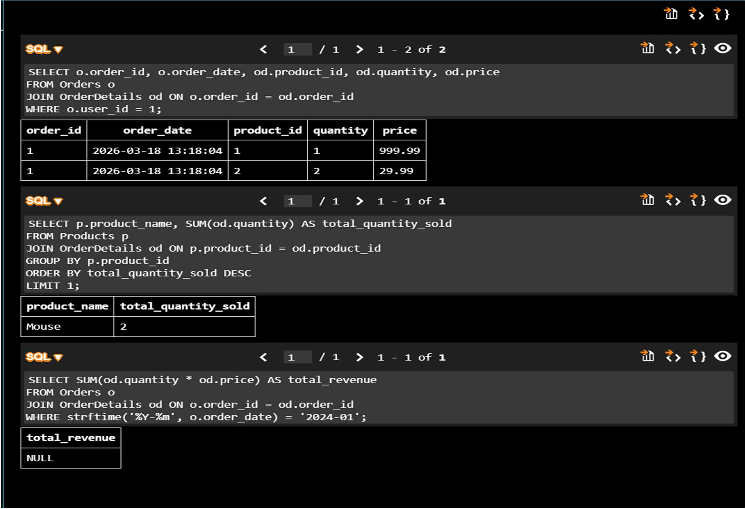

Explanation:
The database uses multiple related tables where OrderDetails acts as a bridge between Orders and Products, ensuring proper normalization and avoiding redundancy. SQL joins and aggregate functions are used to analyze user orders, identify top-selling products, and calculate monthly revenue efficiently.

Task 3: Library Database Prompt:
Generate a complete SQL solution for a Library Management System by creating a normalized database schema with three tables: Books, Members, and Loans. Include primary keys, foreign keys, appropriate data types, and constraints such as NOT NULL and UNIQUE, ensuring compatibility with SQLite. Establish proper relationships between tables and maintain at least Third Normal Form (3NF). Then write SQL queries using joins to retrieve all books currently issued (not yet returned), find overdue books where the loan date is more than 30 days from the current date, and count the number of books loaned by each member. Also suggest an indexing strategy to improve query performance. Include sample INSERT statements for testing and ensure the output is clean, well-structured, and fully executable without errors.

Code:
-- SQLite
--Generate a complete SQL solution for a Library Management System by creating a normalized database schema with three tables: Books, Members, and Loans. Include primary keys, foreign keys, appropriate data types, and constraints such as NOT NULL and UNIQUE, ensuring compatibility with SQLite. Establish proper relationships between tables and maintain at least Third Normal Form (3NF). Then write SQL queries using joins to retrieve all books currently issued (not yet returned), find overdue books where the loan date is
more than 30 days from the current date, and count the number of books loaned by each

member. Also suggest an indexing strategy to improve query performance. Include sample INSERT statements for testing and ensure the output is clean, well-structured, and fully executable without errors.
-- Create the Books table CREATE TABLE Books (
BookID INTEGER PRIMARY KEY AUTOINCREMENT, Title TEXT NOT NULL,
Author TEXT NOT NULL,
PublishedYear INTEGER NOT NULL, UNIQUE(Title, Author)
);
-- Create the Members table CREATE TABLE Members (
MemberID INTEGER PRIMARY KEY AUTOINCREMENT,
FirstName TEXT NOT NULL, LastName TEXT NOT NULL, Email TEXT NOT NULL UNIQUE
);
-- Create the Loans table CREATE TABLE Loans (
LoanID INTEGER PRIMARY KEY AUTOINCREMENT, BookID INTEGER NOT NULL,
MemberID INTEGER NOT NULL, LoanDate DATE NOT NULL, ReturnDate DATE,
FOREIGN KEY (BookID) REFERENCES Books(BookID),
FOREIGN KEY (MemberID) REFERENCES Members(MemberID)
);
-- Sample INSERT statements for testing
INSERT INTO Books (Title, Author, PublishedYear) VALUES ('The Great Gatsby', 'F. Scott Fitzgerald', 1925);
INSERT INTO Books (Title, Author, PublishedYear) VALUES ('To Kill a Mockingbird', 'Harper Lee', 1960);
INSERT INTO Books (Title, Author, PublishedYear) VALUES ('1984', 'George Orwell', 1949); INSERT INTO Members (FirstName, LastName, Email) VALUES ('John', 'Doe', 'john.doe@example.com');
INSERT INTO Members (FirstName, LastName, Email) VALUES ('Jane', 'Smith', 'jane.smith@example.com');
INSERT INTO Loans (BookID, MemberID, LoanDate) VALUES (1, 1, '2024-05-01'); INSERT INTO Loans (BookID, MemberID, LoanDate) VALUES (2, 2, '2024-05-15');
-- Query to retrieve all books currently issued (not yet returned) SELECT b.Title, b.Author, m.FirstName, m.LastName, l.LoanDate FROM Loans l
JOIN Books b ON l.BookID = b.BookID
JOIN Members m ON l.MemberID = m.MemberID WHERE l.ReturnDate IS NULL;
-- Query to find overdue books where the loan date is more than 30 days from the current date
SELECT b.Title, b.Author, m.FirstName, m.LastName, l.LoanDate FROM Loans l
JOIN Books b ON l.BookID = b.BookID
JOIN Members m ON l.MemberID = m.MemberID
WHERE l.ReturnDate IS NULL AND julianday('now') - julianday(l.LoanDate) > 30;
-- Query to count the number of books loaned by each member

SELECT m.FirstName, m.LastName, COUNT(l.LoanID) AS BooksLoaned FROM Members m
LEFT JOIN Loans l ON m.MemberID = l.MemberID GROUP BY m.MemberID;
-- Indexing strategy to improve query performance CREATE INDEX idx_loans_bookid ON Loans(BookID); CREATE INDEX idx_loans_memberid ON Loans(MemberID); CREATE INDEX idx_loans_loan_date ON Loans(LoanDate);
CREATE INDEX idx_books_title_author ON Books(Title, Author);
CREATE INDEX idx_members_email ON Members(Email);

Output:
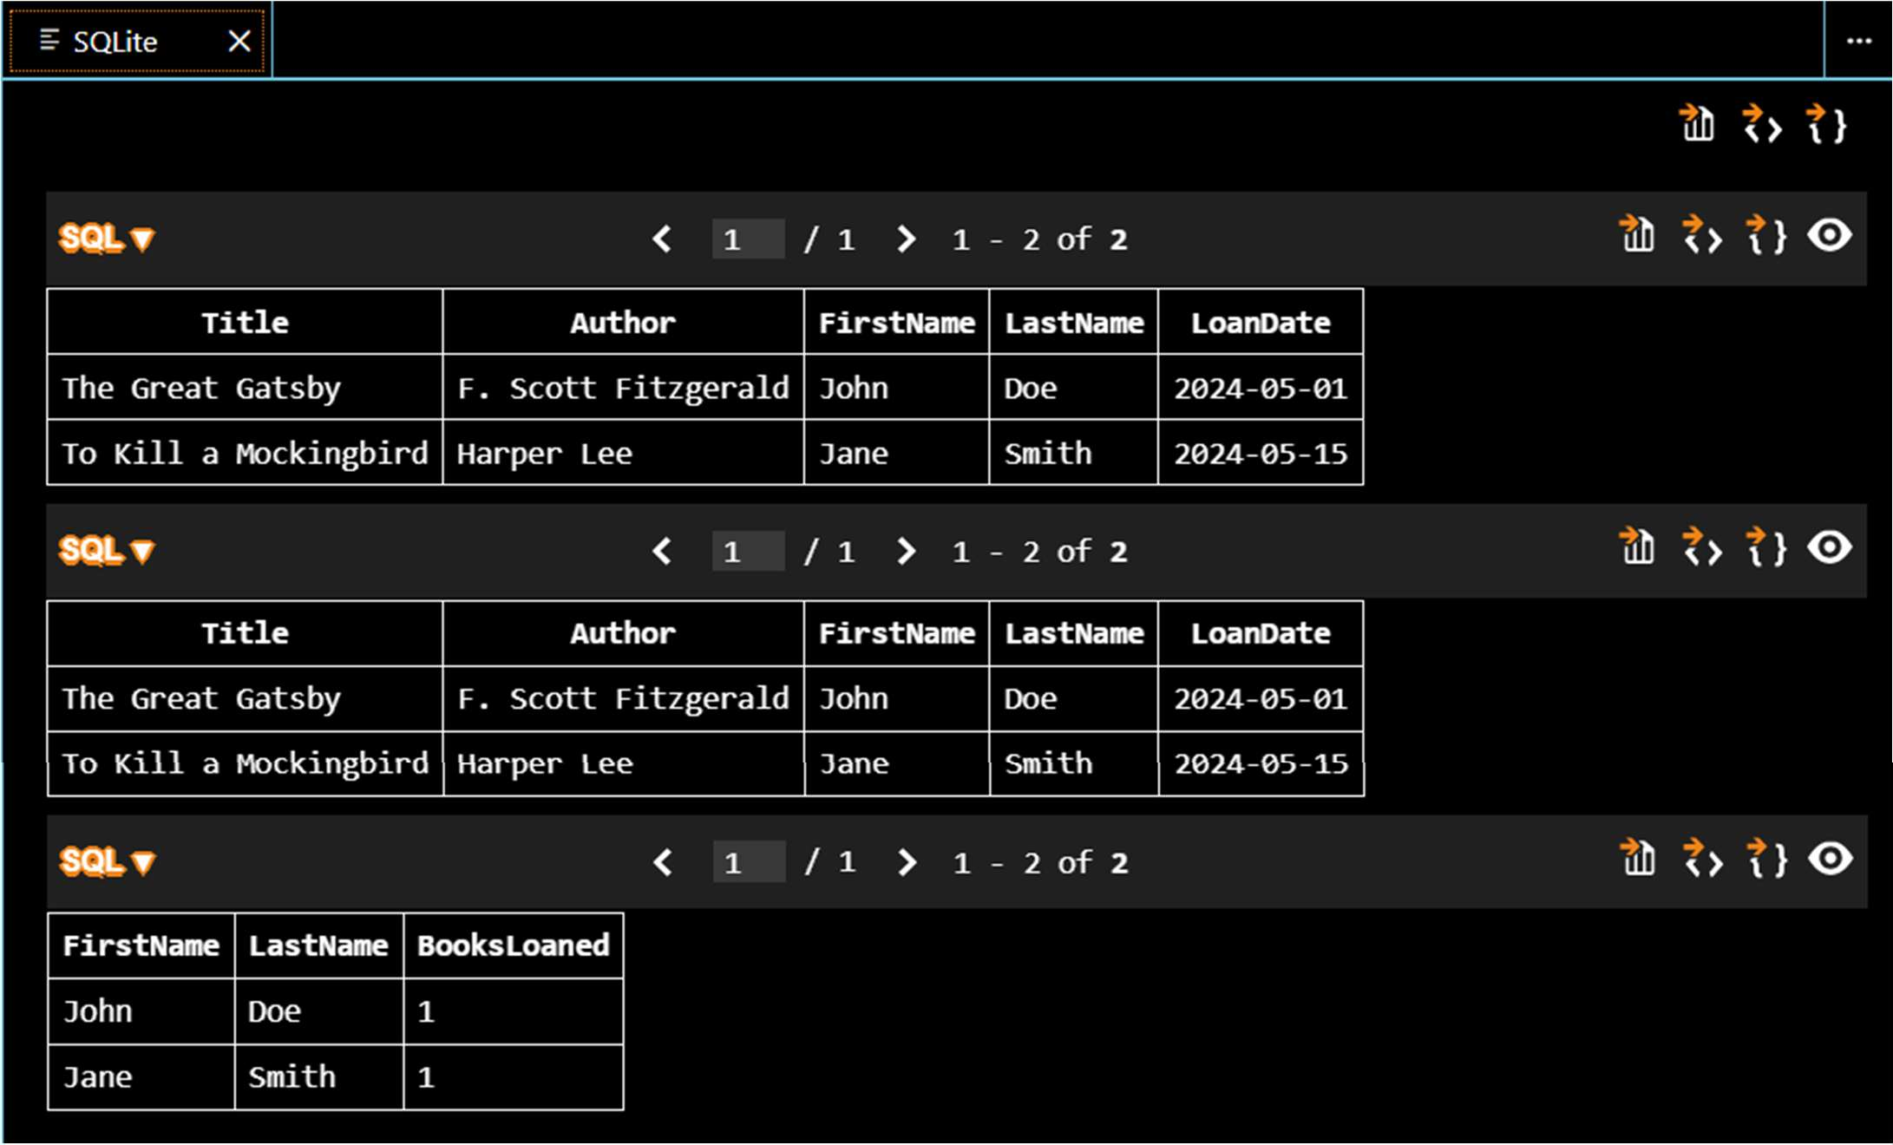

Explanation:
The system uses three related tables where Loans acts as a bridge between Books and Members, ensuring proper normalization and avoiding redundancy. SQL joins and conditions are used to track issued books, detect overdue loans, and calculate borrowing activity efficiently.

Task 4: Optimize Queries Prompt:
Analyze and optimize SQL queries for better performance using a given example. Start with the original query that uses a subquery to retrieve books written by UK authors, then rewrite it using an optimized approach with joins. Ensure both queries return the same result set. Explain briefly how the optimized query improves efficiency in terms of execution time and scalability. Suggest additional optimizations such as indexing relevant columns (e.g., author_id, country) and reducing unnecessary subqueries. Provide both the original and optimized queries, along with a short validation step to confirm correctness of results. Ensure the output is clean, concise, and executable in SQLite.

Code:
-- SQLite
-- Analyze and optimize SQL queries for better performance using a given example

PRAGMA foreign_keys = ON;

-- Create Authors table CREATE TABLE Authors (
id INTEGER PRIMARY KEY AUTOINCREMENT, name TEXT NOT NULL,
country TEXT NOT NULL
);

-- Create Books table CREATE TABLE Books (
book_id INTEGER PRIMARY KEY AUTOINCREMENT, title TEXT NOT NULL,
author_id INTEGER,
FOREIGN KEY (author_id) REFERENCES Authors(id)
);

-- Insert sample data
INSERT INTO Authors (name, country) VALUES ('Author A', 'UK'),
('Author B', 'USA'),
('Author C', 'UK');

INSERT INTO Books (title, author_id) VALUES ('Book 1', 1),
('Book 2', 2),
('Book 3', 3);

-- Original Query using subquery SELECT title
FROM Books
WHERE author_id IN ( SELECT id
FROM Authors
WHERE country = 'UK'
);

-- Optimized Query using JOIN SELECT b.title
FROM Books b
JOIN Authors a ON b.author_id = a.id WHERE a.country = 'UK';

-- Validation query (should return empty if both are same) SELECT title
FROM Books
WHERE author_id IN (
SELECT id FROM Authors WHERE country = 'UK'
)

EXCEPT

SELECT b.title FROM Books b
JOIN Authors a ON b.author_id = a.id WHERE a.country = 'UK';

-- Indexing for optimization
CREATE INDEX idx_books_author_id ON Books(author_id); CREATE INDEX idx_authors_country ON Authors(country);

-- Explanation:
-- The original query uses a subquery which may scan data multiple times.
-- The optimized query uses JOIN, allowing faster execution and better use of indexes.

Output:
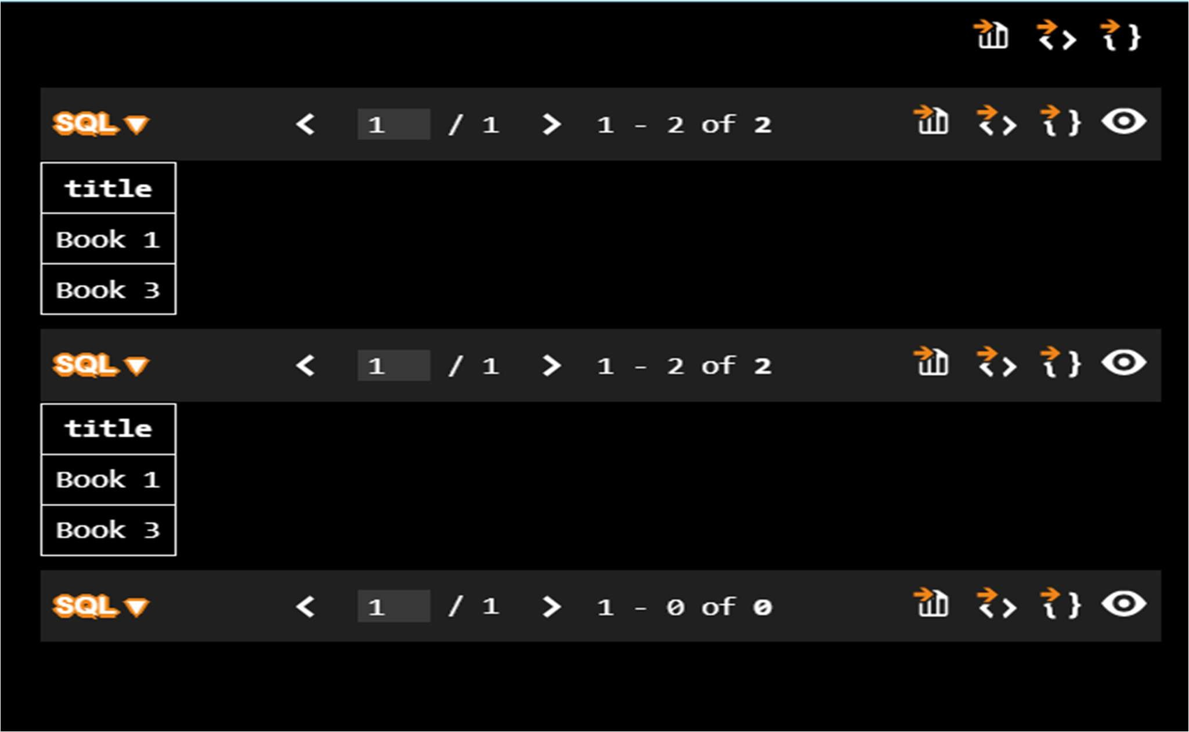

Explanation:
The original query uses a subquery, which can be slower for large datasets, while the optimized query replaces it with a join for faster execution. Indexing and reducing nested queries improve performance without changing the result.

Task 5: University Course Registration Prompt:
Generate a complete SQL solution for a University Course Registration System by creating a normalized database schema with four tables: Students, Courses, Faculty, and Registrations. Include primary keys, foreign keys, appropriate data types, and constraints such as NOT NULL and UNIQUE, ensuring compatibility with SQLite. Define relationships such that each student can register for multiple courses and each course is taught by one faculty member. Maintain at least Third Normal Form (3NF). Then write SQL queries using joins to list all students enrolled in a specific course using course_id, find faculty members teaching more than 2 courses, and retrieve courses with the

highest number of registrations. Include sample INSERT statements for testing and ensure the output is clean, well-structured, and fully executable without errors.

Code:
-- SQLite
--Generate a complete SQL solution for a University Course Registration System by creating a normalized database schema with four tables: Students, Courses, Faculty, and Registrations. Include primary keys, foreign keys, appropriate data types, and constraints such as NOT NULL and UNIQUE, ensuring compatibility with SQLite. Define relationships such that each student can register for multiple courses and each course is taught by one faculty member. Maintain at least Third Normal Form (3NF). Then write SQL queries using joins to list all students enrolled in a specific course using course_id, find faculty members teaching more than 2 courses, and retrieve courses with the highest number of registrations. Include sample INSERT statements for testing and ensure the output is clean, well-structured, and fully executable without errors.
-- Create the Students table CREATE TABLE Students (
student_id INTEGER PRIMARY KEY AUTOINCREMENT,
first_name TEXT NOT NULL, last_name TEXT NOT NULL, email TEXT NOT NULL UNIQUE
);
-- Create the Faculty table CREATE TABLE Faculty (
faculty_id INTEGER PRIMARY KEY AUTOINCREMENT,
first_name TEXT NOT NULL, last_name TEXT NOT NULL, email TEXT NOT NULL UNIQUE
);
-- Create the Courses table CREATE TABLE Courses (
course_id INTEGER PRIMARY KEY AUTOINCREMENT,
course_name TEXT NOT NULL, faculty_id INTEGER NOT NULL,
FOREIGN KEY (faculty_id) REFERENCES Faculty(faculty_id)
);
-- Create the Registrations table CREATE TABLE Registrations (
registration_id INTEGER PRIMARY KEY AUTOINCREMENT, student_id INTEGER NOT NULL,
course_id INTEGER NOT NULL,
FOREIGN KEY (student_id) REFERENCES Students(student_id), FOREIGN KEY (course_id) REFERENCES Courses(course_id), UNIQUE(student_id, course_id)
);
-- Sample INSERT statements for testing
INSERT INTO Faculty (first_name, last_name, email) VALUES ('John', 'Doe', 'john.doe@university.edu');
INSERT INTO Students (first_name, last_name, email) VALUES ('Alice', 'Smith', 'alice.smith@university.edu');
INSERT INTO Courses (course_name, faculty_id) VALUES ('Introduction to Computer Science', 1);
INSERT INTO Registrations (student_id, course_id) VALUES (1, 1);

-- Query to list all students enrolled in a specific course using course_id SELECT s.first_name, s.last_name, s.email
FROM Students s
JOIN Registrations r ON s.student_id = r.student_id WHERE r.course_id = 1;
-- Query to find faculty members teaching more than 2 courses
SELECT f.first_name, f.last_name, COUNT(c.course_id) AS course_count FROM Faculty f
JOIN Courses c ON f.faculty_id = c.faculty_id GROUP BY f.faculty_id
HAVING course_count > 2;
-- Query to retrieve courses with the highest number of registrations SELECT c.course_name, COUNT(r.registration_id) AS registration_count FROM Courses c
JOIN Registrations r ON c.course_id = r.course_id GROUP BY c.course_id
ORDER BY registration_count DESC LIMIT 1;

Output:
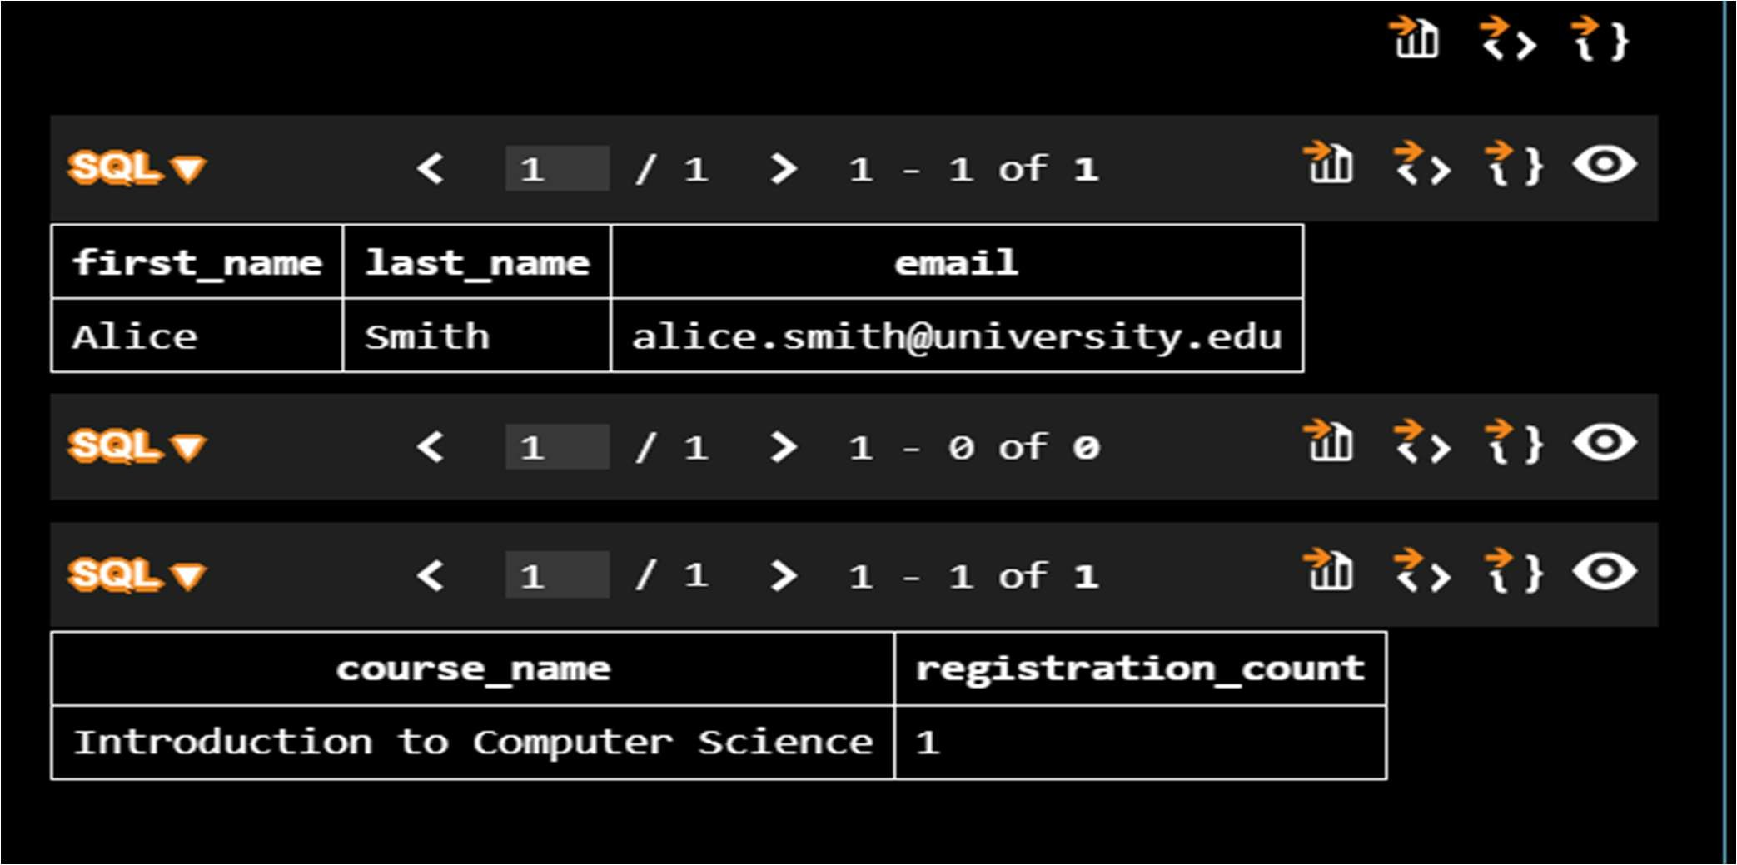

Explanation:
The Registrations table connects Students and Courses, handling the many-to-many relationship efficiently. SQL joins and aggregation functions are used to analyze enrollments, faculty workload, and popular courses.

