Name: B.Priyanka
Hall Ticket: 2303A52468
Batch: 42
Task 1: Hospital Management Database Prompt:
Convert the above Python Student class into equivalent C++ code. Include a main() function and produce the same output as the Python program.
Code:
// Python Code (for reference)
/*
class Student:
def init (self, name, age, marks): self.name = name
self.age = age self.marks = marks

def display(self): print("Name:", self.name) print("Age:", self.age) print("Marks:", self.marks)

s1 = Student("Likki", 20, 85) s1.display()
*/

// Convert the above Python Student class into equivalent C++ code

#include <iostream> #include <string> using namespace std;

class Student { private:
string name; int age;
int marks;

public:
Student(string n, int a, int m) { name = n;
age = a; marks = m;
}

void display() {
cout << "Name: " << name << endl; cout << "Age: " << age << endl; cout << "Marks: " << marks << endl;
}

};

int main() {
Student s1("Likki", 20, 85); s1.display();
return 0;
}

Output:
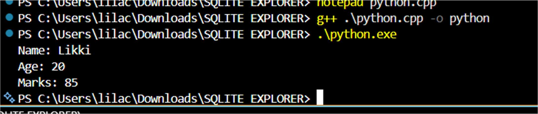
Explanation:
The Python class is converted into a C++ class by defining attributes as private members and initializing them using a constructor. Member functions are used to display output, and the main() function creates an object and calls the display method.
Task 2: Java to Python Function Conversion Prompt:
Convert the above Java isPrime() method into equivalent Python function. Ensure Pythonic syntax and test with multiple inputs.
Code:
# Java Code '''
public class PrimeCheck {
public static boolean isPrime(int n) { if (n <= 1) return false;
for (int i = 2; i <= n / 2; i++) { if (n % i == 0) return false;
}
return true;
}

public static void main(String[] args) { System.out.println(isPrime(7)); System.out.println(isPrime(10));
}
}
*/'''
#Convert the above Java isPrime() method into equivalent Python function. Ensure Pythonic syntax and test with multiple inputs.
def is_prime(n): if n <= 1:
return False
for i in range(2, n // 2 + 1):

if n % i == 0: return False
return True
# Testing the function with multiple inputs print(is_prime(7)) # True print(is_prime(10)) # False print(is_prime(2)) # True print(is_prime(15)) # False print(is_prime(1)) # False print(is_prime(0)) # False print(is_prime(-5)) # False

Output:
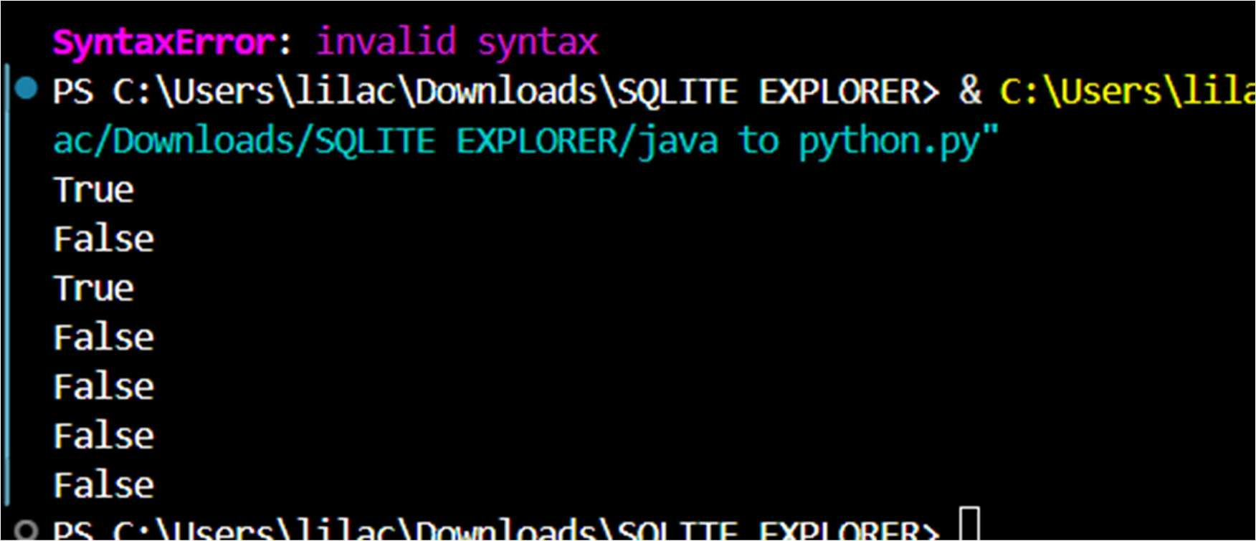
Explanation:
The Java method is converted into a Python function by removing static typing and using Python’s simple syntax with indentation. The logic remains the same, using a loop to check divisibility and returning True or False accordingly.
Task 3: Pseudocode to Python Implementation Prompt:
Convert the above pseudocode into equivalent Python code using bubble sort.Ensure correct logic and test with sample inputs.
Code:
# Pseudocode """
START
Input list of numbers FOR i from 0 to n-1
FOR j from 0 to n-i-2
IF list[j] > list[j+1]
SWAP list[j] and list[j+1]
END FOR
Output sorted list END
"""

#Convert the above pseudocode into equivalent Python code using bubble sort.Ensure correct logic and test with sample inputs.
def bubble_sort(arr): n = len(arr)
# Traverse through all elements in the list for i in range(n):
# Last i elements are already in place, no need to check them for j in range(0, n-i-1):
# Swap if the element found is greater than the next element if arr[j] > arr[j+1]:
arr[j], arr[j+1] = arr[j+1], arr[j]
return arr
# Test the bubble_sort function with sample inputs if name == " main ":
sample_input = [64, 34, 25, 12, 22, 11, 90] sorted_list = bubble_sort(sample_input) print("Sorted list is:", sorted_list)
# Output should be: Sorted list is: [11, 12, 22, 25, 34, 64, 90]

Output:
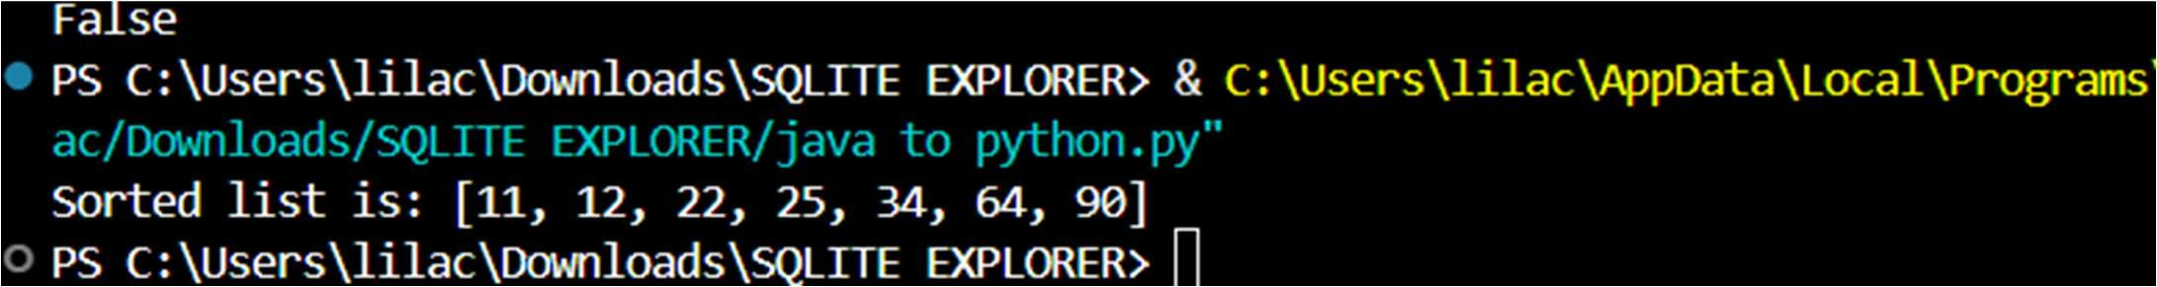
Explanation:
The pseudocode is converted into Python by implementing nested loops and swapping elements using Python syntax. The bubble sort algorithm repeatedly compares adjacent elements and sorts the list step by step.
Task 4: Optimize Queries Prompt:
Convert the above SQL query into equivalent Pandas code
Code:
# SQL Query (for reference) """
SELECT name, salary FROM employees
WHERE salary > 50000; """

# Convert the above SQL query into equivalent Pandas code import pandas as pd
# Assuming we have a DataFrame 'employees' with columns 'name' and 'salary' # Example DataFrame creation (for demonstration purposes)
data = {
'name': ['Alice', 'Bob', 'Charlie', 'David'], 'salary': [60000, 45000, 70000, 30000]
}
employees = pd.DataFrame(data)

# Equivalent Pandas code
result = employees[employees['salary'] > 50000][['name', 'salary']] print(result)

Output:
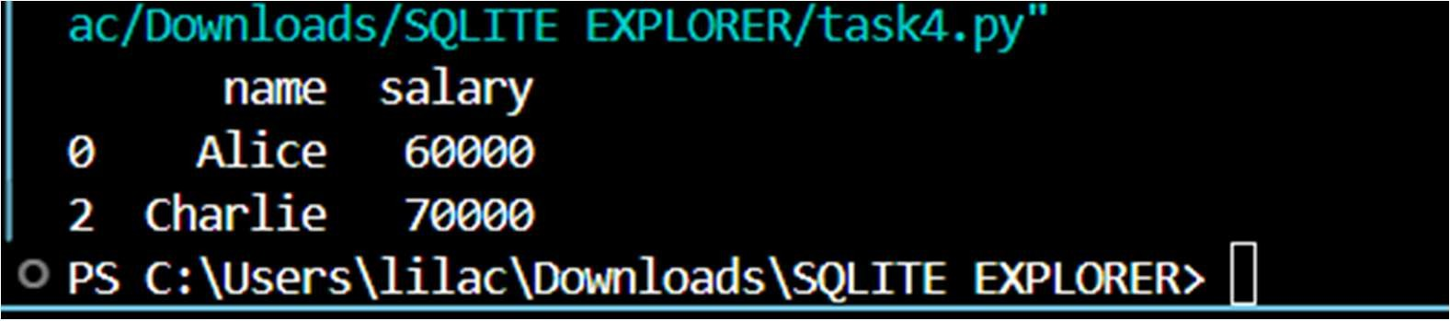
Explanation:
The SQL query is converted into Pandas by filtering rows using conditions and selecting required columns. Boolean indexing is used in Pandas to replicate the WHERE clause and column selection.
Task 5: Real-Time Application: Algorithm Translation Across Languages Prompt:
Convert the above Python linear search algorithm into equivalent C code. Ensure proper handling of arrays, loops, and function structure.
Code: Python Code:
# Python Code

def linear_search(arr, key): for i in range(len(arr)):
if arr[i] == key: return i
return -1

# Test
arr = [10, 20, 30, 40, 50]
key = 30
result = linear_search(arr, key) if result != -1:
print("Element found at index:", result)
else:
print("Element not found")

Converted C Code:
#Convert the above Python linear search algorithm into equivalent C code. Ensure proper handling of arrays, loops, and function structure.
#include <stdio.h>
int linear_search(int arr[], int size, int key) {

for (int i = 0; i < size; i++) { if (arr[i] == key) {
return i; // Return the index of the found element
}
}
return -1; // Return -1 if the element is not found
}
int main() {
int arr[] = {10, 20, 30, 40, 50};
int key = 30;
int size = sizeof(arr) / sizeof(arr[0]);
int result = linear_search(arr, size, key); if (result != -1) {
printf("Element found at index: %d\n", result);
} else {
printf("Element not found\n");
}

return 0;
}

Output:
Python:
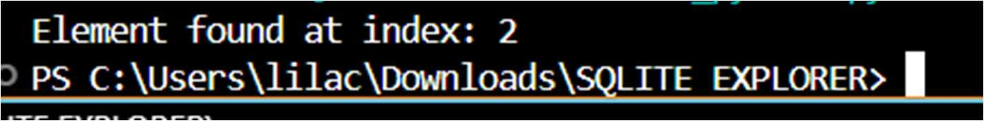
C:
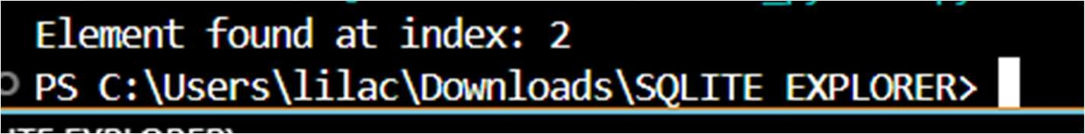
Explanation:
The Python linear search algorithm is translated into C by using arrays, loops, and functions with explicit data types. Unlike Python, C requires manual handling of array size and uses printf for output.

