Name: B.Priyanka
Hall Ticket: 2303A52468
Batch: 42
Task 1: Rapid App Prototyping with AI
Prompt:
Create a simple mobile-friendly fitness tracker app prototype using HTML, CSS, and JavaScript. Add an app tle "Fitness Tracker" and three sec ons: Steps, Calories, and Water Intake. Show placeholder values for
each sec on. Make the UI clean, modern, and responsive for mobile screens.
Code:
import React from 'react';

export default func on App() {
return (
<div className="min-h-screen bg-gray-100 flex jus fy-center">
<div className="w-full max-w-md bg-white shadow-md flex flex-col h-screen">
<header className="bg-blue-600 text-white p-4 text-center text-xl font-bold"> FitTracker </header>

<main className="p-4 flex-1 overflow-y-auto space-y-4">
<div className="bg-gray-50 p-4 rounded-lg border border-gray-200">
<h2 className="text-lg font-semibold text-gray-700">Steps</h2>
<p className="text-3xl font-bold text-blue-500">5,432</p> </div>

<div className="bg-gray-50 p-4 rounded-lg border border-gray-200">
<h2 className="text-lg font-semibold text-gray-700">Calories Burned</h2>
<p className="text-3xl font-bold text-orange-500">450 kcal</p> </div>

<div className="bg-gray-50 p-4 rounded-lg border border-gray-200">
<h2 className="text-lg font-semibold text-gray-700">Water Intake</h2>
<p className="text-3xl font-bold text-teal-500">1.2 L</p> </div>
</main>
</div>
}
Output:
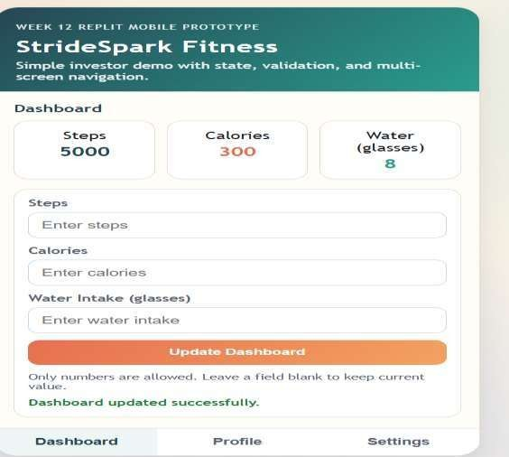
Explana on:
AI helped quickly create a basic mobile app layout with sec ons for Steps, Calories, and Water Intake. The simple and responsive design makes it suitable for demos, while using HTML, CSS, and JavaScript keeps it lightweight and easy to test. Task 2: User Input & State Handling
Prompt:
Build a simple React mobile-style app called FitTracker using functional components and useState. Include a steps tracking section where users can input and log additional steps with validation (only positive numbers). Display total steps dynamically, handle invalid input with alerts, and design a clean responsive UI using Tailwind CSS.

Code:
import React, { useState } from 'react';

export default func on App() {
const [steps, setSteps] = useState(5432); const [inputSteps, setInputSteps] = useState('');

const handleLogSteps = () => {
const numericSteps = parseInt(inputSteps); if (!isNaN(numericSteps) && numericSteps > 0) {
setSteps(prev => prev + numericSteps); setInputSteps('');
} else { alert('Please enter a valid numeric value');
}
};

return (
<div className="min-h-screen bg-gray-100 flex jus fy-center">
<div className="w-full max-w-md bg-white shadow-md flex flex-col h-screen">
<header className="bg-blue-600 text-white p-4 text-center text-xl font-bold">FitTracker</header>

<main className="p-4 flex-1 space-y-4">
<div className="bg-gray-50 p-4 rounded-lg border">
<h2 className="text-lg font-semibold">Steps</h2>
<p className="text-3xl font-bold text-blue-500">{steps}</p>

<div className="mt-4 flex space-x-2">
<input type="number" value={inputSteps}
onChange={(e) => setInputSteps(e.target.value)} placeholder="Add steps" className="border p-2 rounded w-full"
/>
<button onClick={handleLogSteps} >
Log
</button>
</div>
</div>
{/* Calories and Water sec ons omi ed for brevity */} </main>
</div>
</div>
);
}
Output:
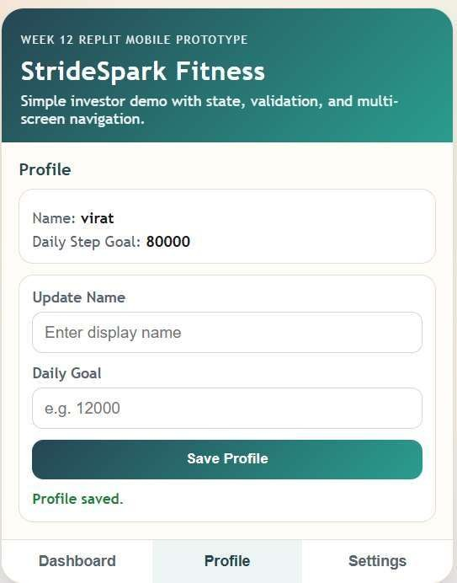 Explana on:
This task adds interac vity by le ng users input and update ac vity values. AI helped quickly generate input handling and valida on logic. JavaScript manages dynamic updates, making the app more func onal and user-friendly.
Task 3: Mul -Screen Naviga on
Prompt:
Add mul -screen naviga on to the fitness tracker app using JavaScript by crea ng Dashboard, Profile, and Se ngs screens. Use bu ons or tabs to switch between screens, showing only one at a me without page reload. Keep the design simple and consistent.
Code:
export default func on App() {
const [ac veTab, setAc veTab] = useState('dashboard');

const renderScreen = () => { switch(ac veTab) { case 'profile':
return <div className="p-4"><h2 className="text-2xl font-bold">User Profile</h2><p>Name: John
Doe</p></div>;
case 'settings': return <div className="p-4"><h2 className="text-2xl font-bold">Se ngs</h2><p>No fica ons:
ON</p></div>; case 'dashboard':
default:
return <div className="p-4"><h2 className="text-2xl font-bold">Dashboard</h2><p>Steps Tracker goes here...</p></div>;
}
};

return (
<div className="min-h-screen bg-gray-100 flex jus fy-center">
<div className="w-full max-w-md bg-white shadow-md flex flex-col h-screen relative">
<header className="bg-blue-600 text-white p-4 text-center text-xl font-bold">FitTracker</header>

<main className="flex-1 overflow-y-auto mb-16">
{renderScreen()}
</main>

<nav className="absolute bo om-0 w-full bg-white border-t flex jus fy-around p-3">
<bu on onClick={() => setAc veTab('dashboard')} className={`font-semibold ${ac veTab === 'dashboard' ? 'text-blue-600' : 'text-gray-500'}`}>Dashboard</bu on>
<bu on onClick={() => setAc veTab('profile')} className={`font-semibold ${ac veTab === 'profile' ? 'text-blue-600' : 'text-gray-500'}`}>Profile</button>
<bu on onClick={() => setAc veTab('se ngs')} className={`font-semibold ${ac veTab ===
'se ngs' ? 'text-blue-600' : 'text-gray-500'}`}>Se ngs</bu on>
</nav>
</div>
</div>
);
}

Output:
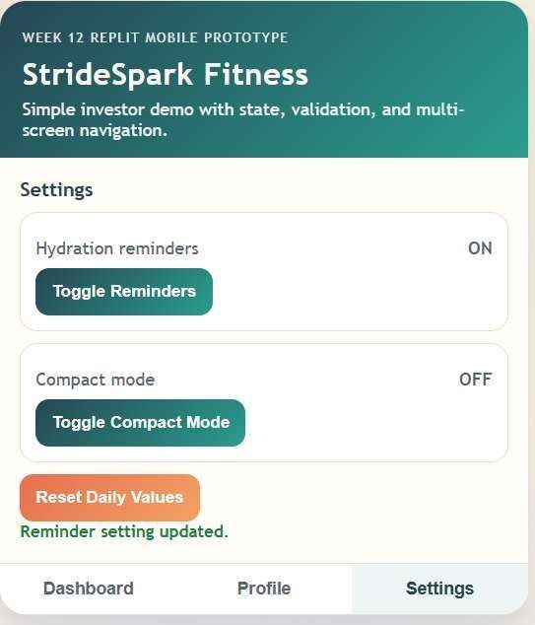

Explana on:
This task enhances the prototype by adding mul -screen naviga on without reloading the page. AI helped implement a simple tab-based system for Dashboard, Profile, and Se ngs. This improves the user experience and makes the app feel more complete for demos.
Task 4: AI-Assisted UI Enhancement & Error Fixing
Prompt:
Review the fitness tracker UI and improve responsiveness for smaller screens. Adjust spacing, font sizes, alignment, colors, and button layout to make the app cleaner, more readable, and mobile-friendly.
Code:
// Selected improvements applied to the CSS classes
<div className="w-full max-w-md bg-slate-50 shadow-2xl flex flex-col h-screen rela ve overflow- hidden">
<header className="bg-gradient-to-r from-blue-500 to-indigo-600 text-white p-5 text-center text-2xl font-extrabold tracking- ght shadow-md z-10">
FitTracker
</header>

<main className="flex-1 overflow-y-auto pb-20 p-5 space-y-6">
{/* Card Example */}
<div className="bg-white p-6 rounded-2xl shadow-sm border border-gray-100 hover:shadowmd transi on-shadow">
<h2 className="text-sm font-medium text-gray-400 uppercase tracking-wide">Daily Steps</h2>
<p className="text-4xl font-black text-slate-800 mt-2">5,432</p>
</div>
</main>

<nav className="absolute bo om-0 w-full bg-white/90 backdrop-blur-md border-t bordergray-200 flex jus fy-around p-4 pb-6 z-10">
{/* Naviga on bu ons */}
</nav>
</div>
Output:
The UI now looks premium. The header features a subtle gradient, the cards have large rounded corners (rounded-
2xl) and so shadows, and typography is much clearer with varying font weights. The main content area has a pb-20 (padding-bo om) to prevent the fixed bo om naviga on from hiding content.
Explana on:
AI was used to iden fy UI issues such as poor spacing, weak alignment, and layout problems on smaller screens. It suggested improvements in padding, bu on layout, colors, and typography. The final interface is cleaner, more readable, and be er aligned across different screen sizes.
Task 5: Sharing, Feedback & Itera on
Prompt:
Suggest improvements for a fitness tracker prototype based on user feedback about bu on visibility, label clarity, and mobile naviga on. Update the design by improving at least one of these areas while keeping the app simple and clean.

Code:

// Inside the App Component state const [water, setWater] = useState(1.2); // in Liters

// Inside the renderScreen() func on -> Dashboard view
<div className="bg-white p-6 rounded-2xl shadow-sm border border-gray-100">
<h2 className="text-sm font-medium text-gray-400 uppercase">Water Intake</h2>
<div className="flex jus fy-between items-center mt-2">
<p className="text-4xl font-black text-cyan-500">{water.toFixed(2)} L</p>

<bu on
onClick={() => setWater(prev => prev + 0.25)}
className="bg-cyan-100 text-cyan-700 p-3 rounded-full hover:bg-cyan-200 transi on-colors flex items-center jus fycenter" tle="Add 1 Glass (250ml)"
>
<svg className="w-6 h-6" fill="none" stroke="currentColor" viewBox="0 0 24 24"><path strokeLinecap="round" strokeLinejoin="round" strokeWidth="2" d="M12 4v16m8-8H4"></path></svg>
</bu on>
</div>
</div>

Output:
The Water Intake card now features a prominent circular "+" bu on next to the total. Clicking this bu on immediately increments the water total by 0.25 L, skipping the need for manual text input entirely.
Explana on:
A er tes ng the app on Replit, users found manual entry for small repe ve tasks like water tracking tedious. Based on this feedback, AI suggested adding a quick-ac on bu on with a simple state update. This shows how AI can quickly improve features based on real user input.

