Name: B.Priyanka
Hall Ticket: 2303A52468 Batch: 42
Task 1: Student Performance Evaluation System Prompt:
Create a Python Student class with attributes and use Copilot to add methods for displaying details and checking performance above average.
Code:
class Student:
"""A class to manage student information and performance."""

def init (self, student_id, name, marks): """
Initialize a student with ID, name, and marks.

Args:
student_id: Unique identifier for the student name: Name of the student
marks: List of marks/scores
"""
self.student_id = student_id self.name = name
self.marks = marks

def display_details(self): """
Display comprehensive student details including name, ID, marks, and average.

Returns:
str: Formatted string with student information
"""
average = sum(self.marks) / len(self.marks) if self.marks else 0 marks_str = ", ".join(map(str, self.marks))

details = f"""
===== STUDENT DETAILS =====
Student ID: {self.student_id} Name: {self.name}
Marks: [{marks_str}]
Individual Average: {average:.2f}
=========================== """
return details

def check_above_class_average(self, class_average): """
Check if student's average marks are above the class average.

Args:

class_average: The average marks of the class

Returns:
str: Message indicating whether student is above or below class average
"""
student_average = sum(self.marks) / len(self.marks) if self.marks else 0

if student_average > class_average:
message = f"{self.name} ({student_average:.2f}) is ABOVE the class average ({class_average:.2f})"
return message
elif student_average == class_average:
message = f"{self.name} ({student_average:.2f}) is EQUAL to the class average ({class_average:.2f})"
return message else:
message = f"{self.name} ({student_average:.2f}) is BELOW the class average ({class_average:.2f})"
return message

# Example usage with 20 students if name == " main ":
# Create 20 student objects students = [
Student(101, "Alice Johnson", [85, 90, 88, 92]),
Student(102, "Bob Smith", [75, 78, 80, 76]),
Student(103, "Carol White", [95, 93, 96, 94]),
Student(104, "David Brown", [88, 85, 89, 87]),
Student(105, "Emma Davis", [92, 94, 91, 93]),
Student(106, "Frank Miller", [72, 75, 73, 74]),
Student(107, "Grace Lee", [98, 96, 99, 97]),
Student(108, "Henry Wilson", [80, 82, 81, 83]),
Student(109, "Iris Taylor", [87, 89, 88, 90]),
Student(110, "Jack Anderson", [76, 78, 77, 79]),
Student(111, "Karen Martinez", [91, 93, 92, 94]),
Student(112, "Leo Thomas", [84, 86, 85, 87]),
Student(113, "Mia Jackson", [79, 81, 80, 82]),
Student(114, "Noah White", [89, 91, 90, 92]),
Student(115, "Olivia Harris", [94, 96, 95, 97]),
Student(116, "Peter Martin", [81, 83, 82, 84]),
Student(117, "Quinn Clark", [86, 88, 87, 89]),
Student(118, "Rachel Lewis", [93, 95, 94, 96]),
Student(119, "Sam Walker", [77, 79, 78, 80]),
Student(120, "Tina Hall", [90, 92, 91, 93])
]

# Display all student details print("\n" + "="*60) print("ALL 20 STUDENT DETAILS")
print("="*60)
for student in students: print(student.display_details())

# Calculate class average all_marks = []
for student in students: all_marks.extend(student.marks)
class_average = sum(all_marks) / len(all_marks) if all_marks else 0

print(f"\n{'='*60}")
print(f"CLASS AVERAGE (20 Students): {class_average:.2f}") print(f"{'='*60}\n")

# Check each student against class average print("="*60)
print("PERFORMANCE COMPARISON - ABOVE/BELOW CLASS AVERAGE")
print("="*60)
for student in students: print(student.check_above_class_average(class_average))
print("="*60)

Output:
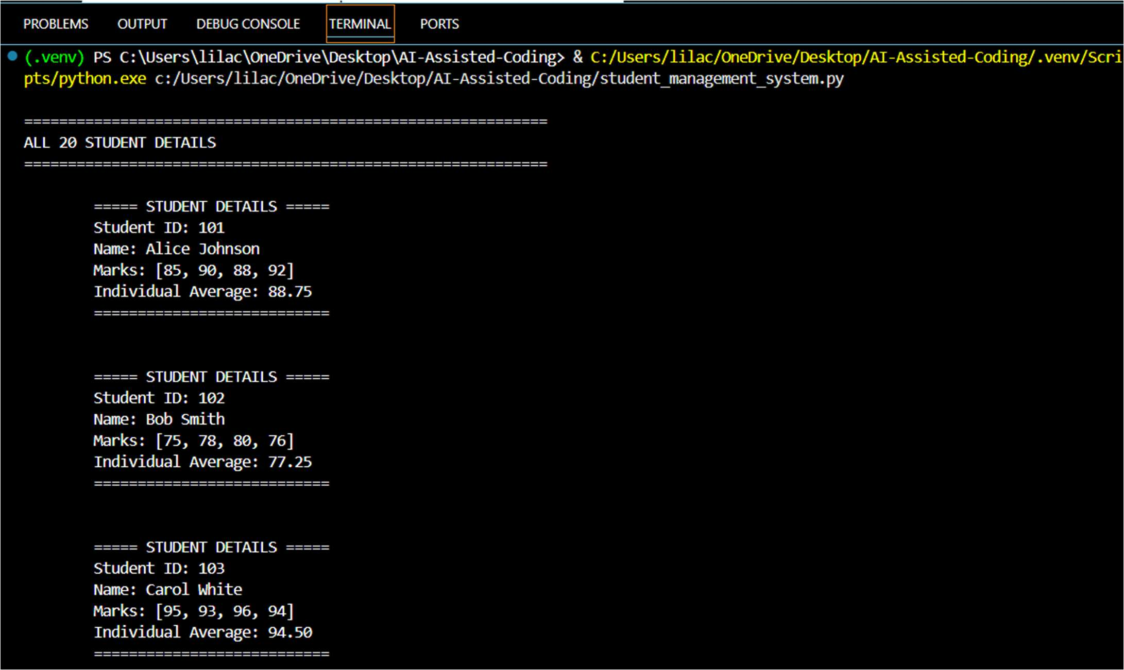

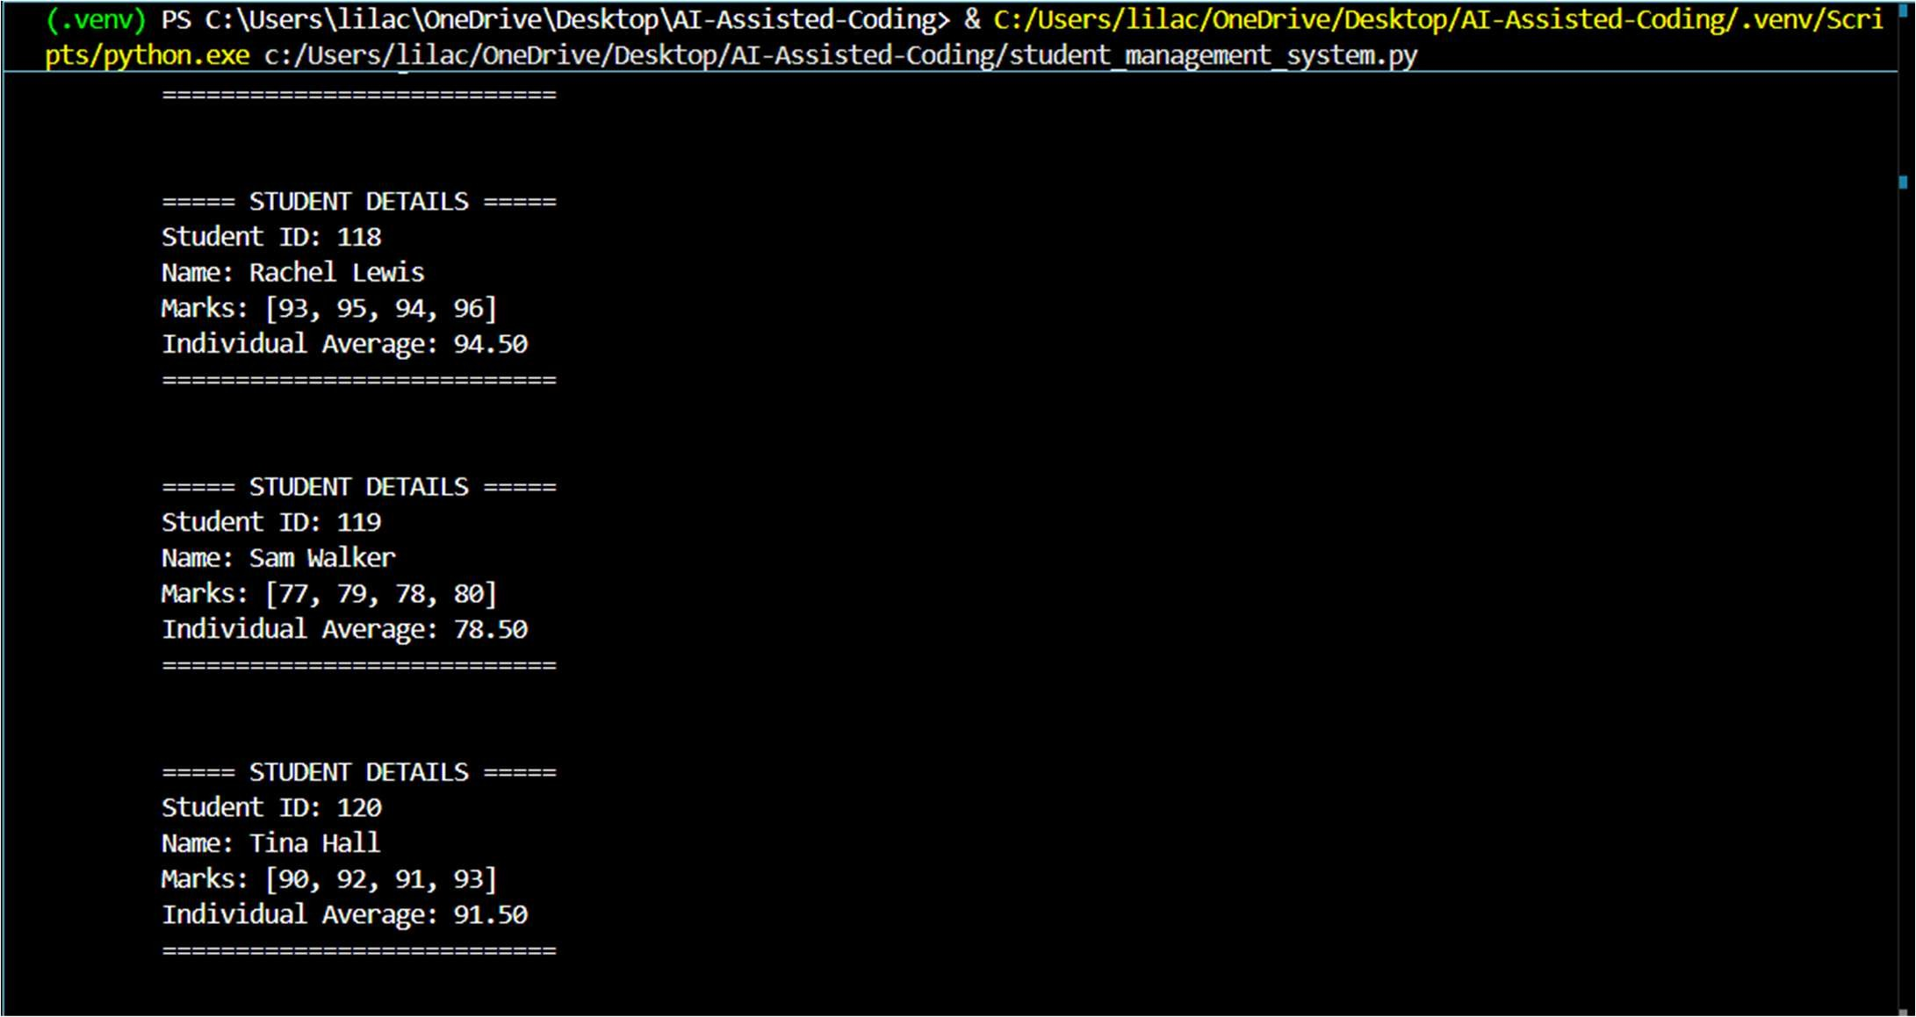
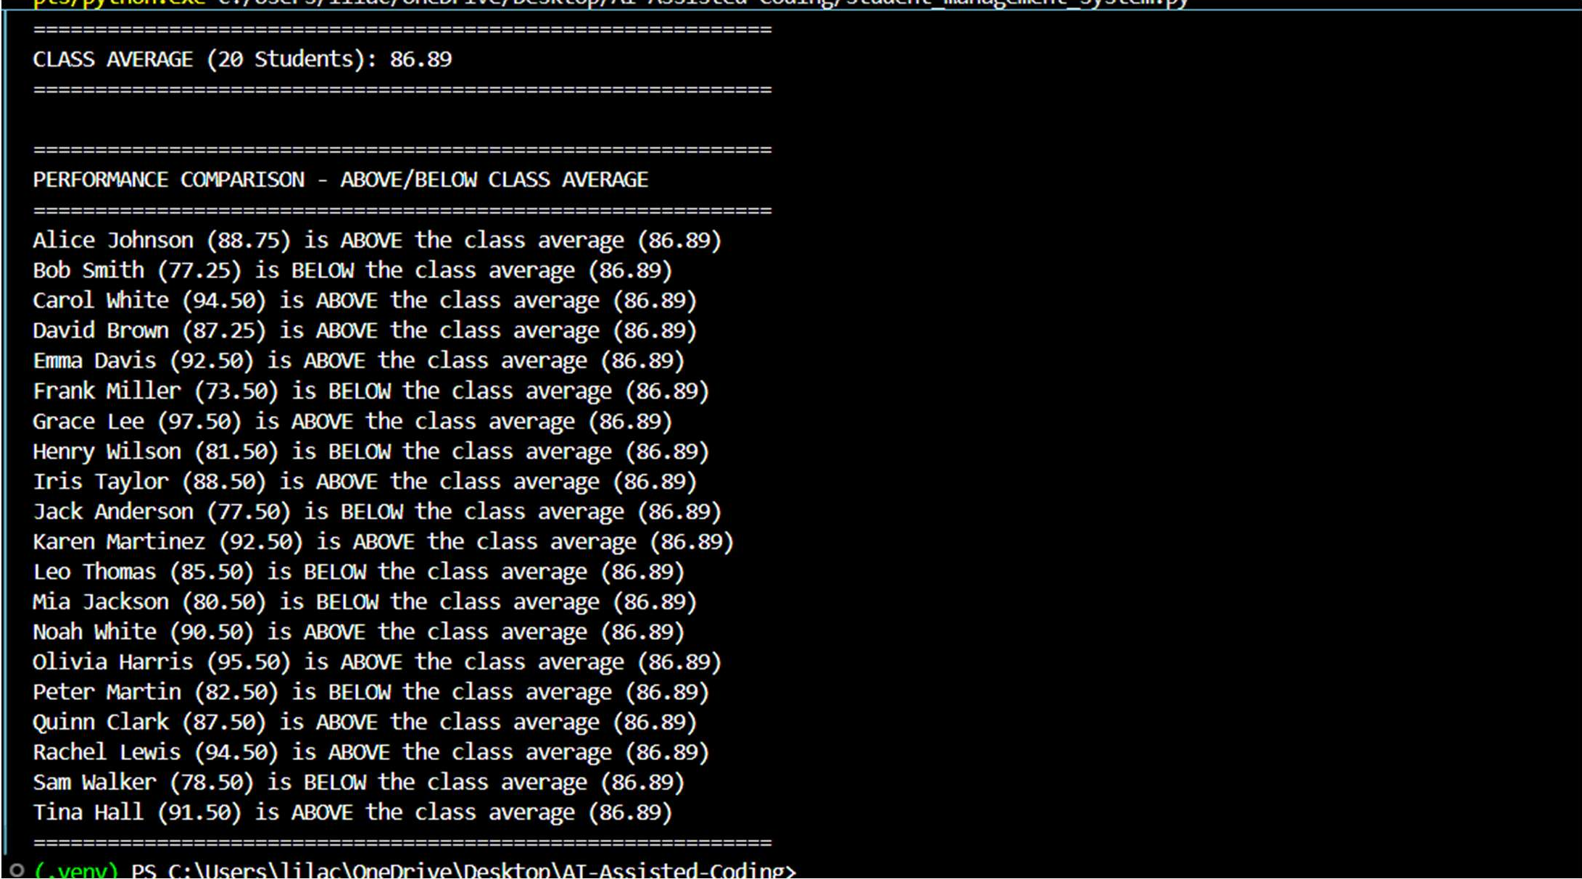

Explanation:

This task focuses on building a class structure using attributes like name, roll number, and marks.
Copilot helps generate methods to display student details clearly.
It also creates logic to compare marks with the class average.
Conditional statements (if-else) are used for evaluation.
Overall, it demonstrates object-oriented programming basics.

Task 2: Data Processing in a Monitoring System Prompt:
Write a for loop for sensor data and use Copilot to find even numbers, square them, and print results.
Code:
"""
Sensor Readings Analysis - Extract even readings and calculate their squares """

def analyze_sensor_readings(readings): """
Analyze sensor readings to identify even values and calculate their squares.

Args:
readings: List of sensor reading values
"""
print("\n" + "="*60)
print("SENSOR READINGS ANALYSIS - EVEN NUMBERS SQUARED")
print("="*60)
print(f"\nOriginal Sensor Readings: {readings}") print(f"Total readings: {len(readings)}\n")

print("-"*60)
print(f"{'Reading':<15} {'Even?':<10} {'Square':<15}") print("-"*60)

# Identify even readings and calculate squares even_readings = []
for reading in readings:
if reading % 2 == 0: # Check if even square = reading ** 2 even_readings.append((reading, square))
print(f"{reading:<15} {'Yes':<10} {square:<15}") else:
print(f"{reading:<15} {'No':<10} {'N/A':<15}")

print("-"*60)
print(f"\nTotal Even Readings Found: {len(even_readings)}")

# Print summary of even readings and their squares if even_readings:
print("\n" + "="*60)
print("SUMMARY - EVEN READINGS AND THEIR SQUARES")
print("="*60)
for reading, square in even_readings: print(f" {reading}² = {square}")
else:
print("\nNo even readings found in the sensor data.")

print("="*60 + "\n")

return even_readings

# Example usage with different sensor datasets if name == " main ":
# Example 1: Temperature sensor readings
print("\n>>> EXAMPLE 1: TEMPERATURE SENSOR READINGS <<<")
temperature_readings = [23, 45, 32, 67, 18, 54, 91, 28, 36, 41] analyze_sensor_readings(temperature_readings)

# Example 2: Pressure sensor readings
print("\n>>> EXAMPLE 2: PRESSURE SENSOR READINGS <<<")
pressure_readings = [100, 105, 200, 315, 420, 502, 618, 750, 812] analyze_sensor_readings(pressure_readings)

# Example 3: Mixed sensor readings
print("\n>>> EXAMPLE 3: MIXED SENSOR READINGS <<<")
mixed_readings = [12, 25, 38, 47, 56, 63, 74, 81, 90, 15, 22, 33, 44, 55]
analyze_sensor_readings(mixed_readings)

Output:
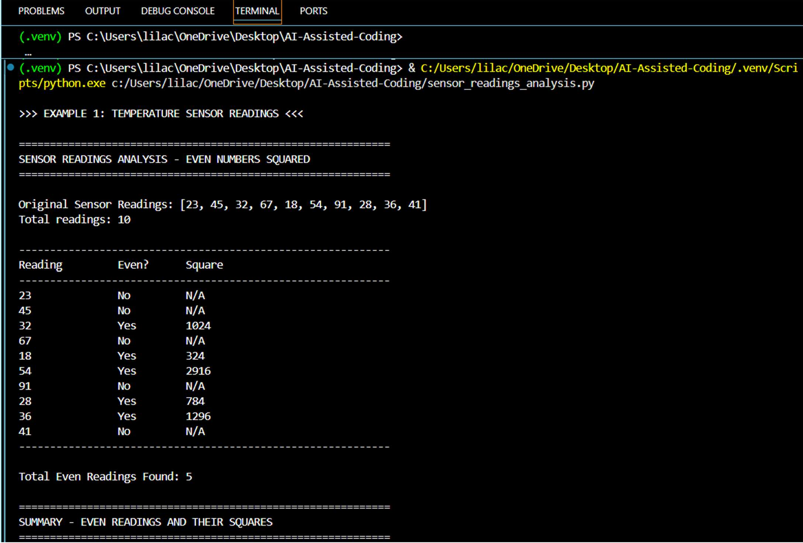

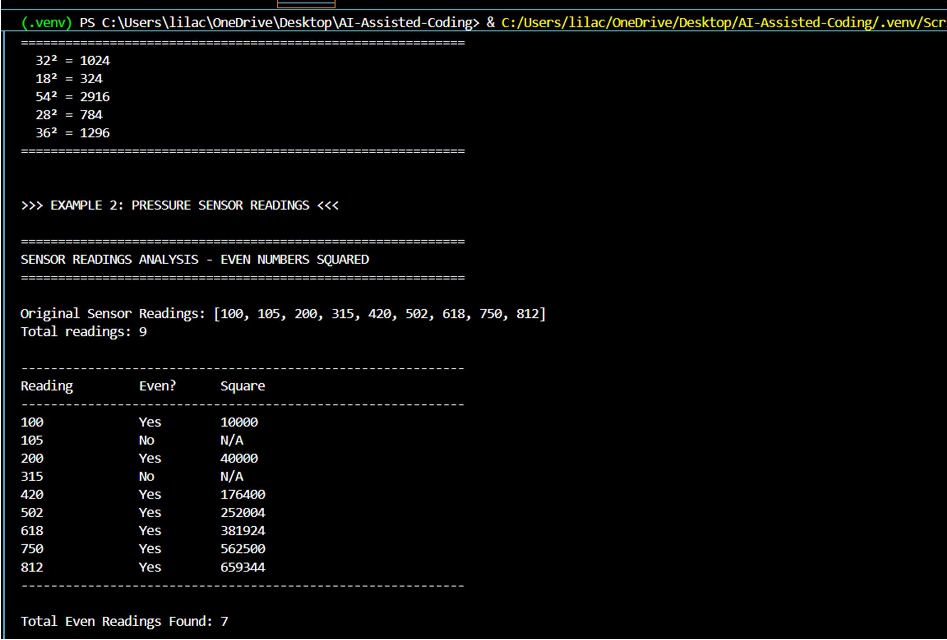
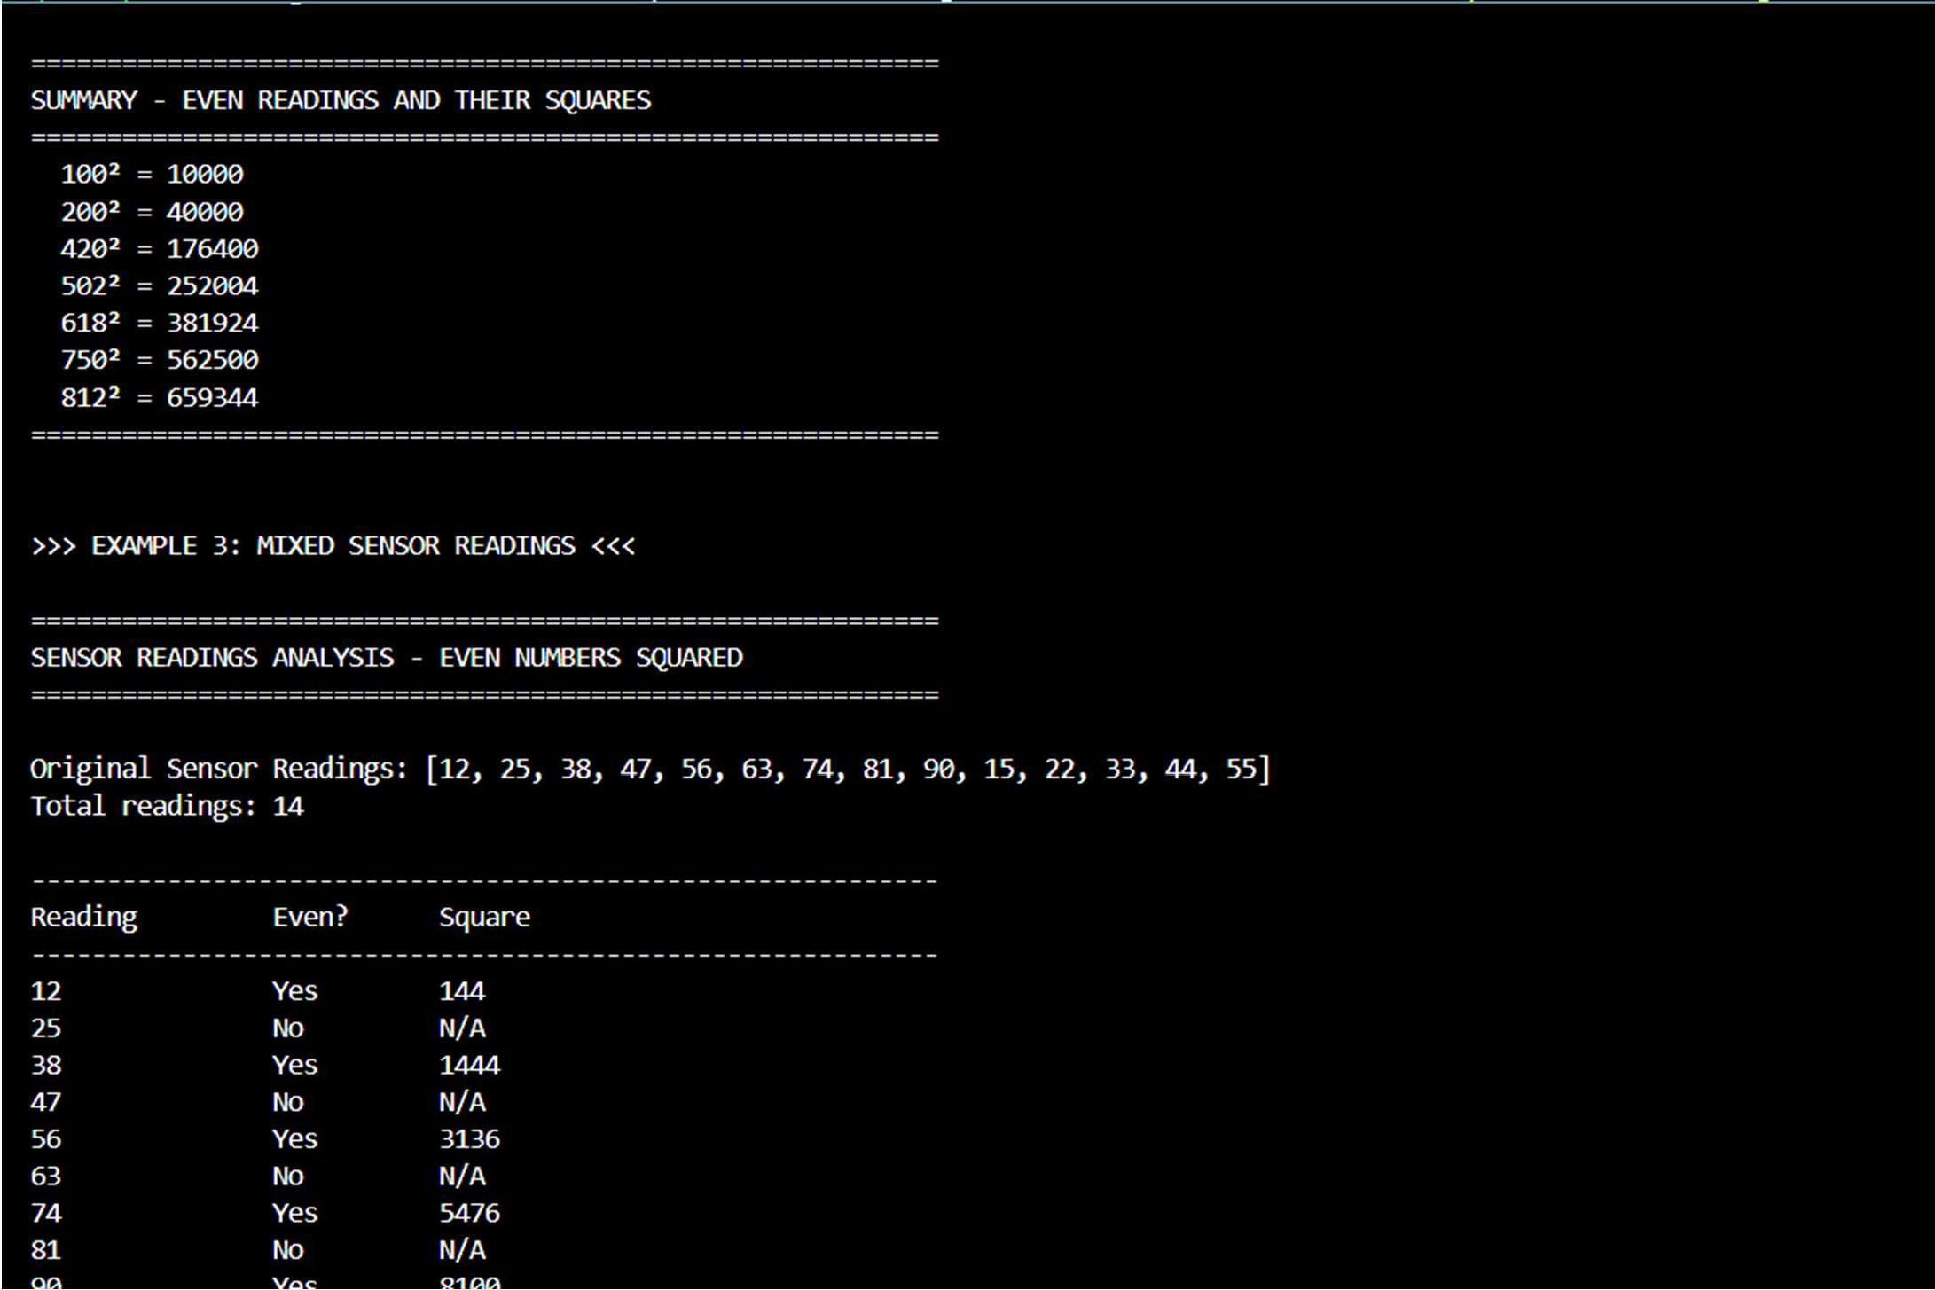

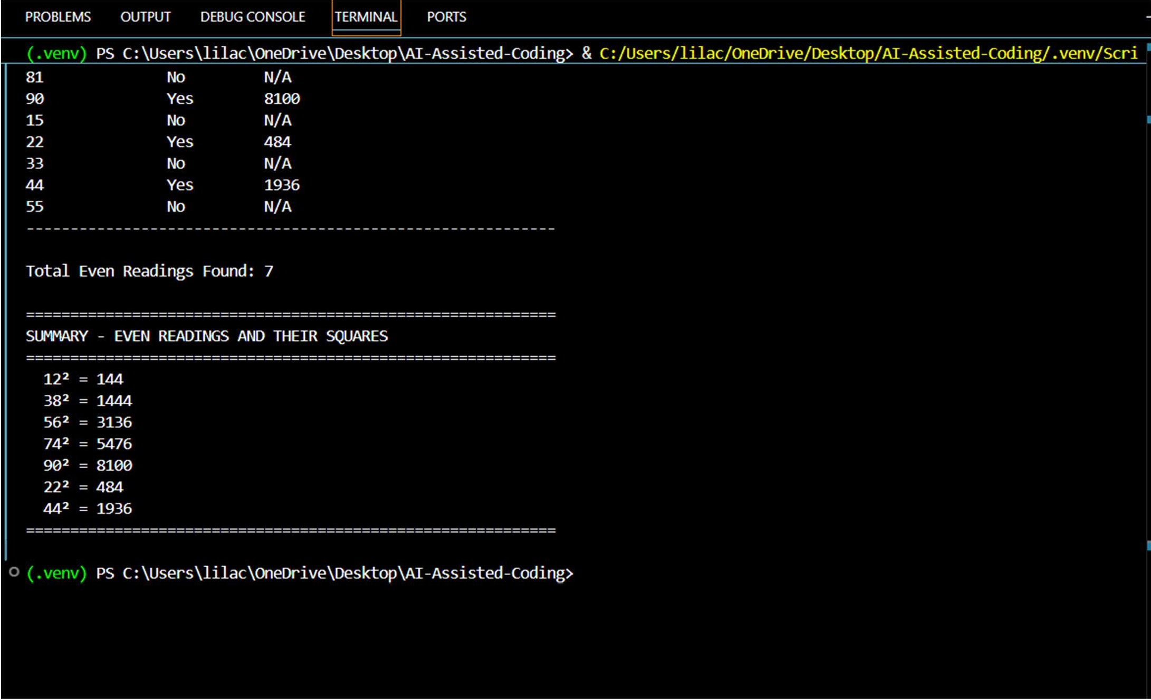
Explanation:
This task deals with processing numerical data using loops. Copilot generates logic to identify even numbers using the modulus operator. It then calculates the square of those numbers. The output is printed in a readable format.
It shows how loops and conditions work together.
Task 3: Banking Transaction Simulation Prompt:
Create a Bank Account class and use Copilot to implement deposit, withdrawal, and balance checks
Code:
"""
Bank Account Management System """

class BankAccount:
"""A class to manage bank account operations with deposits and withdrawals."""

def init (self, account_holder, initial_balance=0): """
Initialize a bank account with account holder name and initial balance.

Args:
account_holder: Name of the account holder initial_balance: Starting balance (default is 0)
"""
self.account_holder = account_holder self.balance = initial_balance self.transaction_history = []

if initial_balance > 0:
self.transaction_history.append(f"Account created with initial balance:
${initial_balance:.2f}")

def deposit(self, amount): """
Deposit money into the account.

Args:
amount: Amount to deposit (must be positive)

Returns:
str: Confirmation message of the deposit
"""
if amount <= 0:
return f"❌ Invalid deposit amount: ${amount:.2f}. Amount must be positive."

self.balance += amount
transaction = f"✓ Deposit: +${amount:.2f} | New Balance: ${self.balance:.2f}" self.transaction_history.append(transaction)
return transaction

def withdraw(self, amount): """
Withdraw money from the account.
Prevents withdrawal if balance is insufficient.

Args:
amount: Amount to withdraw

Returns:
str: Confirmation message or error message if withdrawal fails
"""
if amount <= 0:
return f"❌ Invalid withdrawal amount: ${amount:.2f}. Amount must be
positive."

if amount > self.balance:
error_msg = f"❌ Insufficient balance! Attempted withdrawal: ${amount:.2f} | Current balance: ${self.balance:.2f}"
self.transaction_history.append(f"Failed withdrawal attempt: ${amount:.2f}") return error_msg

self.balance -= amount
transaction = f"✓ Withdrawal: -${amount:.2f} | New Balance: ${self.balance:.2f}" self.transaction_history.append(transaction)
return transaction

def check_balance(self): """
Check the current account balance.

Returns:
str: Formatted balance information

"""
return f"Account Balance for {self.account_holder}: ${self.balance:.2f}"

def display_account_info(self): """
Display comprehensive account information.

Returns:
str: Formatted account details
"""
info = f"""
{'='*60}
ACCOUNT INFORMATION
{'='*60}
Account Holder: {self.account_holder} Current Balance: ${self.balance:.2f}
Total Transactions: {len(self.transaction_history)}
{'='*60}
"""
return info

def display_transaction_history(self): """
Display all transaction history for the account. """
print(f"\n{'='*60}")
print(f"TRANSACTION HISTORY - {self.account_holder}") print(f"{'='*60}")
if self.transaction_history:
for idx, transaction in enumerate(self.transaction_history, 1): print(f"{idx}. {transaction}")
else:
print("No transactions recorded.") print(f"{'='*60}\n")

# Example usage with multiple accounts if name == " main ":
print("\n" + "="*60)
print("BANK ACCOUNT MANAGEMENT SYSTEM")
print("="*60)

# Create accounts
account1 = BankAccount("John Doe", 1000) account2 = BankAccount("Jane Smith", 500)

# Display account information print(account1.display_account_info()) print(account2.display_account_info())

# Perform transactions on Account 1
print("\n>>> ACCOUNT 1: JOHN DOE - TRANSACTIONS <<<\n")
print(account1.deposit(500)) print(account1.deposit(250))

print(account1.withdraw(300)) print(account1.withdraw(200)) print(account1.check_balance())

# Attempt invalid withdrawal print(f"\n{account1.withdraw(2000)}") # This should fail

# Perform transactions on Account 2
print(f"\n>>> ACCOUNT 2: JANE SMITH - TRANSACTIONS <<<\n")
print(account2.deposit(300)) print(account2.withdraw(100)) print(account2.withdraw(400)) # This should fail print(account2.check_balance())

# Display transaction histories account1.display_transaction_history() account2.display_transaction_history()

# Final account status print("\n" + "="*60) print("FINAL ACCOUNT STATUS")
print("="*60) print(account1.check_balance()) print(account2.check_balance()) print("="*60 + "\n")

Output:

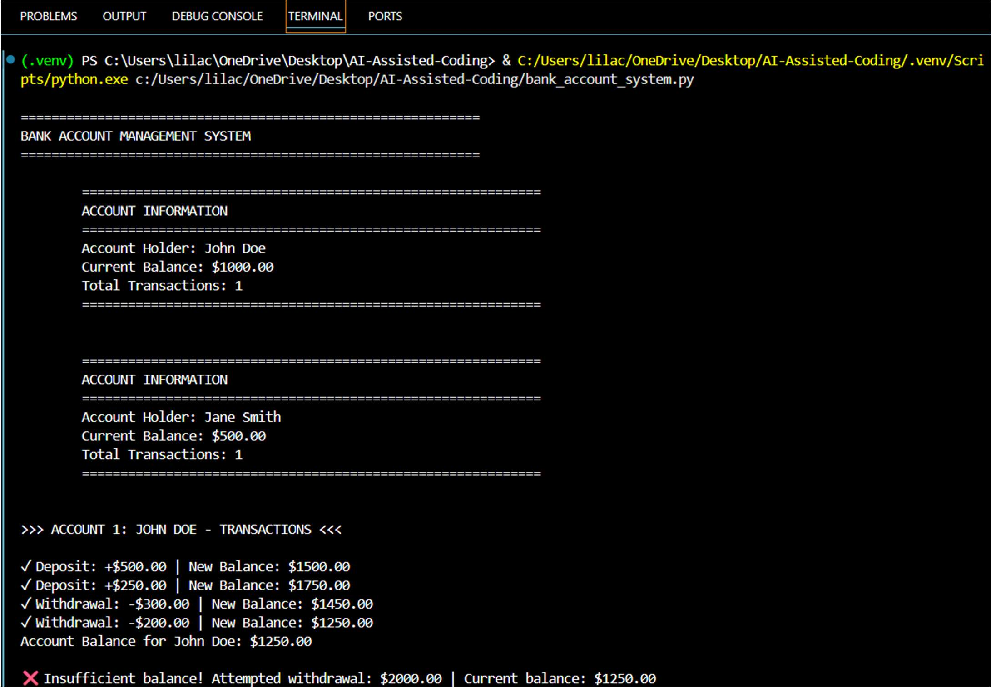
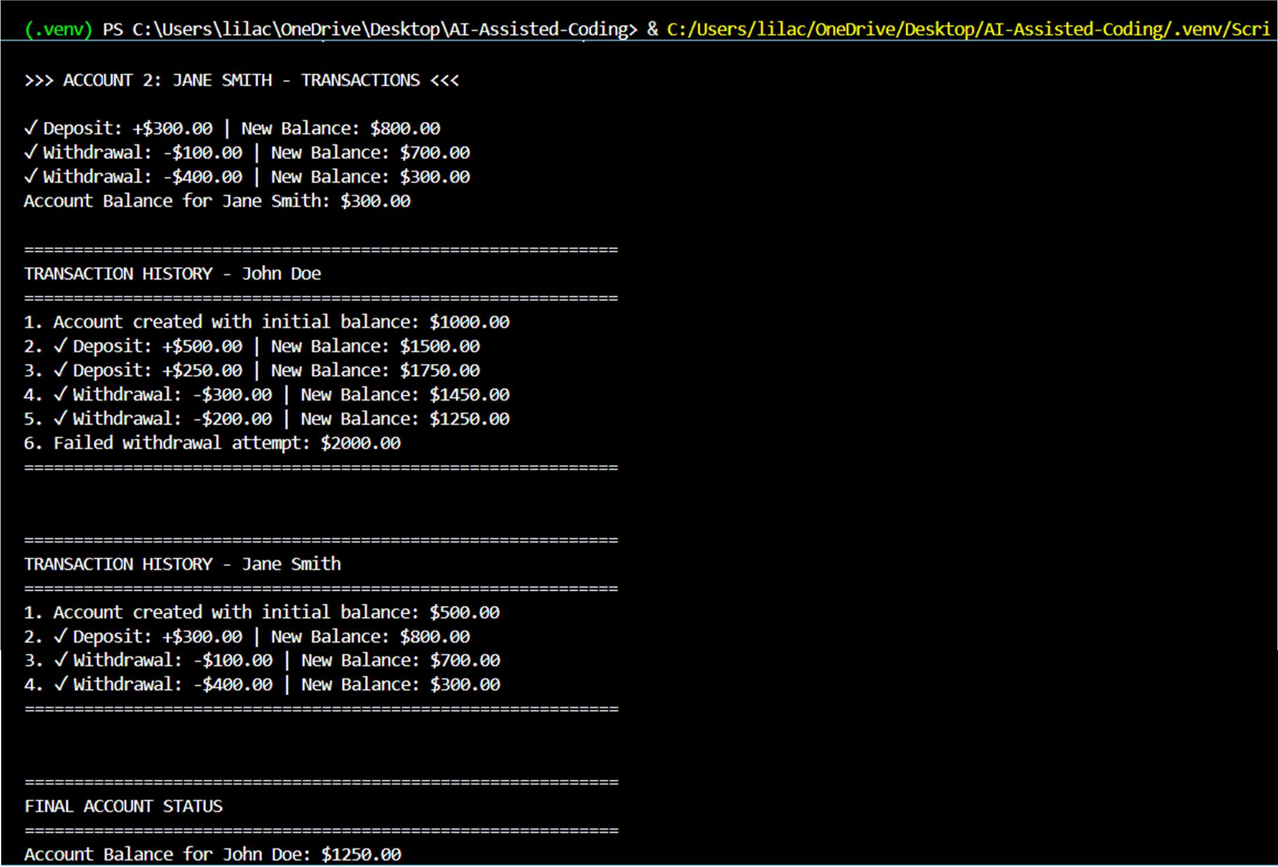

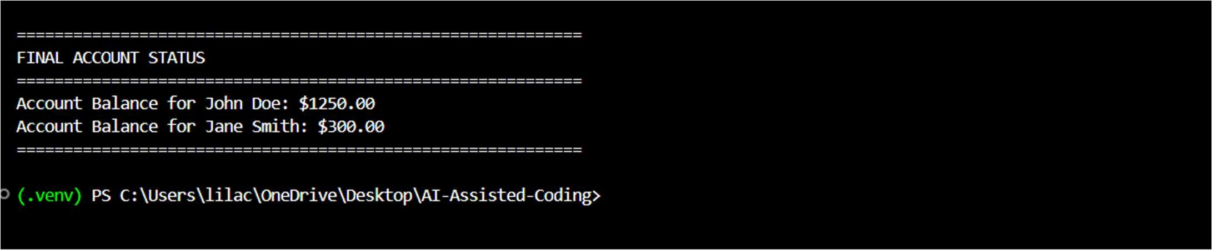
Explanation:
The prompt instructs Copilot to generate a BankAccount class with basic attributes and transaction methods.
It ensures safe banking operations by allowing deposits and preventing withdrawals when the account balance is insufficient.
Task 4: Student Scholarship Eligibility Check Prompt:
Create a while loop that iterates through a list of student dictionaries and takes the scholarship cutoff score as user input.Print the names of students whose score is greater than the entered cutoff value.
Code:
import random

students = []
for i in range(1, 31): student_name = f"Student_{i}"
student_score = random.randint(50, 100) # Assign random scores between 50 and
100
students.append({"name": student_name, "score": student_score})

# Initialize an index for the while loop index = 0
# Loop through each student in the 'students' list while index < len(students):
# Get the current student's dictionary student = students[index]
# Check if the student's 'score' is greater than 75 if student["score"] > 75:
# Print the 'name' of the student if they qualify print(f"{student['name']} (Score: {student['score']})")
# Move to the next student
index += 1

Output:
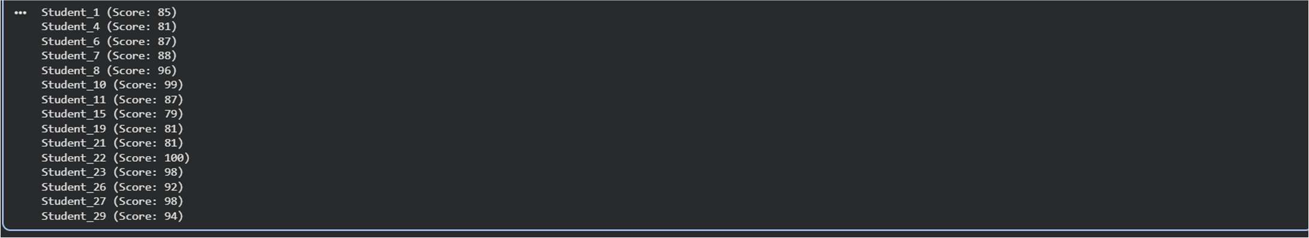

Explanation:
The program stores student details in a list of dictionaries and takes a cutoff score from the user.
Using a while loop, it checks each student’s score and prints the names of those who scored above the cutoff value.
Task 5: Online Shopping Cart Module Prompt:
Create a Python class named ShoppingCart with an empty list to store cart items (name, price, quantity).
Add methods to add and remove items, calculate the total bill using a loop, and apply a discount conditionally when the total exceeds a specified amount.
Code:
class ShoppingCart: def init (self):
# Initialize an empty list to store items in the cart
# Each item will be a dictionary with keys: 'name', 'price', 'quantity' self.items = []

def add_item(self):
# Method to add an item to the shopping cart
# This method should prompt the user for item details item_name = input("Enter item name: ")
item_price = float(input(f"Enter price for {item_name}: ")) item_quantity = int(input(f"Enter quantity for {item_name}: "))

# Create a dictionary for the new item
new_item = {"name": item_name, "price": item_price, "quantity": item_quantity}
# Add the new item to the cart's items list self.items.append(new_item)
print(f"{item_quantity} x {item_name} added to cart.")

def remove_item(self):
# Method to remove an item from the shopping cart
# This method should prompt the user for the name of the item to remove if not self.items:
print("The cart is empty. Nothing to remove.") return

print("Current items in cart:")
for i, item in enumerate(self.items):
print(f"{i+1}. {item['name']} (Quantity: {item['quantity']})")

item_to_remove_name = input("Enter the name of the item to remove: ") item_found = False
# Iterate through the items to find and remove the specified item
# Use a list comprehension to create a new list without the removed item(s) initial_item_count = len(self.items)
self.items = [item for item in self.items if item['name'].lower() != item_to_remove_name.lower()]

if len(self.items) < initial_item_count: item_found = True

print(f"'{item_to_remove_name}' removed from cart.") else:
print(f"'{item_to_remove_name}' not found in cart.")

def calculate_total(self):
# Method to calculate the total bill for all items in the cart # It should iterate through the items and sum (price * quantity) total_bill = 0
for item in self.items:
total_bill += item["price"] * item["quantity"] return total_bill

def apply_discount(self):
# Method to apply conditional discounts to the total bill
# It should ask the user for a discount percentage if a condition is met (e.g., total exceeds a certain amount)
current_total = self.calculate_total()
print(f"Current total before discount: ${current_total:.2f}")

if current_total > 100: # Example condition for applying a discount print("Your total exceeds $100! You are eligible for a discount.") try:
discount_percentage = float(input("Enter discount percentage (e.g., 10 for 10%): "))
if 0 <= discount_percentage <= 100:
discount_amount = current_total * (discount_percentage / 100) discounted_total = current_total - discount_amount print(f"Applied {discount_percentage}% discount
(${discount_amount:.2f}).")
print(f"New total after discount: ${discounted_total:.2f}") return discounted_total
else:
print("Invalid discount percentage. No discount applied.") except ValueError:
print("Invalid input. Please enter a number for the discount
percentage.")
else:
print("No discount applicable at this time (total must exceed $100).") return current_total # Return original total if no discount applied or
invalid input

def view_cart(self):
# Method to display all items currently in the cart if not self.items:
print("Your shopping cart is empty.") return
print("\n--- Your Shopping Cart ---") for item in self.items:
print(f"Name: {item['name']}, Price: ${item['price']:.2f}, Quantity:
{item['quantity']}")
print(" ")
print(f"Subtotal: ${self.calculate_total():.2f}")

# Example usage of the ShoppingCart class:

if name == ' main ': cart = ShoppingCart()

while True:
print("\n1. Add item") print("2. Remove item") print("3. View cart")
print("4. Calculate total bill") print("5. Apply discount") print("6. Exit")
choice = input("Enter your choice: ") if choice == '1':
cart.add_item() elif choice == '2':
cart.remove_item() elif choice == '3':
cart.view_cart() elif choice == '4':
total = cart.calculate_total() print(f"Total bill: ${total:.2f}")
elif choice == '5': cart.apply_discount()
elif choice == '6':
print("Exiting shopping cart. Goodbye!") break
else:
print("Invalid choice. Please try again.")

Output:
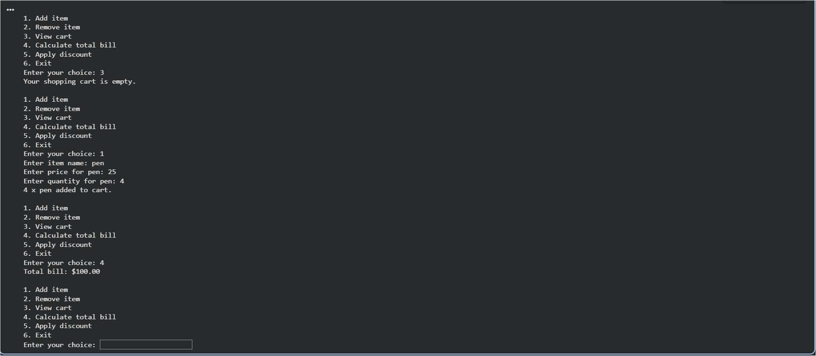
Explanation:
The prompt guides Copilot to generate a ShoppingCart class that manages items using a list structure.
It automates item addition and removal, calculates the total cost with a loop, and applies discounts based on conditional logic.

