AI ASSISTED CODING
LAB-4.1
CHINTHALA DHAKSHAY
2303A51577
BATCH-09
Problem Statement 0:
A news aggregation platform wants to automatically categorize
headlines into Politics, Sports, Technology, and Entertainment
without training a machine learning model.
Tasks to be Completed
1. Prepare Sample Data
Collect 10 news headlines, each belonging to one of the four categories.
PROMPT:
#write a code to collect 10 news headlines each belonging to different categories such as technology,sports,health,entertainment,politics by using only this four categories dont use other categories and store them in a dictonary where the key is category and value is headline
CODE:
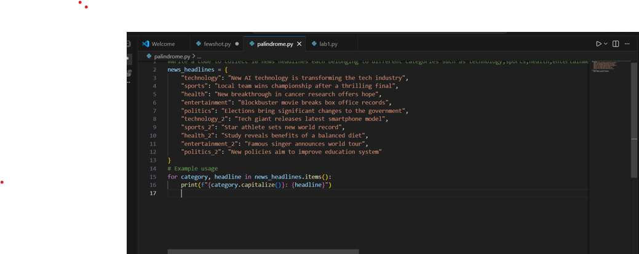
OutPut:
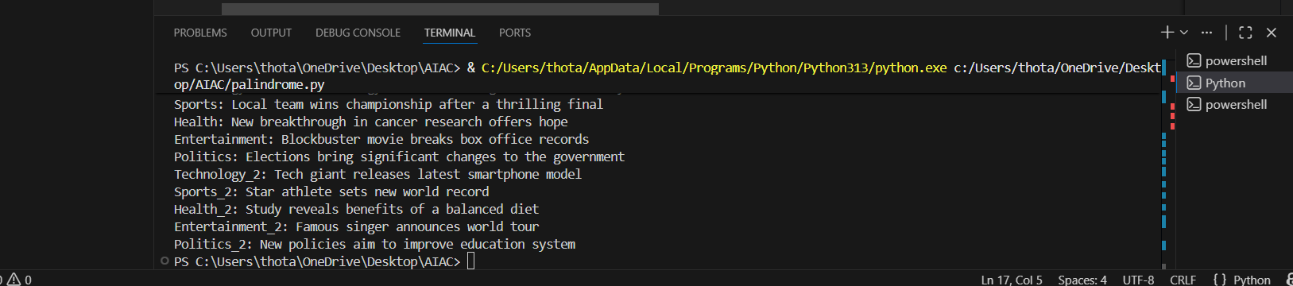
2. Zero-shot Prompting
Write a prompt asking the LLM to classify a headline into a
category without examples.
Prompt:
#write a code to check whether the headline is present in which category or not if present print the category else print not found by using input user
CODE:
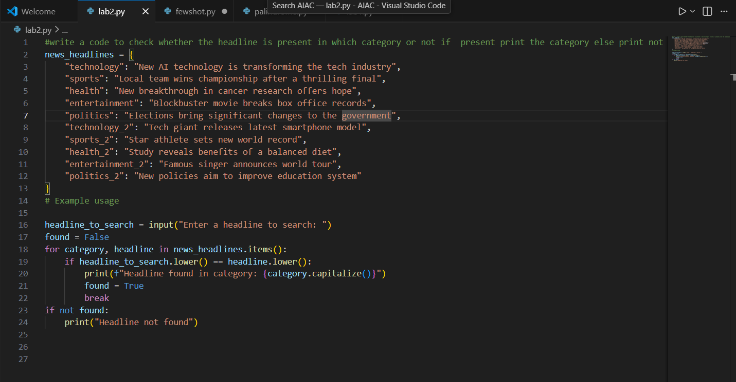
OUTPUT:
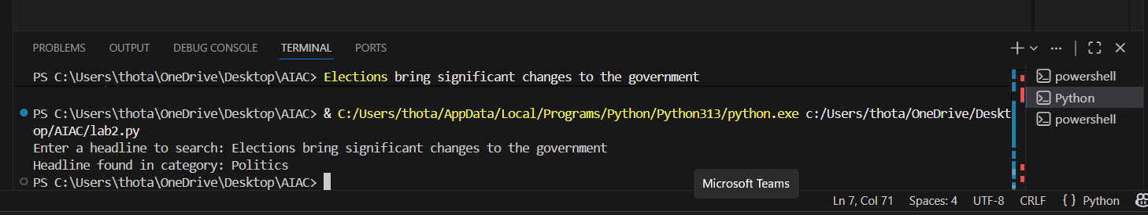
3. One-shot Prompting
Add one labeled headline example before classifying a new
headline.
PROMPT:
#write a code to collect 10 news headlines each belonging to different categories such as technology,sports,health,entertainment,politics by using only this four categories dont use other categories and store them in a dictonary where the key is category and value is headline
#input:"Elections bring significant changes to the government",output:"Headline found in category:Politics"
CODE:
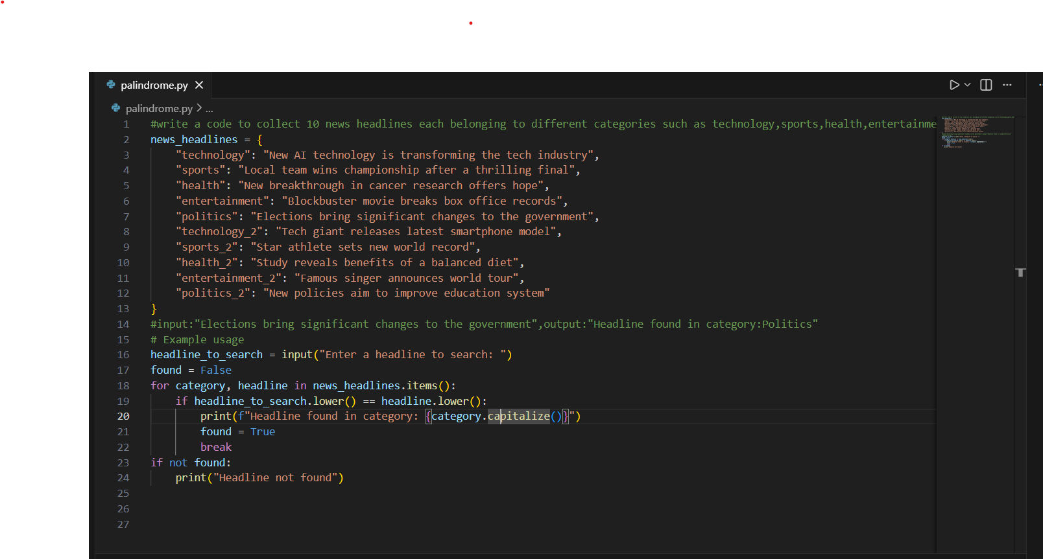
OUTPUT:
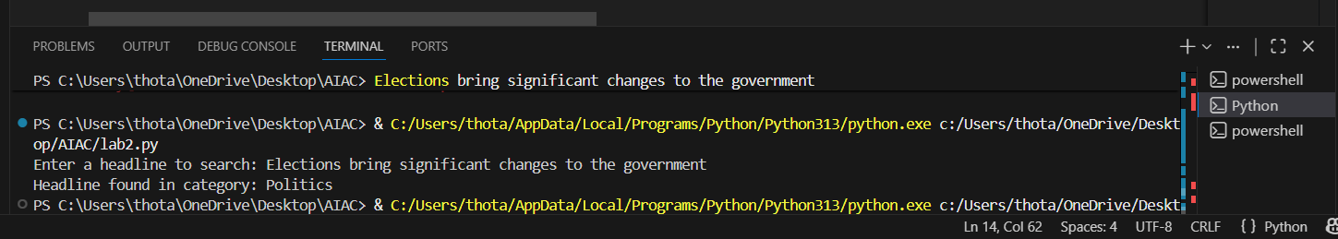
4. Few-shot Prompting
Use 3–5 labeled headlines in the prompt before requesting
Classification
PROMPT:
#write a code to collect 10 news headlines each belonging to different categories such as technology,sports,health,entertainment,politics by using only this four categories dont use other categories and store them in a dictonary where the key is category and value is headline
"""input:"Elections bring significant changes to the government",output:"Headline found in category:Politics
input:"New AI technology is transforming the tech industry",output:"Headline found in category :Technology
input:"Local team wins championship after a thrilling final",output:"Headline found in category:Sports"""
CODE:
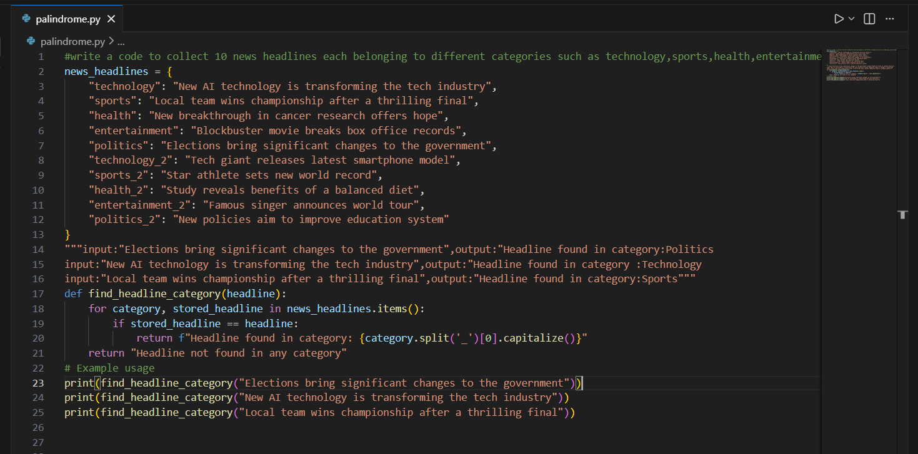
OUTPUT:
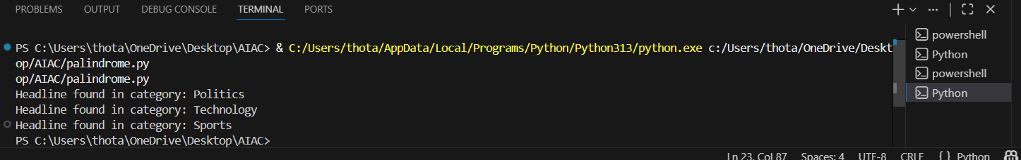
5. Evaluation
Compare outputs from all three prompting methods using
the same test headlines and document observation
Zero-shot:
We will not use any input examples in zero-shot .It will work with minimal instruction,but the output may be incorrect ..We will not provide any examples here.
One-shot:
We will use only one input for example in one-shot.It improves accuracy,as the AI understands the task better from a single labelled example.
Few-shot:
We will use more than one inputs for examples in few-shot.
It gives the best results.The Ai shows hogher consistency and correctly classifies most headlines.
As the number of examples increases, the AI’s understanding of categories becomes clearer.
Therefore, few-shot prompting is the most effective method for news headline classification without training a model.
Customer Email Classification
1.Prepare five short sample emails, each belonging to one of
the above categories.
2. Write a zero-shot prompt to classify a given email into one of
the categories without providing any examples.
Prompt:
#write a code to collect 5 short sample emails each belonging to different categories like billing,technical support,feedback and others by using only this four categories dont use other categories and store them in a dictonary where the key is category and value is email give examples
# write a code to check whethe the give email is present inwhich category or not if present return the category else return email not found in any category
Code:
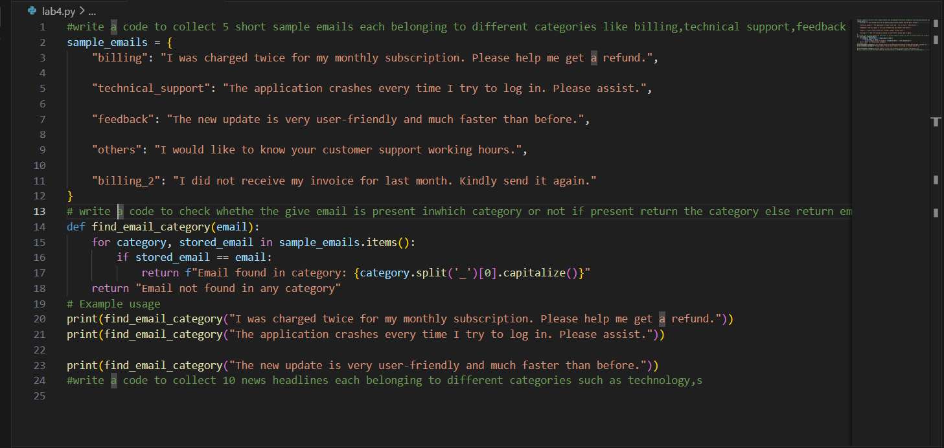
Output:
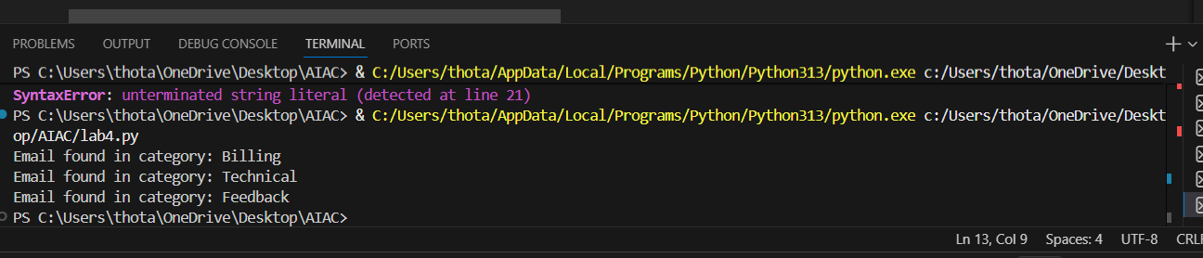
3. Write a one-shot prompt by including one labeled email example and ask the model to classify a new email.
Prompt:
#write a code to collect 5 short sample emails each belonging to different categories like billing,technical support,feedback and others by using only this four categories dont use other categories and store them in a dictonary where the key is category and value is email give examples
#Input: "The application crashes every time I try to log in. Please assist.",output:"technical_support"
Code and Output:
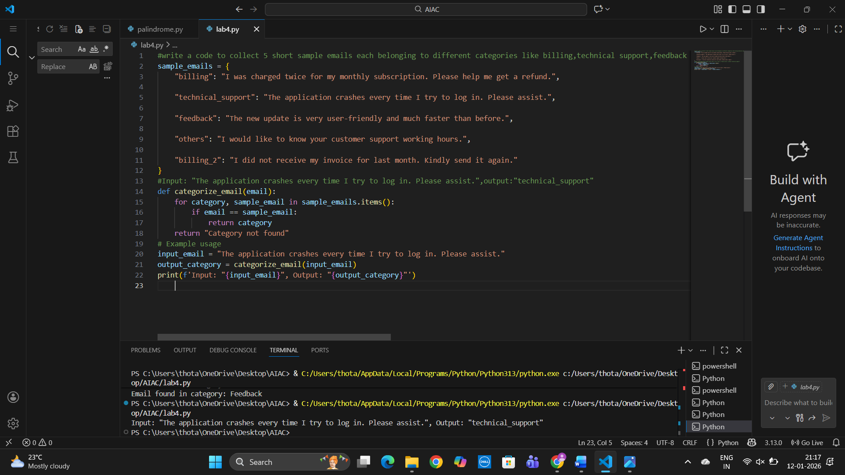
4.Write a few-shot prompt by including two or three labelled email examples and ask the model to classify a new email.
Prompt:
#write a code to collect 5 short sample emails each belonging to different categories like billing,technical support,feedback and others by using only this four categories dont use other categories and store them in a dictonary where the key is category and value is email give examples
"""Input:"I was charged twice for my monthly subscription. Please help me get a refund.",output:"Email found inbilling"
Input:"The application crashes every time I try to log in. Please assist.",output:"Email found in technical_support"
Input:"I would like to know your customer support working hours.",output:"Email found in others"""
Code and Output: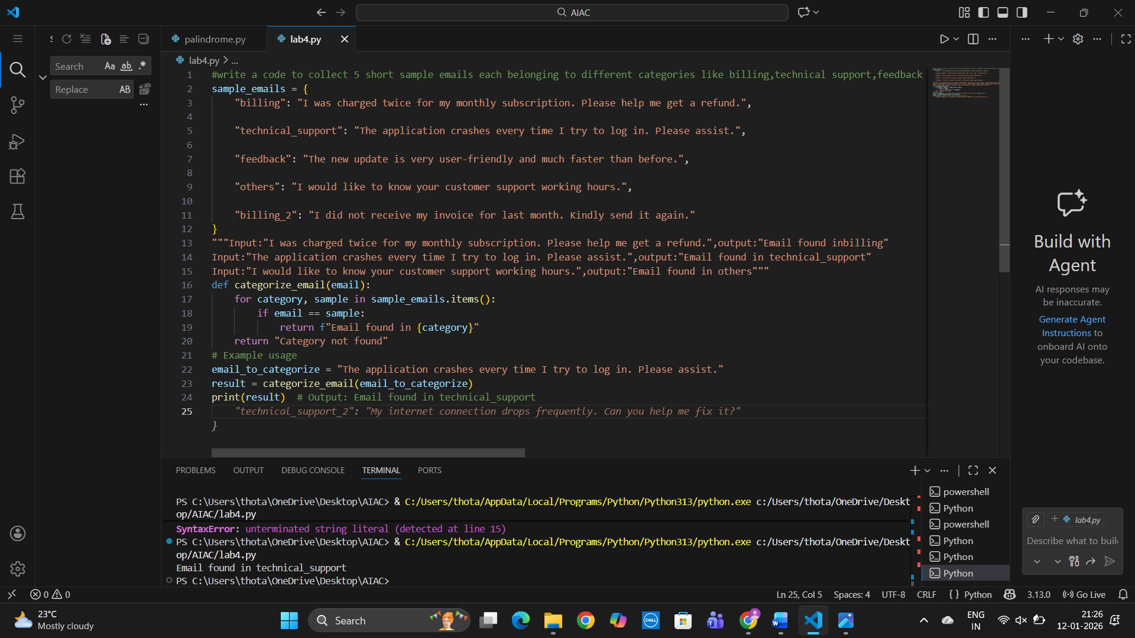
5.Compare the outputs obtained using zero-shot, one-shot, and few-shot prompting techniques and briefly comment on their effectiveness
Zero-shot:
We will not use any input examples in zero-shot .It will work with minimal instruction,but the output may be incorrect ..We will not provide any examples here.
One-shot:
We will use only one input for example in one-shot.It improves accuracy,as the AI understands the task better from a single labelled example.
Few-shot:
We will use more than one inputs for examples in few-shot.
It gives the best results.The Ai shows higher consistency and correctly classifies most headlines.
As the number of examples increases, the AI’s understanding of categories becomes clearer.
Therefore, few-shot prompting is the most effective method for news headline classification without training a model.
Zero-shot:
We will not use any input examples in zero-shot .It will work with minimal instruction,but the output may be incorrect ..We will not provide any examples here.
One-shot:
We will use only one input for example in one-shot.It improves accuracy,as the AI understands the task better from a single labelled example.
Few-shot:
We will use more than one inputs for examples in few-shot.
It gives the best results.The Ai shows hogher consistency and correctly classifies most headlines.
As the number of examples increases, the AI’s understanding of categories becomes clearer.
Therefore, few-shot prompting is the most effective method for news headline classification without training a model.

