LAB ASSIGNMENT-14.4
2303A51580

Task 1: Responsive Homepage Layout for a Startup Website
Scenario:
You are designing a basic homepage for a startup company that needs
to look good on desktops, tablets, and mobile devices.
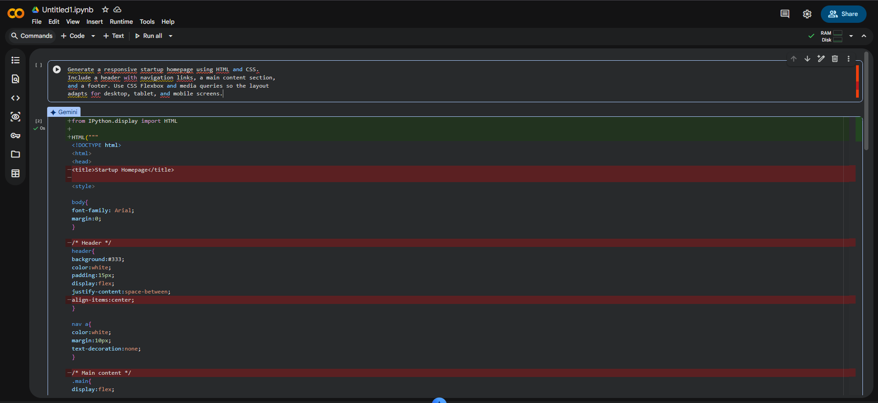
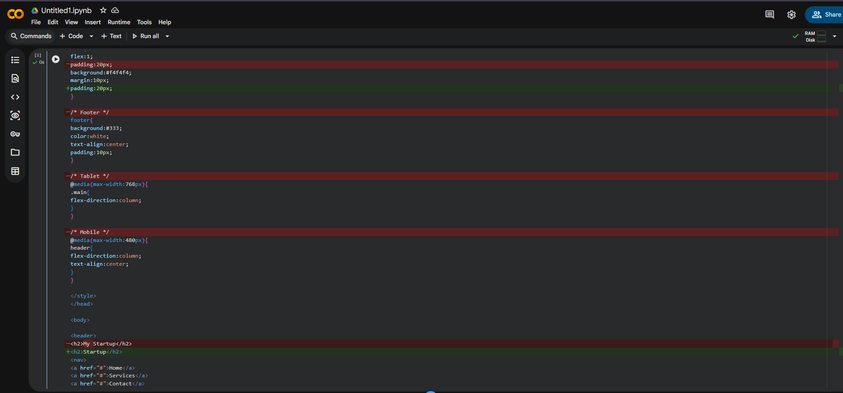
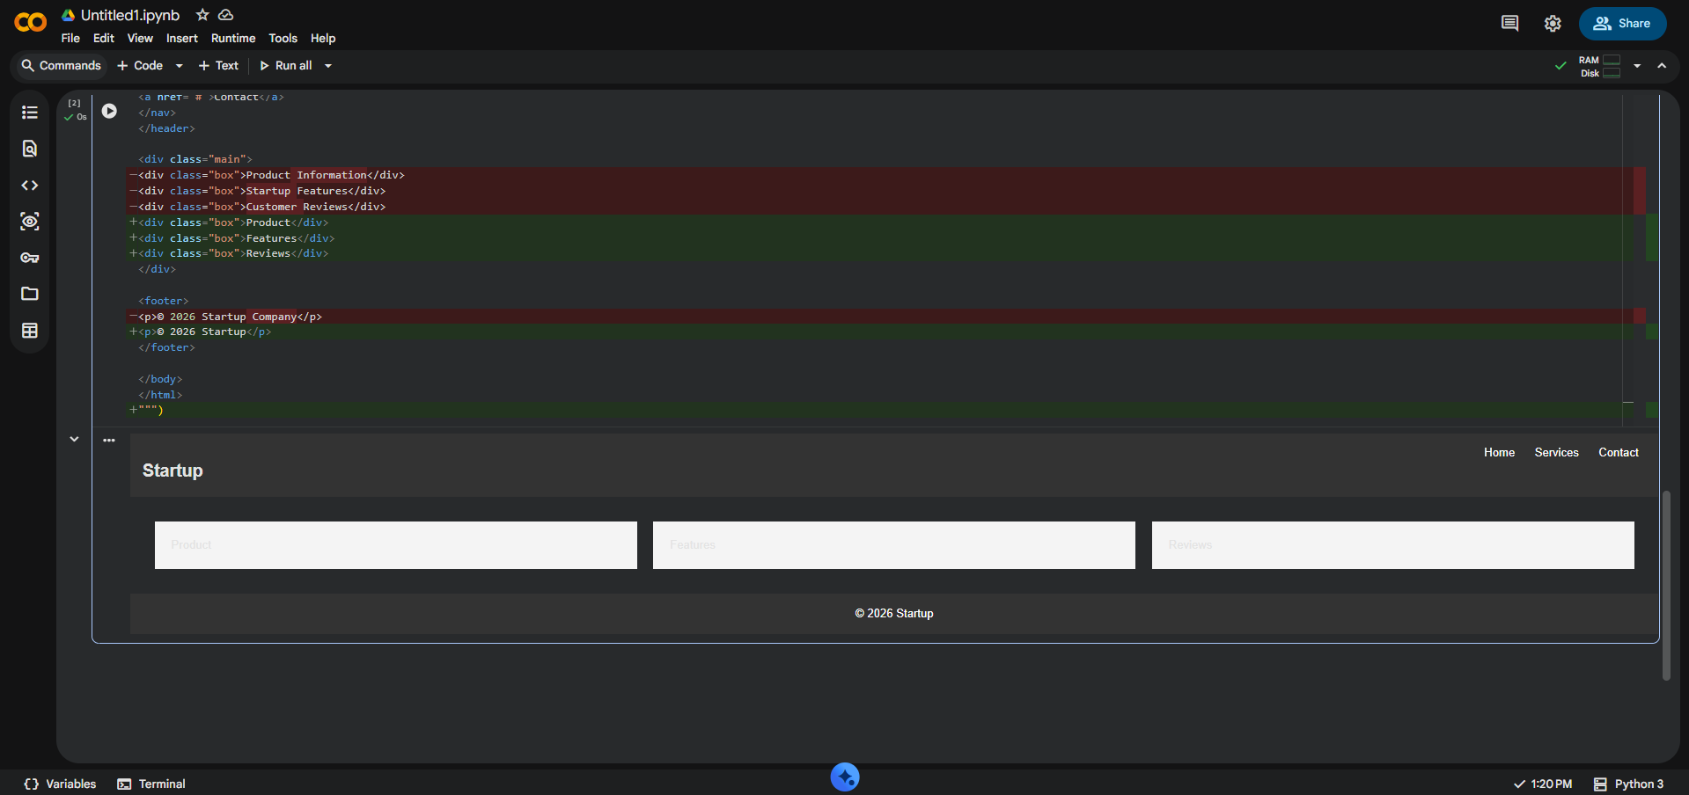
Task 2: Interactive Call-to-Action Button
Scenario:
A marketing page requires a call-to-action button that responds when
users interact with it.
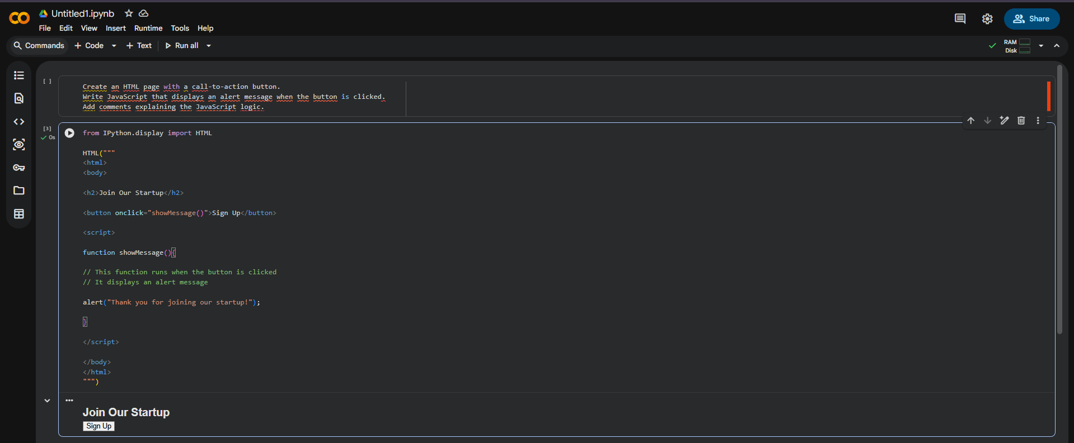

Task 3: Contact Form with Client-Side Validation
Scenario:
You are developing a contact form for a company website to collect
user queries safely and correctly
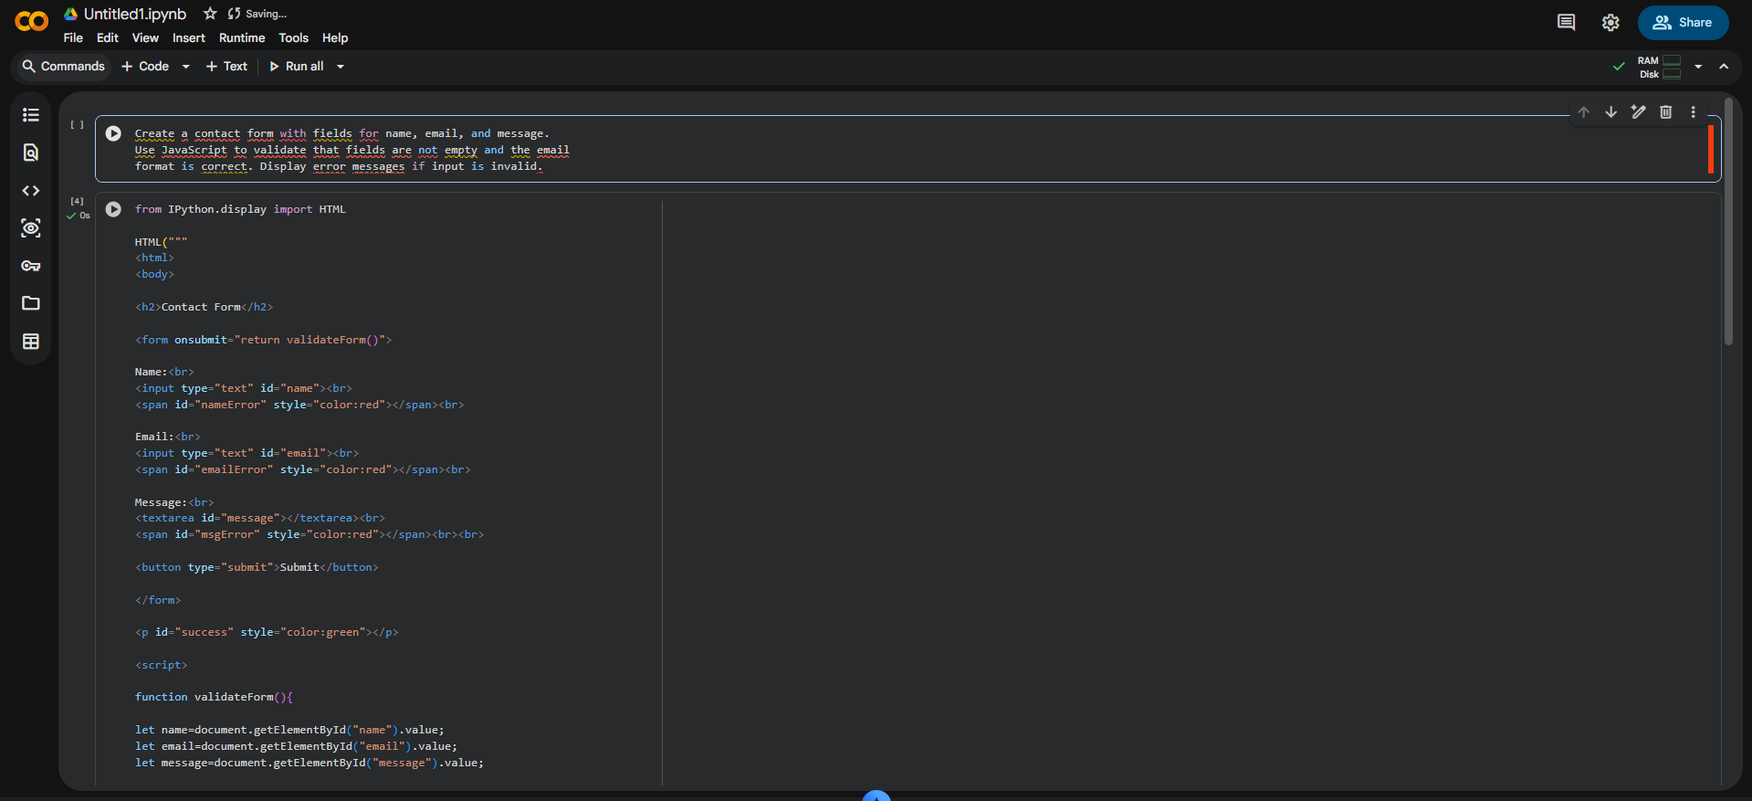
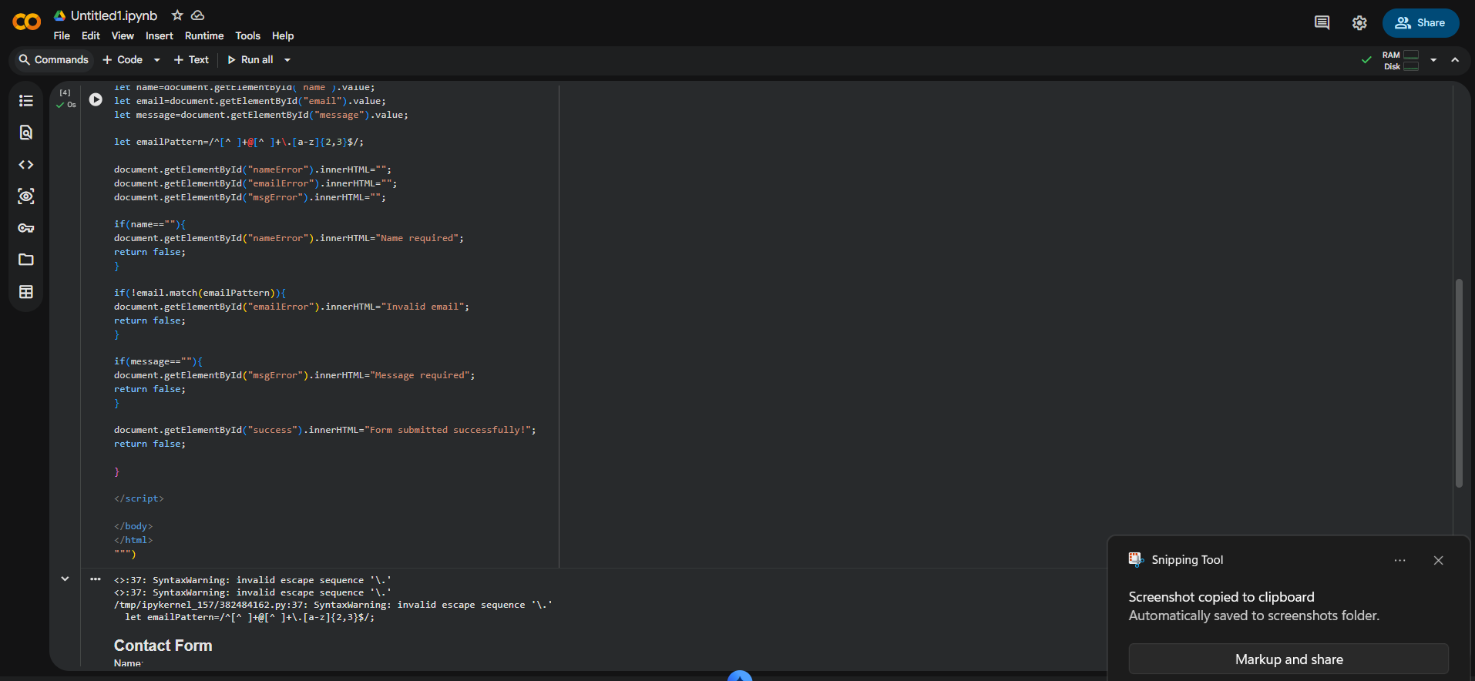
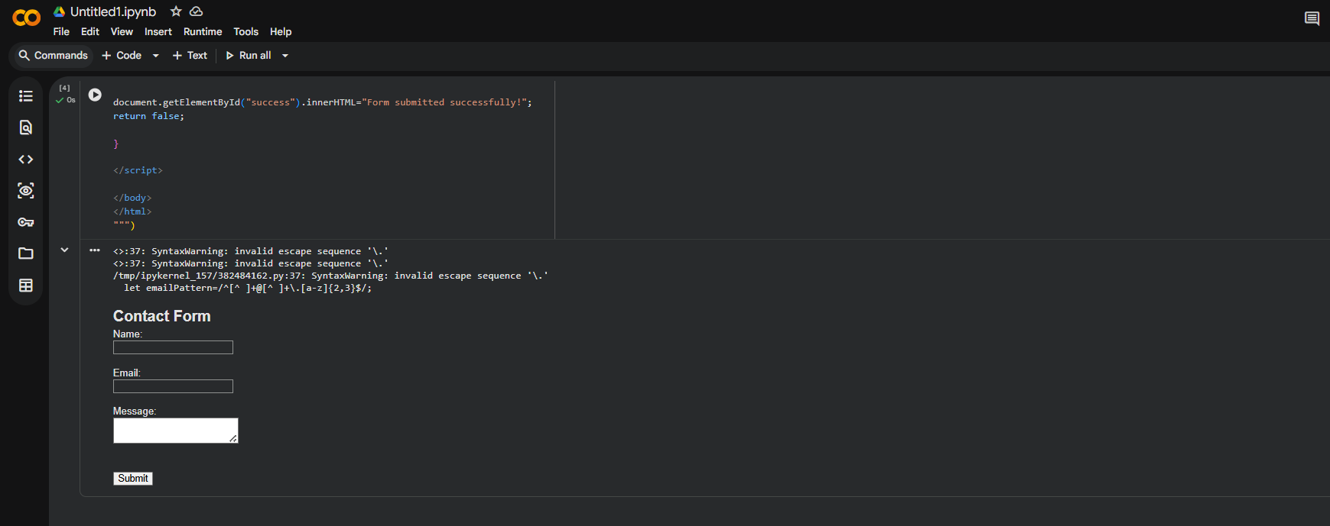
Task 4: Dynamic List Management for a Product Page
Scenario:
A product listing page needs to add or remove items dynamically
without refreshing the page.
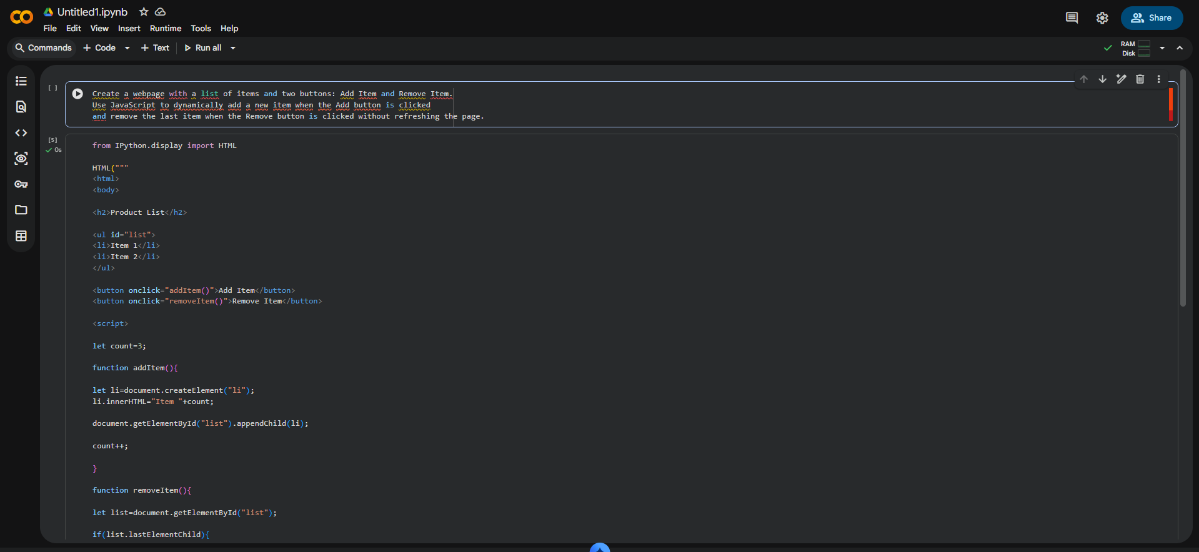
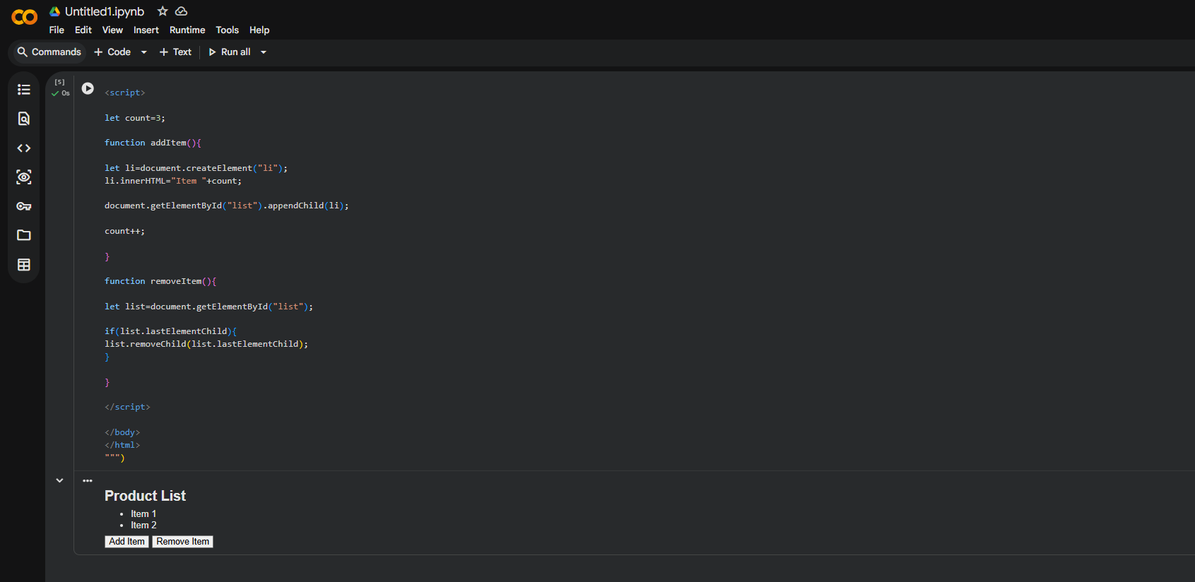
Task 5: Modal Popup for User Notifications
Scenario:
You are building a user notification popup for announcements or alerts
on a website.
