2303A51580
Batch : 26
Task 1: Bubble Sort for Ranking Exam
Scores
Scenario
You are working on a college result processing system where a small
list of student scores needs to be sorted after every internal assessment.
Task Description
• Implement Bubble Sort in Python to sort a list of student scores.
• Use an AI tool to:
o Insert inline comments explaining key operations such as
comparisons, swaps, and iteration passes
o Identify early-termination conditions when the list
becomes sorted
o Provide a brief time complexity analysis
Expected Outcome
• A Bubble Sort implementation with:
o AI-generated comments explaining the logic
o Clear explanation of best, average, and worst-case
complexity
o Sample input/output showing sorted scores
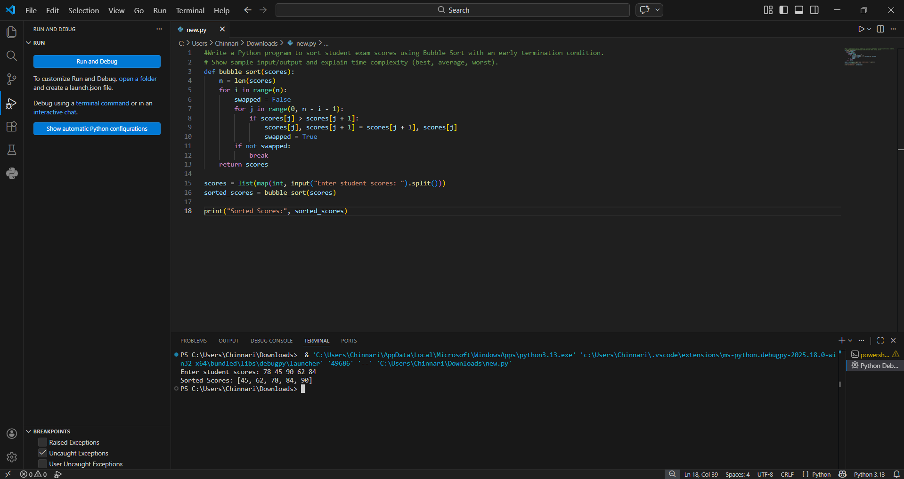
Task 2: Improving Sorting for Nearly Sorted
Attendance Records
Scenario
You are maintaining an attendance system where student roll numbers
are already almost sorted, with only a few late updates.
Task Description
• Start with a Bubble Sort implementation.
• Ask AI to:
o Review the problem and suggest a more suitable sorting
algorithm
o Generate an Insertion Sort implementation
o Explain why Insertion Sort performs better on nearly
sorted data
• Compare execution behavior on nearly sorted input
Expected Outcome
• Two sorting implementations:
o Bubble Sort
o Insertion Sort
• AI-assisted explanation highlighting efficiency differences for
partially sorted datasets give code and promt for this remove comments

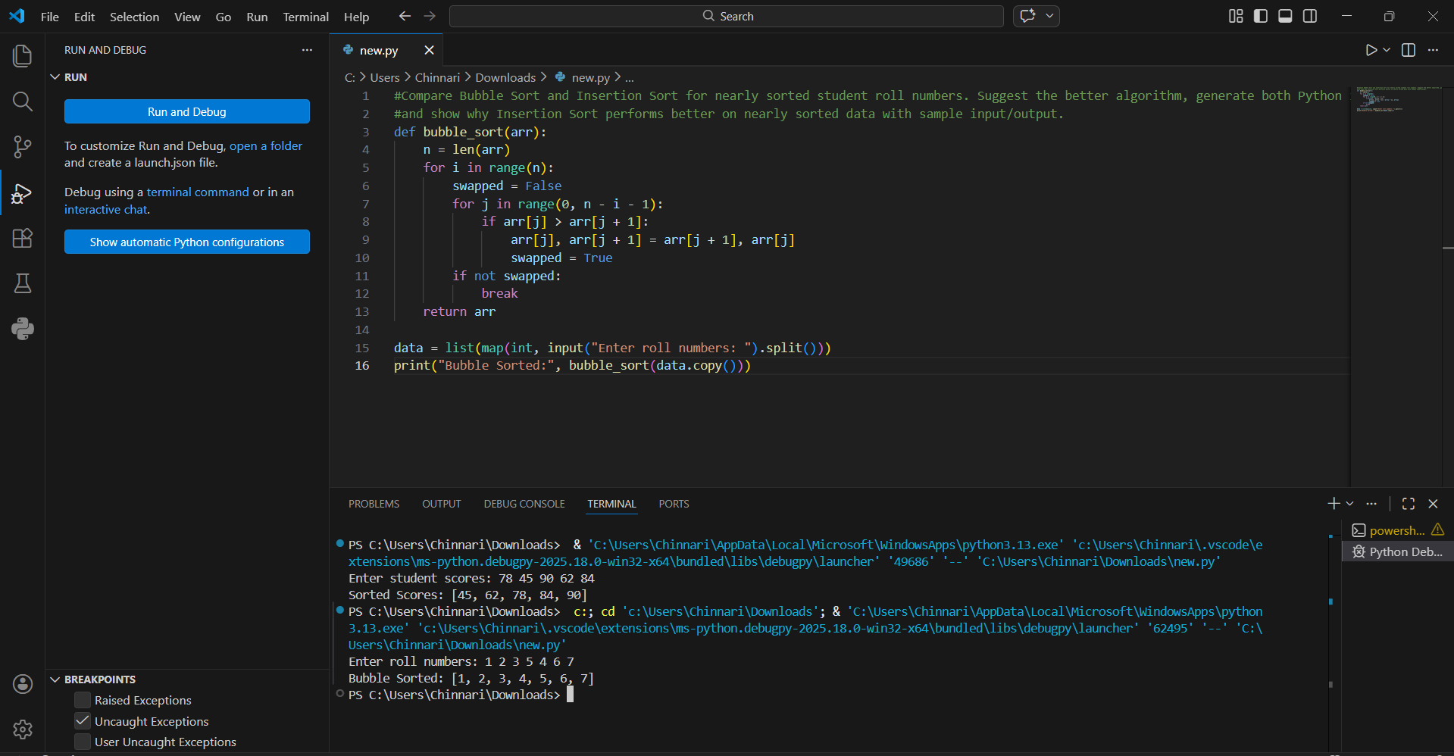
Task 3: Searching Student Records in a
Database
Scenario
You are developing a student information portal where users search for
student records by roll number.
Task Description
• Implement:
o Linear Search for unsorted student data
o Binary Search for sorted student data
• Use AI to:
o Add docstrings explaining parameters and return values
o Explain when Binary Search is applicable
o Highlight performance differences between the two
searches
Expected Outcome
• Two working search implementations with docstrings
• AI-generated explanation of:
o Time complexity
o Use cases for Linear vs Binary Search
• A short student observation comparing results on sorted vs
unsorted lists
give code and promt for this and remove comments

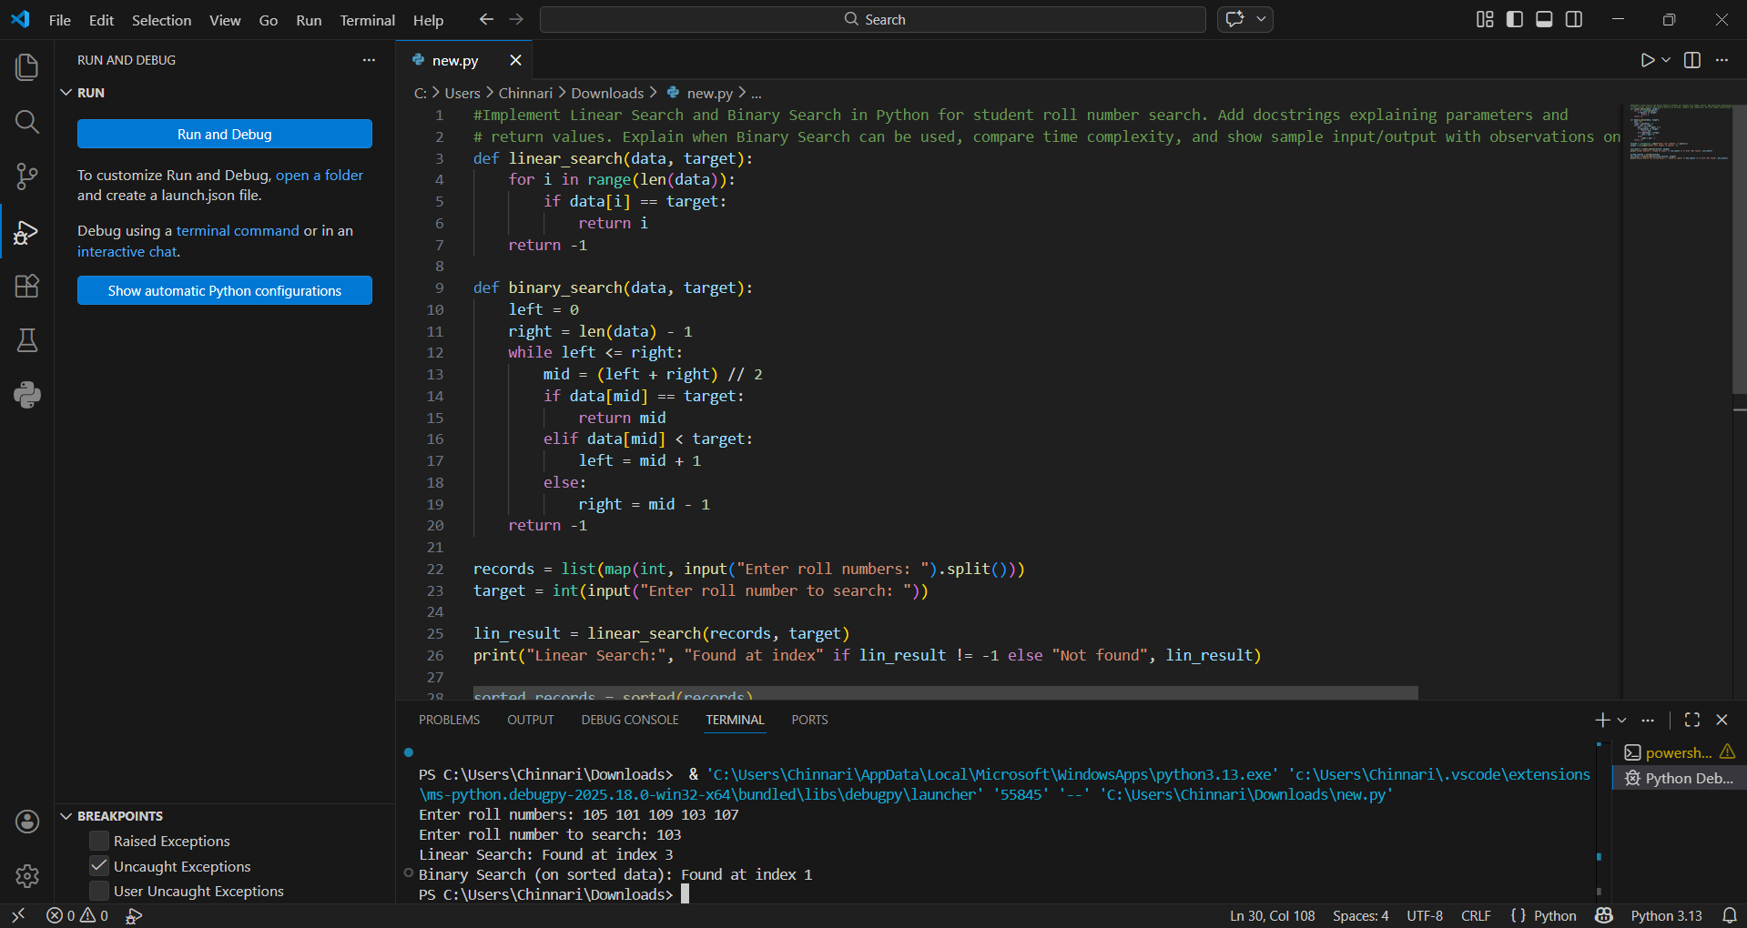
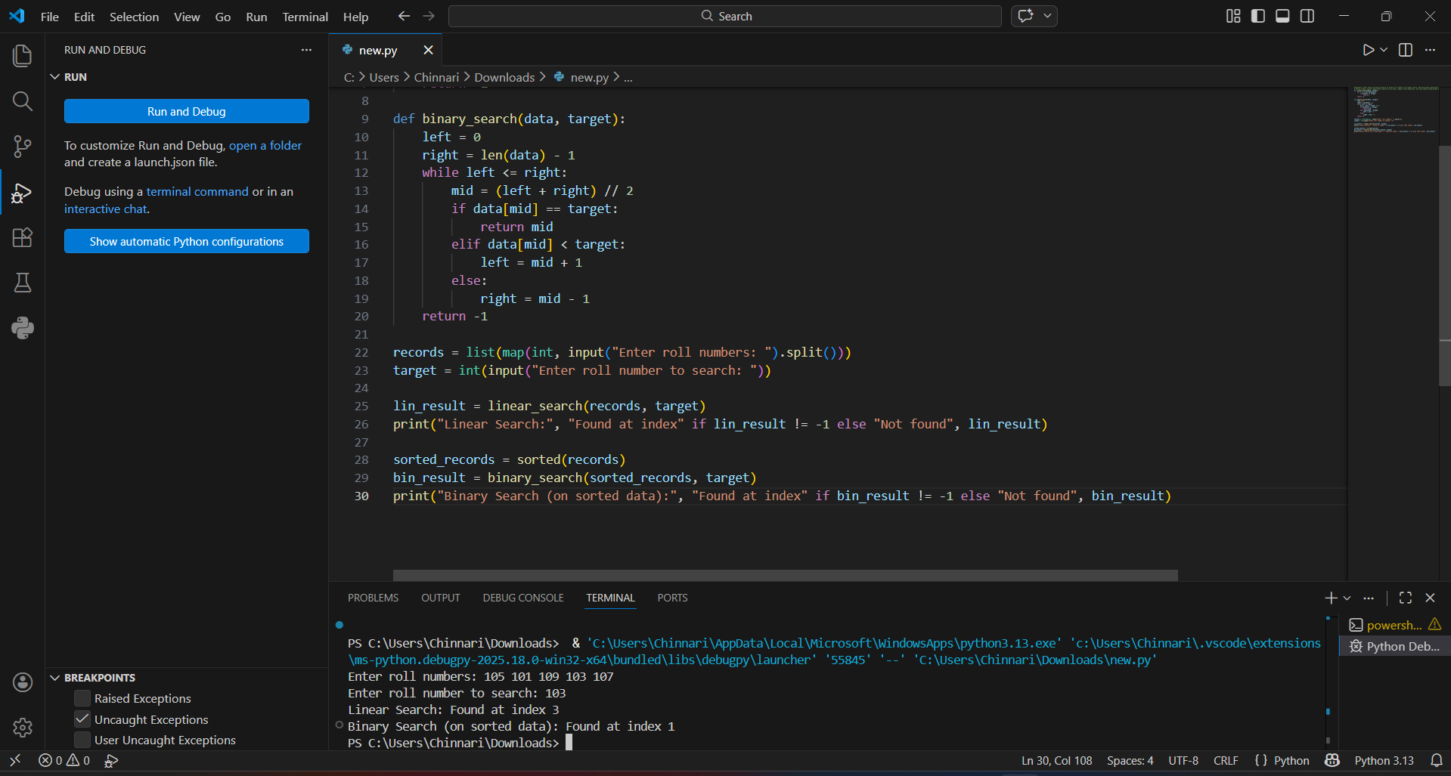

Task 4: Choosing Between Quick Sort and
Merge Sort for Data Processing
Scenario
You are part of a data analytics team that needs to sort large datasets
received from different sources (random order, already sorted, and
reverse sorted).
Task Description
• Provide AI with partially written recursive functions for:
o Quick Sort
o Merge Sort
• Ask AI to:
o Complete the recursive logic
o Add meaningful docstrings
o Explain how recursion works in each algorithm
• Test both algorithms on:
o Random data
o Sorted data
o Reverse-sorted data
Expected Outcome
• Fully functional Quick Sort and Merge Sort implementations
• AI-generated comparison covering:
o Best, average, and worst-case complexities
o Practical scenarios where one algorithm is preferred over
the other give promt and code for this and remove comments
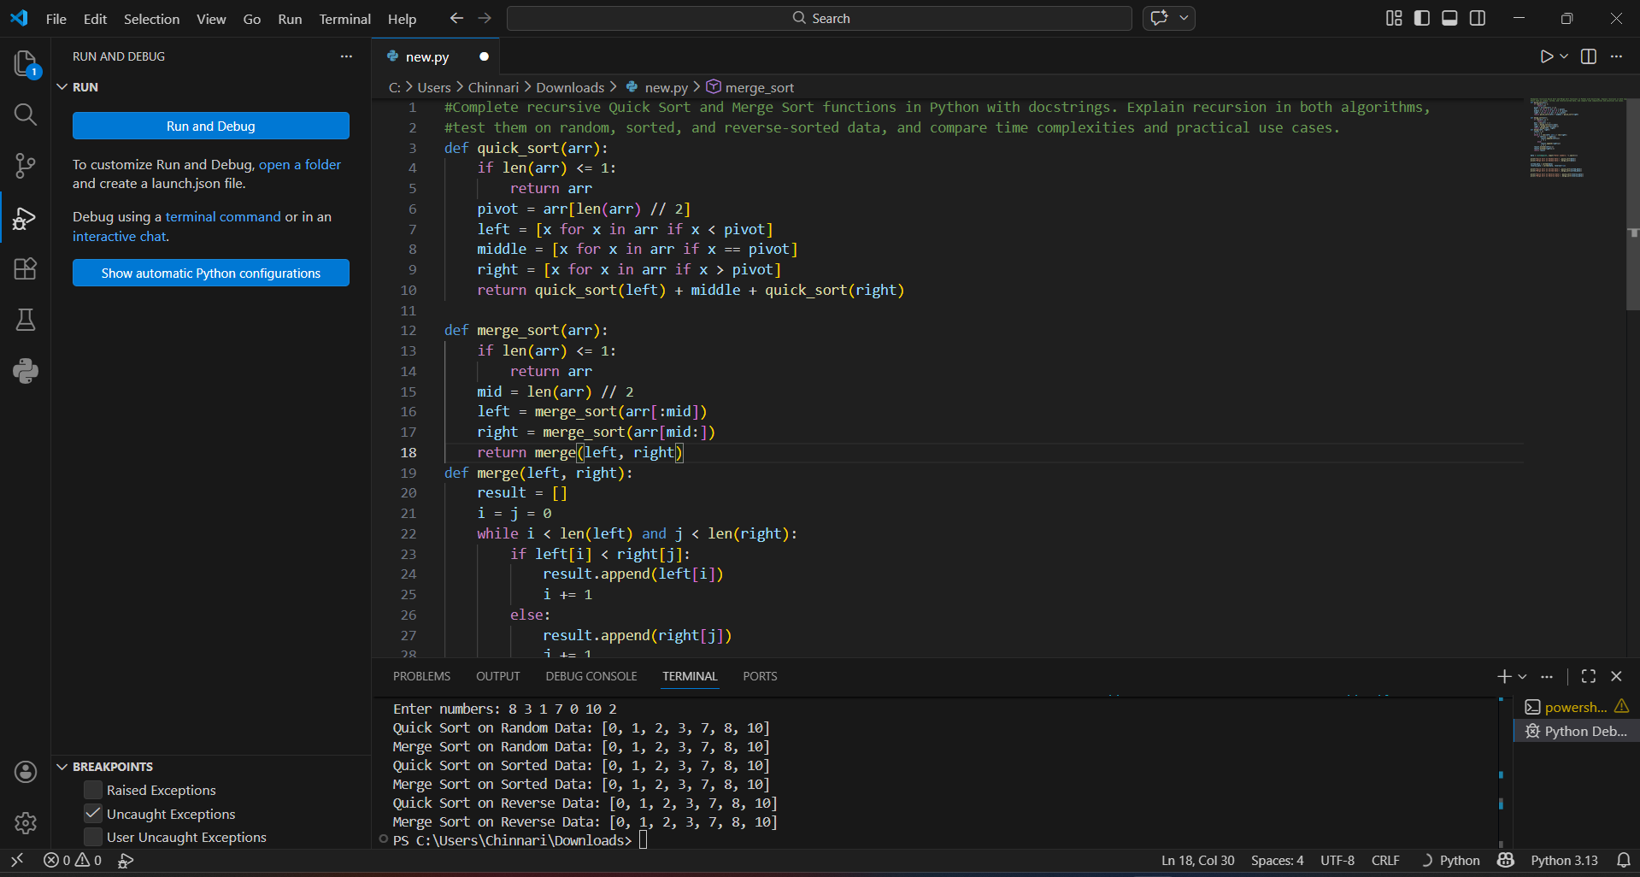
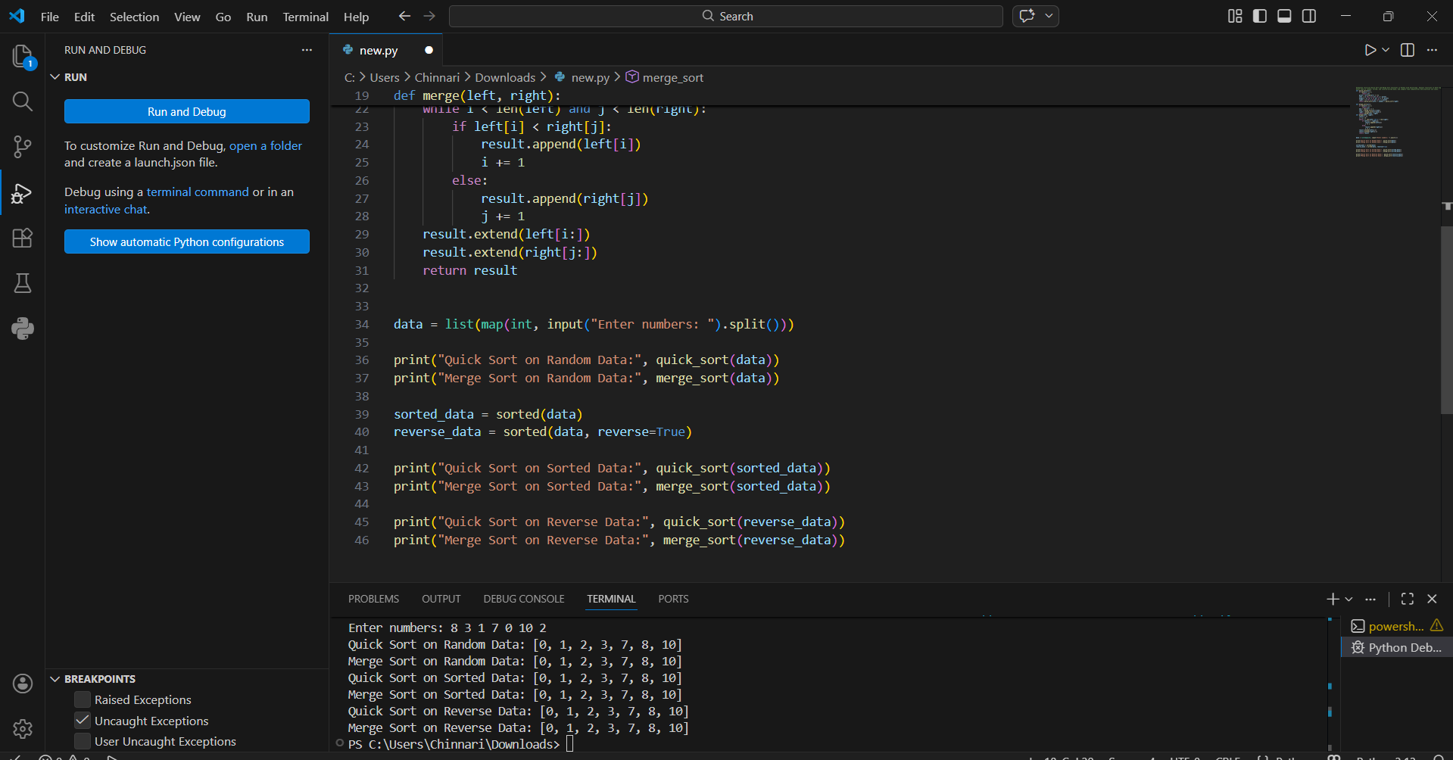
Task 5: Optimizing a Duplicate Detection
Algorithm
Scenario
You are building a data validation module that must detect duplicate
user IDs in a large dataset before importing it into a system.
Task Description
• Write a naive duplicate detection algorithm using nested loops.
• Use AI to:
o Analyze the time complexity
o Suggest an optimized approach using sets or dictionaries
o Rewrite the algorithm with improved efficiency
• Compare execution behavior conceptually for large input sizes
Expected Outcome
• Two versions of the algorithm:
o Brute-force (O(n²))
o Optimized (O(n))
• AI-assisted explanation showing how and why performance
improved give promt and code for this and remove comments
