SCHOOL OF COMPUTER SCIENCE AND ARTIFICIAL INTELLIGENCE |  |  |  |  | DEPARTMENT OF COMPUTER SCIENCE ENGINEERING
Program Name: B. Tech |  |  |  | Assignment Type: Lab |  |  | Academic Year:2025-2026
Course Coordinator Name |  |  |  | Dr. Rishabh Mittal
Instructor(s) Name
  Mr. S Naresh Kumar
  Ms. B. Swathi
  Dr. Sasanko Shekhar Gantayat
  Mr. Md Sallauddin
  Dr. Mathivanan
  Mr. Y Srikanth
  Ms. N Shilpa
  Dr. Rishabh Mittal (Coordinator)
  Dr. R. Prashant Kumar
  Mr. Ankushavali MD
  Mr. B Viswanath
  Ms. Sujitha Reddy
  Ms. A. Anitha
  Ms. M.Madhuri
  Ms. Katherashala Swetha
  Ms. Velpula sumalatha
  Mr. Bingi Raju
Course Code |  |  | 23CS002PC304 | Course Title |  | AI Assisted Coding
Year/Sem |  |  | III/I | Regulation |  | R23
Date and Day  of Assignment |  |  | Week 2 - Wednesday | Time(s) |  | 23CSBTB01 To 23CSBTB52
Duration |  |  | 2 Hours | Applicableto  Batches |  | All batches
Assignment Number: 3.3(Present assignment number)/24(Total number of assignments)
 | Q.No. | Question |  |  |  |  |  | Expected Time  to complete
 | 1 | Lab 4: Advanced Prompt Engineering – Zero-shot, One-shot, and Few-shot Techniques  Lab Objectives  - To explore and apply different levels of prompt examples in AI-assisted code generation  - To understand how zero-shot, one-shot, and few-shot prompting affect AI output quality  - To evaluate the impact of context richness and example quantity on AI performance  - To build awareness of prompt strategy effectiveness for different problem types  Lab Outcomes (LOs)  After completing this lab, students will be able to:  - Use zero-shot prompting to instruct AI with minimal context  - Use one-shot prompting with a single example to guide AI code generation  - Apply few-shot prompting using multiple examples to improve AI responses  - Compare AI outputs across different prompting strategies  Task 1: Zero-Shot Prompting – Leap Year Check  Scenario  Zero-shot prompting involves giving instructions without providing examples.  Prompt: Write a Python function that accepts a year as input from the keyboard and determines whether it is a leap year according to the Gregorian calendar rules. The function should return an appropriate result.  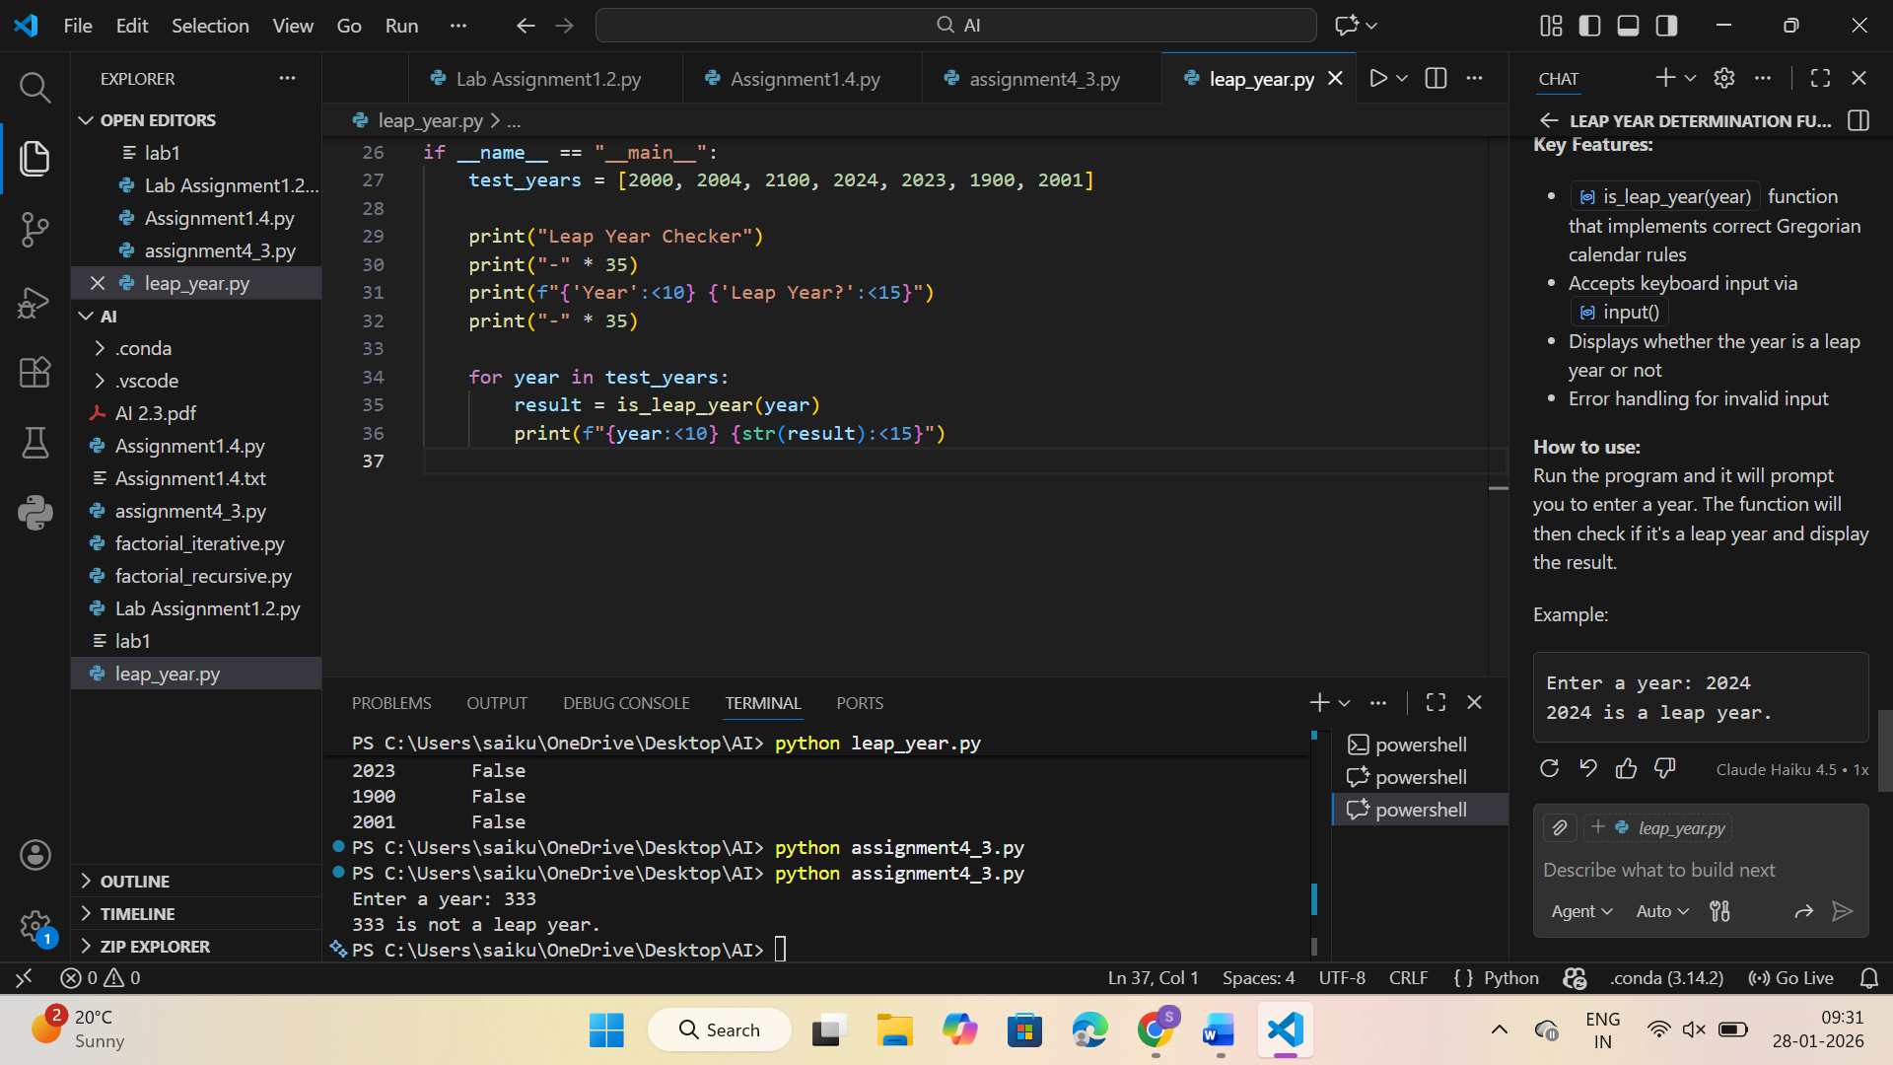  Description: Zero-shot prompting is when an AI is given only instructions without any examples. In this task, the AI is asked to create a Python function that takes a year as keyboard input and checks whether it is a leap year using correct logic.  Task 2: One-Shot Prompting – Centimeters to Inches Conversion  Scenario  One-shot prompting guides AI using a single example.  Prompt: Write a Python function that takes a value in centimeters as input from the user and converts it to inches using the correct formula.  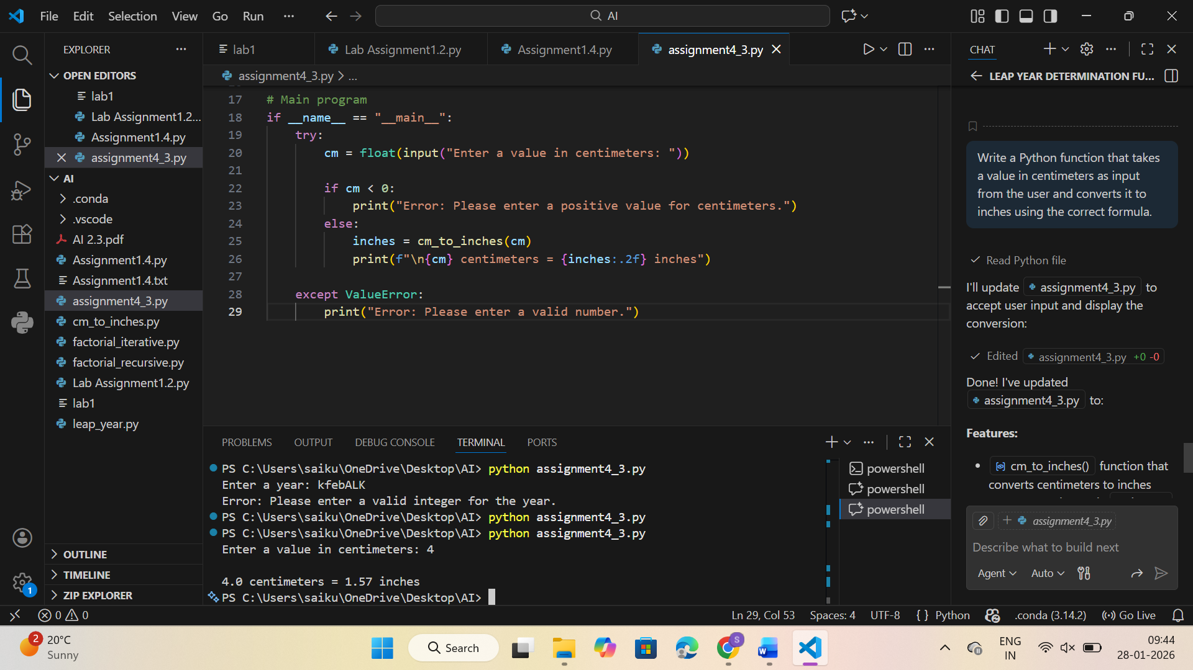  Description:  One-shot prompting provides the AI with a single example to guide its response. In this task, the AI is asked to generate a Python function that takes centimeters as user input and converts it to inches using the correct formula. The given example helps the AI understand the expected format and calculation.  Task 3: Few-Shot Prompting – Name Formatting  Scenario  Few-shot prompting improves accuracy by providing multiple examples.  Prompt: Write a Python function that takes a full name as input from the user and formats it as "Last, First".  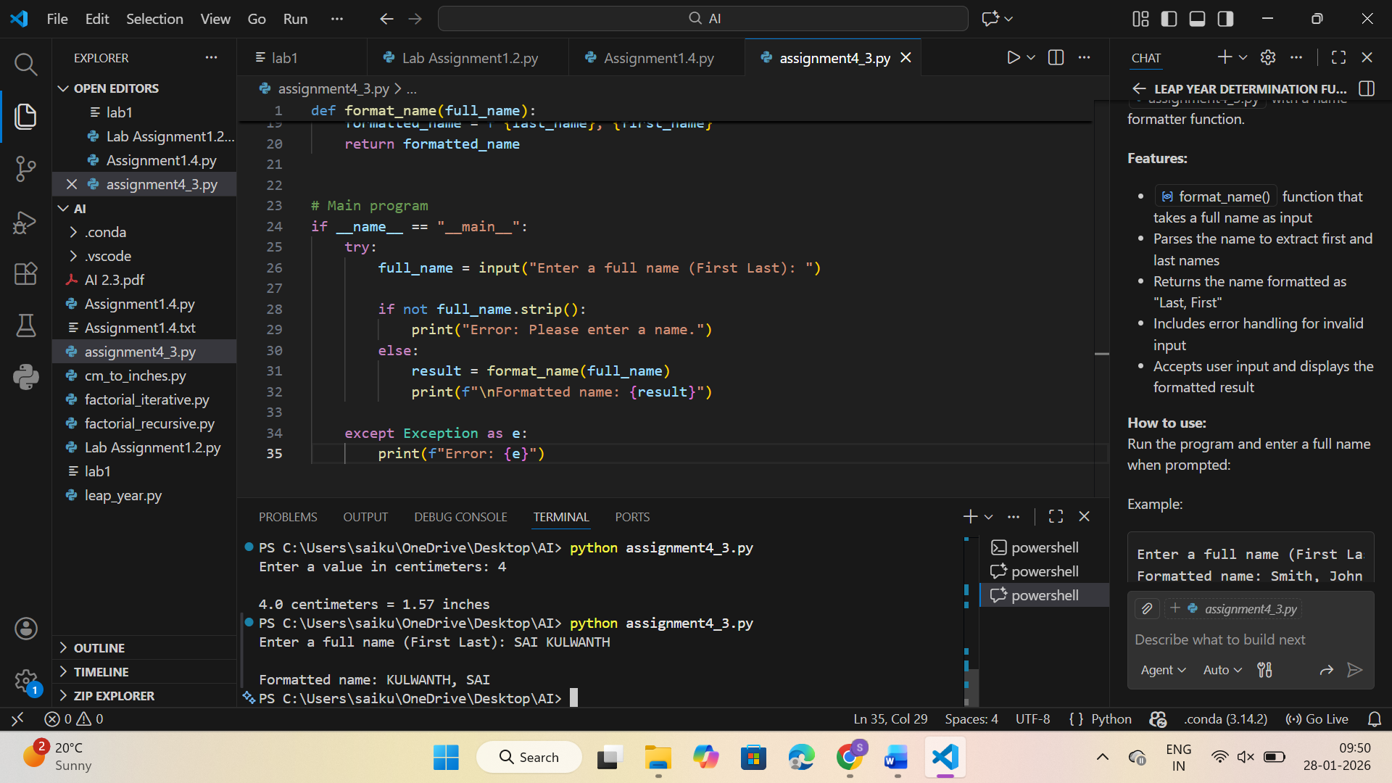 Description:  Few-shot prompting uses multiple examples to guide the AI. The examples help the AI learn the exact name format pattern and produce accurate results.  Task 4: Comparative Analysis – Zero-Shot vs Few-Shot  Scenario  Different prompt strategies may produce different code quality.  Prompt: Write a Python function that takes a string as input from the user and counts the number of vowels in it. The function should return the count.  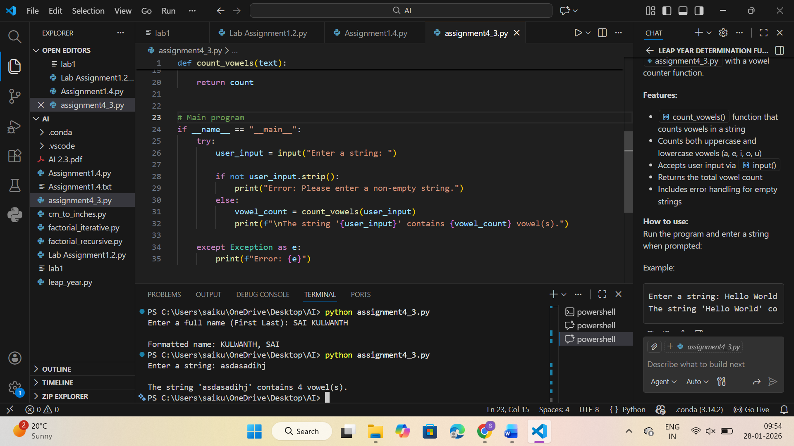 Description:  This task compares zero-shot and few-shot prompting. Zero-shot gives only instructions, while few-shot includes examples to guide the AI. The comparison shows how examples can improve clarity and accuracy.  Task 5: Few-Shot Prompting – File Handling  Scenario  File processing requires clear logical understanding.  Prompt: Write a Python program that automatically creates a .txt file named sample.txt with at least 5 lines of sample text. Then, read the file, count the total number of lines, and print the result in the format: "The file 'sample.txt' has X lines."  Also include a short explanation of how the code works.  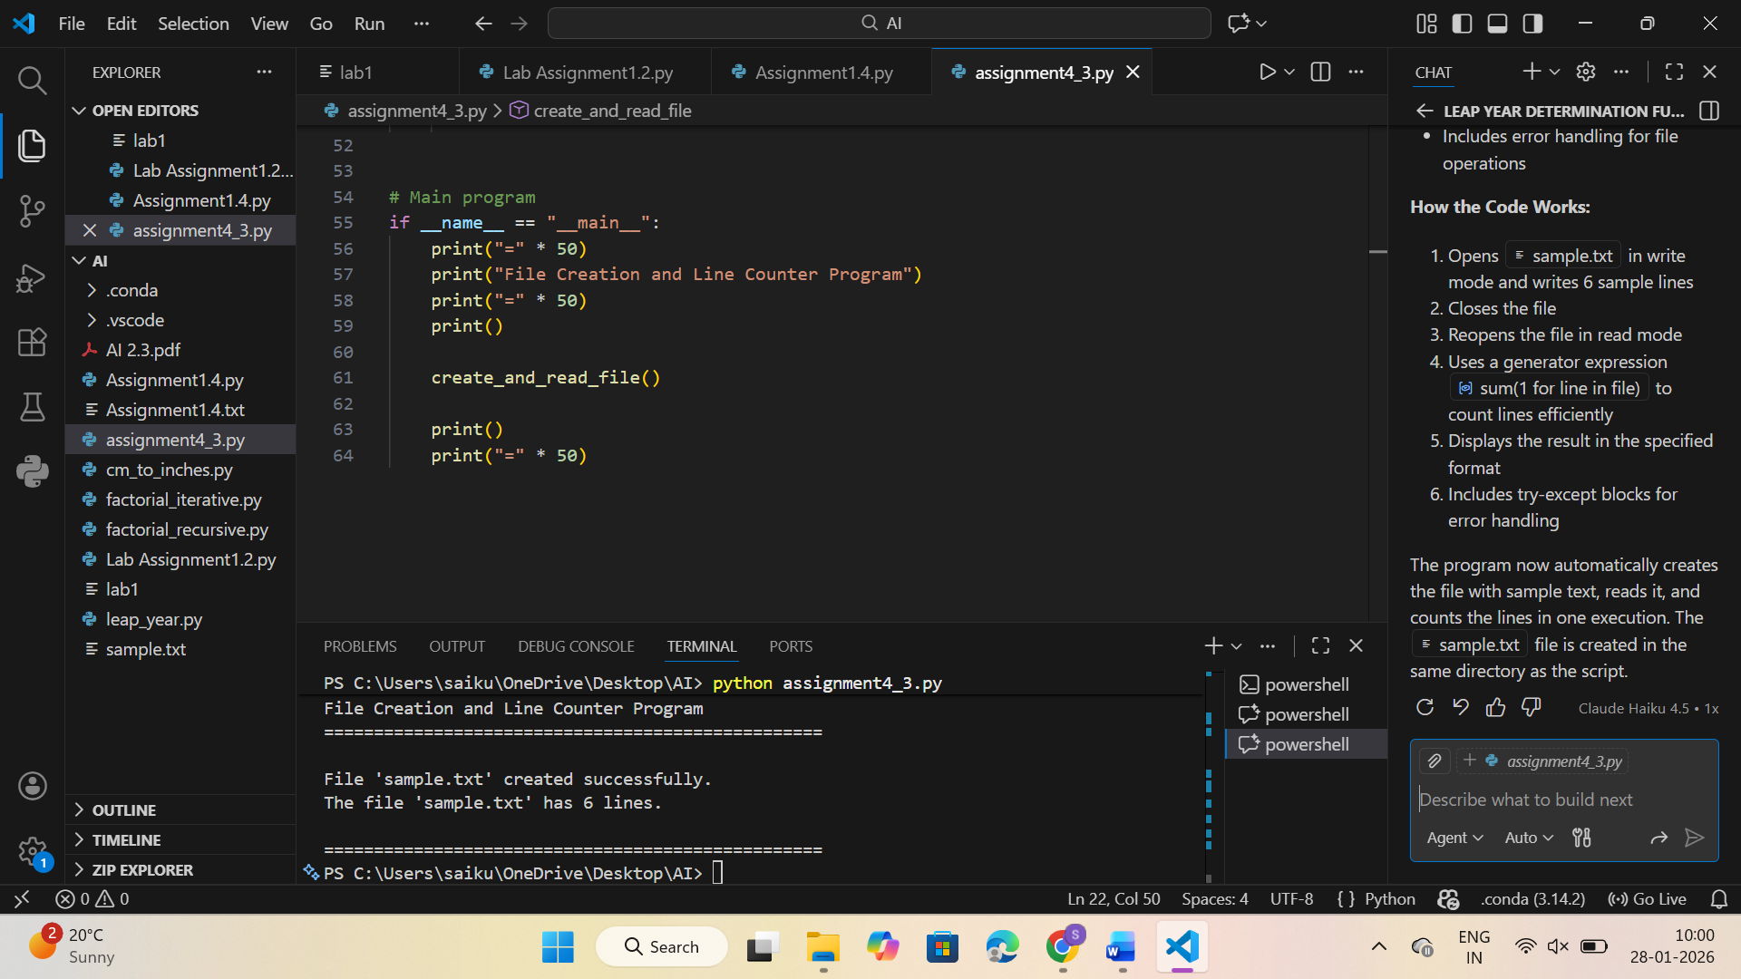  Description:  Few-shot prompting is used here to guide the AI in file handling. The examples help the AI understand how to read a file and count its lines correctly.  Note: Report should be submitted as a word document for all tasks in a single document with prompts, comments & code explanation, and output and if required, screenshots. |  |  |  |  |  | Week2 - Wednesday

