ASSIGNMENT 17.5
2303A51589
A.KRISHNA KOUSHIK
Batch 19

Task 1 –Loan Approval Dataset Cleaning PROMPT:
#Write Python code using pandas and scikit-learn to preprocess a loan approval dataset loaded from a CSV file named "loanapproval.csv". The preprocessing should include handling missing values in the columns loan_amount and credit_score by filling them with appropriate statistical values such as the mean or median. Encode the categorical column loan_status into numerical form (Approved = 1, Rejected = 0). Identify and scale all numerical features using StandardScaler for better model performance. Finally, split the dataset into training and testing sets using train_test_split with an appropriate test size. Ensure the code is clean, well-structured, and prints sample outputs after each preprocessing step for verification.
#you onli create a sampledataset for the demonstration purpose, you can use the full dataset in your actual implementation.

CODE:

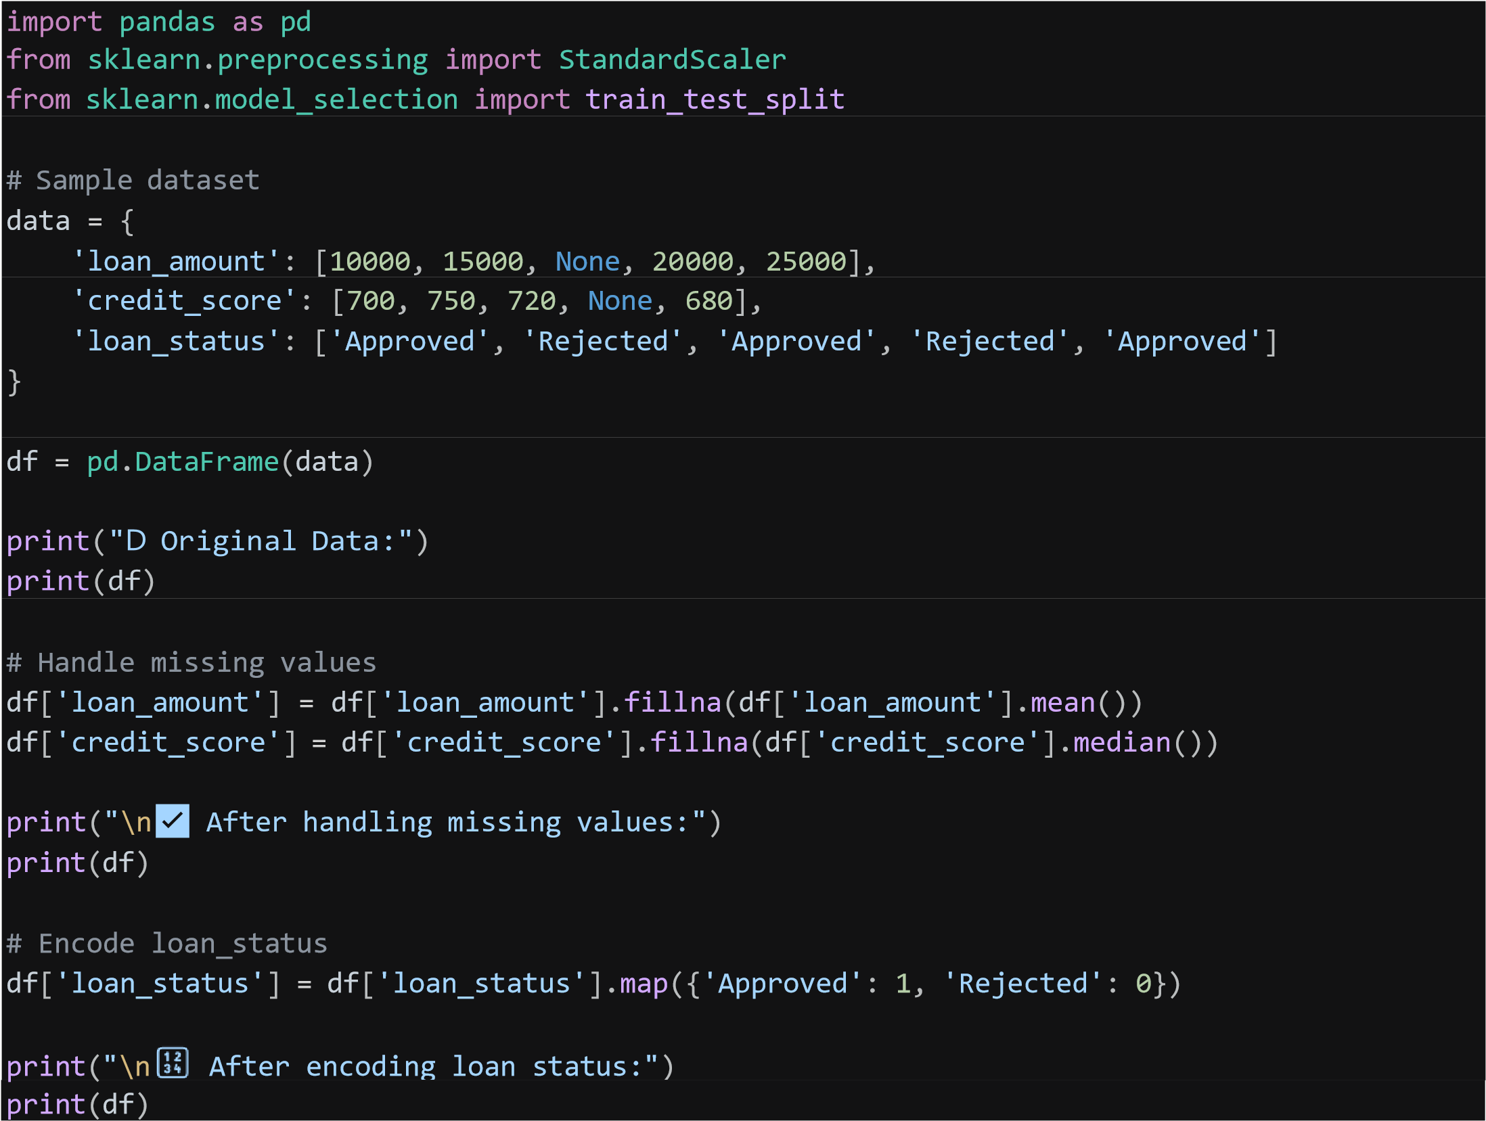
# Separate features and target
X = df[['loan_amount', 'credit_score']] y = df['loan_status']

# Scale numerical features scaler = StandardScaler()
X_scaled = scaler.fit_transform(X)
print("\n📏 Scaled Features:") print(X_scaled)

# Split dataset
X_train, X_test, y_train, y_test = train_test_split( X_scaled, y, test_size=0.2, random_state=42 ) print("\n📦 Training Data:") print(X_train) print(y_train)
print("\nG Testing Data:") print(X_test) print(y_test)

OUTPUT:

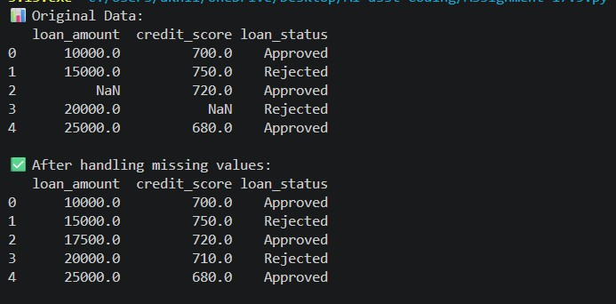
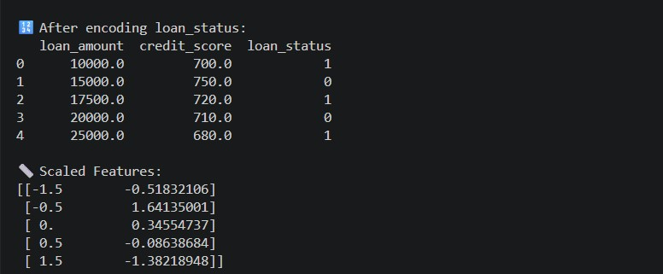
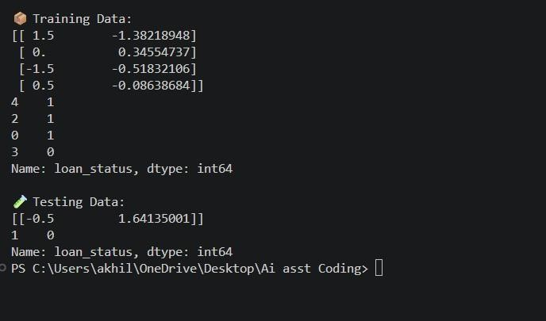
Task 2 – Social Media Profiles
PROMPT:
Write Python code using pandas and scikit-learn to preprocess a social media engagement dataset. For demonstration purposes, first create a sample dataset that includes columns such as user_id, username, age, gender, platform, posts_count, likes, and engagement_level. Perform preprocessing steps including removing duplicate user profiles based on user_id, handling missing values in numerical and categorical columns using appropriate techniques (mean/median for numerical and mode for categorical), and encoding categorical columns like gender, platform, and engagement_level into numerical form. Ensure the code is clean, well-structured, and prints the dataset before and after each preprocessing step for clear verification.
CODE:

import pandas as pd # Sample dataset data = {
'user_id': [1, 2, 3, 4, 5, 1], # Duplicate user_id
'username': ['user1', 'user2', 'user3', 'user4', 'user5', 'user1'],
'age': [25, 30, None, 22, 28, 25],
'gender': ['Male', 'Female', 'Female', None, 'Male', 'Male'],
'platform': ['Instagram', 'Facebook', 'Twitter', 'Instagram', None, 'Instagram'], 'posts_count': [100, 150, 200, None, 250, 100],
'likes': [1000, 1500, None, 2000, 2500, 1000],
'engagement_level': ['High', 'Medium', 'Low', 'Medium', None ,
'High']
} df = pd.DataFrame(data) print("D Original Data:") print(df)
# Remove duplicate user profiles based on user_id df = df.drop_duplicates(subset='user_id') print("\n✅ After removing duplicates:") print(df)
# Handle missing values in numerical columns df['age'] = df['age'].fillna(df['age'].mean()) df['posts_count'] = df['posts_count'].fillna(df['posts_count'].mean()) df['likes'] = df['likes'].fillna(df['likes'].mean()) print("\n✅ After handling missing values in numerical columns:") print(df)

OUTPUT:

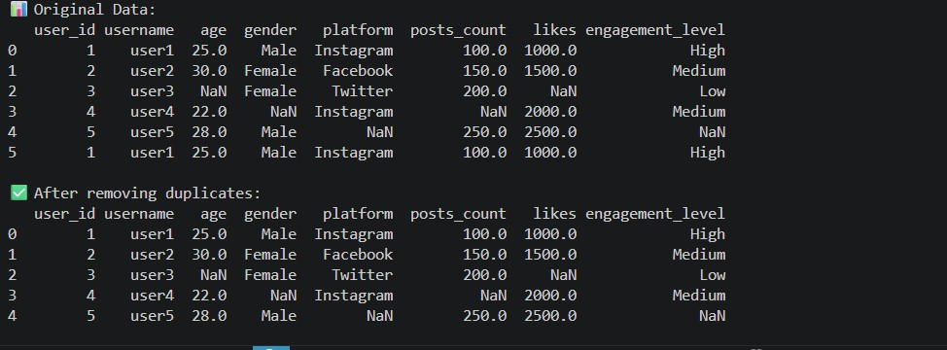
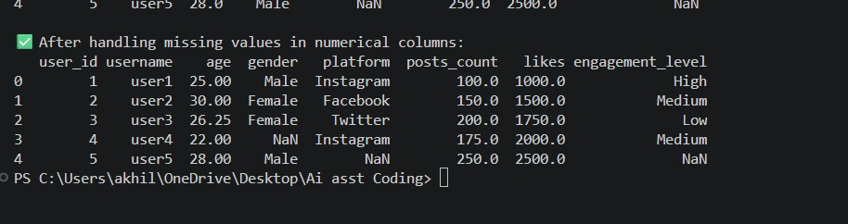
Task 3 – Weather Dataset Feature Engineering
PROMPT:
Write Python code using pandas and scikit-learn to preprocess a weather dataset for forecasting purposes. For demonstration, first create a sample dataset containing columns such as date, temperature, humidity, and rainfall. Convert the date column into datetime format for proper time- based analysis. Handle missing values in temperature and humidity using appropriate techniques like mean or median imputation. Perform feature engineering by creating new columns such as season (based on month) and week_number extracted from the date. Normalize the rainfall values using a suitable scaling technique such as MinMaxScaler or StandardScaler. Ensure the code is clean, well- structured, and prints the dataset before and after each preprocessing step for verification.

CODE:

import pandas as pd from sklearn.preprocessing import MinMaxScaler
# Sample dataset data = {
'date': ['2024-01-01', '2024-02-01', '2024-03-01', '2024-04-01', '2024-05-01'],
'temperature': [30, 28, None, 25, 22],
'humidity': [80, None, 75, 70, 65],
'rainfall': [5, 10, 15, None, 20]
} df = pd.DataFrame(data) print("D Original Data:") print(df)
# Convert date column to datetime format df['date'] = pd.to_datetime(df['date'])
print("\n✅ After converting date to datetime format:") print(df)
# Handle missing values in temperature and humidity
df['temperature'] = df['temperature'].fillna(df['temperature'].mean()) df['humidity'] = df['humidity'].fillna(df['humidity'].mean())
print("\n✅ After handling missing values in temperature and humidity:") print(df)
# Feature engineering: Create season and week_number columns
df['season'] = df['date'].dt.month % 12 // 3 + 1 # 1: Winter, 2: Spring, 3: Summer, 4: Fall df['week_number'] = df['date'].dt.isocalendar().week
print("\n✅ After feature engineering:") print(df)
# Normalize rainfall values using MinMaxScaler scaler = MinMaxScaler() df['rainfall_normalized'] = scaler.fit_transform(df[['rainfall']]) print("\n✅ After normalizing rainfall values:") print(df)

OUTPUT:
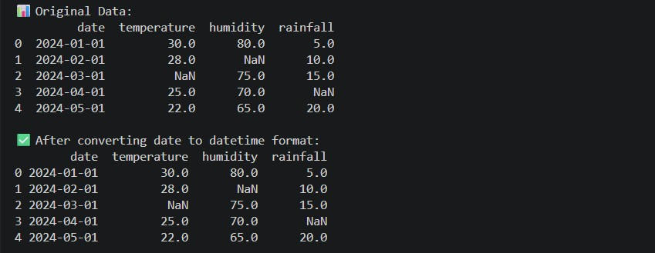

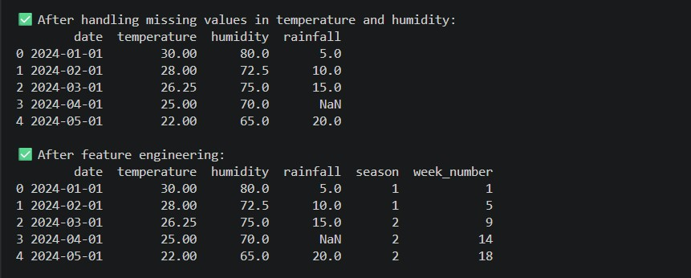

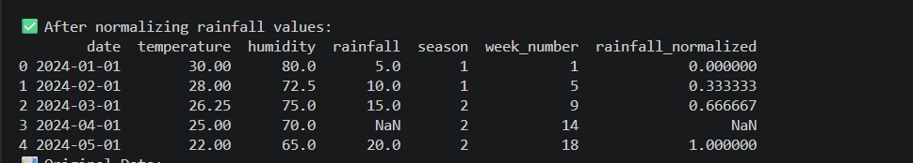
Task 4 – Movie Ratings Dataset Preparation PROMPT:
Write Python code using pandas and scikit-learn to clean and preprocess a movie ratings dataset. For demonstration purposes, first create a sample dataset that includes columns such as movie_id, title, genre, language, and rating. Perform preprocessing steps including handling missing values in rating and genre using appropriate techniques (such as mean for rating and mode for genre), encoding categorical variables like genre and language into numerical form using suitable encoding methods, and removing duplicate movie entries based on movie_id. Finally, scale the rating values between 0 and 1 using a normalization technique such as MinMaxScaler. Ensure the code is clean, well- structured, and prints the dataset before and after each preprocessing step for clear verification.

CODE:
import pandas as pd
from sklearn.preprocessing import MinMaxScaler
# Sample dataset data = {
'movie_id': [1, 2, 3, 4, 5, 1], # Duplicate movie_id
'title': ['Jersey', 'Eega', 'Pokiri', 'ok jaanu', 'Dhurandhar', 'HI nanna'],
'genre': ['Family', 'Drama', None, 'Rom-Com', 'Action', 'Family'],
'language': ['Telugu', 'Telugu', 'Telugu', None, 'Telugu', 'Telugu'],
'rating': [4.5, None, 3.0, 4.0, 5.0, 4.5]
} df = pd.DataFrame(data) print("D Original Data:") print(df)
# Remove duplicate movie entries based on movie_id df = df.drop_duplicates(subset='movie_id') print("\n✅ After removing duplicates:") print(df)
# Handle missing values in rating and genre df['rating'] = df['rating'].fillna(df['rating'].mean()) df['genre'] = df['genre'].fillna(df['genre'].mode()[0]) print("\n✅ After handling missing values in rating and genre:") print(df)

# Encode categorical variables genre and language
df['genre_encoded'] = df['genre'].astype('category').cat.codes df['language_encoded'] = df['language'].astype('category').cat.codes print("\n✅ After encoding genre and language:") print(df)
# Scale rating values between 0 and 1 using MinMaxScaler scaler = MinMaxScaler() df['rating_normalized'] = scaler.fit_transform(df[['rating']]) print("\n✅ After normalizing rating values:") print(df)
OUTPUT:
