Assignment - 1

Name: J. Nandini
Roll Number: 2303A51606 Batch - 03
AI Assisted Coding 07-01-2026
Task 0: Environment Setup:- Task 0
- Install and configure GitHub Copilot in VS Code. Take screenshots of each step.
Expected Output
- Install and configure GitHub Copilot in VS Code. Take screenshots of each step.
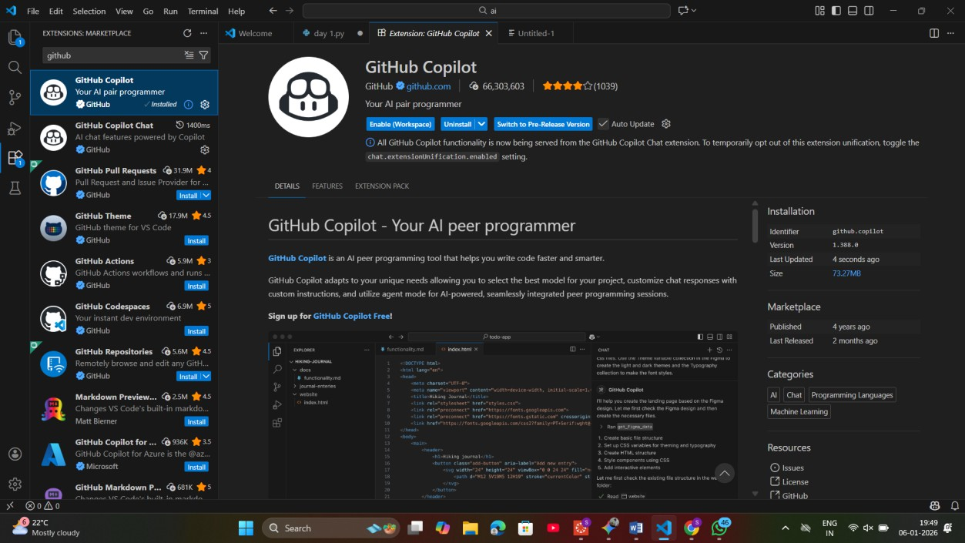

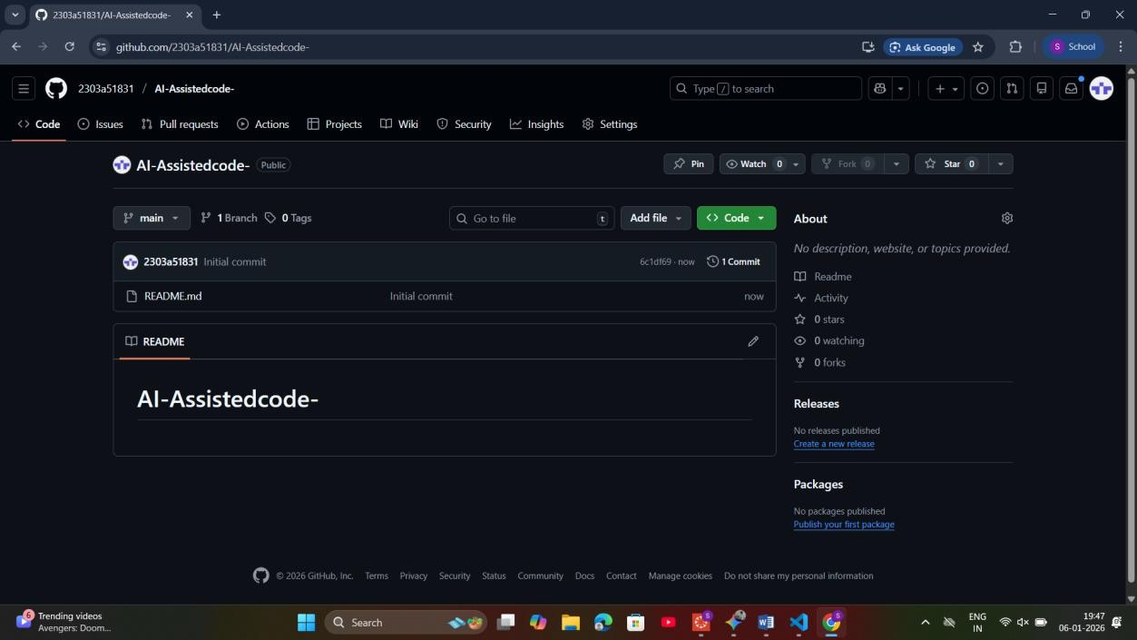
Task 1: Non-Modular Logic (Factorial):-
AI-Generated Logic Without Modularization (Factorial without Functions)
- Scenario
You are building a small command-line utility for a startup intern onboarding task. The program is simple and must be written quickly without modular design.
- Task Description
Use GitHub Copilot to generate a Python program that computes a mathematical product-based value (factorial-like logic) directly in the main execution flow, without using any user-defined functions.
- Constraint:
- Do not define any custom function
- Logic must be implemented using loops and variables only
- Expected Deliverables
- A working Python program generated with Copilot assistance
- Screenshot(s) showing:
- The prompt you typed

- Copilot’s suggestions
- Sample input/output screenshots
- Brief reflection (5–6 lines):
- How helpful was Copilot for a beginner?
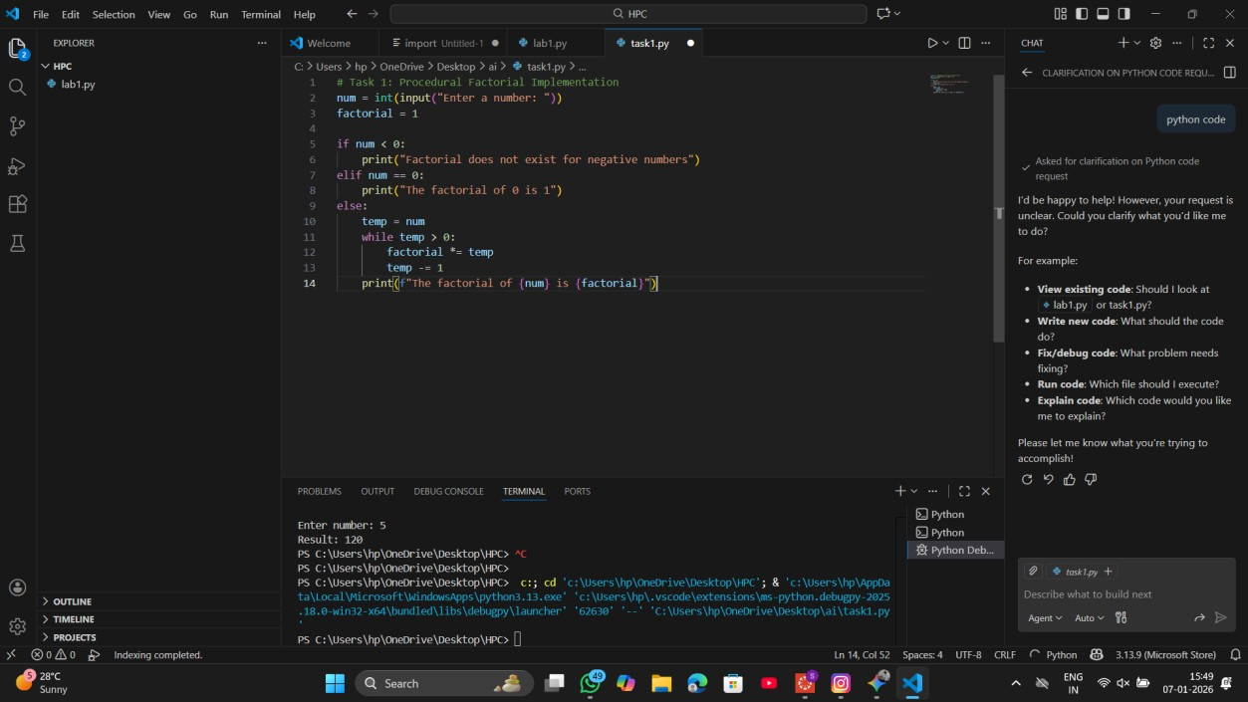
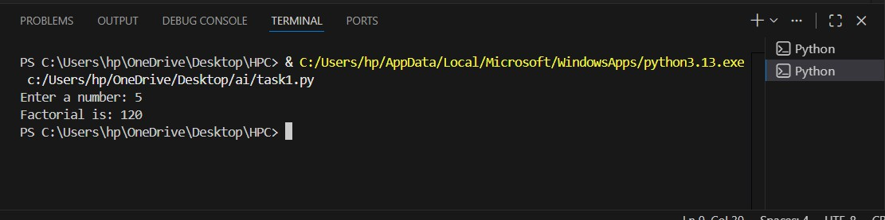
- Did it follow best practices automatically?

Task 2: AI Code Optimization:-
AI Code Optimization & Cleanup (Improving Efficiency)
- Scenario
Your team lead asks you to review AI-generated code before committing it to a shared repository.
- Task Description
Analyze the code generated in Task 1 and use Copilot again to:

- Reduce unnecessary variables
- Improve loop clarity
- Enhance readability and efficiency Hint:
Prompt Copilot with phrases like
“optimize this code”, “simplify logic”, or “make it more readable”
- Expected Deliverables
- Original AI-generated code
- Optimized version of the same code
- Side-by-side comparison
- Written explanation:
- What was improved?
- Why the new version is better (readability, performance, maintainability.
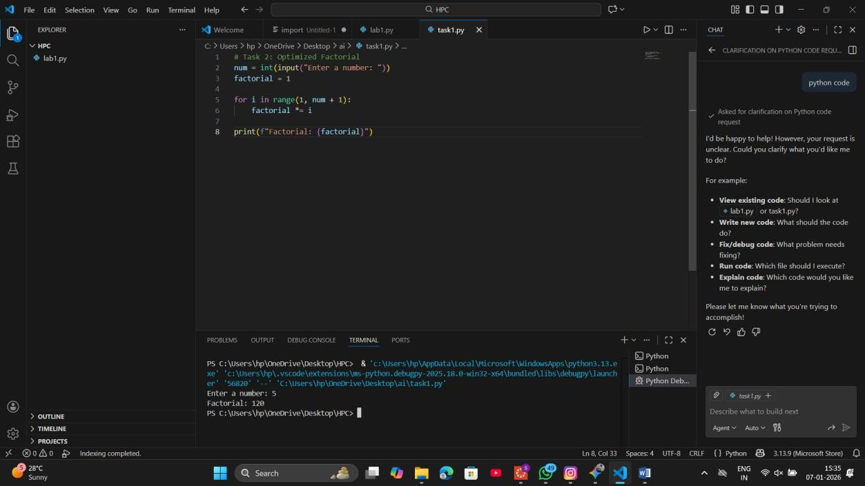
Task 3: Modular Design Using AI Assistance (Factorial with Functions)
- Scenario
The same logic now needs to be reused in multiple scripts.

- Task Description
Use GitHub Copilot to generate a modular version of the program by:
- Creating a user-defined function
- Calling the function from the main block
- Constraints
- Use meaningful function and variable names
- Include inline comments (preferably suggested by Copilot)
- Expected Deliverables
- AI-assisted function-based program
- Screenshots showing:
- Prompt evolution
- Copilot-generated function logic
- Sample inputs/outputs
- Short note:
- How modularity improves reusability.
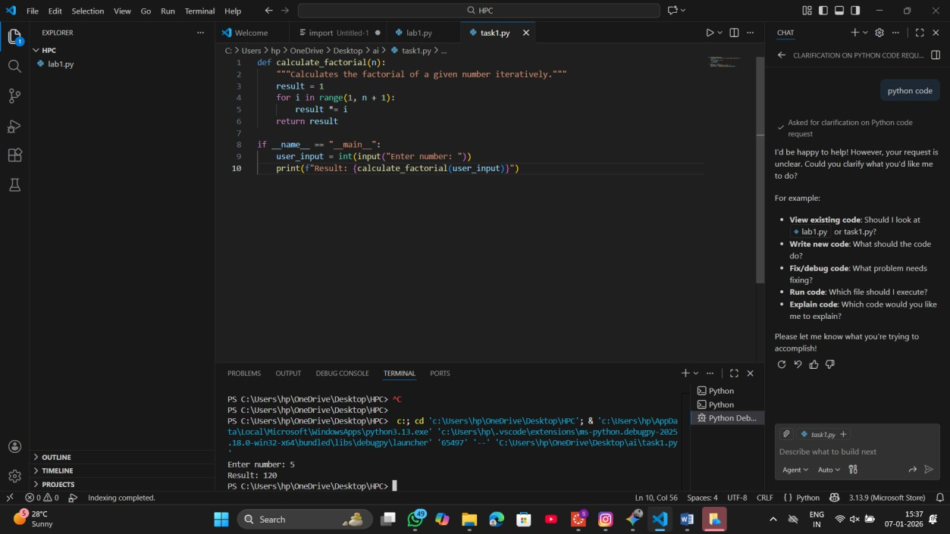
Task 4: Comparative Analysis:-
Comparative Analysis – Procedural vs Modular AI Code (With vs

Without Functions)
- Scenario
As part of a code review meeting, you are asked to justify design choices.
- Task Description
Compare the non-function and function-based Copilot-generated programs on the following criteria:
- Logic clarity
- Reusability
- Debugging ease
- Suitability for large projects
- AI dependency risk
- Expected Deliverables Choose one:
- A comparison table OR
- A short technical report (300–400 words).

Criteria | Procedural (Task 1 & 2) | Modular (Task 3)
Logic Clarity | Linear and straightforward for very small tasks but becomes "spaghetti code" as complexity grows. | High clarity; the mathematical logic is isolated from the input/output logic.
Reusability | None. To use the logic elsewhere, the code must be manually copied and pasted. | High. The function can be imported into other Python files or called multiple times in one script.
Debugging Ease | Difficult. Errors in logic are mixed with errors in user input handling. | Simple. You can test the function with specific values (Unit Testing) to ensure the math is correct.

Criteria | Procedural (Task 1 & 2) | Modular (Task 3)
Project Suitability | Suitable only for small, one-off scripts or prototypes. | Essential for enterprise-level, large-scale software development.
AI  Dependency Risk | High. AI might generate redundant variables or inefficient loops in long scripts. | Low. AI is highly specialized and accurate when asked to write specific, single-purpose functions.

Task 5: Iterative vs Recursive Thinking:-
: AI-Generated Iterative vs Recursive Thinking
- Scenario
Your mentor wants to test how well AI understands different computational paradigms.
- Task Description
Prompt Copilot to generate:
An iterative version of the logic
A recursive version of the same logic
- Constraints
Both implementations must produce identical outputs Students must not manually write the code first
- Expected Deliverables
Two AI-generated implementations
Execution flow explanation (in your own words) Comparison covering:
- Readability
- Stack usage
- Performance implications
- When recursion is not recommended.

