Lab Assignment # 1

Name of Student : Navajeevan
Enrollment No. : 2303A51628
Batch No. : 22

Task 1: AI-Generated Logic Without Modularization (Factorial without
Functions)

Prompt:-
Develop a basic Python program that calculates the factorial of a given number using only loops, without defining or using any functions.
Code:-
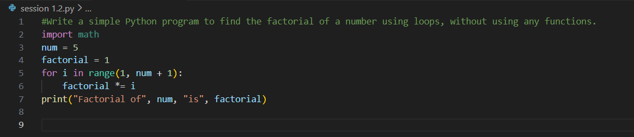

Output:-

Justification:-
This code solves the problem in a very straightforward way by writing everything in one place. It is easy for beginners to understand and good for small tasks. However, since it does not use functions, the code cannot be reused easily in bigger programs.

Task 2: AI Code Optimization & Cleanup (Improving Efficiency)

Prompt:-
Refine the previously written factorial program by simplifying the logic, eliminating unnecessary variables, and improving overall code readability.

Code:-

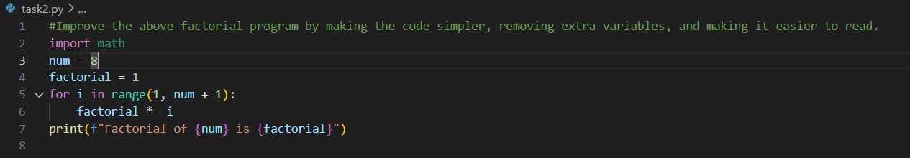

Output:-

Justification:-

This improved version looks cleaner and more organized. It removes unnecessary parts and focuses only on what is needed. Such clean code is easier to understand, debug, and maintain, especially when working with others.

Task 3: Modular Design Using AI Assistance (Factorial with Functions)

Prompt:-
Create a Python program that computes the factorial of a number by implementing the logic inside a user-defined function.
Code:-
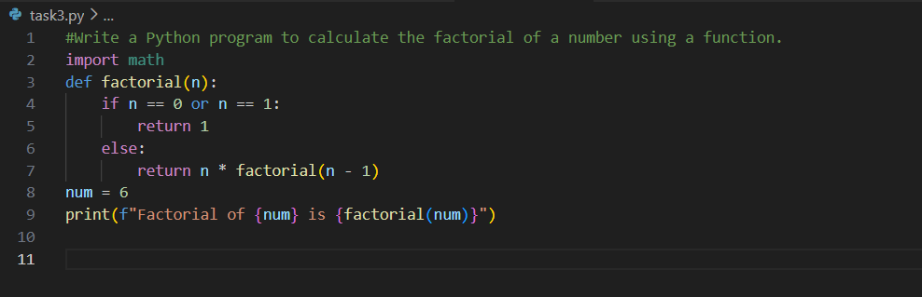

Output:-
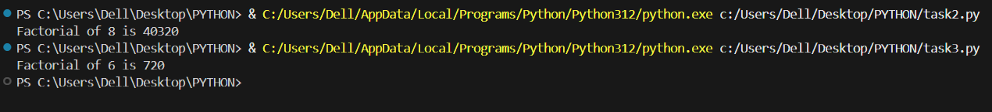

Justification:-
Using a function makes the program more structured and professional. The factorial logic is separated from the main code, which makes it reusable and easy to modify later. This is a better approach for larger programs.

Task 4: Comparative Analysis – Procedural vs Modular AI Code (With vs
Without Functions)

Prompt:-
Design a Python program that demonstrates factorial calculation with and without functions, and compare both approaches based on readability, reusability, debugging ease, and suitability for large projects using a tabular format.
Code:-
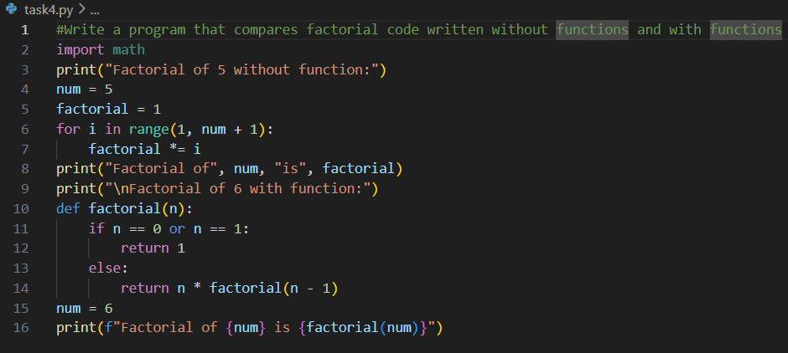

Output:-
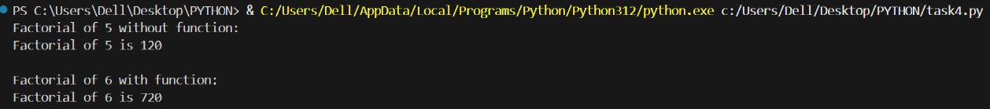

Justification:-

This comparison helps us clearly see the advantages of using functions. Code with functions is easier to understand and debug and can be reused in many places. It is more suitable for large and real-world applications than single-block code.

Task 5: AI-Generated Iterative vs Recursive Thinking

Prompt:-
Implement a Python program that computes factorial using both iterative and recursive techniques, explain the working of each method, and compare them in terms of readability, memory consumption, performance, and limitations.

Code:-
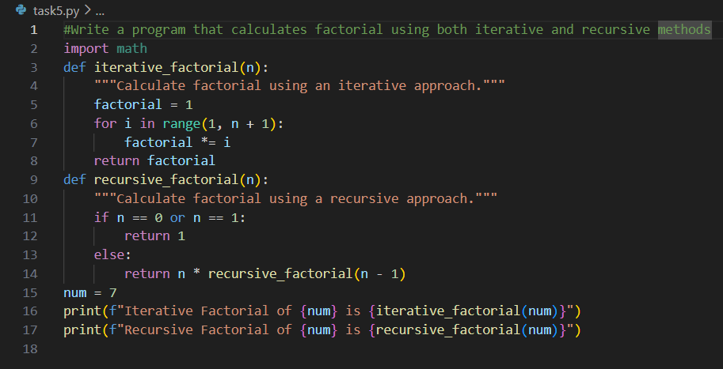

Output:-

Justification:-

This task shows two different ways of solving the same problem. The iterative method is simple and safe for large numbers, while the recursive method is easier to understand logically but can cause memory issues for big inputs. Knowing both methods helps in choosing the right solution..

