ASSIGNMENT-5.1 & 6
Ch.Nanda kishore
2303A51638
Task 1:
Employee Data: Create Python code that defines a class name Employee` with the following attributes: `empid`, `empname`,designation`, `basic_salary`, and `exp`. Implement a method display_details()` to print all employee details. Implement another`calculate_allowance()` to determine additional allowance based on experience:
- If `exp > 10 years` → allowance = 20% of `basic_salary`
- If `5 ≤ exp ≤ 10 years` → allowance = 10% of `basic_salary`
- If `exp < 5 years` → allowance = 5% of `basic_salary`
Finally, create at least one instance of the `Employee` class, call the `display_details()` method, and print the calculated allowance.
CODE:
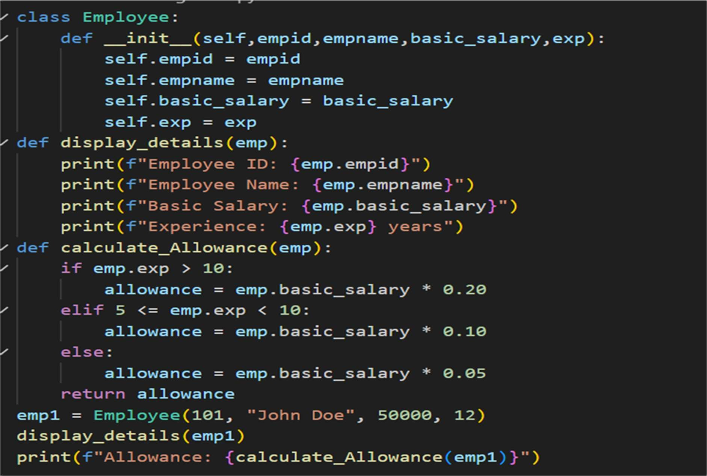

OUTPUT: 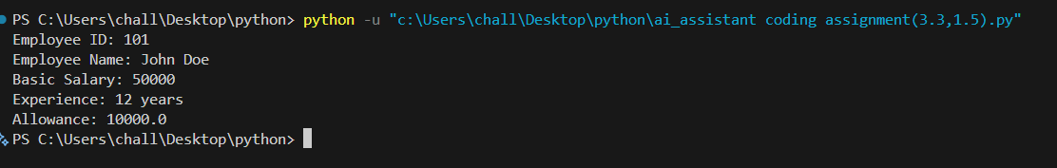

Task 2:
Electricity Bill Calculation- Create Python code that defines a class named
`ElectricityBill` with attributes: `customer_id`, `name`, and `units_consumed`. Implement a method `display_details()` to print customer details, and a method `calculate_bill()` where:
Units ≤ 100 → ₹5 per unit
- 101 to 300 units → ₹7 per unit
- More than 300 units → ₹10 per unit
Create a bill object, display details, and print the total bill amount.
CODE:
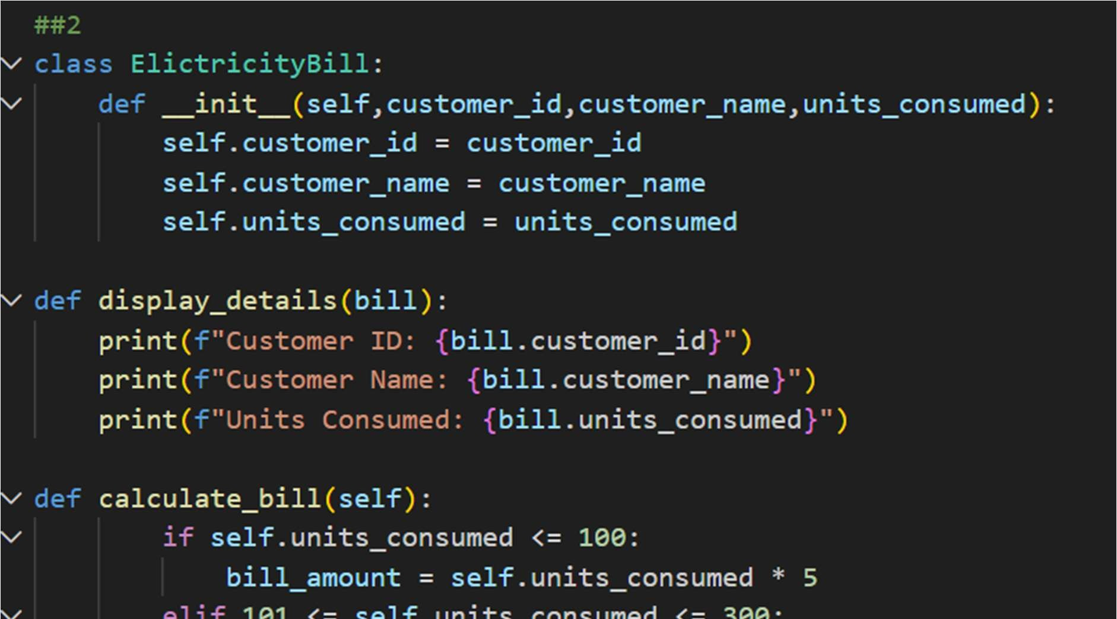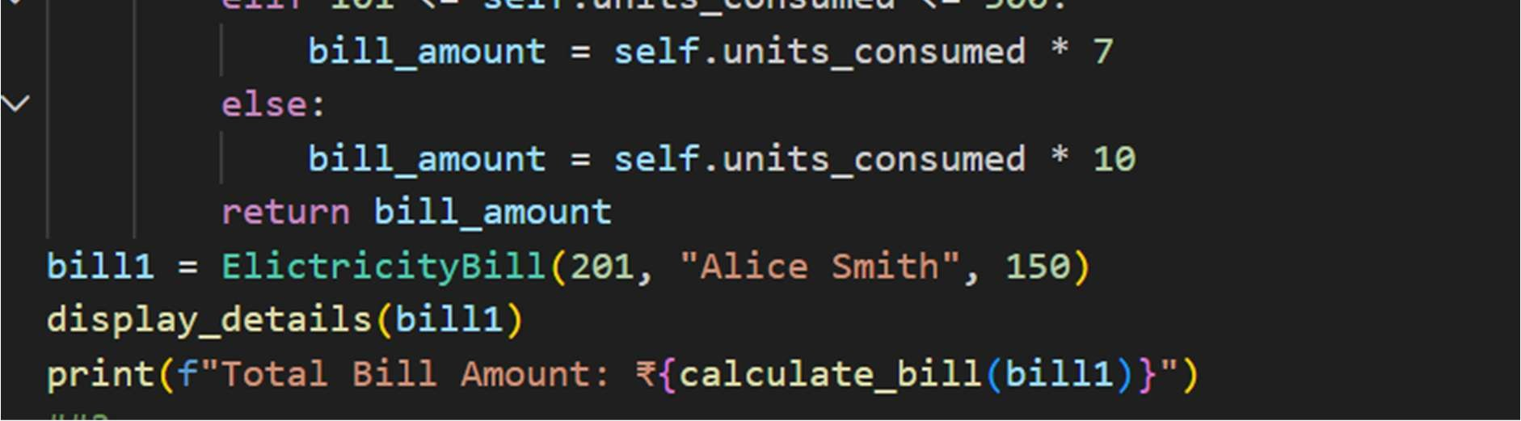
OUTPUT: 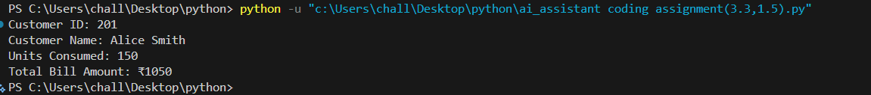

Task 3:
Product Discount Calculation- Create Python code that defines a class named `Product` with attributes: `product_id`, `product_name`,price`, and `category`. Implement a method `display_details()` to print product details. Implement another method calculate_discount()` where: - Electronics → 10% discount
- Clothing → 15% discount
- Grocery → 5% discount
Create at least one product object, display details, and print the final price after discount.
CODE:
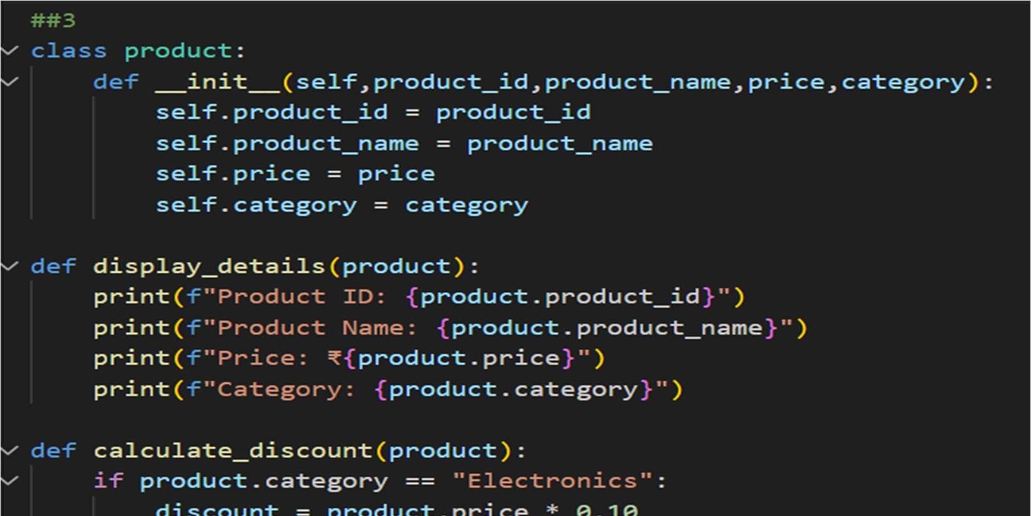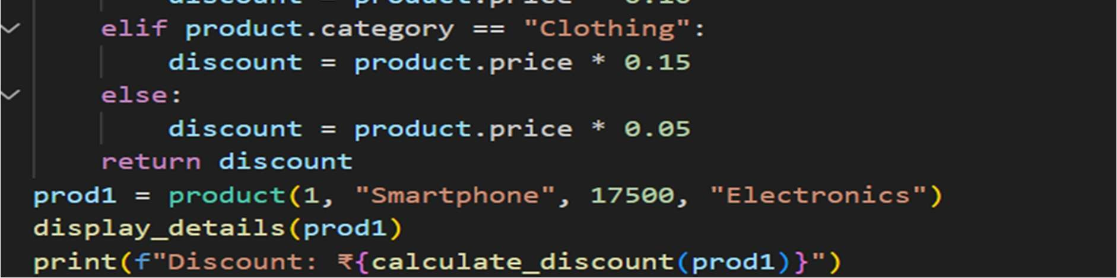
OUTPUT: 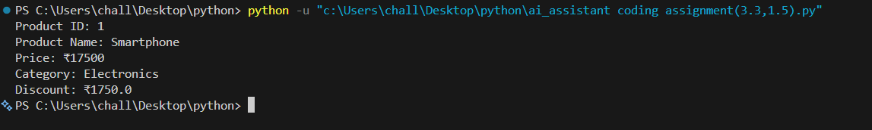

Task 4:
Book Late Fee Calculation- Create Python code that defines a class named `LibraryBook` with attributes: `book_id`, `title`, `author`,`borrower`, and days_late`. Implement a method `display_details()`to print book details, and a method `calculate_late_fee()` where:
- Days late ≤ 5 → ₹5 per day
- 6 to 10 days late → ₹7 per day
- More than 10 days late → ₹10 per day
Create a book object, display details, and print the late fee.
CODE:
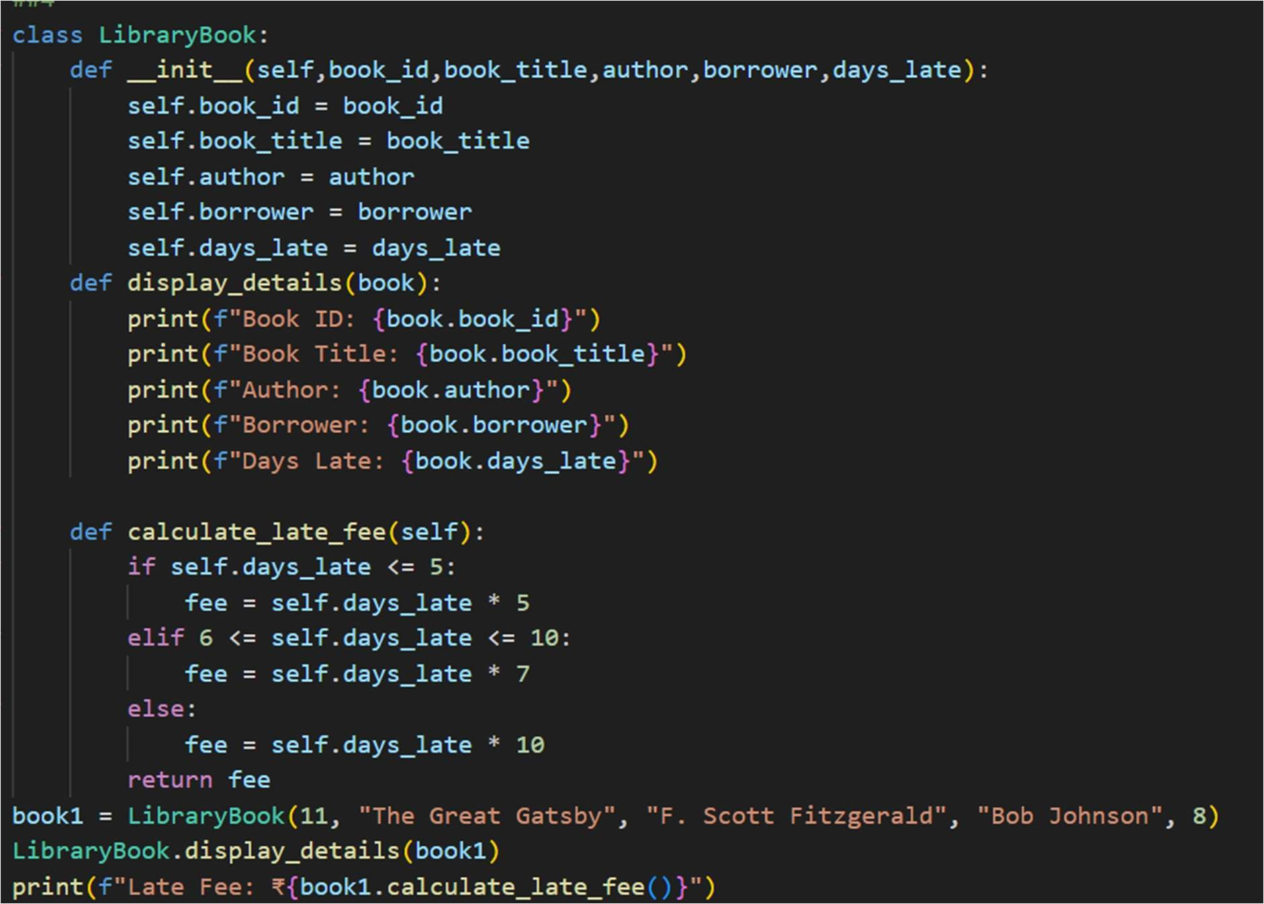
OUTPUT: 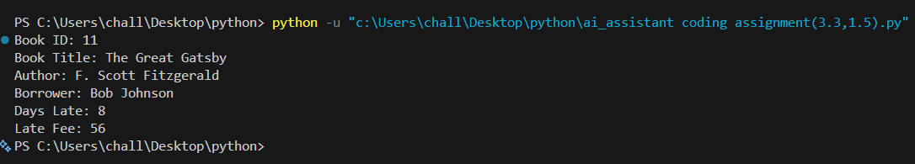

Task 6:
Taxi Fare Calculation-Create Python code that defines a class named TaxiRide` with attributes: `ride_id`, `driver_name`, `distance_km`,and `waiting_time_min`. Implement a method `display_details()` To print ride details, and a method `calculate_fare()` where:
- ₹15 per km for the first 10 km
- ₹12 per km for the next 20 km
- ₹10 per km above 30 km
- Waiting charge: ₹2 per minute
Create a ride object, display details, and print the total fare.
CODE:
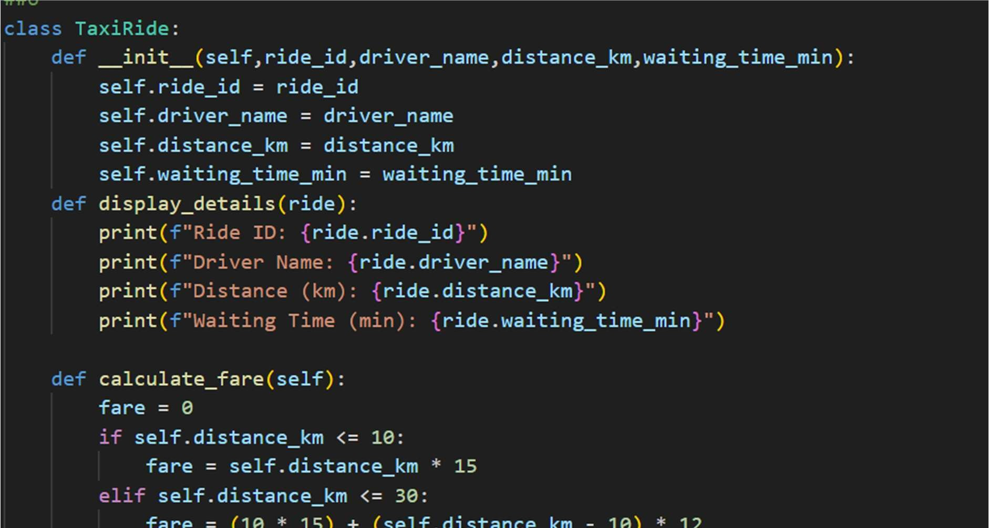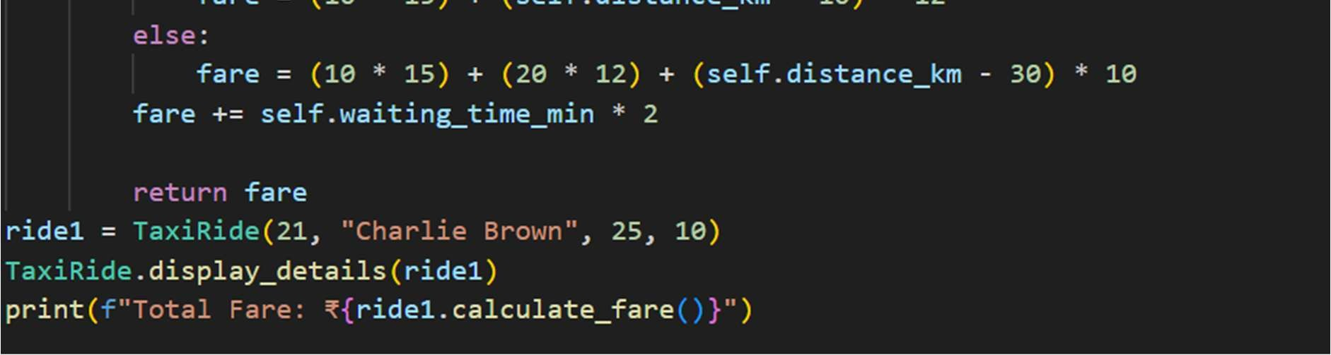
OUTPUT: 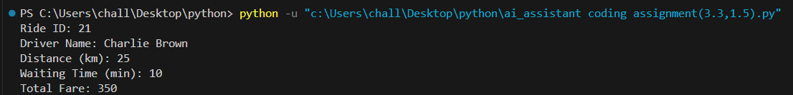

Task Description #8 (Transparency in Algorithm Optimization)
Task: Use AI to generate two solutions for checking prime numbers:
- Naive approach(basic)
- Optimized approach Prompt:
“Generate Python code for two prime-checking methods and explain how the optimized version improves performance.” Expected Output:
- Code for both methods.
- Transparent explanation of time complexity.
- Comparison highlighting e iciency improvements

CODE:

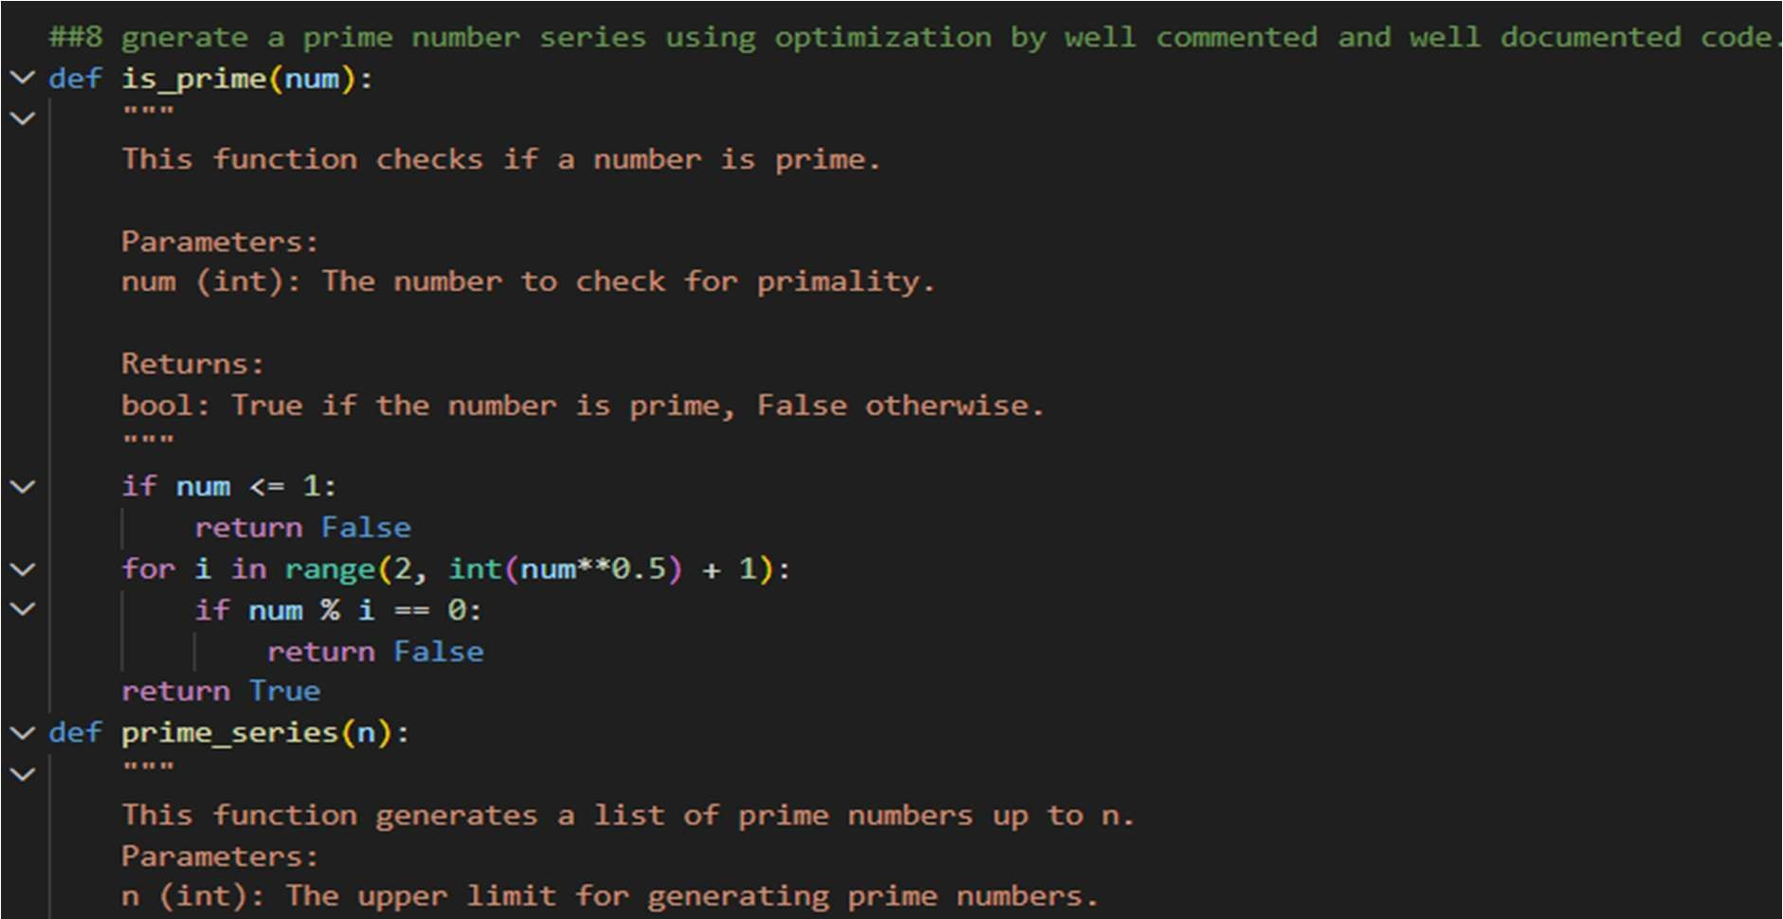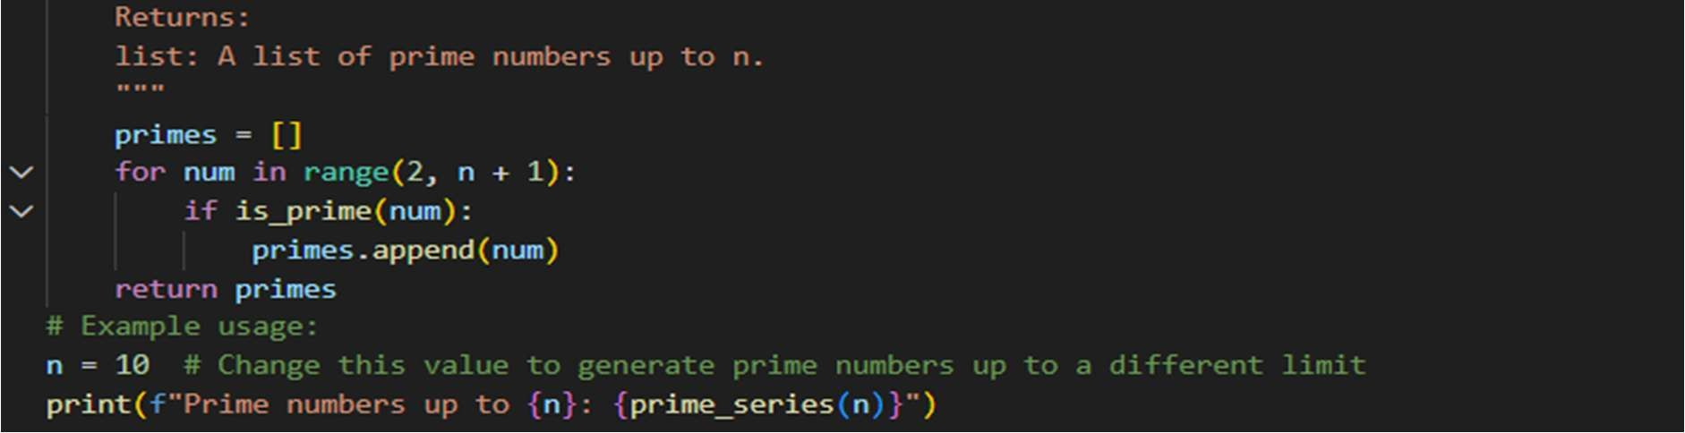
OUTPUT:

Task Description #9 (Transparency in Recursive Algorithms) Objective: Use AI to generate a recursive function to calculate Fibonacci numbers.
Instructions:
- Ask AI to add clear comments explaining recursion.
- Ask AI to explain base cases and recursive calls.
Expected Output:
- Well-commented recursive code.
- Clear explanation of how recursion works.
- Verification that explanation matches actual execution.
CODE:
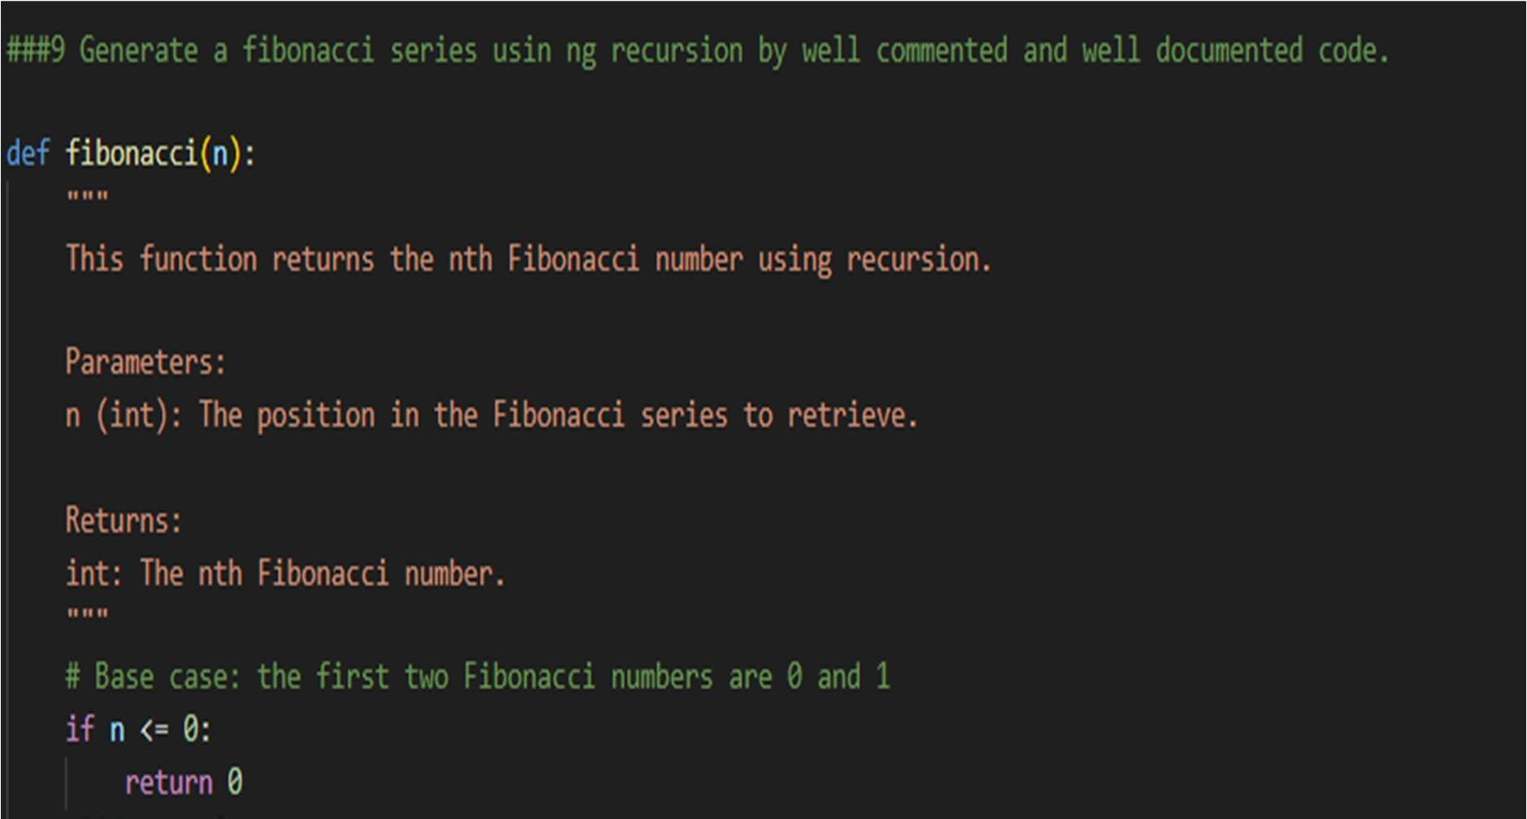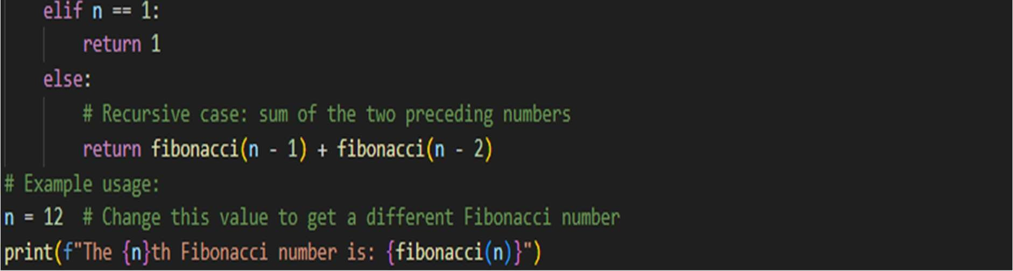
OUTPUT:

Task Description #10 (Transparency in Error Handling) Task: Use AI to generate a Python program that reads a file and processes data.
Prompt:
“Generate code with proper error handling and clear explanations for each exception.”
Expected Output:
- Code with meaningful exception handling.
- Clear comments explaining each error scenario.
- Validation that explanations align with runtime behavior.
CODE:
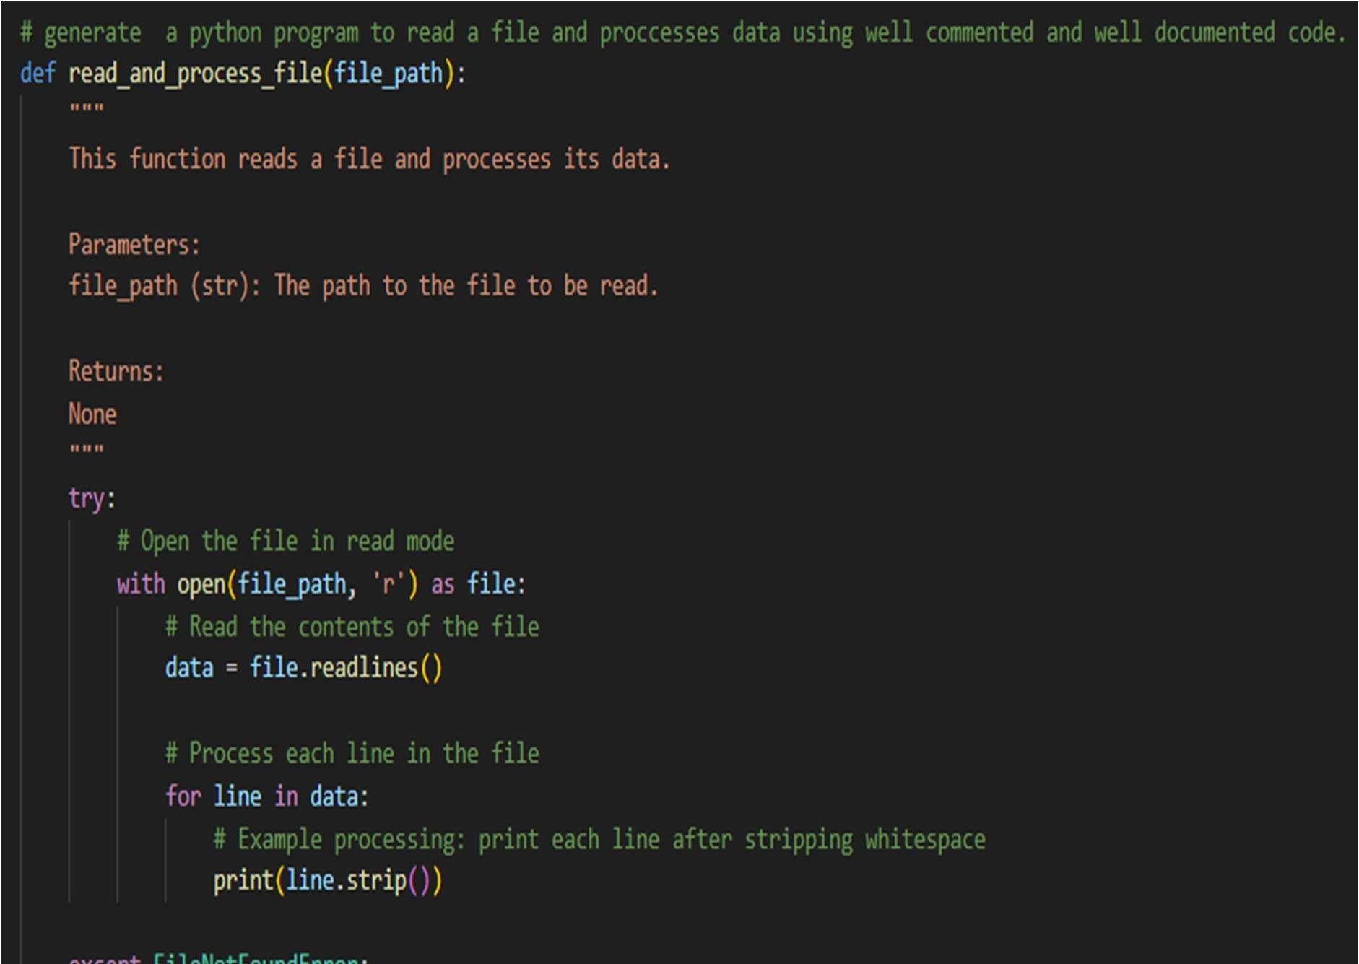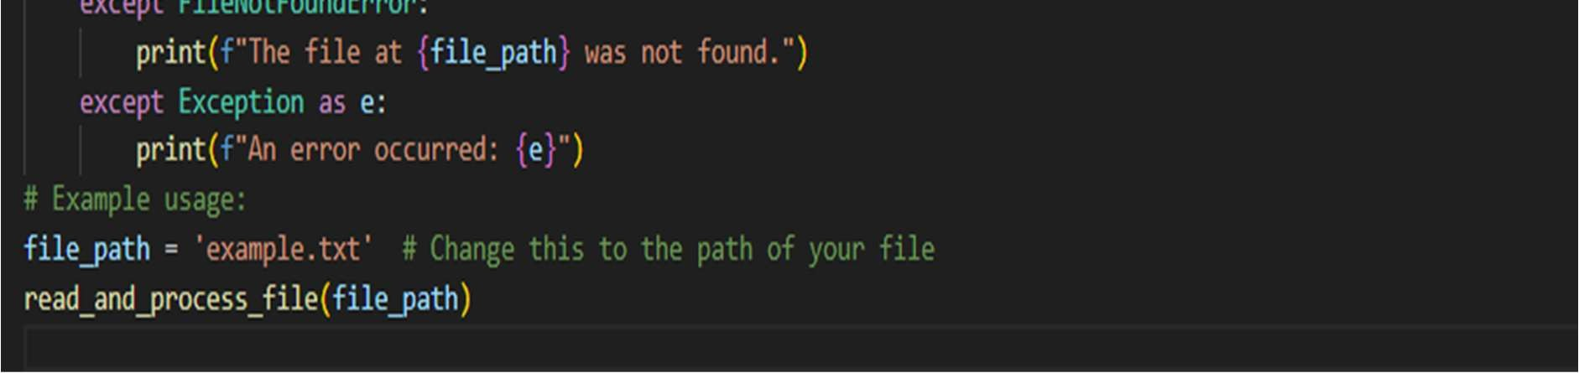
OUTPUT:

