Task 0

Question
Install and configure GitHub Copilot in VS Code.

Prompt
Install and configure GitHub Copilot in VS Code

Code
No code required. Follow installation steps in VS Code Extensions.

Output
Screenshots of Copilot installation and configuration in VS Code.

Analysis
Copilot integrates into VS Code as an extension, requiring GitHub authentication. Once enabled, it provides inline code suggestions.

Conclusion
Environment successfully set up; ready to use Copilot for AI-assisted coding.

Task 1

Code

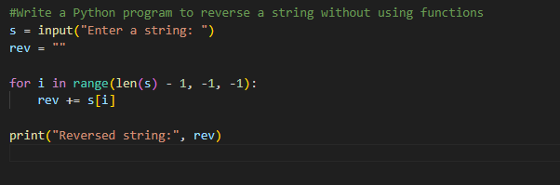Output

Analysis
Copilot generates a loop-based reversal. Readable but not modular.

Conclusion
Works correctly, but lacks reusability and clarity for larger applications.

Task 2

Question
Optimize Task 1 code for readability.

Prompt
Simplify this string reversal code

Code

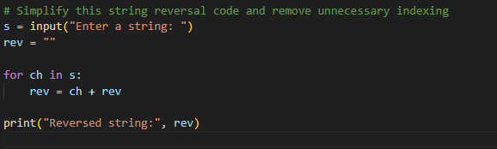Output

Analysis
Uses Python slicing ([::-1]), reducing time complexity and improving readability.

Conclusion
Optimized version is concise, efficient, and developer-friendly.

Task 3

Question
Implement string reversal using functions.

Prompt
Write a Python function to reverse a string with comments

Code

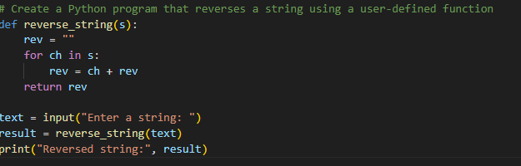Output

Analysis
Modular design improves reusability, readability, and debugging.

Conclusion
Function-based approach is better suited for larger applications.

Task 4

Question
Compare Task 1 and Task 3 approaches.

Prompt
Compare procedural vs modular string reversal approaches

Code
Comparison table below:

Output
Aspect | Procedural (Task 1) | Modular (Task 3) | Remarks
Clarity | Moderate | High | Functions improve readability
Reusability | Low | High | Functions can be reused
Debugging | Harder | Easier | Modular code is easier to test
Large-scale Suitability | Not suitable | Suitable | Modular code scales better

Analysis
Modular design wins in clarity, reusability, and scalability.

Conclusion
Function-based approach is superior for professional coding practices.

Task 5

Question
Compare loop-based and slicing-based string reversal.

Prompt
Generate iterative and slicing-based string reversal approaches

Code

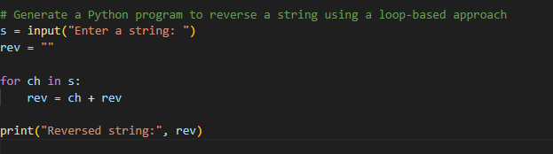Output

Analysis
Iterative: More explicit, slower for large inputs.
Slicing: Concise, efficient, Pythonic.

Conclusion
Slicing is best for performance and readability; iterative is useful for teaching algorithmic logic.

