Name: CH.Nanda Kishore
H.No:2303A51638
Batch:23
LAB-ASSIGNMENT -6
Q1: Task Description #1 (Loops – Automorphic Numbers in a Range)
• Task: Prompt AI to generate a function that displays all Automorphic
numbers between 1 and 1000 using a for loop.
• Instructions:
o Get AI-generated code to list Automorphic numbers using a for
loop.
o Analyze the correctness and efficiency of the generated logic.
o Ask AI to regenerate using a while loop and compare both
implementations.
Prompt: #generate a function that displays all automorphic numbers between 1 and 1000 usig a for loop
Code:
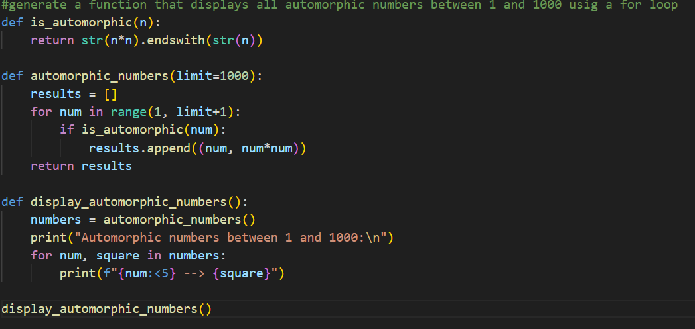output:
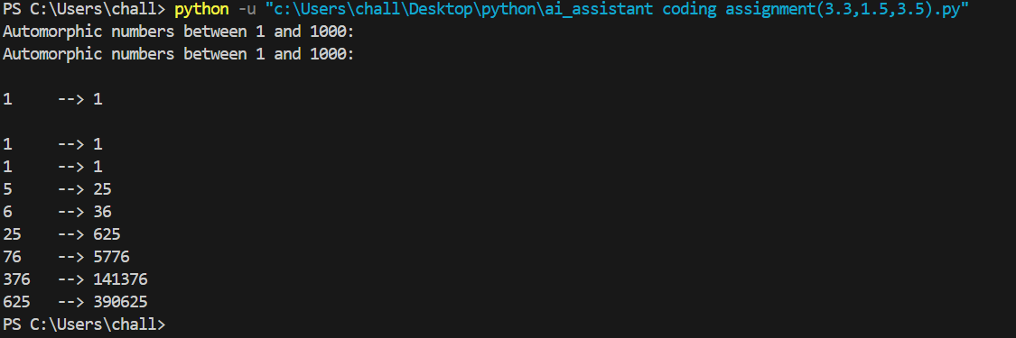Q2:
Task Description #2 (Conditional Statements – Online Shopping Feedback
Classification)
• Task: Ask AI to write nested if-elif-else conditions to classify online
shopping feedback as Positive, Neutral, or Negative based on a
numerical rating (1–5).
• Instructions:
o Generate initial code using nested if-elif-else.
o Analyze correctness and readability.
o Ask AI to rewrite using dictionary-based or match-case
structure.
Code:
Prompt:#generate a python code that classfify feedback as positive,neutral,negative based on rating 1-5
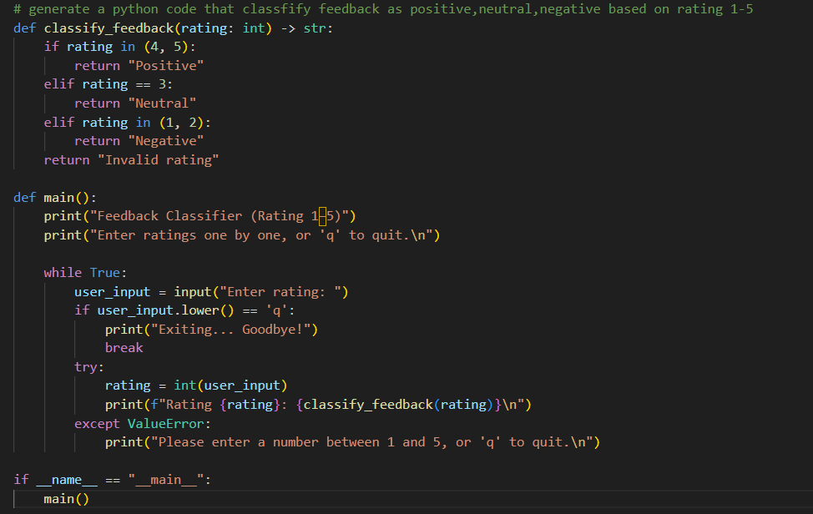output: Rating: 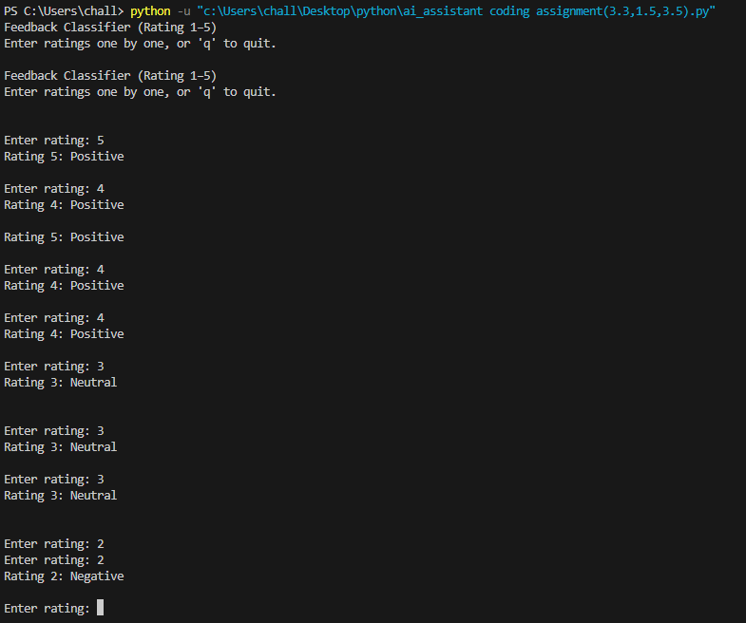
Q3: Task 3: Statistical_operations
Define a function named statistical_operations(tuple_num) that performs the
following statistical operations on a tuple of numbers:
• Minimum, Maximum
• Mean, Median, Mode
• Variance, Standard Deviation
While writing the function, observe the code suggestions provided by GitHub
Copilot.Make decisions to accept, reject, or modify the suggestions based on
their relevance and correctness
Prompt:
#generate a function named statistical_operations(tuple_num) that performs the min,max,mean,median,mode,variance,std
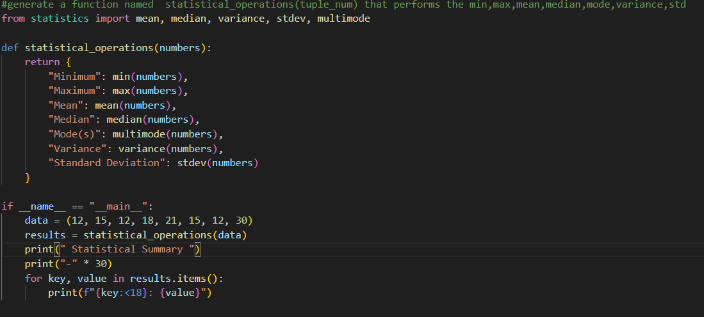Output:
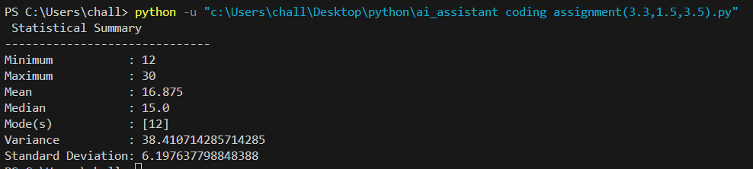Q4: Task 4: Teacher Profile
Create a class Teacher with attributes teacher_id, name,
subject, and experience. Add a method to display teacher details.
• Expected Output: Class with initializer, method, and object creation.
PROMPT:
#Create a class Teacher with attributes teacher_id, name,subject, and experience. Add a method to display teacher details.

Code:
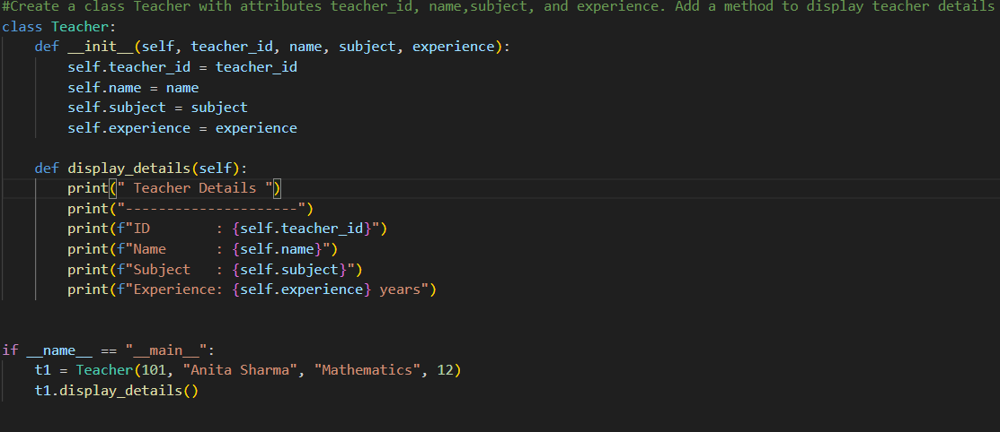
Output:
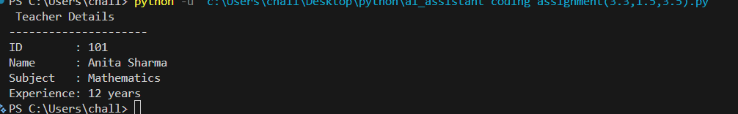
Task 5: Mobile Number Validation
Prompt:
"Generate a Python function that validates Indian mobile numbers using zero-shot prompting."
Code:
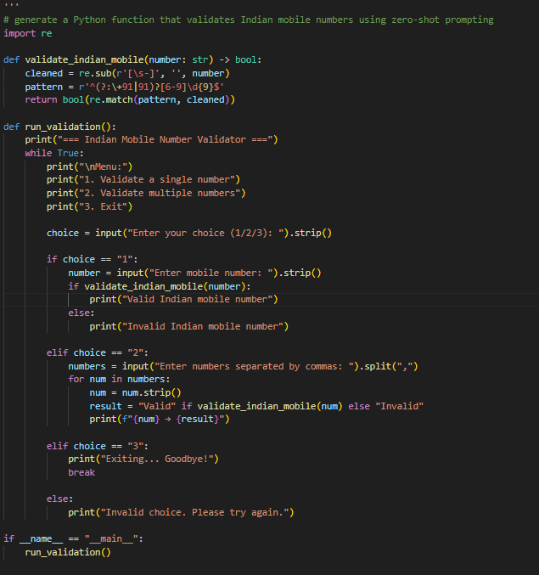
OUTPUT :
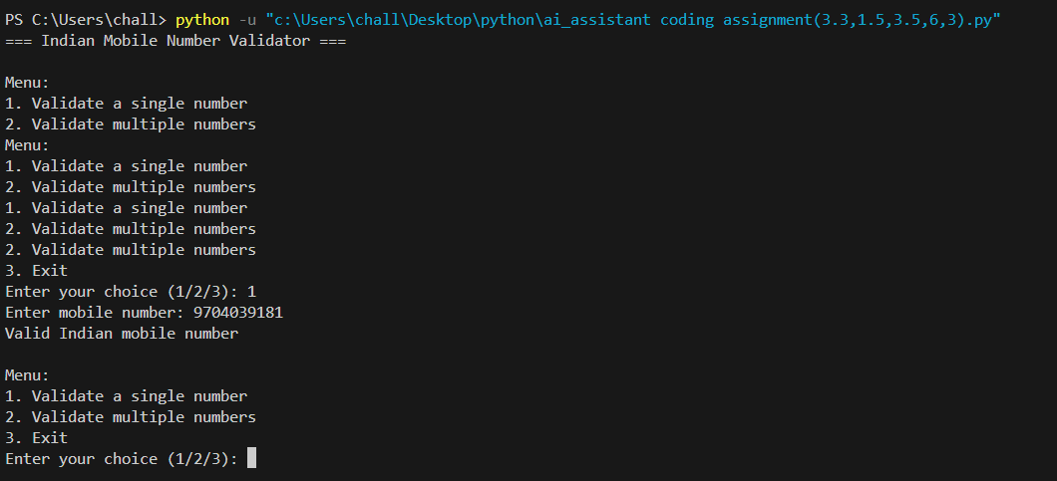
Q6: Task Description #6 (Loops – Armstrong Numbers in a Range)
Task: Write a function using AI that finds all Armstrong numbers in a user-
specified range (e.g., 1 to 1000).
Instructions:
• Use a for loop and digit power logic.
• Validate correctness by checking known Armstrong numbers (153, 370,
etc.).
• Ask AI to regenerate an optimized version (using list comprehensions).
Expected Output #7:
• Python program listing Armstrong numbers in the range.
• Optimized version with explanation.
Prompt:
#write a function that finds all armstrong numbers in given range
Code:
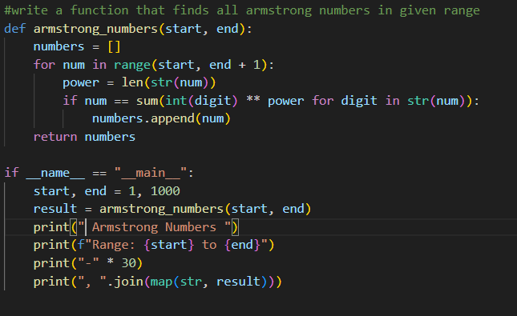output:
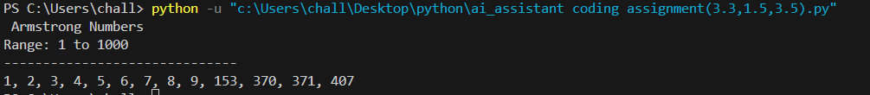
Task 7: Happy Numbers in a Range
Prompt:
"Generate Python code to list Happy Numbers between 1 and 500. Then regenerate optimized version using cycle detection."
Code:
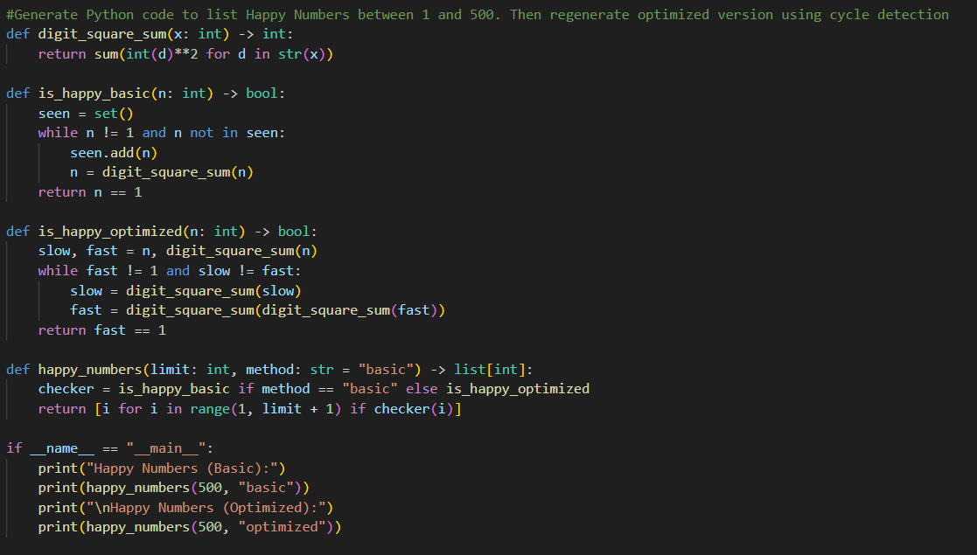
OUTPUT:

Q8: ask Description #8 (Loops – Strong Numbers in a Range)
Task: Generate a function using AI that displays all Strong Numbers (sum of
factorial of digits equals the number, e.g., 145 = 1!+4!+5!) within a given range.
Instructions:
• Use loops to extract digits and calculate factorials.
• Validate with examples (1, 2, 145).
• Ask AI to regenerate an optimized version (precompute digit factorials).
Expected Output #9:
• Python program that lists Strong Numbers.
• Optimized version with explanation.
Prompt;
#write a function that finds all armstrong numbers in given range ptimzized

Code:
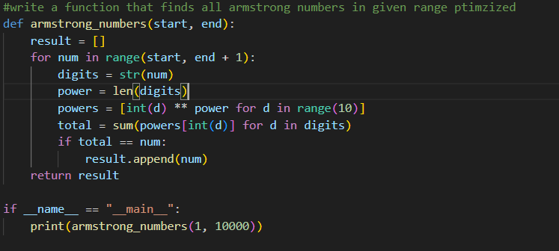output:
Task 9: Nested Dictionary Extraction
Prompt:
# Generate a function that parses nested dictionary with few-shot prompting examples
CODE:
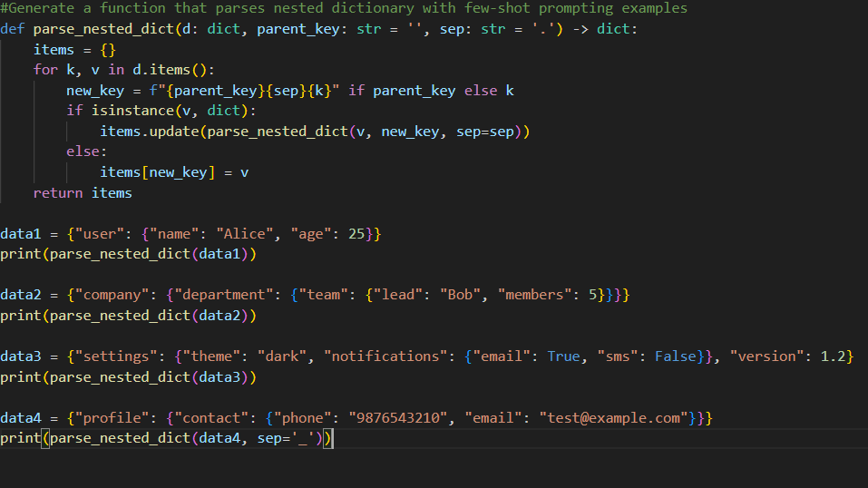
OUTPUT;
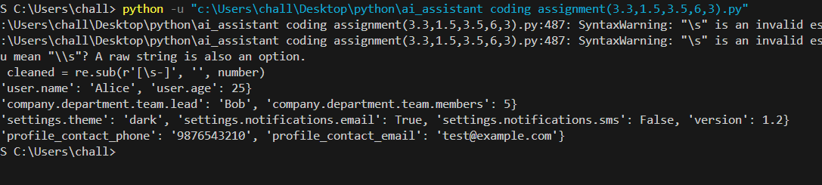

Q10: Few-Shot Prompting for Nested Dictionary Extraction
Objective
Use few-shot prompting (2–3 examples) to instruct the AI to create a
function that parses a nested dictionary representing student
information.
Requirements
• The function should extract and return:
o Full Name
o Branch
o SGPA
Expected Output
A reusable Python function that correctly navigates and extracts values
from nested dictionaries based on the provided examples
Prompt:
"Write Python code to list Perfect Numbers in a given range using a for loop. Then regenerate an optimized version that checks divisors only up to √n."
Code:
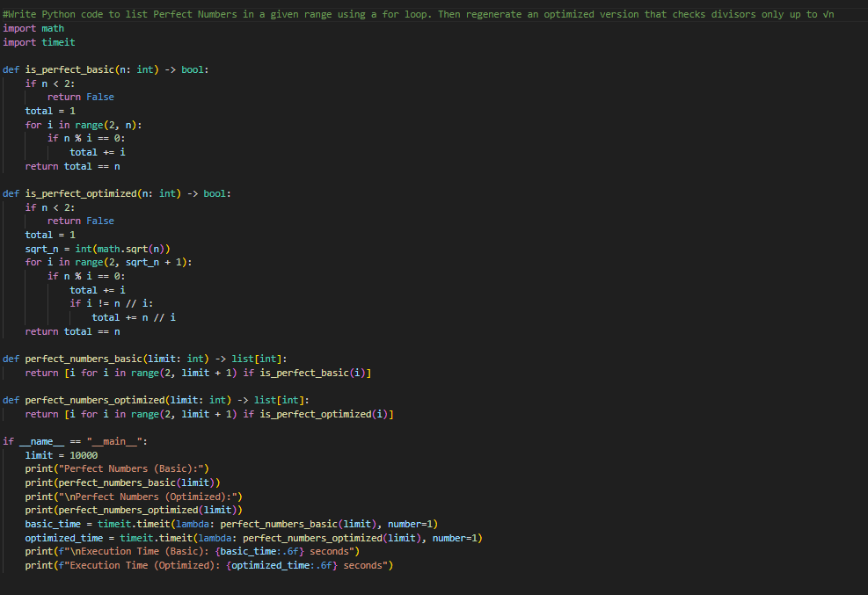
Output:
