AI Assisted Coding
Assignment – 9.1
Name: CH.Nanda kishore
Roll:2303A51638
Batch:23

Problem 1:
Consider the following Python function: def find_max(numbers): return max(numbers)
Task:
• Write documentation for the function in all three formats:
- Docstring
- Inline comments
- Google-style documentation
- Critically compare the three approaches. Discuss the advantages, disadvantages, and suitable use cases of each
style.
- Recommend which documentation style is most effective for a mathematical utilities library and justify your answer.
Code:
# (a) Docstring
- Inline comments
- Google-style documentation
- Critically compare the three approaches. Discuss the advantages, disadvantages, and suitable use cases of each
style.
- Recommend which documentation style is most effective
for a mathematical utilities library and justify your
answer.

Code:
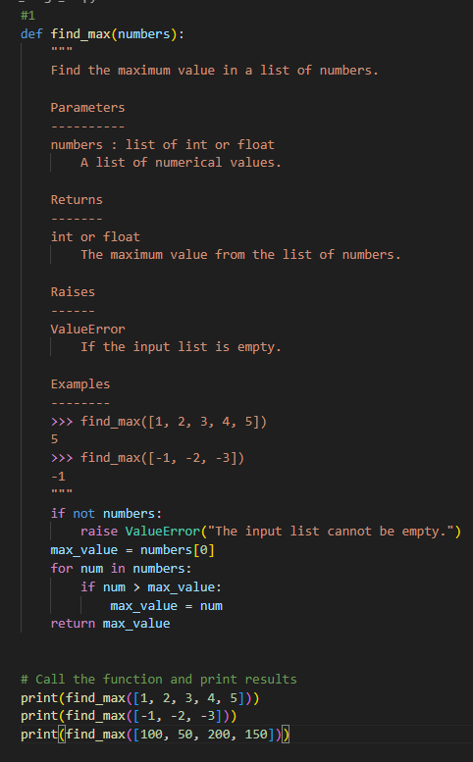
OUTPUT:
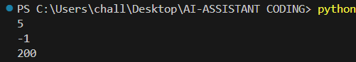
Problem 2: Consider the following Python function: def login(user, password, credentials): return credentials.get(user) == password Task:
- Write documentation in all three formats.
- Critically compare the approaches.
- Recommend which style would be most helpful for new developers onboarding a project, and justify your choice
Code:
import unittest

def login(user, password, credentials):
if user not in credentials:
raise KeyError(f"Username '{user}' does not exist.")
return credentials.get(user) == password

def register(user, password, credentials):
if user in credentials:
raise ValueError(f"Username '{user}' already exists.")
credentials[user] = password
return True

def update_password(user, old_password, new_password, credentials):
if login(user, old_password, credentials):
credentials[user] = new_password
return True
return False

def delete_user(user, credentials):
if user not in credentials:
raise KeyError(f"Username '{user}' does not exist.")
del credentials[user]
return True

# ---------------- Interactive Menu ----------------
def main():
credentials = {
'alice': 'password123',
'bob': 'securepass',
'charlie': 'mypassword'
}

while True:
print("\n--- User Management System ---")
print("1. Login")
print("2. Register")
print("3. Update Password")
print("4. Delete User")
print("5. Show Users")
print("6. Exit")
choice = input("Enter your choice: ")

if choice == "1":
user = input("Enter username: ")
password = input("Enter password: ")
try:
if login(user, password, credentials):
print("Login successful!")
else:
print("Login failed. Incorrect password.")
except KeyError as e:
print(e)

elif choice == "2":
user = input("Enter new username: ")
password = input("Enter new password: ")
try:
if register(user, password, credentials):
print("User registered successfully!")
except ValueError as e:
print(e)

elif choice == "3":
user = input("Enter username: ")
old_password = input("Enter old password: ")
new_password = input("Enter new password: ")
if update_password(user, old_password, new_password, credentials):
print("Password updated successfully!")
else:
print("Password update failed. Incorrect old password.")

elif choice == "4":
user = input("Enter username to delete: ")
try:
if delete_user(user, credentials):
print("User deleted successfully!")
except KeyError as e:
print(e)

elif choice == "5":
print("Registered users:", ", ".join(credentials.keys()))

elif choice == "6":
print("Exiting program...")
break

else:
print("Invalid choice. Try again.")

# ---------------- Unit Tests ----------------
class TestUserSystem(unittest.TestCase):
def setUp(self):
self.credentials = {
'alice': 'password123',
'bob': 'securepass',
'charlie': 'mypassword'
}

def test_login_success(self):
self.assertTrue(login('alice', 'password123', self.credentials))

def test_login_failure(self):
self.assertFalse(login('alice', 'wrongpass', self.credentials))

def test_register_new_user(self):
self.assertTrue(register('david', 'newpass', self.credentials))
self.assertIn('david', self.credentials)

def test_register_existing_user(self):
with self.assertRaises(ValueError):
register('alice', 'anotherpass', self.credentials)

def test_update_password_success(self):
self.assertTrue(update_password('bob', 'securepass', 'newsecure', self.credentials))
self.assertEqual(self.credentials['bob'], 'newsecure')

def test_update_password_failure(self):
self.assertFalse(update_password('bob', 'wrongpass', 'newsecure', self.credentials))

def test_delete_user_success(self):
self.assertTrue(delete_user('charlie', self.credentials))
self.assertNotIn('charlie', self.credentials)

def test_delete_user_failure(self):
with self.assertRaises(KeyError):
delete_user('david', self.credentials)

if __name__ == "__main__":
main()
print("\nRunning unit tests...\n")
unittest.main(exit=False)
OUTPUT:
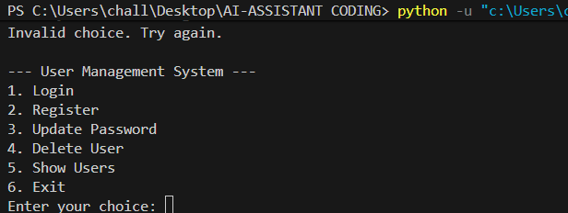
Problem 3: Calculator (Automatic Documentation Generation) Task: Design a Python module named calculator.py and demonstrate automatic documentation generation.
Instructions:
1. Create a Python module calculator.py that includes the following functions, each written with appropriate docstrings: o add(a, b) – returns the sum of two numbers o subtract(a, b) – returns the difference of two numbers o multiply(a, b) – returns the product of two numbers o divide(a, b) – returns the quotient of two numbers 2. Display the module documentation in the terminal using Python’s documentation tools.
3. Generate and export the module documentation in HTML format using the pydoc utility, and open the generated HTML file in a web browser to verify the output.

Code:
"""
conversion.py
A simple module for number system conversions.
"""

def decimal_to_binary(n):
"""Convert a decimal number to its binary representation.

Parameters
----------
n : int
A non-negative integer in decimal format.

Returns
-------
str
The binary representation of the input decimal number.

Raises
------
ValueError
If n is negative.

Examples
--------
>>> decimal_to_binary(10)
'1010'
>>> decimal_to_binary(0)
'0'
"""
if n < 0:
raise ValueError("Input must be a non-negative integer.")
return bin(n)[2:]

def binary_to_decimal(b):
"""Convert a binary string to its decimal representation.

Parameters
----------
b : str
A binary string.

Returns
-------
int
The decimal representation of the input binary string.

Raises
------
ValueError
If b is not a valid binary string.

Examples
--------
>>> binary_to_decimal('1010')
10
>>> binary_to_decimal('0')
0
"""
try:
return int(b, 2)
except ValueError:
raise ValueError("Input must be a valid binary string.")

def decimal_to_hexadecimal(n):
"""Convert a decimal number to its hexadecimal representation.

Parameters
----------
n : int
A non-negative integer in decimal format.

Returns
-------
str
The hexadecimal representation of the input decimal number.

Raises
------
ValueError
If n is negative.

Examples
--------
>>> decimal_to_hexadecimal(255)
'ff'
>>> decimal_to_hexadecimal(0)
'0'
"""
if n < 0:
raise ValueError("Input must be a non-negative integer.")
return hex(n)[2:]

Problem 4: Conversion Utilities Module
Task:
1. Write a module named conversion.py with functions:
o decimal_to_binary(n) o binary_to_decimal(b) o decimal_to_hexadecimal(n)
- Use Copilot for auto-generating docstrings.
- Generate documentation in the terminal.
- Export the documentation in HTML format and open it in a browser.

Code:
"""
conversion.py
A simple module for number system conversions.
"""

def decimal_to_binary(n):
"""Convert a decimal number to its binary representation.

Args:
n (int): A non-negative integer in decimal format.

Returns:
str: The binary representation of the input decimal number.

Raises:
ValueError: If n is negative.

Examples:
>>> decimal_to_binary(10)
'1010'
>>> decimal_to_binary(0)
'0'
"""
if n < 0:
raise ValueError("Input must be a non-negative integer.")
return bin(n)[2:]

def binary_to_decimal(b):
"""Convert a binary string to its decimal representation.

Args:
b (str): A binary string.

Returns:
int: The decimal representation of the input binary string.

Raises:
ValueError: If b is not a valid binary string.

Examples:
>>> binary_to_decimal('1010')
10
>>> binary_to_decimal('0')
0
"""
try:
return int(b, 2)
except ValueError:
raise ValueError("Input must be a valid binary string.")

def decimal_to_hexadecimal(n):
"""Convert a decimal number to its hexadecimal representation.

Args:
n (int): A non-negative integer in decimal format.

Returns:
str: The hexadecimal representation of the input decimal number.

Raises:
ValueError: If n is negative.

Examples:
>>> decimal_to_hexadecimal(255)
'ff'
>>> decimal_to_hexadecimal(0)
'0'
"""
if n < 0:
raise ValueError("Input must be a non-negative integer.")
return hex(n)[2:]

Problem 5 – Course Management Module
Task:
- Create a module course.py with functions: o add_course(course_id, name, credits) o remove_course(course_id) o get_course(course_id)
- Add docstrings with Copilot.
- Generate documentation in the terminal.
- Export the documentation in HTML format and open it in a browser.
Code:
"""
courses.py
A simple course management system.
"""

courses = {}

def add_course(course_id, name, credits):
"""Add a course to the course management system.

Args:
course_id (str): The unique identifier for the course.
name (str): The name of the course.
credits (int): The number of credits for the course.

Returns:
None

Examples:
>>> add_course('CS101', 'Introduction to Computer Science', 3)
>>> add_course('MATH201', 'Calculus I', 4)
"""
courses[course_id] = {'name': name, 'credits': credits}

def remove_course(course_id):
"""Remove a course from the course management system.

Args:
course_id (str): The unique identifier for the course to be removed.

Returns:
None

Raises:
KeyError: If the course_id does not exist.

Examples:
>>> remove_course('CS101')
>>> remove_course('MATH201')
"""
if course_id in courses:
del courses[course_id]
else:
raise KeyError(f"Course ID '{course_id}' does not exist.")

def get_course(course_id):
"""Retrieve course information from the course management system.

Args:
course_id (str): The unique identifier for the course to be retrieved.

Returns:
dict: A dictionary containing the course name and credits.

Raises:
KeyError: If the course_id does not exist.

Examples:
>>> get_course('CS101')
{'name': 'Introduction to Computer Science', 'credits': 3}
>>> get_course('MATH201')
{'name': 'Calculus I', 'credits': 4}
"""
if course_id in courses:
return courses[course_id]
else:
raise KeyError(f"Course ID '{course_id}' does not exist.")

