Lab_Assignment_6.4
H.no: 2303A1648
Task 1: Student Performance Evaluation System
Prompt: # create a python class named student with the attributes name, roll_num,marks
# the code display student details and checks whether the student's marks are above the class average or not if not then return an appropriate message.user input velue for student details and marks of 3 students
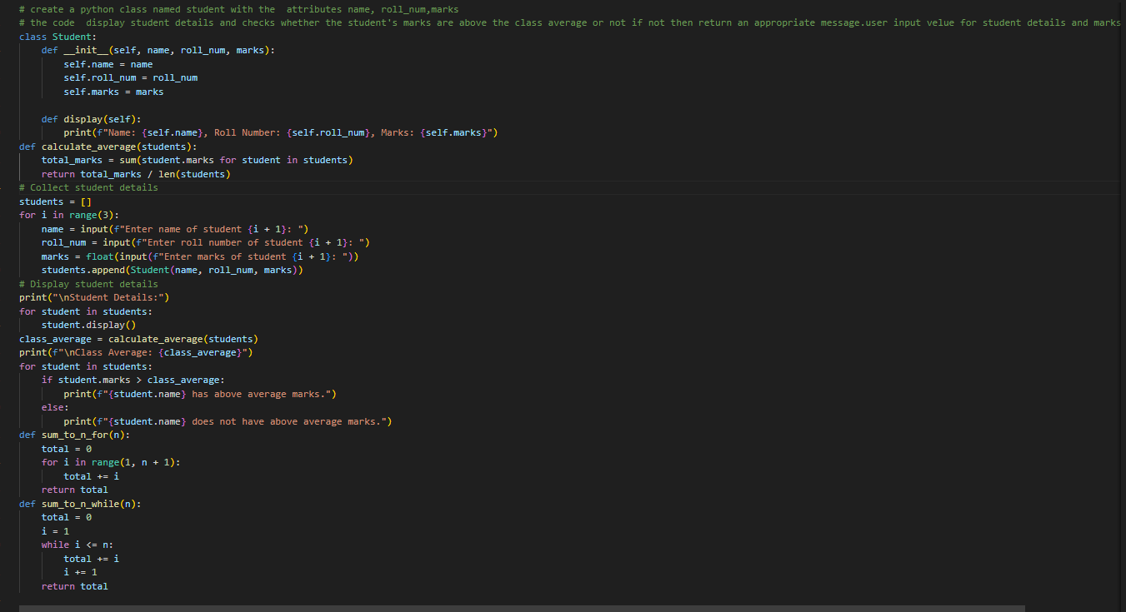
Output:
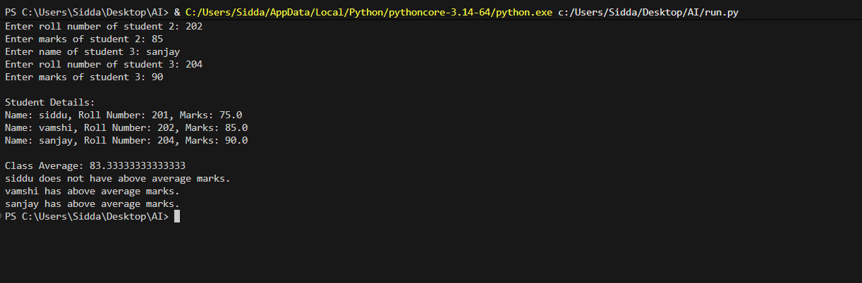

Task 2: Data Processing in a Monitoring System
Prompt:
# create a python code using part of for loop to iterate over a list of integers that represent sensor readings.
# Identify even numbers in the sensor readings using the modulus operator
# Calculate the square of the even number,Print the result in a readable format. user input list of integers.
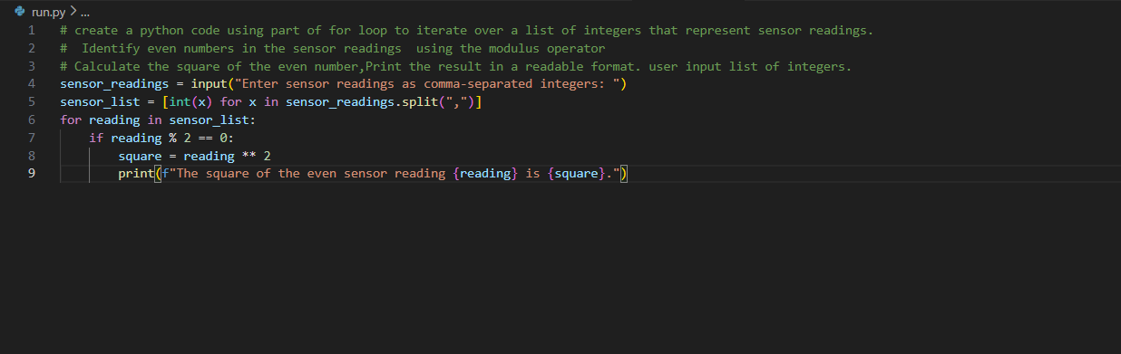
Output:
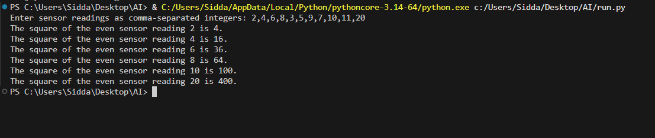
Task 3: Banking Transaction Simulation
Prompt: #Write a Python class named BankAccount with attributes account_holder and balance. Add methods to deposit money, withdraw money, and prevent withdrawal if the balance is insufficient. Use clear if-else conditions and print user-friendly messages.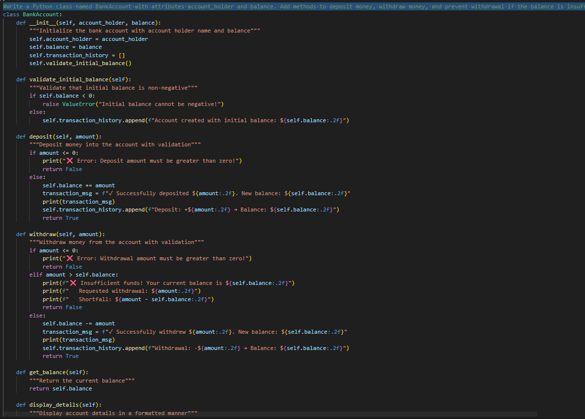

Output:
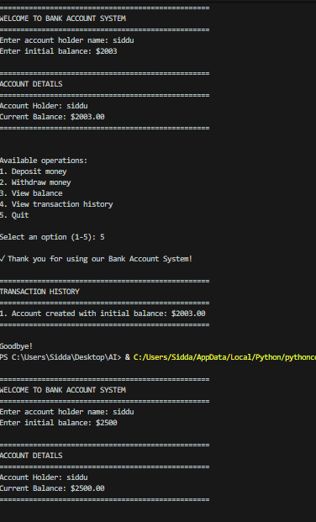
Task 4: Student Scholarship Eligibility Check
Prompt:
Create a Python script that defines a list of students (name and score) and uses a while loop to display students eligible for a scholarship (score > 75)
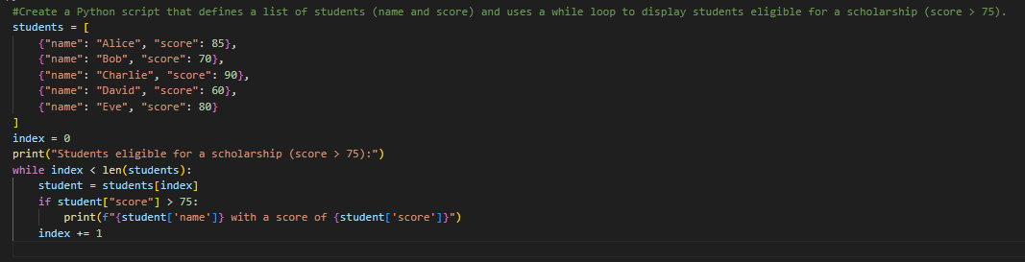
Output:
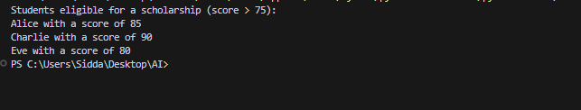
Task 5: Online Shopping Cart Module
Prompt:
#Write a Python code create some 10 random items and price quantity , user take input can add items, remove items and calculate the total bill , and apply a discount if the total exceeds a certain amount.

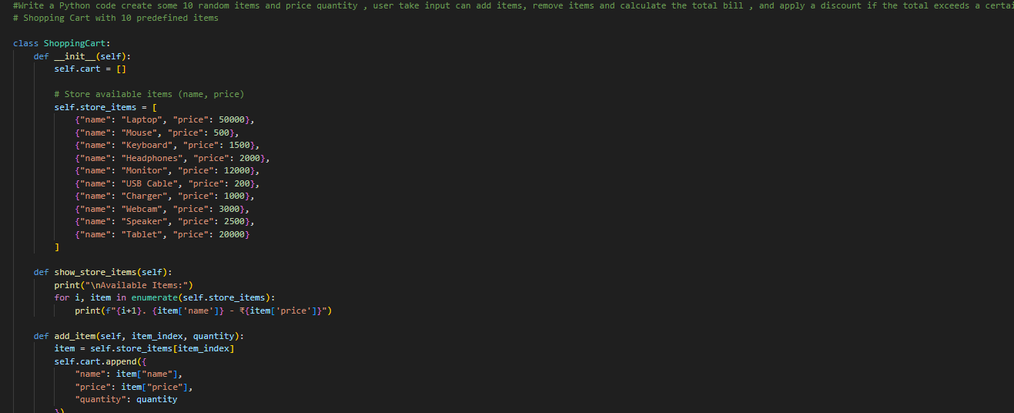
Output:
