Lab_Assignment_3.4

2303A51648
Task 1: Zero-shot Prompt – Fibonacci Series Generator
Prompt:
# Generate a Python function that takes an integer N as input and prints the first N Fibonacci numbers using clear logic and proper structure.
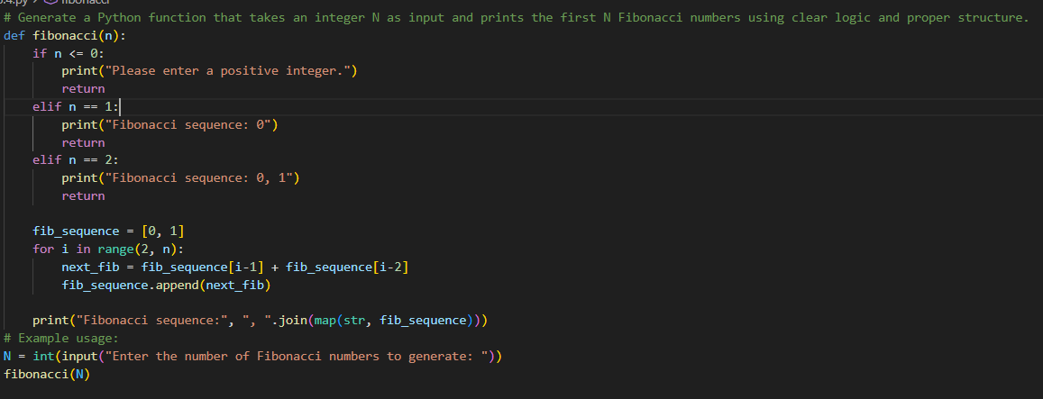
Output:
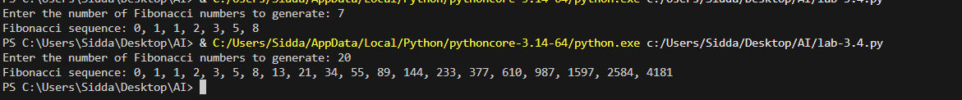
Task 2: One-shot Prompt – List Reversal Function
Prompt:
#create a pytho code that take usre list of integers and print the reversed list example: [1,2,3] output: [3.,2,1]
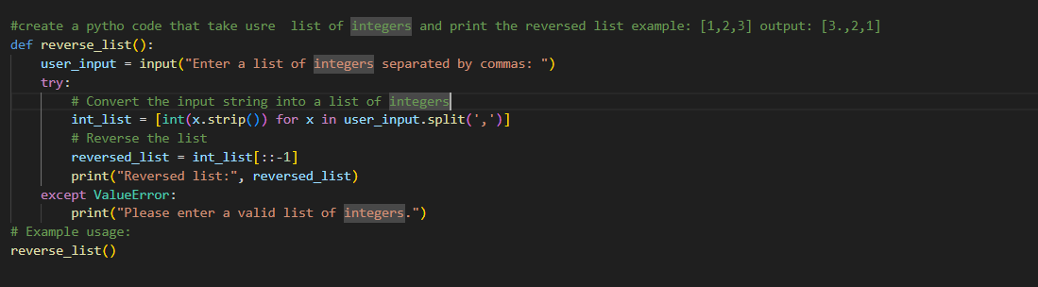
Output:
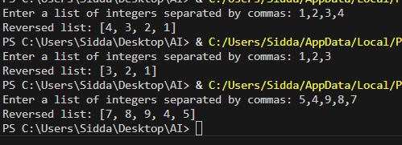
Task 3: Few-shot Prompt – String Pattern Matching
Prompt:
# Write a program with a function is_valid(text) that checks whether the user-input string
# starts with a capital letter and ends with a period.
# Examples:
# Input: "Hello world." → True
# Input: "hello world." → False
# Input: "Hello world" → False
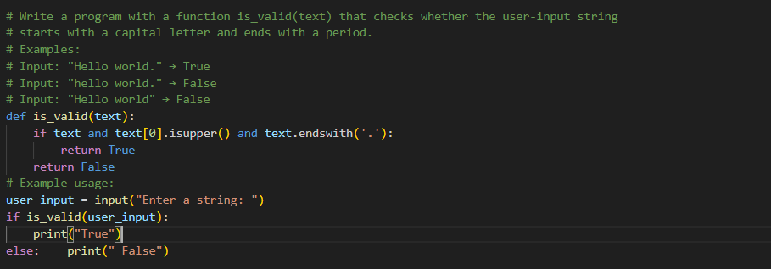
Output:
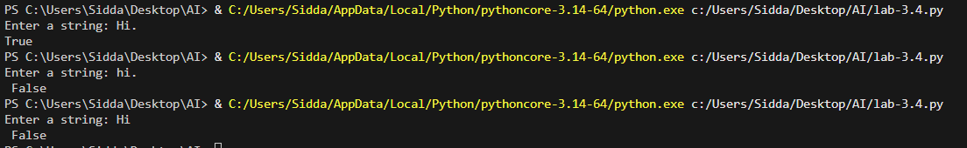
Task 4: Zero-shot vs Few-shot – Email Validator
Zero-Shot Prompt
# Write a Python function is_valid_email(email) that validates whether an email address is in a correct format and returns True or False. 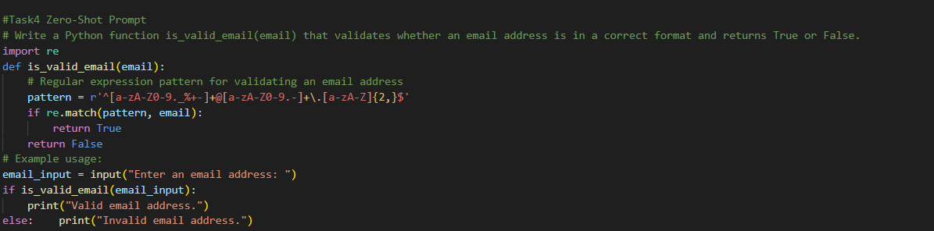
Output:

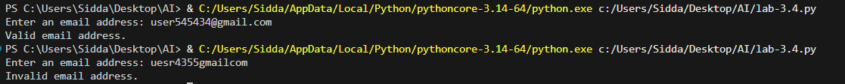
Few-Shot Prompt
# Write a Python function is_valid_email(email) that validates an email address.
# The function should return True or False.
# Examples:
# is_valid_email("user@example.com") → True
# is_valid_email("john.doe@mail.co") → True
# is_valid_email("userexample.com") → False
# is_valid_email("user@@example.com") → False
# is_valid_email(".user@example.com") → False
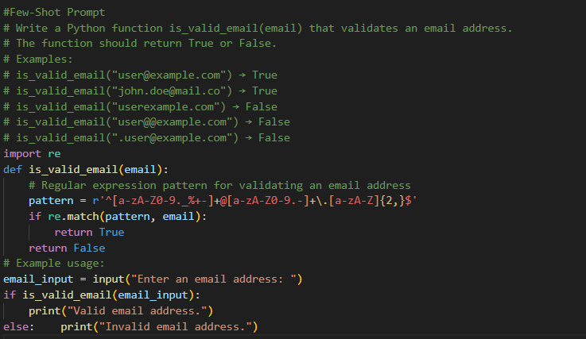
Task 5: Prompt Tuning – Summing Digits of a Number
Prompt:
Generic Task Prompt:
# Write a Python code that takes an integer and returns the sum of its digits.
Task + Input/Output Example:
# Write a Python function sum_of_digits(n) that returns the sum of digits of a number.
# Example:
# sum_of_digits(1234) → 10
# sum_of_digits(500) → 5
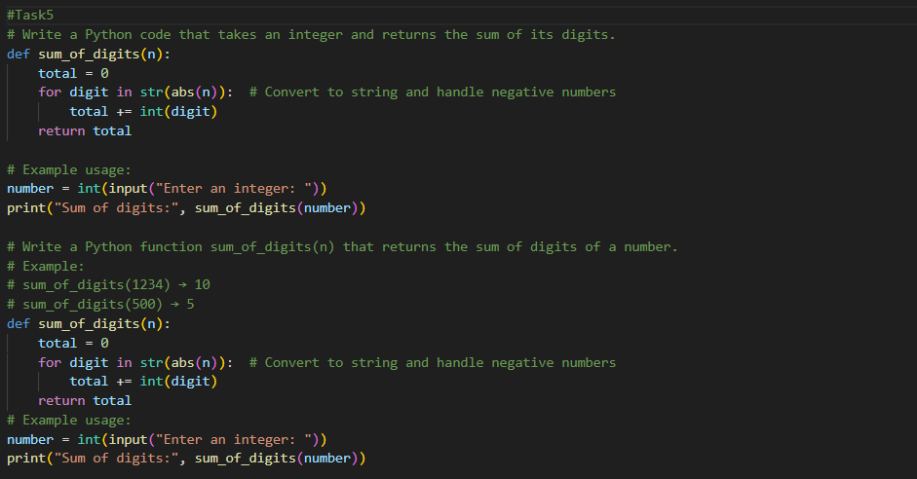
Output:
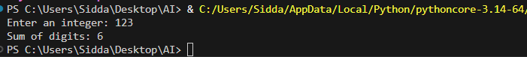
CODE EXPLANATION:
# Task 1: The function `fibonacci(n)` generates the first N Fibonacci numbers. It checks for edge cases (like non-positive integers) and builds the sequence iteratively, storing it in a list and printing it at the end.
# Task 2: The function `reverse_list()` prompts the user for a list of integers, converts the input string into a list of integers, reverses the list using slicing, and prints the reversed list.
# Task 3: The function `is_valid(text)` checks if the input string starts with a capital letter and ends with a period. It returns True if both conditions are met, otherwise it returns False.
# Task 4: The function `is_valid_email(email)` uses a regular expression to validate the format of an email address. It checks for a valid username, an '@' symbol, a domain name, and a top-level domain.
# Task 5: The function `sum_of_digits(n)` calculates the sum of the digits in an integer. It converts the number to a string to iterate over each digit, converts each digit back to an integer, and sums them up. It also handles negative numbers by taking the absolute value.

