Lab Assignment 8.3
2303A51648
Task 1: Email Validation using TDD
Prompt:
# Test-Driven Development with AI – Email Validation
# I’m building a user registration system and need a reliable way to validate email addresses. To make sure the validation works correctly, I want to follow a Test-Driven Development (TDD) approach. The email should contain both @ and . characters, must not start or end with special characters, and should not allow more than one @ symbol. Use AI to generate test cases for both valid and invalid email formats, and implement the function is_valid_email(email) so that it passes all the tests.
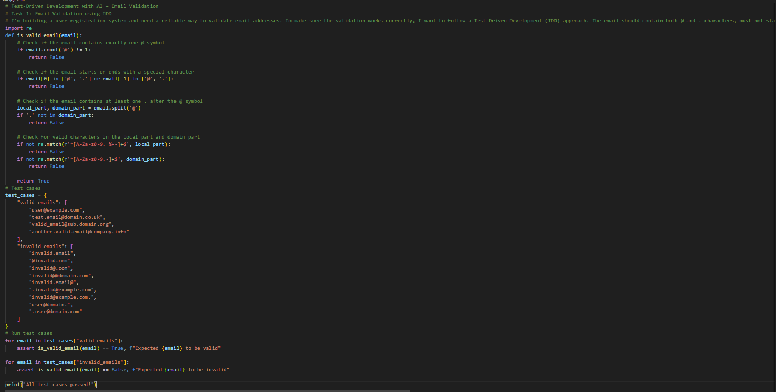
Task 2: Grade Assignment using Loops
Prompt:
# Task 2: Grade Assignment using Loops
# I am creating an automated grading feature for an online examination system. Use AI to generate test cases for assign_grade(score) with grading rules: 90–100 → A, 80–89 → B, 70–79 → C, 60–69 → D, and below 60 → F. Include boundary values (60, 70, 80, 90) and invalid inputs such as -5, 105, and "eighty". Implement the function following a test-driven development approach. At the end, prompt the user to enter a score and display the resulting grade.
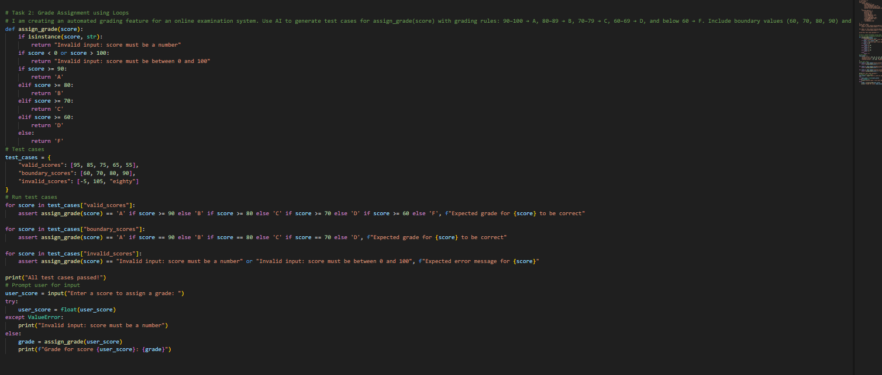
Output:
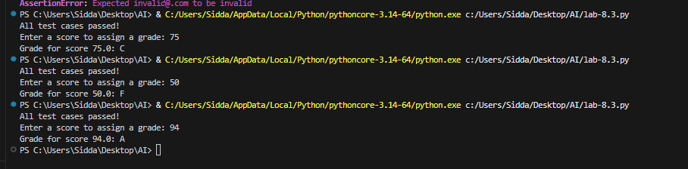
Task 3: Sentence Palindrome Checker
Prompt:
# I am building a text processing feature to determine if a sentence is a palindrome. The program should take input from the user and display the result. AI should create test cases for is_sentence_palindrome(sentence) while ignoring case sensitivity, spaces, and punctuation. Test both palindrome and non-palindrome cases. Example: "A man a plan a canal Panama" → True.
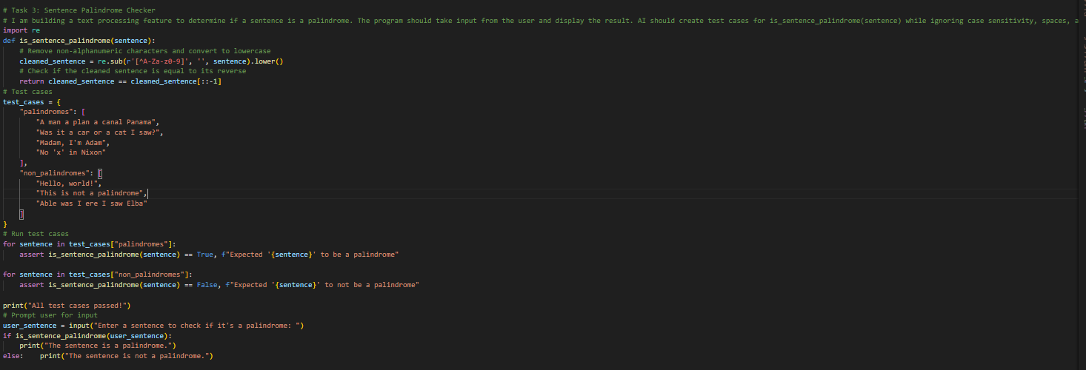
Task 4: ShoppingCart Class
Prompt:
# I am creating a shopping cart feature for an online shopping application. The ShoppingCart class should allow users to manage items by adding and removing them and calculating the total cost. Verify correct functionality for addition, removal, and price calculation, and ensure empty cart cases are handled.
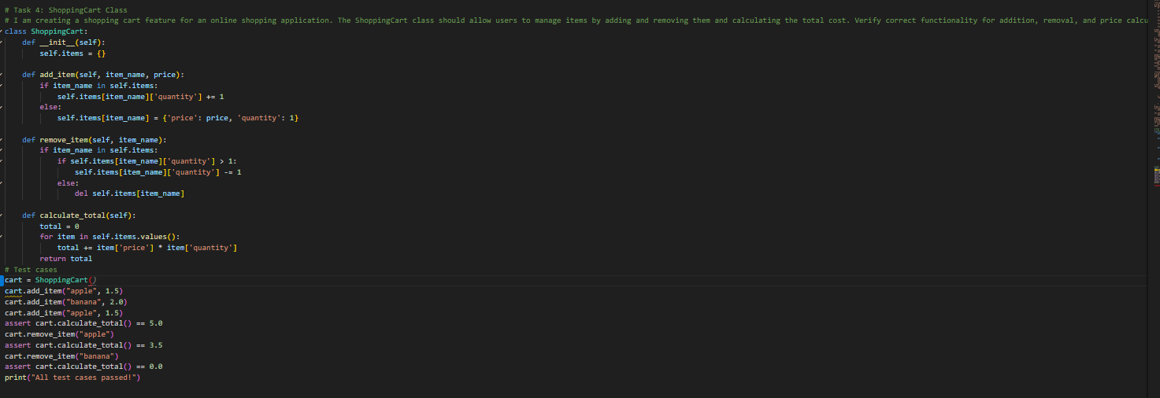
Task 5: Date Format Conversion
Prompt:
# I am building a date conversion utility for reports. Use AI to create test cases for convert_date_format(date_str) where the input format is "YYYY-MM-DD" and the expected output format is "DD-MM-YYYY". Example: "2023-10-15" → "15-10-2023".
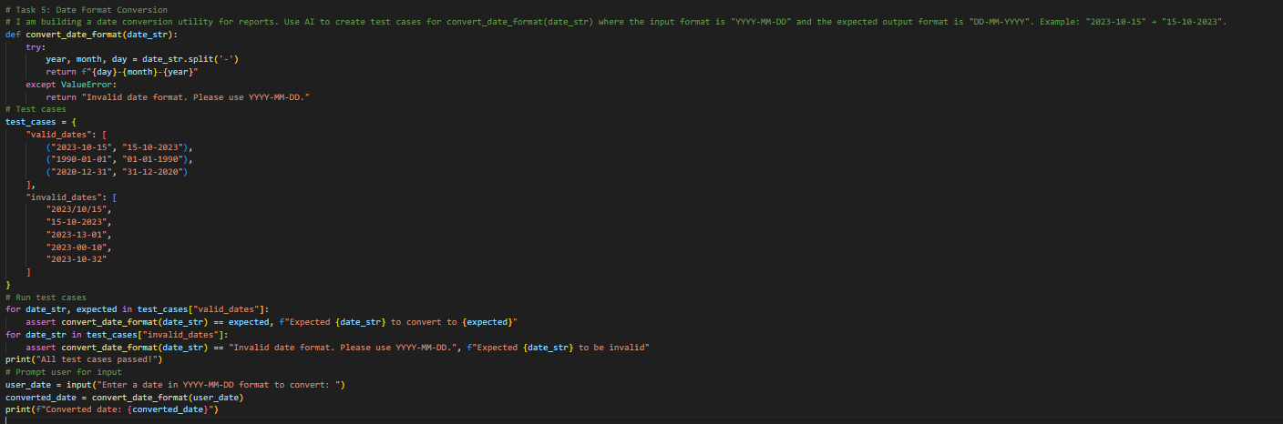
CODE EXPLANATION:

# Task 1: This task involves creating a function to validate email addresses based on specific criteria. The function checks for the presence of '@' and '.' characters, ensures the email does not start or end with special characters, and validates the format of the local and domain parts. Test cases are provided to verify both valid and invalid email formats.
# Task 2: This task implements a grading system that assigns letter grades based on numerical scores. The function checks for valid input and assigns grades according to defined thresholds. Test cases include valid scores, boundary values, and invalid inputs to ensure the function behaves as expected.
# Task 3: This task checks if a given sentence is a palindrome by removing non-alphanumeric characters and ignoring case sensitivity. The function compares the cleaned sentence to its reverse to determine if it is a palindrome. Test cases include both palindrome and non-palindrome sentences.
# Task 4: This task defines a ShoppingCart class that allows users to add and remove items and calculate the total cost. The class uses a dictionary to store items, their prices, and quantities. Test cases verify the functionality of adding items, removing items, and calculating the total cost.
# Task 5: This task creates a function to convert date formats from "YYYY-MM-DD" to "DD-MM-YYYY". The function splits the input string and rearranges the components. Test cases include valid date formats and invalid formats to ensure the function handles errors appropriately.
hgh

