Lab Assignment 4.3
H.no: 2303A51648

Lab 4: Advanced Prompt Engineering – Zero-shot, One-shot, and Few-shotTechniques
Lab Objectives
• To explore and apply different levels of prompt examples in AI-assisted code generation
• To understand how zero-shot, one-shot, and few-shot prompting affect AI output quality
• To evaluate the impact of context richness and example quantity on AI performance
• To build awareness of prompt strategy effectiveness for different problem types
Lab Outcomes (LOs)
After completing this lab, students will be able to:
• Use zero-shot prompting to instruct AI with minimal context
• Use one-shot prompting with a single example to guide AI code generation
• Apply few-shot prompting using multiple examples to improve AI responses
• Compare AI outputs across different prompting strategies
Task 1: Zero-Shot Prompting – Leap Year Check Scenario
Zero-shot prompting involves giving instructions without providing examples.
Task Description
Use zero-shot prompting to instruct an AI tool to generate a Python function that:
• Accepts a year as input
• Checks whether the given year is a leap year
• Returns an appropriate result
Note: No input-output examples should be provided in the prompt.
Expected Output
• AI-generated leap year checking function
• Correct logical conditions
• Sample input and output
• Screenshot of AI-generated response (if required)
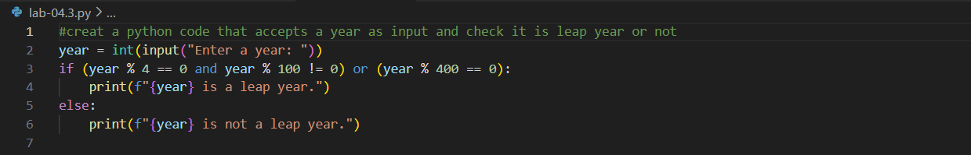
Output:
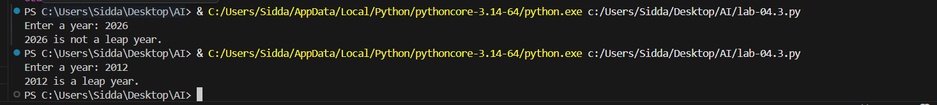
Task 2: One-Shot Prompting – Centimeters to Inches Conversion
Scenario: One-shot prompting guides AI using a single example.
Task Description
Use one-shot prompting by providing one input-output example to generate a Python function that:
• Converts centimeters to inches
• Uses the correct mathematical formula
Example provided in prompt:
Input: 10 cm → Output: 3.94 inches
Expected Output
• Python function with correct conversion logic
• Accurate calculation
• Sample test cases and outputs
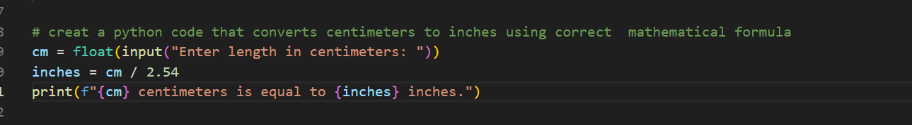
Output:
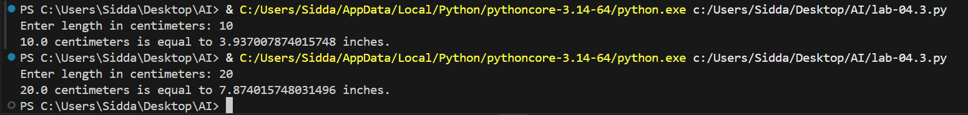
Task 3: Few-Shot Prompting – Name Formatting
Scenario: Few-shot prompting improves accuracy by providing multiple examples.
Task Description
Use few-shot prompting with 2–3 examples to generate a Python function that:
• Accepts a full name as input
• Formats it as “Last, First”
Example formats:
• "John Smith" → "Smith, John"
• "Anita Rao" → "Rao, Anita"
Expected Output
• Well-structured Python function
• Output strictly following example patterns
• Correct handling of names
• Sample inputs and outputs
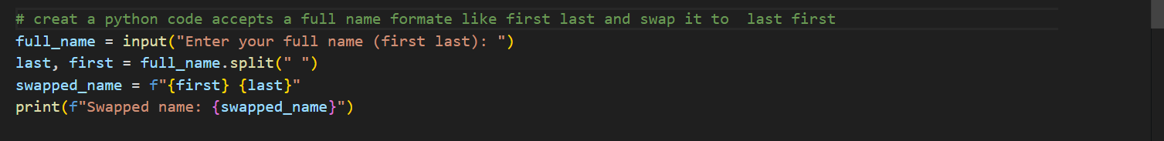
Output:
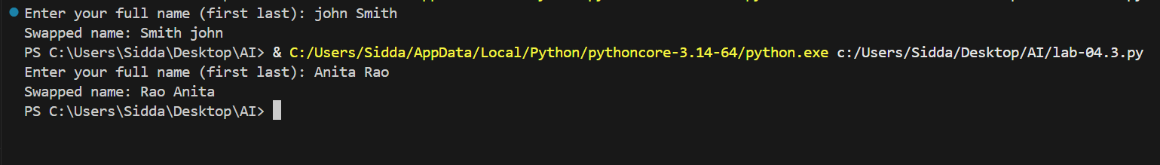
Task 4: Comparative Analysis – Zero-Shot vs Few-Shot
Scenario
Different prompt strategies may produce different code quality.
Task Description
• Use zero-shot prompting to generate a function that counts vowels in a string
• Use few-shot prompting for the same problem
• Compare both outputs based on:
o Accuracy
o Readability
o Logical clarity
Expected Output
• Two vowel-counting functions
• Comparison table or short reflection paragraph
• Conclusion on prompt effectiveness
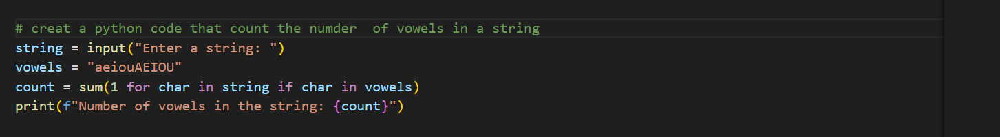
Output:
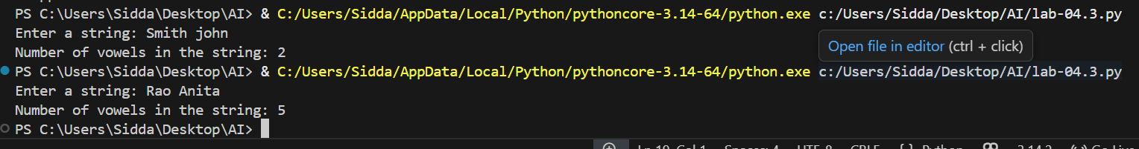
Task 5: Few-Shot Prompting – File Handling
Scenario
File processing requires clear logical understanding.
Task Description
Use few-shot prompting to generate a Python function that:
• Reads a .txt file
• Counts the number of lines in the file
• Returns the line count
Expected Output
• Working Python file-processing function
• Correct line count
• Sample .txt input and output
• AI-assisted logic explanation
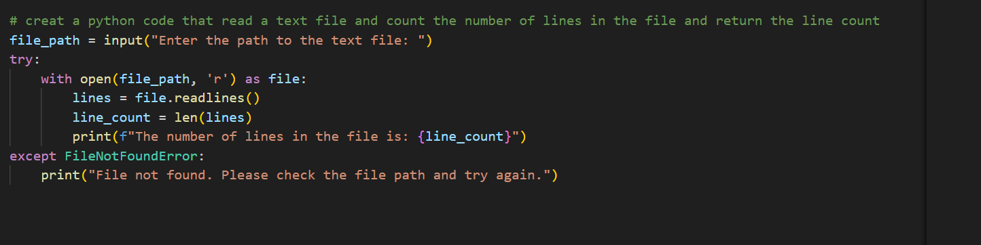
Output:

