Lab_Assignment_9.4
2303A51648
Task 1: Auto-Generating Function Documentation in a Shared
Codebase
Prompt: # Documentation Generation: Automatic Documentation and Code Comments
# Lab Objectives To use AI-assisted coding tools for generating Python documentation and code comments. To apply zero-shot, few-shot, and context-based prompt engineering for documentation creation. To practice generating and refining docstrings, inline comments, and module-level documentation. To compare outputs from different prompting styles for quality analysis.
# Lab Outcomes Generate structured code documentation using AI tools Apply appropriate documentation styles to different code contexts Improve code readability through selective commenting Convert informal developer comments into professional documentation Analyze and refine AI-generated documentation
# Task 1: Auto-Generating Function Documentation in a Shared Codebase
# I have joined a development team where several utility functions are already implemented, but the code lacks proper documentation. New team members are struggling to understand how these functions should be used.
# I have given a Python script containing multiple functions without docstrings. Generate the Google-style function doc strings for each function.Each docstring should include (A brief description of the function, Parameters with data types, return values, At least one example usage(if applicable)).
# Example Python script without docstrings

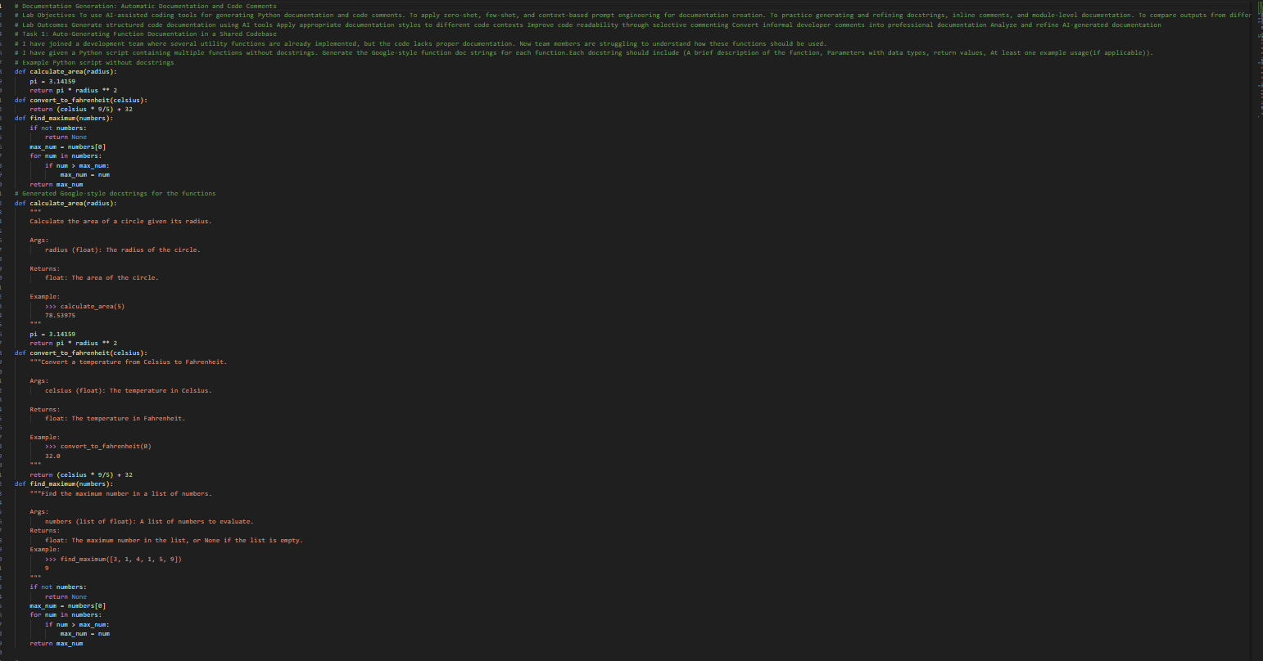
Task 2: Enhancing Readability Through AI-Generated Inline
CommentsPrompt: Improving Code Readability with AI-Generated Inline Comments
# The provided Python program includes loops, conditional statements, and algorithmic logic that works correctly but may be hard to understand initially. This can make future debugging or enhancements difficult.
# Use AI to insert inline comments only where the logic is complex or not immediately obvious. Avoid commenting on simple or self-explanatory lines. The objective is to enhance clarity while keeping the code clean and uncluttered.
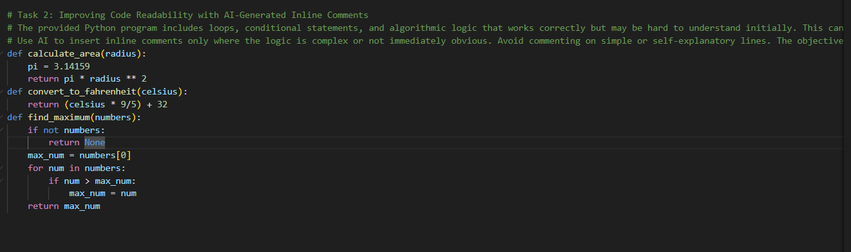Task 3: Generating Module-Level Documentation for a Python
Package
Prompt: Creating Module-Level Documentation for a Python Package
# Our team is preparing a Python module for internal use or repository sharing. Anyone opening the file should quickly understand its purpose and structure.
# Provide the complete module to an AI tool and request it to generate a module-level docstring at the top of the file that includes:
# - The purpose of the module
# - Required libraries or dependencies
# - A brief overview of key functions and classes
# - A short usage example
# Ensure the documentation is clear, concise, and written in a professional tone.

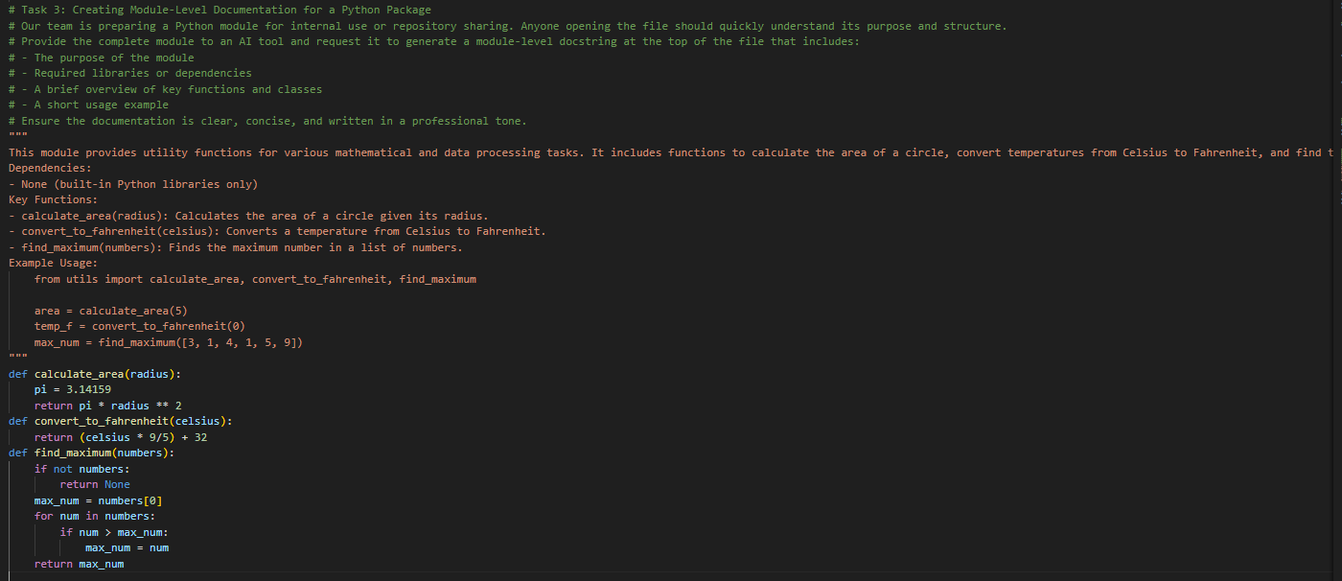
Task 4: Converting Developer Comments into Structured Docstrings
Prompt: Converting Developer Comments into Structured Docstrings
# Scenario: In a legacy codebase, developers have added lengthy explanatory comments within functions instead of using proper docstrings. The team wants to standardize documentation.
# Task Description: Given a Python script where functions contain detailed inline comments describing their logic, use AI to convert these comments into structured Google-style or NumPy-style docstrings. Ensure the original meaning is preserved and remove any redundant inline comments after conversion.
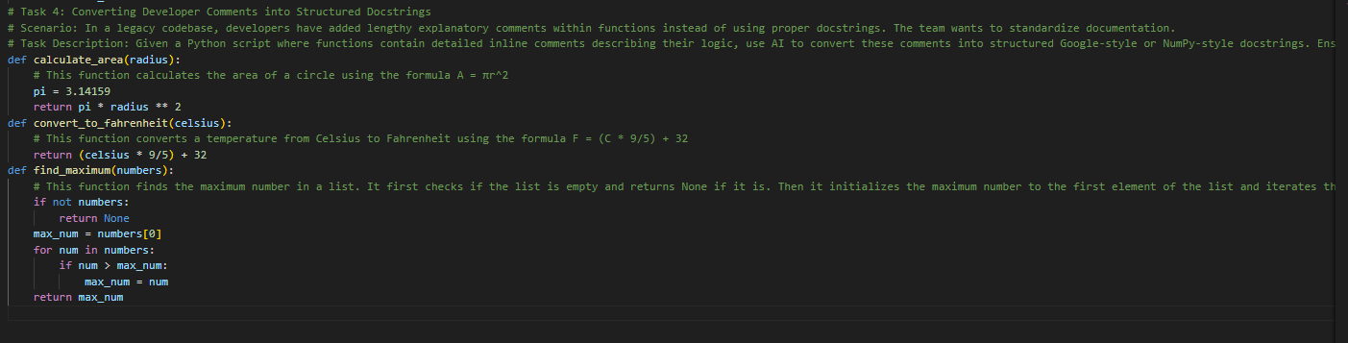
Task 5: Building a Mini Automatic Documentation Generator
Prompt: Building a Mini Automatic Documentation Generator
# Scenario: our team wants a simple internal tool that helps developers start documenting new Python files quickly, without writing documentation from scratch.
# Task Description: Design a small Python utility that: Reads a given .py file, Automatically detects:, Functions, Classes, Inserts placeholder Google-style docstrings for each detected function or class AI tools may be used to assist in generating or refining this utility.
# Note: The goal is documentation scaffolding, not perfect documentation.
import ast
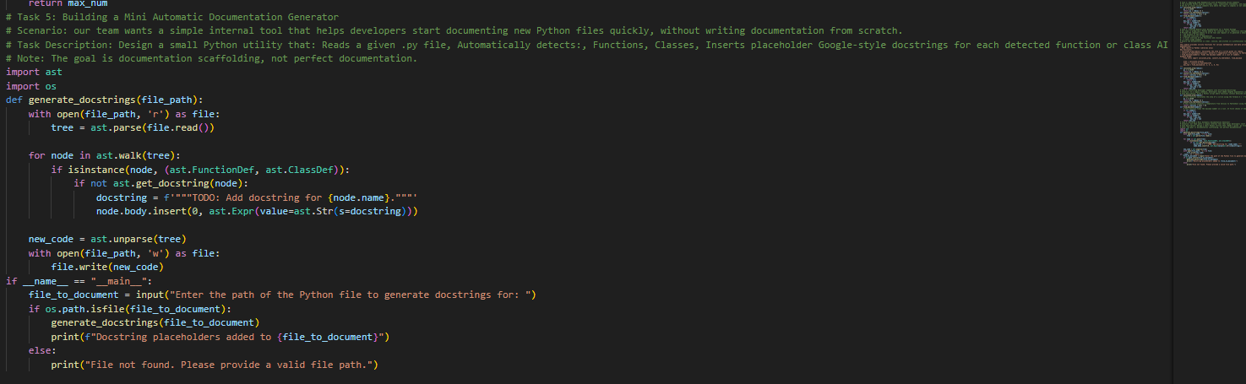
CODE EXPLANATION:
# Task 1: This task involves generating Google-style docstrings for functions in a Python script that lacks documentation. The docstrings include a brief description, parameters with data types, return values, and example usage.
# Task 2: This task focuses on improving code readability by inserting inline comments only where the logic is complex or not immediately obvious. The goal is to enhance clarity without cluttering the code with comments on simple lines.
# Task 3: This task requires creating module-level documentation for a Python package. The docstring at the top of the file includes the purpose of the module, required libraries or dependencies, a brief overview of key functions and classes, and a short usage example.
# Task 4: This task involves converting developer comments into structured docstrings. The AI tool is used to transform detailed inline comments within functions into Google-style or NumPy-style docstrings, ensuring that the original meaning is preserved while removing redundant inline comments.
# Task 5: This task is about building a mini automatic documentation generator. The utility reads a given .py file, detects functions and classes, and inserts placeholder Google-style docstrings for each detected function or class. The goal is to provide documentation scaffolding for developers to start documenting new Python files quickly.

