Lab_Assignment_1.4
2303A51648
Task 1: AI-Generated Logic Without Modularization (Prime Number Check
Without Functions)
Prompt: #Create a Python program that:
#Takes integer input from the user
# Checks if the number is prime using a for loop
# Does not use functions
# Prints "Prime" or "Not Prime"
# Get integer input from the user
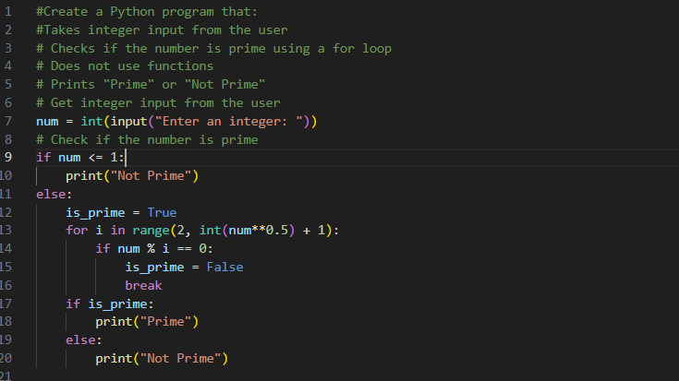
Output:
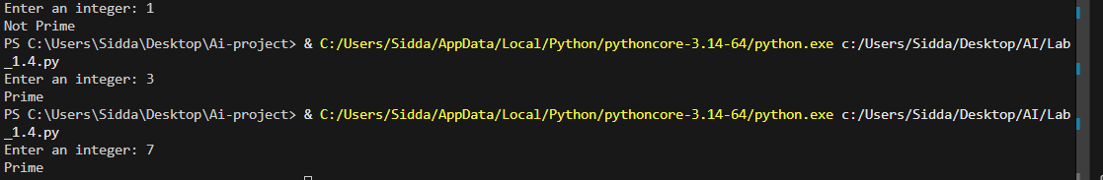
Task 2: Efficiency & Logic Optimization (Cleanup)
Prompt: #Task2 Optimize this prime number checking code to improve efficiency and readability.
# Reduce unnecessary iterations and use early termination (check up to square root of the number).
# Keep the code simple and clear without using functions.
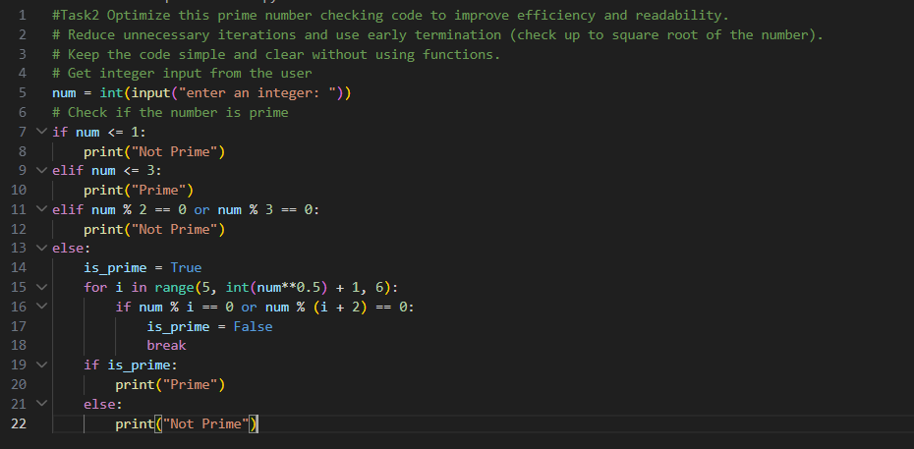
Output:
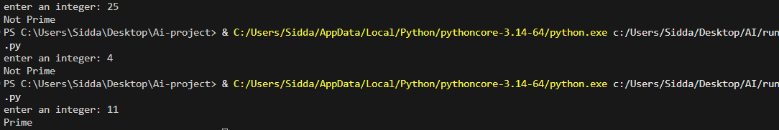
Task 3: Modular Design Using AI Assistance (Prime Number Check Using
Functions)
Prompt: # Write a Python program that checks whether a number is prime using a user-defined function.
# The function should return True if the number is prime and False otherwise.
# Include clear comments explaining the logic.
# Take input from the user and display the result.
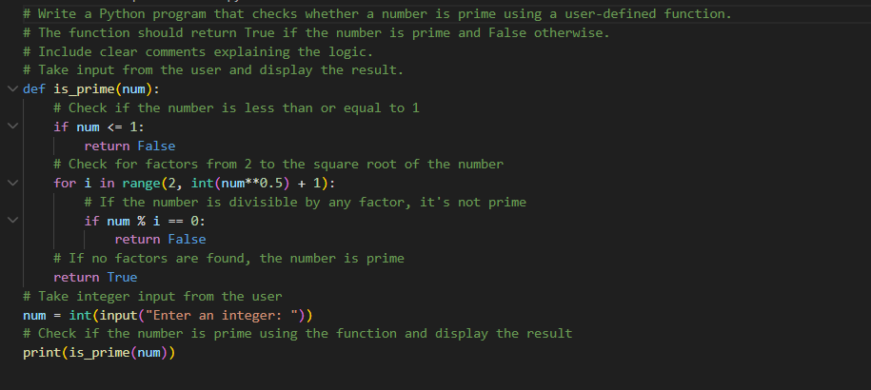
Output: 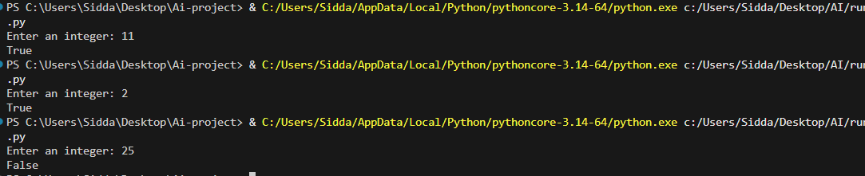
Task 4: Comparative Analysis –With vs Without Functions
Prompt:#Compare two Python programs:
# Prime number check without using functions
#Prime number check using a user-defined function
#Analyze based on: Code clarity,Reusability,Debugging ease,Suitability for large-scale applications
#Present the comparison in a table format with a short explanation.
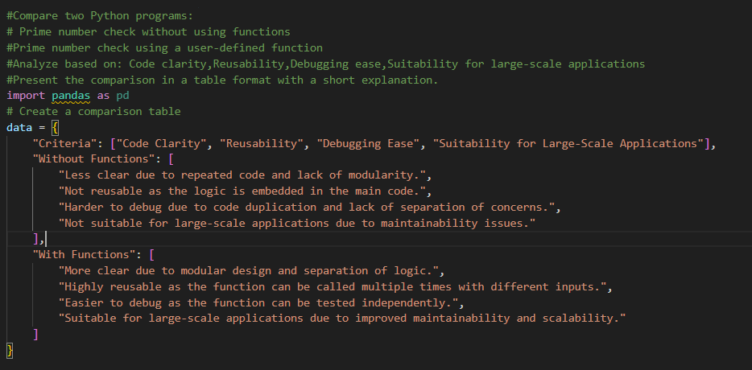
Task 5: AI-Generated Iterative vs Recursive Fibonacci Approaches (Different
Algorithmic Approaches to Prime Checking)
Prompt: # Generate two Python implementations to check if a number is prime:
# 1. Basic approach using full divisibility check from 2 to n-1
# 2. Optimized approach checking only up to square root of n
# Include clear comments explaining both methods
# Also compare them based on execution flow, time complexity, and performance
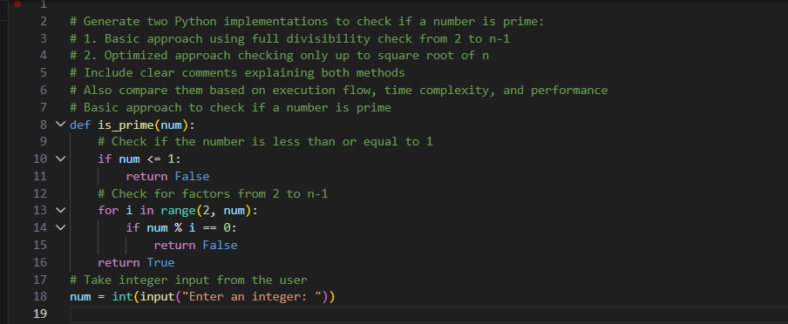
Output:
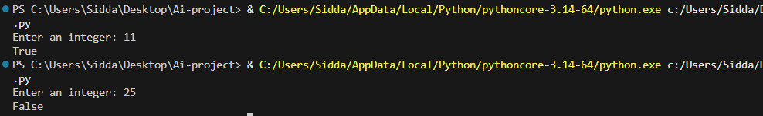
Code explanation:
# Task 1: This task defines a function `is_prime` that checks if a number is prime. It checks if the number is less than or equal to 1, and then iterates from 2 to the square root of the number to check for factors. If any factor divides the number evenly, it returns False; otherwise, it returns True.
# Task 2: This task optimizes the prime checking by reducing unnecessary iterations. It first checks for numbers less than or equal to 3, and then eliminates even numbers greater than 2 and multiples of 3. It then checks for factors starting from 5 up to the square root of the number, skipping even numbers.
# Task 3: This task is similar to Task 2 but does not use a function. It directly implements the logic in the main code, which can be less modular and harder to maintain.
# Task 4: This task compares the two approaches (with and without functions) based on criteria such as code clarity, reusability, debugging ease, and suitability for large-scale applications. The comparison is presented in a table format.
# Task 5: This task provides two implementations for checking if a number is prime. The first implementation uses a basic approach that checks for divisibility from 2 to n-1, while the second implementation optimizes this by only checking up to the square root of n. The optimized approach is more efficient, especially for larger numbers, as it reduces the number of iterations needed to determine if a number is prime.
m

