ASSIGNMENT – 3.3
2303A51648
Batch-10

Task-1
Prompt: #Create a Python application for the TGNPDCL electricity bill generation system that collects accurate consumer information, including previous meter readings, current meter readings, and customer category.
#The application should calculate the electricity bill based on the collected data and display the bill amount to the user. Additionally, it should provide an option for users to save their bill details for future reference.

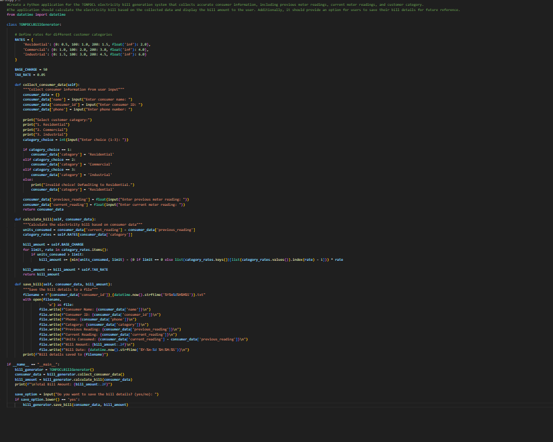
Output: 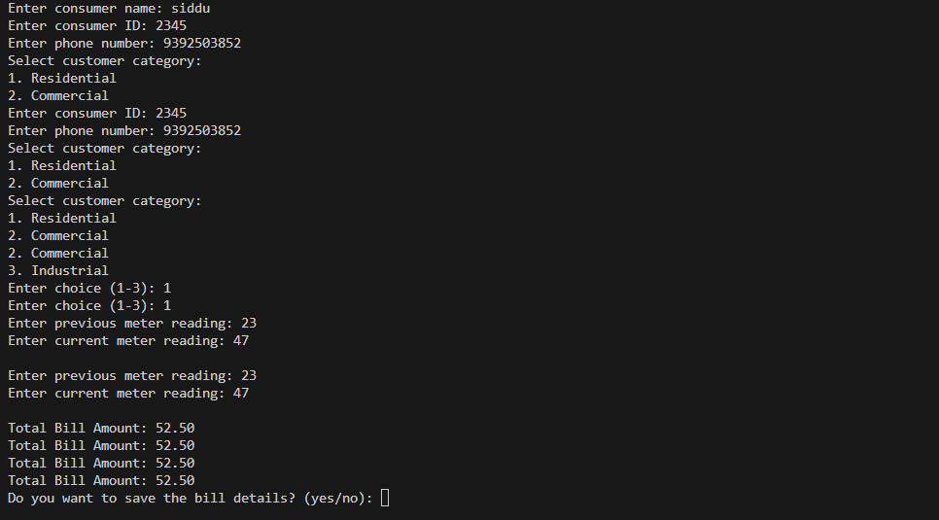

Code Analysis :
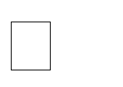 The program uses a function calculate_bill() to separate billing logic from user input.
Units consumed are calculated by subtracting previous units from current units.
Nested if–elif conditions apply slab-based tariff rates.
Customer type is normalized using .lower() to avoid case mismatch errors. Exception handling ensures invalid customer types are handled safely.

Task-2
Prompt: #Write a Python program to calculating Energy Charges (EC) based on units consumed and customer type (Domestic, Commercial, Industrial). Use clear and optimized conditional statements and show sample output.

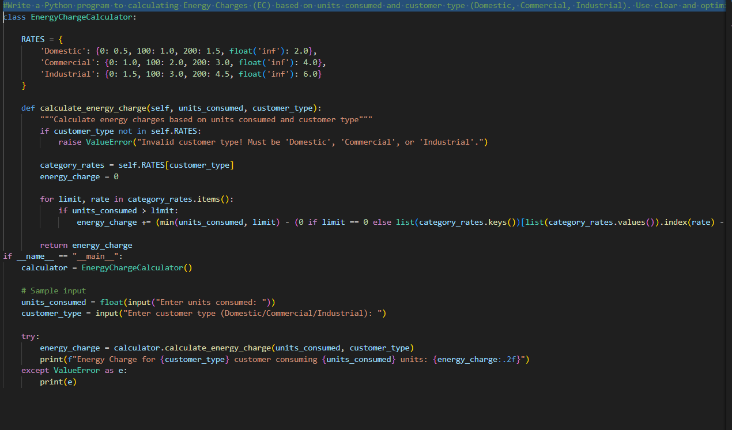

Output : 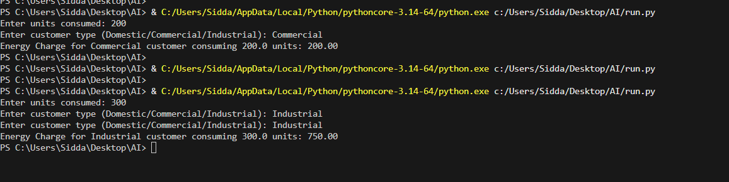

Code Analysis : A single function, calculate_energy_charges() handles all consumer categories.
Slab-based billing is implemented using structured conditional blocks.
Logical grouping avoids redundant calculations.
Function returns computed charges for further processing.
Error handling improves robustness against invalid inputs.

Task-3
Prompt #Create a function-based Python billing program that calculates energy and fixed charges with proper comments and sample test results.
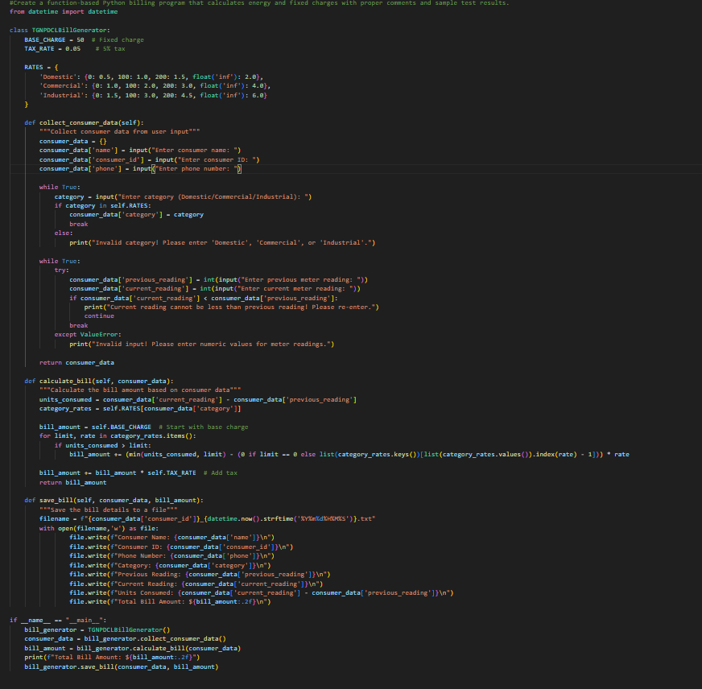

Output :
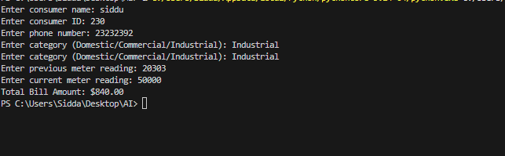
Code Analysis :

Code is modularised using multiple user-defined functions. Energy charges and fixed charges are calculated independently. generate_bill() integrates all charge components into one structure.
Dictionary return type improves readability and structured output. Design supports reuse for multiple consumers efficiently.

Task-4
Prompt: #Create a Python program that calculates additional electricity bill charges such as fixed charges, customer charges, and electricity duty with accurate results and print the Detailed fixed charges, customer charges, and electricity duty and its total bill

Code : 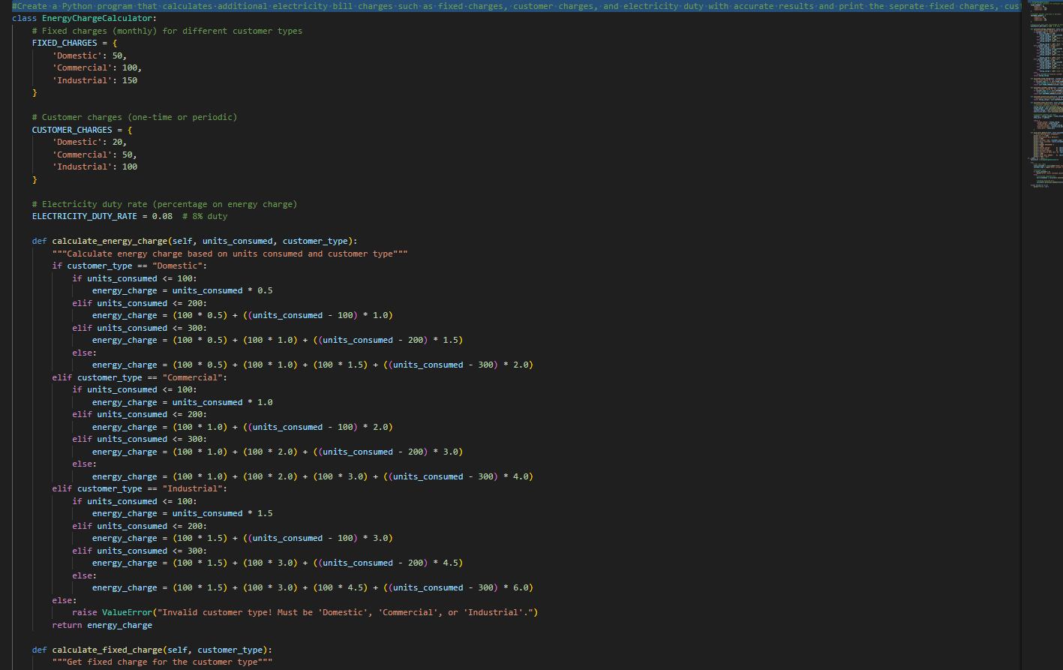
Output
: 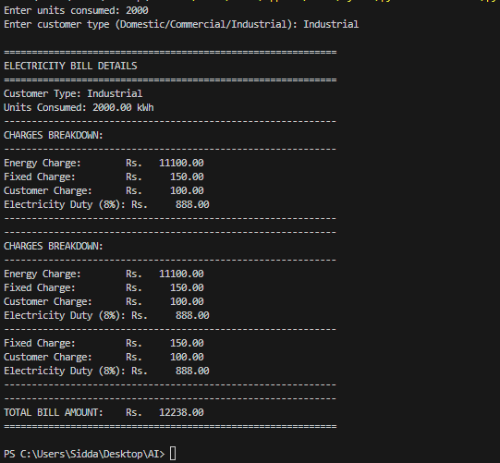

Code Analysis :
Additional charge components are added through dedicated functions.
Electricity duty is computed as a percentage of energy charges.
Dynamic user input improves billing accuracy and flexibility.
Functions maintain separation of concerns for clarity.
The total bill aggregates all computed components systematically.

Task 5
Prompt #Write a Python program to generate the final electricity bill by calculating Total Bill = EC + FC + CC + ED. Display Energy Charges, Fixed Charges, Customer Charges, Electricity Duty, and Total Bill in a neat format. Include sample input/output and a short analysis of accuracy, readability, and real-world applicability.
# Function to calculate the electricity bill

code :
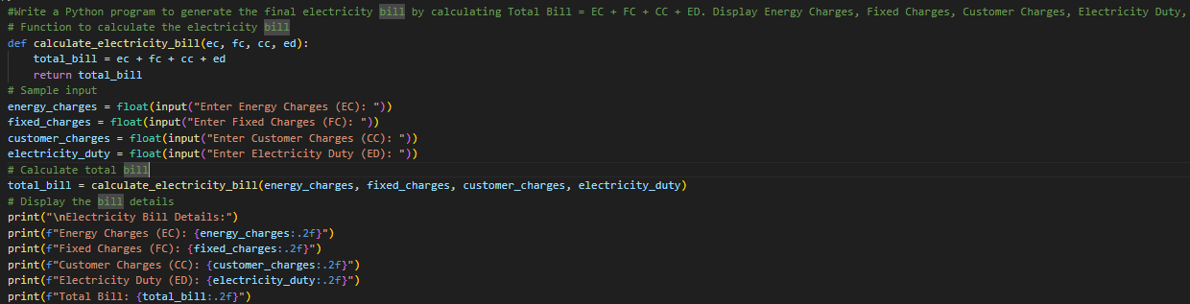

Output :
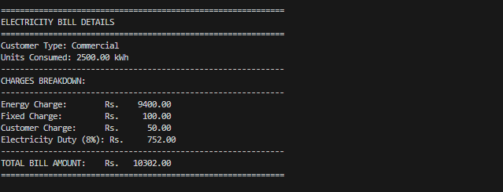
Code Analysis :
Display logic is isolated in the display_bill() function.
Formatted printing ensures professional bill presentation.
Uses dictionary keys to access bill components safely.
Separation of calculation and presentation improves maintainability. Supports easy modification for real-world billing systems.

