Lab Assignment 6.3
H.no2303A51648

Lab 6: AI-Based Code Completion – Classes, Loops, and Conditionals

Task Description #1: Classes (Student Class)
Prompt 1#create a python code for defines student class that has attributes like name , roll num , branch . using constructor (_init_)
# add a method display to display to print student information, give the output for 5 different students in table format

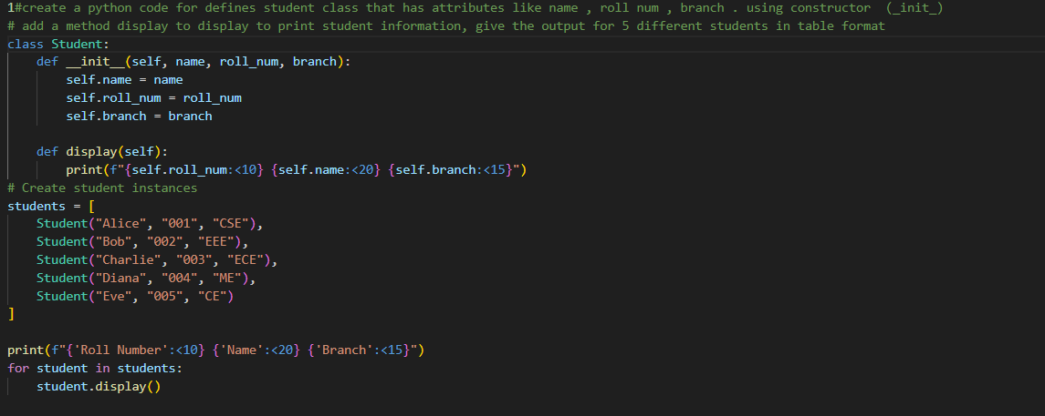
Output:
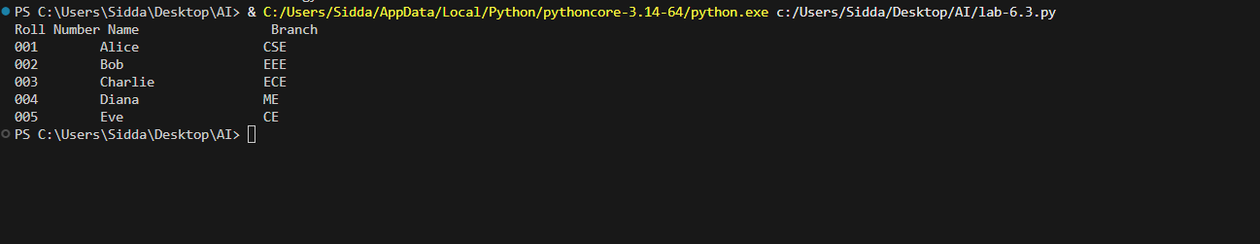
Task Description #2: Loops (Multiples of a Number)
Prompt: # create python to print first 10 multiples of a given numder of using a loop.
# create same functionality using another controlled looping structure.
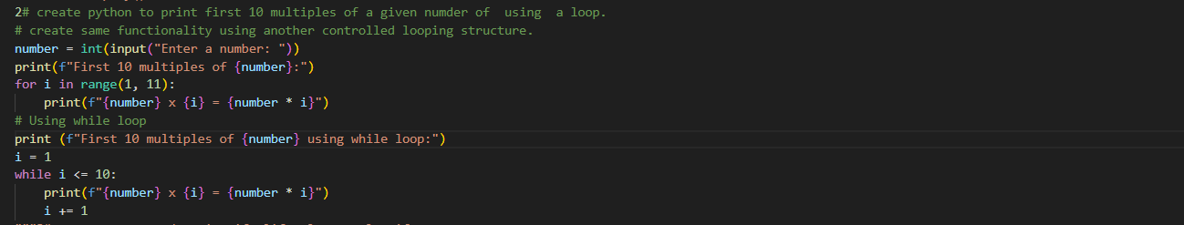
Output:
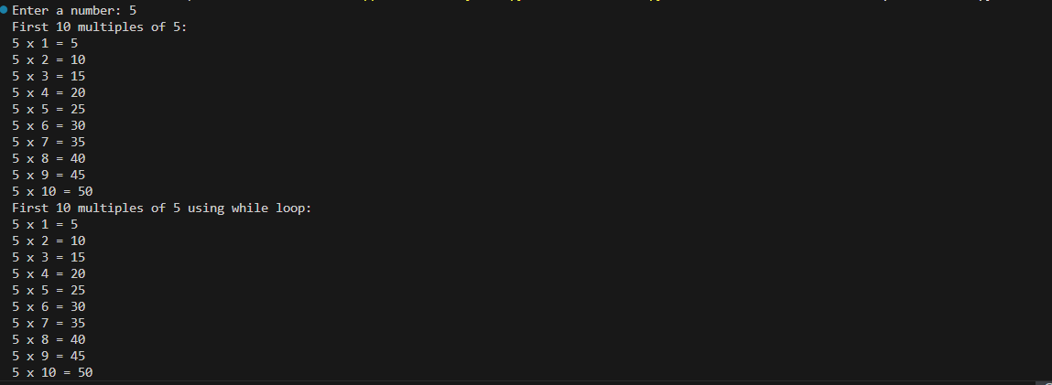
Task Description #3: Conditional Statements (Age Classification)
Prompt:
# create pyton code using if,elif, else to classify age groups
# create same classfication using other steructure
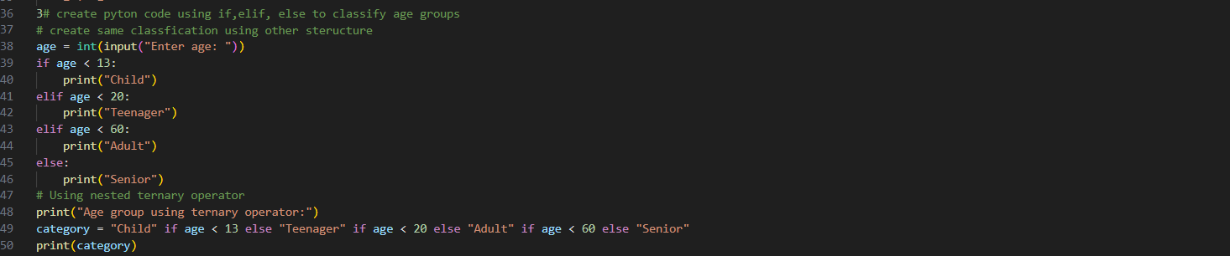
Output:

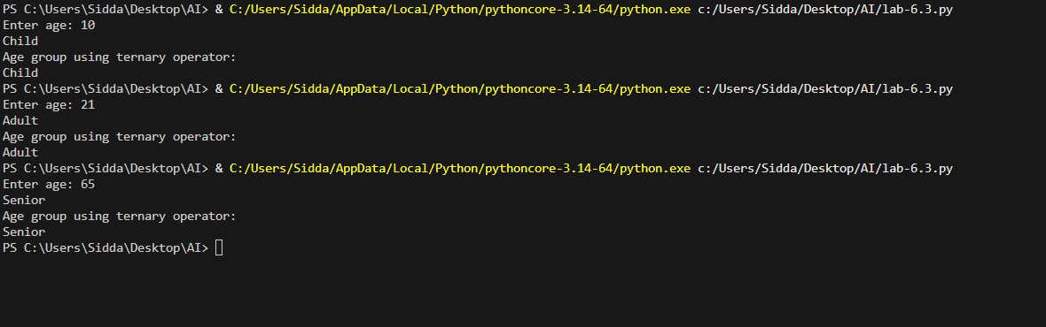
Task Description #4: For and While Loops (Sum of First n Numbers)
Prompt:
#Generate a Python function sum_to_n(n) that calculates the sum of the first n natural numbers using a for loop.
# create same functionality using while loop, take as user input value
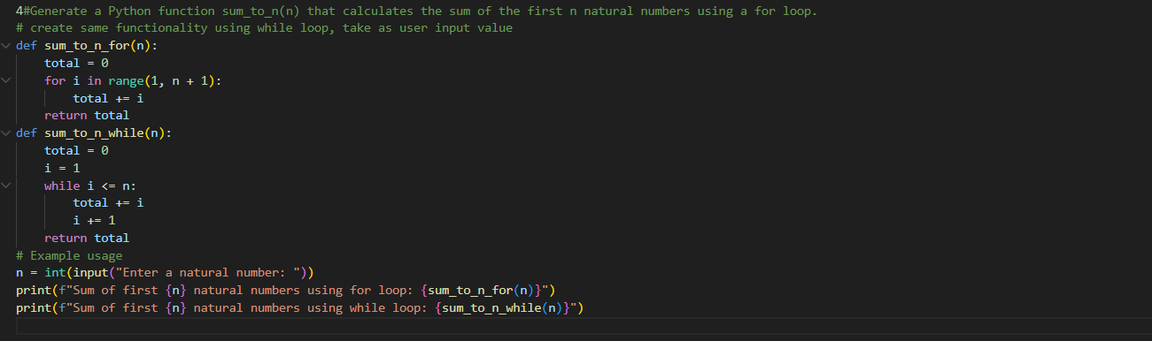
Output:
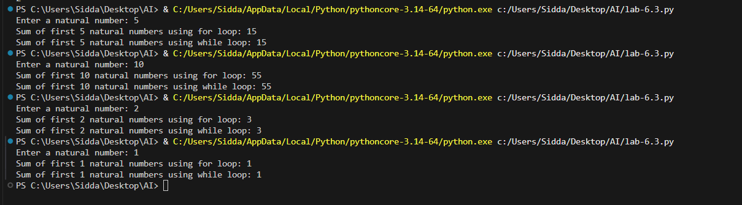
Task Description #5: Classes (Bank Account Class)
Prompt:
5#Generate a Python BankAccount class with the following methods:deposit(amount),withdraw(amount),check_balance(). take as user input values
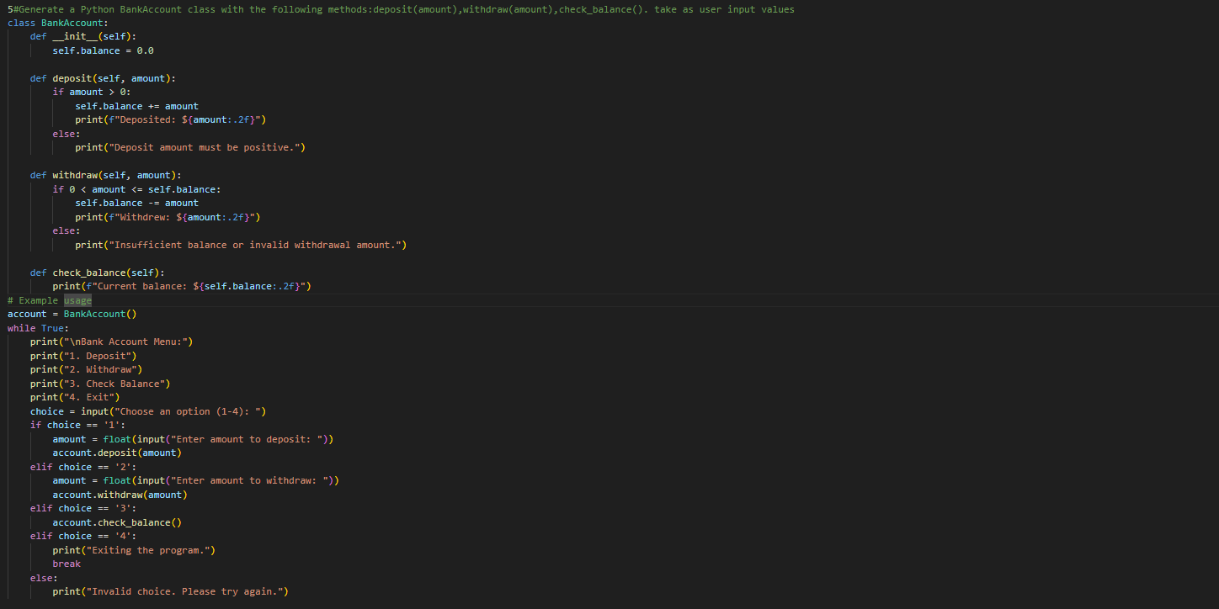
Output:
