LAB ASSIGNMENT-13.4
Name: D.Sreeja
H NO:2303A51664
Batch-14

Task 1: Refactoring Data Transformation Logic Scenario
You are maintaining a data preprocessing script where numerical transformations are written using verbose loops.

Task Description
- Review the legacy code that computes transformed values using an explicit loop.
- Use an AI tool to suggest a more Pythonic refactoring approach. • Refactor the code using list comprehensions or helper functions while preserving the output. Legacy Code
values = [2, 4, 6, 8, 10] doubled = [] for v in values:
doubled.append(v * 2) print(doubled)

Expected Output
[4, 8, 12, 16, 20]
#PROMPT:
#Refactor the following Python loop code into a more Pythonic version using list comprehension while keeping the same output

#Original Code
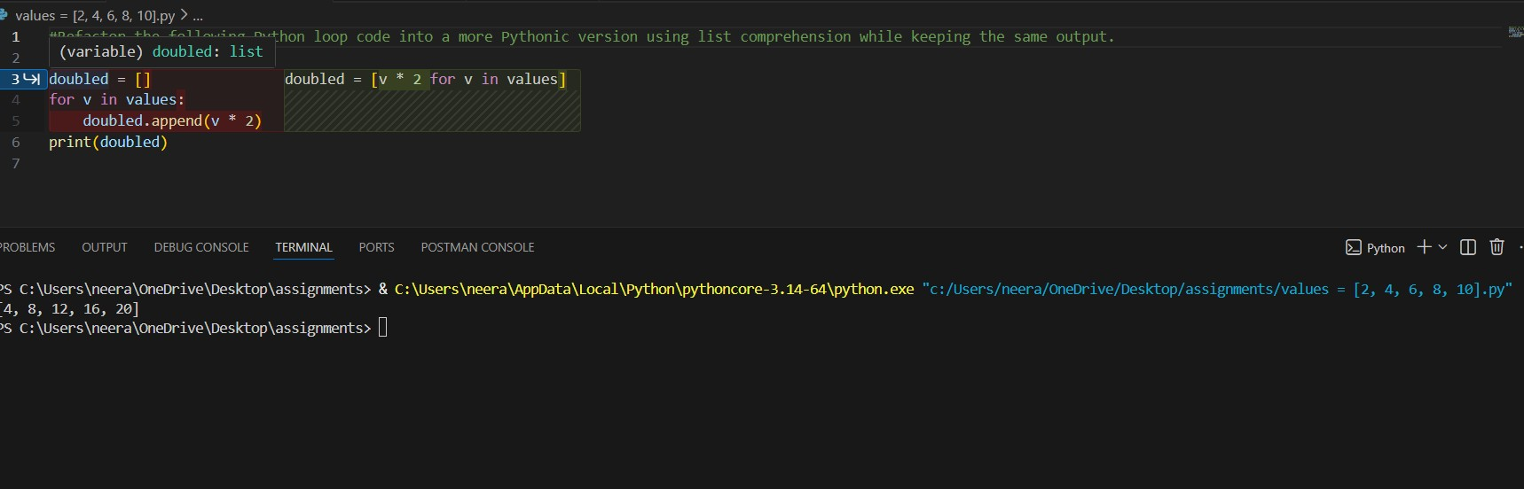

#Refactored Code
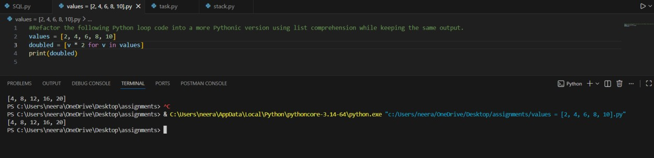

#Justification
The original code uses a traditional for loop to iterate over the list of values and append the doubled values to a new list. The refactored version uses a list comprehension, which is more concise and often considered more readable in Python. List comprehensions allow you to create a new list by applying an expression to each item in an iterable, all in one line.

Task 2: Improving Text Processing Code Readability Scenario
You are working on a log message generator that builds messages word by word.

Task Description
- Analyze the legacy code that constructs a sentence using repeated string concatenation.
- Ask AI to suggest a more efficient and readable approach.
- Refactor the code accordingly while keeping the final output unchanged. Legacy Code
words = ["Refactoring", "with", "AI", "improves", "quality"] message = "" for w in words: message += w + " " print(message.strip())

Expected Output
Refactoring with AI improves quality #PROMPT:
Refactor the following Python code that builds a sentence using repeated string concatenation into a more efficient and readable approach .

#Original Code
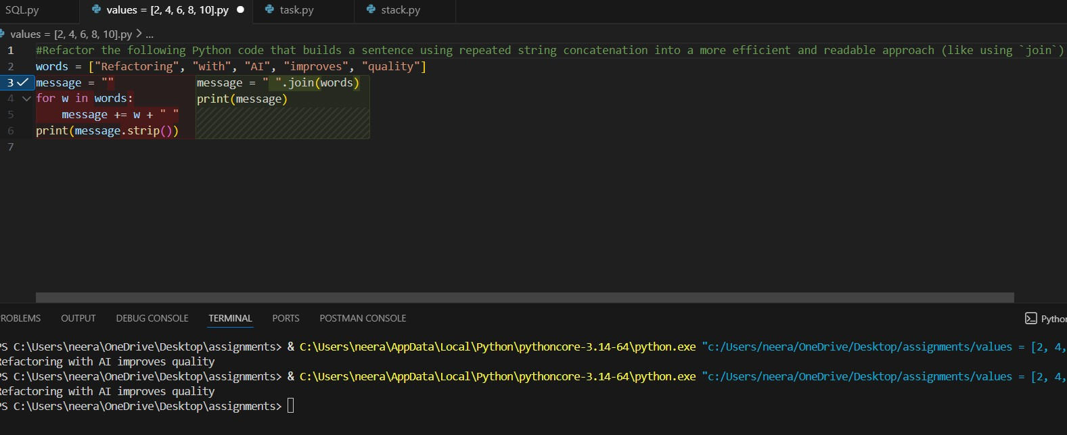

#Refactored Code
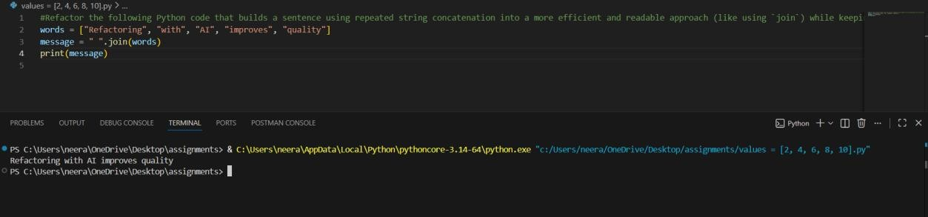

#Justification
Using “join” is more efficient than repeated string concatenation because it creates the final string in one step, rather than creating multiple intermediate strings. This approach is not only faster but also more readable, as it clearly shows that we are combining a list of words into a single sentence.

Task 3: Safer Access to Configuration Data Scenario
You are maintaining a configuration loader where dictionary keys may or may not exist depending on deployment settings.

Task Description
- Review the legacy code that manually checks for dictionary keys. • Use AI suggestions to refactor the code using safer dictionary access methods.
- Ensure the behavior remains the same for missing keys. Legacy Code
config = {"host": "localhost", "port": 8080} if "timeout" in config: print(config["timeout"]) else:
print("Default timeout used")
Expected Output
Default timeout used

#PROMPT
Refactor the following Python code that manually checks dictionary keys into a safer and more Pythonic approach using dict.get() .

#Original Code
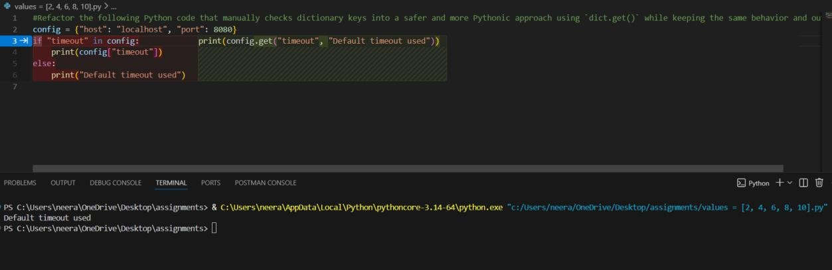

#Refactored Code
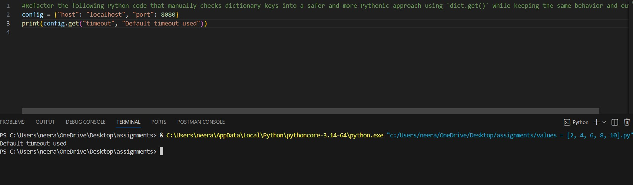

#Justification
The original code checks if the key exists before accessing it, which makes the code longer.Using dict.get() simplifies the process by safely accessing the value.If the key is missing, it can return a default value instead of causing an error.This makes the code cleaner, safer, and more Pythonic.

Task 4: Refactoring Conditional Logic for Scalability Scenario
You are enhancing a utility module that performs different operations based on user input.

Task Description
- Examine the multiple if–elif conditions used to determine operations.
- Ask AI to suggest a cleaner, scalable alternative.
- Refactor the logic using mapping techniques while preserving functionality. Legacy Code action = "divide" x, y = 10, 2 if action == "add":
result = x + y elif action == "subtract":
result = x - y elif action == "multiply":
result = x * y elif action == "divide":
result = x / y else:
result = None print(result)
Expected Output
5.0

#PROMPT
Refactor the following Python code that uses multiple if–elif conditions into a cleaner and scalable solution using a dictionary mapping #Original Code
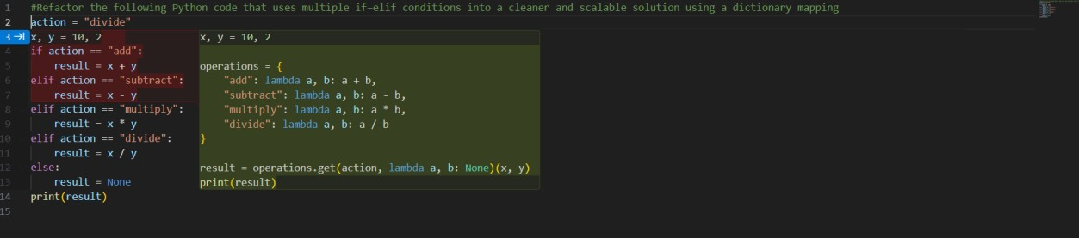

#Refactored Code
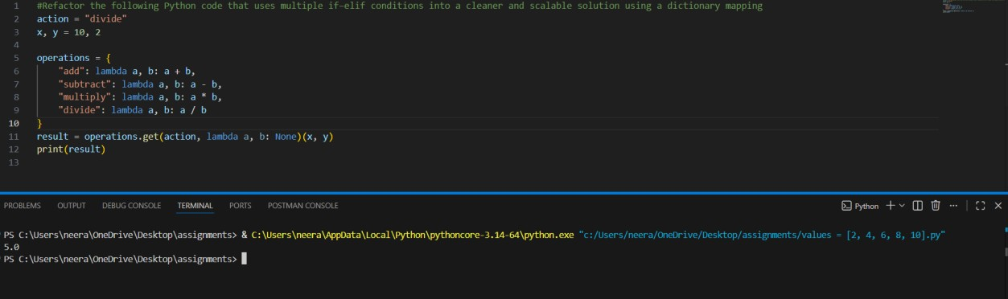

#Justification
This refactored code uses a dictionary to map string keys (the actions) to their corresponding operations (implemented as lambda functions). This approach eliminates the need for multiple if–elif conditions, making the code cleaner and more scalable.

Task 5: Simplifying Search Logic in Collections Scenario
You are reviewing legacy inventory-check code that uses manual loops to find elements.

Task Description
- Identify the explicit loop used for searching an item.
- Use AI assistance to refactor the logic into a more concise and readable form.
- Maintain the same output behavior. Legacy Code
inventory = ["pen", "notebook", "eraser", "marker"] found = False for item in inventory: if item == "eraser":
found = True
break
print("Item Available" if found else "Item Not Available")
Expected Output
Item Available

#PROMPT
#Refactor the following Python code that uses a manual loop to search for an item into a more concise and readable Pythonic approach while keeping the same output

#Original Code
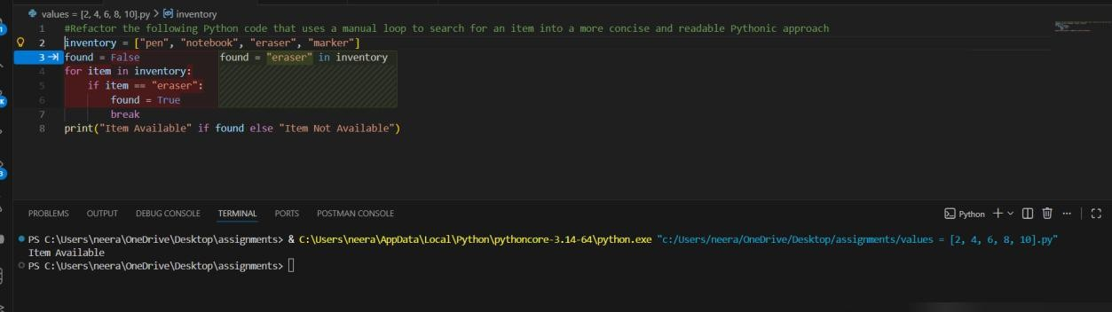

#Refactored Code
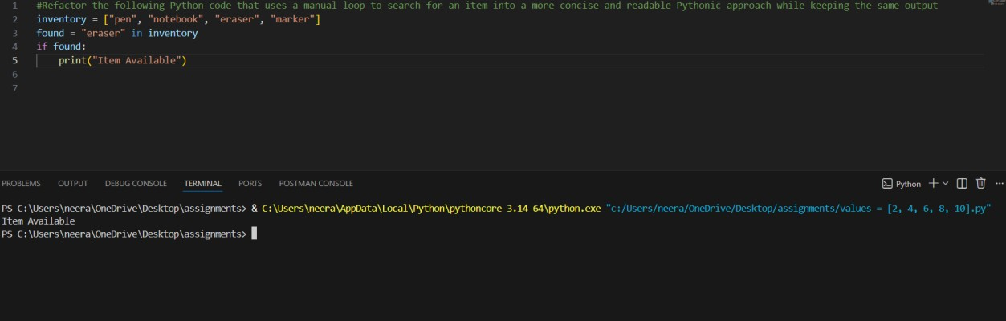

#Justification
The refactored code uses the “in” keyword, which is a more concise and readable way to check for the presence of an item in a list. This approach eliminates the need for a manual loop and a separate variable to track whether the item was found, making the code cleaner and easier to understand.

