2303A51664-Sreeja
Assignment 8.1
Batch - 14

Test-Driven Development with AI – Generating and Working with Test Cases

TASK 1: Password Strength Validator – Apply AI in Security Context

Prompt:

- Now implement the Python function is_strong_password(password) so that it passes all the previously generated assert test cases. Handle invalid inputs properly and ensure clean error handling. Return only the function implementation.
- Generate at least 3 assert-based test cases for a Python function is_strong_password(password).
- Requirements: Minimum 8 characters, Must include uppercase, lowercase, digit, and special character, Must not contain spaces and Include both valid and invalid test cases. Return only assert statements.

Code:
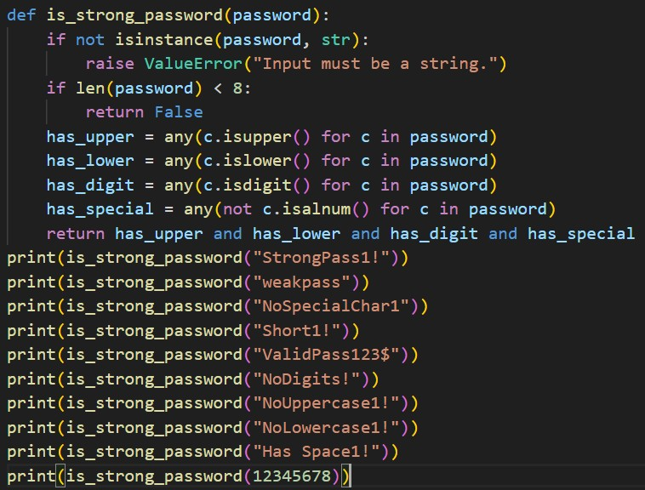
Output:
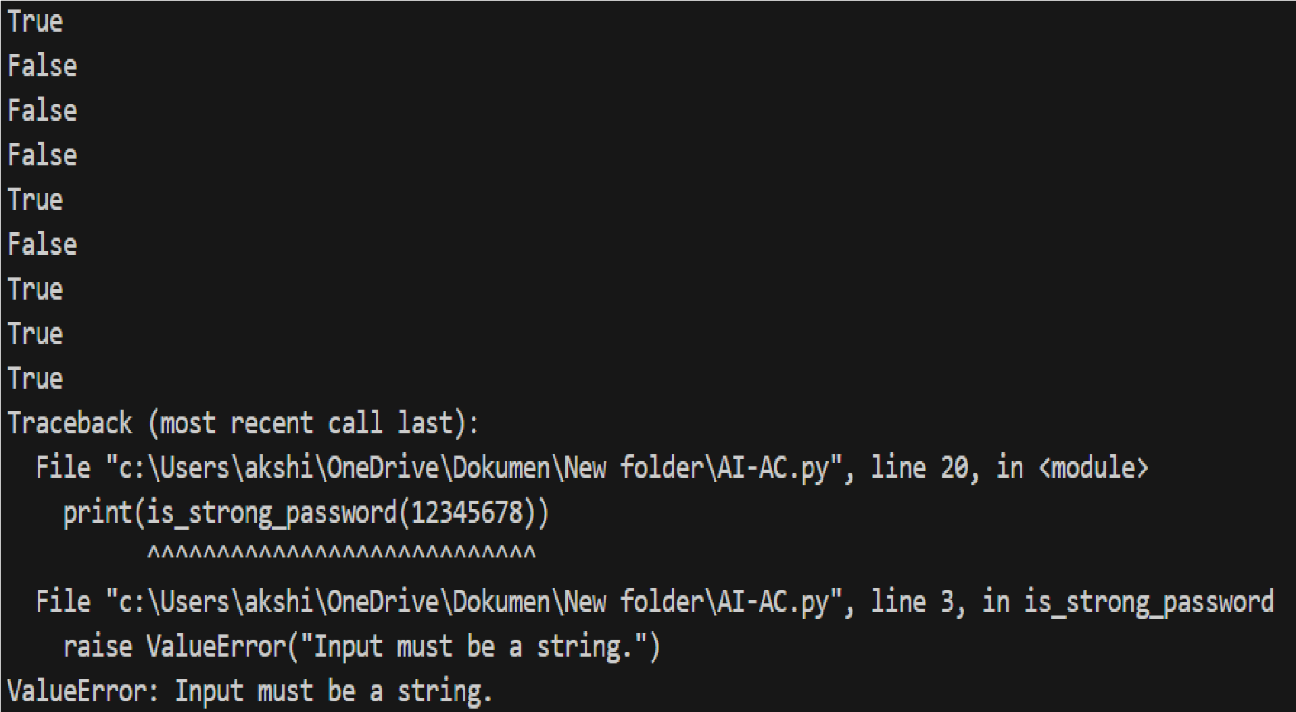

TASK 2. Number Classification with Loops – Apply AI for Edge Case Handling

Prompt:
- Generate at least 3 assert test cases for a Python function classify_number(n).
- Requirements: Return "Positive", "Negative", or "Zero", Handle boundary cases (-1, 0, 1), Handle invalid inputs like strings and None and Return only assert statements.
- Implement classify_number(n) using loops. The function must: Classify numbers as Positive, Negative, or Zero, Return "Invalid Input" for non-numeric values. Ensure it passes all previously generated test cases. Return only the function code.

Code:
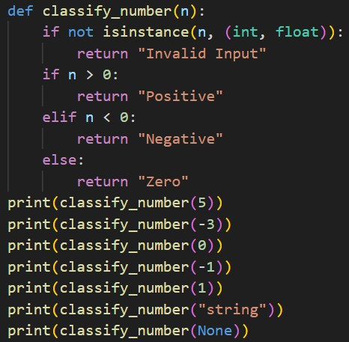
Output:
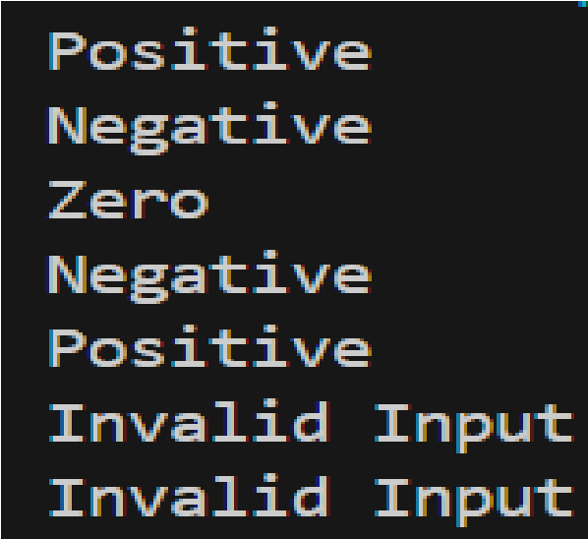

TASK 3: Anagram Checker – Apply AI for String
Analysis

Prompt:

- Generate at least 3 assert test cases for a function is_anagram(str1, str2). Implement is_anagram(str1, str2) in Python.
- Requirements: Ignore case differences, Ignore spaces and punctuation, Handle empty strings, Include both True and False cases and Return only assert statements.
- Requirements: Ignore case, spaces, and punctuation, Return True if strings are anagrams, Handle edge cases like empty strings. Ensure it passes all generated test cases. Return only the function implementation.

Code:
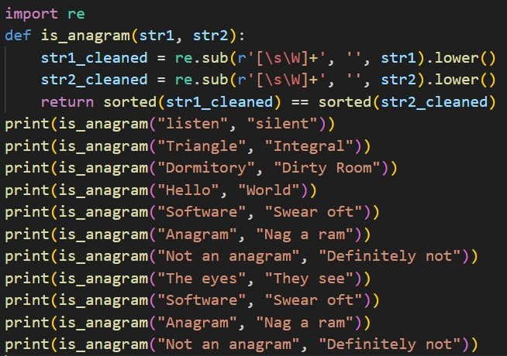

Output:
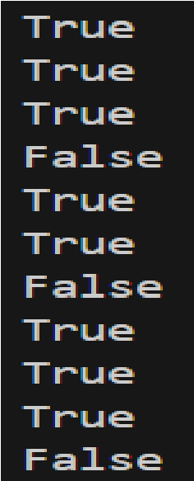

TASK 4: Inventory Class – Apply AI to Simulate Real- World Inventory System

Prompt:
- Generate at least 3 assert-based test cases for a Python class Inventory.
- Methods: add_item(name, quantity), remove_item(name, quantity), get_stock(name)
- Include: Adding new items, Removing stock, Removing more than available stock. Return only the assert test cases.
- Implement a Python class Inventory with methods:
add_item(name, quantity), remove_item(name, quantity), get_stock(name)
- Requirements: Prevent negative stock, Handle non-existing items safely. Ensure it passes all previously generated assert test cases. Return only the class implementation.

Code:
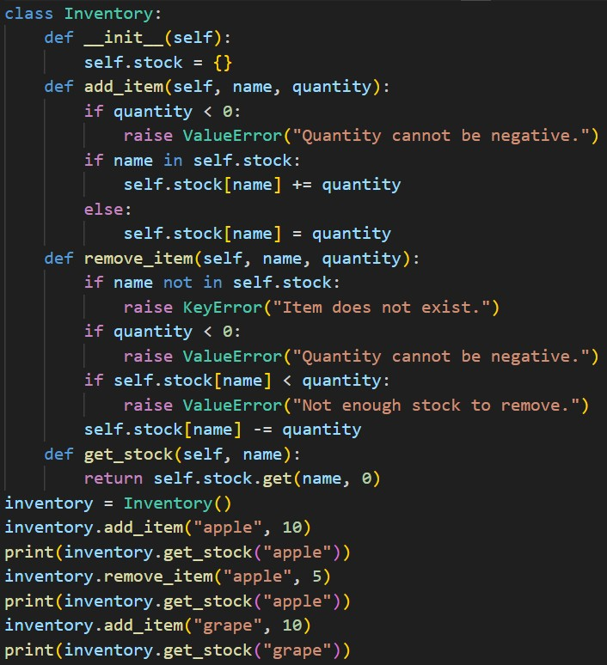
Output:
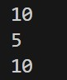

TASK 5: Date Validation & Formatting – Apply AI for Data Validation

Prompt:

- Generate at least 3 assert test cases for a Python function validate_and_format_date(date_str).
- Requirements: Input format: "MM/DD/YYYY", Convert valid dates to "YYYY-MM-DD", Return "Invalid Date" for invalid formats or impossible dates, Include edge cases. Return only assert statements.
- Implement validate_and_format_date(date_str) in Python.
- Requirements: Validate input format "MM/DD/YYYY", Handle invalid dates properly, Convert valid dates to "YYYY-MM-DD".
Ensure the function passes all previously generated assert tests. Return only the function implementation.

Code:

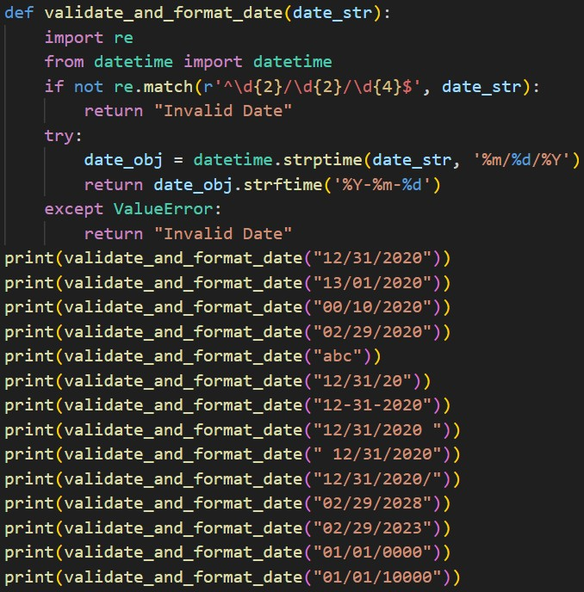

Output:

