AIAC Assignment-8
Name : M.Chandhana
Ht no: 2303A51688
Batch 24

Task Description #1 (Username Validator – Apply AI in Authentication Context)
• Task: Use AI to generate at least 3 assert test cases for a function is_valid_username(username) and then implement the function using Test-Driven Development principles.
• Requirements:
o Username length must be between 5 and 15 characters.
o Must contain only alphabets and digits.
o Must not start with a digit.
o No spaces allowed.
Example Assert Test Cases:
assert is_valid_username("User123") == True
assert is_valid_username("12User") == False
assert is_valid_username("Us er") == False
Expected Output #1:
• Username validation logic successfully passing all AI-generated test cases.
Code:
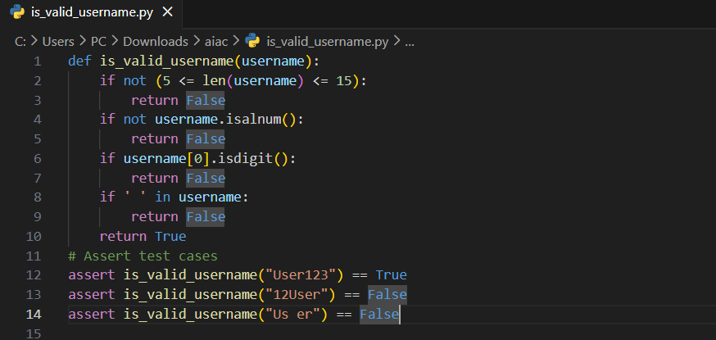
Output :
Task Description #2 (Even–Odd & Type Classification – Apply AI for Robust Input Handling)
• Task: Use AI to generate at least 3 assert test cases for a function classify_value(x) and implement it using conditional logic and loops.
• Requirements:
o If input is an integer, classify as "Even" or "Odd".
o If input is 0, return "Zero".
o If input is non-numeric, return "Invalid Input".
Example Assert Test Cases:
assert classify_value(8) == "Even"
assert classify_value(7) == "Odd"
assert classify_value("abc") == "Invalid Input"
Expected Output #2:
• Function correctly classifying values and passing all test cases.
Code:
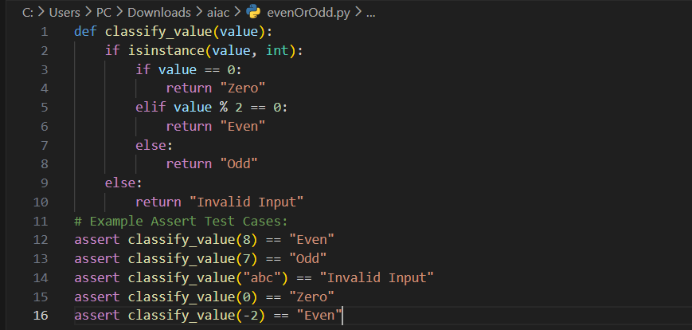
Output:
Task Description #3 (Palindrome Checker – Apply AI for String Normalization)
• Task: Use AI to generate at least 3 assert test cases for a function is_palindrome(text) and implement the function.
• Requirements:
o Ignore case, spaces, and punctuation.
o Handle edge cases such as empty strings and single characters.
Example Assert Test Cases:
assert is_palindrome("Madam") == True
assert is_palindrome("A man a plan a canal Panama") == True
assert is_palindrome("Python") == False
Expected Output #3:
• Function correctly identifying palindromes and passing all AI-generated tests.
Code:
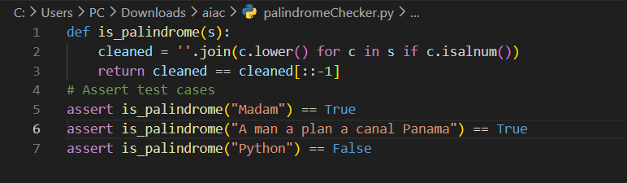
Output:
Task Description #4 (Email ID Validation – Apply AI for Data Validation)
• Task: Use AI to generate at least 3 assert test cases for a function validate_email(email) and implement the function.
• Requirements:
o Must contain @ and .
o Must not start or end with special characters.
o Should handle invalid formats gracefully.
Example Assert Test Cases:
assert validate_email("user@example.com") == True
assert validate_email("userexample.com") == False
assert validate_email("@gmail.com") == False
Expected Output #4:
• Email validation function passing all AI-generated test cases and handling edge cases correctly.
Code:
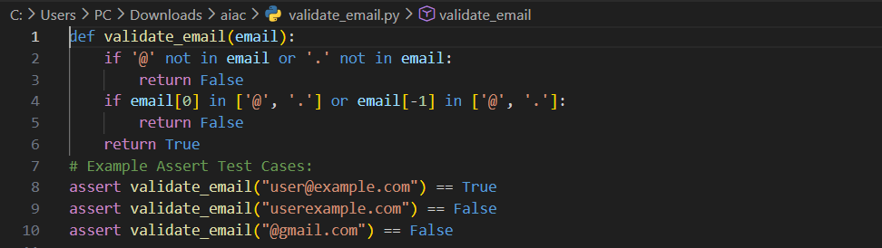
Output:
Task 5 (Perfect Number Checker – Test Case Design)
• Function: Check if a number is a perfect number (sum of divisors = number).
• Test Cases to Design:
o Normal case: 6 → True, 10 → False.
o Edge case: 1.
o Negative number case.
o Larger case: 28.
• Requirement: Validate correctness with assertions.

Code:
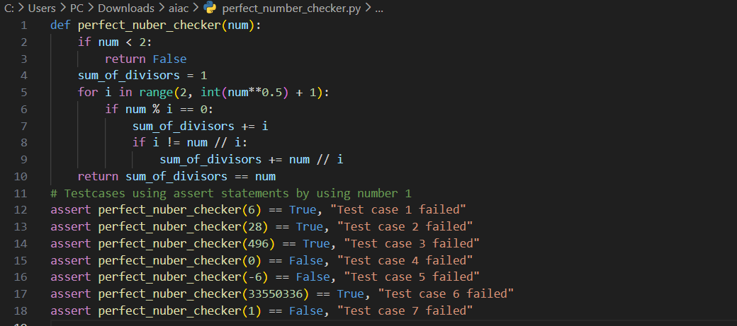
Output:
Task 6 (Abundant Number Checker – Test Case Design)
• Function: Check if a number is abundant (sum of divisors >number).
• Test Cases to Design:
o Normal case: 12 → True, 15 → False.
o Edge case: 1.
o Negative number case.
o Large case: 945.
Requirement: Validate correctness with unittest
Code:
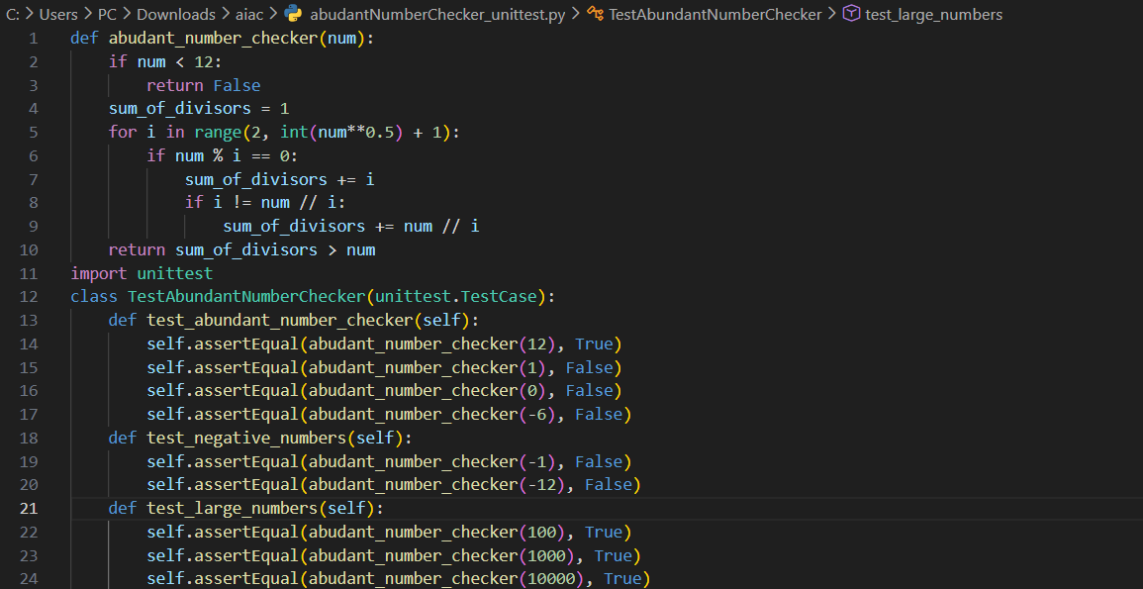
Output:
Task 7 (Deficient Number Checker – Test Case Design)
• Function: Check if a number is deficient (sum of divisors <number).
• Test Cases to Design:
o Normal case: 8 → True, 12 → False.
o Edge case: 1.
o Negative number case.
o Large case: 546.
Requirement: Validate correctness with pytest.
Code:
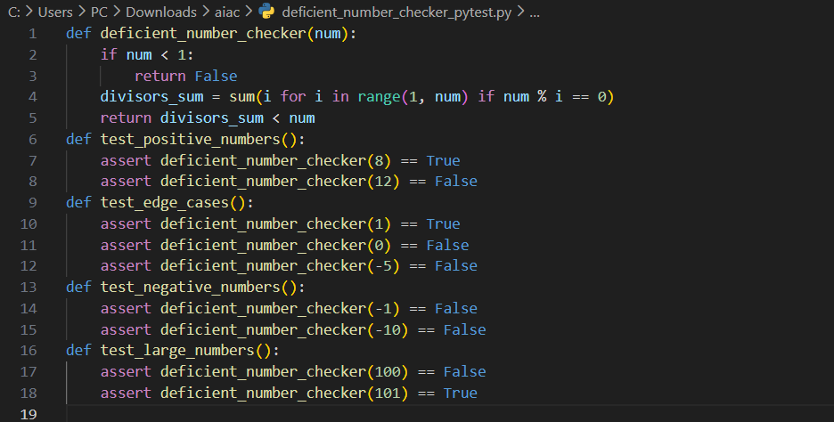
Output:
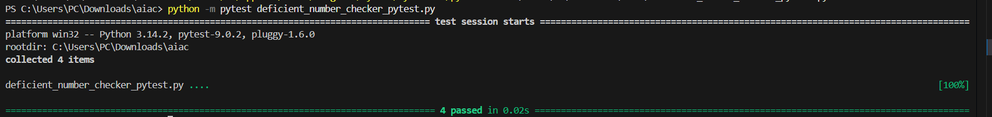
Task 8 :
Write a function LeapYearChecker and validate its implementation using 10 pytest test cases
Code:
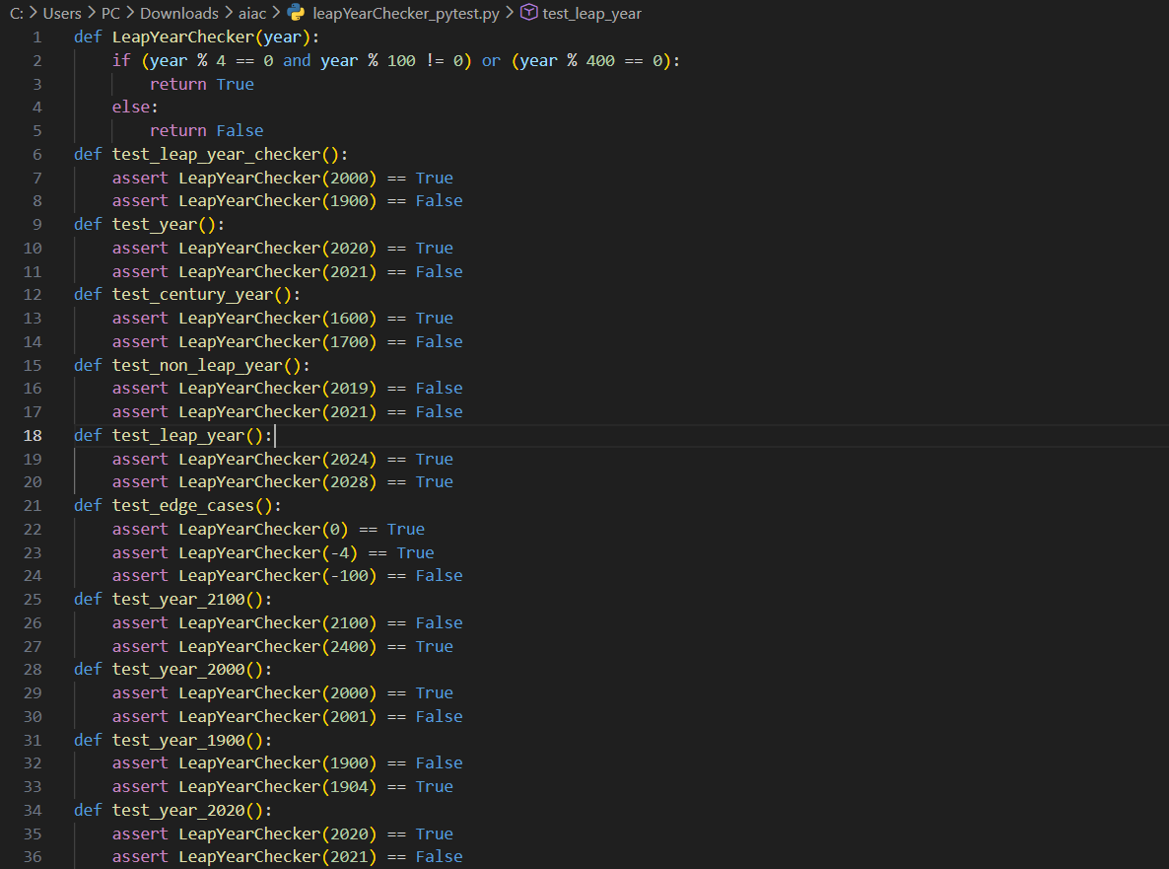

Output:
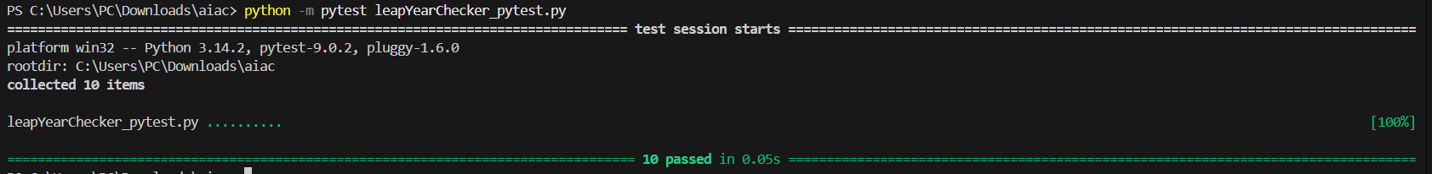
Task 9 :
Write a function SumOfDigits and validate its implementation using 7 pytest test cases.
Code:
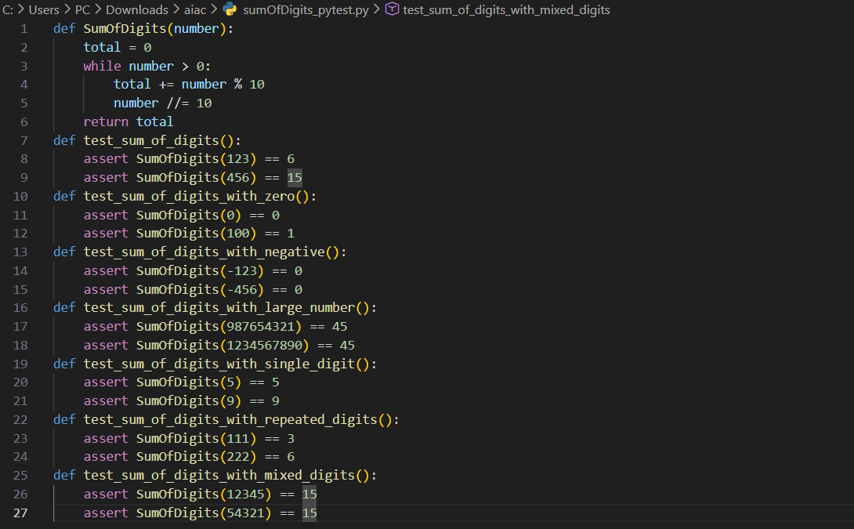
Output:
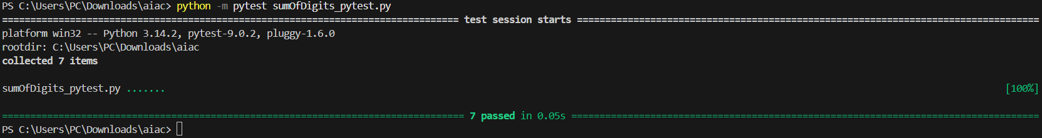

Task 10 :
Write a function SortNumbers (implement bubble sort) and validate its implementation using 25 pytest test cases.
Code :
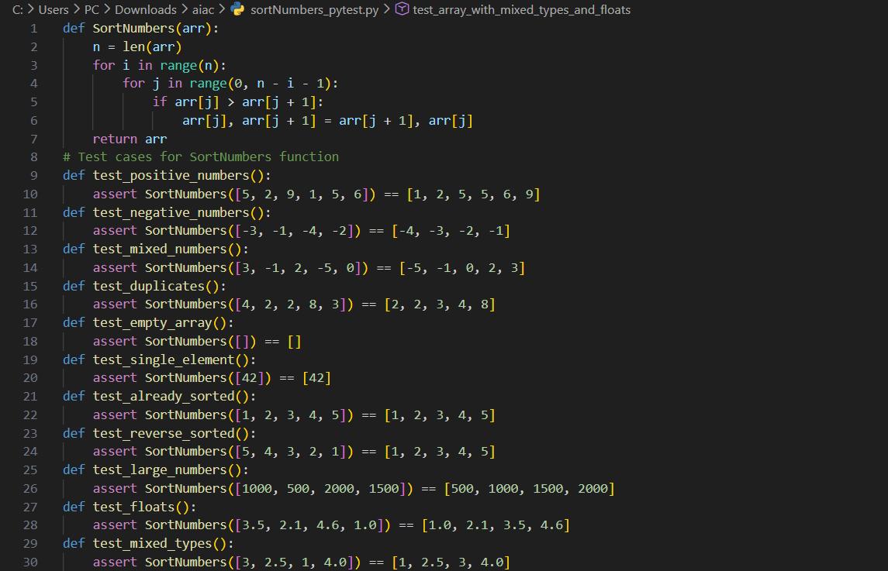
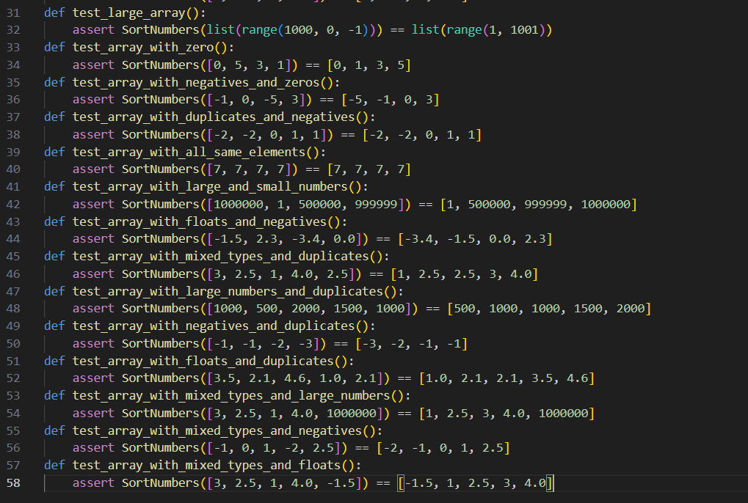
Output:
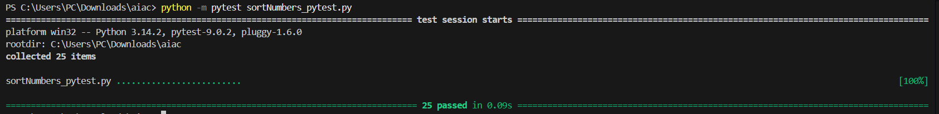
Task 11 :
Write a function ReverseString and validate its implementation using 5 unittest test cases
Code:
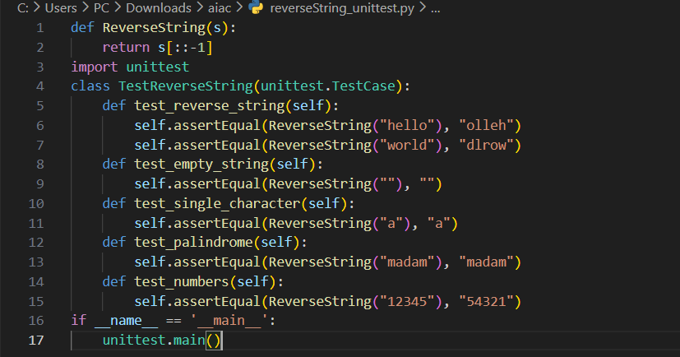
Output:
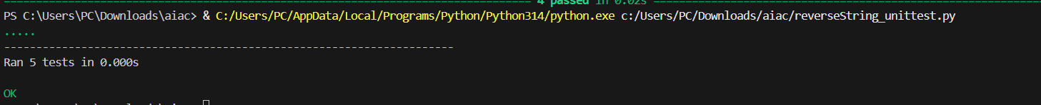

Task 12 :
Write a function AnagramChecker and validate its implementation using 10 unittest test cases.
Code:
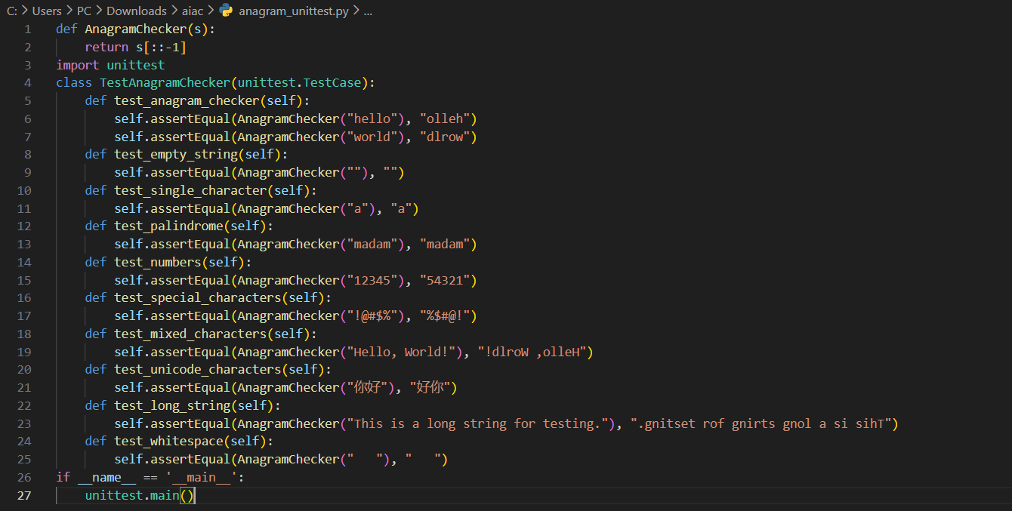
Output:
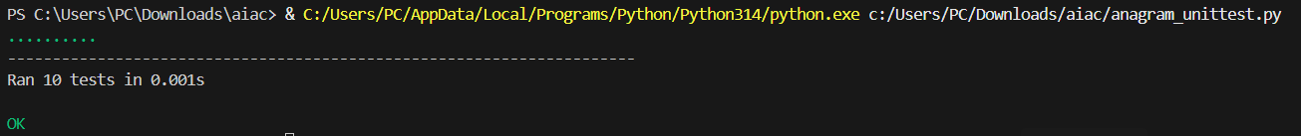
Task 13 :
Write a function ArmstrongChecker and validate its implementation using 8 unittest test cases.
Code:
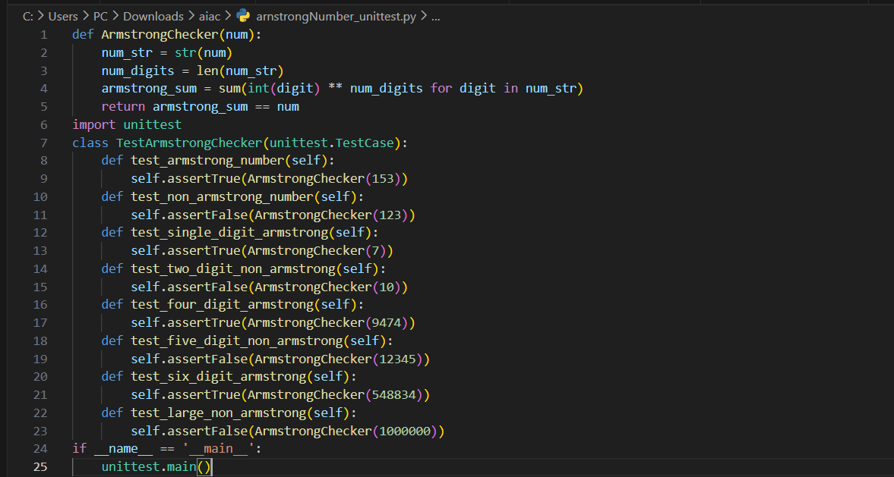
Output:

