AIAC Assignment 3.5
Name : M.Chandhana
Ht.no : 2303A51688
Batch :24

Question 1: Zero-Shot Prompting (Leap Year Check)
Write a zero-shot prompt to generate a Python function that checks
whether a given year is a leap year.
Task:
• Record the AI-generated code.
• Test with years like 1900, 2000, 2024.
• Identify logical flaws or missing conditions.

Prompt : # Generate a python code to check whether a given year is a leap year or not.
Code:
def is_leap_year(year):
"""Check if a given year is a leap year."""
if (year % 4 == 0 and year % 100 != 0) or (year % 400 == 0):
return True
else:
return False
# Check if a given year is a leap year
if __name__ == "__main__":
year = int(input("Enter a year: "))
if is_leap_year(year):
print(f"{year} is a leap year.")
else:
print(f"{year} is not a leap year.")

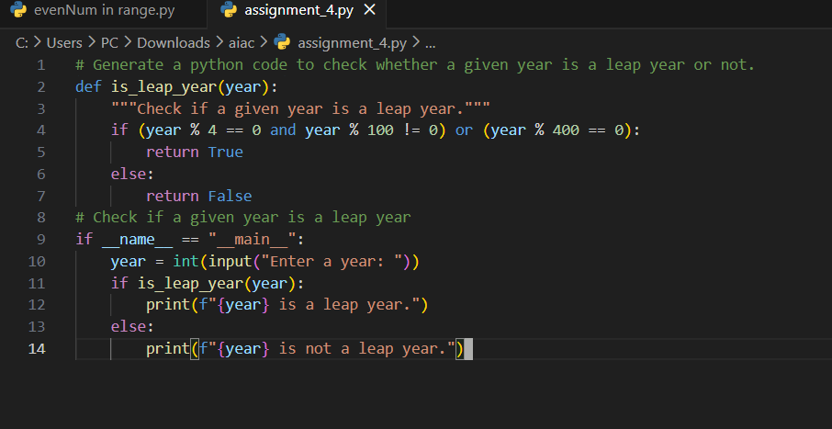

OUTPUT :

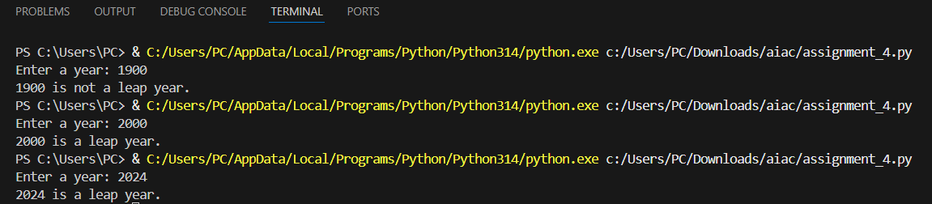

Question 2: One-Shot Prompting (GCD of Two Numbers)
Write a one-shot prompt with one example to generate a Python
function that finds the Greatest Common Divisor (GCD) of two numbers.
Example:
Input: 12, 18 → Output: 6
Task:
• Compare with a zero-shot solution.
• Analyze algorithm efficiency.

Prompt : (One short)
"""
Input: 12, 18 → Output: 6
"""
Code:
def gcd(a, b):
while b:
a, b = b, a % b
return a
if __name__ == "__main__":
num1 = int(input("Enter first number: "))
num2 = int(input("Enter second number: "))
print("GCD:", gcd(num1, num2))

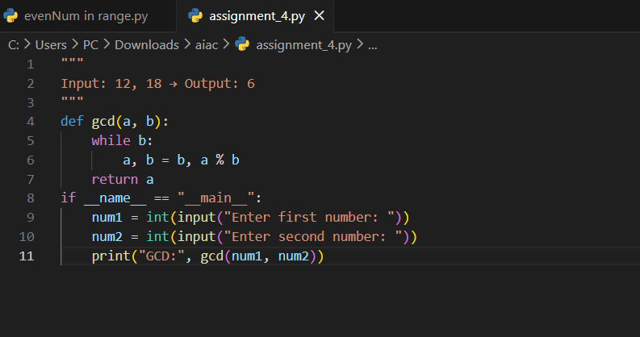

OUTPUT:

Question 3: Few-Shot Prompting (LCM Calculation)
Write a few-shot prompt with multiple examples to generate a Python
function that computes the Least Common Multiple (LCM).
Examples:
• Input: 4, 6 → Output: 12
• Input: 5, 10 → Output: 10
• Input: 7, 3 → Output: 21
Task:
• Examine how examples guide formula selection.
• Test edge cases.
Prompt: """This program calculates the Least Common Multiple (LCM) of two given numbers.
Input: 4, 6 → Output: 12
Input: 5, 10 → Output: 10
Input: 7, 3 → Output: 21
"""
Code:
def calculate_lcm(x, y):
if x > y:
greater = x
else:
greater = y

while True:
if greater % x == 0 and greater % y == 0:
lcm = greater
break
greater += 1
return lcm
num = int(input("Enter first number: "))
num1 = int(input("Enter second number: "))
result = calculate_lcm(num, num1)
print(f"The LCM of {num} and {num1} is {result}")

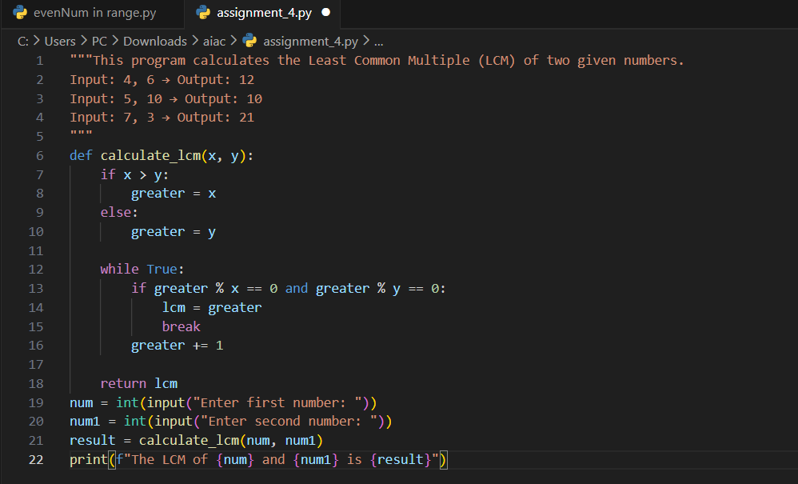

OUTPUT :

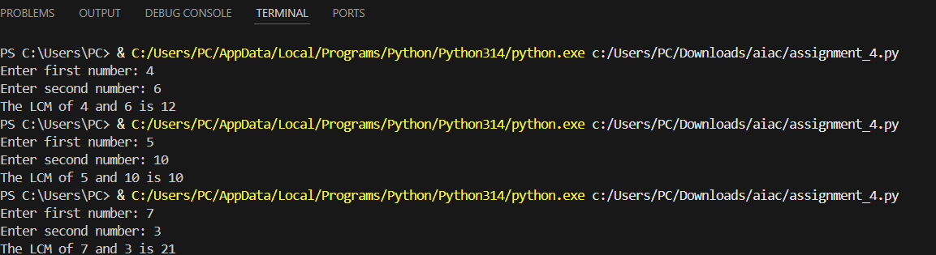

Question 4: Zero-Shot Prompting (Binary to Decimal Conversion)
Write a zero-shot prompt to generate a Python function that converts a
binary number to decimal.
Task:
• Test with valid and invalid binary inputs.
• Identify missing validation logic.

Prompt : # Generate a python program to convert decimal number to binary number.

Code :
def decimal_to_binary(num):
if num < 0:
return "Please enter a non-negative integer."
elif num == 0:
return "0"

binary_num = ""
while num > 0:
remainder = num % 2
binary_num = str(remainder) + binary_num
num = num // 2
return binary_num
num = int(input("Enter a decimal number: "))
binary_representation = decimal_to_binary(num)
print(f"The binary representation of {num} is {binary_representation}")
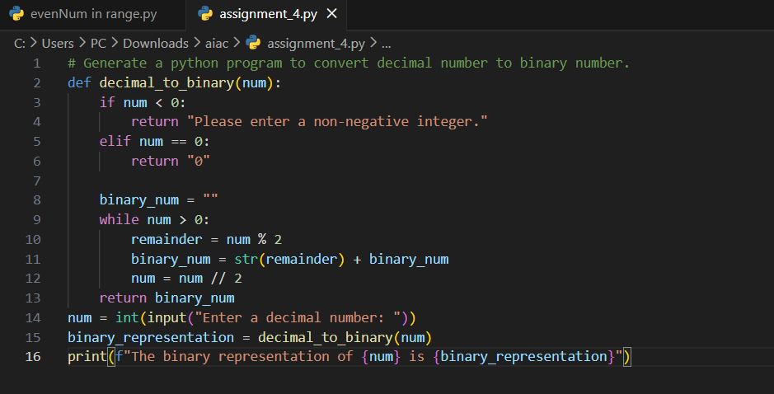

OUTPUT :

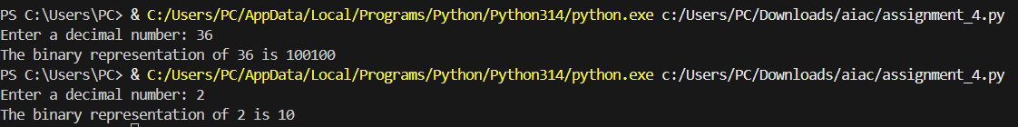

Question 5: One-Shot Prompting (Decimal to Binary Conversion)
Write a one-shot prompt with an example to generate a Python function
that converts a decimal number to binary.
Example:
Input: 10 → Output: 1010
Task:
• Compare clarity with zero-shot output.
• Analyze handling of zero and negative numbers.

Prompt : """
Input: 10 → Output: 1010
"""

Code:

def decimal_to_binary(n):
if n == 0:
return "0"
binary = ""
while n > 0:
binary = str(n % 2) + binary
n = n // 2
return binary
num = int(input("Enter a decimal number: "))
print(f"The binary representation of {num} is {decimal_to_binary(num)}")

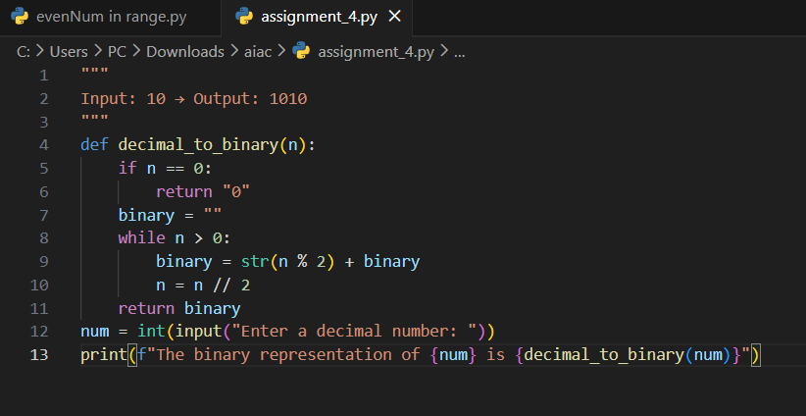
OUTPUT :

Question 6: Few-Shot Prompting (Harshad Number Check)
Write a few-shot prompt to generate a Python function that checks
whether a number is a Harshad (Niven) number.
Examples:
• Input: 18 → Output: Harshad Number
• Input: 21 → Output: Harshad Number
• Input: 19 → Output: Not a Harshad Number
Task:
• Test boundary conditions.
• Evaluate robustness

Prompt :
"""
Input: 18 → Output: Harshad Number
Input: 21 → Output: Harshad Number
Input: 19 → Output: Not a Harshad Number

"""
Code :
def is_harshad_number(n):
digit_sum = sum(int(digit) for digit in str(n))
if n % digit_sum == 0:
return f"{n} is a Harshad Number"
else:
return f"{n} is Not a Harshad Number"
num = int(input("Enter a number: "))
print(is_harshad_number(num))
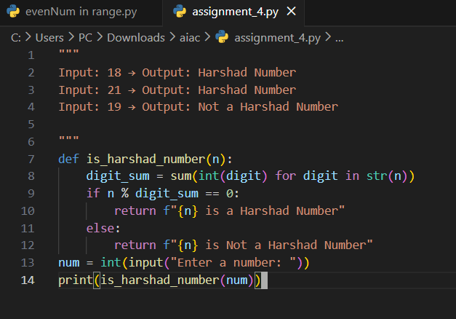
OUTPUT :
