AIAC Assignment 9.1
Name : M.Chandhana
Ht.no : 2303A51688
Batch 24

Problem 1:
Consider the following Python function:
def find_max(numbers):
return max(numbers)
Task:
• Write documentation for the function in all three formats:
(a) Docstring
(b) Inline comments
(c) Google-style documentation
• Critically compare the three approaches. Discuss the advantages, disadvantages, and suitable use cases of each style.
• Recommend which documentation style is most effective
for a mathematical utilities library and justify your answer.

Code :
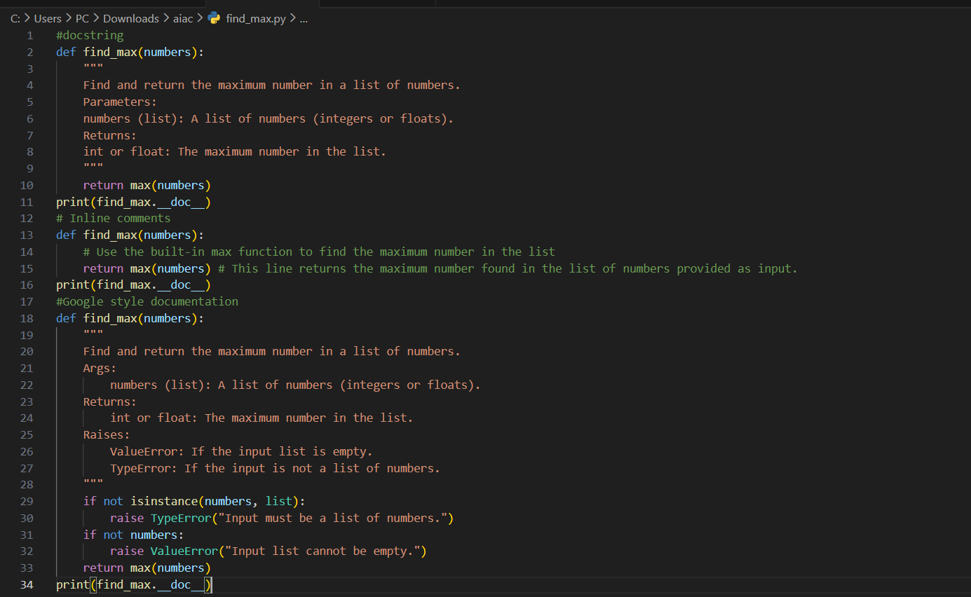

Output:

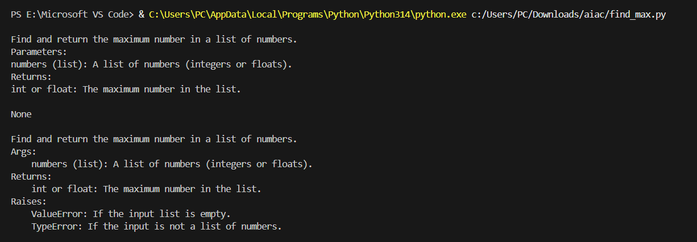

Problem 2: Consider the following Python function:
def login(user, password, credentials):
return credentials.get(user) == password
Task:
1. Write documentation in all three formats.
2. Critically compare the approaches.
3. Recommend which style would be most helpful for new developers on boarding a project, and justify your choice.

Code:
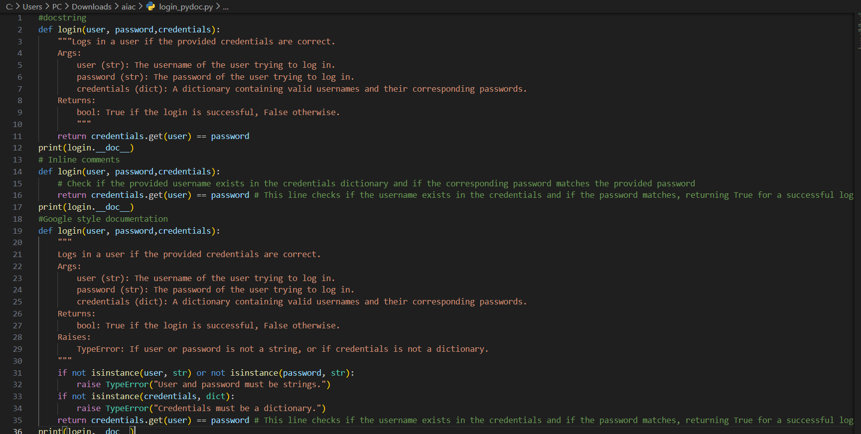

Output :
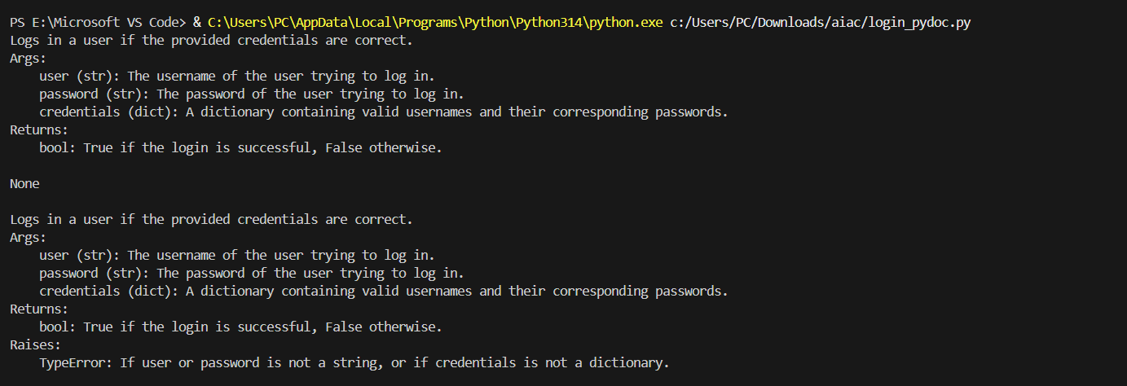

Problem 3: Calculator (Automatic Documentation Generation)
Task: Design a Python module named calculator.py and demonstrate automatic documentation generation.
Instructions:
1. Create a Python module calculator.py that includes the following functions, each written with appropriate docstrings:
o add(a, b) – returns the sum of two numbers
o subtract(a, b) – returns the difference of two numbers
o multiply(a, b) – returns the product of two numbers
o divide(a, b) – returns the quotient of two numbers
2. Display the module documentation in the terminal using Python’s documentation tools.
3. Generate and export the module documentation in HTML format using the pydoc utility, and open the generated HTML file in a web browser to verify the output.

Code:
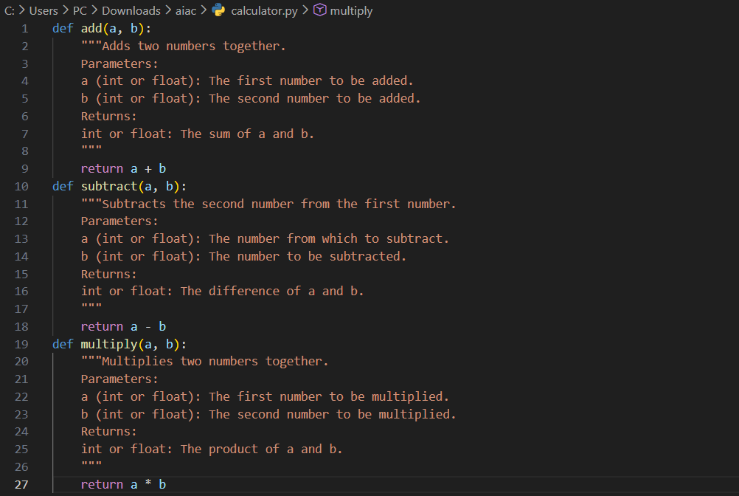
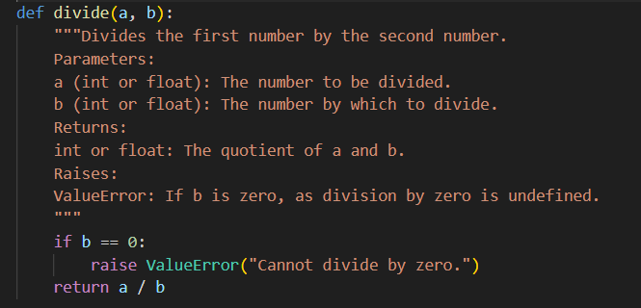
Output :

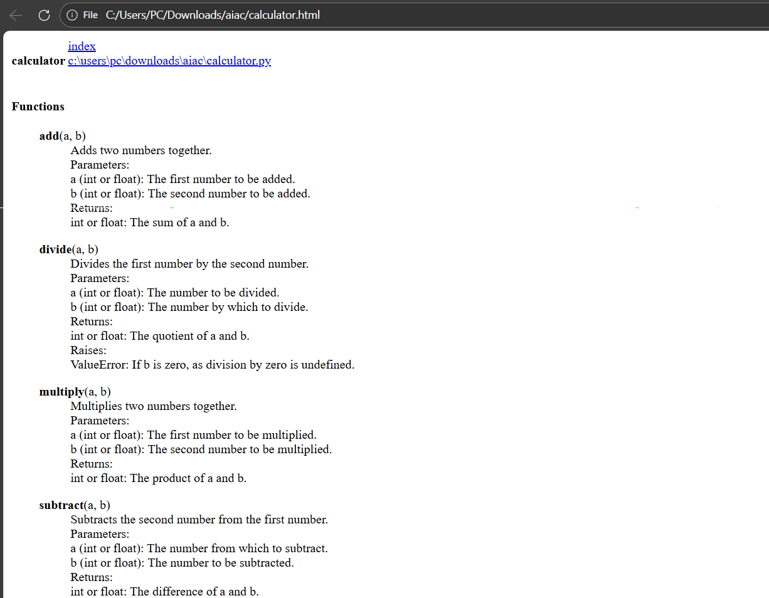

Problem 4: Conversion Utilities Module
Task:
1. Write a module named conversion.py with functions:
o decimal_to_binary(n)
o binary_to_decimal(b)
o decimal_to_hexadecimal(n)
2. Use Copilot for auto-generating docstrings.
3. Generate documentation in the terminal.
4. Export the documentation in HTML format and open it in a browser.

Code:
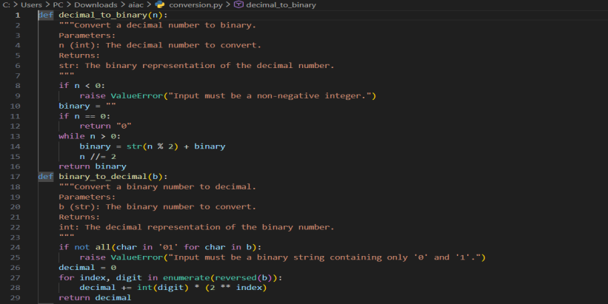
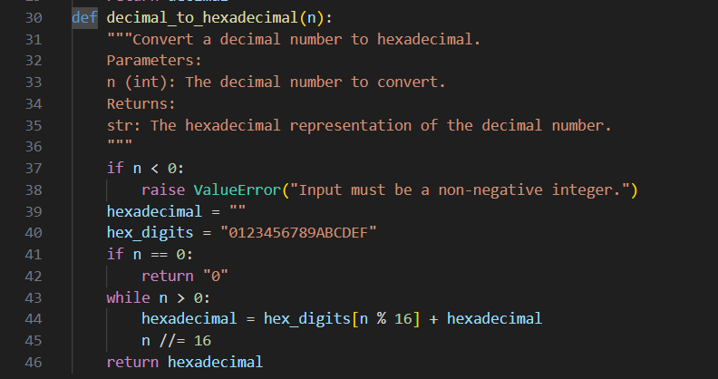

Output:

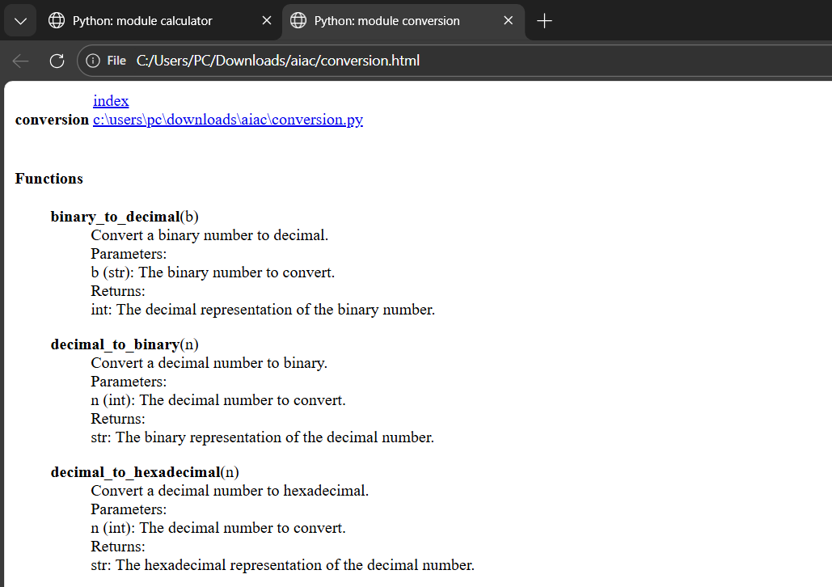

Problem 5 – Course Management Module
Task:
1. Create a module course.py with functions:
o add_course(course_id, name, credits)
o remove_course(course_id)
o get_course(course_id)
2. Add docstrings with Copilot.
3. Generate documentation in the terminal.
4. Export the documentation in HTML format and open it in a browser.

Code:
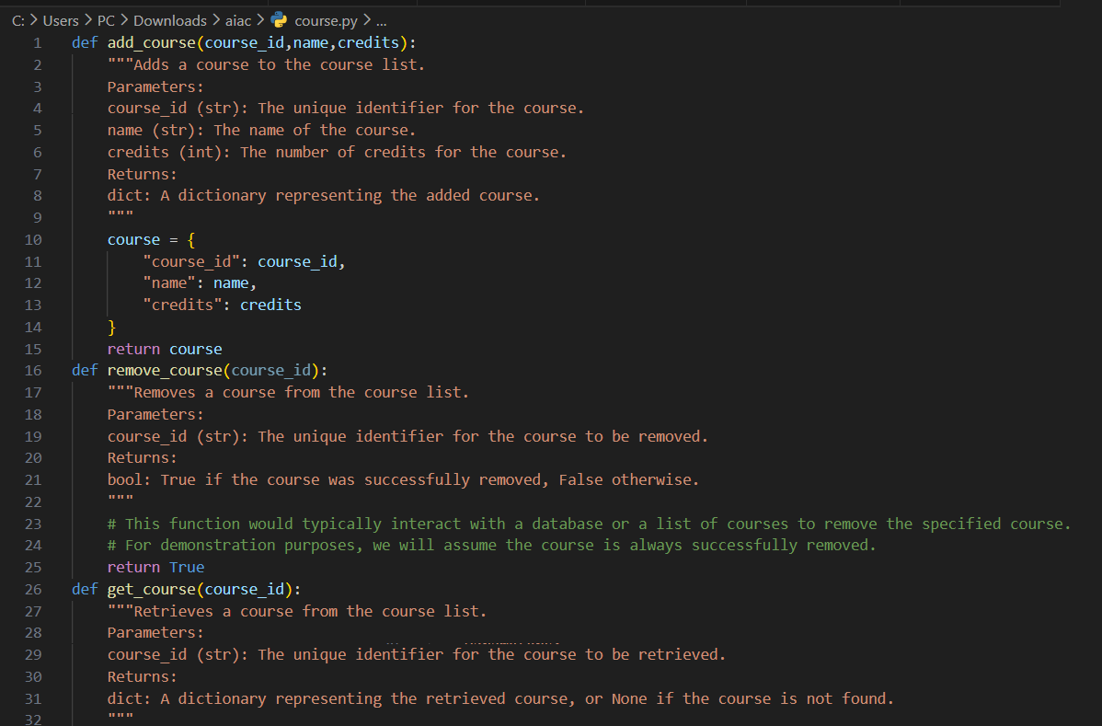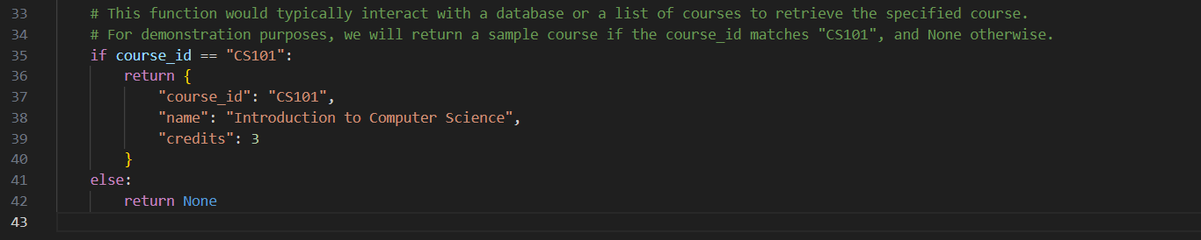
Output :
