AIAC Assignment-6
Name : K.Nikshitha
Ht.no : 2303A51692
Batch 24
#1 (Loops – Automorphic Numbers in a Range)
• Task: Prompt AI to generate a function that displays all Automorphic
numbers between 1 and 1000 using a for loop.
• Instructions:
o Get AI-generated code to list Automorphic numbers using a for
loop.
o Analyze the correctness and efficiency of the generated logic.
o Ask AI to regenerate using a while loop and compare both
implementations.
Expected Output #1:
• Correct implementation that lists Automorphic numbers using both
loop types, with explanation.
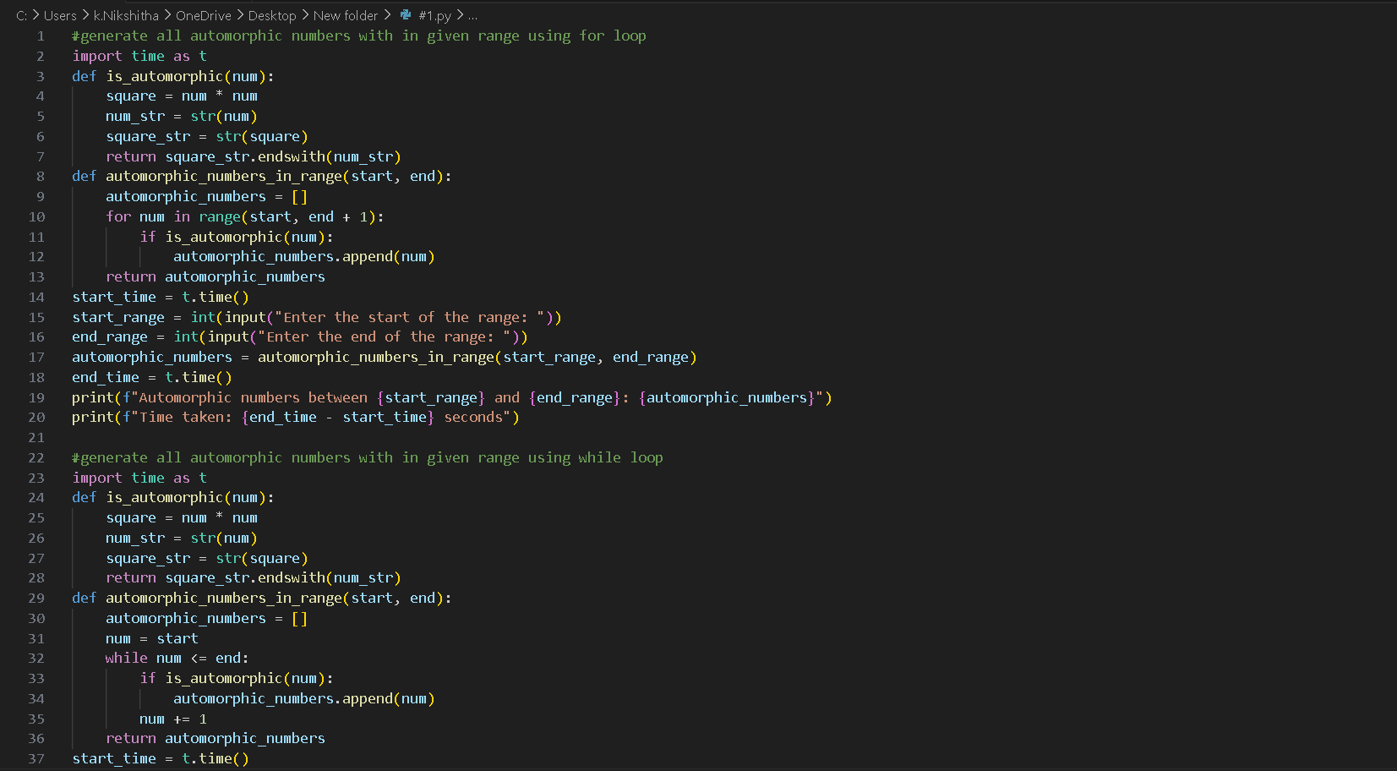
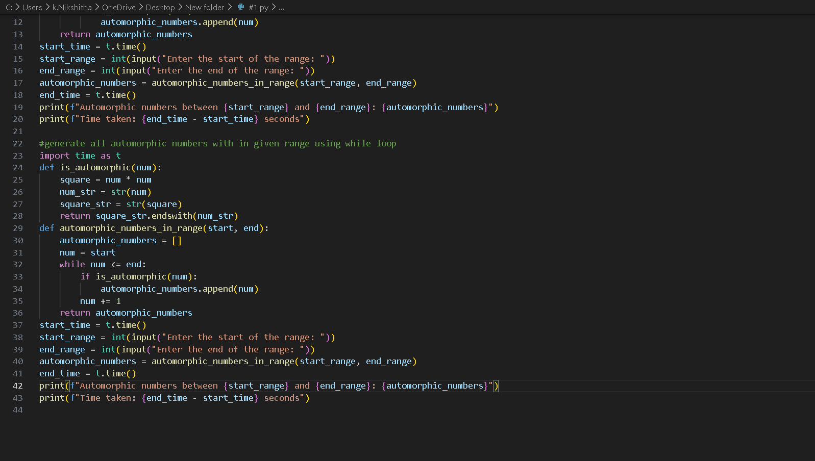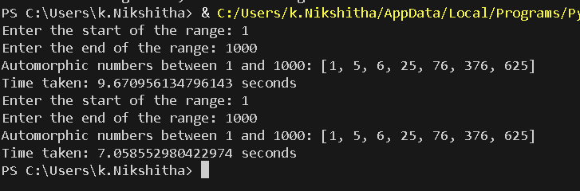

2
Task Description #2 (Conditional Statements – Online Shopping Feedback
Classification)
• Task: Ask AI to write nested if-elif-else conditions to classify online
shopping feedback as Positive, Neutral, or Negative based on a
numerical rating (1–5).
• Instructions:
o Generate initial code using nested if-elif-else.
o Analyze correctness and readability.
o Ask AI to rewrite using dictionary-based or match-case
structure.
Expected Output #2:
• Feedback classification function with explanation and an alternative
approach.
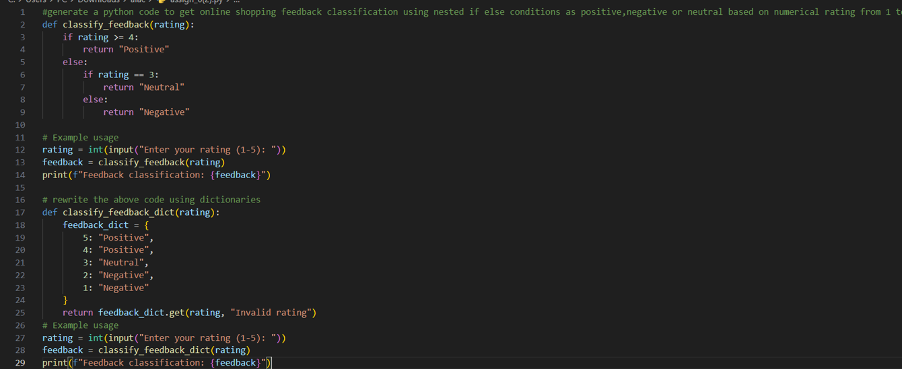
OUTPUT :
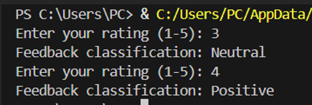
Explanation :
The dictionary approach is more Pythonic and preferred for mapping-style problems. Both produce identical output for valid inputs (1-5), but the dictionary version handles edge cases better with its default parameter.

3
Task 3: Statistical_operations
Define a function named statistical_operations(tuple_num) that performs the
following statistical operations on a tuple of numbers:
• Minimum, Maximum
• Mean, Median, Mode
• Variance, Standard Deviation
While writing the function, observe the code suggestions provided by GitHub
Copilot.Make decisions to accept, reject, or modify the suggestions based on
their relevance and correctness
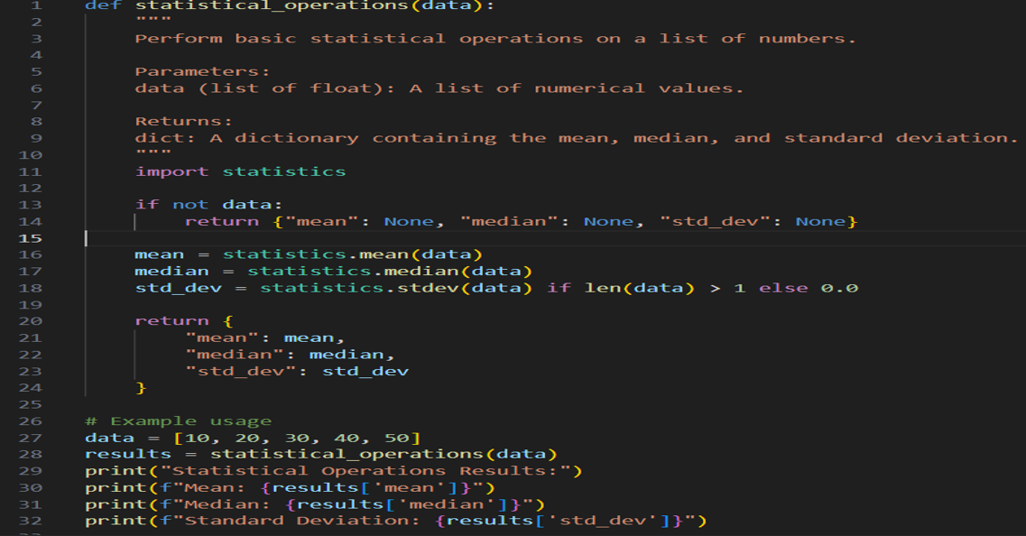
OUTPUT :
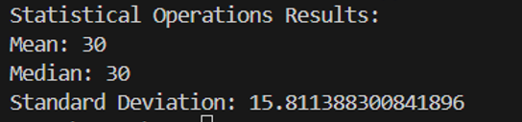

4
Task 4: Teacher Profile
• Prompt: Create a class Teacher with attributes teacher_id, name,
subject, and experience. Add a method to display teacher details.
• Expected Output: Class with initializer, method, and object creation.
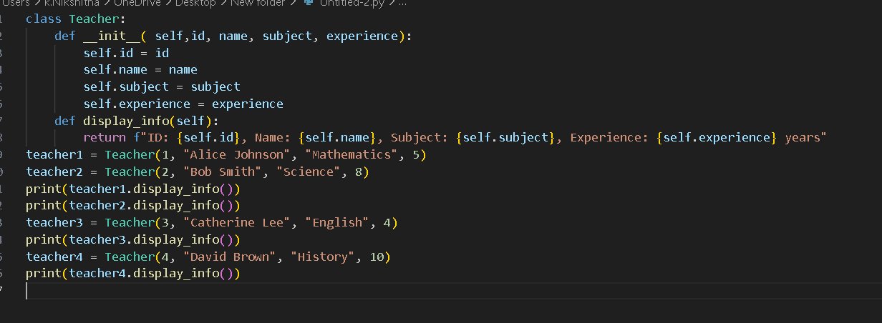
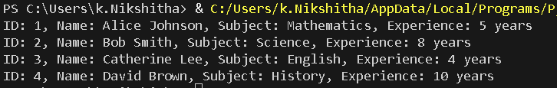
5
Task #5 – Zero-Shot Prompting with Conditional Validation
Use zero-shot prompting to instruct an AI tool to generate a function
that validates an Indian mobile number.
Requirements
• The function must ensure the mobile number:
o Starts with 6, 7, 8, or 9
o Contains exactly 10 digits
Expected Output
• A valid Python function that performs all required validations
without using any input-output examples in the prompt.
CODE :
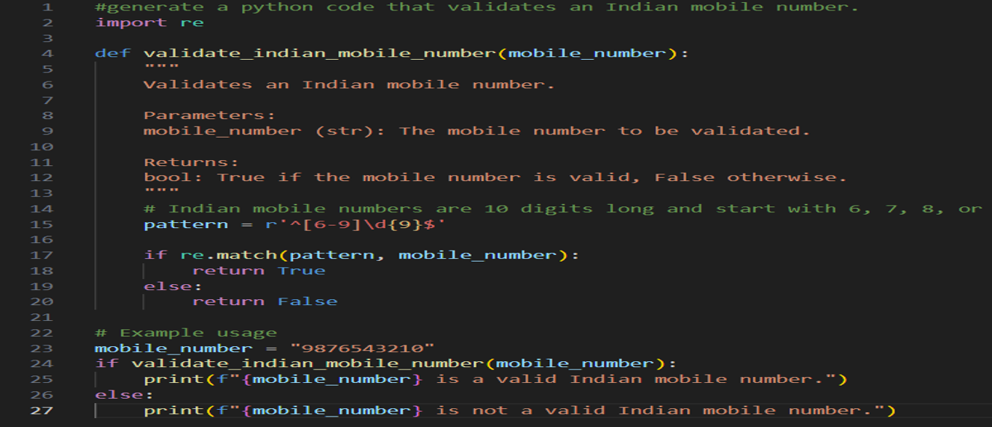
OUTPUT :
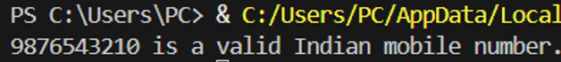

6
Task Description #6 (Loops – Armstrong Numbers in a Range)
Task: Write a function using AI that finds all Armstrong numbers in a user-
specified range (e.g., 1 to 1000).
Instructions:
• Use a for loop and digit power logic.
• Validate correctness by checking known Armstrong numbers (153, 370,
etc.).
• Ask AI to regenerate an optimized version (using list comprehensions).
Expected Output #7:
• Python program listing Armstrong numbers in the range.
• Optimized version with explanation.
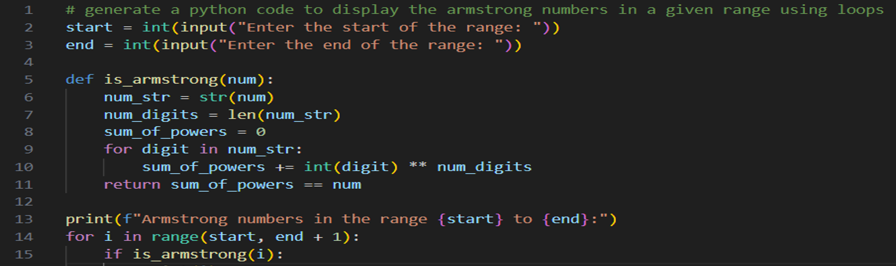
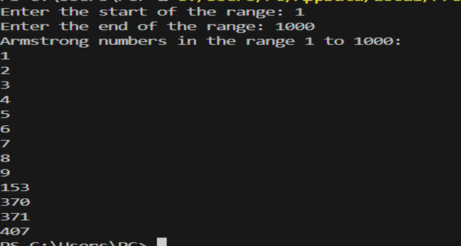
7
Task Description #7 (Loops – Happy Numbers in a Range)
Task: Generate a function using AI that displays all Happy Numbers within a
user-specified range (e.g., 1 to 500).
Instructions:
• Implement the logic using a loop: repeatedly replace a number with the
sum of the squares of its digits until the result is either 1 (Happy
Number) or enters a cycle (Not Happy).
• Validate correctness by checking known Happy Numbers (e.g., 1, 7, 10,
13, 19, 23, 28…).
• Ask AI to regenerate an optimized version (e.g., by using a set to detect
cycles instead of infinite loops).
Expected Output #8:
• Python program that prints all Happy Numbers within a range.
• Optimized version using cycle detection with explanation.
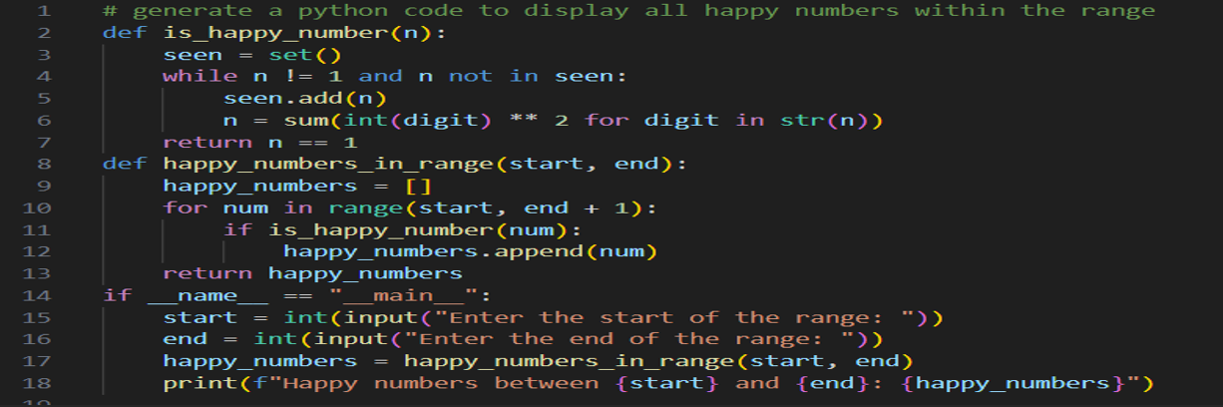
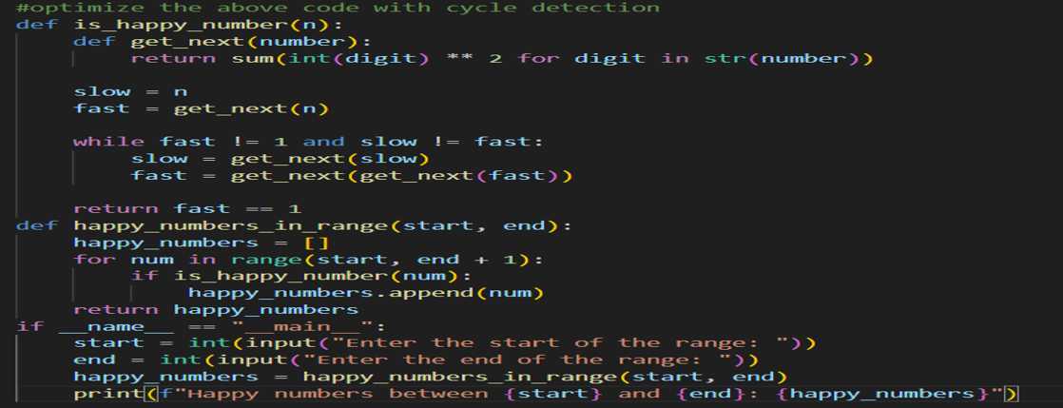
OUTPUT :
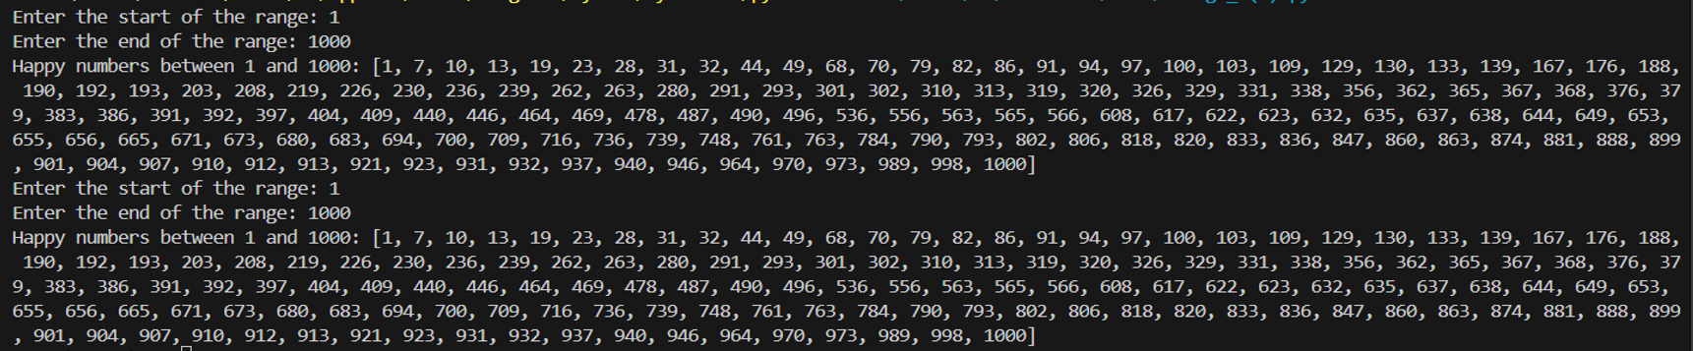
Explanation :
The first approach uses O(k) space where k is the number of unique values encountered before determining happiness. The second approach uses O(1) constant space but performs more function calls. For typical ranges, both are fast—the optimization shines with very large numbers or massive ranges where memory becomes a bottleneck.

8 Task Description #8 (Loops – Strong Numbers in a Range)
Task: Generate a function using AI that displays all Strong Numbers (sum of
factorial of digits equals the number, e.g., 145 = 1!+4!+5!) within a given range.
Instructions:
• Use loops to extract digits and calculate factorials.
• Validate with examples (1, 2, 145).
• Ask AI to regenerate an optimized version (precompute digit factorials).
Expected Output #9:
• Python program that lists Strong Numbers.
• Optimized version with explanation.
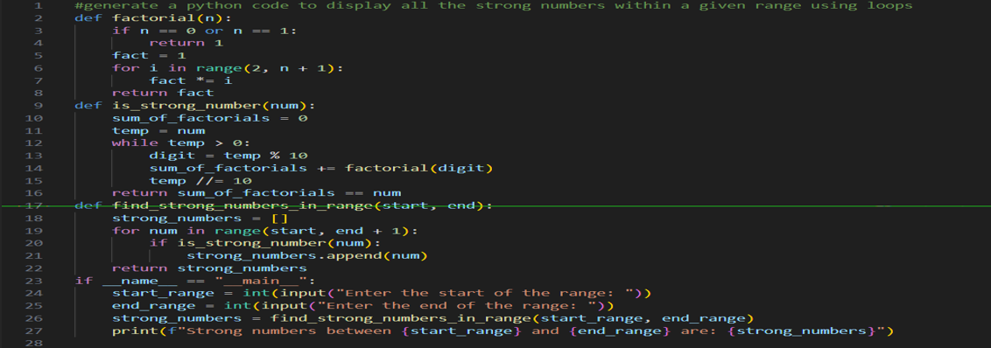
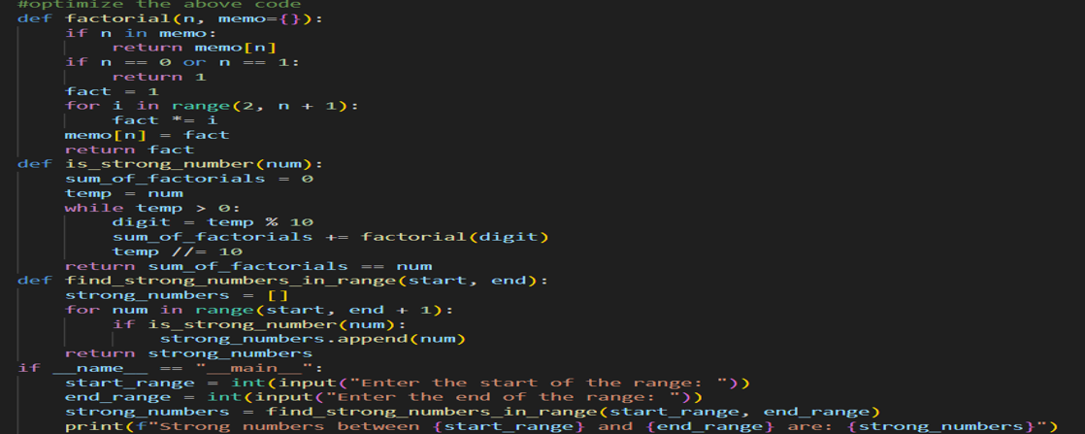
OUTPUT :
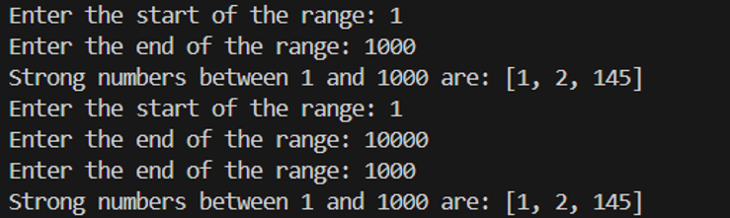
Explanation :
The optimization provides dramatic speedup for large ranges. Without memoization, a range like 1-10,000 recalculates 5! thousands of times. With memoization, each factorial computes only once, delivering consistent O(1) lookup for subsequent calls.

9
Task #9 – Few-Shot Prompting for Nested Dictionary Extraction
Objective
Use few-shot prompting (2–3 examples) to instruct the AI to create a
function that parses a nested dictionary representing student
information.
Requirements
• The function should extract and return:
o Full Name
o Branch
o SGPA
Expected Output
A reusable Python function that correctly navigates and extracts values
from nested dictionaries based on the provided examples
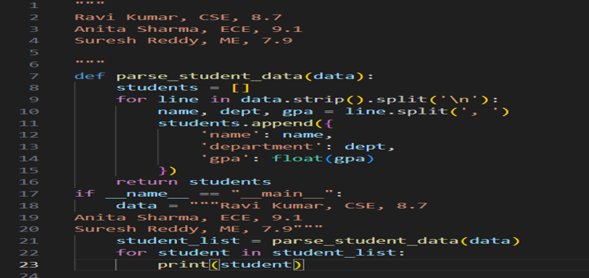
OUTPUT :
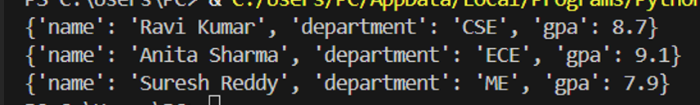

10
Task Description #10 (Loops – Perfect Numbers in a Range)
Task: Generate a function using AI that displays all Perfect Numbers within a
user-specified range (e.g., 1 to 1000).
Instructions:
• A Perfect Number is a positive integer equal to the sum of its proper
divisors (excluding itself).
o Example: 6 = 1 + 2 + 3, 28 = 1 + 2 + 4 + 7 + 14.
• Use a for loop to find divisors of each number in the range.
• Validate correctness with known Perfect Numbers (6, 28, 496…).
• Ask AI to regenerate an optimized version (using divisor check only up to
√n).
Expected Output #12:
• Python program that lists Perfect Numbers in the given range.
• Optimized version with explanation.
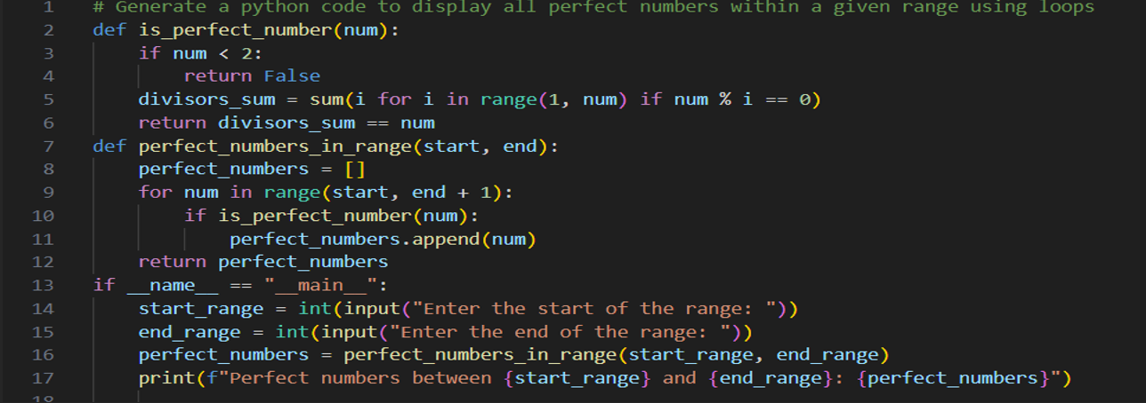
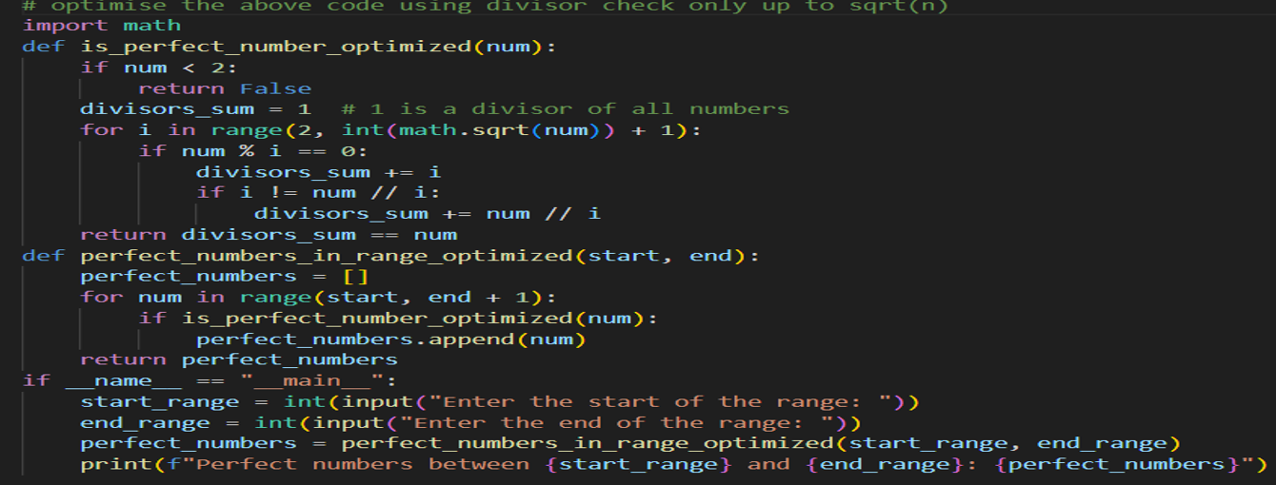
OUTPUT :
