Syed Naziya Parveen
Batch-42
2303A52394
Task 1: Refactoring Data Transformation Logic
PROMPT:
Refactor the following Python code to make it more Pythonic using list comprehensions or a helper function.
values = [2, 4, 6, 8, 10]
doubled = []
for v in values:
doubled.append(v * 2)
print(doubled)
CODE:
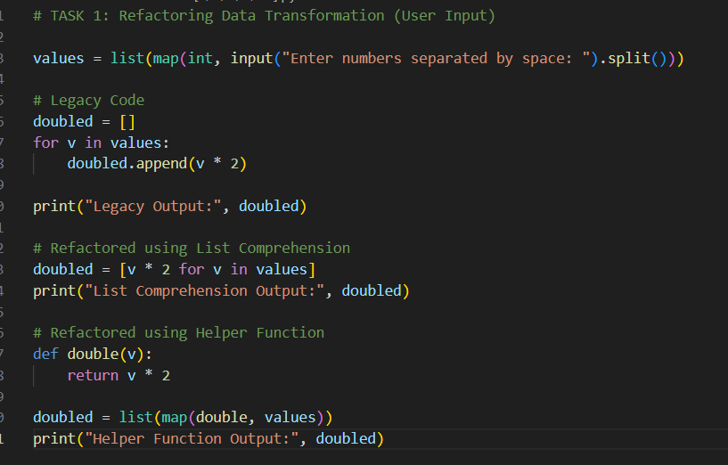
OUTPUT:
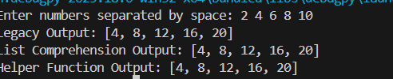
JUSTIFICATION:
The refactored code uses a list comprehension to create the `doubled` list in a more concise and readable way. Instead of initializing an empty list and then appending each doubled value in a loop, the list comprehension allows us to generate the entire list in a single line. This approach is more Pythonic as it is clearer and more efficient, while still producing the same output.
Task 2: Improving Text Processing Code Readability
PROMPT:
Refactor the following python code to improve readability and efficiency an davoid repeated string concatenation inside a loop and take input from the user
words = ["Refactoring", "with", "AI", "improves",
"quality"]
message = ""
for w in words:
message += w + " "
print(message.strip())
CODE:

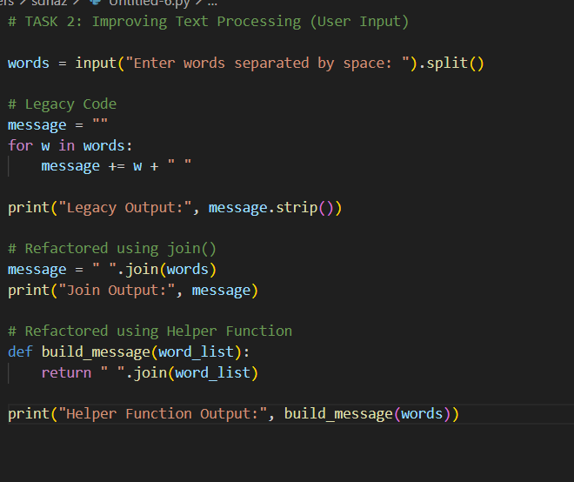
OUTPUT:
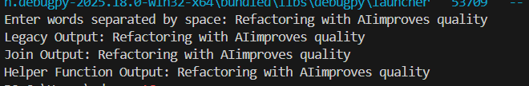
JUSTIFICATION:
The refactored code uses the `join` method to concatenate the list of words into a single string with spaces in between. This is more efficient than using string concatenation in a loop, as it avoids creating multiple intermediate string objects. Additionally, it improves readability by clearly indicating that we are joining the words together, and it eliminates the need for stripping the trailing space at the end. The final output remains unchanged, but the code is cleaner and more efficient.
Task 3: Safer Access to Configuration Data
PROMPT:
Refactor my Python code to use a safer dictionary access method instead of manually checking if a key exists. Use a more Pythonic approach like the get() method. Make the code shorter and cleaner while keeping the same behavior when the key is missing.
config = {"host": "localhost", "port": 8080}
if "timeout" in config:
print(config["timeout"])
else:
print("Default timeout used")

CODE:
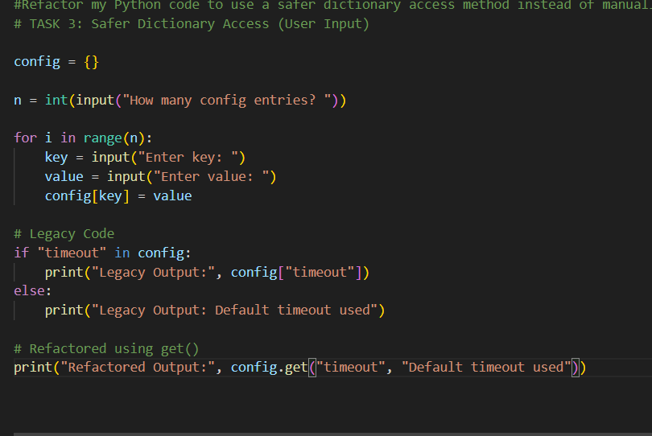
OUTPUT:
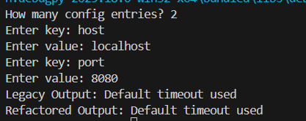
JUSTIFICATION:
The refactored code uses the get() method of dictionaries, which allows for a more concise and readable way to access values while providing a default value if the key is missing. This eliminates the need for an explicit if statement to check for the key's existence, making the code cleaner and more efficient.
Task 4: Refactoring Conditional Logic for Scalability
PROMPT:
Refactor my Python code to replace multiple if-elif conditions with a cleaner and more scalable approach using a dictionary mapping technique. Keep both the legacy version and the refactored version in the same program for comparison. The functionality and output must remain the same.
action = "divide"
x, y = 10, 2
if action == "add":
result = x + y
elif action == "subtract":
result = x - y
elif action == "multiply":
result = x * y
elif action == "divide":
result = x / y
else:
result = None
print(result)
CODE:
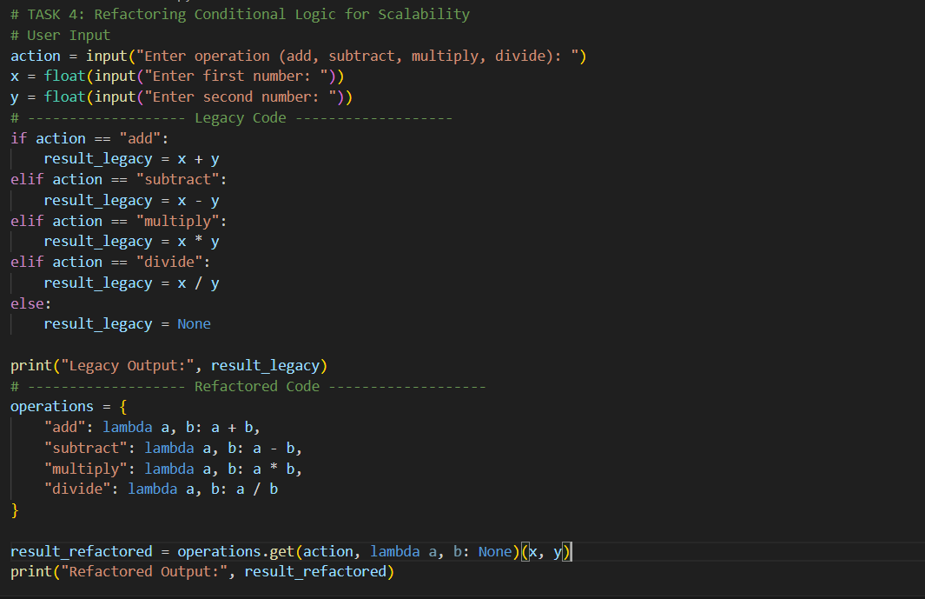
OUTPUT:
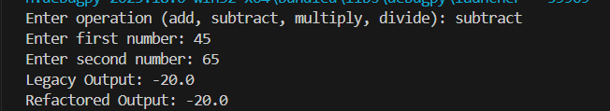
JUSTIFICATION:
The refactored code uses a dictionary to map operation names to their corresponding functions, which eliminates the need for multiple if-elif statements. This approach is more scalable, as adding new operations simply involves adding new entries to the dictionary without modifying the existing logic. It also enhances readability by clearly associating each action with its operation in a structured way.
Task 5: Simplifying Search Logic in Collections
PROMPT:
Refactor my Python inventory search program to make it more concise and readable. Keep both the legacy loop-based version and a refactored version in the same program for comparison. The program should take inventory items and the item to search from user input. Maintain the same output behavior.
inventory = ["pen", "notebook", "eraser", "marker"]
found = False
for item in inventory:
if item == "eraser":
found = True
break
print("Item Available" if found else "Item Not Available")
CODE:
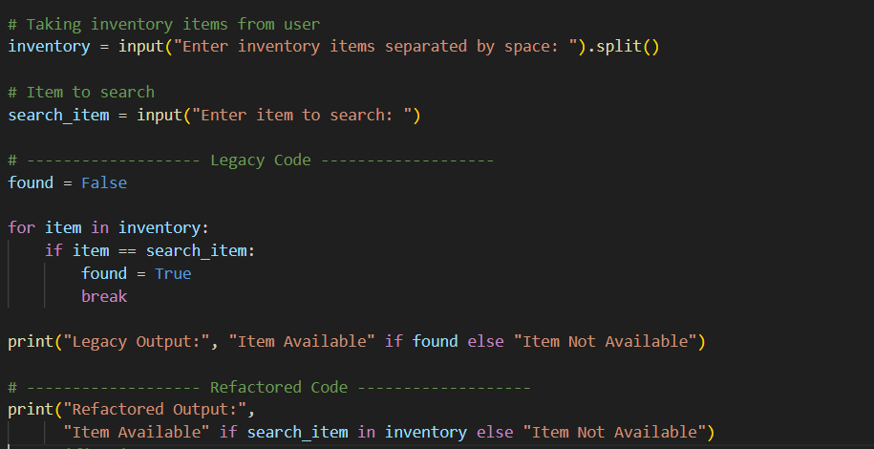
OUTPUT:
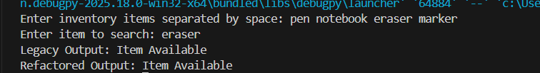
JUSTIFICATION:
The refactored code uses the 'in' keyword to check for the presence of the search item in the inventory list, which is more concise and readable than the loop and flag method used in the legacy code. This approach is more efficient and Pythonic, as it directly expresses the intent of checking for membership without the need for additional variables or control flow.

