ASSIGNMNET 8.2
SYED NAZIYA PARVEEN
BATCH-42
2303A52394
Task 1: Email Validation using TDD
PROMPT
Develop a Python program that validates an email address entered by the user. The program must check whether the email: Contains exactly one @ symbol, Contains at least one, Does not start or end with special characters, Does not contain spaces The program should display whether the email is VALID or INVALID and allow the user to test multiple email addresses until they choose to exit.
CODE:

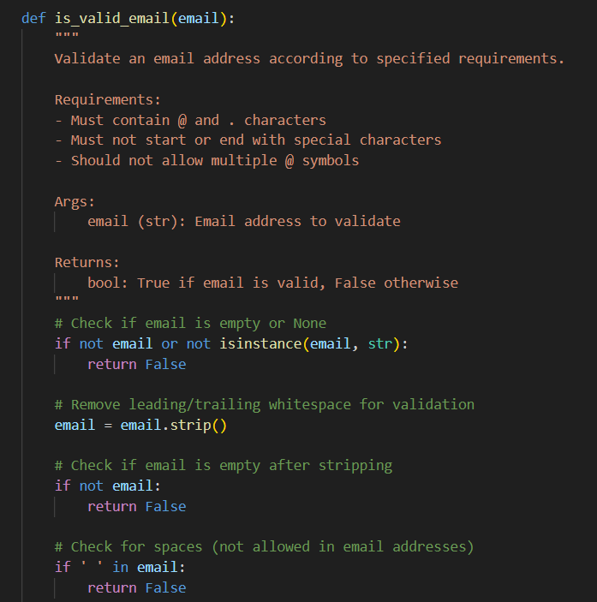
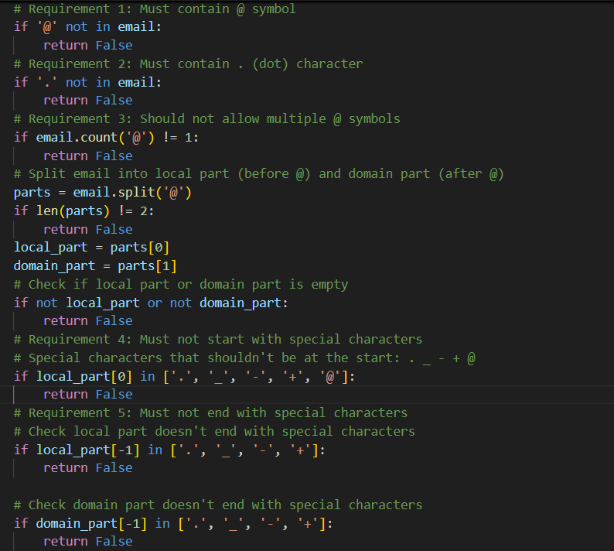
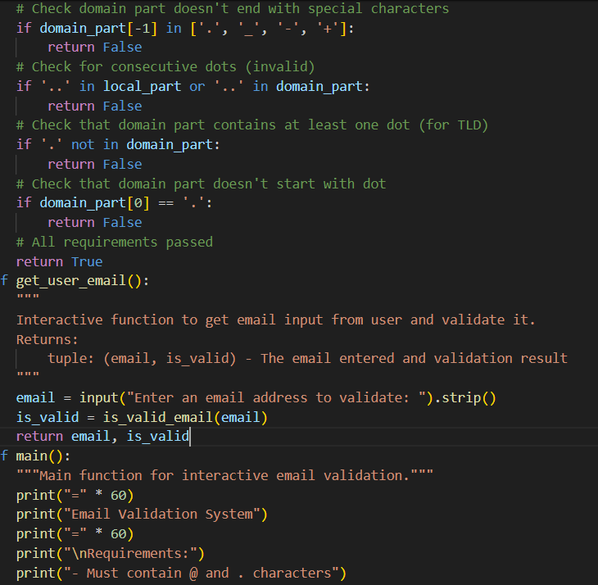
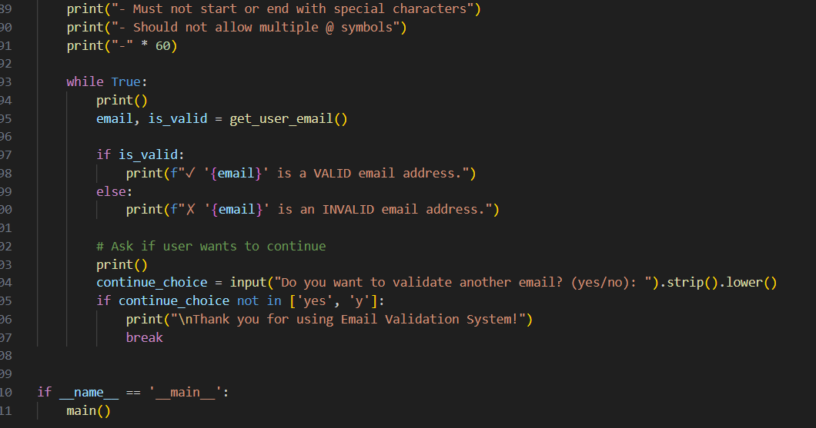
OUTPUT:
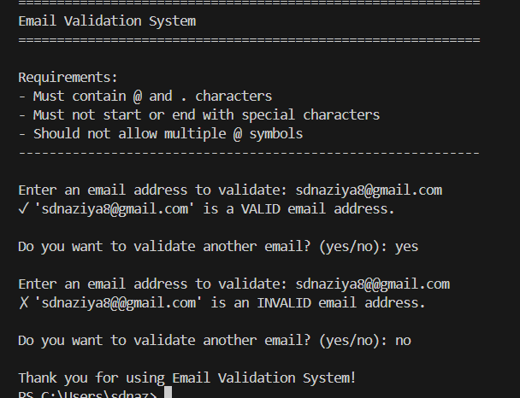
JUSTIFICATION
By running the code, The email validation system is created to stop users from entering invalid email addresses. It checks rules like one @, at least one dot, and no spaces. This makes the program more reliable and user-friendly.
Task 2: Grade Assignment using Loops
PROMPT:
Create a Python assign_grade(score) function that returns A–F grades based on standard grading rules, handles invalid inputs by returning "Invalid score", and passes all unittest test cases including boundary values and edge cases.
CODE: 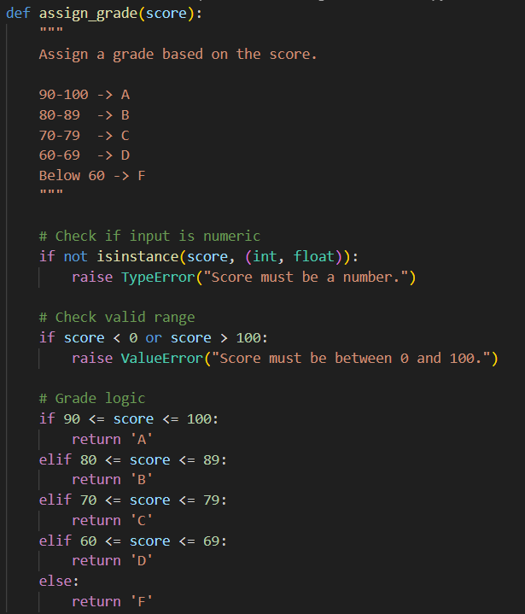

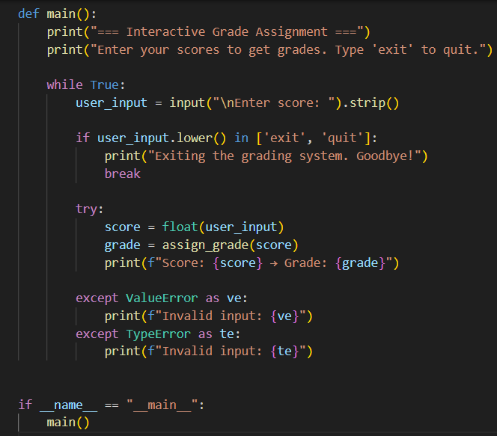
OUTPUT:
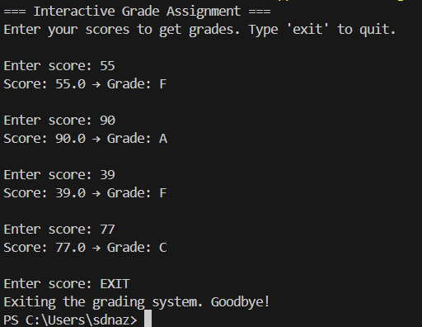
JUSTIFICATION:
This program ensures accurate grade assignment by following standard grading ranges and validating input properly. It prevents invalid data such as negative numbers, values above 100, or non-numeric inputs from crashing the system. The use of exception handling makes the program reliable and user-friendly.
Task 3: Sentence Palindrome Checker
Prompt:
Create a Python function `is_sentence_palindrome(sentence)` that checks if a sentence is a palindrome. Ignore case, spaces, and punctuation. Also, generate unittest test cases covering palindromic and non-palindromic sentences.
CODE:
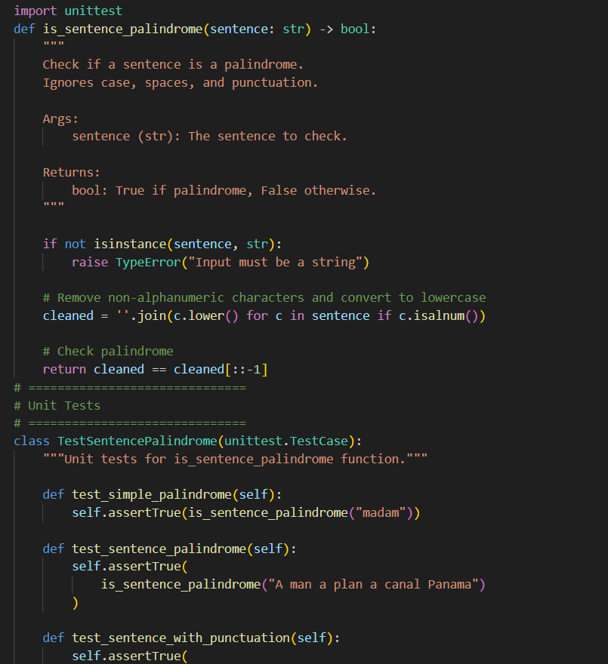
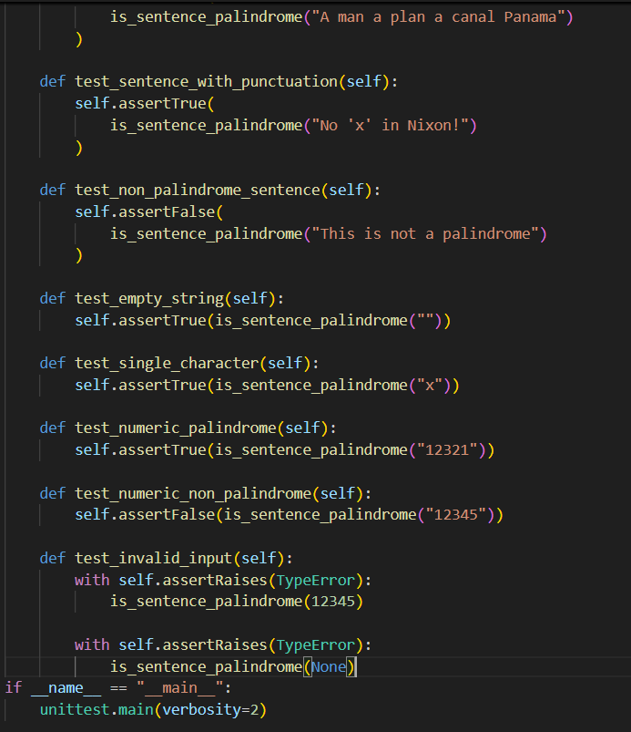
OUTPUT:
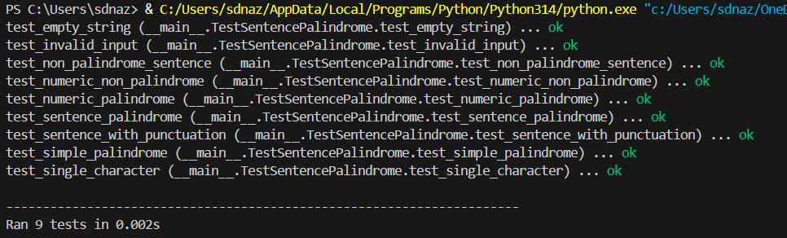
JUSTIFICATION:
This implementation correctly checks whether a sentence is a palindrome by removing spaces, punctuation, and ignoring case differences. It ensures accurate comparison by cleaning the input before checking. The unit tests verify different scenarios, including valid palindromes, non-palindromes, numeric inputs, and invalid data types, making the solution reliable and well-tested.
Task 4: ShoppingCart Class
Prompt:
Write a Python class ShoppingCart with methods add_item(name, price), remove_item(name), and total_cost(). Include validation for empty cart and correct total cost
calculation. Also, create unit tests to verify adding, removing, and total cost.
CODE:
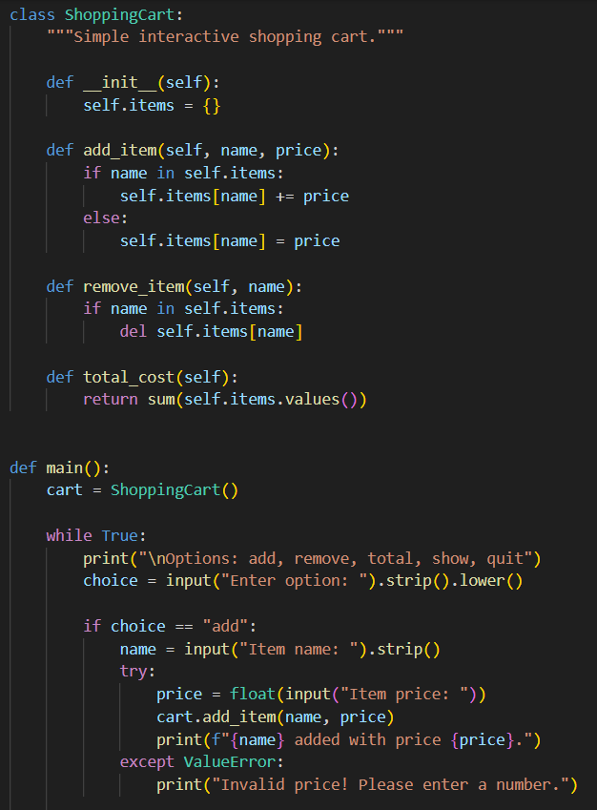
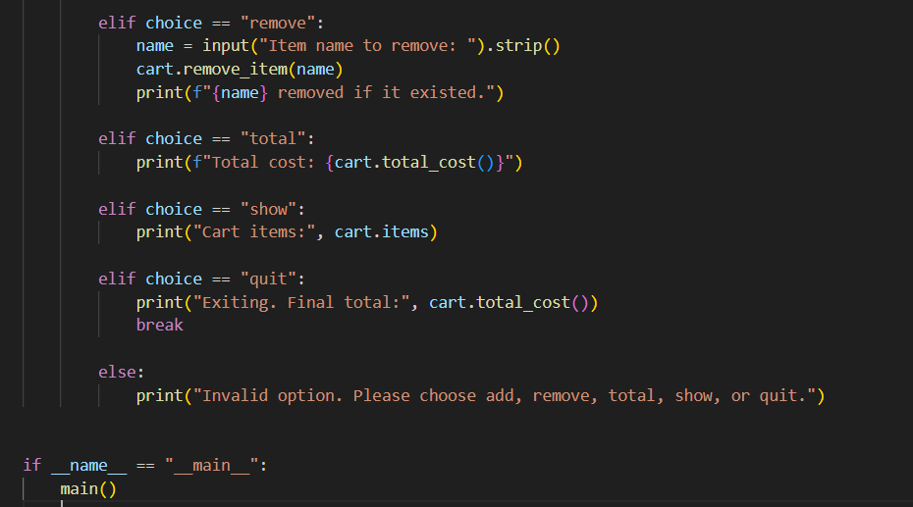
OUTPUT:
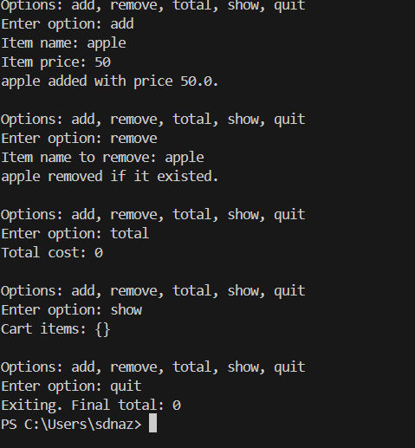
JUSTIFICATION:
This program provides a basic but functional shopping cart system using object-oriented programming. It allows users to manage items easily and calculates the total cost dynamically. Exception handling ensures invalid price inputs do not crash the program, making it user-friendly and reliable.
Task 5: Date Format Conversion
Prompt:
Write a Python function convert_date_format(date_str) that converts a date from YYYY-MM-DD format to DD-MM-YYYY. Include input validation and test cases.
Code:
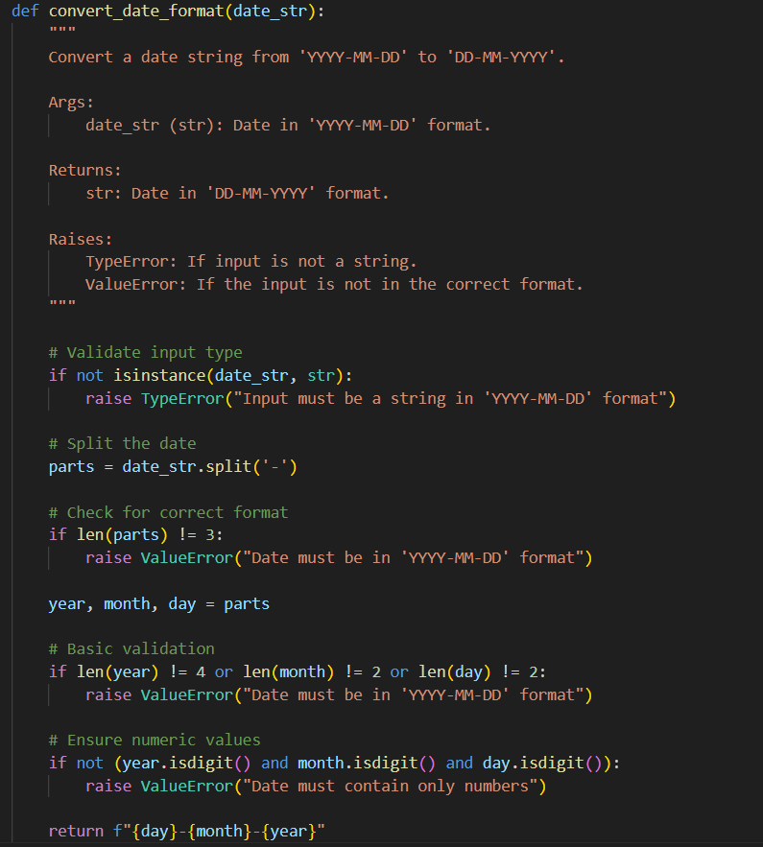
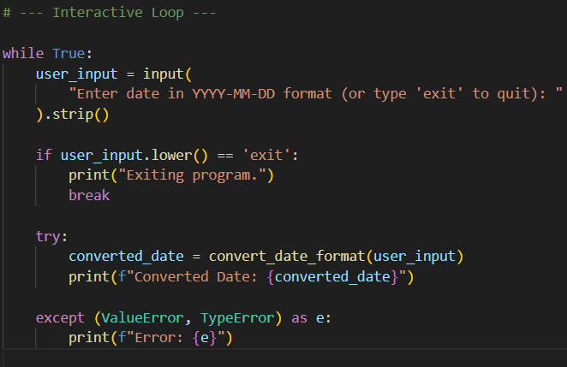
OUTPUT:
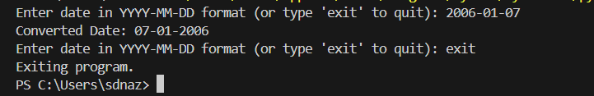
JUSTIFICATION:
This program converts dates from YYYY-MM-DD to DD-MM-YYYY format. It defines a function convert_date_format that checks if the input is a string and properly formatted, then rearranges the year, month, and day. The program runs in a loop, asking the user for input repeatedly until they type exit, If the input is valid, it prints the converted date; if not, it shows a clear error message. This way, the program handles both correct and incorrect inputs interactively.

