AI ASSISTANT CODING - ASSIGNMENT-14.4

Name: Syed Naziya Parveen
Roll No: 2303A52394
Batch: 42

Task 1: Responsive Homepage Layout for a Startup Website
Prompt:
create a webpage structure using HTML that includes a header with navigation links ,a main content section, a footer with basic information and generate responsive CSS using media queries and ensure that layout adjusts smoothly across different screen sizes, the header, content, and footer are clearly separated layout adapts correctly to mobile, tablet, and desktop views and code is clean and well-structured
Code:
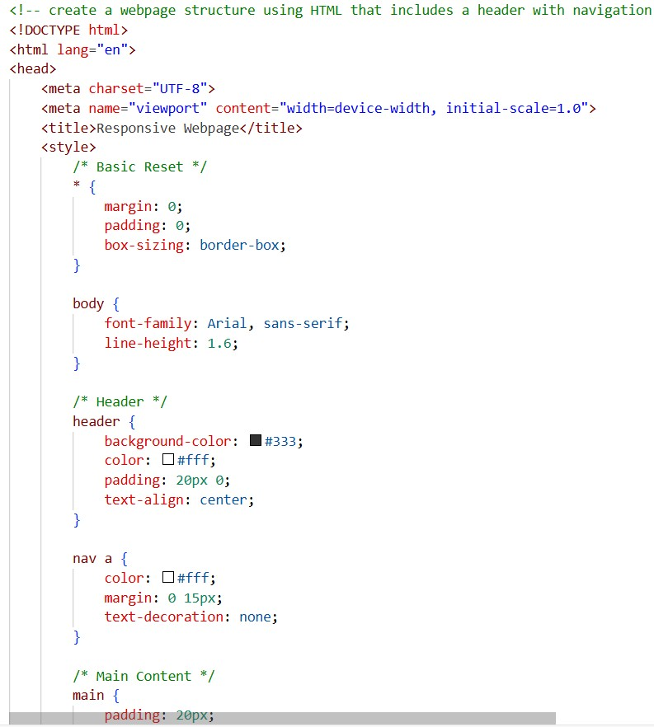
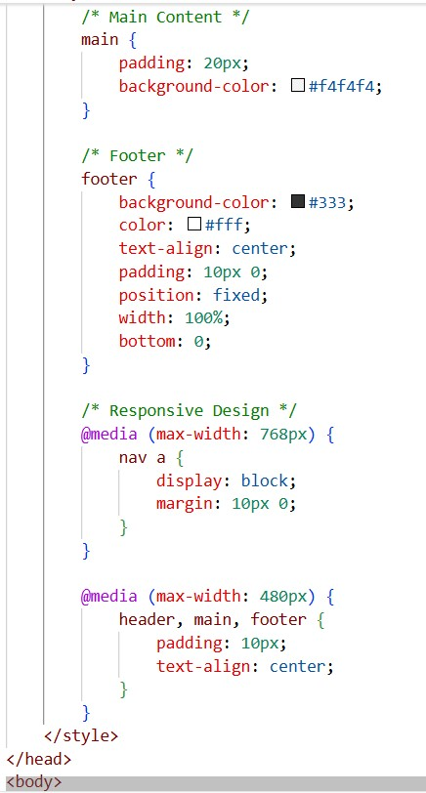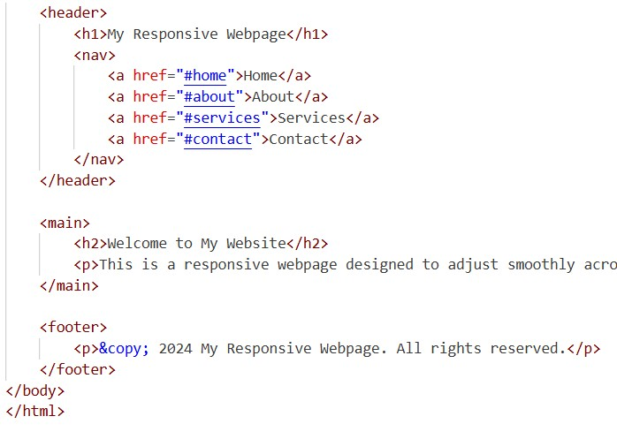

Output:
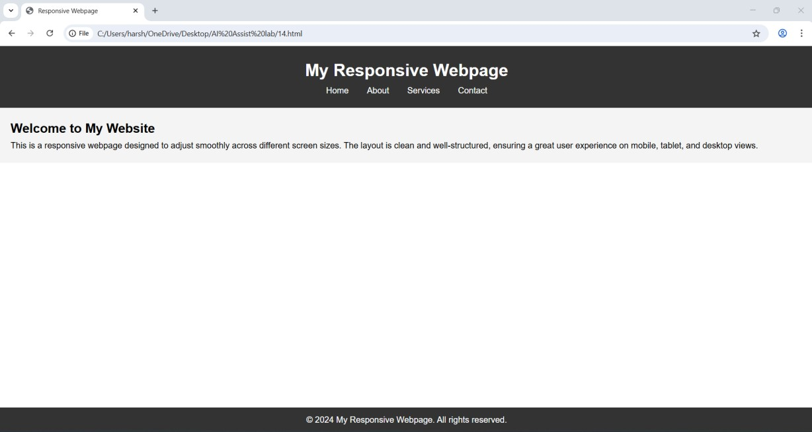
Justification:
In this task, a appropriate homepage layout was created using HTML and CSS. With the help of AI, responsive CSS using media queries was generated so that the layout adjusts properly for desktop, tablet, and mobile devices.

Task 2: Interactive Call-to-Action Button
Prompt:
A marketing page requires a call-to-action button that responds when users interact with it, add a button to a web page using HTML and generate
JavaScript that responds to the button click by displaying a message or alert and add the meaningful comments explaining the JavaScript logic Code:
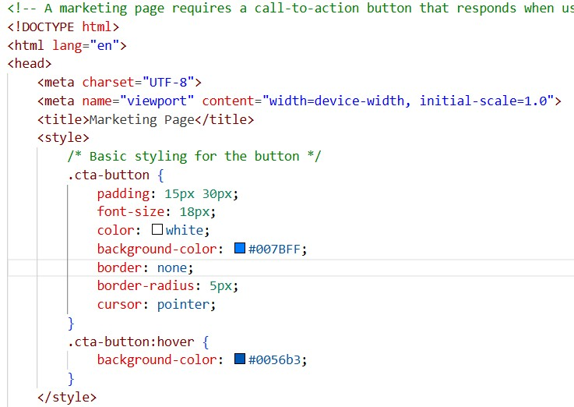
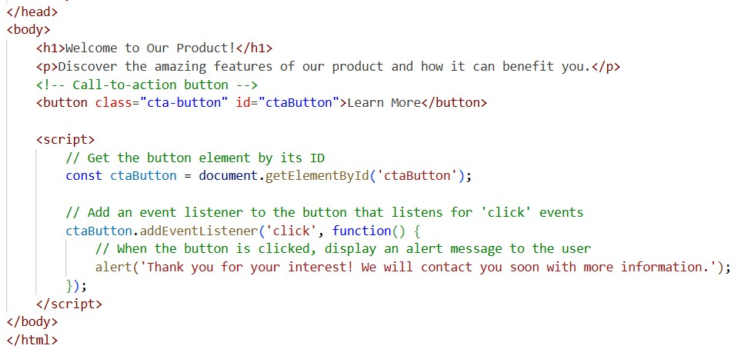
Output:
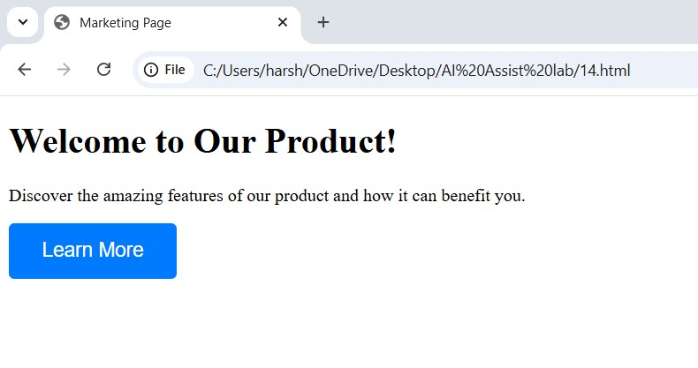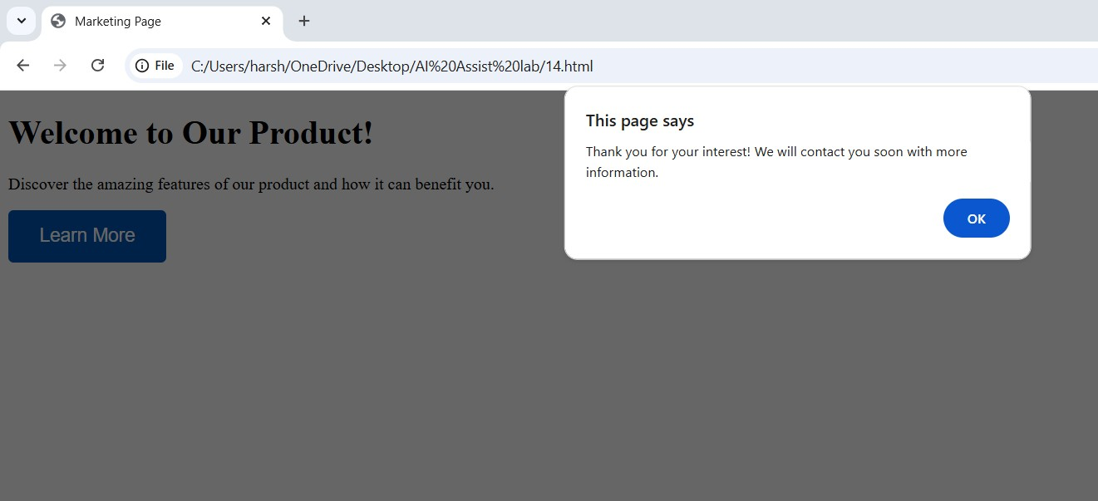

Justification:
In this task, a call-to-action button was added to the page using HTML and JavaScript. AI assistance helped to generate JavaScript that displays an alert message when the button is clicked without reloading the page.

Task 3: Contact Form with Client-Side Validation
Prompt:
generate a contact form for a company website to collect user queries safely and correctly and design a form with fields for name, email, message and generate JavaScript validation logic that prevents empty submissions and checks for a valid email format and display clear error messages for valid input
Code:
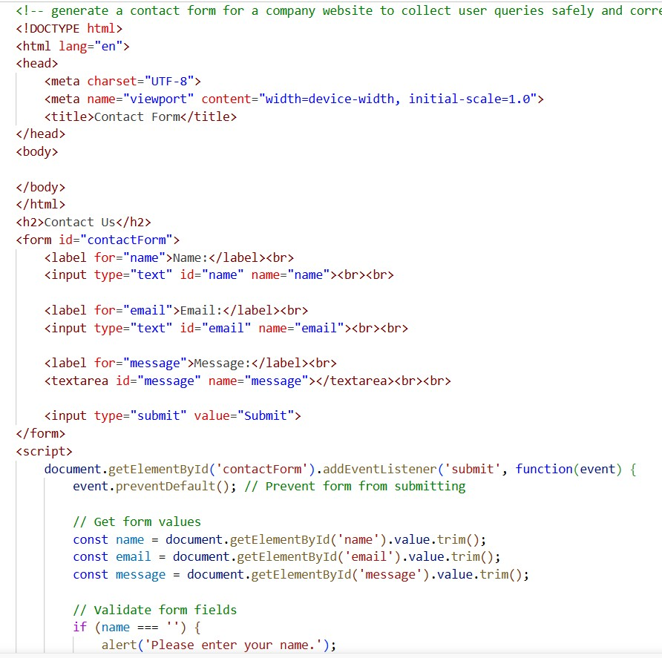
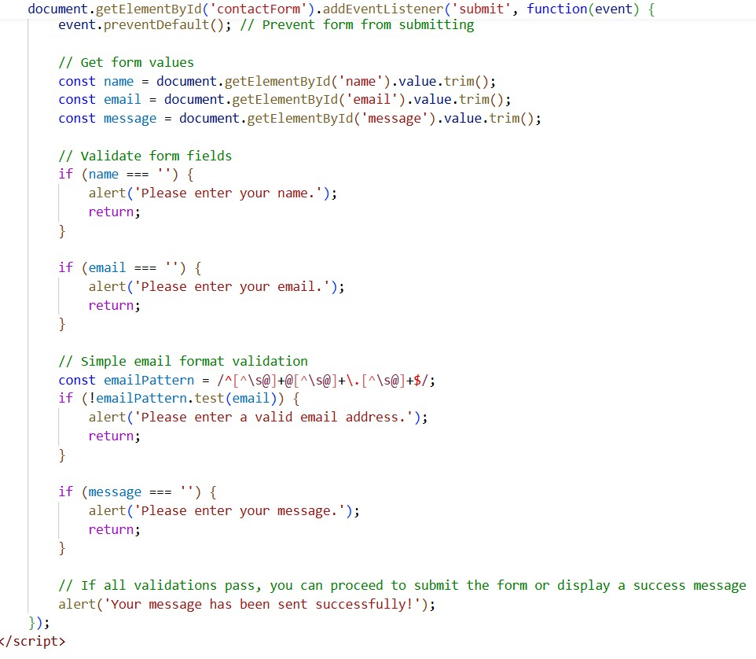
Output:
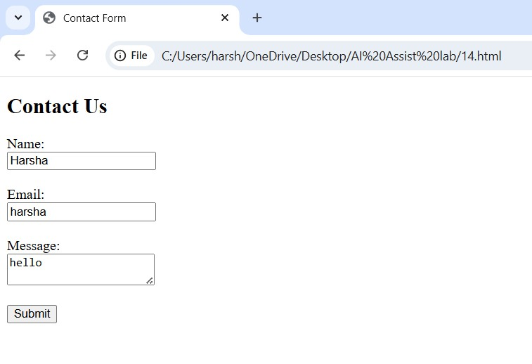
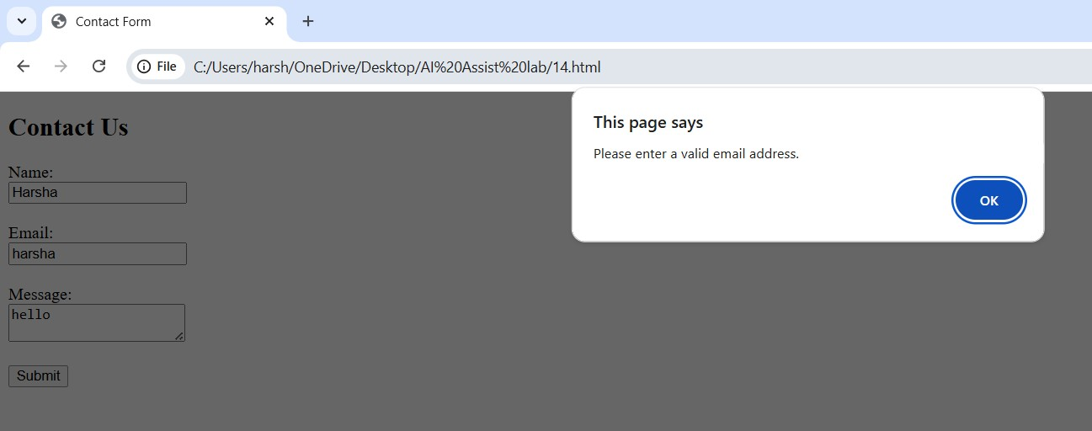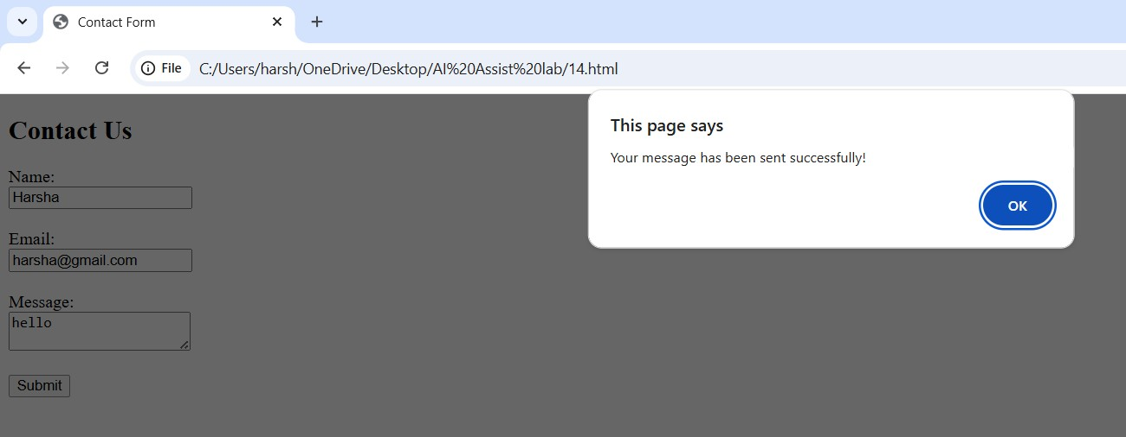
Justification:
In this task, a contact form with fields for name, email, and message was created. JavaScript validation generated with AI ensures that when the user enters the empty inputs those are prevented and displays the message and email format is checked.

Task 4: Dynamic List Management for a Product Page
Prompt:
A product listing page needs to add or remove items dynamically without refreshing the page, create a simple HTML list to display items and generate JavaScript that Adds a new item when an "Add" button is clicked, Removes the last item when a "Remove" button is clicked and ensure the DOM updates dynamically Code:
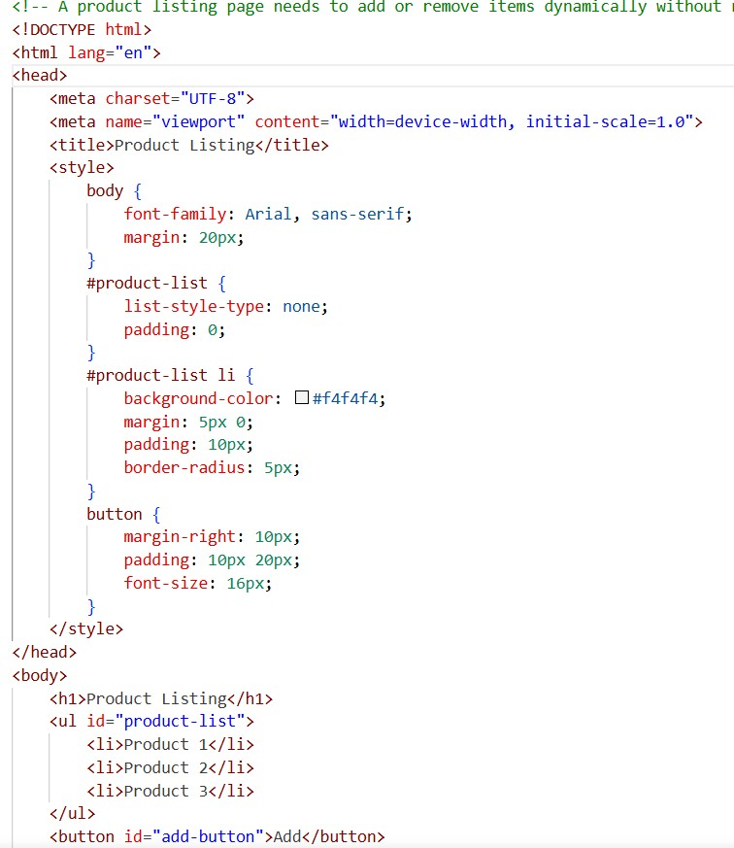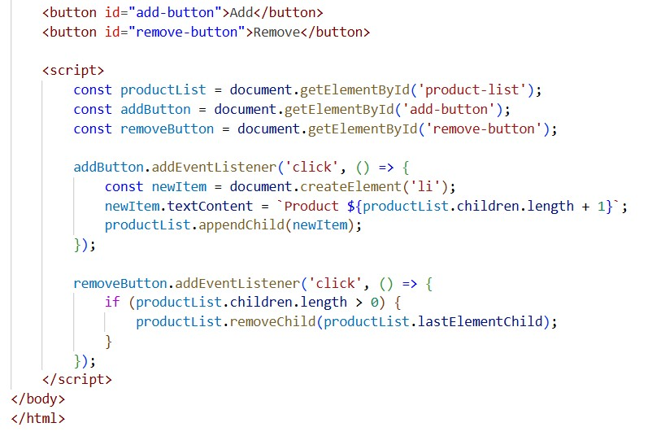

Output:
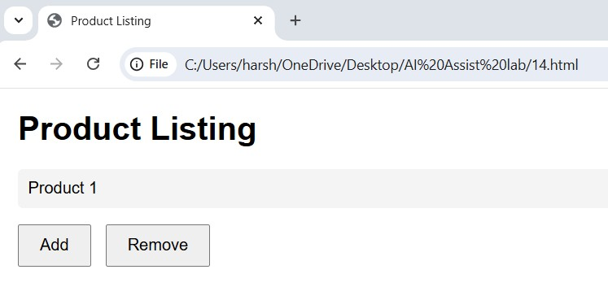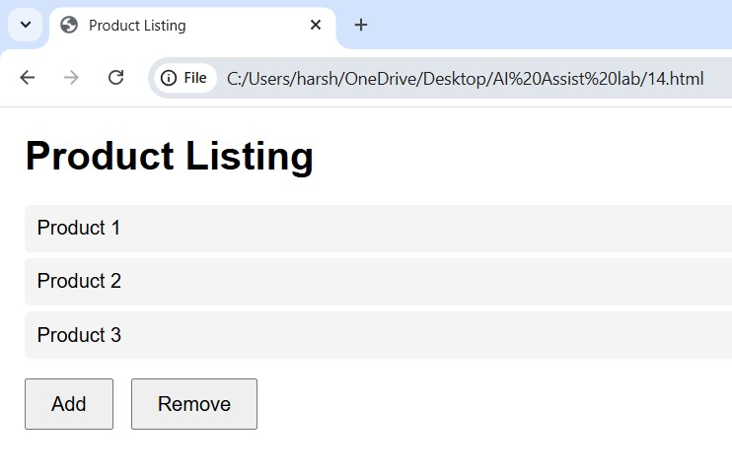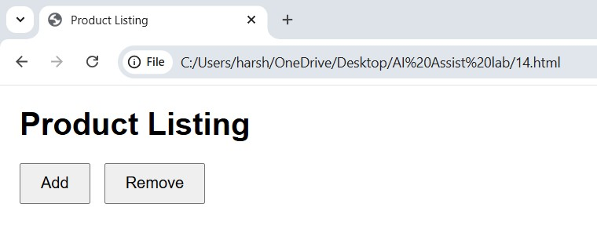

Justification:
In this task, a dynamic list was created using HTML and JavaScript to manage items on a product page. With the help of AI assistance, JavaScript logic was generated to add new items and remove existing ones using buttons. The list updates instantly on the web page without refreshing. This task helped in understanding DOM manipulation and dynamic content updates.

Task 5: Modal Popup for User Notifications
Prompt:
A user notification popup for announcements or alerts on a website, and generate HTML structure for a model popup and CSS styling with a semitransparent background overlay and JavaScript to open and close the modal and Include multiple ways to close the modal (button or overlay click)
Code:
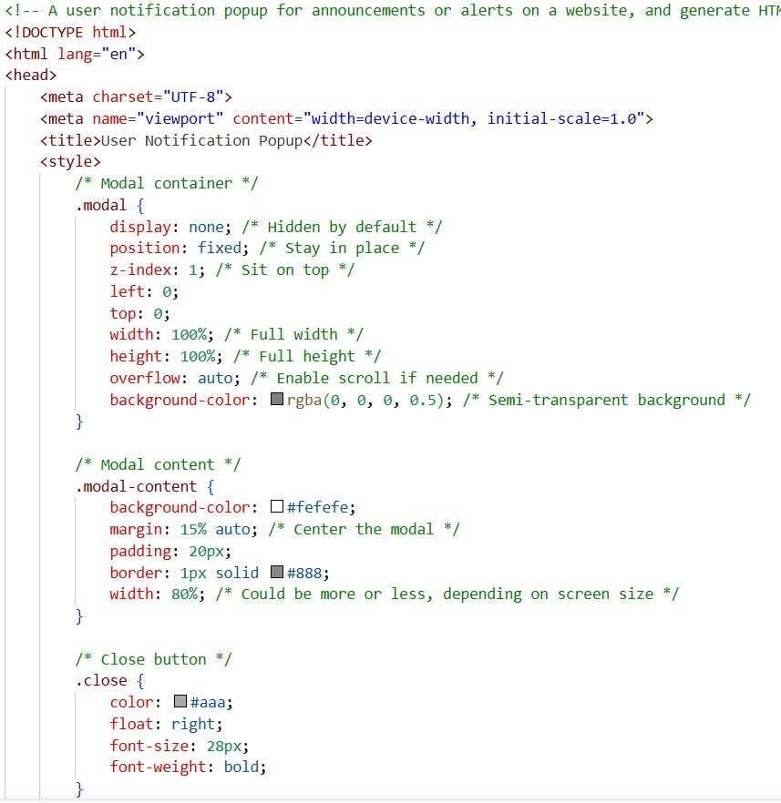
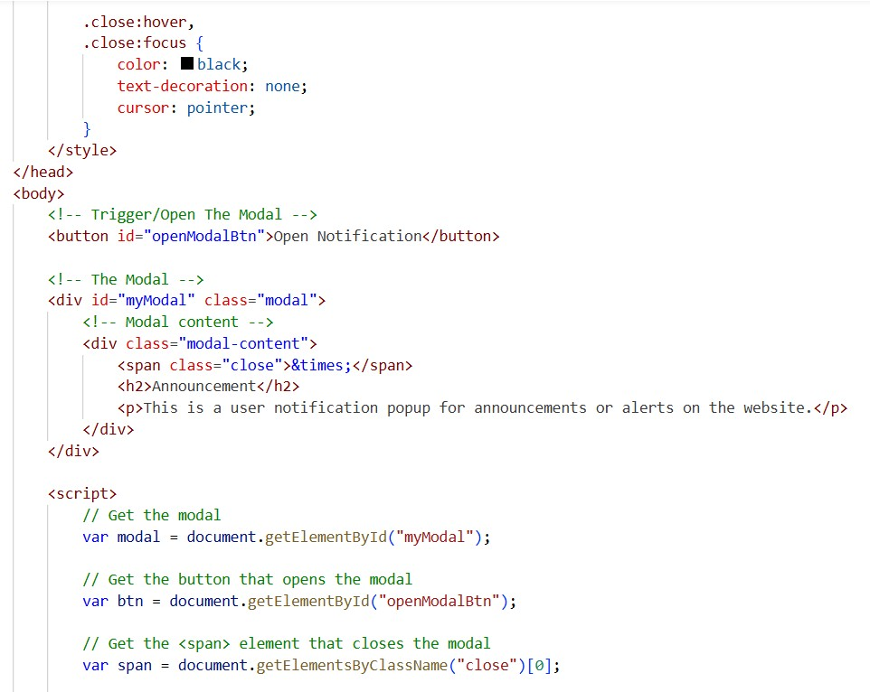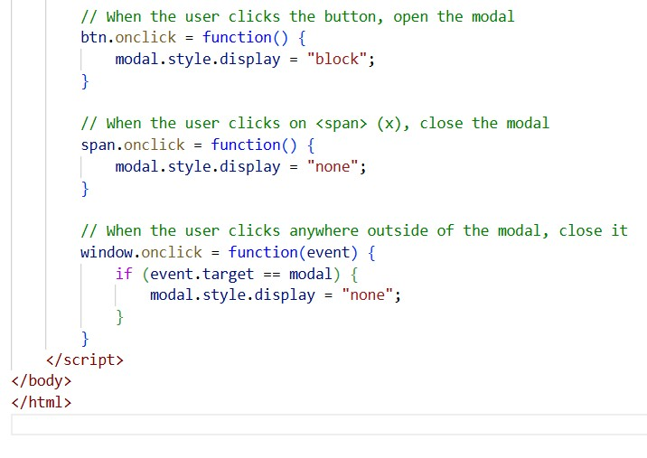

Output:
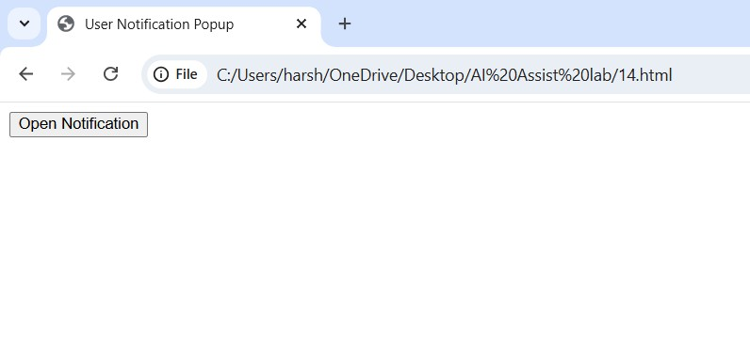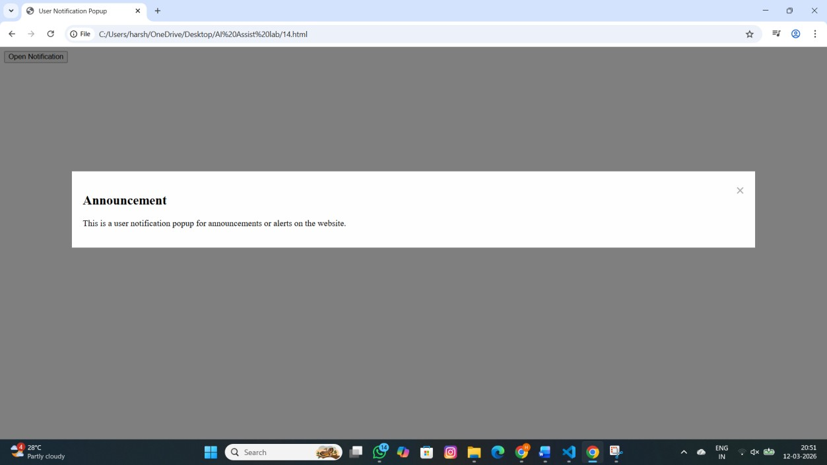
Justification:
In this task, a modal popup was designed to display notifications or announcements on a web page. AI assistance helped generate the HTML structure, CSS styling with an overlay, and JavaScript logic to control opening and closing of the modal. The popup can be closed using a button or by clicking outside the modal. This task helped in understanding how interactive UI components improve user experience.

