ASSIGNMENT-4
U.AKHIL
23O3A51704
BATCH-24
Q1. Zero-Shot Prompting (Basic Lab Task) Task:
Write a Python function that classifies a given text as Spam or Not Spam using zero-shot prompting.
Steps:
- Construct a prompt without any examples.
- Clearly specify the output labels.
- Display only the predicted label.
Input:
"Congratulations! You have won a free lottery ticket." Expected Output:
Spam
INPUT:
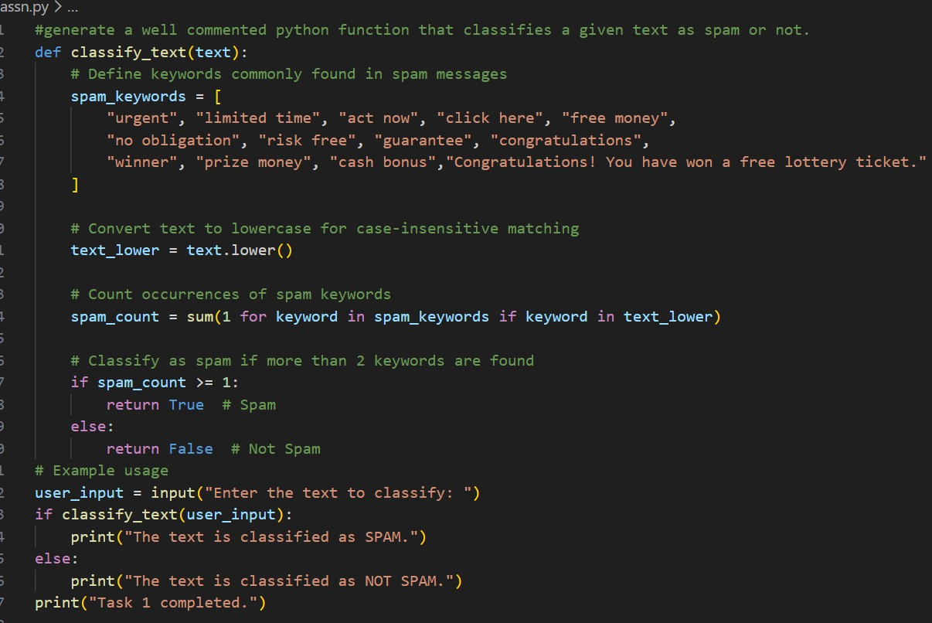

OUTPUT:
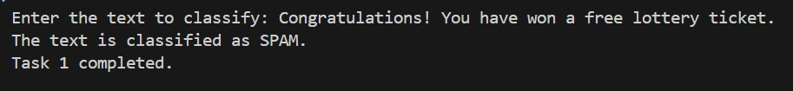

Q2. One-Shot Prompting (Emotion detection) Task:
Write a Python program that detects the emotion of a sentence using one-shot prompting.
Emotions: [‘happy', 'sad', 'angry', 'excited', 'nervous', ’neutral’] Steps:
- Provide one labeled example inside the prompt.
- Take a sentence as input.
- Print the predicted emotion

INPUT:
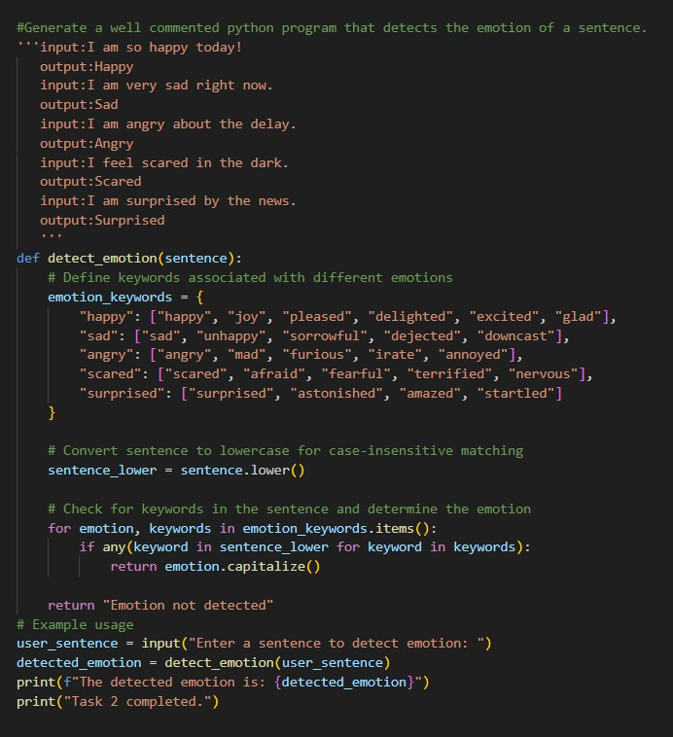

OUTPUT:
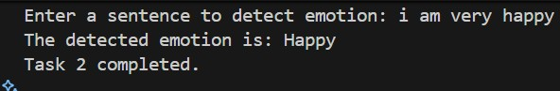

Q3. Few-Shot Prompting (Student Grading Based on Marks) Task:
Write a Python program that predicts a student’s grade based on marks using few-shot prompting.
Grades:
['A', 'B', 'C', 'D', 'F']
Grading Criteria (to be inferred from examples):
- 90–100 → A
- 80–89 → B
- 70–79 → C
- 60–69 → D
- Below 60 → F

INPUT:
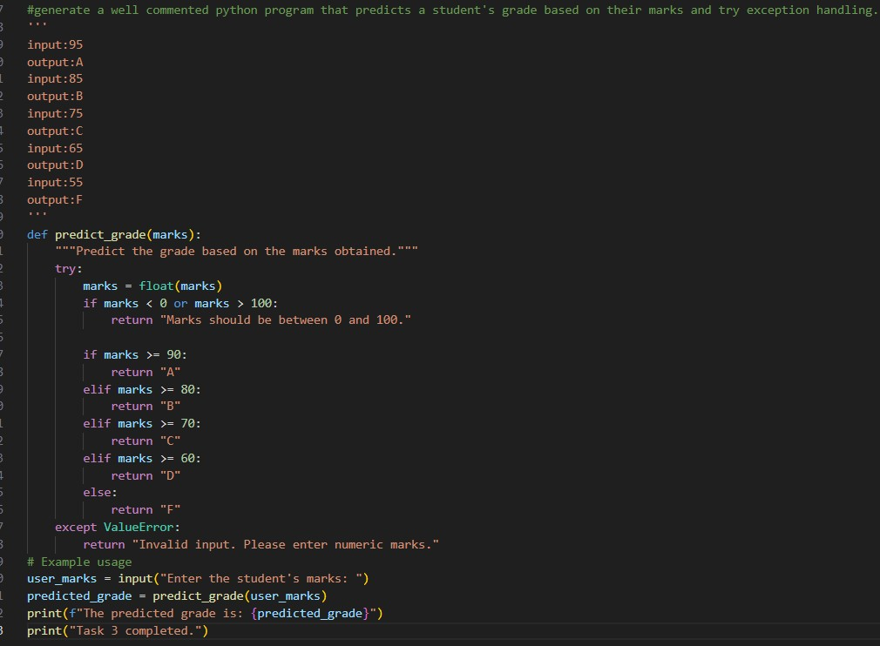

OUTPUT:

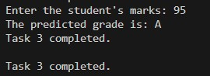

Q4. Multi-Shot Prompting (Indian Zodiac Sign Prediction using
Month Name)
Task:
Write a Python program that predicts a person’s Indian Zodiac sign (Rashi) based on the month of birth (month name) using multi-shot prompting.
Indian Zodiac Order (Simplified Month-Based Model): The Indian Zodiac cycle starts in March with Mesha and follows this order:
March → Mesha
April → Vrishabha
May → Mithuna
June → Karka
July → Simha
August → Kanya
September → Tula
October → Vrischika
November → Dhanu
December → Makara
January → Kumbha February → Meena

INPUT:
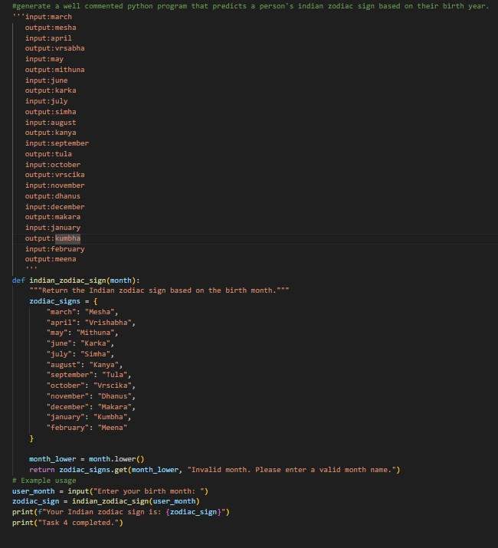

OUTPUT:

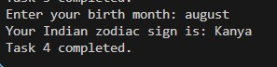

Q5. Result Analysis Based on Marks
Task: Write a Python program that determines whether a student Passes or Fails based on marks using Chain-of-Thought (CoT) prompting. Result Categories:
['Pass', 'Fail']
INPUT:
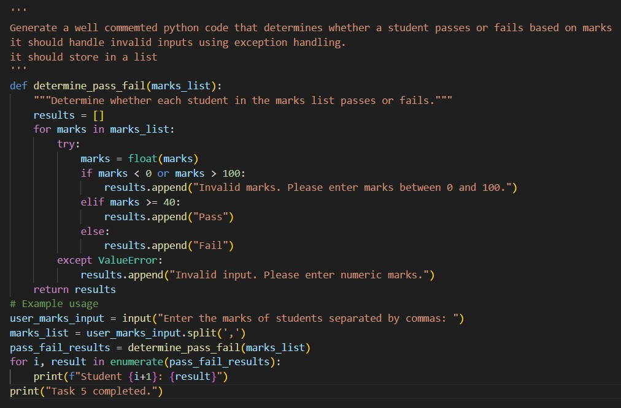

OUTPUT:
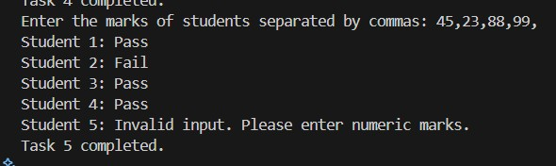

Q6 Voting Eligibility Check (Chain-of-Thought Prompting)
Task: Write a Python program that determines whether a person is eligible to vote using Chain-of-Thought (CoT) prompting.

INPUT:
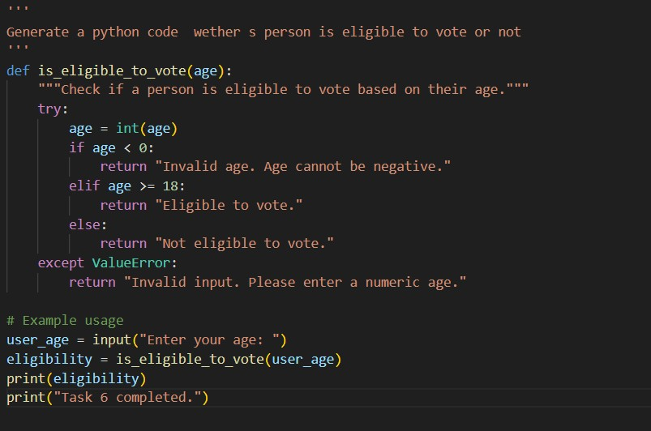
OUTPUT:
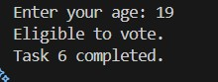

Q7 Prompt Chaining (String Processing – Palindrome Names) Task: Write a Python program that uses the prompt chaining technique to identify palindrome names from a list of student names.

INPUT:

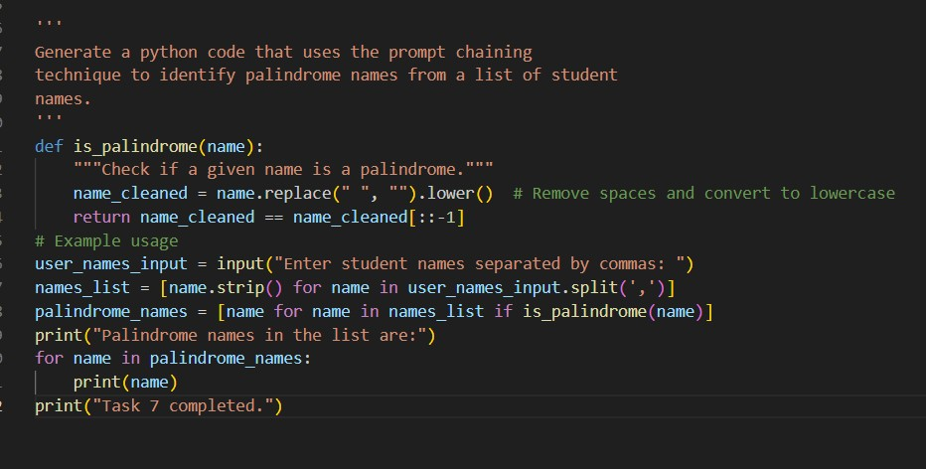

OUTPUT:
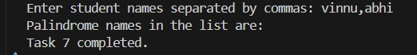

Q8 Prompt Chaining (String Processing – Word Length
Analysis)
Task: Write a Python program that uses prompt chaining to analyze a list of words. In the first prompt, generate a list of words. In the second prompt, traverse the list and calculate the length of each word. In the third prompt, use the output of the previous step to determine whether each word is Short (length less than 5) or Long (length greater than or equal to 5), and display the result for
Each word

INPUT:

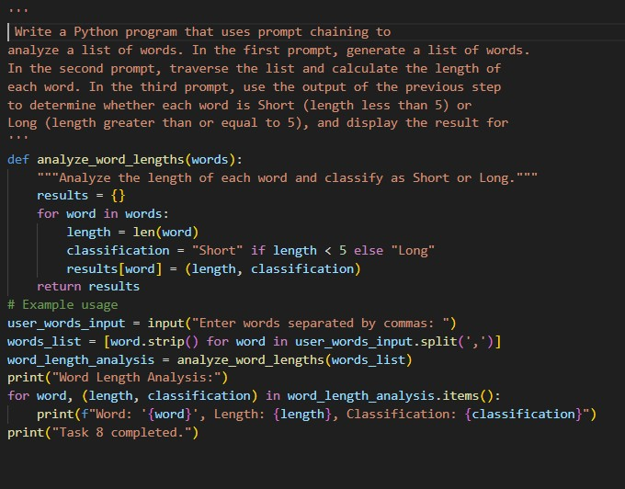

OUTPUT:
