HIGH PERFORMANCE COMPUTING

Assignment-2

NAME:Budati Gayathri
HT.NO:2303A51717
BATCH: 11

Section 2: Naïve Matrix Multiplication (O(n3) compute)
Aim
Measure serial performance of a triple-loop matrix multiplication implemented in pure Python, and profile computational hotspots. Requirements
- Python 3.8+
- Standard library: time, random, cProfile, pstats, io, tracemalloc.

Code:
import random import time import cProfile import pstats import io
import tracemalloc
#
# Generate a random n x n matrix #
def generate_matrix(n):
return [[random.random() for _ in range(n)] for _ in range(n)]
#

# Naïve matrix multiplication (O(n^3)) #
def matmul_naive(A, B):
n = len(A)
C = [[0.0 for _ in range(n)] for _ in range(n)] for i in range(n):
for j in range(n):
for k in range(n):
C[i][j] += A[i][k] * B[k][j]
return C
#
# Measure execution time #
def run_timing(n):
A = generate_matrix(n)
B = generate_matrix(n)
start = time.perf_counter() matmul_naive(A, B)
end = time.perf_counter()
print("=== Execution Time ===") print(f"Matrix size : {n} x {n}")
print(f"Time taken : {end - start:.4f} seconds\n")
#
# CPU profiling using cProfile
#
def run_cpu_profile(n):
A = generate_matrix(n)
B = generate_matrix(n)
profiler = cProfile.Profile()
profiler.enable() matmul_naive(A, B)

profiler.disable() s = io.StringIO()
stats = pstats.Stats(profiler, stream=s).sort_stats("cumulative") stats.print_stats(10)
print("=== CPU Profiling (Top 10) ===") print(s.getvalue())

#
# Memory profiling using tracemalloc
#
def run_memory_profile(n):
A = generate_matrix(n)
B = generate_matrix(n)
tracemalloc.start()
matmul_naive(A, B)
current, peak = tracemalloc.get_traced_memory() tracemalloc.stop()
print("=== Memory Profiling ===")
print(f"Current memory usage : {current / 10**6:.2f} MB") print(f"Peak memory usage : {peak / 10**6:.2f} MB\n")
#
# Main function #
def main():
N = 200 # Change carefully: 100, 200, 300 (higher = much slower) print("\nNaïve Matrix Multiplication Performance Analysis\n") run_timing(N)
run_cpu_profile(N)
run_memory_profile(N)
if name == " main ": main()

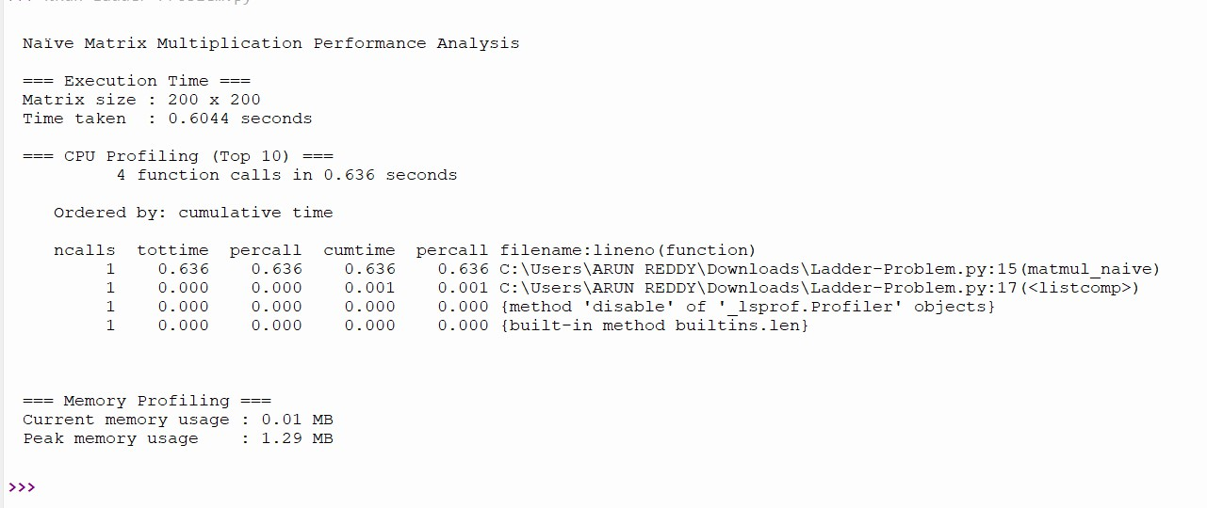
LOCAL OUTPUT:

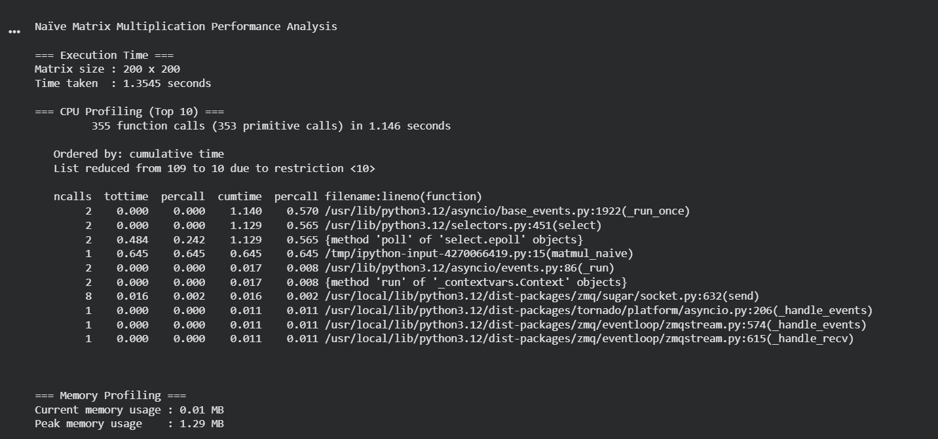
GOOGLE COLAB CPU:

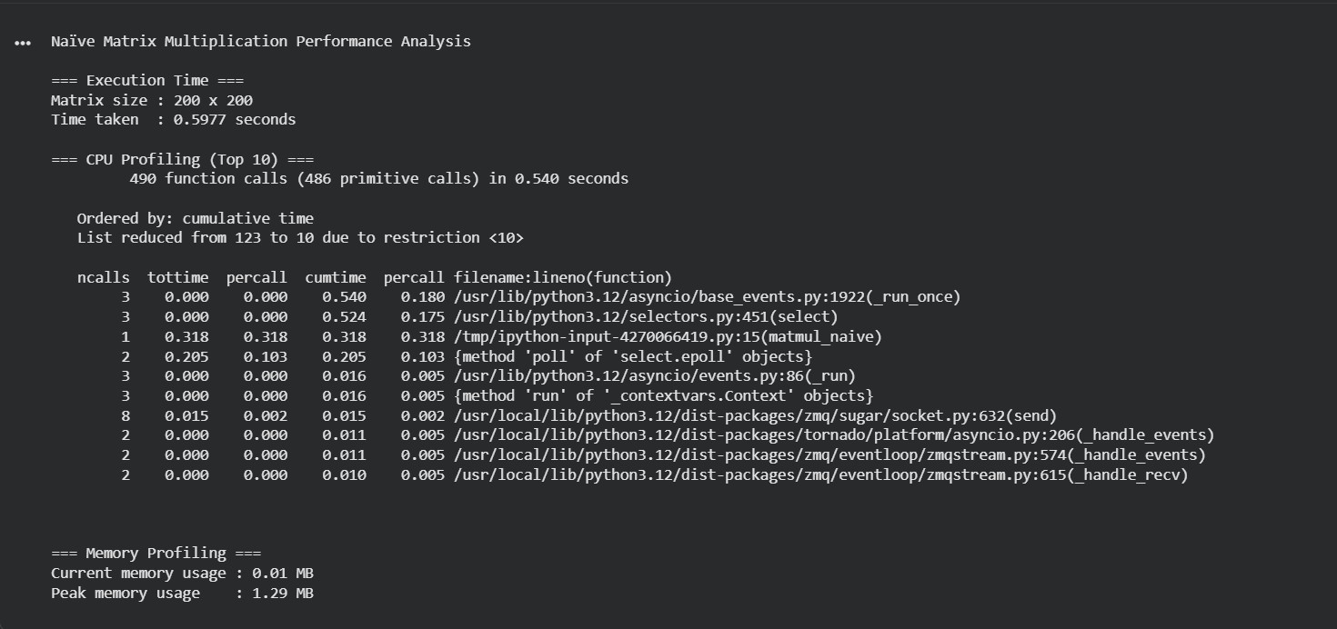
TPU:

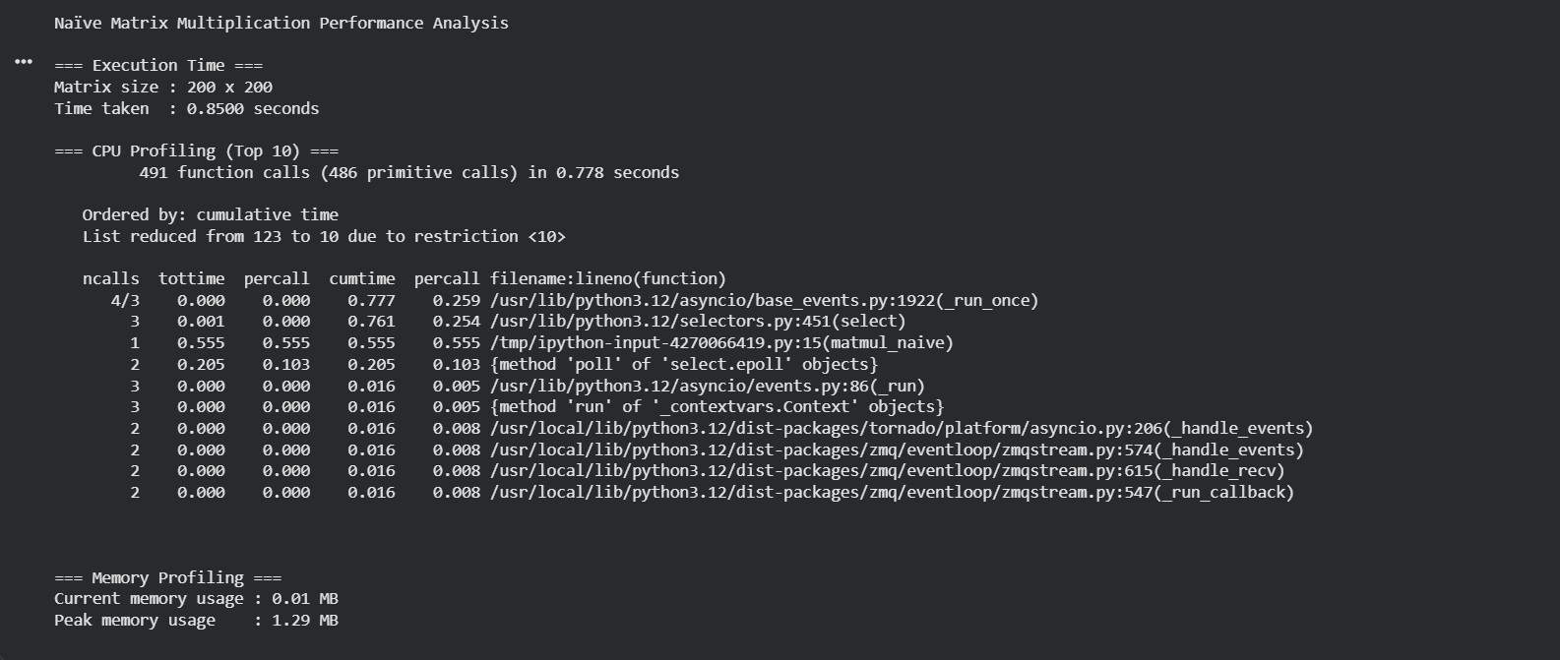
GPU:

