Lab 5: Ethical Foundations – Responsible AI Coding Practices
Hall Ticket: 2303A51734
Task Description #1 (Privacy in API Usage)
Task: Use an AI tool to generate a Python program that connects to a weather API.
Prompt.
#Generate code to fetch weather data securely without exposing API keys in the code.
Code.
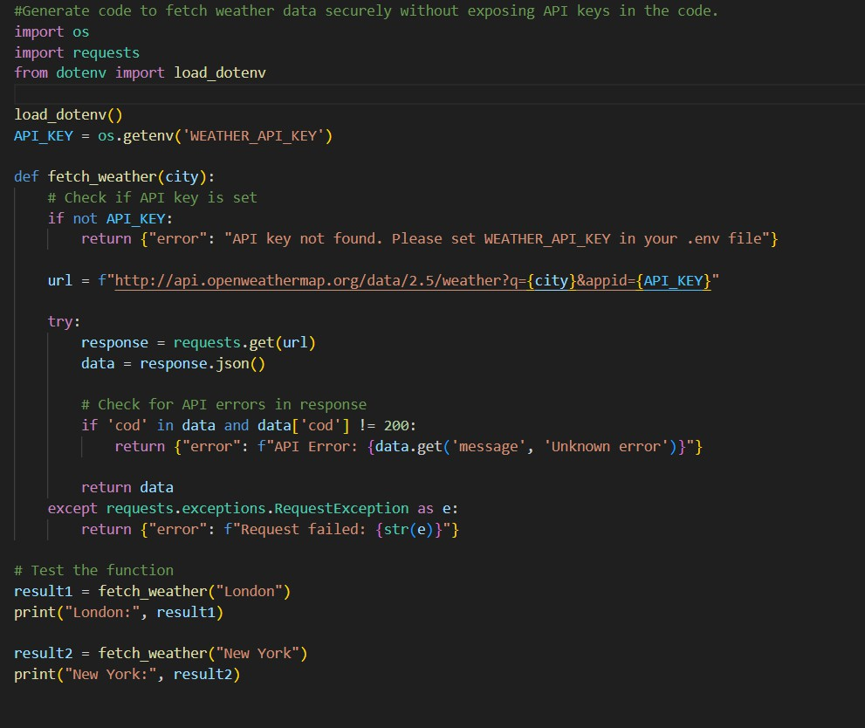
Observation:
- API Key Is Not Hardcoded (Good Practice)
The program does not directly write the API key in the source code. Instead, it uses an environment variable (WEATHER_API_KEY), which helps prevent accidental exposure of sensitive credentials.
- Use of .env File with dotenv Library

The code uses load_dotenv() to load environment variables from a .env file. This is a secure and widely accepted method to manage secrets separately from the codebase.
- Potential Security Issue in URL Construction
Although the API key is stored securely, it is still appended directly to the request URL. This can expose the key in logs, browser history, or debugging tools.
- Lack of HTTPS Protocol
The API URL uses http:// instead of https://. This is a security risk because the API key and data may be transmitted in plain text over the network.
- Basic Error Handling Is Implemented The program includes error handling for:
  - Missing API key
  - API errors returned by the server 3.Network-related request failures
4.This improves robustness and reliability.
Task Description #2 (Privacy & Security in File Handling)
Task: Use an AI tool to generate a Python script that stores user data (name, email, password) in a file.
Analyze: Check if the AI stores sensitive data in plain text or without encryption.
Prompt:
#write a python code to store the data of a person including name,email,password. #Identified privacy risks.
#Revised version with encrypted password storage (e.g., hashing).
Code:

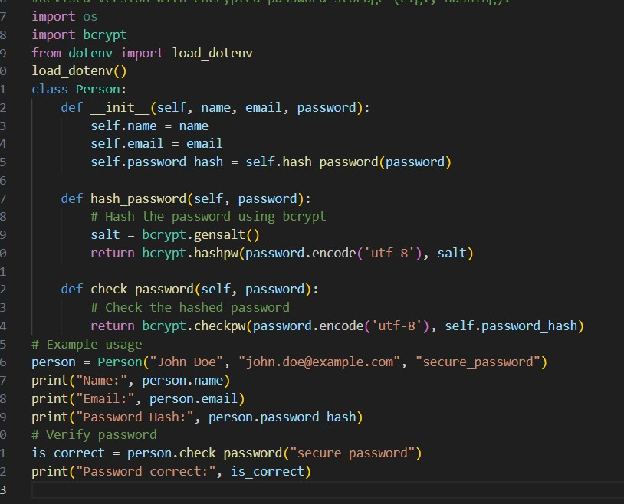
Output:
Observation:
The program securely stores passwords by hashing them using the bcrypt algorithm instead of storing plain text passwords.
A unique salt is generated for each password using bcrypt.gensalt(), which helps protect against rainbow table and brute-force attacks.
Password verification is implemented using bcrypt.checkpw(), ensuring safe and reliable comparison of hashed passwords.
The code does not hardcode sensitive information such as passwords or API keys, following secure and privacy-aware coding practices.
The hashed password is printed to the console, which may lead to information leakage and should be avoided in real-world applications.

The program imports unnecessary modules (os and dotenv) that are not used, reducing code clarity and violating clean coding principles.

Task Description #3 (Transparency in Algorithm Design)
Objective: Use AI to generate an Armstrong number checking function with comments and explanations.
Instructions:
- Ask AI to explain the code line-by-line.
- Compare the explanation with code functionality.
Prompt:
#generate an Armstrong number checking function with comments and explanations and explain code line by line.
#Compare the explanation with code functionality.
Code:
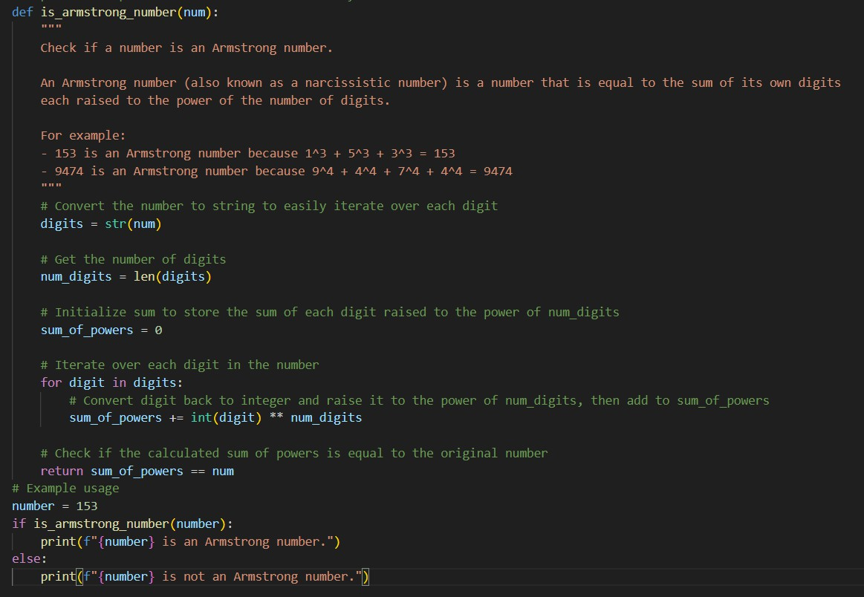
Output:

Observation:
- The program correctly defines a function is_armstrong_number() to check whether a given number is an Armstrong (narcissistic) number.
- The input number is converted into a string to easily iterate through each digit, improving code simplicity and readability.
- The number of digits is calculated using len(), which is essential for raising each digit to the correct power.
- The program uses a loop to compute the sum of each digit raised to the power of the total number of digits, following the Armstrong number definition.
- A boolean comparison (sum_of_powers == num) is used to determine the result, ensuring accurate and efficient validation.
- The output clearly indicates whether the given number is an Armstrong number, improving user understanding and program clarity.
Task Description #4 (Transparency in Algorithm Comparison)
Task: Use AI to implement two sorting algorithms (e.g., QuickSort and BubbleSort).
Prompt:
"Generate Python code for QuickSort and BubbleSort, and include
comments explaining step-by-step how each works and where they differ.”
Code:

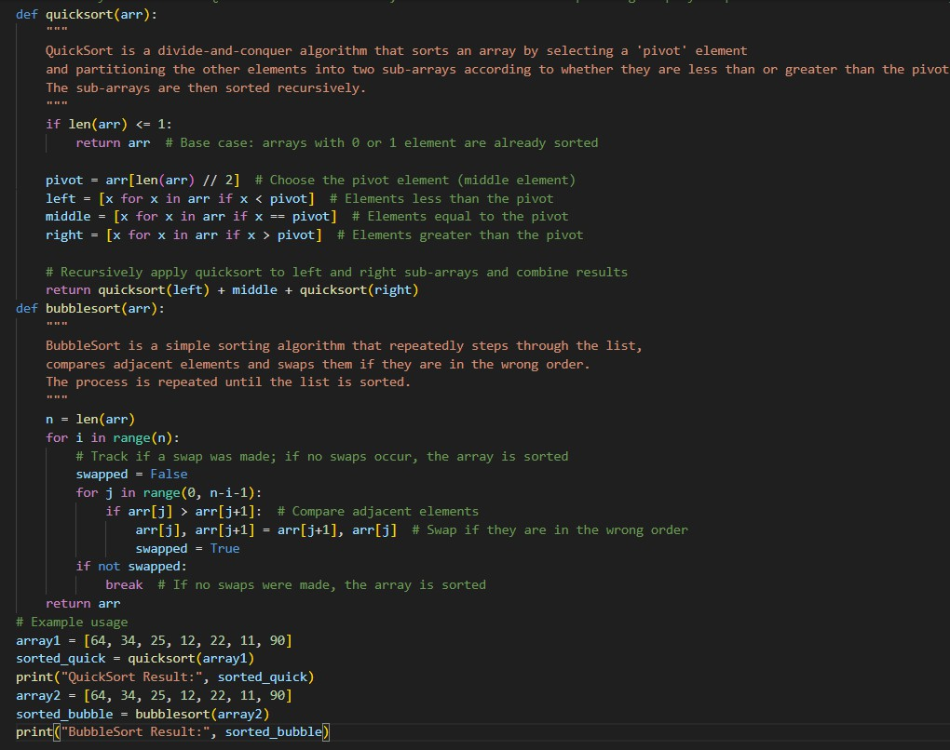
Output:
Observation:
- The program correctly implements QuickSort using the divide-and-conquer approach by selecting a pivot and partitioning the array into smaller sub-arrays.
- Recursion is effectively used in QuickSort to sort the left and right sub-arrays until the base case of one or zero elements is reached.
- The program also implements Bubble Sort, which repeatedly compares and swaps adjacent elements to sort the array.
- An optimization is included in Bubble Sort using a swapped flag, allowing the algorithm to terminate early if the array becomes sorted.
- Both sorting algorithms produce the same correctly sorted output, verifying the correctness of the implementations.
- The program clearly prints the results of QuickSort and Bubble Sort, enabling easy comparison of both algorithms.

Task Description #5 (Transparency in AI Recommendations) Task: Use AI to create a product recommendation system. Prompt:
"Generate a recommendation system that also provides reasons for each suggestion."
Code:
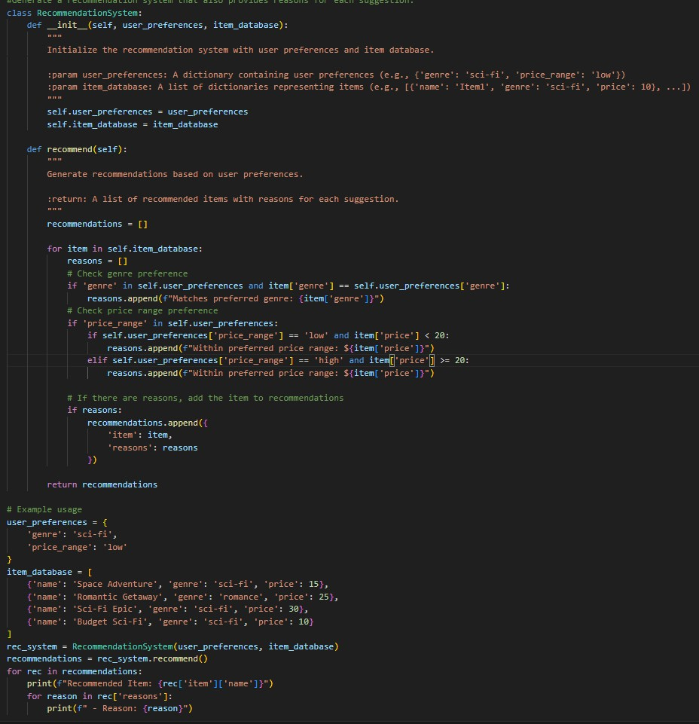
Output:

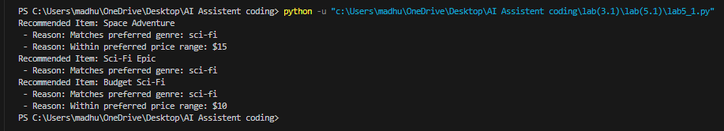
Observation:
- The program implements a rule-based recommendation system that suggests items based on user preferences such as genre and price range.
- User preferences and item details are stored using dictionaries and lists, making the data structure simple and easy to understand.
- The recommendation logic checks multiple conditions (genre and price) to filter relevant items from the database.
- For every recommended item, the system provides clear reasons for the suggestion, improving transparency and explainability.
- Items are added to the recommendation list only when at least one preference rule is satisfied, ensuring relevant outputs.
- The final output displays recommended items along with their matching reasons, enhancing user clarity and trust in the system.

