AI ASSISTED CODING LAB-15.5

MANI SHARANYA 2303A51755
Batch-11

Task 1 – Student Attendance API Task:
Create a RESTful API for student attendance tracking. Instructions:
- Endpoints required:
- GET /attendance → View attendance records
- POST /attendance → Mark attendance
- PUT /attendance/{id} → Update attendance record
- DELETE /attendance/{id} → Remove attendance entry
- Ensure JSON-based request and response handling. Expected Output:
- API for maintaining and updating attendance records. PROMPT:
"""Generate a Python Flask REST API for student attendance with in-memory storage.
Implement GET /attendance, POST /attendance, PUT /attendance/<id>, DELETE
/attendance/<id>.
Use JSON request/response and add comments."""

GIVEN CODE:

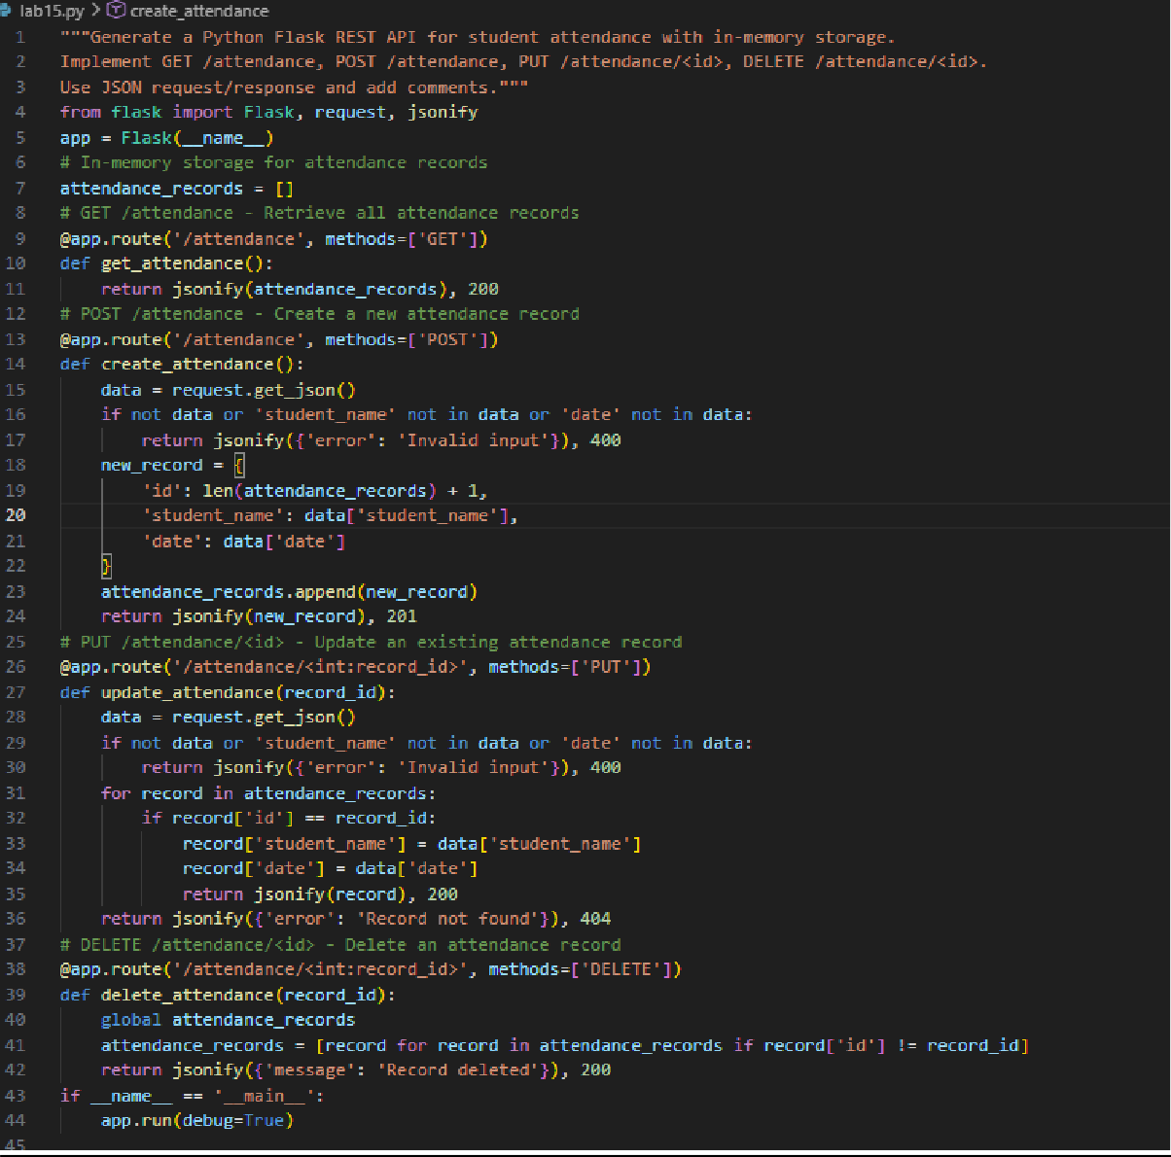
Task 2 – Inventory Management API Task:
Develop a REST API for warehouse inventory management. Instructions:
- Endpoints required:
- GET /inventory → List all items
- POST /inventory → Add new item
- PUT /inventory/{id} → Update stock quantity
- DELETE /inventory/{id} → Remove an item
- Implement validation for stock values.

Expected Output:
- API capable of managing inventory stock levels. PROMPT:
"""Create a Flask REST API for inventory management with item id, name, and quantity. Implement GET, POST, PUT, DELETE endpoints for /inventory.
Add validation so stock quantity cannot be negative."""

GIVEN CODE AND OUTPUT:

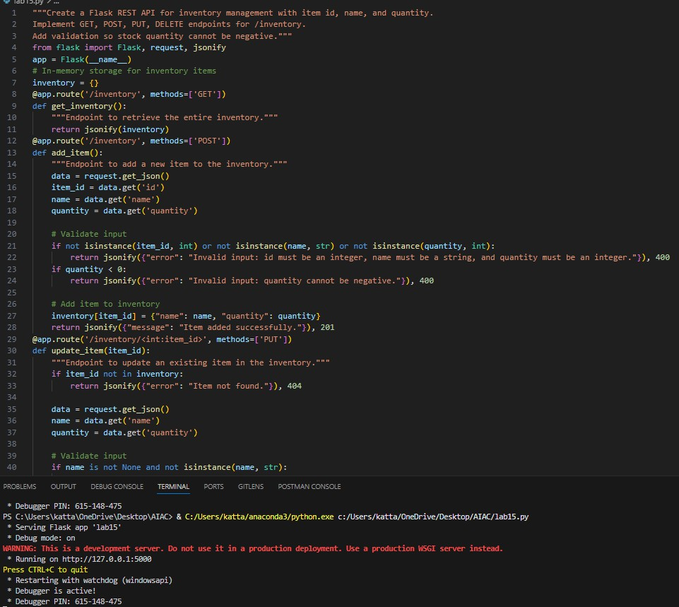
Task 3 – Hotel Room Booking API Task:
Develop a RESTful API for hotel room booking. Instructions:
- Endpoints required:

- GET /rooms → View available rooms
- POST /rooms/book → Book a room
- GET /rooms/{id} → View booking details
- DELETE /rooms/{id} → Cancel booking
- Implement error handling for unavailable rooms. Expected Output:
- API simulating hotel room booking operations. PROMPT:
"""Generate a Flask REST API for hotel room booking using in-memory data.
Endpoints: GET /rooms, POST /rooms/book, GET /rooms/<id>, DELETE /rooms/<id>. Add error handling if a room is already booked."""

GIVEN OUTPUT:

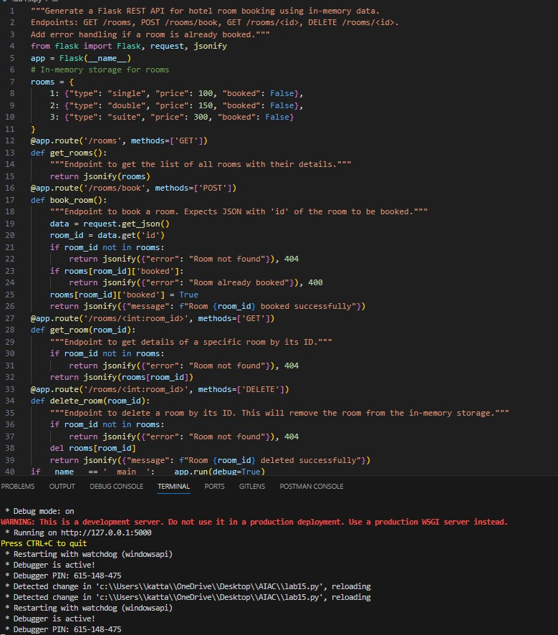
Task 4 – Online Voting API Task:
Create a RESTful API for an online voting system. Instructions:
- Endpoints required:
- GET /candidates → List candidates
- POST /vote → Cast a vote
- GET /results → View voting results
- Ensure one vote per user using in-memory validation. Expected Output:

- API simulating a secure online voting process. PROMPT:
"""Create a Flask REST API for an online voting system. Endpoints: GET /candidates, POST /vote, GET /results.
Ensure each user can vote only once using in-memory validation."""

GIVEN OUTPUT:

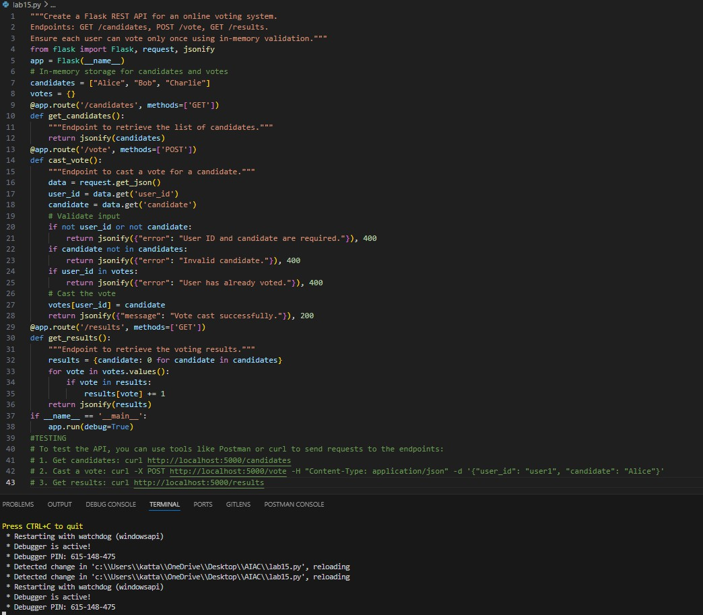
Task 5 – Teacher Management API Task:
Develop a RESTful API to manage teacher records. Instructions:
- Endpoints required:
- GET /teachers → List all teachers

- POST /teachers → Add a new teacher
- PUT /teachers/{id} → Update teacher details
- DELETE /teachers/{id} → Remove a teacher
- Ensure proper error handling and JSON responses. Expected Output:
- Functional API for managing teacher information. PROMPT:
"""Generate a Flask REST API to manage teachers with id, name, and subject. Implement GET, POST, PUT, DELETE endpoints for /teachers.
Return JSON responses and handle errors properly."""
GIVEN OUTPUT:

