AI ASSISTED CODING LAB-9.1
G. MANI SHARANYA
2303A51755
Batch 11

Problem 1:
Consider the following Python function: def find_max(numbers): return max(numbers)
Task:

- Write documentation for the function in all three formats:
- Docstring
- Inline comments
- Google-style documentation
- Critically compare the three approaches. Discuss the advantages, disadvantages, and suitable use cases of each
style.
- Recommend which documentation style is most effective for a mathematical utilities library and justify your answer.
- Docstring

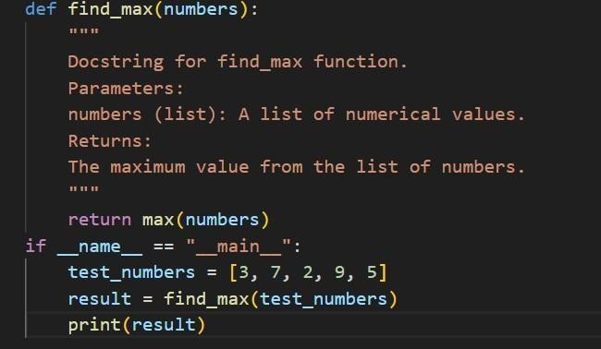
- Inline comments
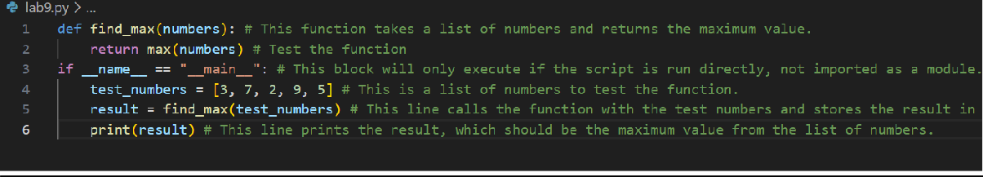
- Google-style documentation

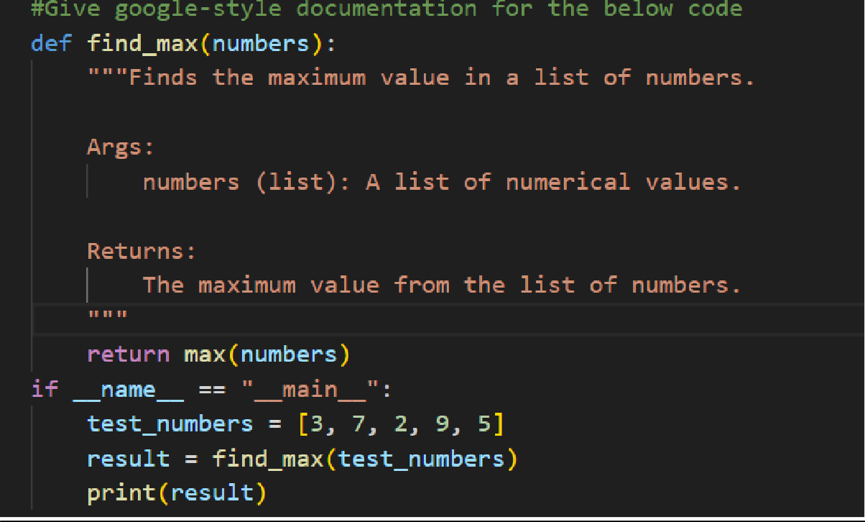
Problem 2:
Consider the following Python function:
def login(user, password, credentials):
return credentials.get(user) == password Task:
- Write documentation in all three formats.
- Critically compare the approaches.
- Recommend which style would be most helpful for new developers onboarding a project, and justify your choice.
  - Docstring

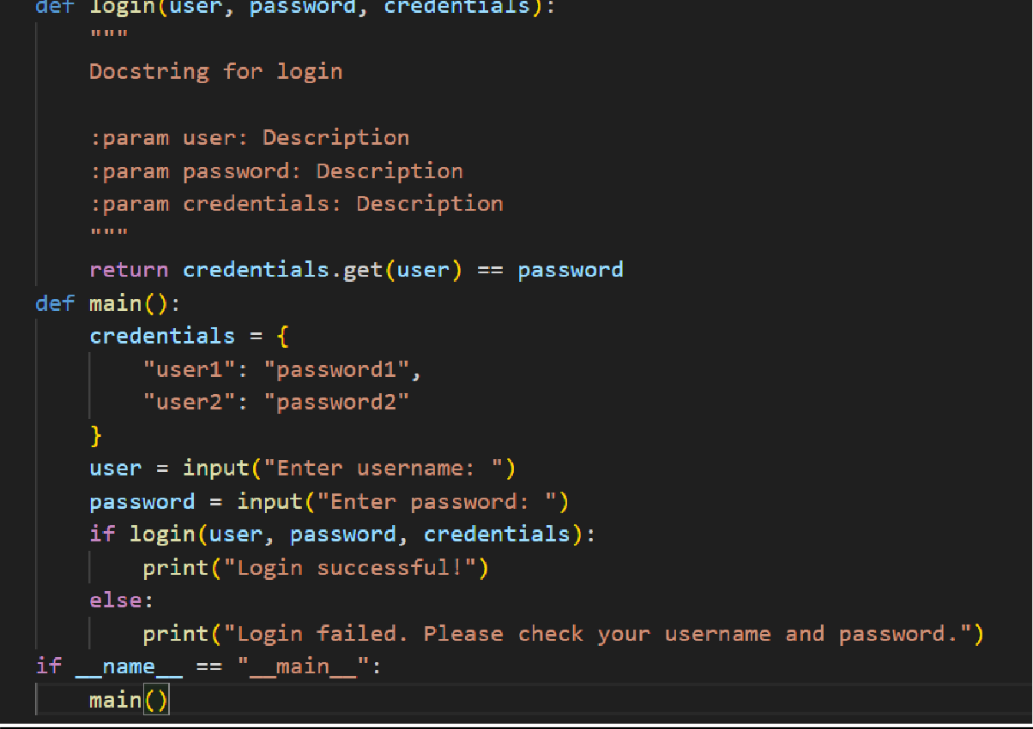
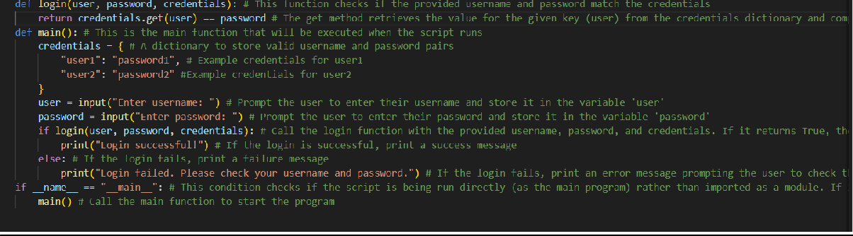
  - Inline comments
  - Google-style documentation

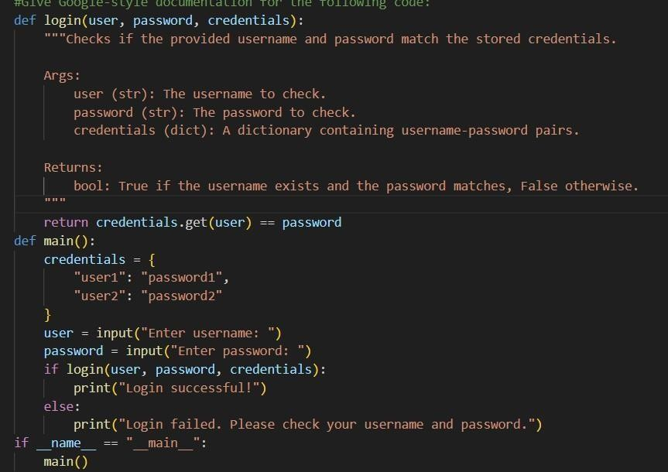
Problem 3: Calculator (Automatic Documentation Generation)
Task: Design a Python module named calculator.py and demonstrate automatic documentation generation.
Instructions:
- Create a Python module calculator.py that includes the following functions, each written with appropriate docstrings:
o add(a, b) – returns the sum of two numbers o subtract(a, b) – returns the difference of two numbers o multiply(a, b) – returns the product of two numbers
o divide(a, b) – returns the quotient of two numbers
- Display the module documentation in the terminal using Python’s documentation tools.
- Generate and export the module documentation in HTML format using the pydoc utility, and open the generated HTML file in a web browser to verify the output.
Prompt:
#Give python code for a calculator that has functions of addition, subtraction, multiplication and division

Docstring
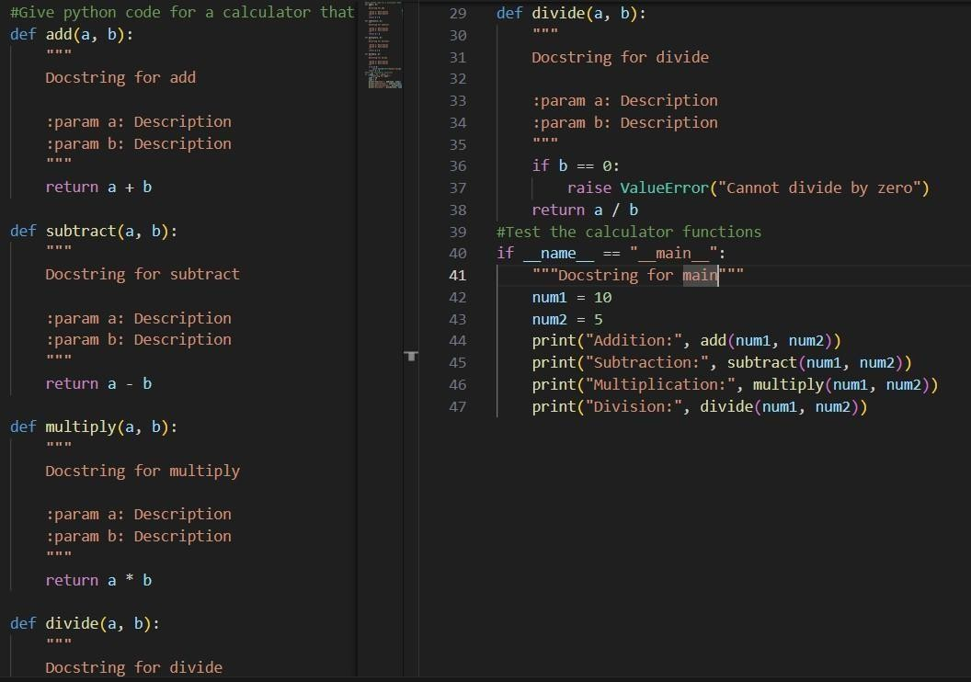
Using pydoc
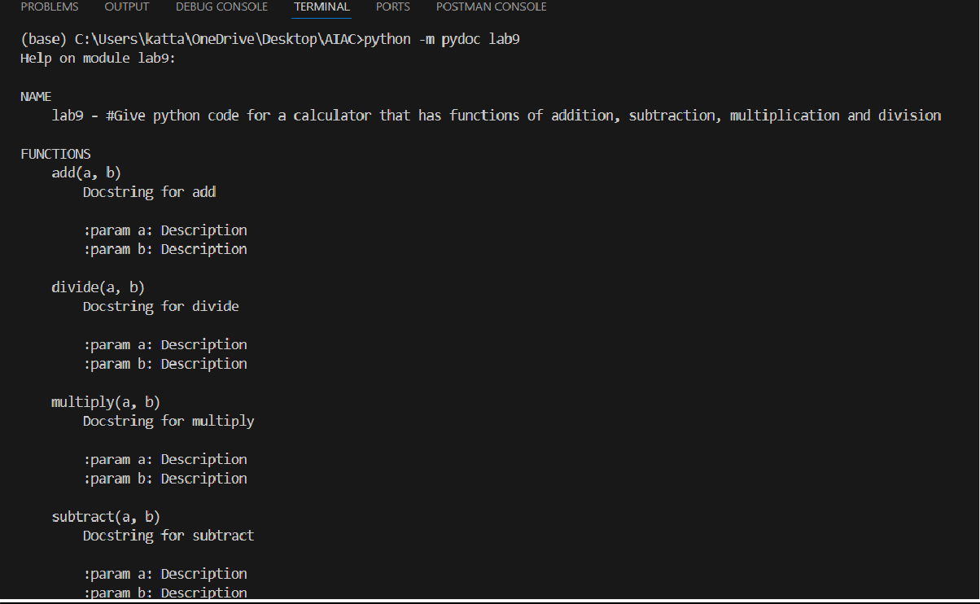
- ​python -m pydoc filename

- ​python -m pydoc -w filename
- ​python -m pydoc -p 8080
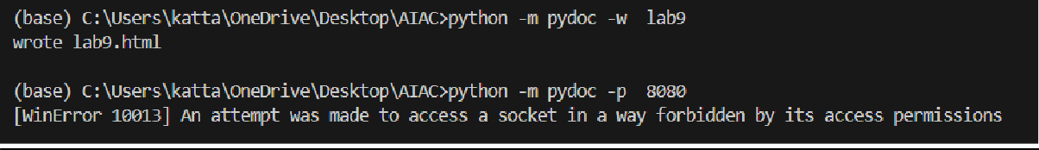
Problem 4: Conversion Utilities Module Task:
- Write a module named conversion.py with functions: o decimal_to_binary(n) o
binary_to_decimal(b) o
decimal_to_hexadecimal(n)
- Use Copilot for auto-generating docstrings.
- Generate documentation in the terminal.
- Export the documentation in HTML format and open it in a browser. Given Code:

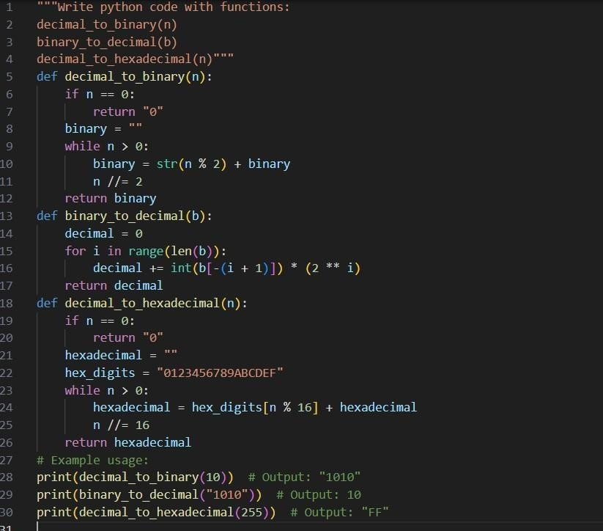
Docstring:

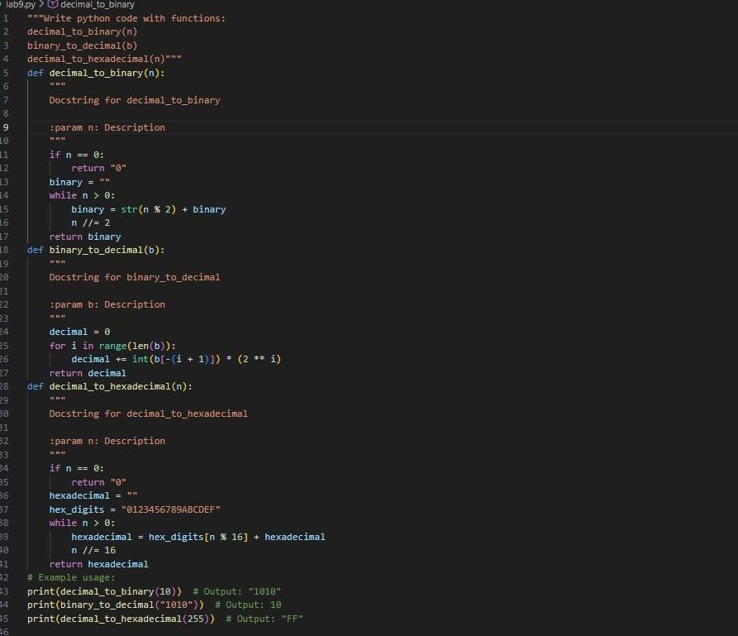
Using pydoc
- ​python -m pydoc filename
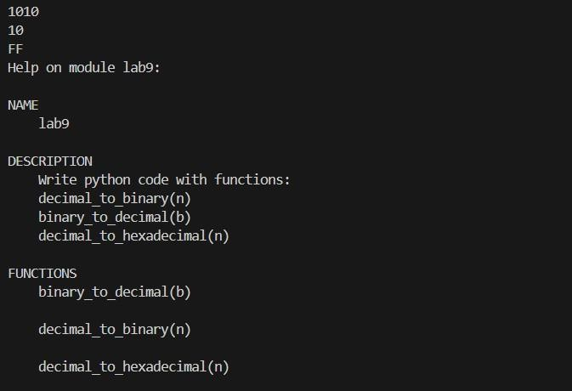

- ​python -m pydoc -w filename
- ​python -m pydoc -p 8080
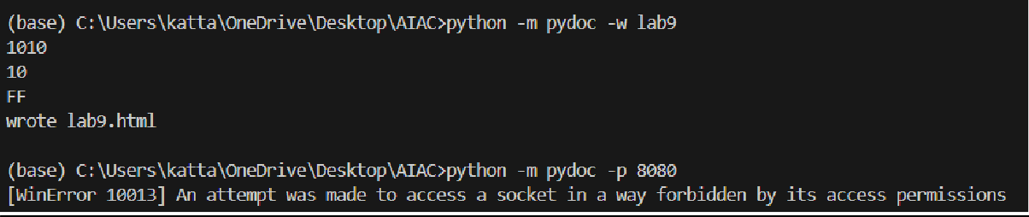
Problem 5 – Course Management Module Task:
- Create a module course.py with functions: o add_course(course_id, name, credits) o remove_course(course_id) o get_course(course_id)
- Add docstrings with Copilot.
- Generate documentation in the terminal.
- Export the documentation in HTML format and open it in a browser Given Code:
Docstrings:

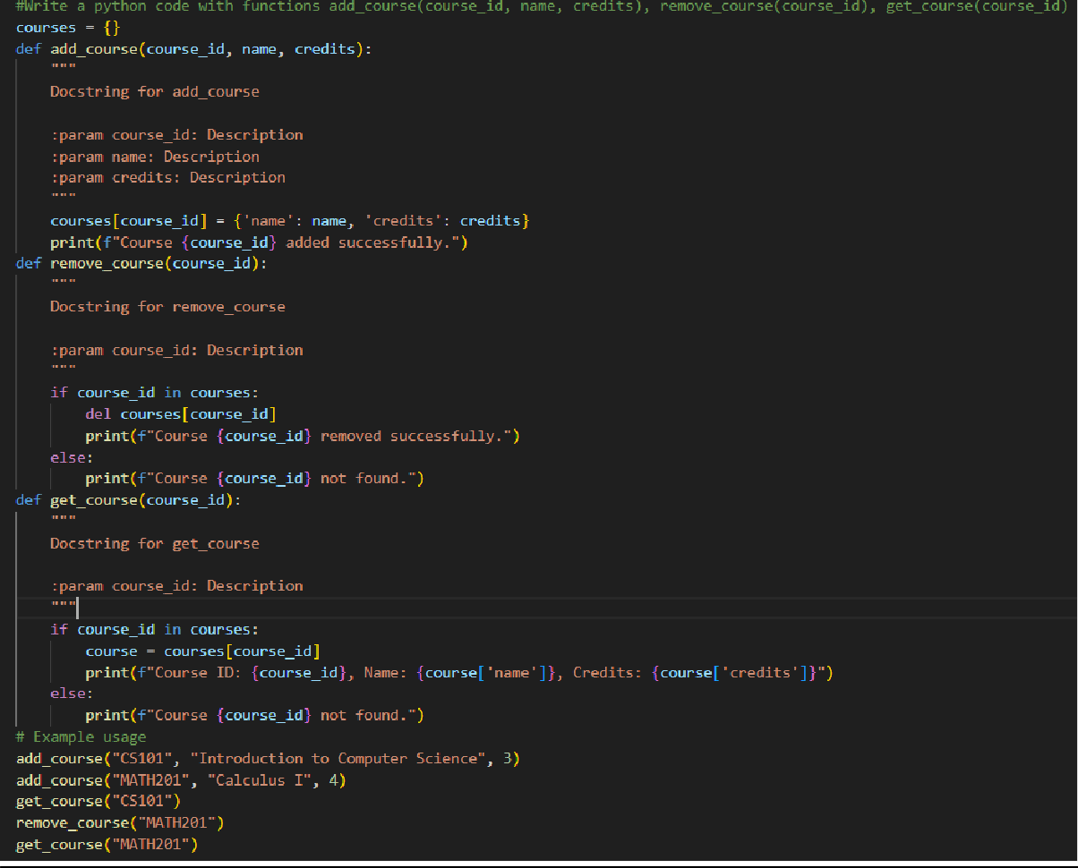
Using pydoc
- ​python -m pydoc filename
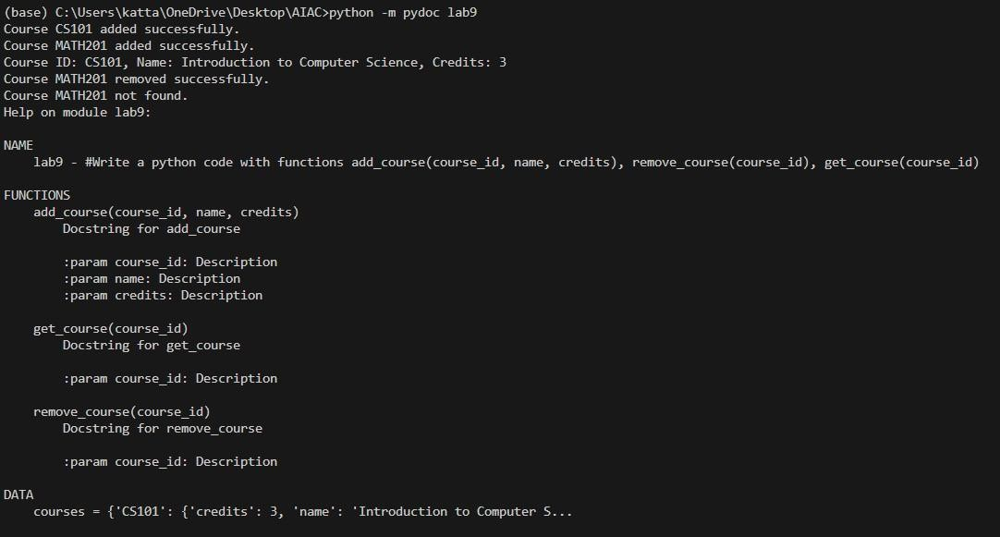

- ​python -m pydoc -w filename
- ​python -m pydoc -p 8080
