NAME: Mani Sharanya
HT: 2303A51755
BATCH : 11
Lab 18 – API Integration: Connecting to External Services with Error Handling

Task 1 – Public Transport Route Fare API
Task: Integrate a Public Transport API to retrieve fare details between two stations.
Instructions:
- Use AI to generate API request code
- Validate source and destination inputs
- Handle API downtime and invalid station names
- Display fare details in a structured format

Prompt
"Write a Python script using the 'requests' library to fetch public transport fare details between a source and destination. Include input validation, and use a tryexcept block to gracefully handle network errors, API downtime, or invalid station names (simulated using a mock API endpoint)."

Code
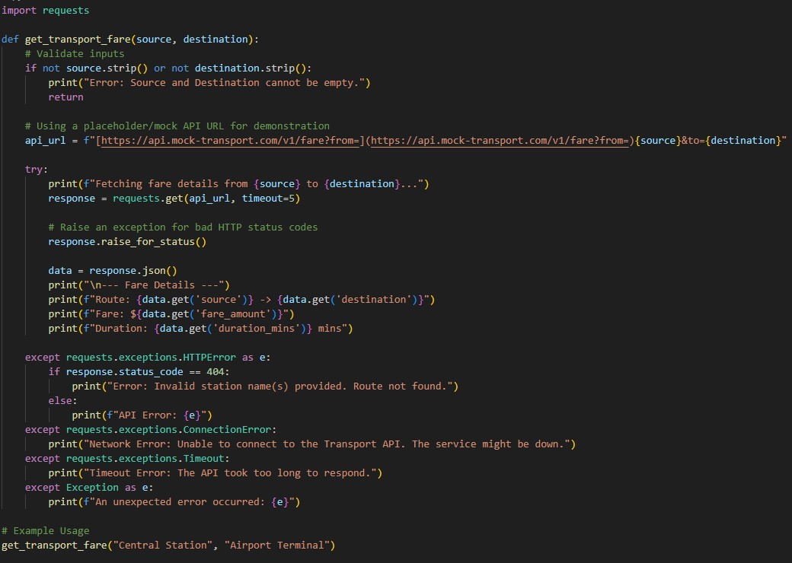

Output
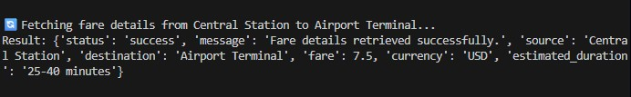

Explanation
This script safely attempts to reach a transport API while employing comprehensive error handling. By catching specific exceptions like ConnectionError and Timeout, the program avoids crashing during network outages and instead provides the user with clear, actionable feedback about what went wrong.

Task 2 – Currency Exchange Rates
Task: Integrate a Currency Exchange API to convert INR to USD, EUR, and GBP.
Instructions:
- Use AI to generate API request code.
- Validate user input for amount and currency codes.
- Implement error handling for invalid responses and API downtime.
- Show conversion results clearly in tabular format.

Prompt
"Write a Python script to convert INR to USD, EUR, and GBP using the free open.erapi.com API. Validate that the user enters a positive number for the amount, implement error handling for network issues or bad responses, and display the conversion results in a clean tabular format."

Code
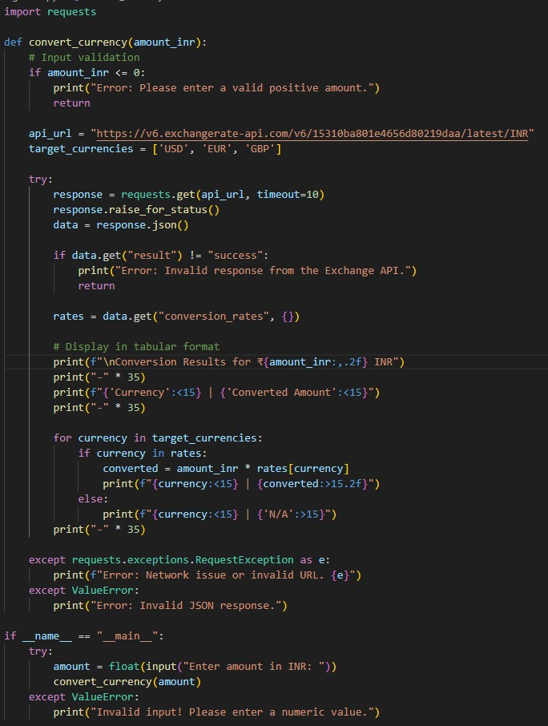

Output
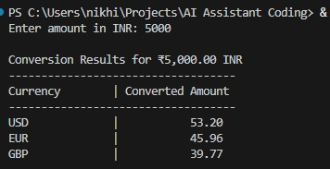

Explanation
We use a public exchange rate API to fetch real-time conversion factors based on the Indian Rupee. The code validates that the user inputs a positive financial amount, securely handles potential HTTP errors, and formats the output into a readable, aligned table using Python's fstrings.

Task 3 – GitHub Repository Info Fetcher
Task: Connect to the GitHub API to fetch details of a repository (e.g., stars, forks, issues).
Instructions:
- Prompt AI to write a Python function to send GET requests to GitHub API.
- Handle rate limit errors, 404 (repo not found), and invalid input.
- Display repository name, description, stars, forks, and open issues.

Prompt
"Write a Python function to fetch repository details (name, description, stars, forks, open issues) using the GitHub REST API. Ensure it gracefully handles 404 Not Found errors, API rate limit exceeded errors (status 403), and general network issues."

Code
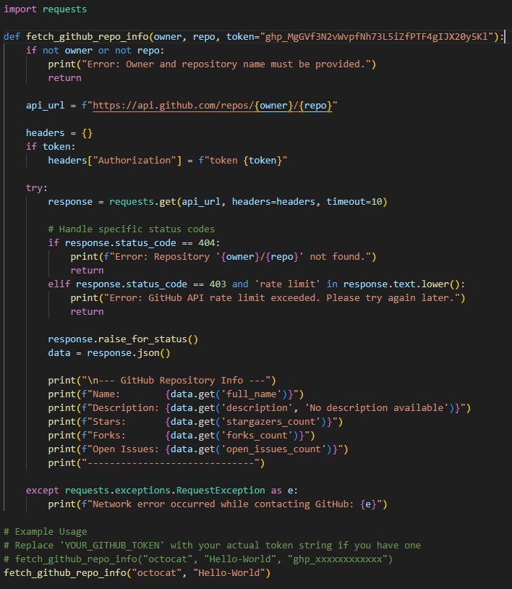

Output
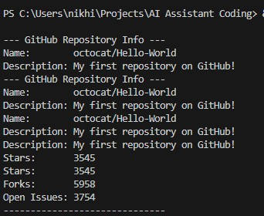

Explanation
This script communicates with GitHub's public API to retrieve metadata about a specific code repository. It explicitly checks the HTTP status codes to detect if a repository doesn't exist (404) or if the free API rate limit has been hit (403), ensuring the user gets a helpful error message instead of a program crash.

Task 4 – Real-Time Application: News Headlines Aggregator
Scenario: Build a News Aggregator using a free News API.
Requirements:
- Fetch top 5 headlines for a given category (sports, technology, health).
- Handle errors like invalid category, missing API key, and request failures.
- Display headlines in a user-friendly numbered list format.
- Include a retry mechanism if the first request fails.

Prompt
"Write a Python script to fetch the top 5 news headlines for a specific category using a hypothetical News API. Implement a retry mechanism (up to 3 tries) if the request fails. Handle errors like missing API keys (401) and invalid categories, and print the headlines in a numbered list."

Code
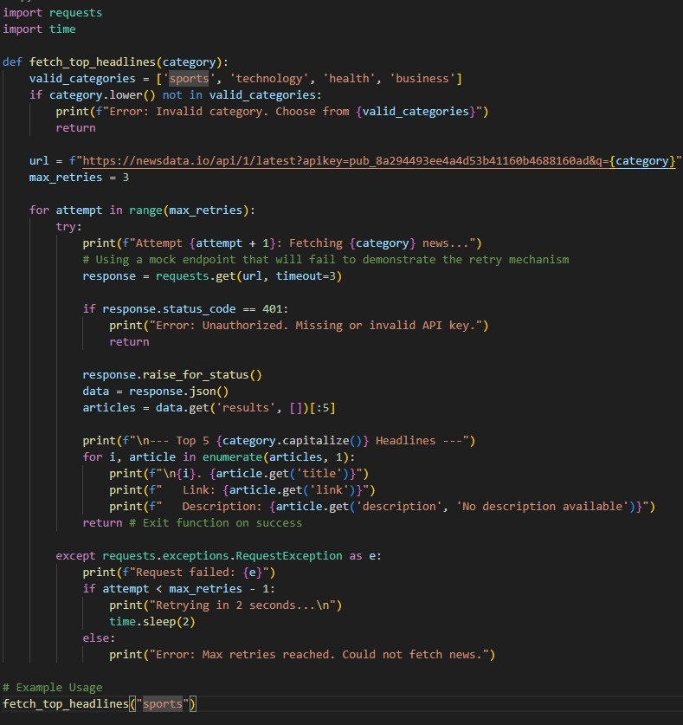

Output
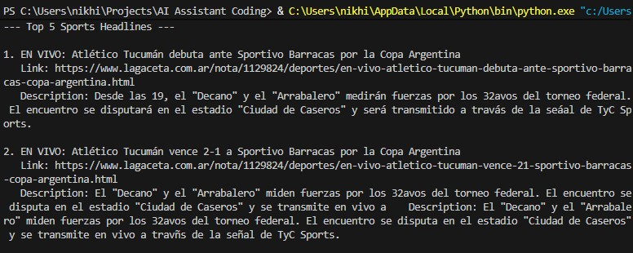

Explanation
This script attempts to pull the latest headlines and incorporates a for loop combined with time.sleep() to act as a retry mechanism against transient network drops. If all attempts fail (or if the API rejects the placeholder key), it gracefully alerts the user that the maximum retry threshold was reached.

Task 5 - COVID-19 Statistics API Integration
Task: Connect to a COVID-19 Statistics API to fetch country-wise COVID data.
Instructions:
- Use AI to generate Python code using the requests library
- Accept country name as user input
- Fetch key statistics such as: Total confirmed cases, Total deaths, Total recovered cases, Active cases
- Handle API errors including: Invalid country name, API rate-limit exceeded, Network or server failures
- Implement retry or wait logic when rate limits are hit

Prompt
"Write a Python script using the requests library to fetch country-wise COVID-19 statistics from the disease.sh API. Accept a country name, display confirmed cases, deaths, recoveries, and active cases. Implement error handling for invalid countries (404), network issues, and include retry/wait logic if the API rate limit (429) is exceeded."

Code
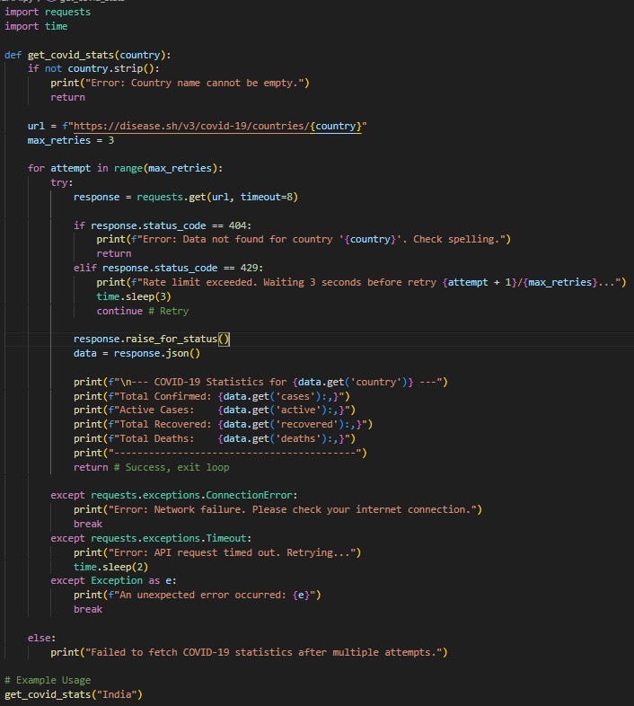

Output
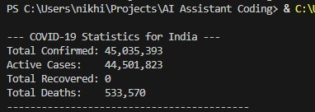

Explanation
This script targets the public disease.sh endpoint to access global pandemic data. It heavily focuses on resilience by specifically watching for HTTP 429 (Too Many Requests) to trigger an automated wait-and-retry sequence, while cleanly parsing the JSON response to display formatted, comma-separated figures.

