AI ASSISTED CODING LAB-3.5
G. MANI SHARANYA
2303A51755
Batch-11
1. Select a simple task: "Write a Python function to check if a number is prime."
Prompt 1:
Write a code to check if a number is prime or not input by user.
Given Code and Output:
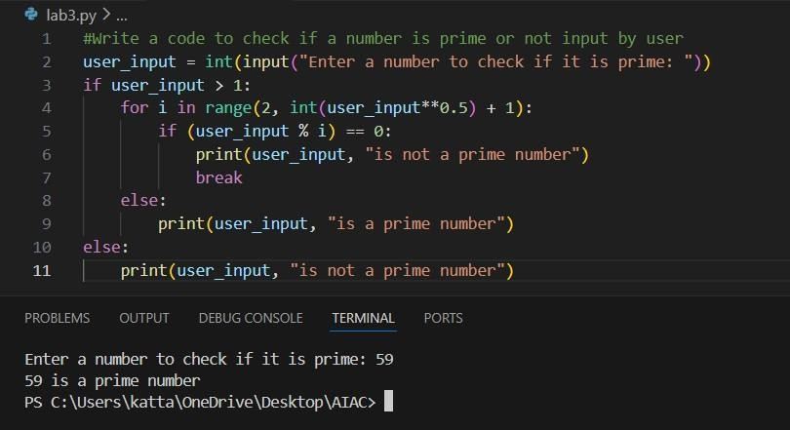
Prompt 2:
Write a code to check if a number is prime or not input by user using functions.
Given Code and Output:

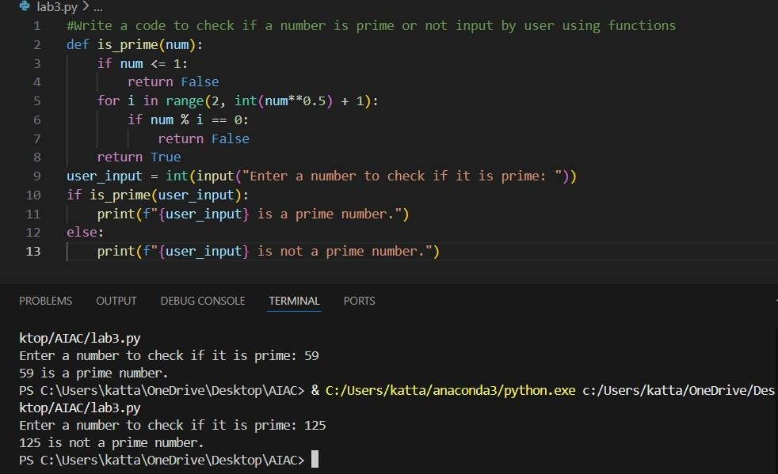

Prompt 3:
Give an optimized code to check if a number is prime Given Code and Output:
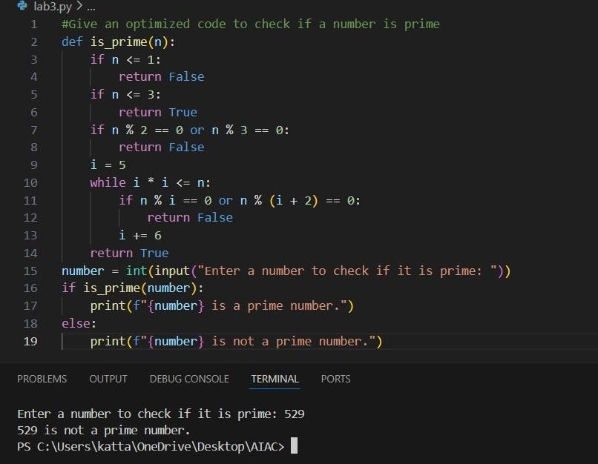

Task: Mobile Data Usage Billing Application (1.0 Marks)
Prompt 1:
# Write a code for mobile data usage billing application that takes the input of o Data Consumed (in GB), Plan Type (Prepaid / Postpaid), Additional Services Used (e.g., caller tune,
OTT subscription, etc.) and calculate the total bill amount Code:
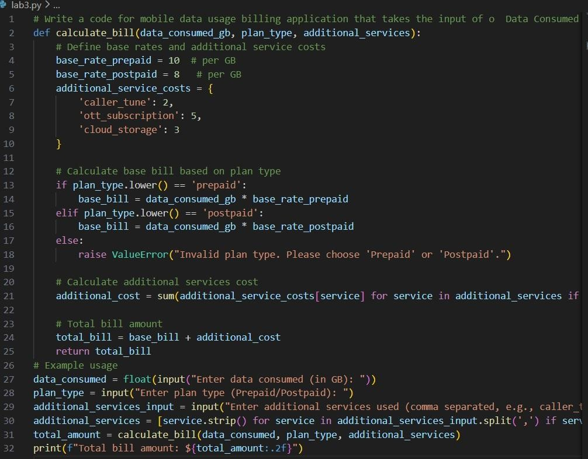
Output:
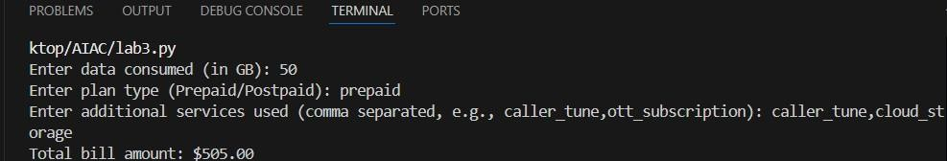
Prompt 2:
improve the code by adding Data Charges (based on data usage), Value-added service charges, Tax on total amount, Display an itemized bill.
Code:

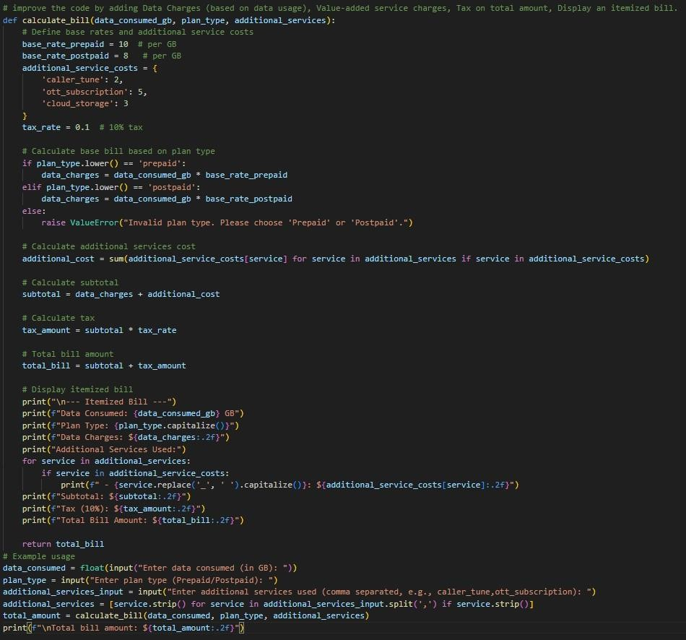
Output:
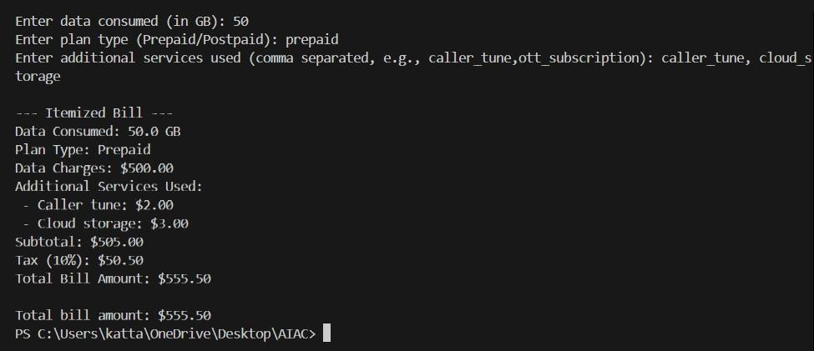
Prompt 3:
Make the above code more optimized and structured
Code:

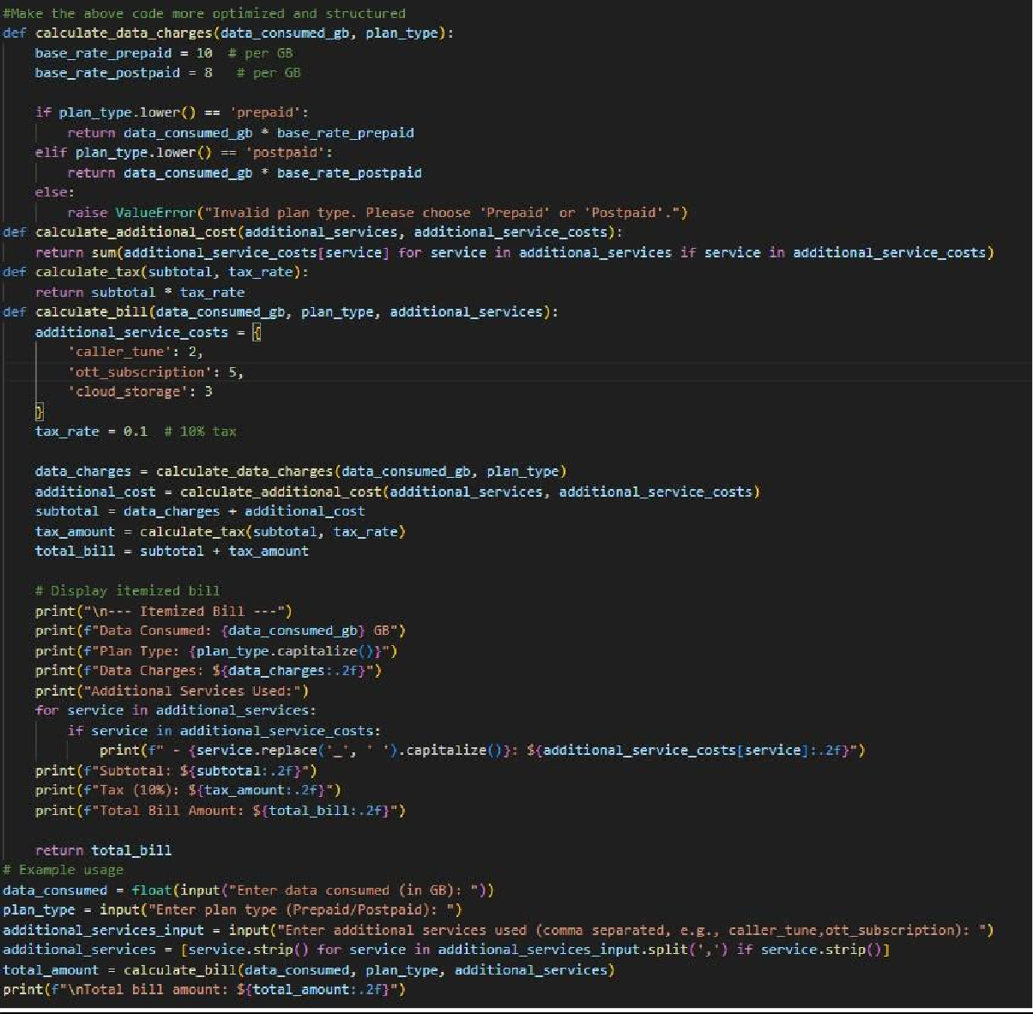
Output:
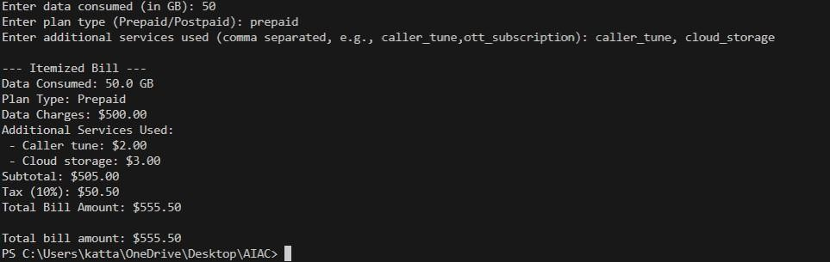
Task: Develop an LPG Billing System (1.0 Marks) Prompt 1:

#Write a code to calculate the LPG bill based on cylinder type, number of cylinders booked, subsidy amount, and delivery charges input by user.
Code:
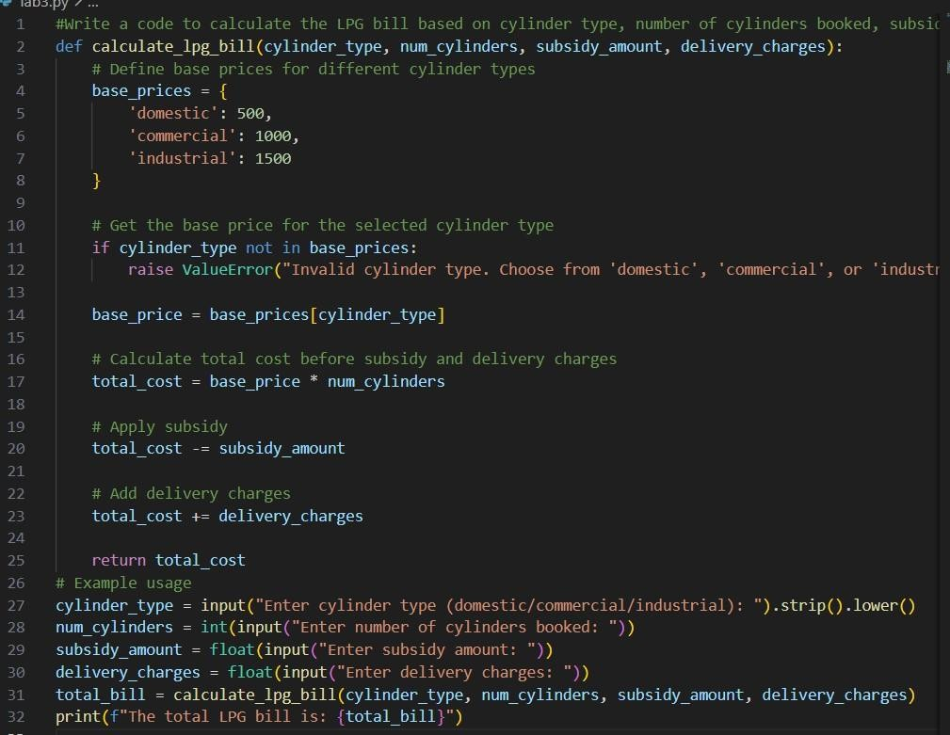
Output:
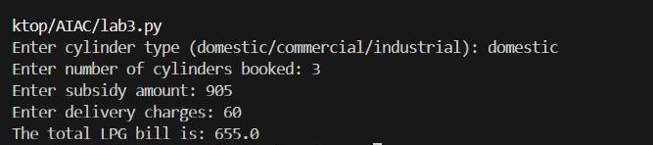
Explanation:
- In all the tasks at first I asked a basic prompt without any requirements, then the response that was given was very basic.
- After specifying what I wanted in the next prompts the response that was given was more optimised and structured.

