AI ASSISTED CODING LAB-11.1

G. MANI SHARANYA

2303A51755

Batch-11

Task Description #1 – Stack Implementation
Task: Use AI to generate a Stack class with push, pop, peek, and is_empty
methods.
Sample Input Code:
class Stack:
pass
Expected Output:
- A functional stack implementation with all required methods and docstrings

PROMPT:
#Write a code to generate a stack class with push,pop,peek and isEmpty methods

CODE:

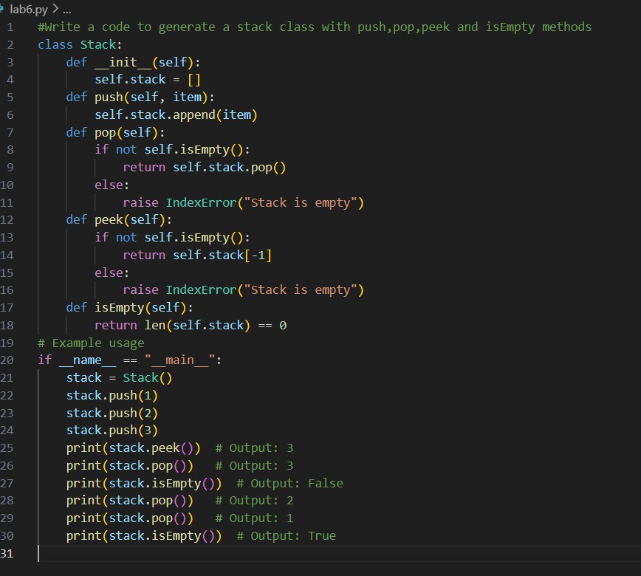

OUTPUT:
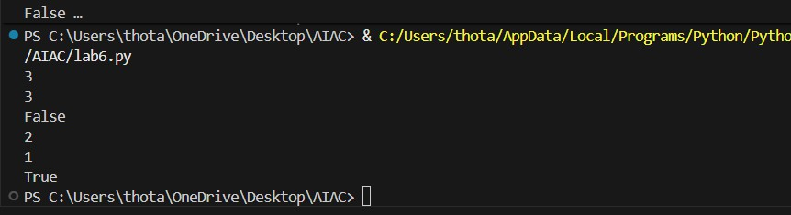

Task Description #2 – Queue Implementation
Task: Use AI to implement a Queue using Python lists.

Sample Input Code:
class Queue:
pass
Expected Output:
- FIFO-based queue class with enqueue, dequeue, peek, and size
methods.

PROMPT:
#Write a code to generate a queue class with enqueue,dequeue,peek and size methods

CODE:

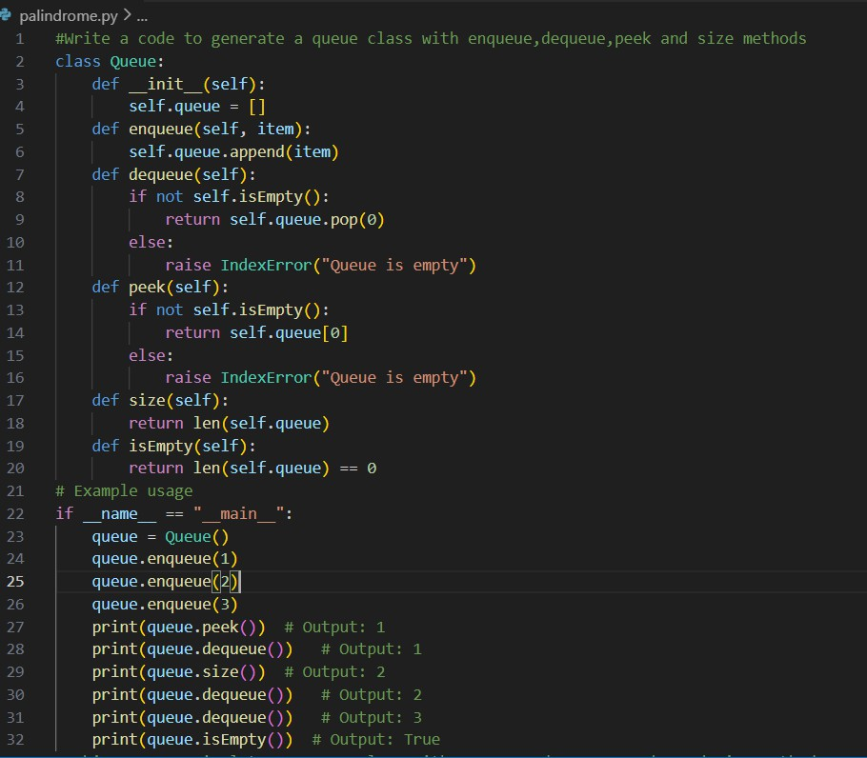
OUTPUT:
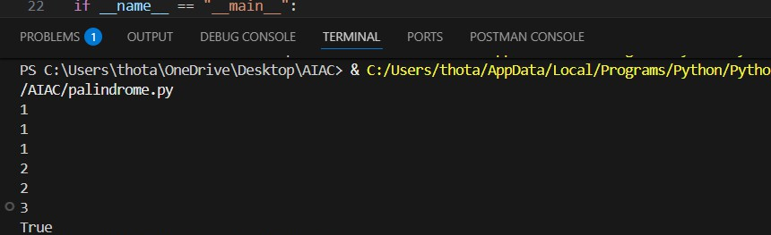

Task Description #3 – Linked List

Task: Use AI to generate a Singly Linked List with insert and display
methods.
Sample Input Code:
class Node:
pass
class LinkedList:
pass
Expected Output:
- A working linked list implementation with clear method
documentation

PROMPT:
#Write a code to generate a singly linkedlist with insert and display methods

CODE AND OUTPUT:

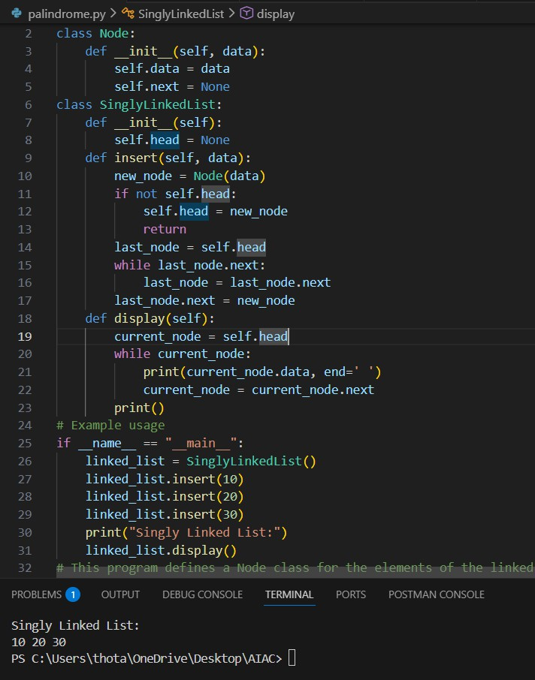

Task Description #4 – Binary Search Tree (BST)
Task: Use AI to create a BST with insert and in-order traversal methods.

Sample Input Code:
class BST:
pass
Expected Output:
- BST implementation with recursive insert and traversal methods.

PROMPT:
#Write a code to create a binary search tree and inorder traversal methods using recursive insert and travesal methods

CODE AND OUTPUT:

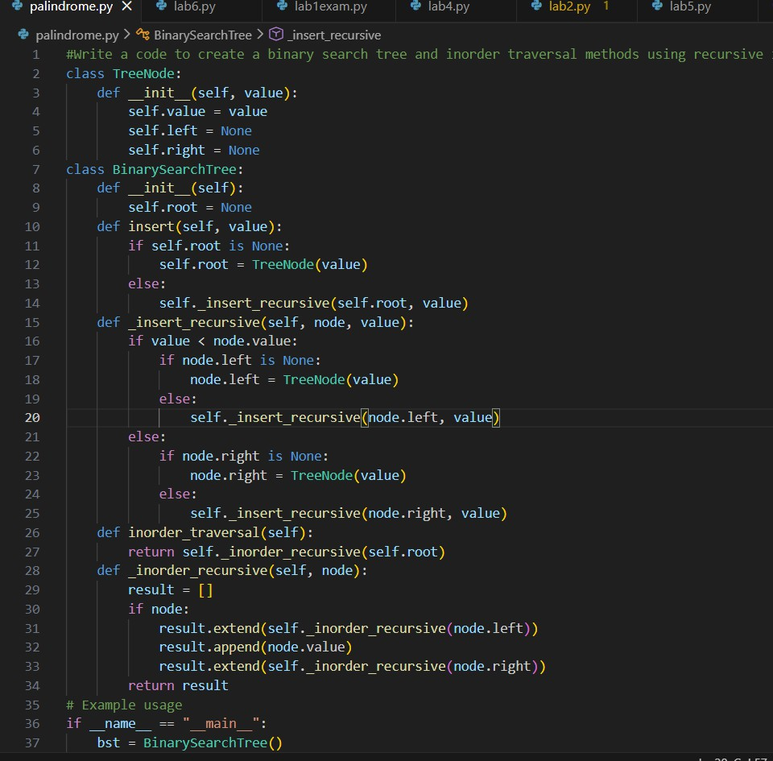

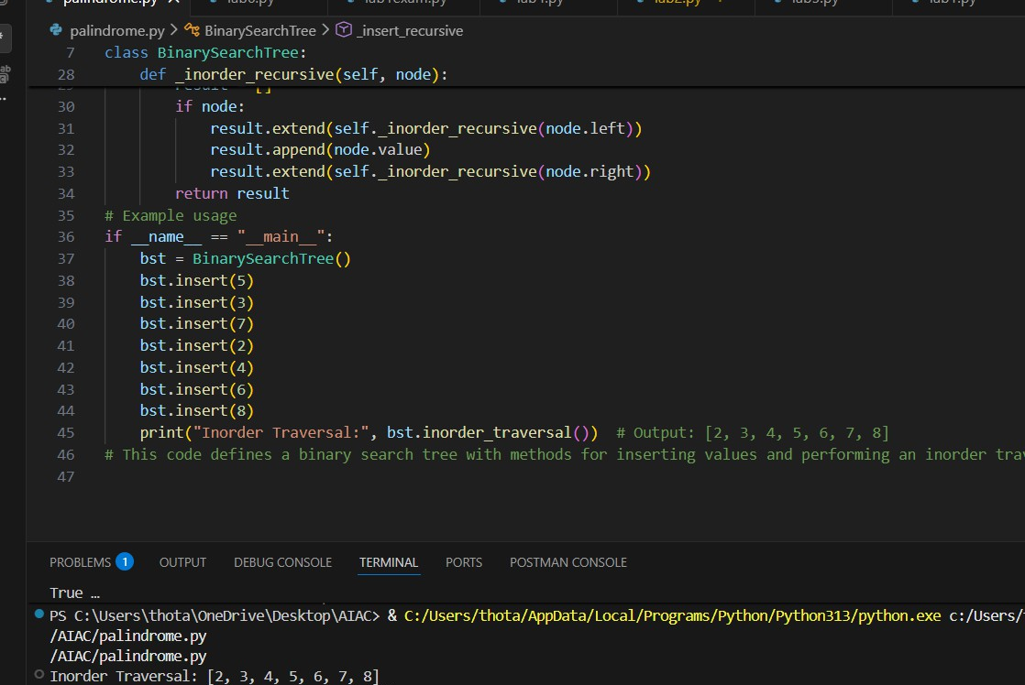

Task Description #5 – Hash Table
Task: Use AI to implement a hash table with basic insert, search, and
delete methods. Sample Input Code: class HashTable: pass
Expected Output:

- Collision handling using chaining, with well- commented methods.

PROMPT:
#Write a code to implement a hash table with basic operations like insert, delete and search methods using chaining for collision handling with well commented methods

CODE AND OUTPUT:
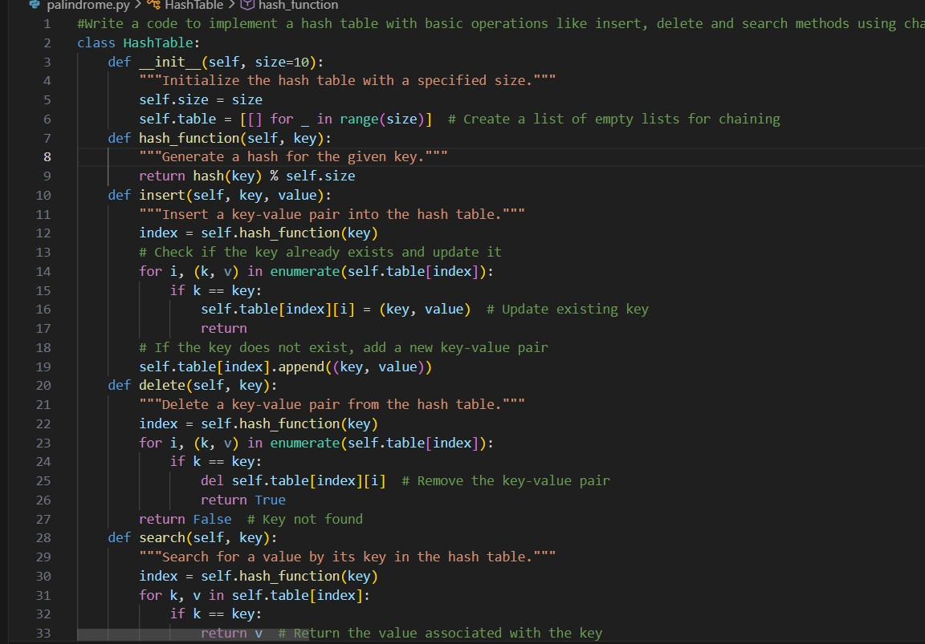

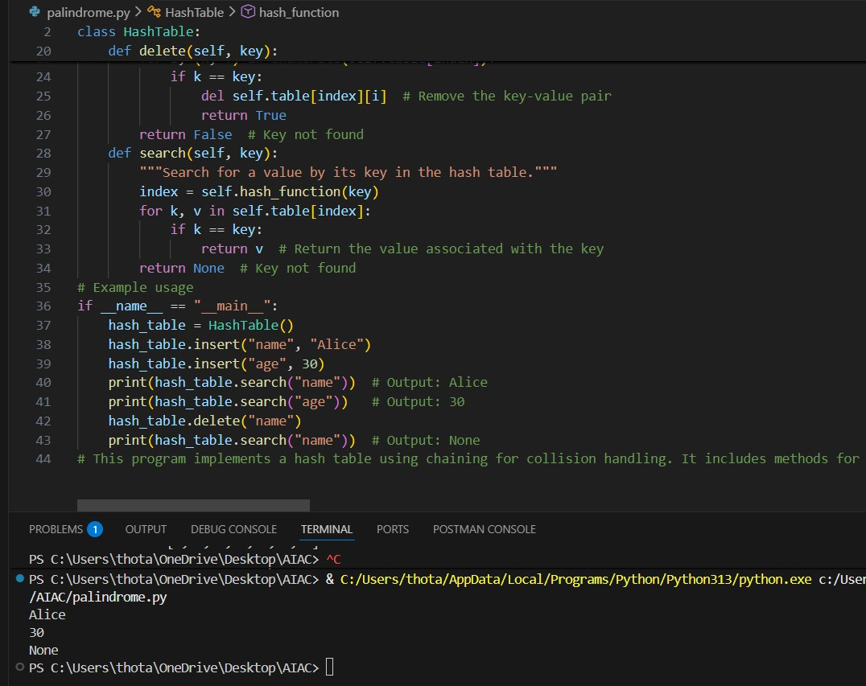

Task Description #6 – Graph Representation
Task: Use AI to implement a graph using an adjacency list.
Sample Input Code:
class Graph:
pass
Expected Output:
- Graph with methods to add vertices, add edges, and display
connections.

PROMPT:
#Write a code to implement a graph using an adjacency list and perform methods like add_vertices,add_edges and display connections

CODE AND OUTPUT:
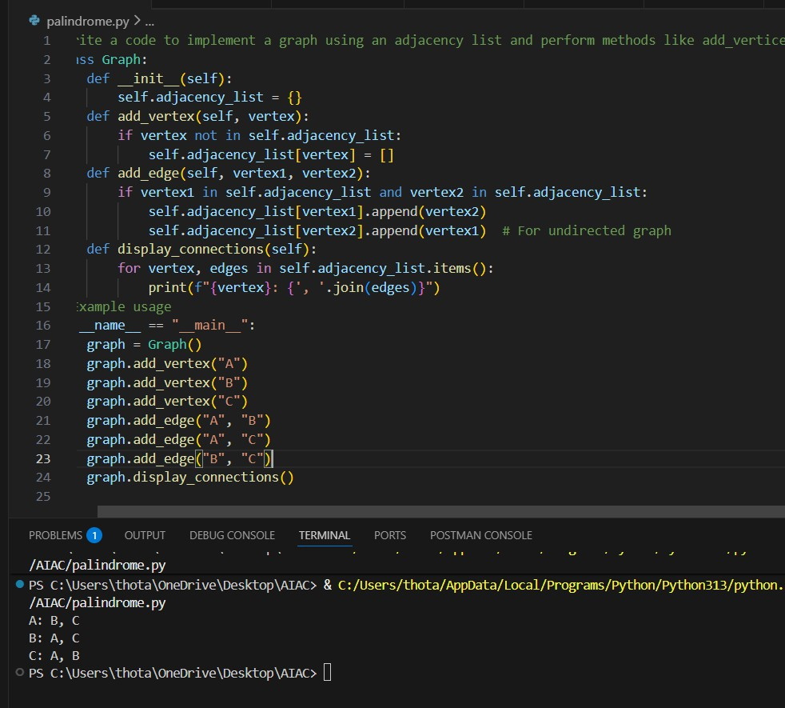

Task Description #7 – Priority Queue
Task: Use AI to implement a priority queue using Python’s heapq
module.

Sample Input Code:
class PriorityQueue:
pass
Expected Output:
- Implementation with enqueue (priority), dequeue (highest priority),
and display methods.

PROMPT:
#Write a code to implement a priority queue using python's heapq module and implement with methods for enqueue,dequeue and display methods

CODE AND OUTPUT:

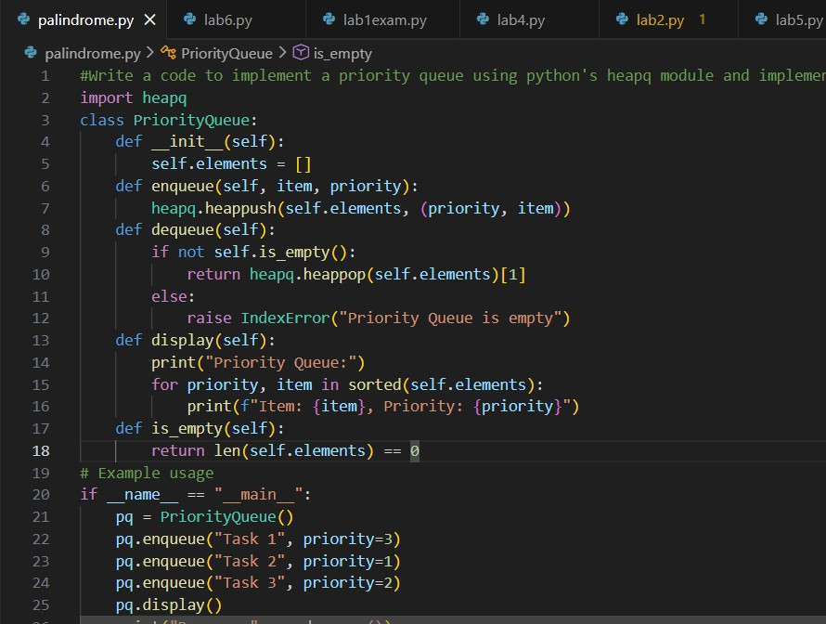

Task Description #8 – Deque
Task: Use AI to implement a double-ended queue using collections.deque.
Sample Input Code:
class DequeDS:
pass
Expected Output:
- Insert and remove from both ends with docstrings.

PROMPT:
#Write a code to implement a double ended queue using collections.dequeue using insert and remove from both ends with docstring
CODE AND OUTPUT:
