Lab Assignment-10.5
Moses Supreeth Raj
2303A51770
Batch-12
Lab 10 – Code Review and Quality: Using AI to Improve Code
Quality and Readability
Task Description #1 – Variable Naming Issues
Task: Use AI to improve unclear variable names.

Prompt: rewrite the above code with meaningful function and variable names, with documentation and inline suggestions, use pydoc to generate documentation

Code:
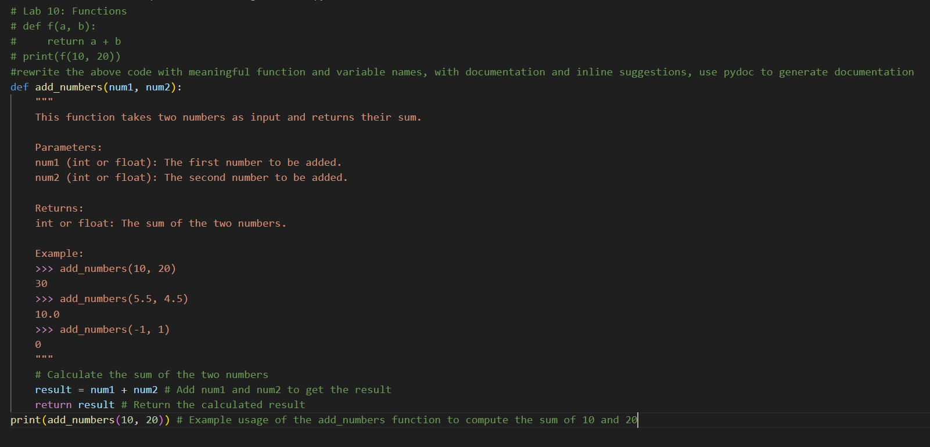
Output: 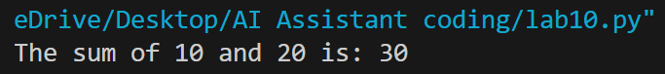
Explaination: The function `add_numbers` takes two numbers as input and returns their sum. It includes a docstring that explains the purpose of the function, its parameters, return value, and provides example usage. Inline comments are added to clarify the steps involved in calculating the sum.

Task Description #2 – Missing Error Handling
Task: Use AI to add proper error handling.
Sample Input Code:
def divide(a, b):
return a / b
print(divide(10, 0))

Prompt: Handle the above code with exception handling, with documentation and inline suggestions, use pydoc to generate documentation

Code:
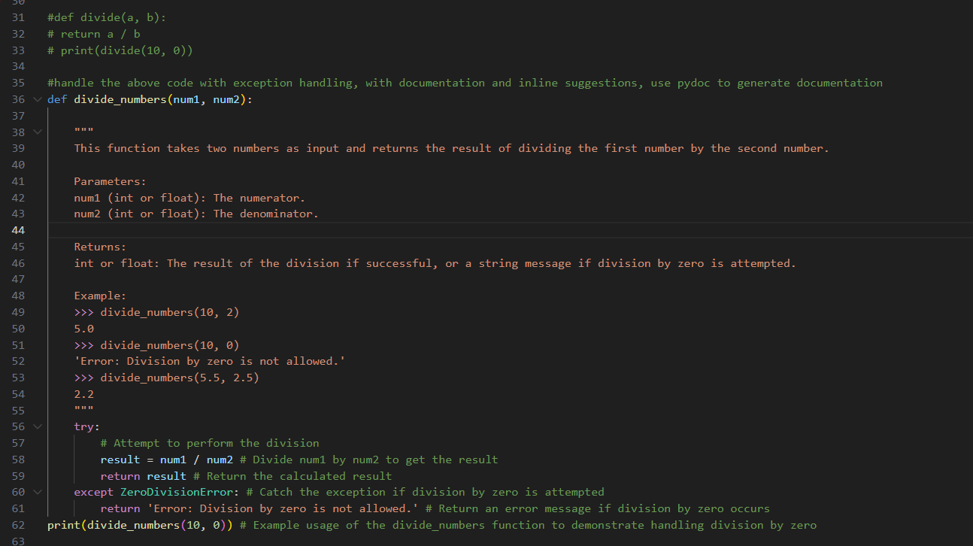
Output:
Explaination: Thefunction `divide_numbers` performs division of two numbers while handling the potential error of division by zero. It uses a try-except block to catch the `ZeroDivisionError` and returns an appropriate error message if such an exception occurs. The function is also documented with a docstring that describes its functionality, parameters, return value, and includes examples.

Task Description #3: Student Marks Processing System
The following program calculates total, average, and grade of a
student, but it has poor readability, style issues, and no error
handling.
marks=[78,85,90,66,88]
t=0
for i in marks:
t=t+i
a=t/len(marks)
if a>=90:
print("A")
elif a>=75:
print("B")
elif a>=60:
print("C")
else:
print("F")
Task:
• Use AI to refactor the code to follow PEP 8 standards.
• Add meaningful variable names, functions, and comments.
• Add basic input validation and documentation.
Prompt: Rewrite the code to follow PEP 8 style with meaningful variable names and comments, with documentation and inline suggestions, use pydoc to generate documentation

Code:
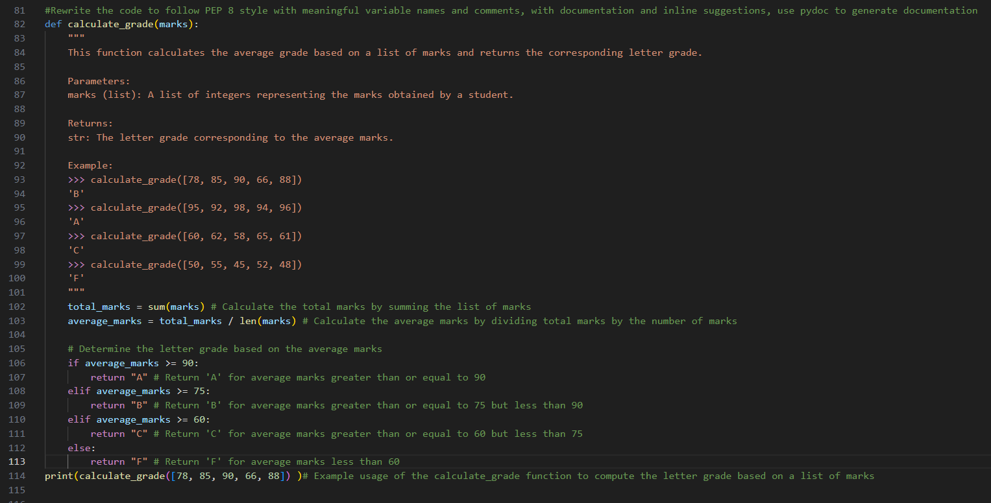
Output:
Explaination: The `calculate_grade` function computes the average of a list of marks and determines the corresponding letter grade based on predefined thresholds. It uses conditional statements to evaluate the average marks and return the appropriate grade. The function is well-documented with a docstring that outlines its purpose, parameters, return value, and example usage.

Task Description #4: Use AI to add docstrings and inline comments
to the following function.
def factorial(n):
result = 1
for i in range(1,n+1):
result *= i
return result
Prompt: Rewrite the code to add documentation and inline suggestions, use pydoc to generate documentation

Code: 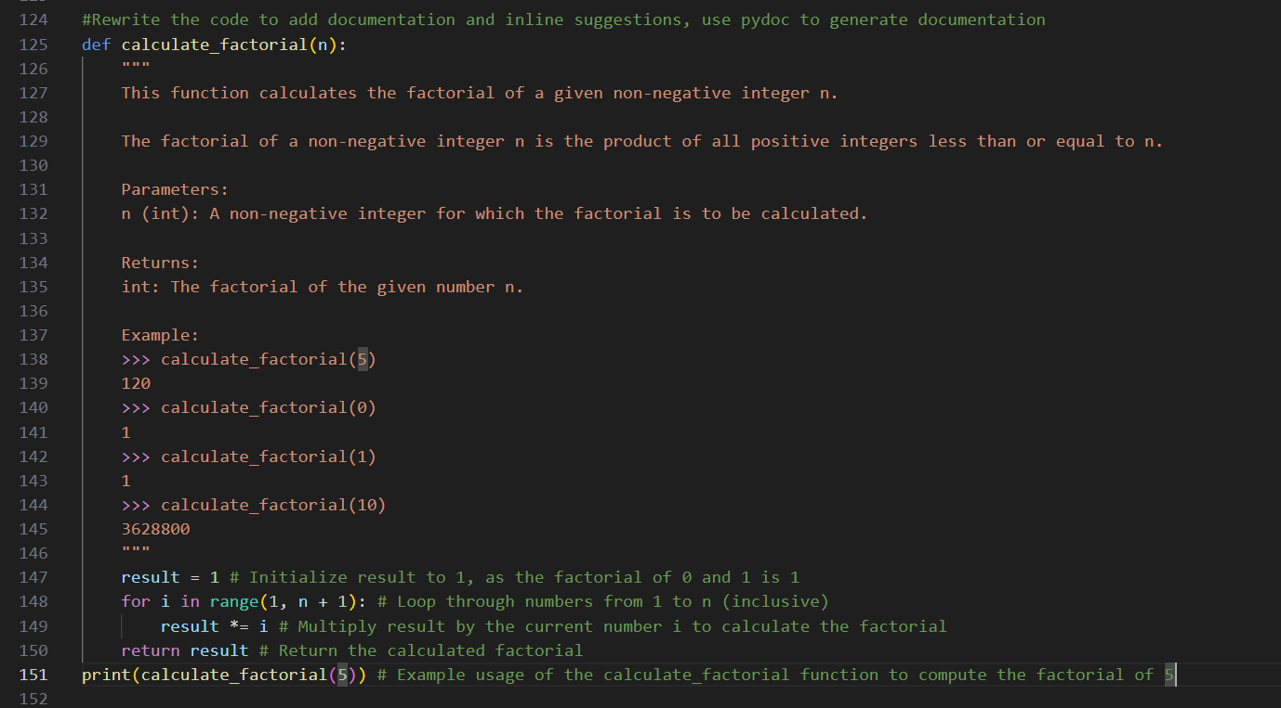
Output:
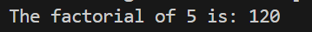
Explaination: The `calculate_factorial` function calculates the factorial of a non-negative integer using a loop. It initializes a result variable to 1 and multiplies it by each integer from 1 to n to compute the factorial. The function includes a docstring that explains its purpose, parameters, return value, and provides examples for clarity.

Task Description #5: Password Validation System (Enhanced)
The following Python program validates a password using only a
minimum length check, which is insufficient for real-world
security requirements.
pwd = input("Enter password: ")
if len(pwd) >= 8:
print("Strong")
else:
print("Weak")
Prompt:
Enhance the code with Minimum length requirement
o Presence of at least one uppercase letter
o Presence of at least one lowercase letter
o Presence of at least one digit
o Presence of at least one special character
2. Refactor the program to:
o Use meaningful variable and function names
o Follow PEP 8 coding standards
o Include inline comments and a docstring

Code: 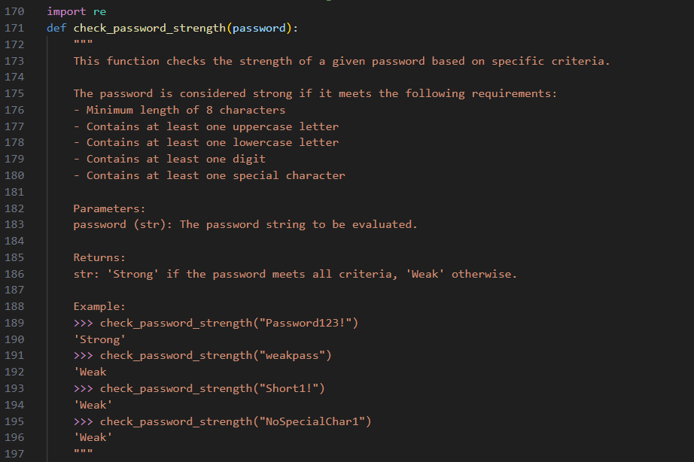
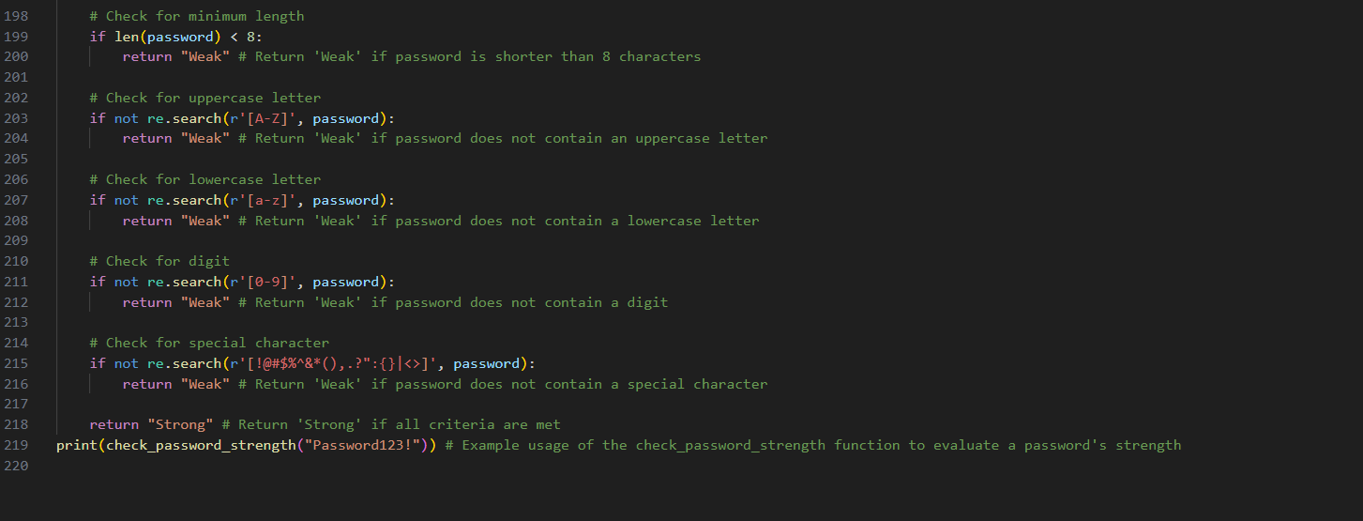
Output:
Explaination:The `check_password_strength` function evaluates the strength of a password based on specific criteria such as length, presence of uppercase and lowercase letters, digits, and special characters. It uses regular expressions to check for these criteria and returns 'Strong' or 'Weak' accordingly. The function is documented with a comprehensive docstring that describes its functionality, parameters, return value, and includes examples for better understanding.

