Lab Assignmnet-8.1

Test-Driven Development with AI – Generating and Working with Test Cases

Moses Supreeth Raj
2303A51770
Batch-12

Task 1 (Password Strength Validator – Apply AI in Security Context)
• Task: Apply AI to generate at least 3 assert test cases for is_strong_password(password) and implement the validator function.

Prompt:
#Generate a python code for password validation function that checks if a password is at least 8 characters long, contains at least one uppercase letter, one lowercase letter, one digit, and one special character.
#Generate test cases for high end password checker

Code: 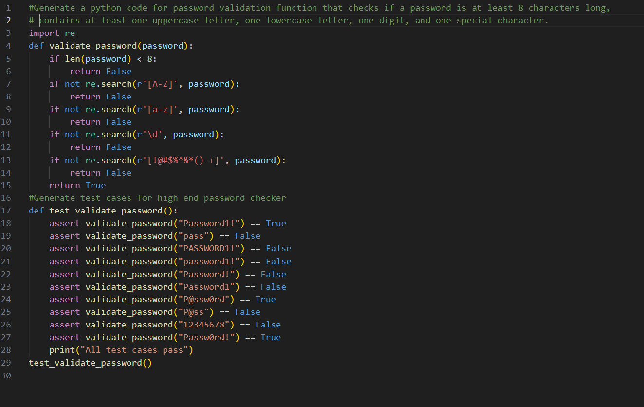
Output:
Explaination: This task involves creating a password validation function that ensures a password meets specific security criteria. The function checks if the password is at least 8 characters long and contains at least one uppercase letter, one lowercase letter, one digit, and one special character.By running these tests, we can confirm that the password validation logic is robust and reliable.

Task 2 (Number Classification with Loops– Apply AI for Edge Case Handling)
• Task: Use AI to generate at least 3 assert test cases for a classify_number(n) function. Implement using loops.
Prompt:
#Generate a python code for number classification with loops
#Generate assert statements for number classification function
Code: 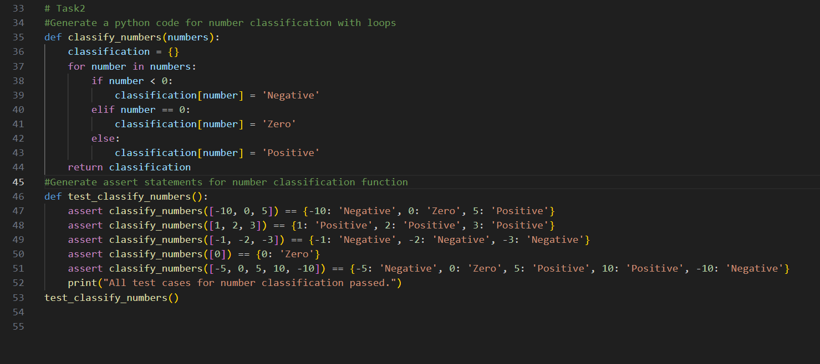
Output: 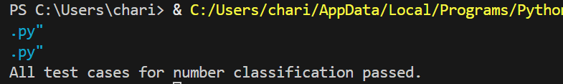
Explaination: This task focuses on classifying numbers into three categories: negative, zero, and positive. The function iterates through a list of numbers and assigns each number to its respective category based on its value. By validating the function with these tests, we can ensure its accuracy and reliability in handling diverse inputs.

Task 3 (Anagram Checker – Apply AI for String Analysis)
• Task: Use AI to generate at least 3 assert test cases for is_anagram(str1, str2) and implement the function.
Prompt:
#Python code for anagram checker function and give test cases using assert statements
Code:
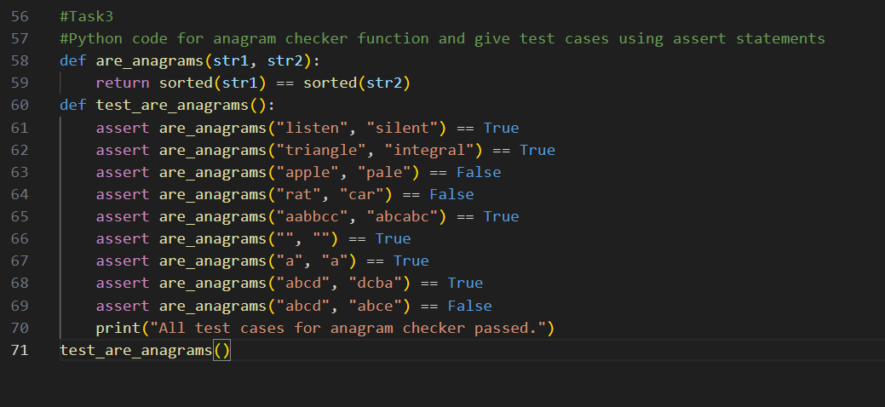
Output:
Explaination: This task is to develop an anagram checker function that determines whether two strings are anagrams of each other. Anagrams are words or phrases formed by rearranging the letters of another, and this function checks for that by sorting the characters in both strings and comparing them. By running these tests, we can confirm the function's correctness and reliability in identifying anagram relationships.

Task 4 (Inventory Class – Apply AI to Simulate Real-World Inventory System)
• Task: Ask AI to generate at least 3 assert-based tests for an Inventory class with stock management.
Prompt:
#Python code for inventory management system using classes and give test cases using assert statements
Code:
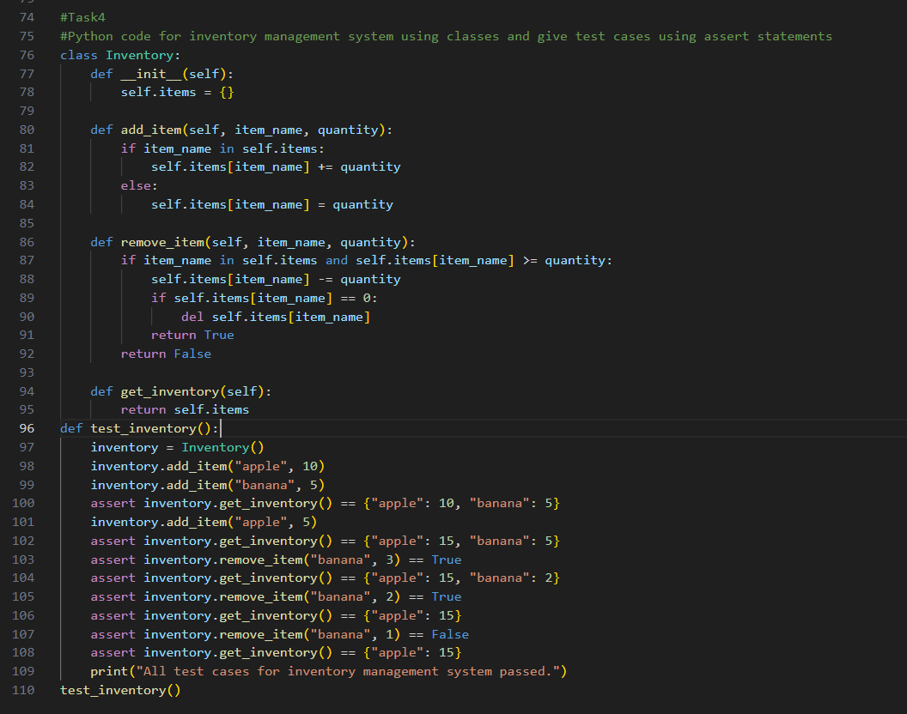
Output:
Explaination: This task involves creating an inventory management system using a class-based approach. The Inventory class allows for adding and removing items, as well as retrieving the current inventory state. By validating the class with these tests, we can ensure that the inventory management system operates reliably and accurately reflects the current stock status.

Task 5 (Date Validation & Formatting – Apply AI for Data Validation)
• Task: Use AI to generate at least 3 assert test cases for validate_and_format_date(date_str) to check and convert dates.
Prompt:
#Python code date validation and formatting function with test cases using assert statements
Code: 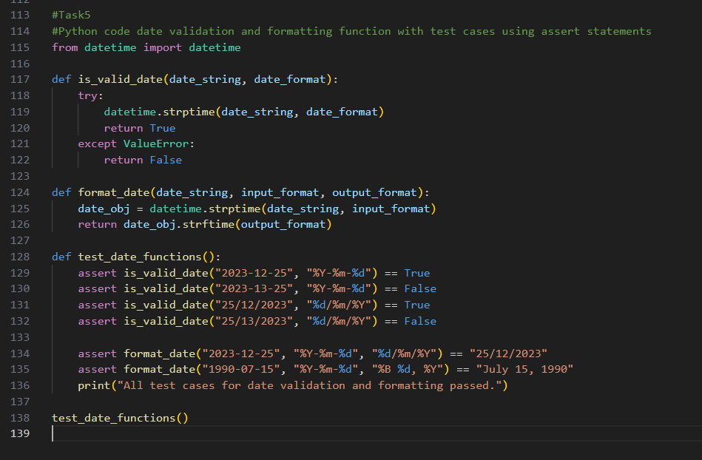
Output:
Explaination: This task focuses on date validation and formatting functions. The is_valid_date function checks whether a given date string conforms to a specified format, ensuring that only valid dates are accepted. By running these tests, we can confirm that the date functions work correctly and handle a variety of input formats reliably.

