LAB ASSIGNMENT-7.5
NAME: M. SUPREETH RAJ
2303A51770
BATCH-12
Lab 7: Error Debugging with AI: Systematic approaches to finding and fixing bugs
Lab Objectives:
• To identify and correct syntax, logic, and runtime errors in
Week4 -Monday:
Python programs using AI tools.
• To understand common programming bugs and AI-assisted
debugging suggestions.
• To evaluate how AI explains, detects, and fixes different
types of coding errors.
• To build confidence in using AI to perform structured
debugging practices.
Lab Outcomes (LOs):After completing this lab, students will be able to:
• Use AI tools to detect and correct syntax, logic, and runtime
errors.
• Interpret AI-suggested bug fixes and explanations.
• Apply systematic debugging strategies supported by AI-
generated insights.
Refactor buggy code using responsible and reliable programming
patterns.
Task 1 (Mutable Default Argument – Function Bug)
Task: Analyze given code where a mutable default argument causes unexpected behavior. Use AI to fix it.
# Bug: Mutable default argument
def add_item(item, items=[]):
items.append(item)
return items
print(add_item(1))
print(add_item(2))
Expected Output: Corrected function avoids shared list bug.
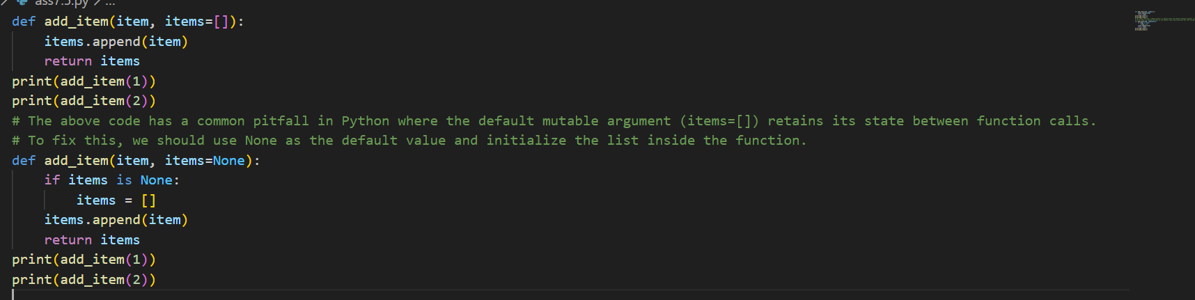
Output:
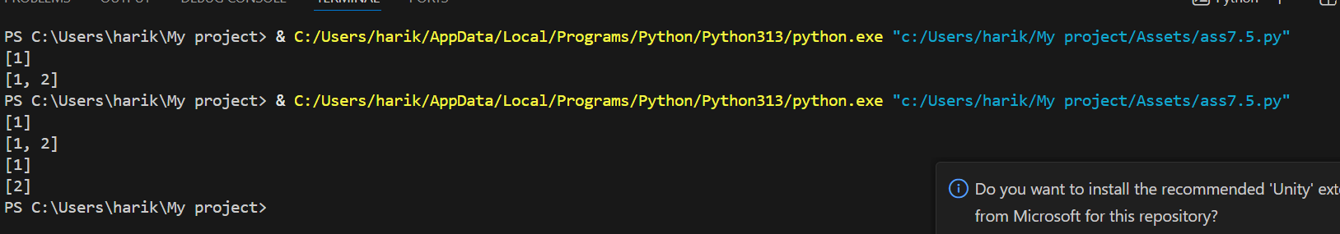
Task 2 (Floating-Point Precision Error)
Task: Analyze given code where floating-point comparison fails.
Use AI to correct with tolerance.
# Bug: Floating point precision issue
def check_sum():
return (0.1 + 0.2) == 0.3
print(check_sum())
Expected Output: Corrected function
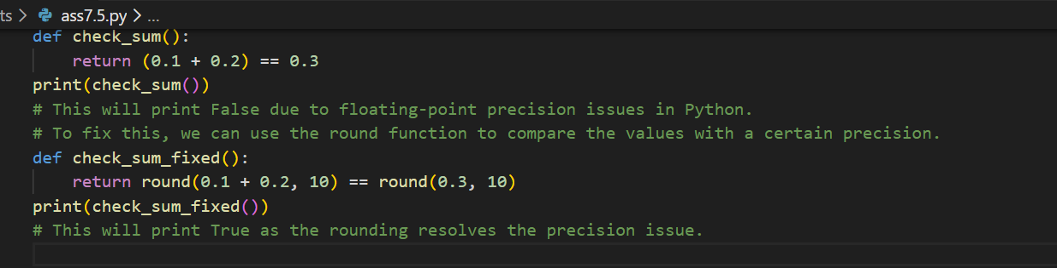
Output:
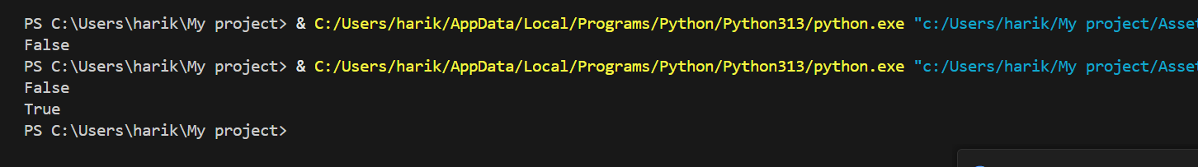
Task 3 (Recursion Error – Missing Base Case)
Task: Analyze given code where recursion runs infinitely due to
missing base case. Use AI to fix.
# Bug: No base case
def countdown(n):
print(n)
return countdown(n-1)
countdown(5)
Expected Output : Correct recursion with stopping condition
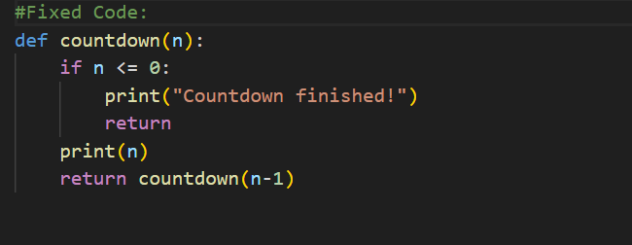
Output:
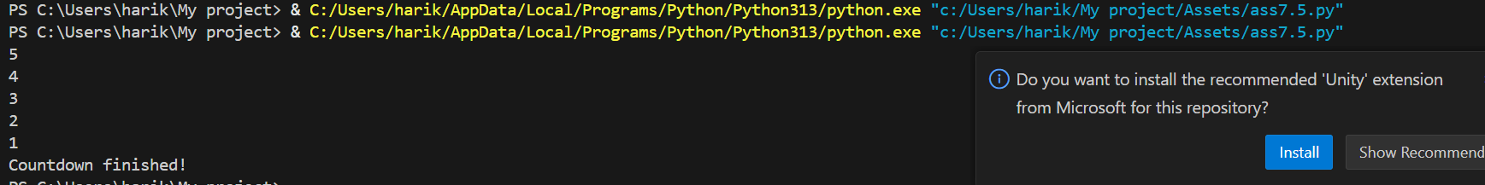
Task 4 (Dictionary Key Error)
Task: Analyze given code where a missing dictionary key causes
error. Use AI to fix it.
# Bug: Accessing non-existing key
def get_value():
data = {"a": 1, "b": 2}
return data["c"]
print(get_value())
Expected Output: Corrected with .get() or error handling.
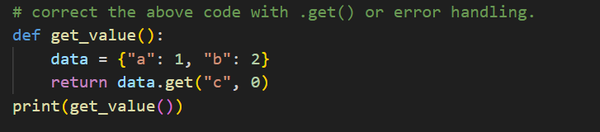
Output:
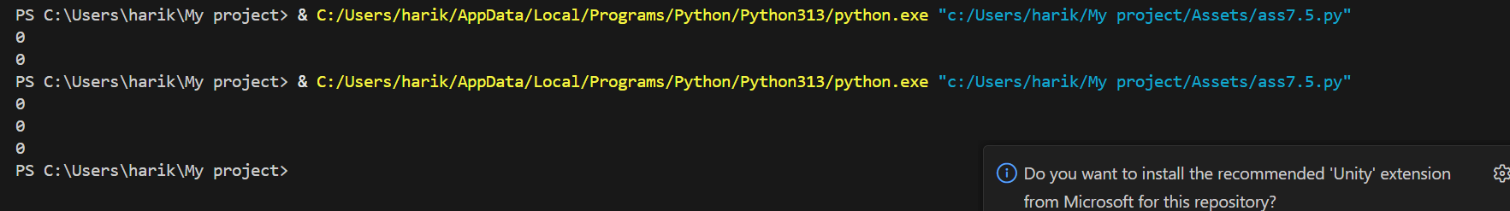
Task 5 (Infinite Loop – Wrong Condition)
Task: Analyze given code where loop never ends. Use AI to detect
and fix it.
# Bug: Infinite loop
def loop_example():
i = 0
while i < 5:
print(i)
Expected Output: Corrected loop increments i.
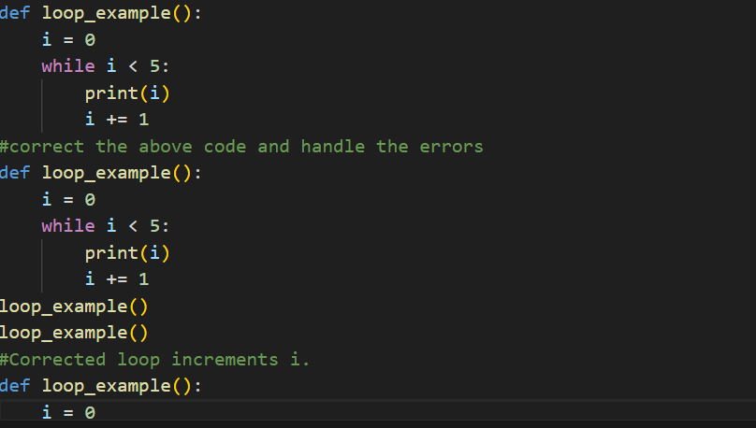
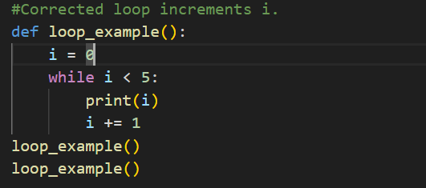
Output:
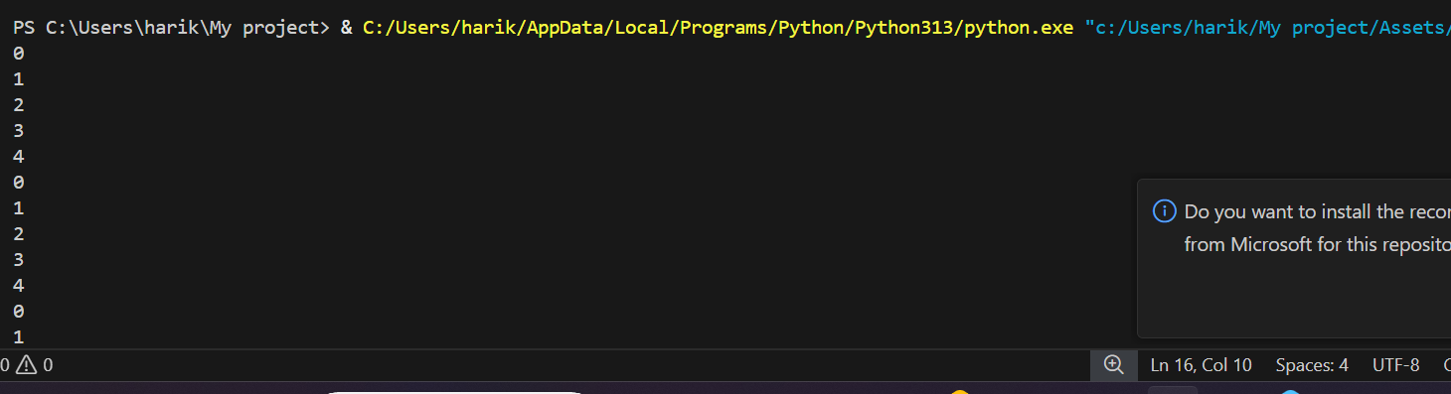
Task 6 (Unpacking Error – Wrong Variables)
Task: Analyze given code where tuple unpacking fails. Use AI to
fix it.
# Bug: Wrong unpacking
a, b = (1, 2, 3)
Expected Output: Correct unpacking or using _ for extra values.
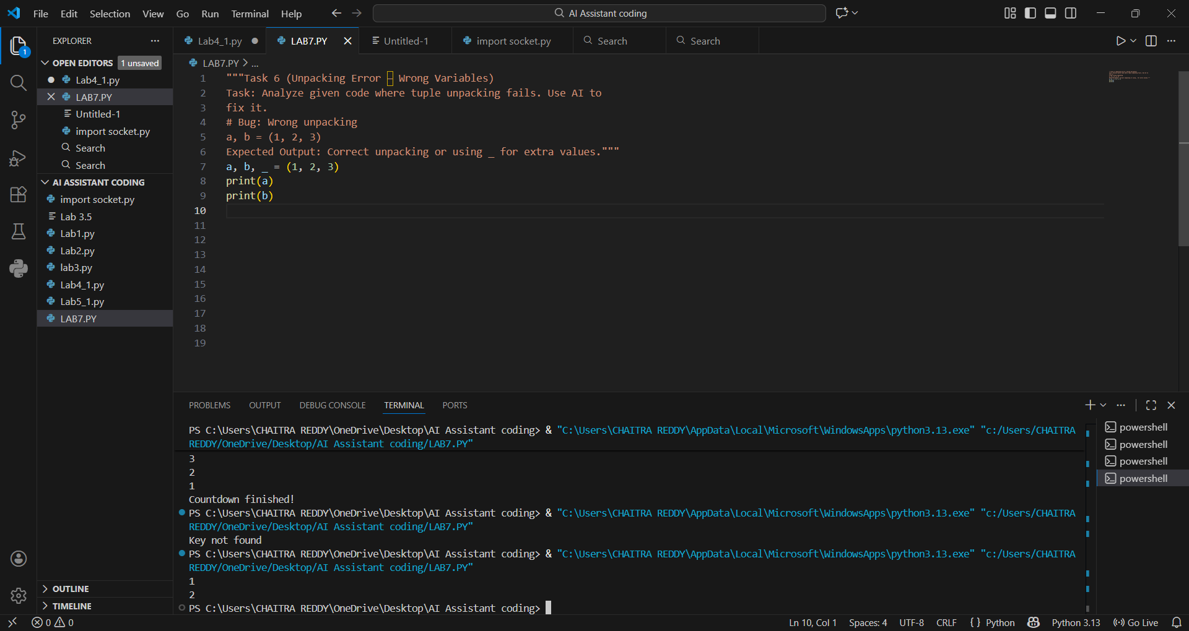
Output:

Task: Analyze given code where mixed indentation breaks execution. Use AI to fix it.
# Bug: Mixed indentation
def func():
x = 5
y = 10
return x+y
Expected Output : Consistent indentation applied.
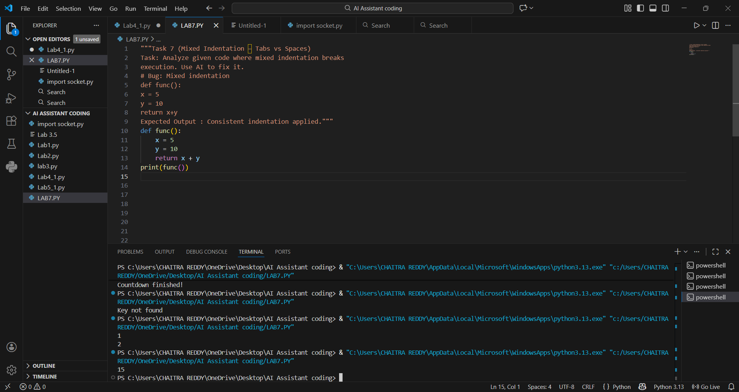
Output:

Task 8 (Import Error – Wrong Module Usage)
Task: Analyze given code with incorrect import. Use AI to fix.
# Bug: Wrong import
import maths
print(maths.sqrt(16))
Expected Output: Corrected to import math
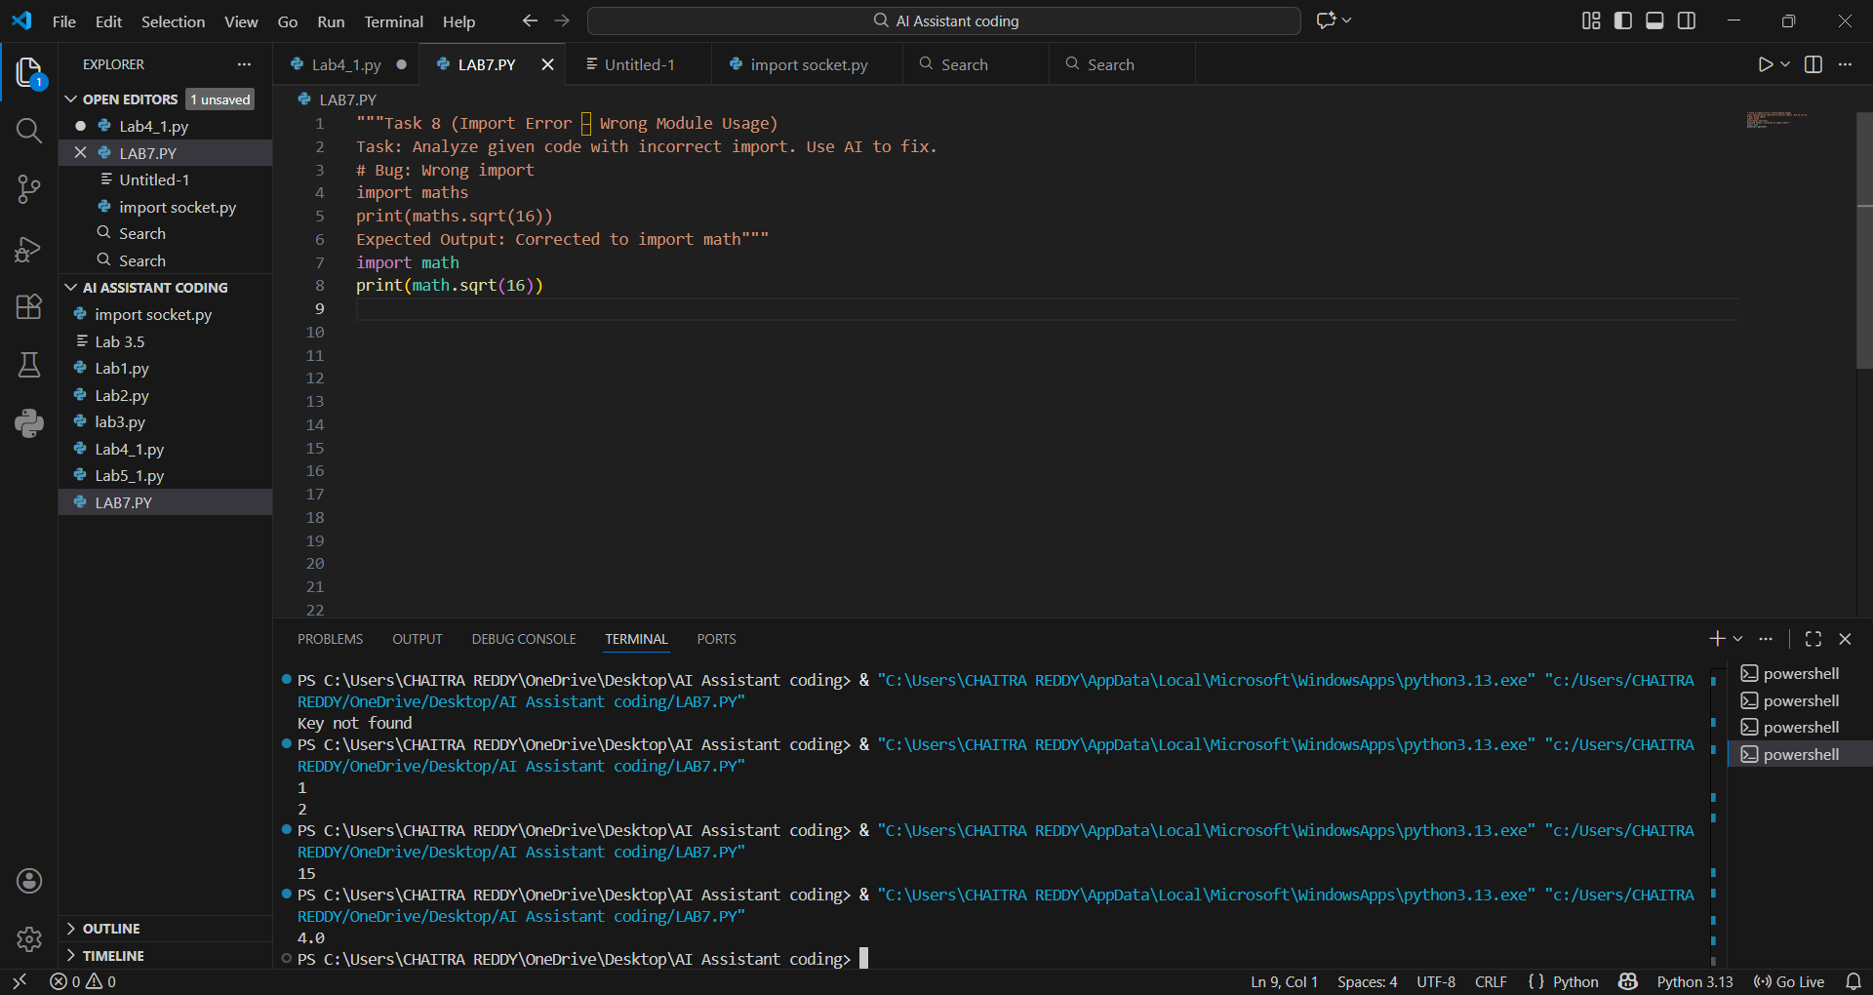
Output:


