Course Title : HIGH PERFORMANCE COMPUTING Lab Ass-5

Name:M. Supreeth Batch no-12
Hall Ticket:2303A51770

Lab: Loop Scheduling Comparison
Task 1: Code (reuse Week-3 code, only change directive) #pragma omp parallel for schedule(runtime) reduction(+:sum)
for (long i = 0; i &lt; N; i++) { sum += i;
}
Run commands:
gcc -fopenmp sum_openmp.c -o sum_openmp

export OMP_SCHEDULE=static export OMP_NUM_THREADS=8
./sum_openmp

export OMP_SCHEDULE=dynamic 04-02-2026 EOD
./sum_openmp

export OMP_SCHEDULE=guided
./sum_openmp
Fill the table below:

Scheduling Time Observation Static ? ?
Dynamic ? ? Guided ? ?

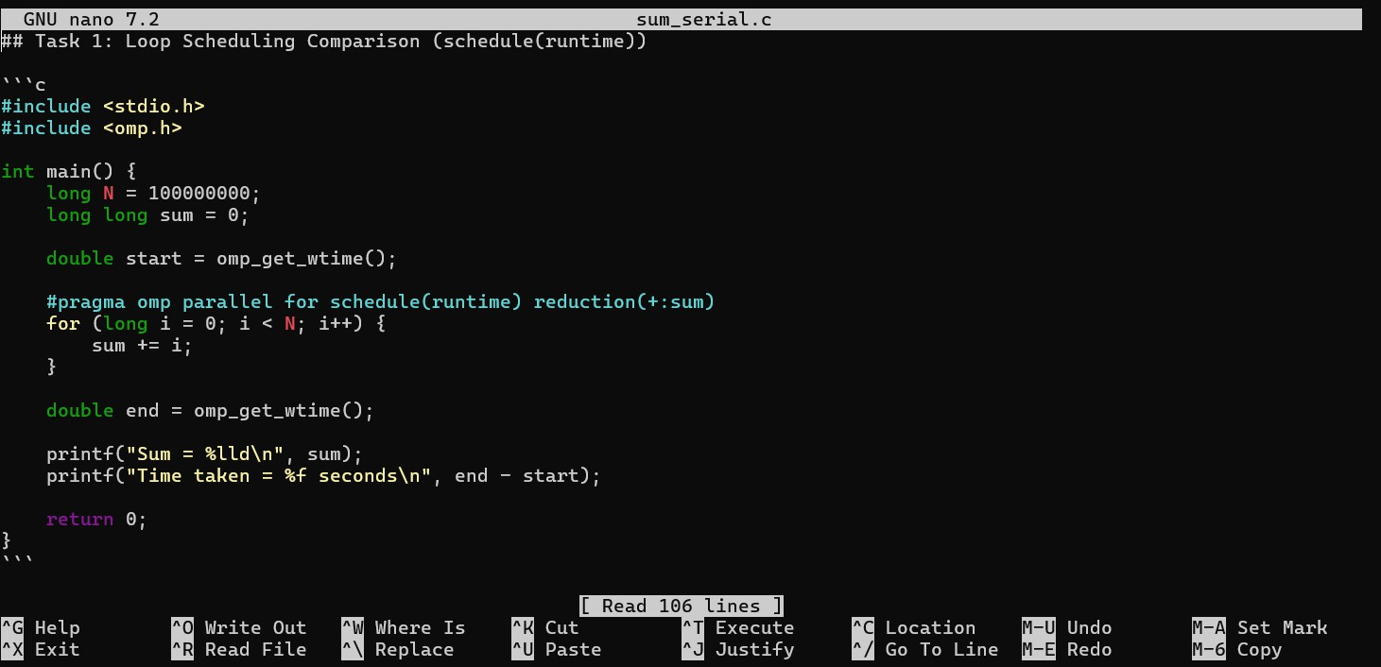
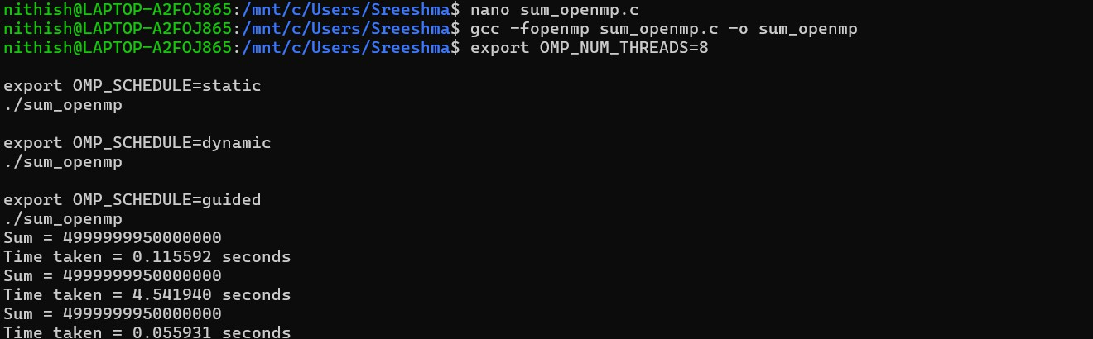

Scheduling | Time | Observation
Static | 0.115592 seconds | 4999999950000000
Dynamic | 4.541940 seconds | 4999999950000000
Guided | 0.055931 seconds | 4999999950000000

2
Task 2: Synchronization Overhead Comparison Variant-1: Reduction
#pragma omp parallel for reduction(+:sum)

Variant-2: Atomic #pragma omp parallel for for (...) {

#pragma omp atomic sum += i;
}

Variant-3: Critical #pragma omp parallel for

04-02-2026 EOD

for (...) {
#pragma omp critical sum += i;
}

Expected trend: Reduction → fastest Atomic → slower Critical → slowest

Reduction:
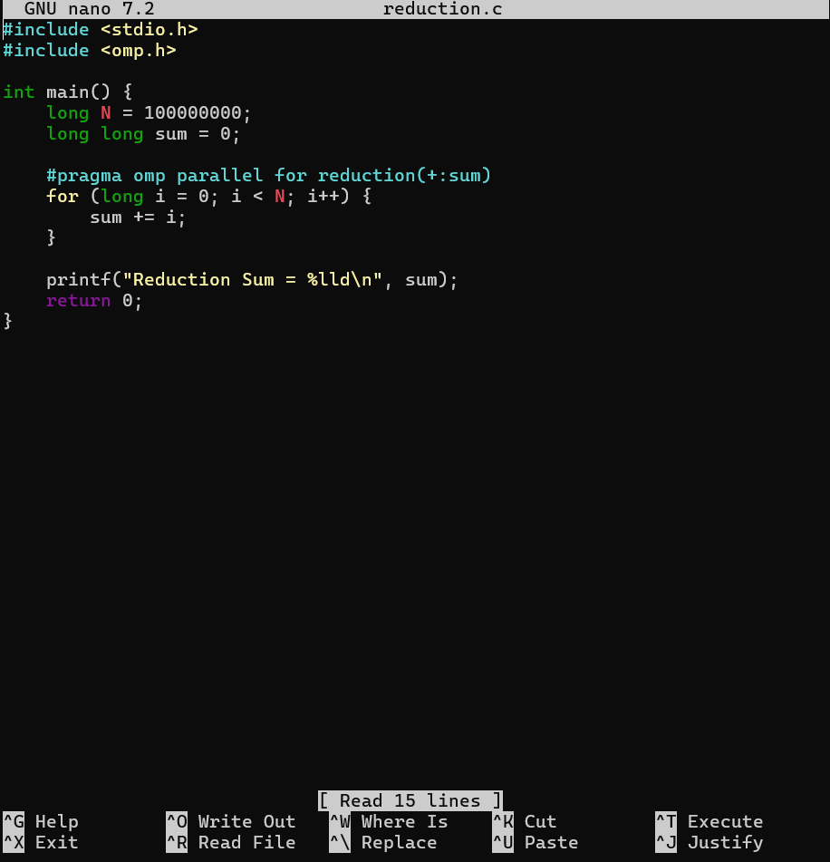
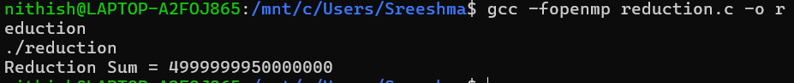

Atomic:

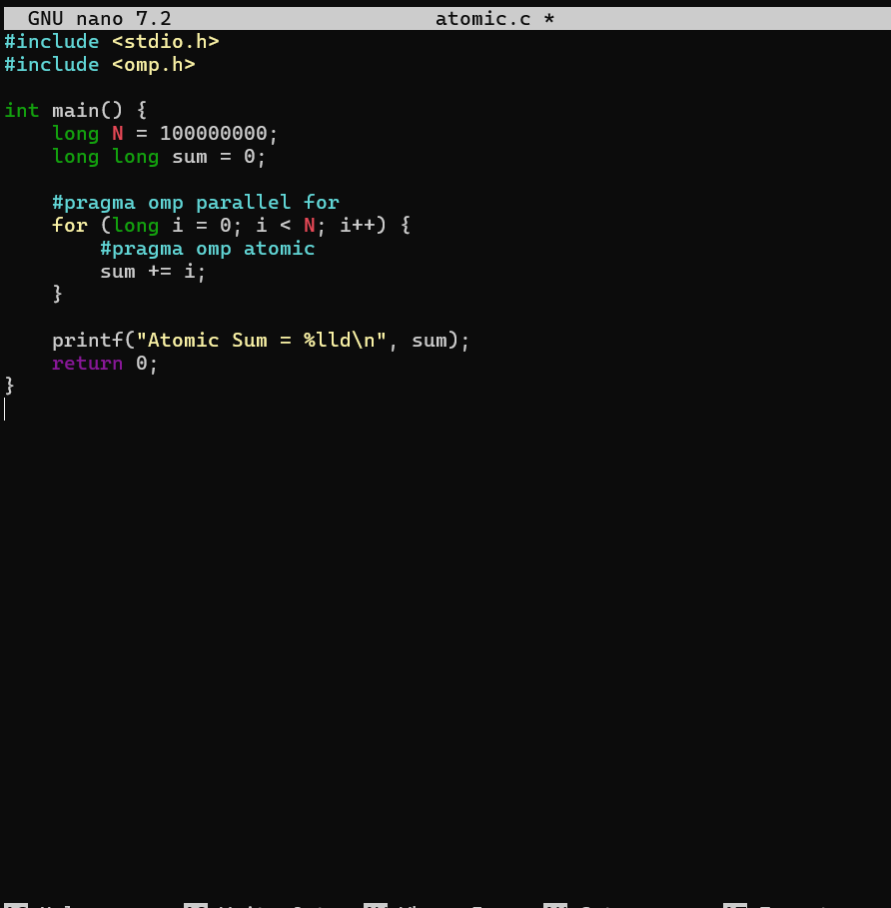
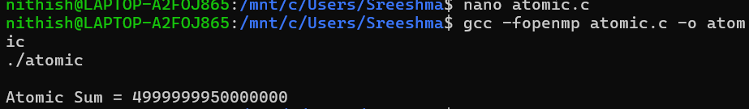

Critical:

