AI ASSISTED CODING

LAB-15.5

Name: M.Saikrishna
Hall.No:2303A51771 Batch - 12

Task 1 – Student Attendance API
Task:
Create a RESTful API for student attendance tracking.
Instructions:
- Endpoints required: o GET /attendance → View attendance records o POST /attendance → Mark attendance o PUT /attendance/{id} → Update attendance record o DELETE /attendance/{id} → Remove attendance entry
- Ensure JSON-based request and response handling.
Expected Output:
- API for maintaining and updating attendance records.
PROMPT:
"""Generate a Python Flask REST API for student attendance with in-memory storage.
Implement GET /attendance, POST /attendance, PUT /attendance/<id>, DELETE /attendance/<id>.
Use JSON request/response and add comments."""
GIVEN CODE:
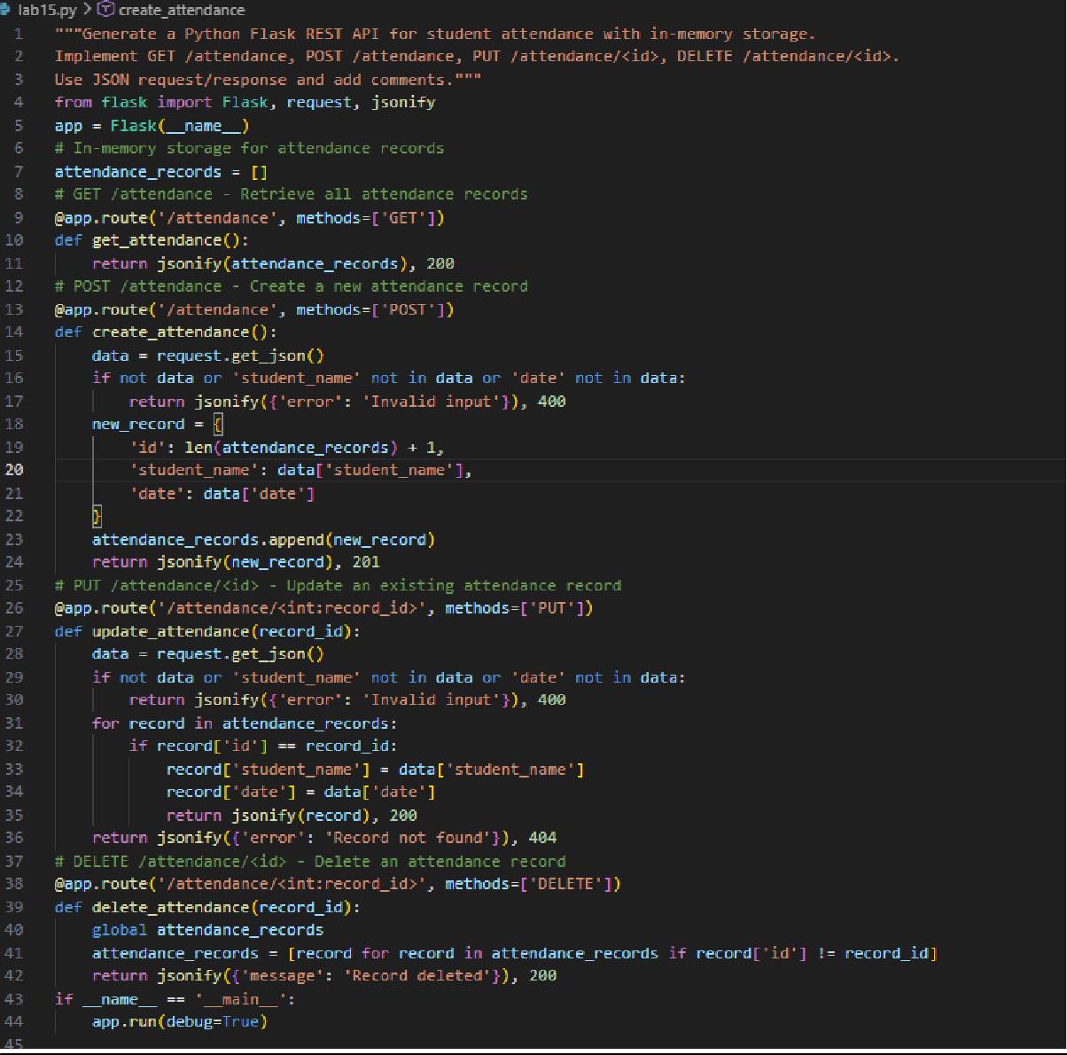
Task 2 – Inventory Management API
Task:
Develop a REST API for warehouse inventory management.
Instructions:
- Endpoints required:
o GET /inventory → List all items o POST /inventory → Add new item o PUT /inventory/{id} → Update stock quantity o DELETE /inventory/{id} → Remove an item
- Implement validation for stock values.
Expected Output:
- API capable of managing inventory stock levels.
PROMPT:
"""Create a Flask REST API for inventory management with item id, name, and quantity.
Implement GET, POST, PUT, DELETE endpoints for /inventory.
Add validation so stock quantity cannot be negative."""
GIVEN CODE AND OUTPUT:

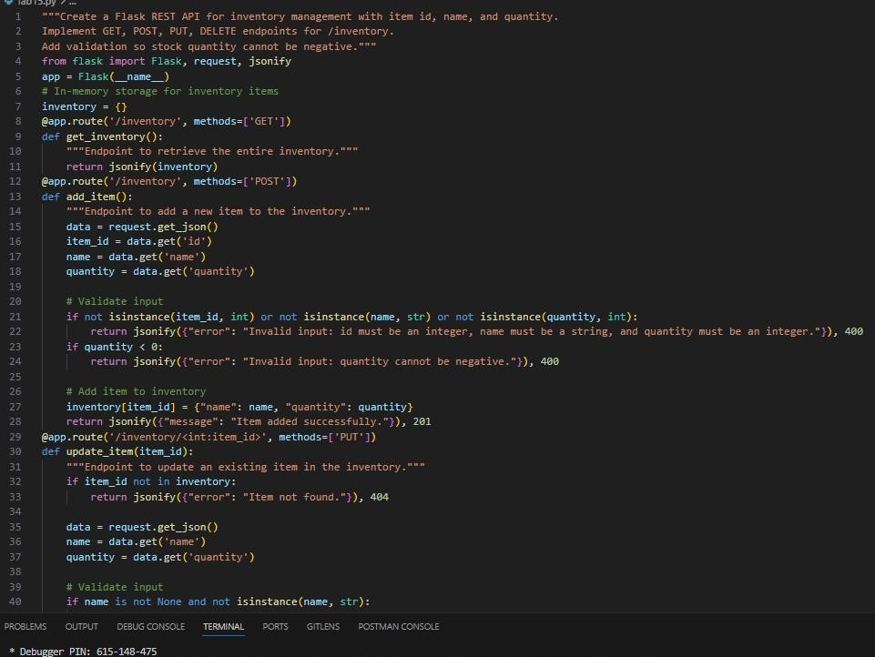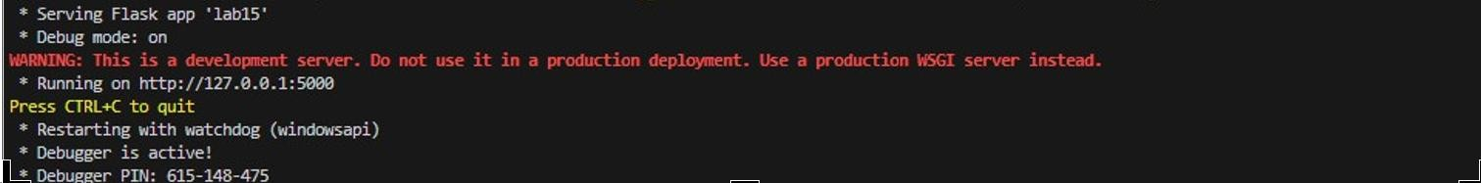
Task 3 – Hotel Room Booking API
Task:
Develop a RESTful API for hotel room booking.
Instructions:
- Endpoints required:
o GET /rooms → View available rooms o POST /rooms/book → Book a room o GET /rooms/{id} → View booking details o DELETE /rooms/{id} → Cancel booking • Implement error handling for unavailable rooms.
Expected Output:
- API simulating hotel room booking operations.
PROMPT:
"""Generate a Flask REST API for hotel room booking using in-memory data.
Endpoints: GET /rooms, POST /rooms/book, GET /rooms/<id>, DELETE /rooms/<id>.
Add error handling if a room is already booked.""" GIVEN OUTPUT:
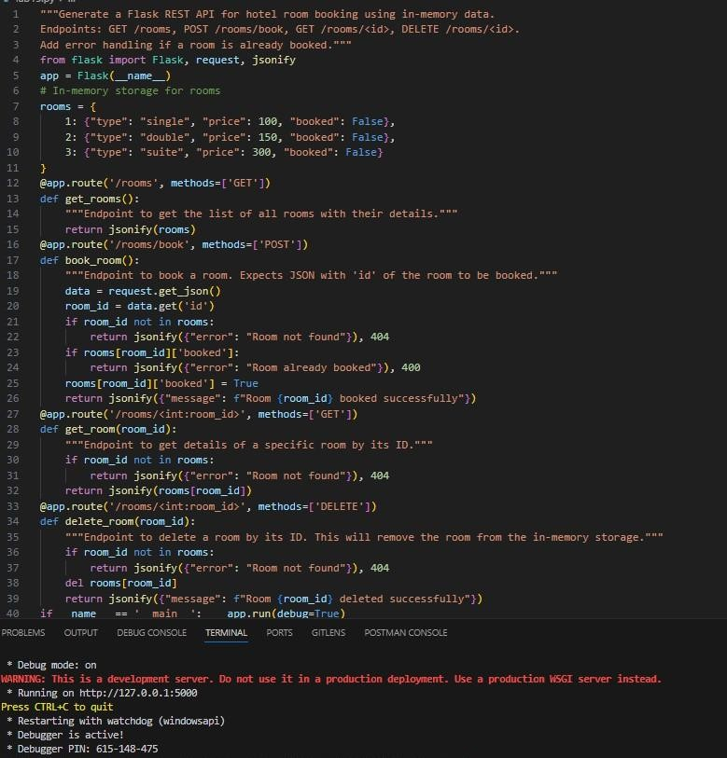
Task 4 – Online Voting API
Task:
Create a RESTful API for an online voting system.
Instructions:
- Endpoints required:
o GET /candidates → List candidates o POST /vote → Cast a vote o GET /results → View voting results
- Ensure one vote per user using in-memory validation.
Expected Output:
- API simulating a secure online voting process.
PROMPT:
"""Create a Flask REST API for an online voting system. Endpoints: GET /candidates, POST /vote, GET /results.
Ensure each user can vote only once using in-memory validation."""
GIVEN OUTPUT:

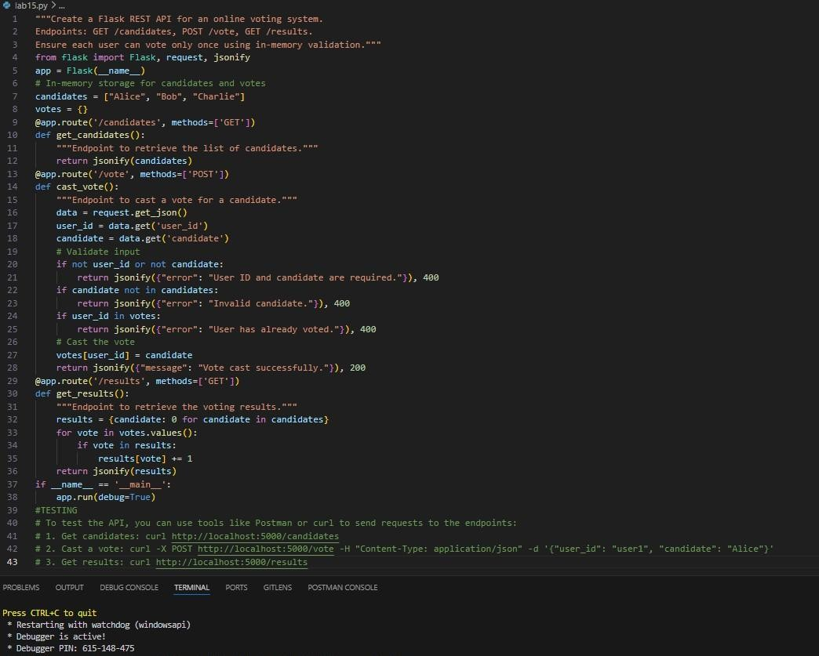
Task 5 – Teacher Management API
Task:
Develop a RESTful API to manage teacher records.
Instructions:
- Endpoints required:
- GET /teachers → List all teachers
- POST /teachers → Add a new teacher o PUT /teachers/{id} → Update teacher details o DELETE /teachers/{id} → Remove a teacher • Ensure proper error handling and JSON responses.
Expected Output:
• Functional API for managing teacher information.
PROMPT:
"""Generate a Flask REST API to manage teachers with id, name, and subject.
Implement GET, POST, PUT, DELETE endpoints for /teachers.
Return JSON responses and handle errors properly."""
GIVEN OUTPUT:
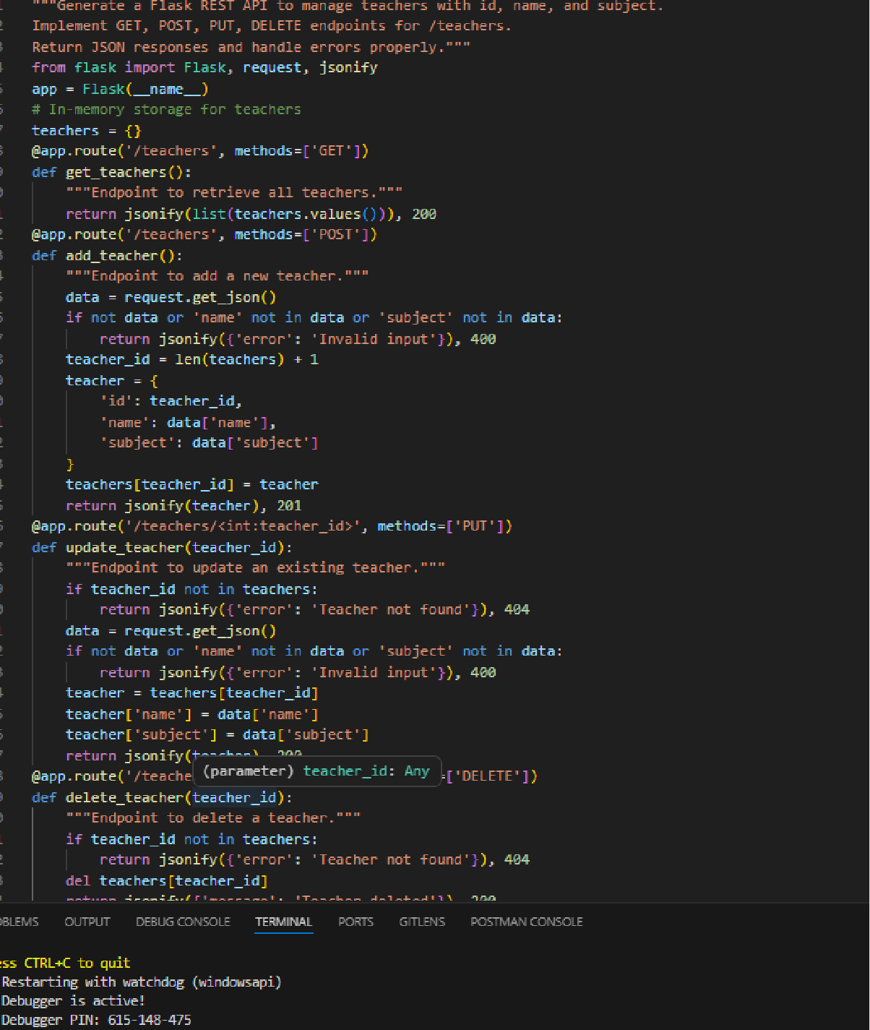

Explanation: In this lab, we created different REST APIs using Flask with the help of AI. We implemented CRUD operations for attendance, inventory, hotel booking, voting system, and teacher management. Each API uses JSON for data handling and includes proper validation and error handling. We also learned how to design endpoints and manage data using in-memory storage. Overall, this lab helped us understand backend development and how AI makes coding faster and easier.

