ASSIGNMENT-14.5
Name: M.Saikrishna
Hall.No: 2303A51771
Batch- 12
Lab 14: Web Design Application – AI-Assisted HTML/CSS/JS
Generation

Lab Objectives
- Design functional, visually appealing web applications Week7 -Friday using HTML, CSS, and JavaScript with AI assistance.
- Apply responsive, accessible, and interactive design principles.
- Create practical UI components for real-world web applications.
- Use AI to optimize layout, UX, and performance
Task 1 – Image Gallery Website Create an image gallery web page.
Requirements:
- Display images in a grid layout.
- Use AI to:
o Optimize layout using CSS Grid. o Add hover zoom or overlay effects. o Ensure mobile responsiveness.
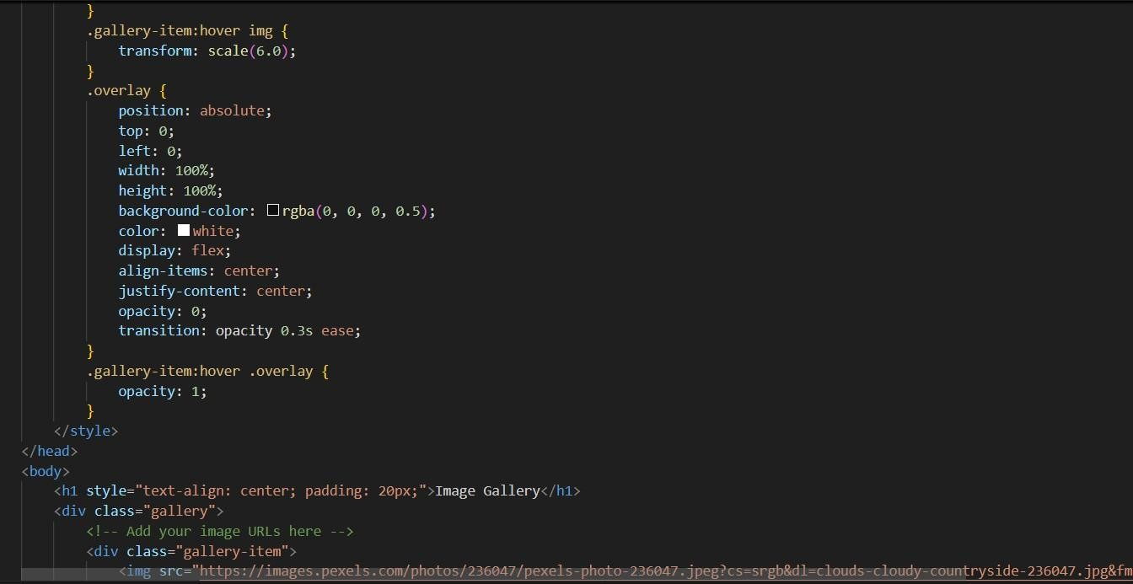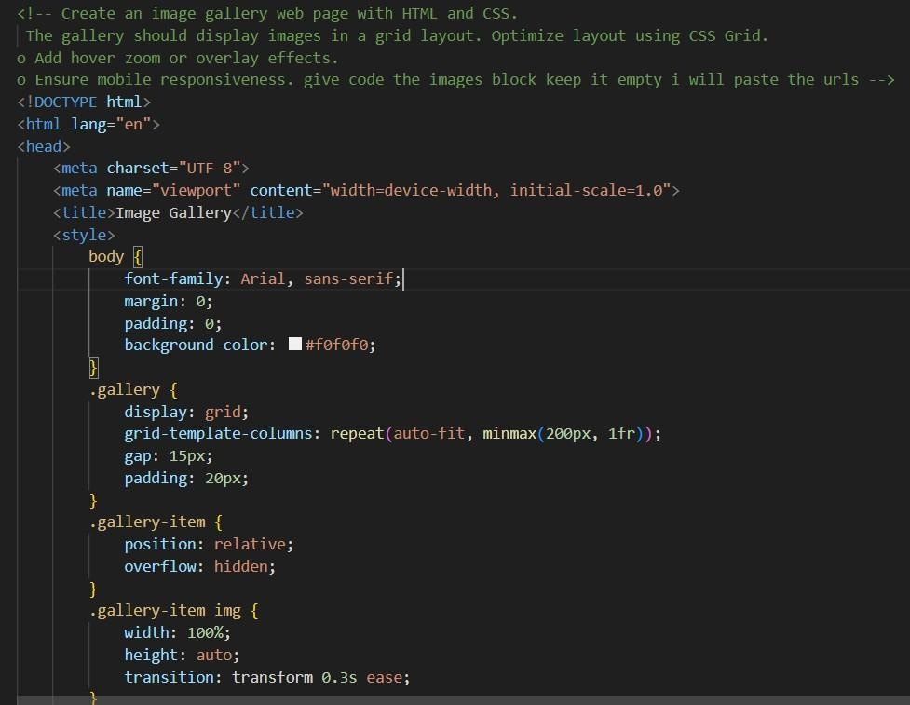
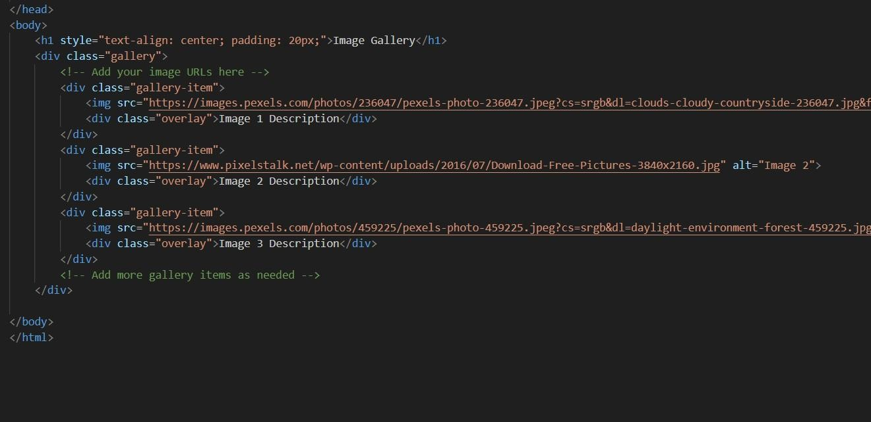
Output


Task 2 – Profile Card Generator Create a profile card web page.
Requirements:
- Display user image, name, role, and social media links.
- Use AI to:
- Suggest modern UI colors and fonts. o Design the card using Flexbox.
- Add hover animation and shadow effects
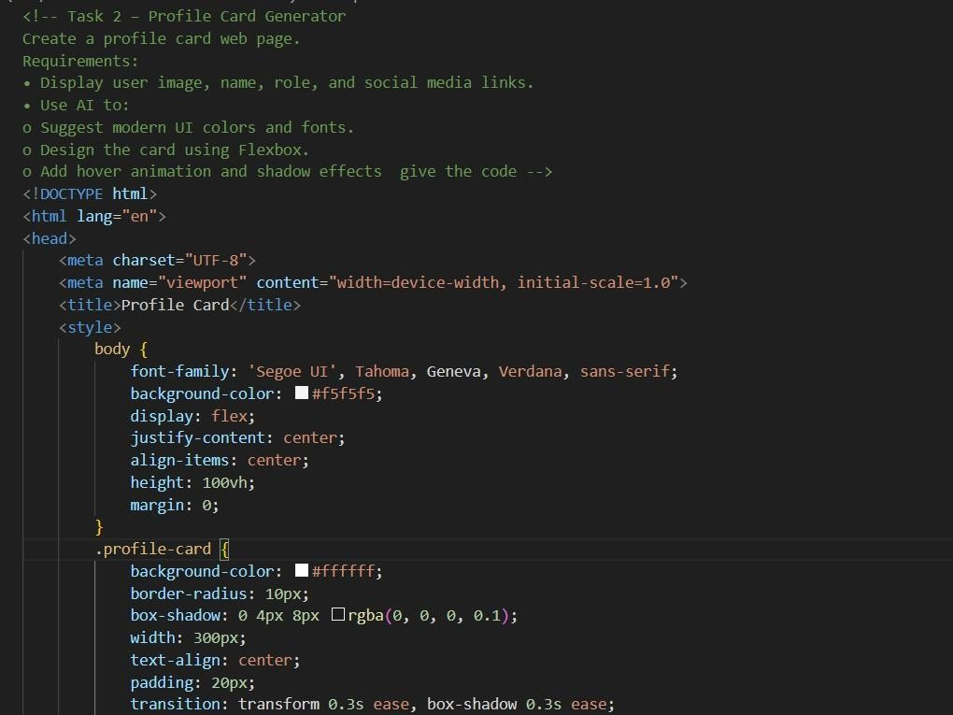

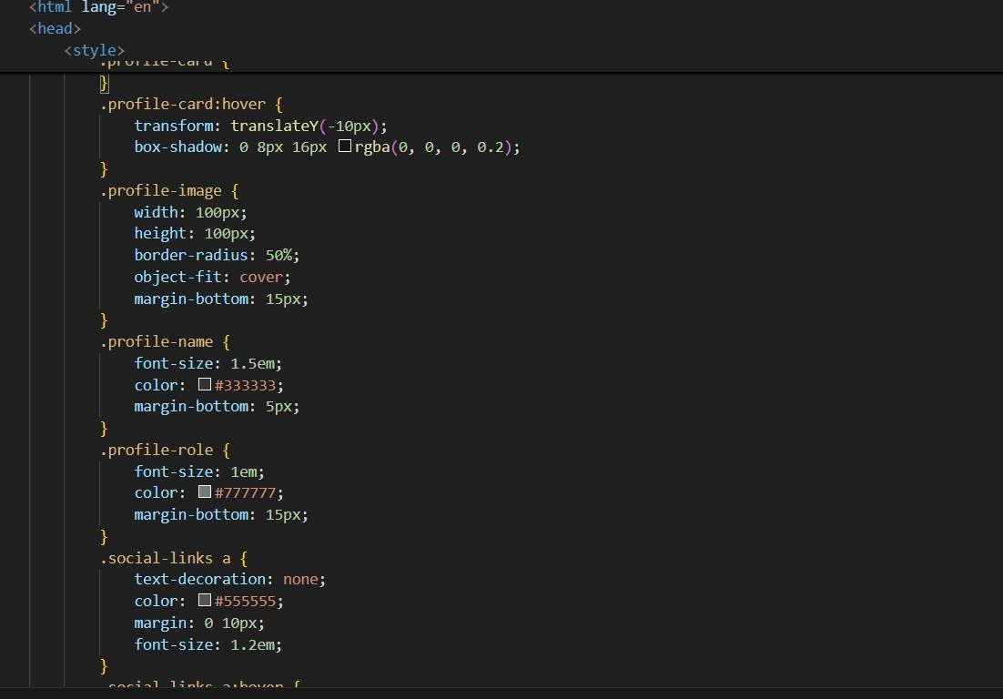
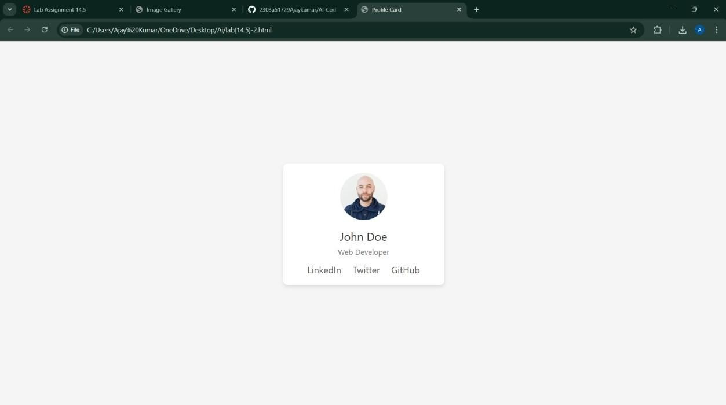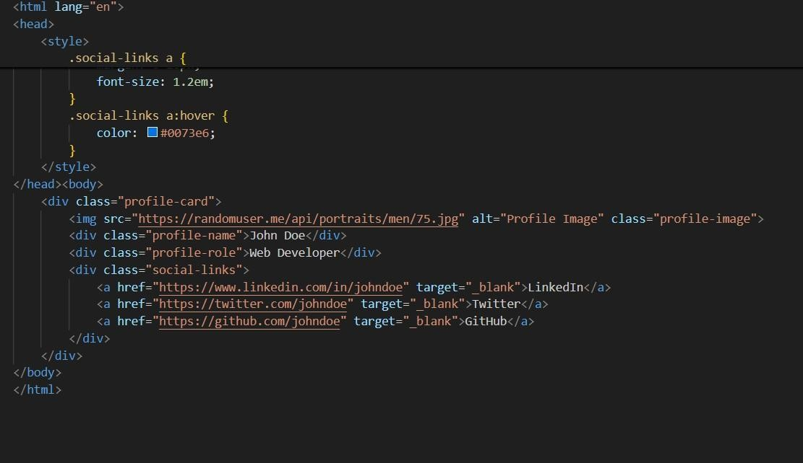
Task 3 -Develop a dynamic shopping cart system.
Requirements:
- Add, remove, and update product quantities.
- Display real-time total price.
- Use AI to:
- Manage cart state using JavaScript objects.
- Persist cart data in localStorage.

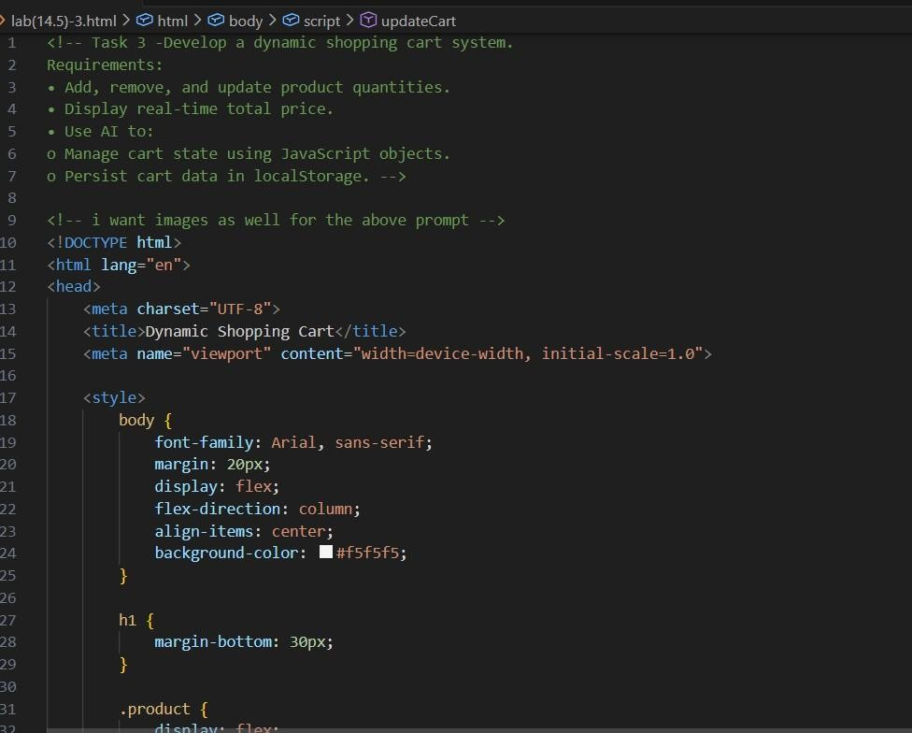
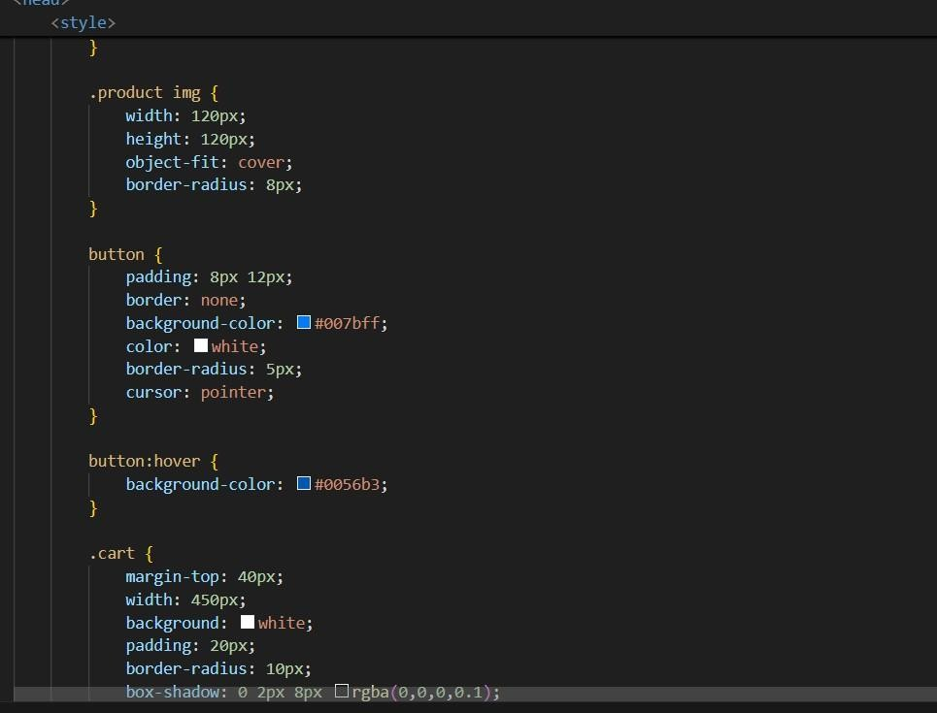
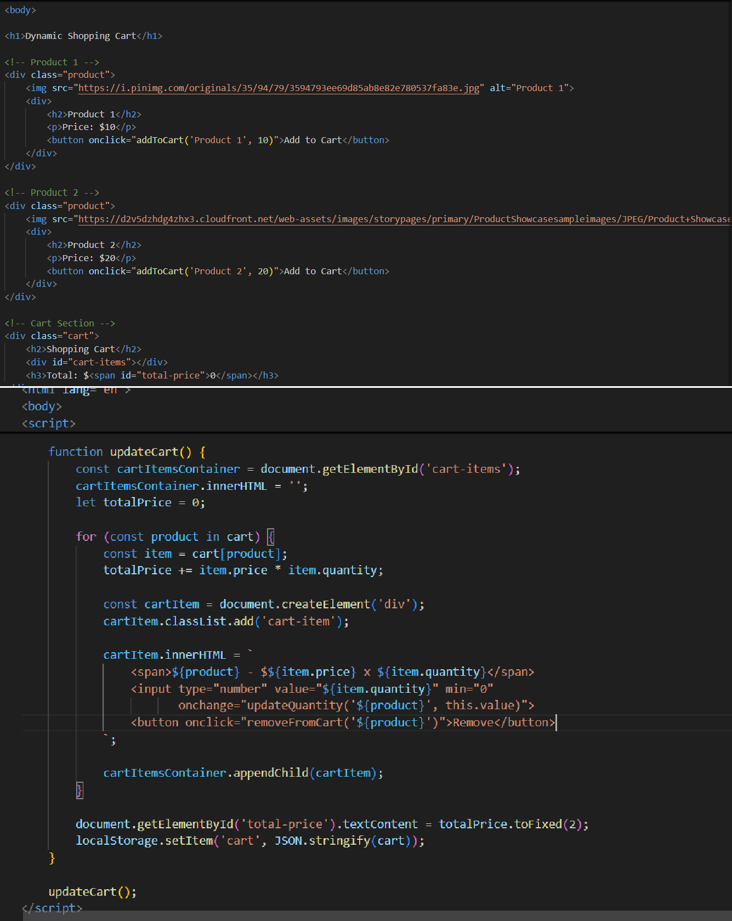
Output
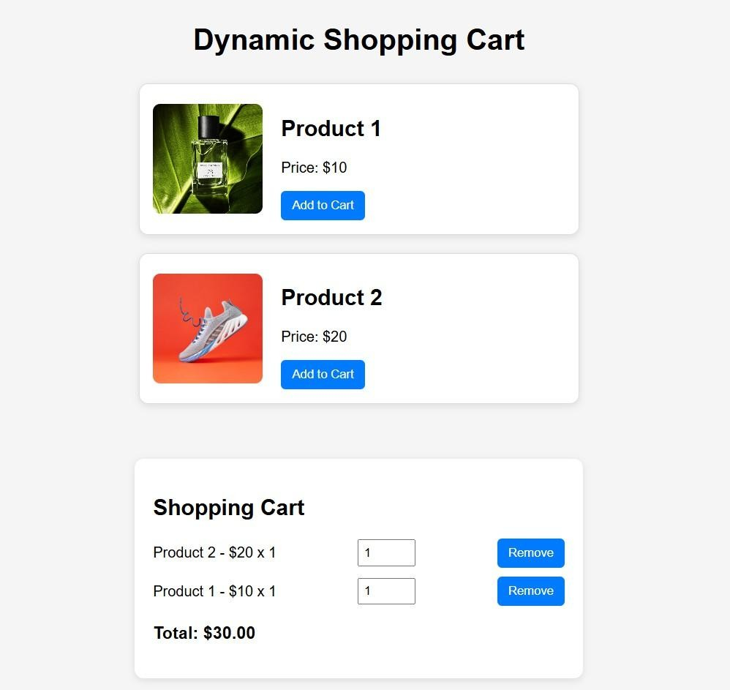
Task 4 – Role-Based Access Control Application Create a role-based web application.
Requirements:
- Admin, Editor, User roles.
- Conditional UI rendering.
- Use AI to:
- Design access control logic.
- Maintain secure state transitions. o Create scalable UI components.
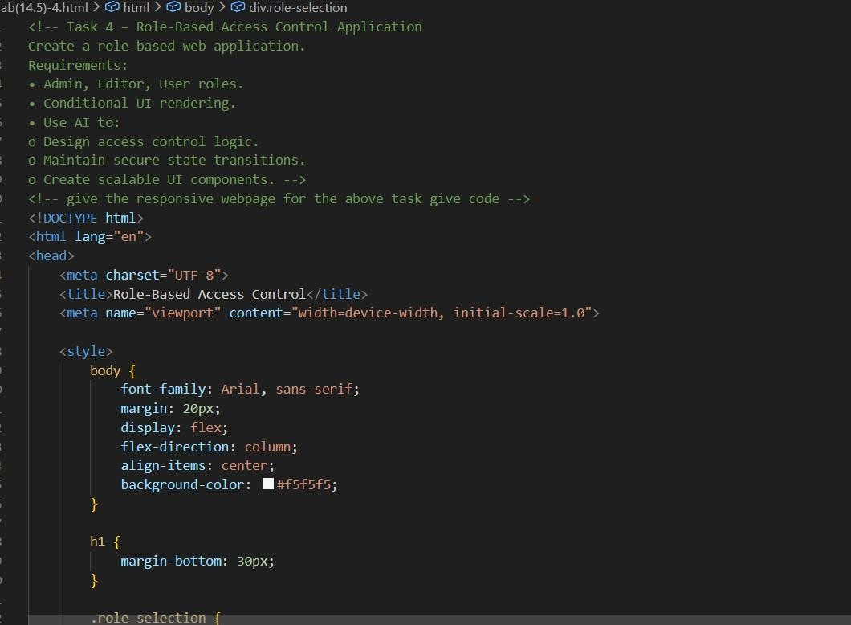
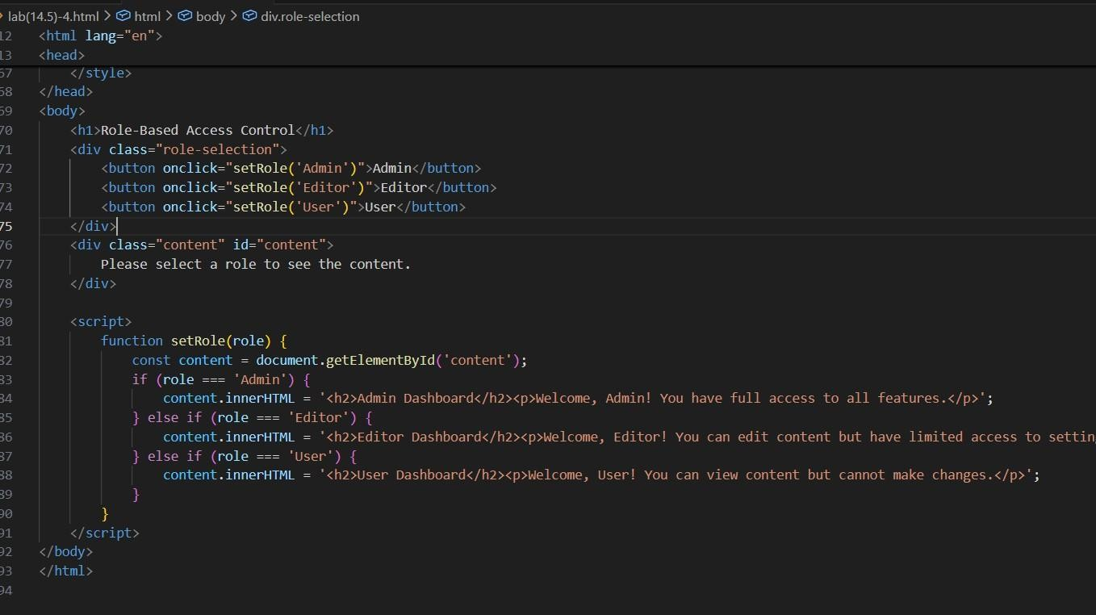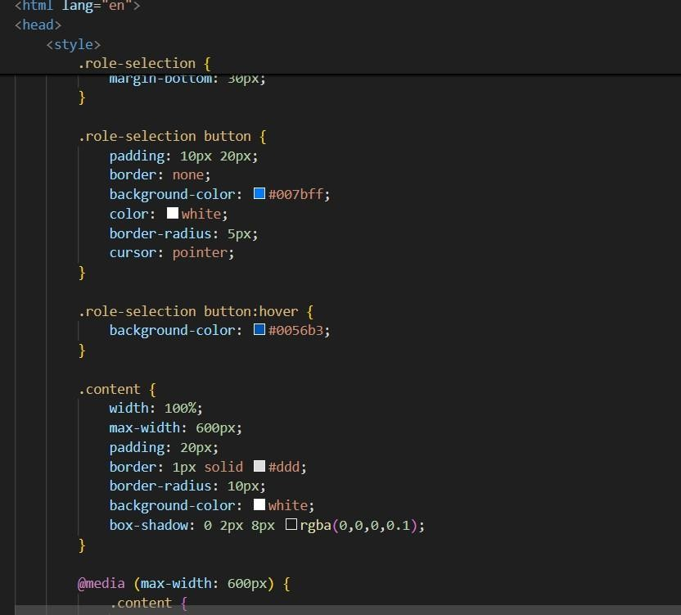
Output:
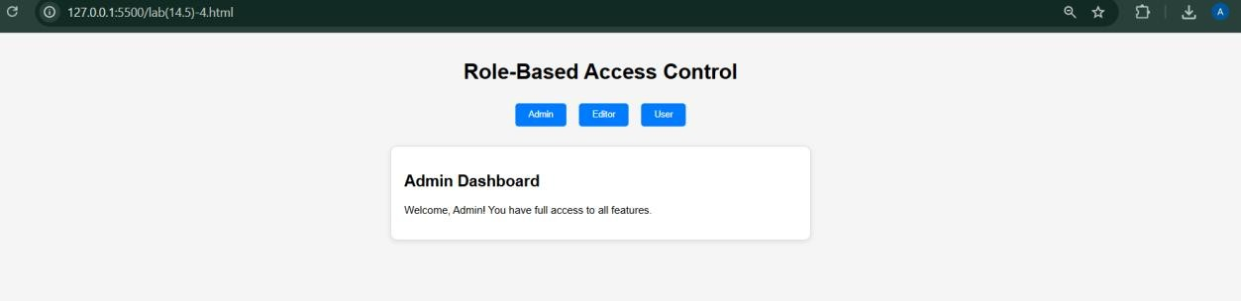
Task 5 – Multi-Language Website Design a multilingual website.
Requirements:
- Switch languages dynamically.
- Persist language preference.
- Use AI to:
o Structure translation files. o Handle RTL/LTR layouts. o Improve accessibility.

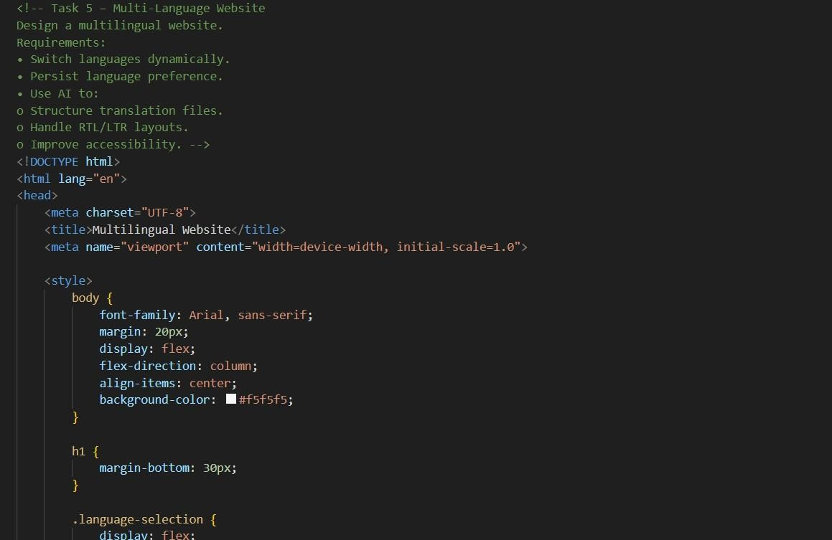

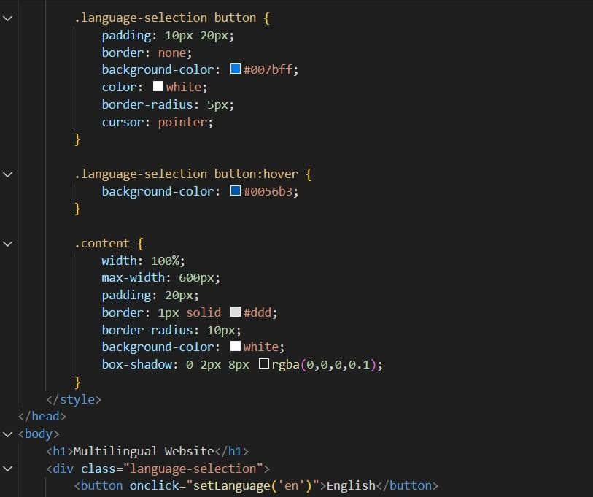

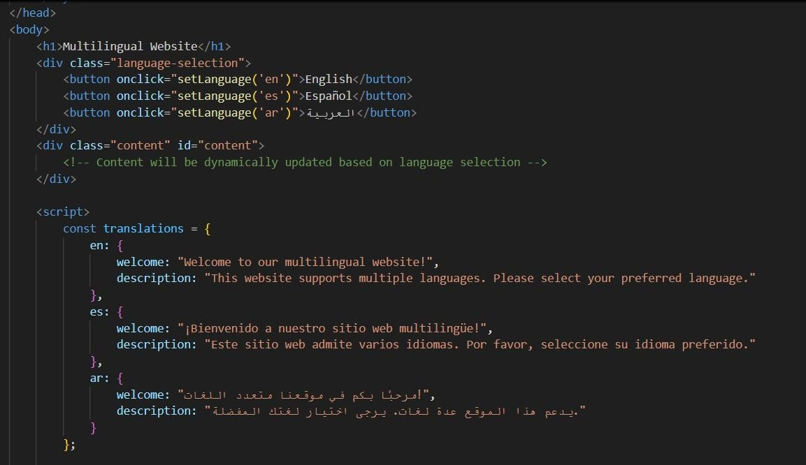
Output:

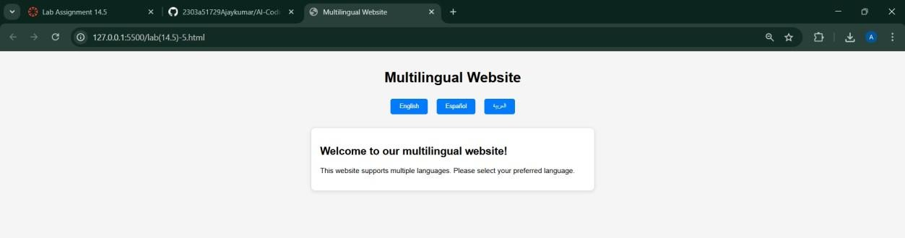
Task 6 – Online Examination System Create an online exam interface.
Requirements:
- Timer, questions, and submission.
- Prevent multiple submissions.
- Use AI to: o Manage exam state. o Improve exam UX. o Ensure accessibility.
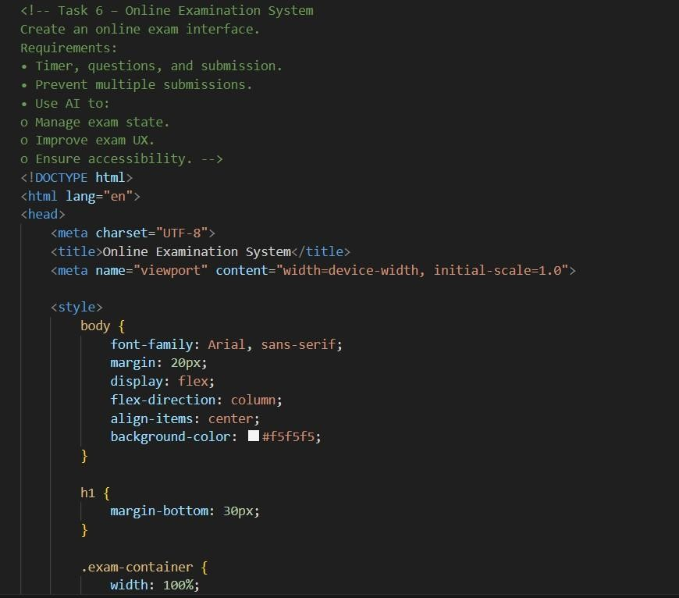
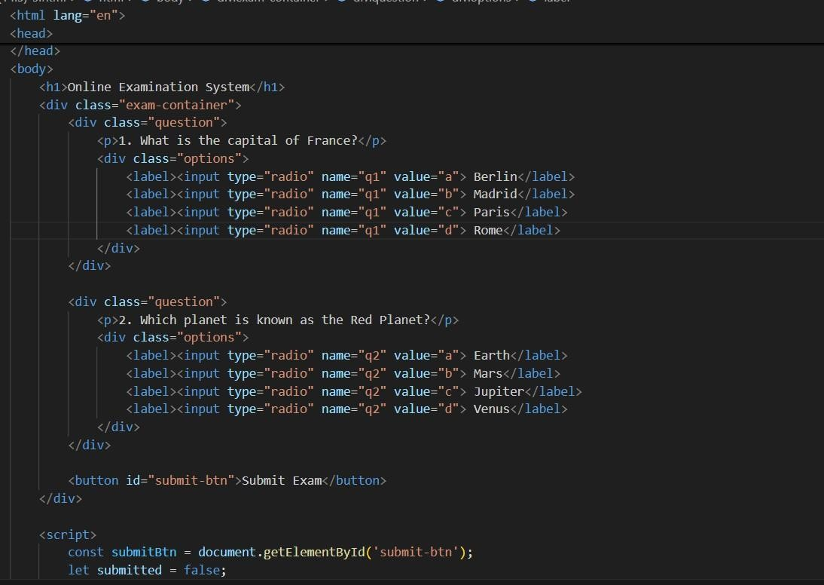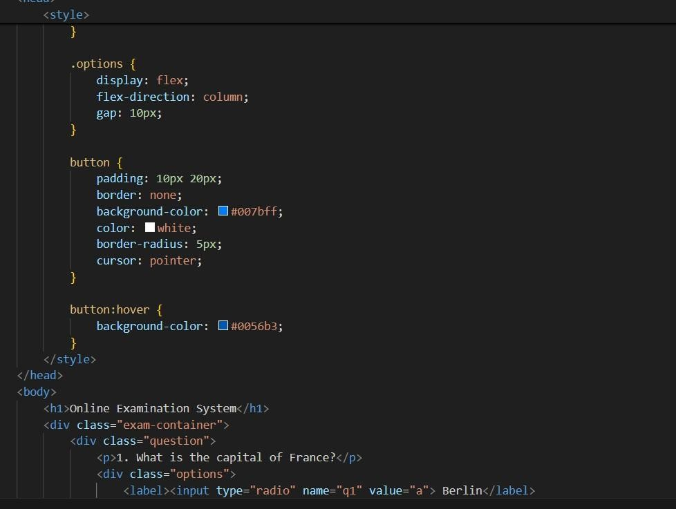
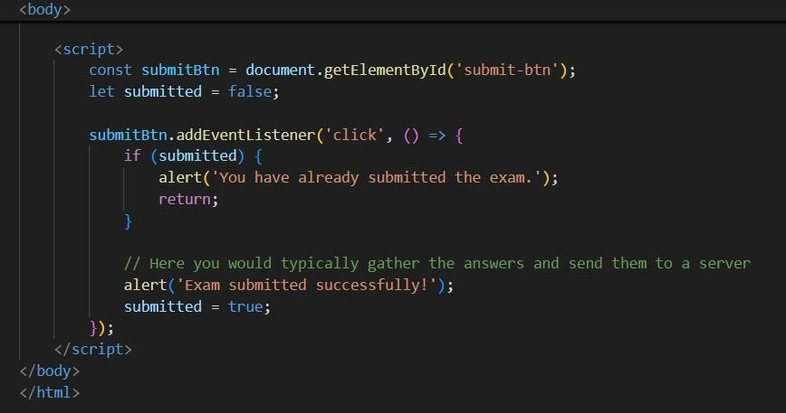
Output:

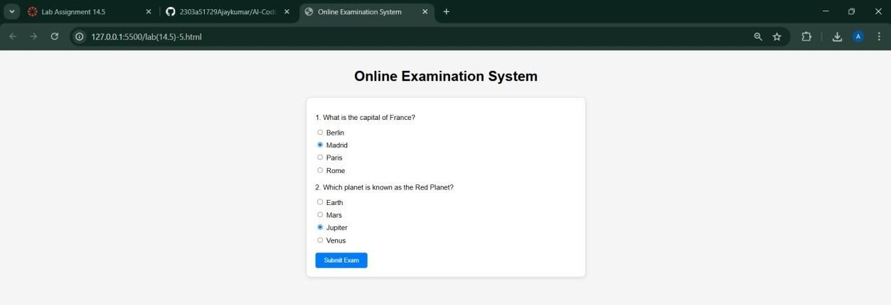

Explanation: In this lab, we developed different web applications using HTML, CSS, and JavaScript with the help of AI. We created an image gallery, profile cards, shopping cart system, role-based access system, multilingual website, and an online exam system. By using AI, we improved design, responsiveness, and user experience. We also learned how to make websites interactive, accessible, and efficient. This lab helped us understand how AI can make web development faster, smarter, and more effective.

